**DEVELOPMENT OF SAFETY-CRITICAL SOFTWARE EXHAUSTIVE TESTING FRAMEWORK FOR NUCLEAR POWER PLANT DIGITAL I&C SYSTEM**

**Sang Hun Lee**

Submitted in Partial Fulfillment of the Requirements

for the Degree of

*DOCTOR OF PHILOSOPHY*

Approved by:

Dr. Hyun Gook Kang, Chair

Dr. Yaron Danon

Dr. Li Liu

Dr. Ana Milanova



*Department of Mechanical, Aerospace and Nuclear Engineering*

Rensselaer Polytechnic Institute

Troy, New York

[December 2019]

Submitted November 2019

# TABLE OF CONTENTS

LIST OF TABLES vii

LIST OF FIGURES ix

NOMENCLATURE xiii

ACKNOWLEDGEMENT xvii

ABSTRACT xviii

1. INTRODUCTION 1

1.1 Digital I&C Systems in NPP 1

1.2 Issues in Risk Assessment of Digital I&C Systems 4

1.3 Reliability Assessment of Safety Software in NPP 7

1.3.1. Software Reliability Growth Model (SRGM) 7

1.3.2. Bayesian Belief Network (BBN) 9

1.3.3. Test-based Method 12

1.3.3.1. Black-box Test-based Method 13

1.3.3.2. White-box Test-based Method 15

1.4 The Problem Statement 16

1.5 Thesis Objective 19

1.6 Thesis Scope 20

1.7 Thesis Organization 23

2. BACKGROUND 28

2.1 Introduction 28

2.2 PLC Platform 29

2.2.1. PLC Hardware 29

2.2.1.1. Central Processing Unit 31

2.2.1.2. Memory 33

2.2.1.3. PLC Scan Cycle 37

2.2.2. PLC Software 39

2.2.2.1. PLC Software Model 39

2.2.2.2. PLC Programming Languages 41

2.2.2.3. PLC Software Development Process 47

2.3 PLC Software Testing 49

2.3.1. Definition of Software Failure 51

2.3.2. Software Testing Techniques 53

2.4 Summary and Conclusions 58

3. EXHAUSTIVE TEST CASE GENERATION OF NPP SAFETY SOFTWARE 61

3.1 Introduction 61

3.2 Related Works 62

3.3 Satisfiability Modulo Theory 64

3.4 Automated Exhaustive Test Case Generation for FBD Program 69

3.4.1. Translation from FBD to SMT formula 70

3.4.1.1. Function Block Translation 72

3.4.1.2. Component FBD Translation 77

3.4.1.3. System FBD Translation 83

3.4.2. Single Test Case Generation for FBD Program 88

3.4.3. Exhaustive Test Case Generation for FBD Program 92

3.5 Summary and Conclusions 99

4. SIMULATION-BASED TEST-BED FOR NPP SAFETY SOFTWARE 101

4.1 Introduction 101

4.2 Related Works 102

4.3 Microprocessor Architecture of NPP Safety PLC 107

4.3.1. TMS320C32 Microprocessor 107

4.3.2. CPU Registers 109

4.3.3. Memory Organization 111

4.3.4. Addressing Modes 112

4.3.5. Microprocessor Instruction Sets 115

4.4 Development of Simulation-based Software Test-bed 121

4.4.1. Functional Requirements of the Software Test-bed 121

4.4.2. I/O Structure of the Software Test-bed 123

4.4.3. Design of Software Test-bed 130

4.4.3.1. Architecture Module 131

4.4.3.2. Assembler Module 135

4.4.3.3. Emulation Module 139

4.4.3.4. Test Module 144

4.4.4. Implementation of Software Test-bed 149

4.5 Verification of Simulation-based Software Test-bed 151

4.5.1. Unit Testing of Instruction Set Operation Emulated in Test-Bed 153

4.5.1.1. Unit Test Case Generation for Software Test-bed 154

4.5.1.2. Unit Test Procedure for Software Test-bed 161

4.5.1.3. Unit Test Result for Software Test-bed 164

4.5.2. Functional Testing of Software Test-Bed 165

4.5.2.1. Lamp On/Off Software 168

4.5.2.2. KNICS IDiPS-RPS BP Software 171

4.6 Summary and Conclusions 176

5. APPLICATION OF PROPOSED METHODOLOGY 178

5.1 Target System: KNICS IDiPS-RPS BP 178

5.2 Test Case Generation of Target Software 194

5.2.1. Variables and States of the Target Software 194

5.2.2. Obtaining the Profile of the Target Software Variables 200

5.2.3. Exhaustive Test Case Generation of the Target Software 211

5.3 Test Execution and Result Analysis of Target Software 228

5.4 Summary and Conclusions 236

6. SUMMARY AND CONCLUSIONS 238

6.1 Discussion 238

6.2 Contributions 241

6.2.1. FBD Exhaustive Test Case Generation Algorithm 241

6.2.2. Simulation-based Test Environment 242

6.2.3. FBD-to-SMT Translation Rules 243

6.3 Future Works 243

REFERENCES 247

APPENDICES 266

Appendix A. List of TMS320C32 Instruction Sets 267

Appendix B. Subroutines of Software Test-bed 273

Appendix C. Unit Test Result of Software Test-bed 287

Appendix D. Benchmarks of the Software Test-bed 322

# LIST OF TABLES

Table 1.1: Digital system failure events reported in LERs during 1990-1993 6

Table 3.1: Fault types of reactor protection system in NPP 70

Table 3.2: Definition of EN and ENO used in function block for FBD program 75

Table 4.1: Header files of simulation-based test-bed for PLC software testing 149

Table 4.2: Source files of simulation-based test-bed for PLC software testing 150

Table 4.3: Input/internal/output variables of Lamp On/Off program 169

Table 4.4: Functional test cases for test-bed regarding KNICS IDiPS-RPS BP pressurizer pressure low trip logic 173

Table 4.5: Result of functional testing of test-bed for KNICS IDiPS-RPS BP trip logic software 175

Table 5.1: KNICS IDiPS-RPS BP trip logic modules 188

Table 5.2: Information on the translated FBDs of BP pressurizer pressure low trip logic 196

Table 5.3: List of software input and internal variables for pressurizer pressure low trip logic output generation 198

Table 5.4: Reactor trip signal actuated for various initiating events of APR-1400 206

Table 5.5: $Dmax$ of the pressurizer pressure for APR-1400 initiating events 210

Table 5.6: Truth table of BP scan mode decision 211

Table 5.7: Summary of the software variables’ states for KNICS IDiPS-RPS BP pressurizer pressure low trip logic software 215

Table 5.8: Summary of the exhaustive test cases for pressurizer pressure low trip logic 222

Table 5.9: An example of exhaustive test cases developed for pressurizer pressure low trip logic 223

Table 5.10: Statistics on KNICS IDiPS-RPS BP trip logic software execution by software test-bed 233

Table A.1: List of TMS320C32 instruction sets 267

Table B.1: Subroutines defined in Architecture module 273

Table B.2: Subroutines defined in Assembler module 274

Table B.3: Subroutines defined in Emulation module 277

Table B.4: Subroutines defined in Test module 284

Table C.1: Result of instruction set unit testing of software test-bed 287

Table D.1: Examples of functional test cases for test-bed regarding pressurizer pressure high trip logic of KNICS IDiPS-RPS BP trip logic 322

Table D.2: Examples of functional test cases for test-bed regarding steam generator-1 level low RPS trip logic of KNICS IDiPS-RPS BP trip logic 323

Table D.3: Examples of functional test cases for test-bed regarding steam generator-1 level low ESF trip logic of KNICS IDiPS-RPS BP trip logic 324

Table D.4: Examples of functional test cases for test-bed regarding steam generator-1 level high trip logic of KNICS IDiPS-RPS BP trip logic 325

Table D.5: Examples of functional test cases for test-bed regarding steam generator-1 pressure low trip logic of KNICS IDiPS-RPS BP trip logic 326

Table D.6: Examples of functional test cases for test-bed regarding containment pressure high trip logic of KNICS IDiPS-RPS BP trip logic 327

Table D.7: Examples of functional test cases for test-bed regarding containment pressure high-high trip logic of KNICS IDiPS-RPS BP trip logic 328

Table D.8: Examples of functional test cases for test-bed regarding steam generator-2 level low RPS trip logic of KNICS IDiPS-RPS BP trip logic 329

Table D.9: Examples of functional test cases for test-bed regarding steam generator-2 level low ESF trip logic of KNICS IDiPS-RPS BP trip logic 330

Table D.10: Examples of functional test cases for test-bed regarding steam generator-2 level high trip logic of KNICS IDiPS-RPS BP trip logic 331

Table D.11: Examples of functional test cases for test-bed regarding steam generator-2 pressure low trip logic of KNICS IDiPS-RPS BP trip logic 332

Table D.12: Examples of functional test cases for test-bed regarding logarithmic power level high trip logic of KNICS IDiPS-RPS BP trip logic 333

Table D.13: Examples of functional test cases for test-bed regarding departure from nuclear boiling ratio low trip logic of KNICS IDiPS-RPS BP trip logic 334

Table D.14: Examples of functional test cases for test-bed regarding local power density high trip logic of KNICS IDiPS-RPS BP trip logic 335

Table D.15: Examples of functional test cases for test-bed regarding CEA withdraw prohibit trip logic of KNICS IDiPS-RPS BP trip logic 336

# LIST OF FIGURES

Figure 1.1: Functional overview of a typical NPP I&C systems 2

Figure 1.2: Configuration of digital I&C systems in APR-1400 NPP, reused with permission from [7] 3

Figure 1.3: Illustration on a software reliability estimation using SRGM 8

Figure 1.4: BBN model for estimating the software defects in the software design phase, reused with permission from [39] 10

Figure 2.1: Block diagram of a typical PLC hardware architecture 30

Figure 2.2: Block diagram of a typical PLC CPU architecture 32

Figure 2.3: Memory map of a typical PLC and its connection to I/O modules 34

Figure 2.4: Scan cycle of a typical PLC 38

Figure 2.5: An illustration on the PLC software model based on IEC 61131-3 standard 41

Figure 2.6: An example of instruction list program 42

Figure 2.7: An example of structured text program 42

Figure 2.8: An example of ladder logic program 43

Figure 2.9: An example of function block diagram program 44

Figure 2.10: Example of sequential function chart program 45

Figure 2.11: An example FBD program for generating reactor pre-trip signal 46

Figure 2.12: A typical PLC software development life cycle for NPP safety applications 48

Figure 2.13: Illustration on the concept of error crystal in software 52

Figure 3.1: An overview of the FBD-to-SMT translation scheme 72

Figure 3.2: Examples of function blocks defined in IEC 61131-3 74

Figure 3.3: FBD-to-SMT translation rules for function blocks 76

Figure 3.4: Formal definitions and translations for example function blocks 77

Figure 3.5: An example FBD program for generating *TRIP_LOGIC* signal 78

Figure 3.6: FBD-to-SMT translation rules for component FBDs 81

Figure 3.7: An example of FBD-to-SMT translation for the component FBD 82

Figure 3.8: FBD-to-SMT translation rules for system FBD 85

Figure 3.9: A part of the system FBD of KNICS IDiPS-RPS BP software 86

Figure 3.10: An example of FBD-to-SMT translation for the system FBD 87

Figure 3.11: An overview of a single test case generation procedure 90

Figure 3.12: Input file for generating a single test case satisfying the test requirement (*TRIP_LOGIC* = true) for the example FBD program 91

Figure 3.13: An example of a single test case generation result for FBD program 92

Figure 3.14: A flowchart of exhaustive test case generation for FBD program 93

Figure 3.15: FBDET algorithm for exhaustive test case generation of the FBD program 95

Figure 3.16: Execution screenshot of FBDET algorithm for an example FBD program 97

Figure 3.17: Screenshot of FETCG, a tool for FBD exhaustive test case generation 98

Figure 4.1: Illustration on the software validation using SIVAT test-bed 105

Figure 4.2: Functional block diagram of a TMS320C3x microprocessor 108

Figure 4.3: Encoding of TMS320C32 indirect addressing mode 114

Figure 4.4: An example of TMS320C32 instruction set encoding 116

Figure 4.5: Input file of PLC software test-bed – PLC program file 125

Figure 4.6: Input file of PLC software test-bed – test setup file 126

Figure 4.7: Input file of PLC software test-bed – test case file 127

Figure 4.8: Input file of PLC software test-bed – expected output file 128

Figure 4.9: Input file of PLC software test-bed – test execution file 129

Figure 4.10: Input file of PLC software test-bed – test result file 130

Figure 4.11: An overview of the simulation-based test-bed for PLC software testing 131

Figure 4.12: An overview of the simulation-based test-bed for PLC software testing 132

Figure 4.13: A part of CPU register and memory map emulation in Architecture module 133

Figure 4.14: Read and write operation of CPU register and memory map 135

Figure 4.15: Process of decoding binary code into the instruction set 136

Figure 4.16: Process of decoding binary code into instruction set by Assembler module 138

Figure 4.17: A part of machine code decoder in Assembler module 139

Figure 4.18: An example of instruction set operation emulation in Emulator module 141

Figure 4.19: Direct addressing mode of TMS320C32 microprocessor 142

Figure 4.20: An example of indirect addressing of TMS320C32 microprocessor 143

Figure 4.21: A part of addressing mode emulation in Emulation module 143

Figure 4.22: Process of instruction code execution and test result analysis in Test module 146

Figure 4.23: A part of instruction code execution in Test module 148

Figure 4.24: Process of test result analysis in Test module 148

Figure 4.25: Compilation of the test-bed to executable code 150

Figure 4.26: Verification and Validation activities throughout the software test-bed development life cycle 152

Figure 4.27: Verification of the software test-bed with instruction set unit test cases 154

Figure 4.28: Unit test case development for PLC microprocessor instruction sets 157

Figure 4.29: Implementation of unit test cases for instruction sets emulated in test-bed 163

Figure 4.30: Process of unit testing for instruction sets emulated in test-bed 164

Figure 4.31: Result of unit testing for software test-bed 165

Figure 4.32: Verification of the software test-bed with functional testing using the benchmark programs 167

Figure 4.33: An FBD program for Lamp On/Off function 168

Figure 4.34: Functional testing of software test-bed for Lamp On/Off benchmark 170

Figure 4.35: Functional testing of software test-bed for KNICS IDiPS-RPS BP benchmark 174

Figure 5.1: Architecture of four redundant channel IDiPS-RPS 179

Figure 5.2: Hierarchical architecture of POSAFE-Q PLC 181

Figure 5.3: FBD program compile procedure of POSAFE-Q PLC 182

Figure 5.4: Software V&V activities for KNICS IDiPS-RPS BP software, reused with permission from [39] 183

Figure 5.5: Manual reset trip logic configuration 185

Figure 5.6: Fixed set-point trip logic configuration 186

Figure 5.7: Variable set-point trip logic configuration 187

Figure 5.8: A part of KNICS IDiPS-RPS BP trip logic software 192

Figure 5.9: Illustration on the pressurizer pressure low trip logic 194

Figure 5.10: Generated files of the FETCG: (a) Function block, (b) Component FBDs, (c) System FBD, (d) Test module 195

Figure 5.11: Execution of FBDET for the pressurizer pressure low trip logic output of KNICS IDiPS-RPS BP software: (a) Generated model for software output in SMT-LIB format, (b) Generated list of software variables that contributes to software output 197

Figure 5.12: Illustration on the process parameter profile for trip demand generation in consideration of the plant dynamics and scan time of the NPP digital I&C system 201

Figure 5.13: MARS-KS nodal diagram for APR-1400 thermal-hydraulic analysis, reused with permission from [254] 205

Figure 5.14: Input-profile of pressurizer pressure for a 2.0 inch small-break-size loss of coolant accident 208

Figure 5.15: Input-profile of pressurizer pressure for a 0.5 inch small-break-size loss of coolant accident 208

Figure 5.16: Input-profile of pressurizer pressure for steam generator tube rupture 209

Figure 5.17: Test module for generating exhaustive test cases for BP PZR_PR_LO trip logic: (a) FBD program and variable definition, (b) test requirement and variable state definition 219

Figure 5.18: Exhaustive test case generation for BP PZR_PR_LO trip logic: (a) Screenshot of the FBDET execution, (b) A part of generated exhaustive test cases for target scenario 221

Figure 5.19: Conventional software exhaustive test case generation method 227

Figure 5.20: Comparison between the proposed and traditional approach on exhaustive test case generation time for KNICS IDiPS-RPS BP pressurizer pressure low trip logic 228

Figure 5.21: Test case file for KNICS IDiPS-RPS BP pressurizer pressure low trip logic 229

Figure 5.22: Program file of KNICS IDiPS-RPS BP software: (a) program file, (b) constant file 229

Figure 5.23: Expected output file for KNICS IDiPS-RPS BP pressurizer pressure low trip logic 231

Figure 5.24: Test execution file for KNICS IDiPS-RPS BP pressurizer pressure low trip logic 232

Figure 5.25: Test setup file for KNICS IDiPS-RPS BP pressurizer pressure low trip logic 232

Figure 5.26: A part of the test result for KNICS IDiPS-RPS BP pressurizer pressure low trip logic software: (a) Screenshot of software test-bed execution, (b) test output file, (c) A part of BP FBD program 235

# NOMENCLATURE

**ADC –** Analog-to-digital Converter.

**AI –** Analog Input.

**ALU –** Arithmetic Logic Unit.

**APR-1400 –** Advanced Power Reactor-1400.

**ATIP –** Automated Test and Interface Processor.

**ATR –** Advanced Test Reactor.

**ATWS –** Anticipated Transient Without Scram.

**BBN –** Bayesian Belief Network.

**BIHS –** Basic Interrupt Handling System.

**BP –** Bistable Processor.

**CCF –** Common Cause Failure.

**CNF –** Conjunction Normal Form.

**COM –** Cabinet Operator Module.

**COTS –** Commercial Off-the-shelf.

**CP –** Coincidence Processor.

**CPU –** Central Processing Unit.

**CTD –** Combinatorial Test Design.

**DBA –** Design Basis Accident.

**DI –** Digital Input.

**DMA –** Direct Memory Access.

**DPLL –** Davis-Putnam-Logemann-Loveland.

**EN –** Enable In.

**ENO –** Enable Out.

**ESFAS –** Engineering Safety Feature Actuation System.

**FB –** Function Block.

**FBD –** Function Block Diagram.

**FBDET –** FBD Exhaustive Test Case Generation.

**FETCG –** FBD Exhaustive Test Case Generator.

**FMEA –** Failure Mode and Effect Analysis.

**GTRN –** General Transient.

**HMI –** Human-Machine Interface.

**HR-SDL –** High Reliability-Safety Data Link.

**I&C –** Instrumentation and Control.

**IDE –** Integrated Development Environment.

**IDiPS-RPS –** Integrated Digital Protection System-Reactor Protection System.

**IL –** Instruction List.

**ISLOCA –** Interfacing System LOCA

**KNICS –** Korea Nuclear Instrumentation and Control Systems.

**LD –** Ladder Diagram.

**LLOCA -** Large-break-size Loss of Coolant Accidents.

**LOCCW –** Loss of Component Cooling Water.

**LOCS –** Loop-operating Control System.

**LOCV –** Loss of Condenser Vacuum.

**LODC –** Loss of 125V DC Bus.

**LOFW –** Loss of Feed-water.

**LOIA –** Loss of Instrument Air.

**LOKV –** Loss of 4.16 kV Bus.

**LOOP –** Loss of Off-site Power.

**LSB –** Least Significant Bit.

**LSSB –** Large Secondary Side Break.

**MAT –** Manual Automatic Test.

**MCR –** Main Control Room.

**MLOCA -** Medium-break-size Loss of Coolant Accidents

**MT –** Manual Test.

**NHPP –** Non-Homogeneous Poisson Process.

**NPP –** Nuclear Power Plant.

**OPR-1000 –** Optimized Power Reactor-1000.

**PAT –** Periodic Automatic Test.

**PLC –** Programmable Logic Controller.

**POU –** Program Organization Units.

**PRA –** Probabilistic Risk Assessment.

**QSRM –** Quantitative Software Reliability Method.

**RAM –** Random Access Memory.

**RCS –** Reactor Coolant System.

**ROM –** Read Only Memory.

**RPS –** Reactor Protection System.

**RSR –** Remote Shutdown Room.

**RTOS –** Real Time Operating System.

**RVR –** Reactor Vessel Rupture.

**SAT –** Boolean Satisfiability.

**SBO –** Station Black-out.

**SDLC –** Software Development Life Cycle.

**SDS –** Software Design Specification.

**SGTR -** Steam Generator Tube Rupture.

**SIL –** Safety Integrity Level.

**SIVAT –** Simulation Validation Test.

**SLOCA -** Small-break-size Loss of Coolant Accidents.

**SMT –** Satisfiability Modulo Theories.

**SRGM –** Software Reliability Growth Model.

**SRS –** Software Requirement Specification.

**ST –** Structured Text.

**V&V –** Verification and Validation.

# ACKNOWLEDGEMENT

I would like to express my gratitude to people and institutions that have made this doctoral research possible. Firstly, I would like to express my sincere gratitude to my advisor Prof. Hyun Gook Kang for the continuous support of my Ph.D. study and related research, for his patience, motivation, and immense knowledge. Under his supervision, I have learned how to identify research problems, solve it using systematic and logical thought processes, document and publish the process flow and results. His advice was invaluable to shape the engineer I am today.

I would like to thank my dissertation committee, Prof. Yaron Danon, Prof. Li Liu, and Prof. Ana Milanova who have provided constructive feedback during my candidacy which has helped me to steer the direction of this study. I acknowledge the feedback on software test-bed development from Prof. Han Sung Son of Joongbu University, Prof. Seung Jun Lee of Ulsan National Institute of Science and Technology, and from Dr. Jinkyun Park of Korea Atomic Energy Research Institute. I am grateful for the questions and feedback from my colleagues on this research. Especially, Dr. Sung Min Shin and Dr. Hee Eun Kim for being reliable and bright teammates as we worked on the digital I&C reliability assessment projects.

I appreciate the financial support from Central Research Institute (CRI) of the Korea Hydro and Nuclear Power (KHNP) company, Republic of Korea in the safety software reliability evaluation project.

# ABSTRACT

As the use of digital I&C systems triggered a challenge in incorporating the software failure into the risk assessment of digitalized NPPs, the software testing for safety-critical systems in nuclear power plants (NPPs) has become an important issue. In response, various quantitative software reliability methods such as software reliability growth model, Bayesian belief network model, and test-based methods have been proposed and adopted in the nuclear field. However, the limitations of the state-of-the-art methods include: (1) the uncertainty in estimating model parameters, (2) the limitation on demonstrating the tested inputs match to the actual operation profile, and (3) a long testing time for each case.

By its nature, the software is a logical matter and determines the function of hardware in the digitalized environment. The space that digitalized input and internal variables construct can be considered as the domain that the software may encounter during system operation, which may be very large but not infinite. For many safety-critical systems, the size and complexity of the program are relatively small and simple, and the number of inputs and internal variables is limited to finite resolution. Therefore, if we can perform the software testing over the whole of this space, the issues related to input selection and model parameter estimation can be resolved. To make it practically achievable, the speed of software testing also needs to be drastically improved compared to the conventional hardware-based test methods.

In this research, an exhaustive software testing method based on an automated test case generation framework for the function block diagram (FBD) programs used in NPP safety systems combined with the simulation-based test-bed was developed. As the software output is determined by the combinations of the states of software input and internal variables, generating the exhaustive test cases can be considered as a problem of finding the solutions that satisfy the on-demand situation of a software. The proposed test case generation framework translates FBD program to semantically equivalent SMT formula based on the formal definition of FBD and generates exhaustive test cases given desired software output by iteratively solving the SMT formula. In addition, an emulation-based software test-bed was developed which emulates the microprocessor architecture and memory map of a safety-critical programmable logic controller (PLC) used in NPP digital I&C system and captures its behavior at each machine instruction while the software executes its dedicated safety function. The test-bed can be used to execute the FBD program given the test cases and generate the test results by comparing the software output generated by the test-bed and the expected output.

The proposed software testing method was applied to the safety-critical trip logic software of an integrated digital protection system-reactor protection system (IDiPS-RPS), a fully digitalized reactor protection system developed under the Korea Nuclear Instrumentation and Control Systems (KNICS) project. Among 15 trip logics of IDiPS-RPS, the pressurizer pressure low trip logic, which is one of the most complicated logics among IDiPS-RPS trip logics, was chosen as a case study to demonstrate the effectiveness of the proposed software test method. As a result, a total of 4,206,164,480 exhaustive test cases were generated for the case study and were tested using a simulation-based test-bed where all test cases generated the pressurizer pressure low trip logic signal. Compared to the traditional approach where all possible combinations of each software variable are exercised and the test cases are derived by extracting the cases which generate the desired software output, the proposed framework showed 2.94 times faster performance in generating each exhaustive test case. In addition, the test execution time per each test case using the simulation-based software test-bed was 6.205 milliseconds in average which is much faster compared to the that of the hardware-based test-bed which ranges from few seconds to few minutes.

An important characteristic of the proposed software test approach is that the test sets can be systematically and quantitatively derived to achieve exhaustive testing of the safety-critical software. In addition, the developed simulation-based test-bed can effectively reduce the software testing time per test case compared to the existing black-box testing from few minutes to few milliseconds by emulating the software behavior given the software input and internal states at the machine language level and automating the process from providing the software input to verifying the output. The proposed software test method is expected to be used to support the software reliability quantification of NPP safety-critical I&C applications and further ensure the safety of software-based digital systems.

# INTRODUCTION

* 1. **Digital I&C Systems in NPP**

For efficient power production and safety, hundreds of plant parameters, such as power, power-density, temperatures, pressures, and flow rates, in a nuclear power plant (NPP) must be kept within the design limits. For this reason, NPP contains thousands of field components, such as motors, pumps, or valves that control the plant process. This coordination is performed by the instrumentation and control (I&C) systems in NPP. Figure 1.1 shows a simplified functional overview of the I&C systems in NPPs [1]. In order to operate NPP in a safe and reliable manner, I&C systems monitor the process parameters and plant condition indicators measured from the field sensors, process the signal by calculating the deviation of these parameters and conditions from the design set points or control demands, and generate corrective actuation signals to the related actuator to bring the process parameters within the safety margin or to achieve its safety function or control objective. In addition, I&C systems display the key information about the plant parameters and deviations from set points through the human-machine interface (HMI) to inform the operator about the plant status.

The operating NPPs were originally built with analog I&C systems which relied son a mixture of analog components such as mechanical, pneumatic and electric components. Due to the obsolescence of the traditional analog-based I&C technologies and the rapid development of digital I&C systems with the advent of microprocessors, operating NPPs have been currently engaged in replacing analog I&C systems to digital ones, while new plant designs fully incorporate digital systems [2]. The first fully digitalized I&C system was integrated into the Kashiwazaki-Kariwa Unit 6 advanced boiling-water reactor in 1996. In Korea, Ulchin 5 & 6 nuclear units, an optimized power reactor-1000 (OPR-1000) type NPP, have adopted the digital-based safety-critical systems, including digital reactor protection system (RPS) and digital engineered safety feature actuation system (ESFAS) [3]. Advanced power reactor 1400 (APR-1400) was developed in 2002, which implemented an advanced main control room with full-digital I&C systems [4]. In the United States, digital I&C systems have been used in many applications, including feed-water control systems, main turbine controls, and many other non-safety systems [5]. While both analog and digital I&C systems are similar in the functional point of view, the digital systems provide advanced performance in terms of accuracy and have the potential for improved capabilities, such as fault tolerance and diagnostics compared to analog systems [6].

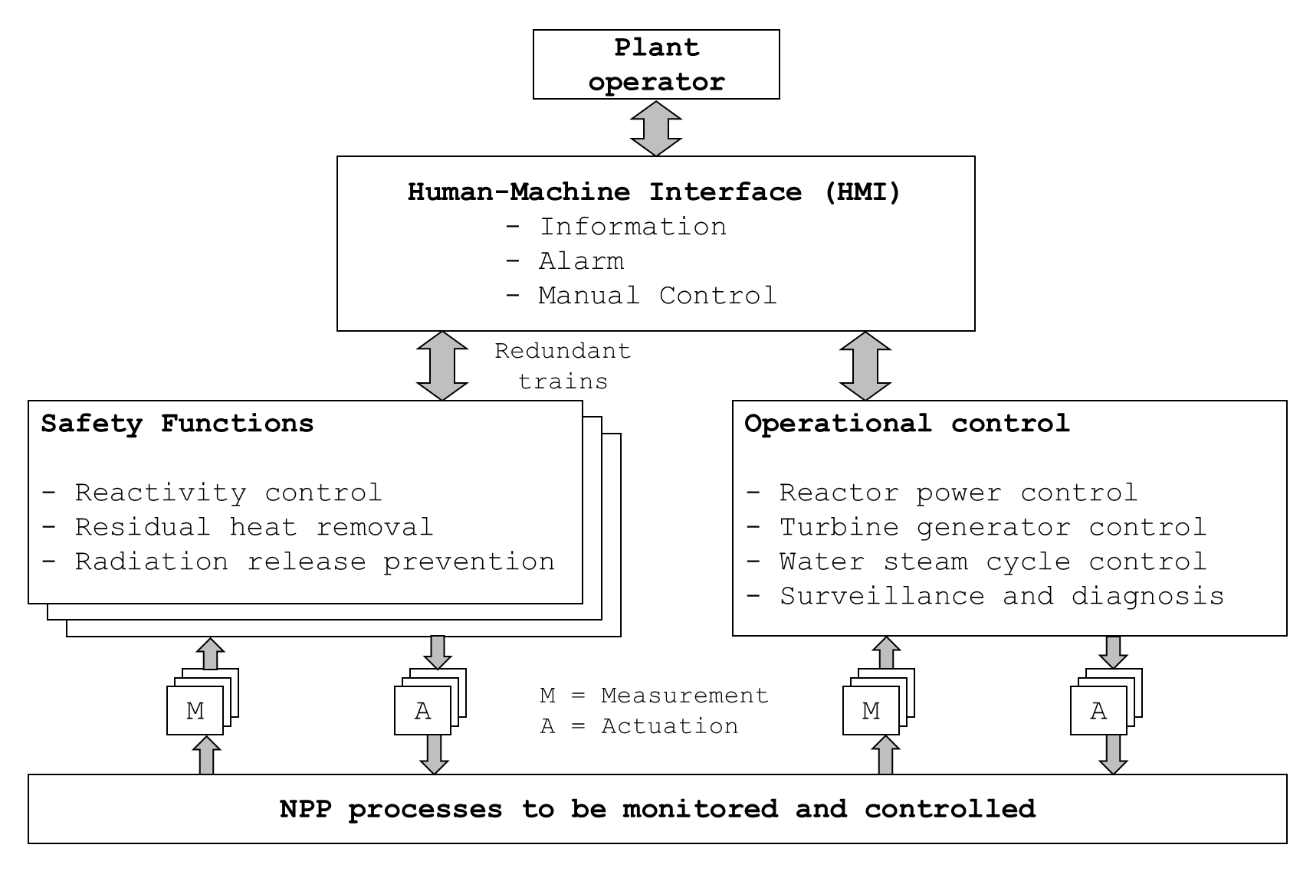

Figure 1.1: Functional overview of a typical NPP I&C systems

Figure 1.2 shows a typical configuration of a digital I&C system in NPP [7]. At the lowest level, sensors and actuators are located to send or receive signals from the devices at higher levels. At the next level, there are plant protection and control systems that collect sensor signals and conduct the signal processing and the actuator control employing computer processors with dedicated software using a binary representation of the measured and controlled parameters in a digital environment. The systems also send information to information processing systems or an HMI located at a higher level. Monitoring systems receive information from the plant protection and control system and process the information to the plant operators via an HMI in the main control room (MCR) and remote shutdown room (RSR). The control signals for the field components can be generated by the operators or by the plant protection and control systems.

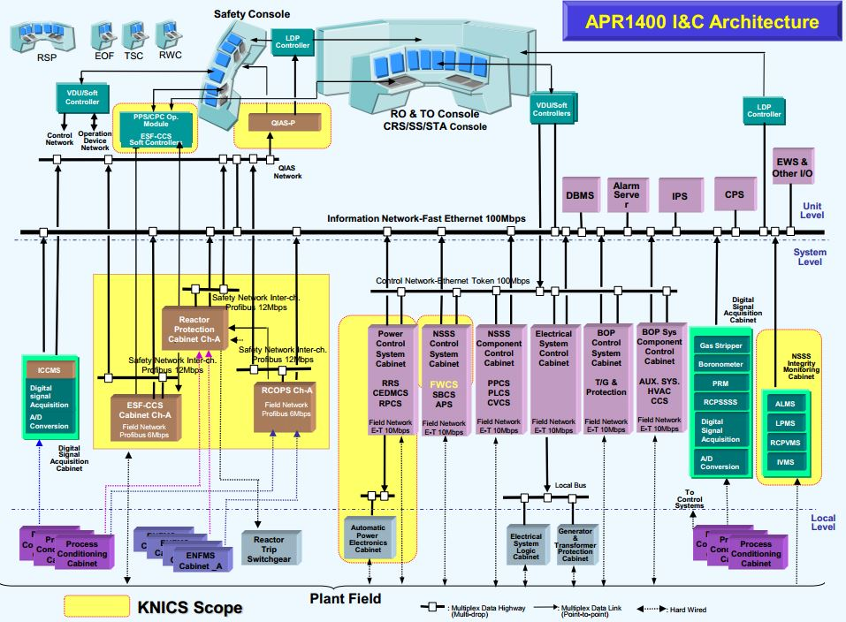

Figure 1.2: Configuration of digital I&C systems in APR-1400 NPP, reused with permission from [7]

As shown in Figure 1.2, the I&C systems in NPPs can be grouped into two categories based on the regulatory guidelines such as IEEE Std. 7-4.3.2-2010 [8] and Nuclear Regulatory Commission (NRC) regulatory guideline 1.152 Rev. 3 [9]: (1) safety systems (placed on the left side of Figure 1.2) and (2) non-safety systems (placed on the right side of Figure 1.2). In some regulatory requirements, the safety systems are graded in a more specific manner as either safety-critical or safety-related. The safety systems are responsible for the safe reactor shutdown and maintaining the plant in a safe shutdown condition while the non-safety systems are responsible for the power generation and control functions during normal operation. As the safety system is essential for the safe operation of NPP, the regulation codes such as 10 CFR 50.55a(h) and General Design Criteria 21 [10] require that the safety systems must be designed for high functional reliability and the quantitative reliability assessment of the system by means of testing or operational experience must be provided to prove the reliable performance of such digital system, including the hardware and software, for the licensing and operation of digitalized NPP.

* 1. **Issues in Risk Assessment of Digital I&C Systems**

Probabilistic risk assessment (PRA) is an integrated risk assessment method for NPP and has been widely used in the nuclear industry for NPP licensing and identifying the vulnerabilities to plant safety [11]. While the PRA analysis have various objectives, it involves the basic tasks such as the definition of accident sequences, the analysis of plant systems and their operation, the collection of component data, and the assessment of accident sequence frequencies. In order to assess the risk of digitalized NPP and to determine the risk effect of digital system on NPP, the reliability model and quantification scheme are needed for the digital systems along with the reliability or test data that are compatible with existing NPP PRA model.

While non-safety systems or control systems are treated in a limited manner in the NPP PRA model, the safety systems or protection systems must be included in the model [12], [13]. As the system architecture and the mode of operation of the NPP protection systems are different from that of the control systems, a different basis for the reliability analysis and modeling needs to be constructed for safety and non-safety systems. For example, for the digital I&C system that is normally operating, such as feed-water control system, its failure can cause an initiating event such as loss of feed-water. Therefore, a model that estimates the frequency of such an initiating event is used for non-safety systems. For protection system, such as RPS and ESFAS, a model that estimates the probability that the system would fail to perform its function for different initiating events and different accident sequences is required.

A comprehensive review of the issues related to the digital I&C system PRA was conducted in [14], [15], [16]. Among various issues, including human reliability and fault tolerance techniques, software failure was identified as one of the most important factors in determining the overall NPP risk. This is due to the fact that the software failure may remove the redundancy effect and cause the common cause failure (CCF) of the processor modules as the same application software of many functions and the operating system software is installed in the redundant processors in the system. In terms of the risk effect of software failure to NPP risk, the sensitivity study [17] was conducted to analyze the relationship between the system reliability and the software failure probability for a typical digital RPS. The result showed that the system unavailability increases from 6.16 x 10-6 to 1.60 x 10-5 (159.74% increase) when software failure probability ranges from 1.00 x 10-6 (good reliability) to 1.00 x 10-4 (poor reliability) when fault detection coverage of 0.3 is assumed.

The operational and maintenance experience data of digital I&C systems also indicates that the software error is a major risk factor to digital system failures among other causes. Table 1.1 shows the statistics of the failure events related to digital I&C system reported in licensee event report (LERs) during 1990-1993 from NRC’s office of analysis and evaluation of operational data [18]. Among a total of 79 digital system failure event, 30 failures were caused by a software error, compared to 9 random component failures. Several reports also stated the importance of software failures that can lead to significant safety threats of NPPs [19], [20].

Table 1.1: Digital system failure events reported in LERs during 1990-1993

|  |  |
| --- | --- |
| Category | Number of Events |
| Software Error | 30 |
| Human-Machine Interface Error | 25 |
| Electromagnetic Interference | 15 |
| Random Component Failure | 9 |
| Total | 79 |

The aforementioned findings inform that the verification of a very low software failure probability plays a significant role in ensuring the safety of NPPs and the quantification of software reliability is crucial for the PRA of a digitalized NPP. However, the fact that the software failure generally comes from the systematic (e.g., design or coding faults) and not the random failure (e.g., wearing off) makes the software and hardware reliability estimation fundamentally different. Unlike hardware, the software-based systems cannot easily be decomposed into subcomponents and the interdependence of the components cannot easily be identified and modeled. In response, several software reliability quantification methods have been proposed and adopted in the nuclear field.

* 1. **Reliability Assessment of Safety Software in NPP**

Most of the existing software reliability estimation techniques depend upon the failure data or expert judgment to predict reliability. The state-of-the-art quantitative software reliability methods (QSRMs) in the nuclear field to quantify software failure rates or per-demand failure probabilities of NPP digital systems include: (1) software reliability growth model (SRGM), (2) Bayesian belief network (BBN) model, and (3) test-based methods. The following sections discuss the methodology and limitations of each method for NPP PRA applications.

* + 1. **Software Reliability Growth Model (SRGM)**

SRGM uses software debug or test data to estimate software failure rates. In the software engineering field, the method was employed to ascertain when a particular software can be released by demonstrating that its failure rate meets the desired reliability level [21]. SRGM is time-based and requires the time between successive failures during tests or the number of failures during different time intervals as input to the model. The method assumes that the software is fixed perfectly and instantaneously after failures so that its reliability grows with time or the software failure rate declines with time [22]. Figure 1.3 illustrates the use of the software failure rate to determine how much testing must be prolonged before reaching a failure rate objective. Based on the findings from the SRGM, the failure rate at the software release time is considered as the failure rate of the software during operation. For this purpose, several SRGMs has been proposed for NPP PRA application [22], [23], [24], including non-homogeneous Poisson process (NHPP), non-exponential NHPP, and Bayesian.

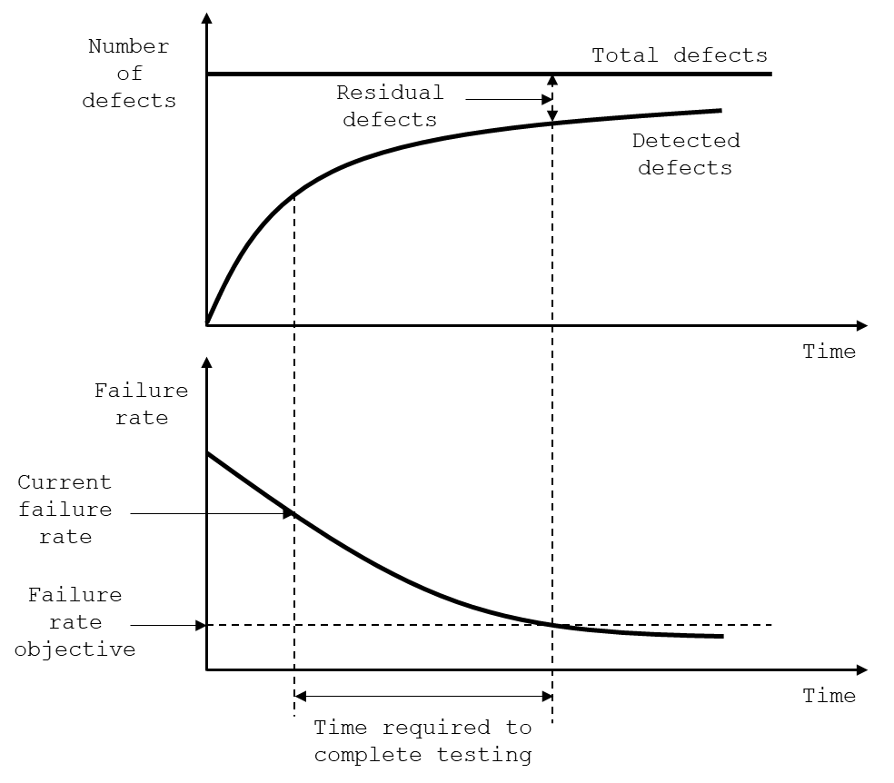

Figure 1.3: Illustration on a software reliability estimation using SRGM

Different SRGMs contain different assumptions on how model variables, such as failure rate and the expected number of failures, change with time. Intuitive use of SRGM in supporting the NPP PRA model would be to take the software failure rate estimated at the end of the test period as the failure rate for the software. SRGM has several advantages in estimating software reliability such that: (1) SRGM can be used without the understanding of the software design or code under test, (2) the reliability can be assessed or predicted once the failure data is available, and (3) the failure trend can be easily estimated after an appropriate model is selected. However, there are several limitations when applying the SRGM to the reliability estimation of NPP safety-critical software:

1. As the SRGMs provide failure rates, they are appropriate for modeling the software failure rate of control systems or non-safety systems in NPP such as the failure rate of the digital feed-water control system and spurious actuation of non-safety systems. For quantifying the failure of a protection system to initiate its protective functions, it would be more appropriate to use a failure-on-demand-based method.
2. Since SRGMs are driven by the test-failure data, the software failure probability calculated by the software reliability growth models is highly sensitive to the time-to-failure data [25]. Therefore, it may not be practical to use these models to demonstrate very high reliability, which is required for safety-critical software in the nuclear domain.
3. Because a safety-critical software is developed under a rigorous verification and validation (V&V) process, the frequency of failure occurrences or the failure data in the safety-critical software is expected to be extremely lower compared to that of commercial software in the non-nuclear fields. Since the conventional SRGMs are known to work well for the software whose failure occurrences are near the anticipated range of some existing empirical formula, SRGMs is difficult to apply to such infrequent failure occurrences that happen in the nuclear domain [25]. For example, the total number of software failures from a total of 775 component and integration tests for the trip-functioning software was identified to be only 6 cases [26].
   * 1. **Bayesian Belief Network (BBN)**

BBN is a probabilistic graphical model that uses Bayesian probability, which is a degree of belief in the occurrence of any event based on prior- and observed-evidence [27], [28]. The BBN method uses conditional probability tables to represent interdependency among disparate software information and potentially combine qualitative information, such as quality in carrying out the development and V&V activities throughout its software development life cycle (SDLC), with quantitative information such as software test and operational data. Figure 1.4 shows the process of software defect insertion and removal modeled in the BBN model.

The BBN methods were used to predict the software reliability in the non-nuclear areas such as medical diagnosis, information technology [29] and were also adopted in nuclear field such as the European projects SERENE [30], IMPRESS [31], OECD Halden Reactor project [32], [33] as well as works by Fenton and Neil [34], Littlewood and Wright [35], Johnson *et al.* [36], Eom *et al.* [37], Bouissou *et al.* [38], and Kang *et al.* [39]. In these studies, various BBN models were proposed which combined disparate sources of reliability evidence for the software used in safety-critical systems in order to predict the software product quality or reliability.

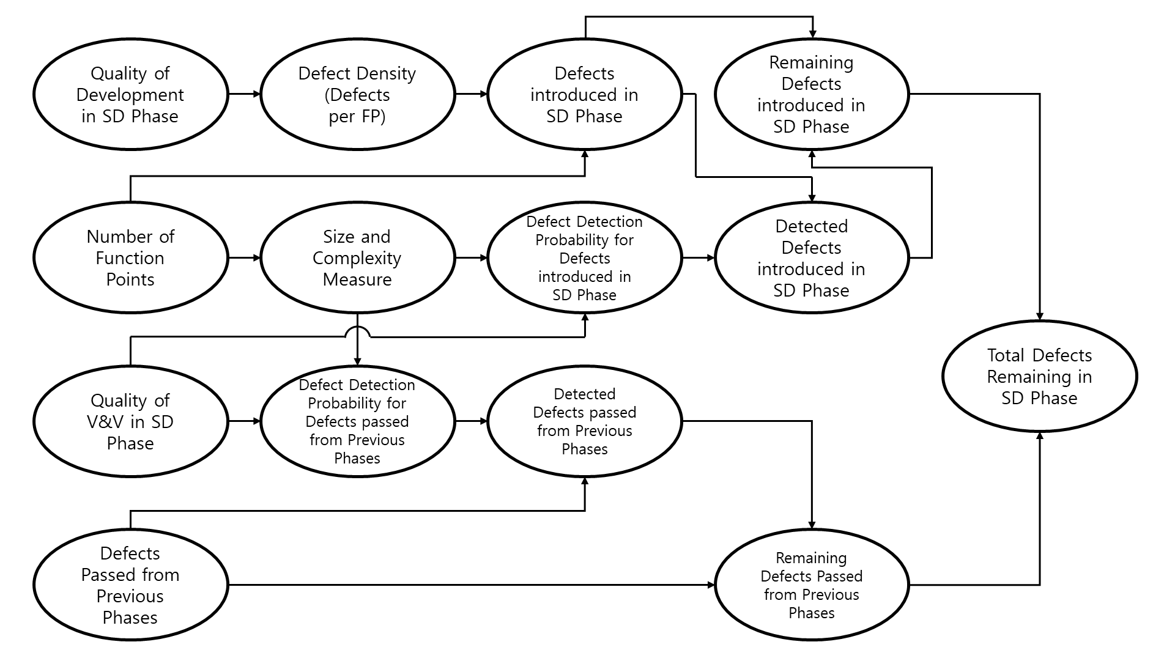

Figure 1.4: BBN model for estimating the software defects in the software design phase, reused with permission from [39]

The BBN method is considered as a promising way to quantify software reliability due to its ability to aggregate disparate information on software, such as software failure data and quality of software lifecycle activities that is assessed using expert elicitation and to include parameter uncertainties as a part of the reliability quantification. However, some challenges in applying the BBN method to safety-critical systems were identified as follows:

1. While the safety-critical software adopts a classical SDLC model [40], [41], [42], such as waterfall model, some software developments utilize much more complicated lifecycle, such as spiral or agile [43], with many more iteration than the waterfall model. Though the overall defects introduction, detection, and removal processes can be captured by general model, some chronical details of the BBN model should be developed and modeled that is specific to each software which involves much work on the manual analysis on the development and V&V documents and the quantification of BBN nodes by expert elicitation.
2. Deciding on how to characterize the dependencies between nodes is one of the most critical parts of developing a BBN model for nuclear safety software. Therefore, the feasibility and accuracy of the model are heavily dependent on the judgment and expertise of the model developer and reviewer.
3. The identification of a set of complete and orthogonal attributes comprises the foundation of a credible BBN model. The standard set of attributes of nuclear software is introduced in IEEE Std. 1012 [42]; however, the analyst must verify that a set of attributes in the BBN model is complete and orthogonal, and develop a better set of attributes or a distinct set of attributes that are specifically applied to the software being analyzed, which involves substantial review and V&V effort on BBN model.
4. Another challenge is that qualitative evidence such as the relationship between the software residual defects and the software reliability needs to be quantified. Since there are no sufficient available data to anchor the conversion of the qualitative information to quantitative values, the uncertainty in the quantitative estimates from the expert elicitations may be substantial as discussed in [44], which may makes it difficult to demonstrate a very low software failure probability required for safety-critical systems.
   * 1. **Test-based Method**

Software testing is a process that evaluates the functionality of software with an intent to find whether the software meets the specified requirements by a set of inputs or test cases and to identify the defects to ensure that the software is error-free [45]. In the nuclear field, test-based methods essentially are those employing standard statistical methods to the results of software tests and possibly to operational data, in the same way as hardware data is analyzed [46]. In software testing, a program is executed with selected data samples from the software’s operational environment and check the answer against an oracle [47]. Here, an oracle is a decision mechanism for judging the outcome of executing a program as successful or failed. The program signifies a logic within software that executes the logic to operate NPP digital system. The studies relevant to the test-based approach conducted in the nuclear field are mainly categorized into two testing methods: (1) black-box testing methods [48], [49], [50], [51] and (2) white-box testing methods [52], [53], [54], [55]. The following subsections discuss each software test-based method and the limitation of the state-of-the-art nuclear application.

* + - 1. *Black-box Test-based Method*

Black-box testing method, or statistical software-testing approach, considers a software program as a single entry, takes random samples from its input space, determines if the outputs are correct given test cases, and uses the results to estimate the software reliability [46]. Here, the software test cases are developed as a trajectory form, i.e., a series of successive values for the input variables of software that occur during the operation of software over time, which is sampled from the operational profile of a software [50]. As the black-box testing is conducted without the knowledge on the program’s internal logic or structure, the test configuration usually employs original hardware or system installed with the software under test. The test results from the test configuration are used for statistical analyses such as the frequentist approach [56] or Bayesian approach [57] in estimating the software reliability. For example, 3 x 105 tests must be successful (no failures observed) to demonstrate a probability of failure of a software per demand of 10-5 with a 95% confidence level based on the frequentist approach.

The black-box testing methods conducted in nuclear field include the reliability tests of the loop-operating control system (LOCS) of an Advance Test Reactor (ATR) experimental loop at Idaho National Laboratory [50], bistable processor (BP) and coincidence processor (CP) trip logic software of APR-1400 RPS [58], and digital RPS based on Versa module Europe bus single-board computer developed by Korea Power Engineering Company, Inc. [59]. For LOCS application [50], the digital protection system, the host computer, and the interface systems were built for test configuration and 10,000 test cases were generated that compose of input signals to the LOCS test platform using a thermal-hydraulic model and simulating the selected accident. For APR-1400 RPS application, the profiles of test cases were generated based on the failure mode and effect analysis (FMEA) data of BP and CP modules and the RPS connected with the I/O simulator [58] for transferring software test cases are used to conduct software testing.

As the probability of the software failures relates to the operational profile of the software, the black-box testing has an advantage of achieving high software reliability with a minimal number of test runs assuming that the test cases with the highest probability of occurrence is tested first. However, some limitations in applying the black-box test-based method for software reliability estimation in NPP PRA model was identified as follows:

1. In black-box testing, the test cases are developed with the prediction of possible usages of the software from the software specifications, module interface specifications, or with the aid of plant simulator. Therefore, the quality of the developed input profile of test cases depends on the testers’ skills or the accuracy of plant simulators, which may introduce additional uncertainty in software reliability estimation based on test results.
2. In terms of the performance of the software testing, the execution time per test case for black-box testing which utilizes the hardware-based test-bed is limited to few hundreds of milliseconds or few minutes [50], [58]. This limits the number of software testing to verify high software reliability and confidence level for black-box testing.
3. A practical limitation of the black-box testing is the availability of the test configuration needed to undertake the tests. As the black-box testing is conducted without the knowledge on the program’s internal logic or structure, the original hardware is utilized as a test-bed to execute the program given test cases. However, employing the original hardware poses extra difficulties in testing and restricted accessibility to the internal states of the software and hardware that may limit the scope of testing.
   * + 1. *White-box Test-based Method*

White-box testing uses the information on the internal structures of the software to derive test cases and the tests are performed to ensure that certain parts or the specific function of software are functioning correctly [60]. Since the white-box testing methods aim to test all possible paths and nodes of the software, the number of tests that must be carried out for exhaustive testing is often huge for complex applications. In the nuclear field, the coverage-based approach has been widely applied to NPP safety-critical software testing for white-box testing, which proposed several coverage measures such as MC/DC [61], LCSAJ [62], [63], CCC [64], FPCC [65] along with the program coverage testing methods [66], [67], [68], [69], [70]. Other white-box testing methods include state-based models, path-based models, and additive approaches [71]. These studies share the common aspect that they generate test cases with respect to specific goals such as coverage achievement from the derived test cases. However, the test results from those coverage-based methods cannot be applied for ensuring a reliable software since they focus on detecting faults or mutants in software by those test cases and not checking whether the software generates its dedicated safety function at its on-demand situation, which is the focus of the software reliability in terms of NPP PRA.

To overcome this limitation, the operational profile-based approaches [52], [54], [72] have been proposed which partition input space that corresponds to the software on-demand situation into a set of bins and estimates the software reliability from the usage distribution of the input partitions. The operational profile is the probability distribution associated with various input values that the software will observe. If all input values are equally likely, this distribution will be uniform. If some input values are more likely than others, the distribution will be non-uniform and used to represent the operational profile of each software input. However, some limitations in applying the operational profile-based method for software reliability estimation in NPP PRA model include the difficulty in knowing what the actual probability distribution will be, which is difficult to verify. For example, it may not be possible to demonstrate a failure probability of 10-5, a typical reliability estimates for a NPP RPS, even if millions of test cases can be performed due to the epistemic uncertainty regarding the representativeness of the test profile [73] such as the uncertainty of the thermal-hydraulic model of the plant, which is used to derive the test trajectories.

* 1. **The Problem Statement**

The previous section informs that there is presently no state-of-the-art consensus method for quantifying the software reliability used in digital systems though many development and V&V activities are carried out in the SDLC of safety-critical systems to ensure a high-quality product. In summary, the limitations of the state-of-the-art methods include: (1) the uncertainty in estimating model parameters [25], [39], (2) the limitation on demonstrating the tested inputs match to the actual operation profile [48], [52], and (3) a long testing time for each case using conventional hardware-based test-bed [50].

As the most obvious source of reliability figure is by testing the software using test sets [74], [75], exhaustive testing among other test methods, such as dynamic testing [76], program coverage testing [64], [65], [66], [67], [68], [69], [70], and operational-profile-based testing [57], [63], are considered as an ideal test method. However, exhaustive testing is generally considered computationally challenging for large and complex systems [77]. This is due to the state explosion of the test space; that is, the number of input and internal variable combinations of software to be tested grows exponentially as the size and complexity of the software increases. Previous white-box testing approach [53] defined the finitude of the input domain for digital I&C system testing and derived the exhaustive test cases in consideration of the digital processing unit and plant dynamics. However, it had a limitation on demonstrating the exhaustiveness of the test cases, which is essential in proving the software is error-free based on the test result using the derived test case.

By its nature, the software is a logical matter and determines the function of hardware in the digitalized environment. The space that digitalized input and internal variables construct can be considered as the domain that the software may encounter during system operation, which may be very large but not infinite. For many safety-critical systems, the size and complexity of the program are relatively small and simple. For example, a rough estimate of 50 function points is considered a typical size of the digital RPS software [78] and the number of inputs and internal variables is limited to finite resolution. Therefore, if we can perform the software testing over the whole of this space, the issues of input selection and model parameter estimation related to the state-of-the-art QSRMs can be resolved.

In this thesis, the general research problems are divided into three specific research questions related to the NPP safety software exhaustive testing, as follows:

1. **Research Question 1 (RQ1)**: How can a full set of software input and internal variables that contribute to software output be found automatically?

Current exhaustive test case generation methods [53], [55] for NPP safety software involve much manual work that makes the use of method expensive and prone to human error. One part of the test case generation that requires human effort is defining the software variables for which the test cases are made. Especially in NPP safety software where the collection of functions blocks (FBs) and function block diagram (FBDs) are wired together and comprises of the whole program, it is difficult to identify the software variables that contribute to the software output generation, as described in [55]. To address this limitation, an FBD analysis tool that allows software variables to be automatically derived from the source code of the software needs to be developed for more systematic exhaustive test case generation of NPP safety-critical software.

1. **Research Question 2 (RQ2)**: How can the exhaustive test cases formally derived for NPP safety software in terms of PRA context?

After the software inputs are defined for which the test cases are made, the test case generation involves the process of identifying program inputs’ states that satisfy the selected testing criterion (e.g., trip signal generation by RPS trip logic software). From the viewpoint of NPP safety, the testing of safety-critical software needs to focus on the failure of its dedicated safety function when demand comes [78]. By demand, it means a plant condition that requires the actuation of safety systems. As the software output is determined by the combinations of the states of software input and internal variables, generating the exhaustive test cases for safety software testing can be considered as a problem of finding the solutions that satisfy the on-demand situation of a software, i.e., the Satisfiability Modulo Theories (SMT) problem. For this purpose, the safety-critical software under test can be translated into the semantically-equivalent SMT formula and the test cases can be generated for the translated SMT formula given the desired software output defined as a set of constraints to be solved.

1. **Research Question 3 (RQ3)**: How can the software test-bed be developed that accurately simulates the operation of safety software and makes exhaustive software testing practically achievable?

As discussed in section 1.3.3, the number of test cases that can be tested in a reasonable timeframe using hardware-based test-beds which most of the state-of-the-art test-based methods employ is limited since providing input and checking the result by interrupt or other measures are relatively time-intensive task and often require human effort [50], [58], [59]. Since the number of tests that must be carried out for exhaustive testing is often large, an efficient and effective software test-bed for NPP safety-critical software must be developed which can read the test cases, mimics the programmable logic controller (PLC) operation where the software is running, and generate test results by comparing with the expected output in an automated manner. For this purpose, a test tool must be designed in a simulated environment, that is, without using the original hardware, such that the source code of the safety-critical software is uploaded to the test-bed and tested for software validation. This can be achieved by emulating the components and execution characteristics of the central processing unit (CPU) used in a PLC in which the compiled machine code of the safety-critical software is executed.

* 1. **Thesis Objective**

This thesis focuses on the development of the software testing method based on an automated exhaustive test case generation framework combined with the simulation-based software test-bed for the NPP safety-critical software. The proposed test case generation framework explicitly unwinds the FBD program and utilizes a symbolic execution technique to generate exhaustive test cases. The simulation-based software test-bed is developed which emulates both the CPU architecture and the memory map of a target PLC microprocessor and then checks whether the software program generates the correct output given software test cases. The test-bed is used to read the test cases, run the software program compiled to machine language, and generate test results. The effectiveness of the proposed software testing framework is demonstrated via a case study of a trip logic software of an integrated digital protection system-reactor protection system (IDiPS-RPS), a fully digitalized reactor protection system developed under the Korea Nuclear Instrumentation and Control Systems (KNICS) project [79]. The test result of the NPP safety software from the suggested method is expected to be applied to the NPP PRA model to analyze the effect of software failure on the NPP risk and utilized to reduce the current regulatory burden on the software reliability quantification of NPP digital I&C systems. The research objectives of this thesis are summarized as follows:

1. Develop an automated exhaustive test case generation framework
2. Develop a simulation-based software test environment
3. Demonstrate the proposed methodology on:
   * KNICS IDiPS-RPS BP trip logic software
   1. **Thesis Scope**

This thesis proposes a novel approach for the exhaustive testing of the NPP safety-critical software. The scopes of this study are summarized below:

1. This thesis focuses on the failure of application software and not on system failures arising due to the hardware or the operating software or the hardware-software interaction.

A PLC [80] is a digital computer used in the automation of various processes, including process control and protection actions in NPPs. The basic architecture of the PLC platform [81], [82] consists of the PLC hardware, the operating system software, and the application software, as follows:

1) System hardware: The hardware platform uses a processing computer module that includes memories for the execution of programs and data storage.

2) Operating system software: The execution of the software is conducted by the operating system software, which communicates with the PLC hardware and the application software. For NPP safety applications, the main functions of the operating system include calling the application software in a deterministic manner with a particular scan time and dispatching computer resources to the application software running on the PLC.

3) Application software: The application software includes the plant-specific safety logics and functions. The application software is usually developed by the domain experts based on the software specifications and coding environment tools that uses qualified software modules to develop a specific application.

In this thesis, it is assumed that the software failure of NPP protection system is modeled at the system level, that is, the software on all microprocessors of the digital system is treated as a single system. In general, the software failures can be considered at a more detailed level, for example, at the microprocessor level, where hardware-software interactions take place [83]. The limitation is related to how an overall model of the protection system, including both hardware and software, is modeled, for which there is no consensus method.

In the PLC platform, there are two types of software: (1) the application software and (2) operating system software and different types of tests are applicable to each software. For example, the testing of operating system software focuses on verifying whether it executes the predefined tasks, or application software, in a certain deterministic execution time bounds [84], [85], while the testing of an application software focuses on verifying whether it generates the correct output [46], [50]. As this study focuses on demonstrating the error-freeness of the software by conducting exhaustive testing for its safety function based on PRA context, the testing of the NPP application software is only considered in this thesis.

1. The thesis assumes the FBD program, the source code of safety-critical software, exactly represents the initial software requirements; thus, the test cases generated from FBD program reflect all on-demand situations of NPP safety software defined in the requirement.

The software development processes for safety software in NPPs generally consist of five different SDLC phases: (1) requirement phase, (2) design phase, (3) implementation phase, (4) test phase, and (5) installation-and-checkout phase [42], [83], [86]. In the requirement phase, the software requirement specification (SRS) documents are usually written in natural language and a formal specification is developed on which various formal analysis techniques are applied. In the design phase, the PLC program, usually written in FBD language, is developed and documented in software design specification (SDS) documents. In the implementation phase, the hardware configuration for PLC, i.e., the number of I/O cards, CPU speed, network communication, is decided and the PLC program is translated into machine code that is installed in the PLC platform. This translation process is conducted automatically by an engineering tool provided by PLC vendors. It is notable that the actual development for PLC software is completed at the end of the design phase and the end product of the software development is the machine code of the FBD program for NPP safety application.

The proposed framework in this study generates the exhaustive test cases from the FBD program. In general, software defects may be inserted or removed by development or V&V activities in each SDLC phase and passed to the next SDLC phases. For example, the faults in software development planning (SDP) process or concept document in the requirement phase may lead to wrong software design in the design phase. This thesis assumes that the FBD program, which is the end product of software design phase is equivalent to the original software specifications, and fully verified and translated from the initial requirement specifications by rigorous formal verification, synthesis, and refinement; thus, the test cases generated from the FBD program reflects all on-demand situation of the NPP safety software defined in the requirement phase. Previous studies focused on generating the test cases from the requirements written in natural language [87], [88]; however, the limitations include that the natural language for which the test cases are generated has to be written using specific format to apply the method; thus, it may require an additional manual effort to rewrite the original requirements according to that format which may introduce other errors in test case generation.

* 1. **Thesis Organization**

A significant part of the research in this thesis is the development of a novel approach for NPP software exhaustive testing. First, an automated exhaustive test case generation framework for NPP safety software is proposed. The method translates FBD program to SMT formula based on the formal definition of FBD and generates the exhaustive test cases given desired software output by iteratively solving the formula using SMT solver. Second, simulation-based software test-bed is developed which emulates the microprocessor architecture of the PLC used in NPP safety-critical applications and captures its behavior at each machine instruction. The test-bed can be used to run the machine code of the NPP safety software given the test cases and generate the test results by comparing the software output with the expected output. The research work includes a case study, in which the feasibility of the developed techniques and methodologies is evaluated with a KNICS IDiPS-RPS BP trip logic software, which generates a reactor trip signal when the plant is in an abnormal state and is one of the most important safety systems in NPP.

This thesis is structured as follows:

* Chapter 1 - Introduction

This Chapter outlines a general context on NPP digital I&C systems and the comprehensive review on the existing QSRMs and their limitations. The motivation, scopes, and objectives of this thesis are provided here.

* Chapter 2 - Background

This Chapter provides the background information on the two fields of studies related to this research: (1) PLC platform including the hardware and software used in NPP safety application and (2) PLC software testing techniques. In addition, the definition of software failure is discussed for which the test cases are derived to demonstrate the software safety in terms of NPP PRA context.

* Chapter 3 – Exhaustive Test Case Generation of NPP Safety Software

This Chapter describes the methodology to generate exhaustive test cases for FBD programs. An automated exhaustive test case generation framework for NPP safety software consists of two major steps: (1) translating the FBD program under test to semantically-equivalent SMT formula and (2) generating exhaustive test cases by finding the models of the translated SMT formula given test requirement by satisfiability check.

In this thesis, the FBD-to-SMT translation rules were developed based on the formal definitions of the FBD components, from the FBs, the most fundamental element of FBD program, to the component FBD, a user-defined FBD that contains several FBs, and system FBD, a whole software program. As exhaustive testing is a test approach in which all possible cases of software demand are tested, the states of software input and internal variables that satisfies test requirement (e.g., safety signal generation) must be derived for NPP safety software. In this thesis, FBD exhaustive test case generation (FBDET) algorithm was developed which utilizes SMT solver to check the satisfiability of the SMT formula translated from the FBD program and retrieve models for software input and internal variables while adding the negation of the last found models as a new constraint to the formula at each iteration.

The proposed framework was implemented to the FBD exhaustive test case generator (FETCG), which automates the process from FBD-to-SMT translation to FBDET algorithm execution. The testers can select the software program written in FBD language to be tested and specify the desired software output. The FETCG generates a test module file for the translated FBD program and derives the exhaustive test cases by FBDET algorithm based on the variable information provided by the tester which specifies the possible ranges or values of software input and internal variables.

* Chapter 4 – Simulation-based Test-bed for NPP Safety Software

This Chapter describes the simulation-based test-bed developed for the safety-critical PLC used in NPP digital I&C systems. The test-bed emulates the microprocessor architecture, including the CPU register and memory map and the operation of a target PLC (i.e., a total of 118 assembly language instruction) and captures its behavior at each machine instruction line while the software executes its dedicated safety function. The test-bed consists of five different independent modules: (1) *Architecture module*, which emulates the major components of the safety PLC microprocessor such as CPU registers and memory map, (2) *Assembler module*, which decodes the PLC application software that contains binary-coded instructions and interpret the syntax of the instruction sets and the related source and destination operands to be processed for each line of machine code, (3) *Emulation module*, which emulates the operation of a total of 118 instruction sets of TMS320C32 microprocessor such as arithmetic/logical operations and load/store operations, (4) *Test module*, which reads input files, writes the test cases to the emulated memory map, passes files to other modules for executing the PLC application software, and generates the test result by comparing the software output to the expected output.

In order to validate the developed software test-bed, the unit testing for the instruction sets emulated in the test-bed and the functional testing using the benchmark programs from simple software (Lamp On/Off software) to a more complicated software (KNICS IDiPS-RPS BP trip logic software) were conducted. The verification activities for the PLC software test-bed were performed in accordance with the nuclear quality assurance standards for software development.

* Chapter 5 – Application of Proposed Methodology

This Chapter shows the application of the proposed software testing method on the KNICS IDiPS-RPS BP trip logic software. Among 15 trip logic modules of BP software, the pressurizer pressure low trip logic categorized as the manual reset trip logic was chosen as a case study for the proposed framework. The pressurizer pressure low trip logic is one of the most complicated logics among BP trip logics which has various functions such as reset delay timer and the trip set-point reset by an operator, making it a good example to demonstrate the applicability of the proposed method to a complex safety system. In the case study, the exhaustive test cases were generated for the pressurizer pressure low trip signal generation by the BP software by: (1) deriving the software input and internal variables that contribute to generating the trip signal output, (2) defining the profile or possible range of each variable, and (3) executing the FBDET algorithm for the translated FBD program in FETCG environment. The derived test cases were tested using a simulation-based test-bed to validate whether the machine code of target software generates a correct output for the derived exhaustive test cases.

* Chapter 6 – Summary and Conclusions

This Chapter summarizes the novel academic contributions made in this thesis, as well as key findings in the previous Chapters. Conclusions are drawn based on these findings and key areas deemed necessary for future studies are identified.

# BACKGROUND

* 1. **Introduction**

This Chapter gives an overview of the two fields of studies involved in this research: (1) PLC and (2) the software testing. The most common digital platforms used for NPP I&C systems include PLCs, field-programmable gate arrays, and industrial computers [89]. The PLC is an industrial microprocessor-based control system which was invented to replace the sequential relay circuits used in analog I&C system. The PLC continuously monitors the state of input devices and makes decisions based upon a software logic to control the state of output devices. It is the most widely used control device for the processes with digital and analog instrumentation (e.g., pumps, valves, sensors), and can be operated under a harsh environment with high reliability. Section 2.2 describes the main characteristics and the concepts of PLC platform that have been taken into account in this study.

The software testing is a technique to achieve discernible differences between intended and actual behaviors of a system, or at gaining confidence that there are no discernible differences [90]. It is a vital aspect of software verification during its SDLC because it may expose potential flaws in the software and can provide feedback on the quality of the software during its development process. For NPP applications, the software testing must be carried out to verify that all input conditions should represent the anticipated operational occurrences in both normal and accident situations to confirm the correct action of the software [83]. Section 2.3 describes the definition of the software failure for which the test cases are developed in this study that can be used to verify the error-freeness in terms of its safety function, and the review of the general software test design techniques related to the NPP software testing.

* 1. **PLC Platform**

Since the advent of the microprocessor, digital systems have been replacing the analog-based systems in the field of real-time control. One of such computer or digital controller designed to replace the systems of industrial control relays is the PLC. The PLC is a type of general industrial control platforms with high reliability. With their capability for convenient programming of complex tasks and fault diagnosis, many applications which would, in the past, have used hundreds of relays to implement specific logic are now built using microprocessor-based PLCs.

A PLC has a relatively simple architecture compared to the commercial computers and servers which use the state-of-the-art microprocessors and supporting hardware. The basic architecture of a PLC consists of the processor module, the power supply, and the I/O modules in which the sensors and actuators are plugged via input and output channels, respectively [80], [81], [82]. The control or safety functions of a PLC are realized as a form of application software logic which is periodically executed by the operating system software of a PLC. The application software reads all input values at the beginning of each cycle, generates the outputs based on the predefined logic, and updates the values of system variables. The following subsections describe the PLC hardware and software components in a detailed manner.

* + 1. **PLC Hardware**

PLC is designed to process the signals from the plants for its dedicated function and facilitate the connection of the plant's sensors, instruments, and actuators through its I/O system. Internally, PLC is comprised of a CPU, several memory units, the peripherals which enable external communication such as I/O modules connected to the input (e.g., sensors, switches) and output (e.g., solenoids, pumps, valves) devices, and the internal buses for the communication between the PLC components. Figure 2.1 shows a block diagram of a typical PLC architecture.

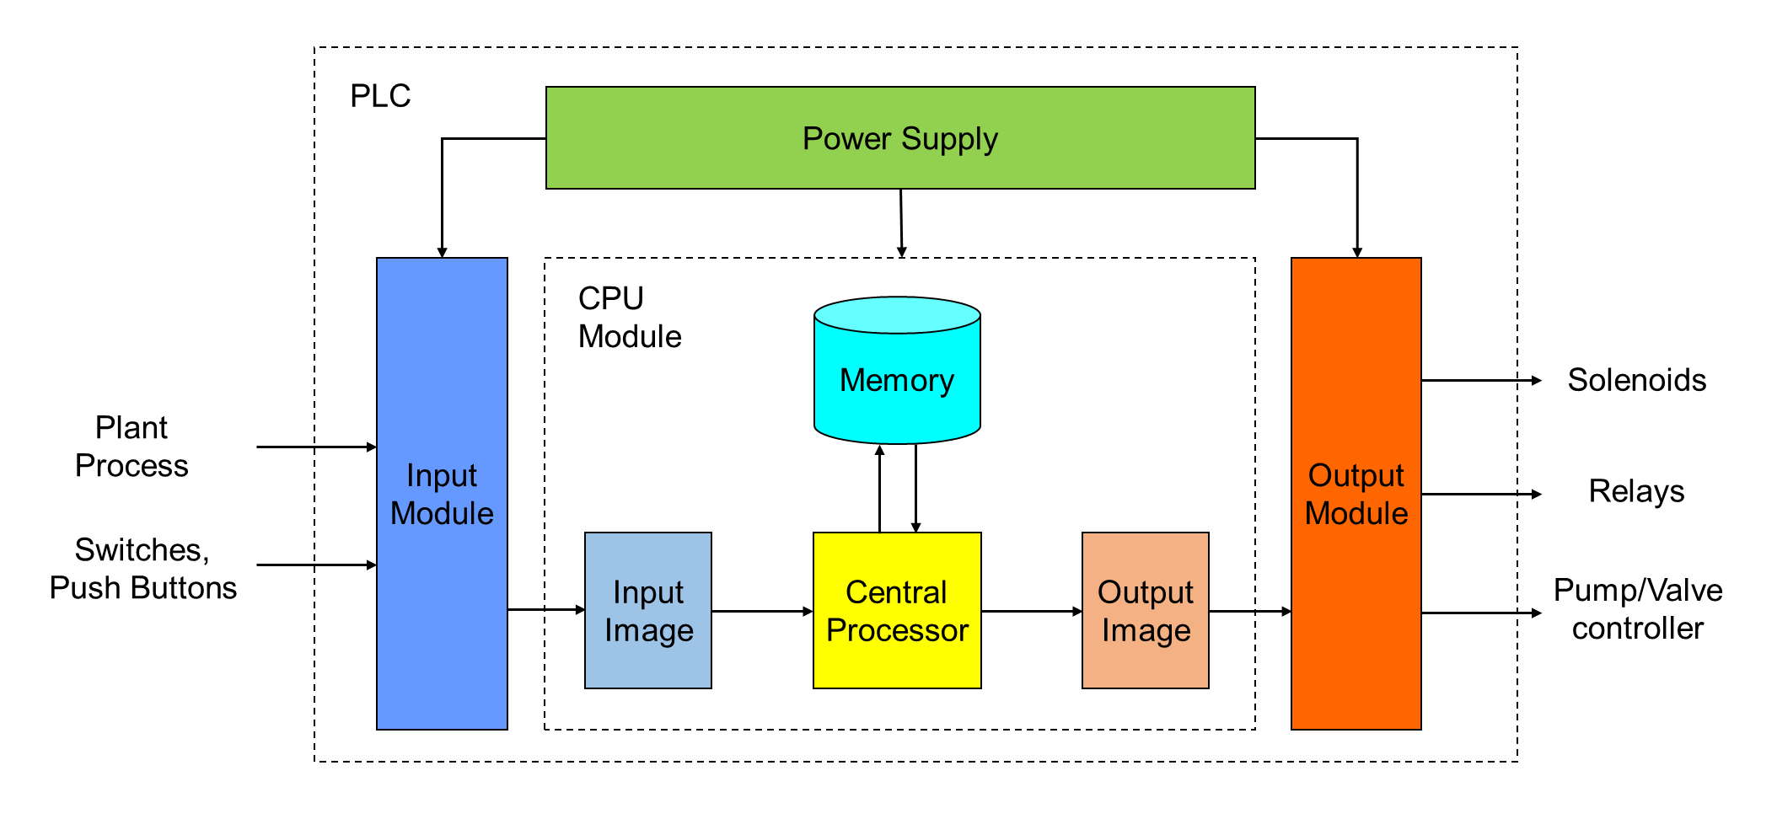

Figure 2.1: Block diagram of a typical PLC hardware architecture

As shown in Figure 2.1, the PLC receives input signals via the input modules, which are conditioned and converted to digital data values which will be processed by the CPU module. The analog signals (e.g., voltage, current) from the system or plant are converted to the digital values via an analog-to-digital converter (ADC) with certain resolution. For example, the resolution of the ADC implemented in the PLC platform of the OPR-1000 RPS is 12-bits [91]. All digital inputs and outputs form input and output image stored in the buffer to protect the CPU from external signal transients and allow the processor to work independently of the read-write and signal conditioning within specified time constraints in a deterministic manner. The memory holds the input and output data, intermediate calculations, application software, and various data that changes during the PLC operation. Here, the application software determines the logical operation of the PLC performed on the state of the inputs; thus, the input data and application software determine how the CPU is to set the output result, which is referred to as the output image. The output module converts the output image into electrical control signals that operate the field devices such as pumps or valves in the plant under control. In the PLC platform, the data manipulation of the digital inputs and outputs is carried out at the discrete or bit-level. The following subsections describe the basic functions of PLC hardware components.

* + - 1. *Central Processing Unit*

PLC contains at least one CPU, which controls and supervises all operations within the PLC. The CPU executes the control instructions of application software, communicates with other devices, carries out logic and arithmetic operations, and performs housekeeping activities such as internal diagnostics [92], [93]. A typical PLC CPU contains an arithmetic logic unit (ALU) that is responsible for the data manipulation and carrying out arithmetic operations (e.g., addition or subtraction) or logic operations (e.g., bitwise AND, OR, NOT, XOR) and the conversion between integer and floating-point formats. The binary operations in the CPU are carried out by the barrel shifter, such as shifting, rotating, extracting and depositing segments. Other subsystems of CPU include the multiplier, floating-point/integer processors, internal buses, and registers. The registers, which are temporary memory locations within CPU, hold intermediate calculations, prepare data for the math processor, serve as a buffer for data transfer, and hold flags for program control. For example, the multiplier takes the values from two registers, multiplies them, and places the result into another register. Through the internal buses, the digital data is transferred between memory units and CPU. Figure 2.2 shows a typical CPU architecture of the microprocessor-based processors [94].

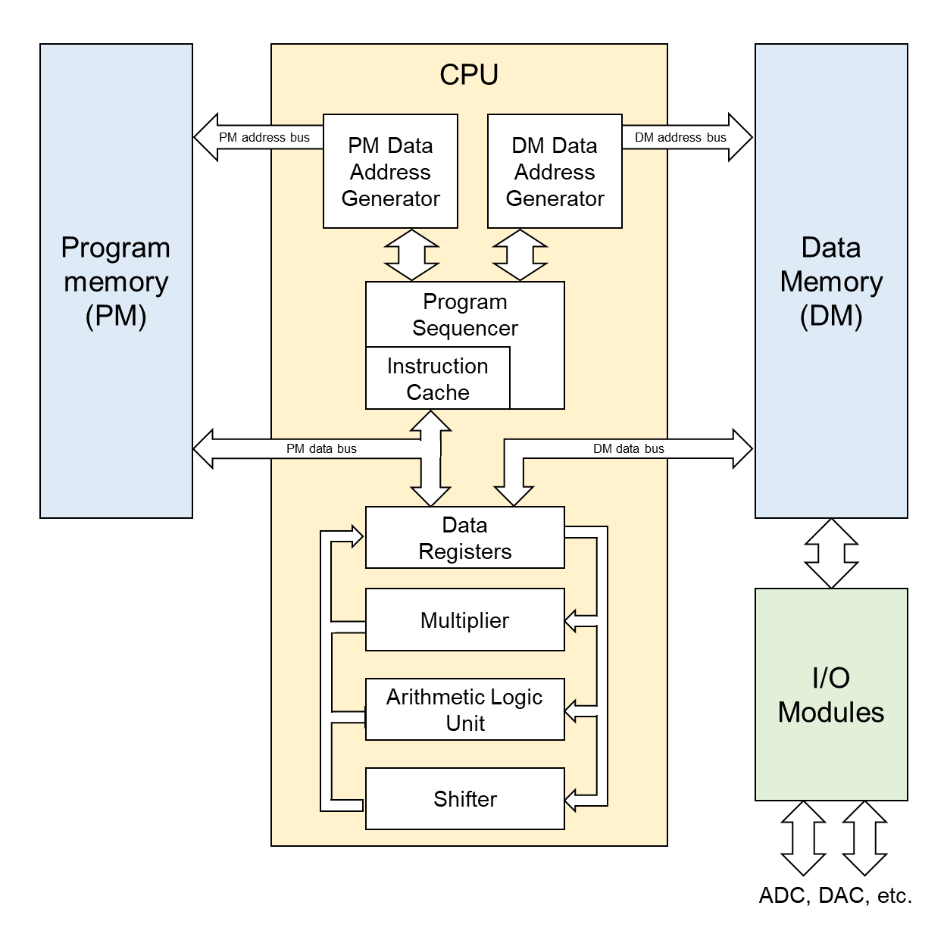

Figure 2.2: Block diagram of a typical PLC CPU architecture

In general, a CPU has two operational modes: (1) programming mode and (2) run mode [80]. When set to programming mode, CPU downloads the application software from the PLC engineering tools to the PLC memory after the user edits or updates the existing program. During this mode, all outputs from the PLC are forced off regardless of their rung logic status and the ladder I/O scan sequence is halted. In the run mode, the CPU executes the application software and the PLC only do what they are instructed to do, which is specified in the application software. While the CPU executes the application software, the input devices are monitored and output devices are energized accordingly. The CPU repeats this process during its execution and the time to execute one cycle of this process is called the scan cycle. The detailed scan cycle of PLC is described in section 2.2.1.3.

* + - 1. *Memory*

To operate the PLC system, the CPU needs to access the data to be processed and the application software which informs it how the data is to be processed. The memory provides storage to the program, data and others such as the operating system and the firmware of the processor and modules, each piece of which is stored in a unique memory address. The use of memory is described with a memory map which shows what addresses correspond to which devices or data and how the memory is being used. For example, which parts of memory are used for the operating system, which parts are used to store a program, or which parts are used to store the data for a program is defined in the memory map. A memory map is often represented as a vertical column where the rows correspond to the memory locations. A typical memory utilization map for PLC is depicted in Figure 2.3.

As shown in Figure 2.3, the size of the stored data, or the number of bits that can be stored in a memory location, is fixed (e.g., 8-bit, 16-bit, 32-bit long). The numbers along the left side of the memory map represent the addresses corresponding to each memory resource. The full address range is referred to as the memory space of the processor and its size is represented by the number of memory locations in the full range. For example, the memory space of the processor represented by the memory map in Figure 2.3 is equal to 16Mbytes (0x000000 ~ 0xFFFFFF).

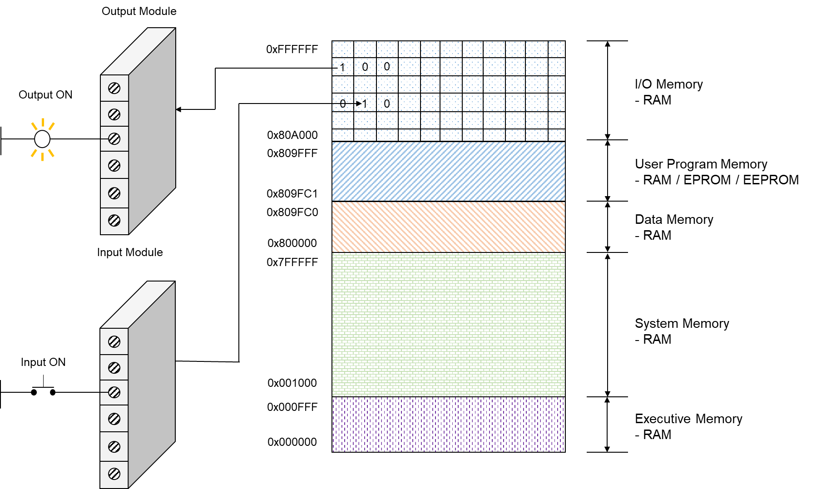

34

Figure 2.3: Memory map of a typical PLC and its connection to I/O modules

The memory space can be divided into two categories: (1) the program memory and (2) the data memory. The program memory is where the application program is downloaded and stored. It contains the logic that controls the machine operation. The data memory stores the information needed to carry out the program such as the states of input and output variables, timer and counter values. The data is stored in a group of bits which are stored in unique bytes or word locations. Figure 2.3 shows a typical connection of a switch device to the input image in the PLC memory. When the switch is closed, the processor detects a voltage at the input terminal and records that information by storing a binary one at a specific bit location. Each connected input has a bit in the input image that corresponds to the terminal to which the input is connected. The input image is constantly being changed to reflect the current status of the input devices. For example, if the switch is closed (input ON), its corresponding bit in the table is set to one. If the switch is opened (input OFF), the corresponding bit is cleared or reset to zero. The output image is an array of bits that controls the status of digital output devices. For example, the status of the light is controlled by the program and indicated by the presence of one (ON) and zero (OFF). Each connected output is allocated with specific bits in the output image and if the program generates for a specific output to be ON, the corresponding bit in the image is set to one and if the program generates for the output to be OFF, it is set to zero.

As the memory space is limited when considering a PLC application, the PLC memory areas are divided in to five major areas according to the type of information to be saved [95]: (1) executive memory, (2) system memory, (3) I/O status memory, (4) data memory, and (5) user memory. The description of each memory type depending on the design of the PLC is as follows:

1. Executive memory: The executive memory includes a collection of permanently stored programs such as operating system software, which is a special program that runs the PLC, and the diagnostics programs to maintain and monitor the current status of the system. These supervisory programs direct all PLC activities such as the execution of the control program and the communication with peripherals such as reading input devices and updating output devices. As it rarely needs any change once developed by the manufacturer and downloaded to the PLC, it is stored in read-only memory (ROM).
2. System memory: In order for the operating system to function, a section of the memory is allocated for system administration. As the executive program performs various functions, it requires a place to store intermediate results and information used by the executive program. The system memory is usually allotted in the random access memory (RAM) for the use of the operating system only and is not available to the user for programming.
3. User program memory: Another area of RAM in PLC is allocated for the storage of the user program. The executive program instructs the microprocessor to scan and execute the user instructions saved in the user program memory. For the majority of PLCs, the user program area is located in RAM so that the developer can upload the program in this memory area and run the system to test its operation.
4. Data memory: Another RAM area is set aside for the data storage of the variables used in the user program. For example, the data memory stores various information related to the user program such as preset or accumulated values for timer and counters, instruction data, and other data used by any data manipulation functions in the user program.
5. I/O status memory: Another portion of RAM is allocated for the storage of current I/O status. Every input and output modules are assigned particular locations in the memory for the input and output image. This memory area is always available for the program to be accessed and can be modified through the programming by the user. At each scan, the microprocessor reads the status of input modules from the input image. The status of the output devices is determined based on the updated output image after the user program execution.
   * + 1. *PLC Scan Cycle*

The PLC scan process is characterized by a "read-execute-write" cycle, which consists of [96]: (1) input scan, (2) program scan, and (3) output scan. Figure 2.4 shows a typical PLC scan cycle. At the start of the PLC cycle, the PLC will check its own hardware and software for any fault or error. If there is no problem, the PLC will copy all the input and copy their values from the input image into the memory, which is called the input scan. In doing so, the current status of the input module is updated in the memory area. Generating input image prevents the problem of false states arising from changing inputs and ensures that all inputs are consistent throughout the cycle. Following the input scan, the CPU executes the user program, which is called the program scan. The execution involves starting at the program's first instruction, then moving on to the second instruction and carrying out its execution sequence to the last program instruction using the data obtained from the input image. Throughout the user program execution, the data memory, which stores the states of program variables and the CPU contexts such as registers, is updated at each machine instruction. After the program execution, the output image, which has a one-to-one mapping to the output modules, is transferred to the output modules during the output scan and the output devices are activated accordingly during the output scan. The whole process is repeated in a continuous cycle known as the PLC scan cycle and the user program is executed at every scan cycle. The PLC repeats the scan cycle until it is stopped or shut down by the user. It is notable that by the virtue of the cyclic nature of the PLC scan, the status of the inputs and outputs are not changed within the same scan cycle. If an input signal changes state after the input scan, it will not be recognized until the next input scan occurs.

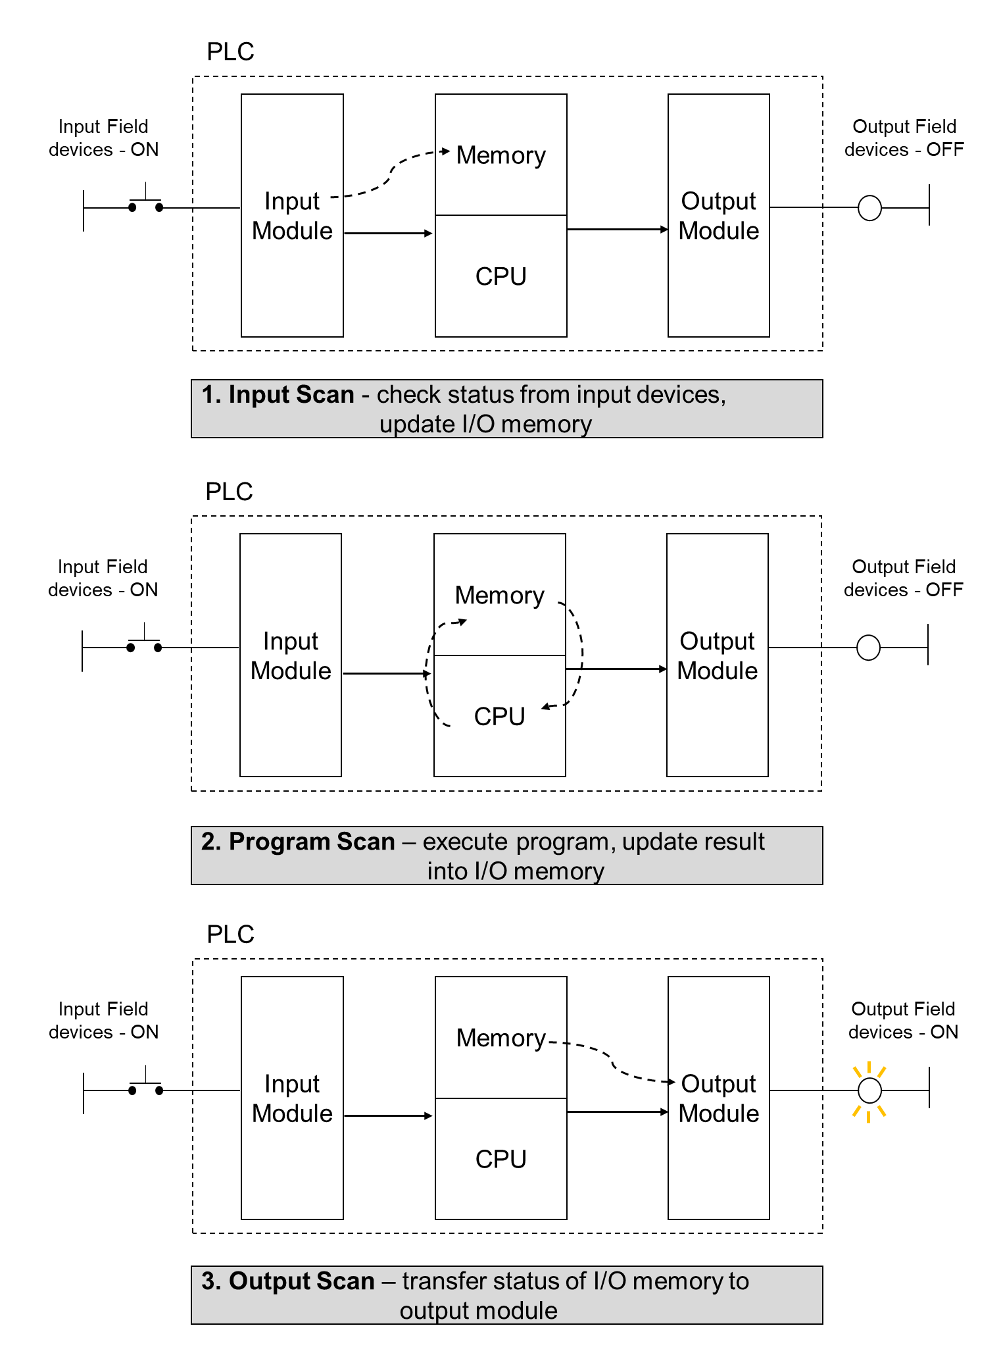

Figure 2.4: Scan cycle of a typical PLC

The time to update all inputs and outputs depends on the total number of variables to be copied and the total program execution time depends on the length of the control program. For a typical PLC, the execution time of a single instruction is in range of 1~10 microseconds [97]. So a 1024 instruction program typically has a cycle time of 1-10 milliseconds. For NPP application, the scan time of PLC is in the range of 30 ~ 50 milliseconds [98], [99] depending on the safety-critical systems, which is set with some margin to ensure the deterministic operation of its safety functions based on the IEEE standards and U.S. regulatory guides [8].

* + 1. **PLC Software**

The PLC software is responsible for processing the inputs received at the input modules to generate the outputs. Like other software programs, the PLC software that resides in the program memory must be written in a particular programming language and implemented to the PLC. In the past, many of the various vendors developed PLCs with different run-time, operating systems, and programming languages. To enhance the compatibility and the interoperability among various products, the International Electrotechnical Commission elaborated the standard IEC 61131 [100]. Part 3 of this standard defines an architecture of the PLC software and specifies the syntax and the semantics of a unified suite of five common programming languages for PLCs.

* + - 1. *PLC Software Model*

The IEC 61131-3 software model [100], [101], [102] is shown in Figure 2.5. At the highest level, the model describes the notion of a configuration, which encloses the software of the particular PLC control application. It consists of several resources which can be seen as CPUs that provides a processing environment for executing the program contained within the resource. Here, the configurations and resources can be started and stopped via the operator interface or operating system functions. The task, or program, is usually executed with certain cycle times or when it is triggered according to its specifications and predefined sequence. Once the task is called, one or several assigned program organization units (POUs) are called.

POUs represent a collection of software elements, including functions, FBs, and program. Functions and FBs are the basic building blocks of a PLC program, which process the input data and pass the data to the next functions or FBs. A function is a particular algorithm, i.e., a sequence of statements, with zero or more input values and one output value. A function always produces the same output value for a given set of input values. As opposed to the function, FB can produce different output values with the same set of input values as FB contains a data structure in which the values can be stored internally in addition to the algorithm.

A POU contains a declaration part and body. In the declaration part of a POU, the types and the physical or logical address of the variables used in it are specified. The body of a POU defines the algorithmic acting on the declared variables in order to generate output values. Programs are similar to FBs, except they declare the global variables used in the program. Programs are instantiated in resources, where their inputs and outputs are connected directly to the represented variables.

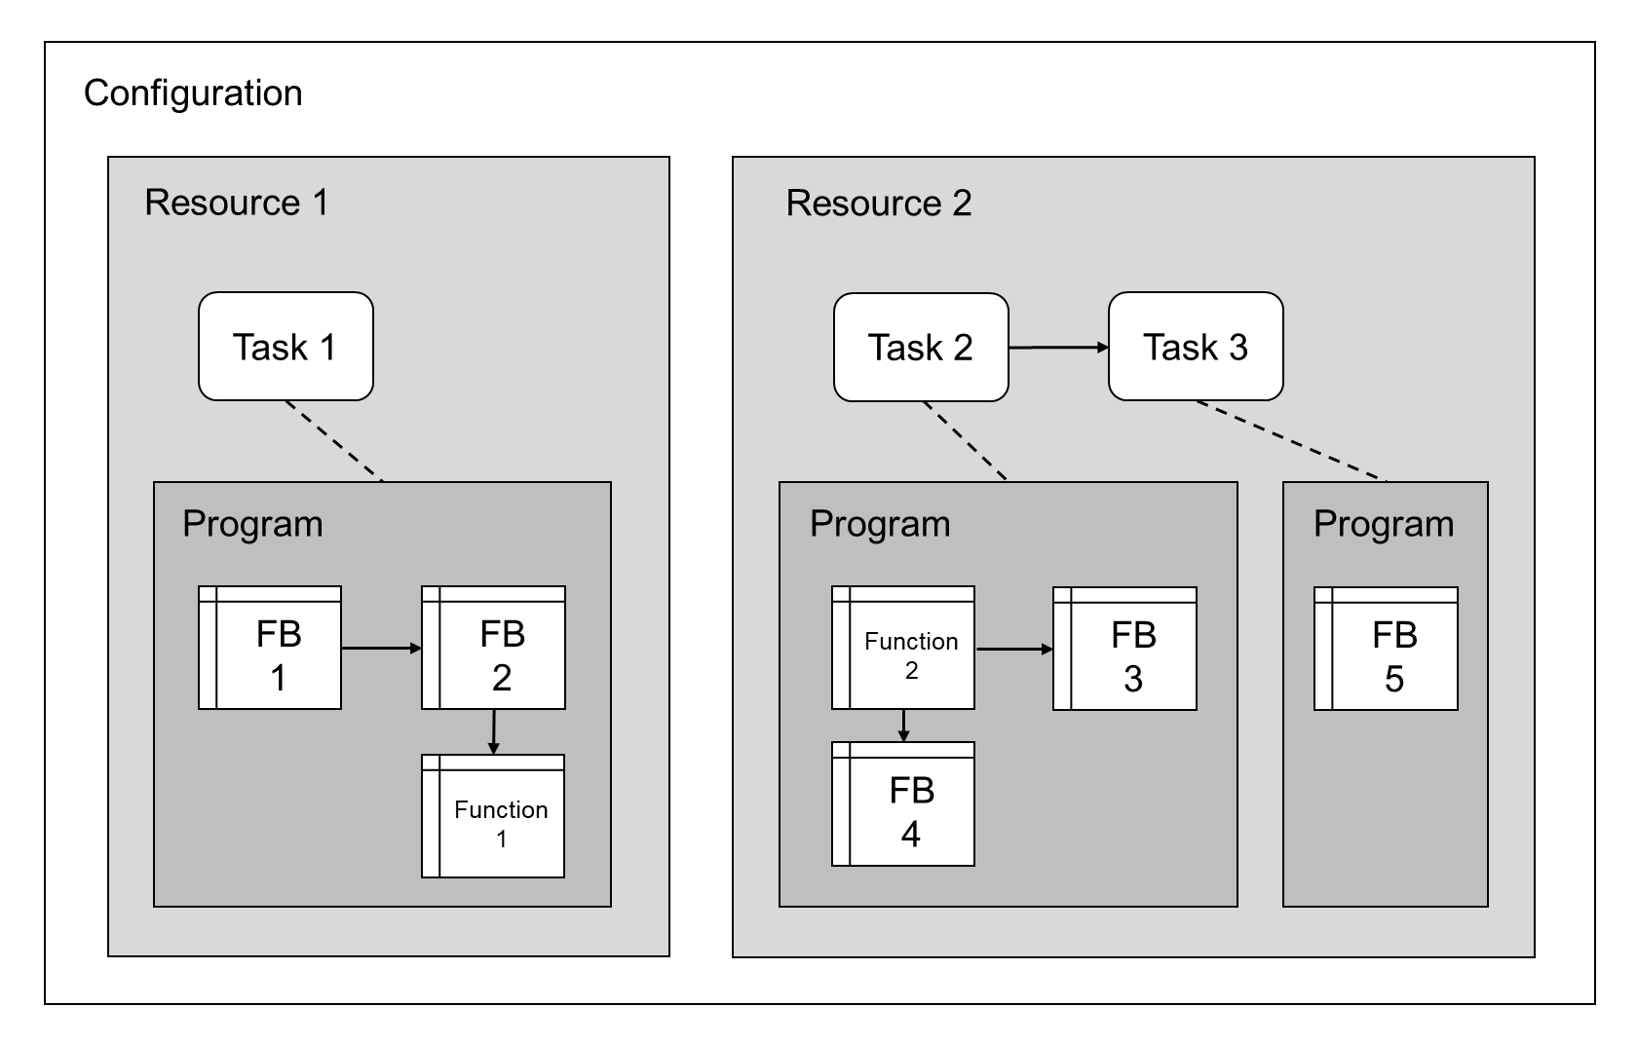

Figure 2.5: An illustration on the PLC software model based on IEC 61131-3 standard

* + - 1. *PLC Programming Languages*

IEC 61131-3 standard identifies five common programming languages for defining the body of POU, which defines the algorithmic behavior of POU [100]. The control programs for most PLC applications are written in these languages. Among five languages, there are two textual languages: (1) instruction list (IL) and (2) structured text (ST), and two graphical languages: (1) ladder diagram (LD) and (2) FBD. Another language, although it is not specifically a programming language, is the sequential function chart (SFC) which is a graphical method of structuring the internal organization of PLC programs.

* **Instruction list (IL)**: IL, or Boolean programming, is similar to low-level assembly language [103]. A POU consists of a series of instructions situated on separated lines, as shown in Figure 2.6. It uses Boolean operators such as AND, OR, NOT, and arithmetic and logic commands such as ADD, LOAD, JUMP.

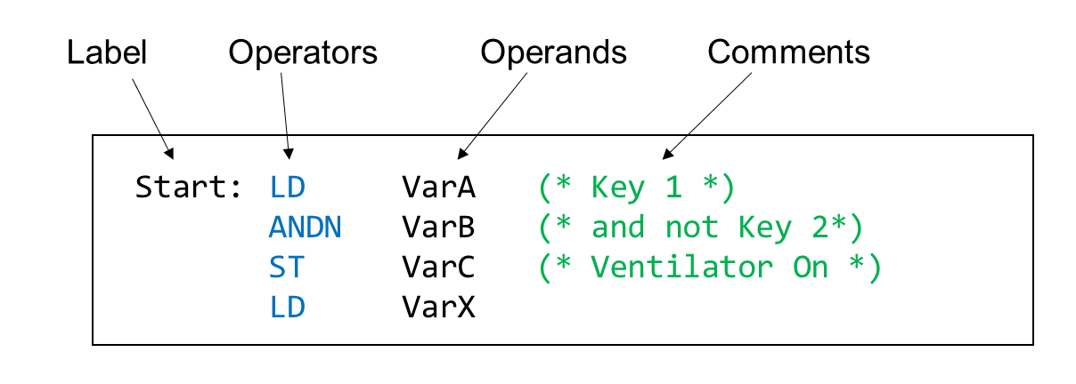

Figure 2.6: An example of instruction list program

* **Structured text (ST)**: ST is a high-level programming language which is based on another high-level procedural programming language, PASCAL [104]. It is defined by the commands and expressions where the semicolon divides each command. The instructions are used to structure and control the expressions, and assign the values returned from the expressions to operands, as shown in Figure 2.7.

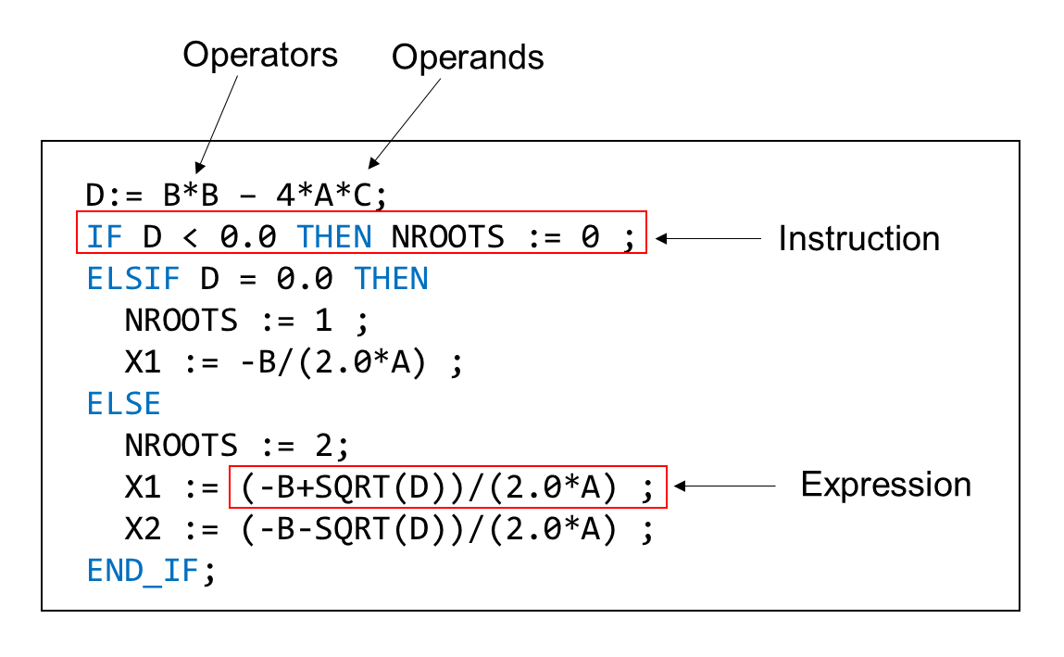

Figure 2.7: An example of structured text program

* **Ladder diagram (LD)**: LD, also known as ladder logic, is the oldest programming language for PLCs and is based on the graphic representation of relay contact logic [105]. It uses horizontal rungs laid out between two vertical bars representing system power. Along the rungs, there are contacts and coils modeled after those that are found on mechanical analog relays. The contacts represent the switches or push-buttons which act as inputs in LD while the coils behave as outputs such as a light or a motor, as shown in Figure 2.8.

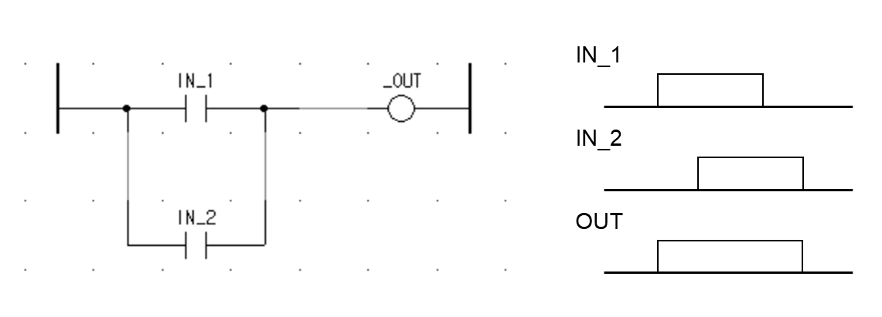

Figure 2.8: An example of ladder logic program

* **Function block diagram (FBD)**: FBD is analogous to the electronic logic gates and the block diagrams of the analog and digital techniques. FBD language is used to express the behaviors of POUs as a set of interconnected blocks. FBD is based on viewing a system in terms of the flow of signals between processing elements. Within FBD, FB is depicted as a rectangular block with inputs entering from the left and outputs exiting on the right, as shown in Figure 2.9. In the standard, the type of FB is shown within the block and the formal names of FB inputs and outputs are shown within the block at the appropriate input and output points. In FBD network, the signals are considered to flow from the output of functions and FBs to the inputs of other functions and FBs. The outputs of FBs are updated as a result of FB evaluations according to their operations. Across the FBD network, the changes of signal states and values propagate from left to right as same as the LD.

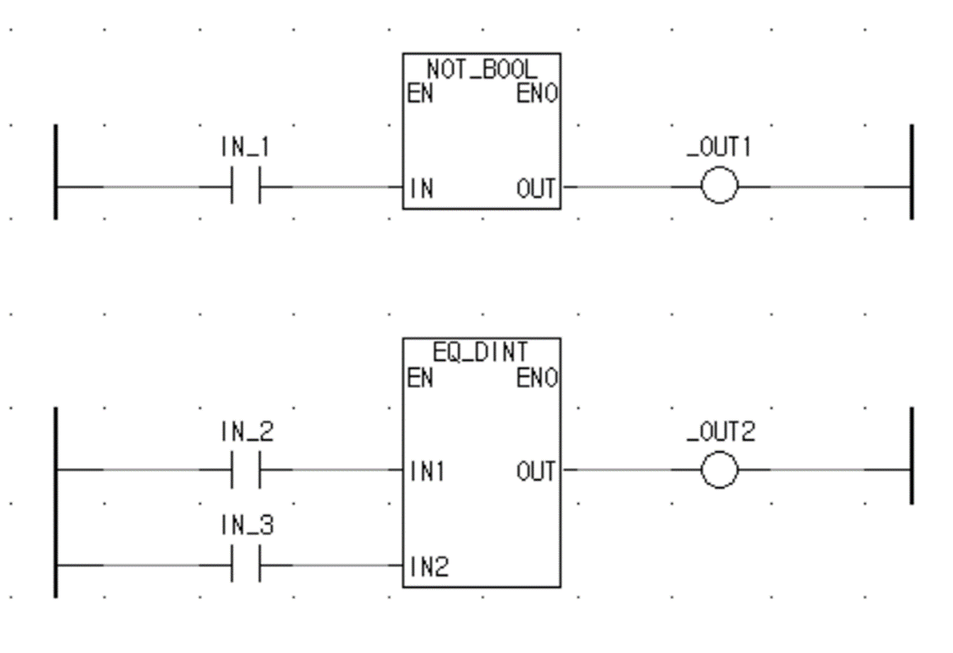

Figure 2.9: An example of function block diagram program

* **Sequential function chart (SFC)**: SFC is derived from the Petri Nets and provides a mechanism to add structure to ladder logic programming [106]. It consists of steps, transitions and actions to perform specific operations or actions. The step represents a state of a controlled system and has assigned an action block. The transition expresses the condition to deactivate the previous step and activate the next step. As shown in Figure 2.10, the transition is drawn graphically to describe the sequence of interactions.

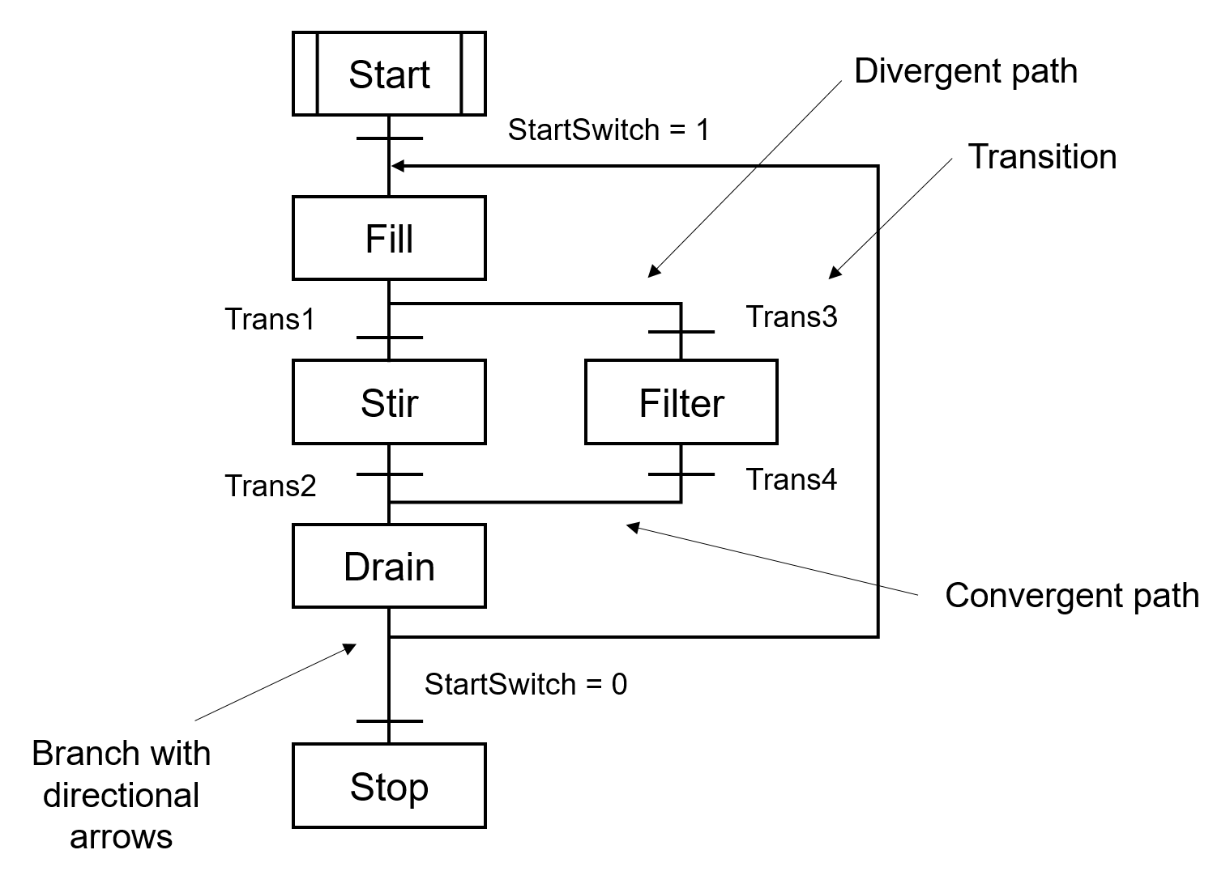

Figure 2.10: Example of sequential function chart program

To address the issue of the PLC programming in safety-related fields such as NPPs, chemical processes, and transportation, the PLCopen working group TC5 [107] investigated the software architecture for safety applications. In result, two graphical programming languages which are FBD and LD among the five IEC 61131 programming languages were recommended as being suitable for the PLC programming in safety applications. Especially in the nuclear domain, the FBD language has been commonly used programming language for PLC applications in designing NPP safety systems. For example, pSET developed for POSAFE-Q PLC by SOOSAN ENS [108] and SPACE developed for Teleperm XS PLC by AREVA [109], [110], Tristation developed for Tricon PLC [111] used FBD language to develop a digital RPS software.

In general, the FBD program applied in NPP systems consists of a collection of blocks wired together like a circuit diagram, as shown in Figure 2.11 [112]. Each block, either a function or FB, implements a fundamental operation. The operation of FBDs is defined by ladder logic where FBs and contacts are connected with a series of horizontal rungs [105]. The outputs from FBs at each rung are processed based on the connected ladder logic and used as an input to the following FBs. When the PLC is in run mode, it executes the entire FBD program from the first rung to the end rung of the program and then resumes at the start. Each rung starts with at least one input and ends with at least one output. For example, the software in Figure 2.11 generates a reactor pre-trip signal *th_X_pretrip* when an unsafe situation occurs. The sequential combination of seven FBs produces an output *th_X_Pretrip* and the computations take place sequentially according to the defined behavior of each FB. For example, GE_INT (greater or equal to) FB is executed first and produces true (or one) as its block output if input variable *f_X* is greater than or equal to the input variable *k_X_Pretrip_Setpoint*. Otherwise, the block’s output value is false (or zero). The output is then negated as denoted as small circle attached to the output of the GE_DINT block. The FBD program used in NPP safety systems is usually developed by the domain expert starting from writing the requirement specifications to mechanically translating the requirements to the FBD programs and to the executable machine code [113], [114], [115]. The following section describes the general processes regarding the NPP software development.

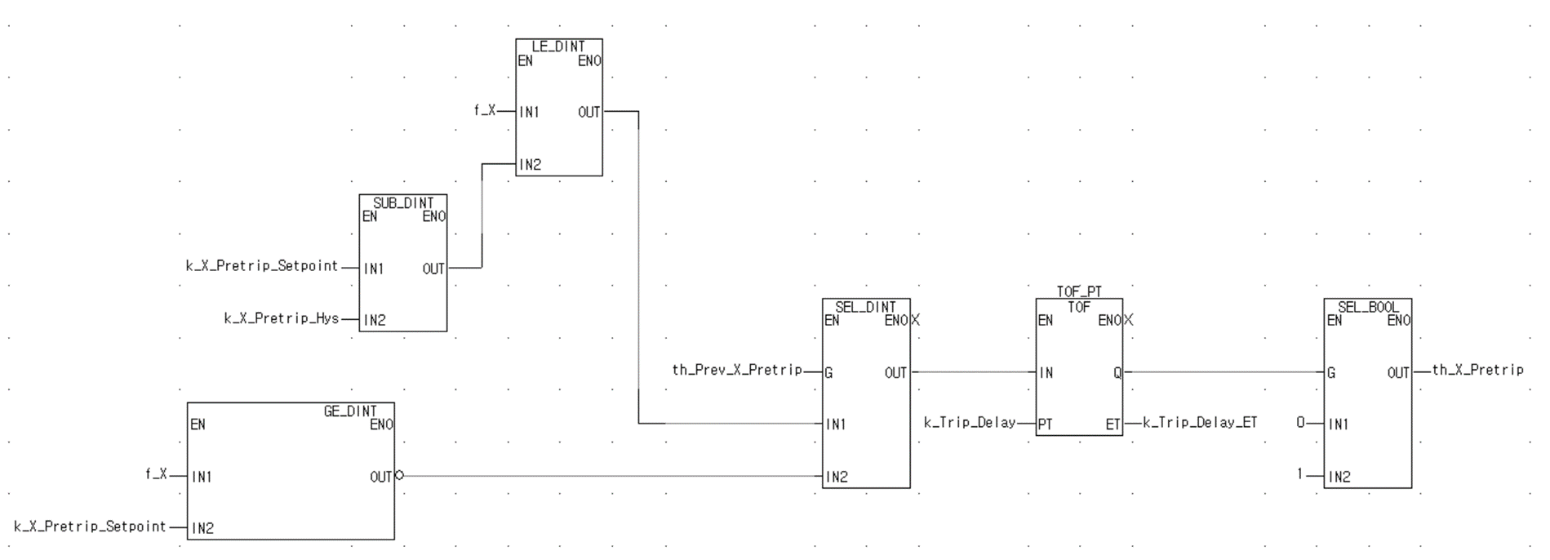

Figure 2.11: An example FBD program for generating reactor pre-trip signal

* + - 1. *PLC Software Development Process*

The development of NPP safety-critical software usually adapts a classical SDLC, such as a waterfall model or a spiral model, owing to its strict development features including the documentation, V&V, and safety considerations [116]. The development lifecycle of NPP safety software is typically designed with a waterfall model based on IEEE Std. 1074 [117] endorsed by RG 1.173 [118] for high functional reliability and design quality of the software used in safety systems. While the actual phases of the waterfall model differ from software applications, the general software lifecycle model [86] consists of five different phases: (1) requirement phase, (2) design phase, (3) implementation phase, (4) test phase, (5) installation-and-checkout phase, as shown in Figure 2.12. Most safety-critical systems in NPPs such as LOCS [50], KNICS IDiPS-RPS [119] were developed based on such a waterfall model.

In the SDLC, the software development process can be considered a software evolution that proceeds through an orderly sequence of transitions from one phase to the next [120]. The typical PLC software development processes include the translation and compilation steps. For example, the SRS written in natural languages or formal specification languages [113], [114], [115] is transformed into the design specification during the design phase. In the design phase, experts on PLC programming languages translate the requirement specifications manually into the design models programmed in FBD language or use an automatic translator such as NuSCRtoFBD [121]. The design specification is then compiled into source codes during the implementation or coding phase. Here, the FBD program is translated into ANSI C programs, or intermediate C programs, which are mostly used for the simulation or verification purpose. For PLC implementation, the assembly language, or executable code, is generated using the commercial off-the-shelf (COTS) software provided by the PLC vendors such as TMS320C3x/4x of Texas Instruments [122] for C compilers.

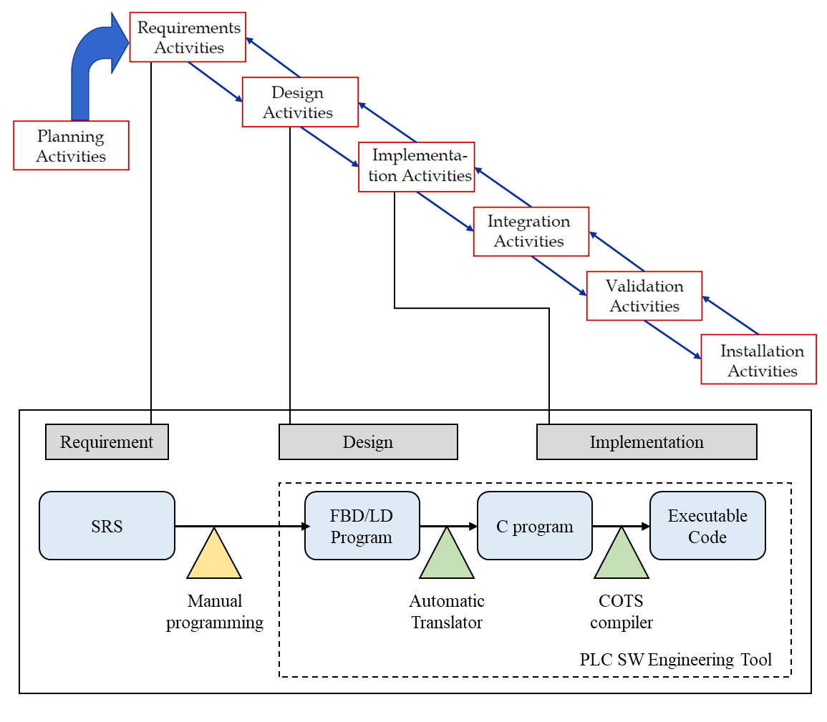

Figure 2.12: A typical PLC software development life cycle for NPP safety applications

Along with the software development, the verification on the software development process and products is performed using various V&V techniques such as control flow graph (CFG) based [123], data flow based structural test [124], [125], and model checking [126] for NPP safety software. For example, the equivalence checking between the FBD and translated C program was proposed as one of the techniques for verifying the equivalence between the design and the implementation phases in the PLC software development lifecycle [127]. Other software verification techniques conducted in the nuclear field include the simulation toolkit for C programs such as LDRA [128] and the SCADE [129], which can perform various testing on the C programs while checking CFG-based structural or MC/DC coverages to assess the quality of the test cases.

While there are various software verification techniques spanning from simulation to formal verification for asserting the correct functioning of the PLC software in high-level languages such as FBD and C, the executable codes are often considered too primitive to conduct the software testing. The COTS compilers are generally considered to be well verified and sufficiently certified to be used for implementing the RPS software; however, the compiler may introduce faults in the executable code even though the source code was fault-free, such as assigning incorrect memory reference and generating an incorrect operation code [130]. In addition, the nuclear industry has not yet acknowledged that a vendor-provided automatic compiler able to translate the source codes (i.e., FBD) to the final product (i.e., executable codes) is a correct and safe tool [131]. However, verifying the FBD-to-C compiler is considered as a grand challenge and is still an ongoing area of research [132]. Therefore, the method for the verification of PLC software in executable code level using proper test sets and test environment must be developed which can demonstrate the functional safety and accuracy of the PLC software while covering the whole PLC software development processes from the requirement to the implementation phase in verifying the safety-critical segments of the program.

* 1. **PLC Software Testing**

The software used in NPP digital I&C systems must be protected against error, such as mistakes in coding, design errors that could occur during the software development process [133]. One of the characteristics that contribute to the assurance that the software will perform its required actions is its correctness, which is the degree to which a design output is free from faults in its specification, design, and implementation [134]. However, even if the correctness of the software can be proven mathematically via formal verification and the software is developed using a quality development process, no software system can be regarded as dependable or reliable if it has not been extensively tested [135]. For example, the developers must demonstrate that the PLC software generates its dedicated function (e.g., *th_X_pretrip* = true in Figure 2.11) when demand comes with the rigorous test results for such safety-critical systems to be approved for operation during licensing process.

In this study, software testing is considered to be a particular method of verifying and validating software. Because software testing is a widely used software verification method and there are many types of testing, this section covers the issues related to NPP software testing. The general classifications for software testing were identified according to the purposes of testing [74]. Among those testing types, it is the reliability-related aspects of the software that are of primary importance in terms of NPP PRA. For example, the reliability targets of RPS can be expressed as the number of failures per demand; while those of the control systems that must continuously operate will be mean time between failures. While the latter figure can quite easily be turned into a probability of success of the mission through failure rate analysis or operating data, the former figure requires the clear definition of software failure and some other important requirements for software testing that distinguishes the software testing from other NPP software V&V methods; that is, (1) how should the test cases be generated and selected, (2) and how can the correctness of the outputs be determined. The following subsections define the software failure in the context of NPP PRA and identify a set of testing techniques that can be applied to quantitatively evaluate the failure probability of NPP safety software or ensure the software to be error-free in terms of its functionality.

* + 1. **Definition of Software Failure**

A software error manifests as a fault in the code, which incorrectly performs a function [74]. Since the behavior of software is deterministic, the software will behave in the same way for a given set of inputs and internal state. The occurrence of software failure can be defined as a discrepancy between the required behavior of the system and the actual behavior of the system.

The nature of regions of the software input space that cause a software to produce errors was examined in previous studies [136], [137]. In those studies, for some faults identified, the input values for the execution on which that fault produced an error were perturbed to investigate the input space adjacent to the error-producing inputs. It was found in many cases that a set of contiguous input points tended to cause the same fault to produce software errors. These sets were called error crystals in the NASA study [138] or mines in the minefield analogy [139]. In these studies, the input space of a program is treated as a field, where colored rectangular fields represent input values that cause a single fault to produce erroneous outputs (error producing space) and empty rectangular fields represent the input that produces correct software output (non-error producing space), as shown in Figure 2.13. This implies that if the input space or domain can be specified for software and is tested, then the software can be verified as error-free regarding the defined input space.

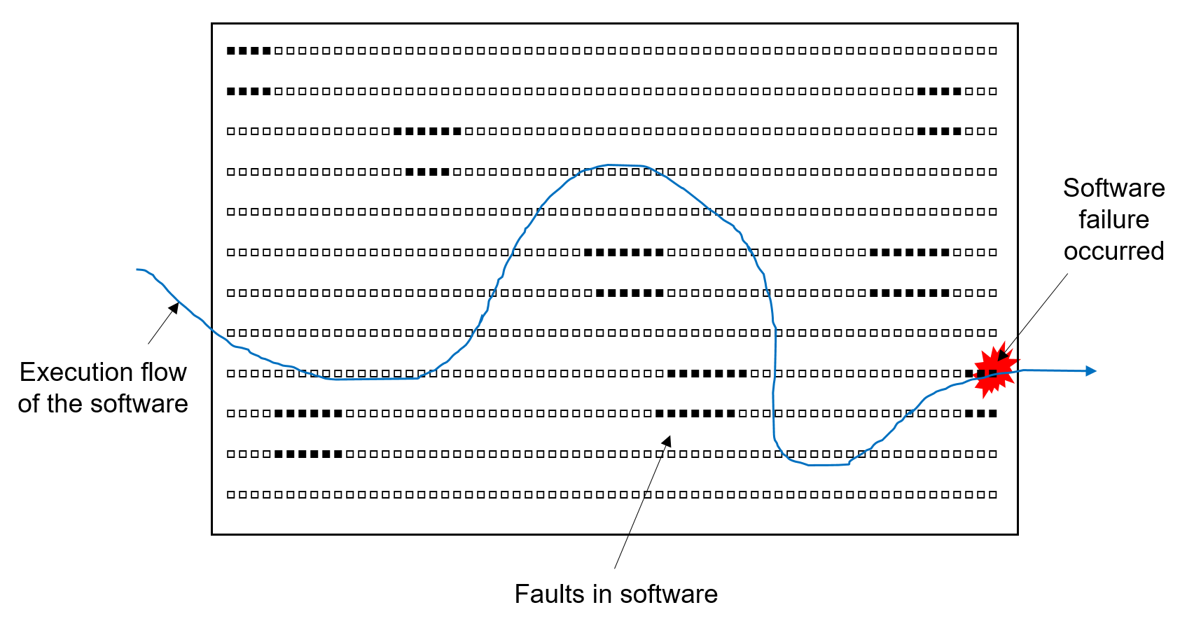

Figure 2.13: Illustration on the concept of error crystal in software

It is obvious that the software differs from the hardware in many fundamental ways, which makes the conventional definition of hardware failure which relies on the assumption that the random failures of subcomponents comprising of hardware dominate in the overall failure rate unsuitable for defining the software failure. Software failures are in general mainly caused by systematic errors such as design specification or modification faults but not by random errors. Some philosophical aspects of software failures and their use in developing a PRA model of digital NPP were discussed in the workshop on the philosophical basis for incorporating software failures in a PRA [46] and WGRISK workshop [47]. In both studies, the question on “what is the probability that a safety system or a function fails when demanded” was derived as a fully feasible and well-formed question for defining the software failure of safety components or systems.

In the above definition, the demand means a plant condition that requires the actuation of specific safety systems. In NPP, safety-critical instrumentation generally falls into one of two operation modes: (1) continuous mode and (2) low demand mode [140]. The safety-critical systems in NPP are typically stand-by systems that monitors plant parameters and are only called upon to act only when needed to drive the plant to a safe state. An example of such demand mode system includes an emergency shut-down system in NPP, which operates pumps or valves in the plant to move the process to a safe state in the event of the design basis accident (DBA) or transients exceeding the normal operational limit.

In the IEC 61508 standard [141] which deals with the functional safety of electrical, electronic and programmable electronic safety-related systems, the concept of safety integrity levels (SIL) was introduced, which is a measure of the performance required for a safety instrumented function. The standard applies different safety indicators depending on the mode of operation: (1) probability of failure per hour (failure rate) for continuous mode systems and (2) probability of failure on demand for low demand mode systems. The safety-critical I&C systems such as RPS and ESFAS in NPP operate as low demand mode as their safe operations are called upon at the time point of demand when NPP is at abnormal state; thus, the software failure of those systems can be defined as the software fails to generate its dedicated safety signal at a plant condition that requires the actuation of safety systems. Based on this definition of software failure, some quantitative estimates for such safety software were proposed in IEC 61226 standard [142]. For example, for an individual system which incorporates software developed in accordance with the highest quality criteria (SIL level 4), a figure of the order of 10–4-10–5 failure per demand was set to be an appropriate limit to place on the software reliability.

* + 1. **Software Testing Techniques**

The software testing aims to achieve discernible differences between the intended and the actual behaviors of a test object and giving confidence in its correct behavior by executing the test object with selected test inputs. The goal of software testing is at defect detection or finding impactful differences between the behavior of the implementation and the intended behavior of the system under test as expressed by its requirements. Here, the selection of proper test input sets is important as every testing technique has its benefits and limitations to reveal the faults in a given system. For example, the test cases could be derived to aim at different objectives, such as exposing deviations from the requirementsm, assessing the conformance to a standard specification, or evaluating robustness to stressful load conditions or malicious inputs.

The general software test methods or test design techniques defined in ISO/IEC/IEEE 29119-4 are categorized into two main categories [143], [144]: (1) specification-based and (2) structure-based test design techniques. The specification-based test technique is a standard procedure for deriving test cases from the software requirements specified in the SRS or SDS to identify the faults in software and focuses on the functionality of the software (i.e., what the software or system does). The structure-based technique derives the test cases based on the structure of the software and the data or control flow of the software to assess the amount of testing covered by test cases or test coverage and focuses on the executional aspects of software (i.e., how the software does).

In the PRA perspective, the regulatory framework of NRC (RG 1.170) [145] on digital computer software used in NPP safety systems requires that the final product of software must meet its functional requirements and be designed for high functional reliability. Therefore, all possible cases that trigger the safety function of the software must be developed as the test cases for software reliability estimation using the specification-based test techniques. For example, the test cases for the RPS of NPP include the software inputs which cause the activation of a protective action such as a reactor trip [146], [147]. There are several specification-based testing techniques and each technique targets different types of software and test scenarios, as follows:

1. Equivalence partitioning [148], [149]: The inputs domain of the software is divided into groups that are expected to exhibit similar behavior. In general, one input from each group is selected to design the test cases. If a condition in an equivalent class is valid, other conditions in that class are considered valid and vice versa.
2. Boundary value analysis [148], [149]: The method assumes the behavior at the edge of each equivalence partition is more likely to be incorrect than the behavior within the partition, so the test cases are chosen on or near the boundaries of the input domain. The test cases can be designed to cover both valid and invalid boundary values.
3. Decision table testing [148], [150]: The decision table, or cause-effect table, is used for checking functionalities, which has logical relationships between inputs. The test cases are systematically derived by considering every possible combination of conditions (inputs) and actions (outputs). Related techniques involve cause-effect graphing [151].
4. State transition testing [152]: The state transition testing is used where some aspect of the system can be described in a finite state machine, a system that can be in a finite number of different states and the transitions from one state to another are determined by the rules of the machine. The test cases are designed to execute valid and invalid state transitions.
5. Combinatorial test design [153]: The combinatorial testing selects the combinations of the software inputs for testing. The process includes modeling the software as a set of factors and values, and deriving a set of exhaustive combinations of factors and values for particular software output to be tested.
6. Classification tree method [154]: The classification tree method identifies the test object regarded under various aspects (classifications) relevant for the test and their corresponding values (classes). The stepwise partition of the input domain by means of classifications is represented graphically in the form of a tree. Subsequently, the test cases are formed by combining classes of different classifications.

The nuclear industry’s definition of testability is different from the testability definition used by the software testing community. NRC BTP 7-19 [19] defined acceptable testability as: “If a portion or component of a system can be fully tested, then it can be considered not to have a potential for software-based CCF. Fully tested or 100% testing means that every possible combination of inputs and every possible sequence of device states are tested and all outputs are verified for every case.” Based on this definition, the exhaustive testing, the most thorough combinatorial test design (CTD) approach [155], can be conducted to show 100% testing of the safety software and resolve the issues related to software risk modeling in the NPP PRA model.

In general, the CTD problem consists of constructing the test space, which covers all valid value combinations of a chosen number of parameters [156]. The key issue with the combinatorial test design for NPP software is to identify the software variables and their state space. When the software testing is used as a technique to verify the software functionality, the property of interest determines the number of tests required. In the analysis of Butler and Finelli [157], a large number of tests was identified as a direct result of the goal of testing for overall functional correctness. In considering the issue of how NPP safety-critical software must be tested, a different view of testing can be applied such that the software testing can be used to show the most significant properties of safety-critical software (i.e., its safety function) rather than its overall correctness. By careful definition of the desired property, the number of tests required can be made tractable. For NPP safety software, the possible property of software can be defined as whether it operates correctly for a set of software input and internal variables that contribute to its safety function based on the definition of software failure discussed in Section 2.3.1. For a typical RPS, the software has only a few variables that contribute to trip signal generation among hundreds of software variables which may enable a testable combinatorial test set in a reasonable timeframe [53], [99].

Another issue based Butler and Finelli’s conclusions [157] on the infeasibility of exhaustive testing was the enormous size of the input space for a software which is the set of all possible input values that software may encounter. As pointed out in the previous studies [157], [158], [159], there is a consensus among computer scientists and practitioners that exhaustive testing for complex devices or software is infeasible, which is due to the enormous number of test vectors (i.e., all pairs of state and inputs) needed to approach exhaustive testing. However, it can be applied to the software in specific conditions if [160]: (1) the testing is used to demonstrate useful but possibly narrow properties rather than overall functional correctness and (2) the size of the set of values that a software system might read for inputs can be made as small as possible consistent with the demands of the application.

In theory, the value sets of the individual inputs for a particular software system are defined by the specification of the system. In practice, the value sets tend to take on default values that are determined by hardware constraints. For example, a digital system treats inputs from instrumentation sensors in a discrete manner by using an ADC. If an ADC converts an analog input signal with k bits, the number of possible test inputs is 2k. By forcing the definition of the value set to be large enough (but not the whole space) that covers all possible demand of software, it is possible to reduce the size of the input space dramatically without affecting the original testing purpose and scope. For example, the possible input domain of the process variables, which represent the plant process such as pressure, temperature, can be reduced from the hardware specifications considering the PLC scan interval and plant dynamics as the PLC has short scan time and the change of process variables’ states in a single scan time is very limited [52], [53], [55].

The related works on the exhaustive testing of NPP safety software include the previous studies by Shin *et al.* [53] and Cho *et al.* [55]. Those studies identified the possible domain of internal-state and input variables of the NPP safety software and derived the test cases for a target trip logic. In those studies, the software input and internal variables were identified based on a software hazard index which categorizes the critical variables related to system unavailability and the test cases are only extracted from the critical level 4 variables, which refer to the variables related to the most hazard that can result in a severe plant accident. The limitations of this approach include that the full list of software input and internal variables that contributes to the safety function output of a target NPP safety software in FBD/LD language were analyzed and derived based on the manual analysis. If the framework is applied to other safety software, the FBD analysis will require huge time and effort, and may introduce errors in generating exhaustive test cases for target NPP safety software.

* 1. **Summary and Conclusions**

This Chapter presents the theoretical background and the related work needed to understand the proposed framework and the contributions of this thesis related to the test case generation and the test-bed development for the NPP safety software. The main concepts of PLC platforms are described, including hardware architecture and software and its programming language. From the perspective of PLC software testing, the definition of software failure important for which the test cases are generated for the NPP software testing is identified based on several standards and regulatory guidelines on NPP safety systems. Regarding the software testing techniques to be applied for the exhaustive testing of NPP software, some considerations on the CTD for NPP software testing and the related works were reviewed. The main implications of the exhaustive testing of NPP safety software and the limitations observed in the previous studies are as follows:

1. Formal methods and model checking [112], [115], [161] have been extensively used for the software verification in nuclear domain; however, the methods are limited in the scope that they check the software structure, not the functionality in terms of NPP PRA and are applied to high-level abstract notations rather than the machine instructions that constitute the actual NPP software and run on the PLC platform.
2. The infeasibility of the exhaustive testing regarding the verification of NPP software is based on the assumption that testing is being used to demonstrate its overall functional correctness [157]. If the testing is used to demonstrate the significant properties of the NPP software (e.g., the software fails to generate its safety output when demanded) and the input space to be tested can be limited in consideration of PLC operation and plant dynamics, the exhaustive testing can be considered as a feasible option for the verification of safety-critical software in terms of NPP PRA.
3. One of the key issues regarding the exhaustive testing of NPP software is to identify the software variables. To avoid any errors in identifying software variables that contribute to its safety output, an FBD/LD analysis tool that allows the related variables to be automatically derived directly from the source code is needed for the systematic exhaustive test case generation of NPP software.
4. Constructing the test configuration in simulating the operation of NPP PLC is essential in software testing. In general, it is recognized that employing the hardware environment to the software testing poses some difficulties for exhaustive testing in terms of time and cost [72]. As safety software is downloaded in PLC memory and executed by its CPU, a simulation-based test-bed that emulates the behavior of NPP safety PLC microprocessor and runs the machine code of target safety software for given test cases can be used to replace the hardware-based test-bed, which may enable the testing of the derived exhaustive test cases in a reasonable timeframe by automating the testing processes from providing the test input to the test-bed and checking the test results from the test-bed.

# EXHAUSTIVE TEST CASE GENERATION OF NPP SAFETY SOFTWARE [1]

* 1. **Introduction**

For the FBD programs that run on PLCs and are used in safety-critical systems in digitalized NPPs [79], [162], the thorough testing of software is crucial for ensuring the plant safety because the failures occurring in the safety-critical systems may lead to catastrophic results. By its nature, the NPP software is a logical matter and determines the function of hardware in the digitalized environment. The space that digitalized input and internal variables construct can be considered as the domain that the software may encounter during system operation, which may be very large but not infinite. For many safety-critical systems, the size and complexity of the program are relatively small and simple and the number of inputs and internal variables is limited to finite resolution. Therefore, if we can perform the software testing over the whole of this space, the limitations related to the state-of-the-art test-based methods such as the uncertainty in input selection and model parameter estimation [50], [52] can be resolved.

This Section proposes an automated exhaustive test case generation framework for NPP safety-critical software testing. From the viewpoint of NPP safety, the testing of safety software needs to focus on the failure of its dedicated safety function when demand comes (i.e., failure-on-demand) as described in Section 2.3.1. By demand, it means a plant condition that requires the actuation of safety systems, for example, the reactor trip signal generation by the RPS. As the software output is determined by the combinations of the states of software input and internal variables, the exhaustive test case generation for safety software can be considered as a problem of finding the solutions that satisfy the on-demand situation of software, i.e., SMT problem. The proposed framework formally translates the FBD program into SMT formula and generates exhaustive test cases by iteratively solving the translated SMT formula using an SMT solver.

* 1. **Related Works**

For the NPP safety-critical systems to be approved for the licensing and operation, software developers must demonstrate that the software will conduct its dedicated function when demand comes based on proper test cases and results. Contemporary practices in testing FBD programs generally convert the model into a C code and then test the generated C code in a functional form [163], [164]. For example, a simulation-based validation tool (SIVAT) [165] generated ANSI C code from the FBD program and performed testing based on the translated C code. An integrated tool environment named PLCTOOLS [164] transformed FBD programs into high-level Petri nets models and performed simulation-based testing using the model. In general, FBD-testing professionals conduct functional testing by manually generating test cases from requirements that are described in natural language and the test cases for FBD programs are generally formed by sequences of inputs (i.e., a test sequence). However, the previous research indicated such approaches are not effective in detecting FB or FBD level defects in FBD programs and do not support automated test case generation [166]. In addition, since the manual generation of test sequences requires considerable amounts of time and cost, several studies were conducted on the automated test case generation that focused on generating test cases that satisfy a target goal.

The test case generation for programs implemented in procedural languages such as FBD program has been a mature research topic [167], [168], [169], [170], [171]. Especially, the use of symbolic execution in test case generation has also been extensively studied [172], [173], [174], [175], [176], [177]. As the model-driven testing has been studied in the industrial automation domain [178], [179], several model-based test case generation approaches for the FBD programs have been proposed [180], [181], [182], [183], [184], which transform the FBD programs into intermediate models such as binary decision diagrams [66], timed automata [65], [67], [185], and UML models [68], [69], [186] in order to generate test sequences.

Wu *et al.* [65] and Enoiu *et al.* [67], [185] proposed model-based test suit generation method for FBD programs, which transforms FBD programs into timed automata models and automatically generates test suites from the timed-automata models using the UPPAAL model checker that satisfies the structural testing coverage criteria such as function coverage, decision coverage, or condition coverage. Those studies involved the creation of the test models from the requirement specifications and the creation of the test data and oracle from the developed model manually or in a semi-automated manner. Lahtinen [66] manually transformed FBD programs into the binary decision diagrams, which behave the same as the original FBD programs. The study generated test data with the structural coverage criteria defined in [124]. Jee *et al.* [187] converted FBD programs into control flow graphs and utilized conventional test coverage criteria such as branch coverage criteria to generate test data. However, it was shown that CFGs could not accurately reflect the data flow-based characteristics of FBD program [124]. As an extension of the study by Jee *et al.* [187], Song *et al.* [70] proposed an automated test data generation technique, or FBDTester2.0, which produces the test cases that ensure each d-path in the FBD program is tested at least once. In result, the generated test sequences achieving the complex condition coverage (CCC) criterion from the study of Song *et al.* [70] were found to detect 97.8 percent of the mutants, or artificially generated faults, on average in their application.

The previous studies conducted in the FBD program testing share the common aspect that they generate the test cases with respect to specific coverage achievement. However, the test results from the previous studies cannot be applied for ensuring a reliable software since they focus on detecting faults or mutants in software by those test cases before its implementation, not the failure of software in terms of NPP PRA, which checks whether the software generates its dedicated safety function at all possible demand situation. In this study, the proposed technique provides a systematic analysis on generating the exhaustive test cases focusing on the safety function of the FBD programs, whereas none of the aforementioned studies did.

* 1. **Satisfiability Modulo Theory**

Initially used for the static analysis and program verification, Boolean satisfiability (SAT) and SMT have received considerable attention during the last decade to derive the test cases from various models automatically. For example, the SMT has been applied to solving many practical problems such as static analysis [188], scheduling [189], model checking [190], [191], program verification [192]. In the model-based test generation field, SMT solvers are considered an attractive alternative [193], [194] to traditional algorithmic test case generation methods. The SMT refers to the problem of determining whether a given first-order formula is satisfiable with respect to some logical theory [195], [196]. The SMT is a sort of constraint satisfaction problem, which defines a set of variables and constraints that specifies the allowable combinations of each variable. Due to the recent advances in SMT solving techniques, there are now several SMT solvers such as CVC [197], MathSAT5 [198], Yices [199], and Z3 [200], which can check and solve the formulas with hundreds of variables. Regarding the software test case generation, there were several applications of the SMT solvers including the FBDTester2.0 developed by Song *et al.* [70], which used Yices to generate test cases for the FBD program, that satisfies various coverage criterions, the HiLiTE developed by Ren *et al.* [201] for the test case generation of MATLAB Simulink designs.

Most SMT solvers are based on the DPLL-(T) algorithm [202], [203] for determining the satisfiability of SMT problems. The algorithm extends the SAT-solving Davis-Putnam-Logemann-Loveland (DPLL) algorithm developed by Davis *et al.* [204], [205] with the ability to reason about an arbitrary theory named *T*. At a high level, the algorithm tries to build a model using three main operations: (1) decide, (2) propagate, and (3) backtrack. The algorithm uses a restricted representation of formulas in conjunction normal form (CNF), where a formula is expressed as conjunctions of clauses. Each clause connected by conjunction must be either a literal or contain a disjunction. The basic backtracking algorithm runs by choosing a literal, assigning a true or false value to it, simplifying the formula, and recursively checking if the simplified formula is satisfiable. If there is at least one model for the literals that makes the formula true, the formula is satisfiable; otherwise, the formula is considered unsatisfiable. The simplification steps essentially remove all clauses that become true under the assignment from the formula and all literals that become false from the remaining clauses. Given a formula $F$ in CNF, which comprises of a set of clauses $C_{i}$, each step of DPLL algorithm for formula $F$ or DPLL($F$) returns a Boolean value true or false and proceeds as follows:

1. Unit propagation to formula $F$
   * If a clause is a unit clause containing only a single unassigned literal of the form $C_{i}=l$, this clause can only be satisfied by assigning the necessary value to make this literal true. Therefore, the variable value can be fixed to be true or false that satisfies this unit clause. The clauses that contain $l$ are then removed (unit subsumption) and the $¬l$ (the negation of l) from the remaining clauses are also removed (unit-resolution).
2. Pure literal elimination
   * If a propositional variable occurs with only one polarity in the formula, it is called pure. These pure literals can always be assigned in a way that makes all clauses containing them in the formula true. These pure clauses do not constrain the search anymore; thus, it can be deleted.
3. Check whether $F$ is empty (empty formula), then return true (satisfiable)
4. Check whether $F$ contains an empty clause, then return false (unsatisfiable)
5. Case splitting rule
   * Select a literal $l$ and set the value of the literal as true. Then, simplify $F$ to $F_{1}$ by removing all clauses containing $l$ and removing the $¬l$ from the remaining clauses.
   * Compute DPLL($F_{1}$). If the result is true, return true (satisfiable)
   * If the result is false, the value of the literal is set as false. Then, simplify $F$ to $F_{2}$ by removing all clauses containing $l$ and removing the $¬l$ from the remaining clauses.
   * Compute DPLL($F_{2}$) and repeat the process.

For example, the satisfiability of the formula $F$ that has literals X, Y, and Z shown in Equation (3.1) can be determined based on the above algorithm, as shown in Equations (3.2)~(3.4).

|  |  |  |
| --- | --- | --- |
|  | $F=\{\left\{X,Y,¬Z\right\},\left\{¬X,¬Y\right\},\left\{Z\right\},\left\{X,¬Y\right\}\}$ | (3.1) |

|  |  |  |
| --- | --- | --- |
|  | 1. unit propagation: $Z⟼True$ 2. No pure literal elimination possible  Then, $F$ is reduced to $\{\left\{X,Y\right\},\left\{¬X,¬Y\right\},\left\{X,¬Y\right\}\}$ | (3.2) |

|  |  |  |
| --- | --- | --- |
|  | 3. Splitting rule:  3-a) $X⟼False$, then $F$ is reduced to $\{\left\{Y\right\},\left\{¬Y\right\}\}$ 3-b) $X⟼True$, then $F$ is reduced to $\{\left\{¬Y\right\}\}$ | (3.3) |

|  |  |  |
| --- | --- | --- |
|  | 4-a) unit propagation for 3-a) case: $Y⟼True$, then then $F$ is reduced to $\{□\}$ 4-b) unit propagation for 3-b) case: $Y⟼False$, then then $F$ is reduced to $\{ \}$ | (3.4) |

In the example, the formula $F$ is considered satisfiable and one solution that makes the formula $F$ satisfiable is derived as {$X=True, Y=False, Z=True$}. As shown above, the algorithm terminates in one of two cases. Either the formula $F$ contains a consistent set of literal, that is, there is no $l$ and $¬l$ for any literal $l$ in the formula. If this is the case, the variables can be trivially satisfied by setting them to the respective polarity of the encompassing literal in the valuation. Otherwise, when the formula contains an empty clause, the clause is false because a disjunction requires at least one member that is true for the overall set to be true. In this case, the existence of such clause implies that the formula cannot be evaluated to be true; thus the formula is unsatisfiable. The detailed theoretical background of the DPLL algorithm and other SAT solving techniques can be found in previous studies [202], [206].

The SMT problem is the problem of determining whether such a formula in first-order logic is satisfiable where some function and predicate symbols have additional interpretations such as linear inequalities or function symbols. These predicates are classified according to each respective theory assigned. For instance, linear inequalities over integer variables are evaluated using the rules of the theory of linear integer arithmetic. Other theories include the theory of real arithmetic and theories of various data structures such as bit-vectors. Most SMT solvers including Z3 [200] uses DPLL-(T) algorithm which extends the DPLL algorithm to incorporate reasoning about a specific theory of *T*. In the DPLL-(T) framework, a common approach for deciding the satisfiability of such formula is to use incremental forms of Simplex similar to the algorithms described in [207], [208], [209], [210]. The detailed theoretical background of DPLL-(T) and SMT solving can be found in previous studies [195], [196], [211], [212].

As the test case generation is the process of identifying the software variables’ states that satisfy the given test requirement, the exhaustive test case generation problem can be formulated as the problem of finding all possible combinations of software variables’ states that generate the desired output, as shown in Equation (3.5).

|  |  |  |
| --- | --- | --- |
|  | $$\arg_{x_{i}∈S}{f\left(x_{i}\right)=true}$$ | (3.5) |

In Equation (3.5), the formula (𝑓) represents the FBD program that defines the logic between the software safety output ($f\left(x_{i}\right)$) and the software input and internal variables, or the literals ($x_{i}$). Space (𝑆) is defined as the domain of all possible software input and internal variables’ states that may encounter during software operation. For NPP safety software, the test requirement can be set to the safety signal initiation by the software (i.e., $f\left(x_{i}\right)=true$). In this case, the derived test cases will reflect all possible safety signal demand situations. In this paper, the proposed approach utilizes Z3 [200], an SMT solver developed by Microsoft Research, to identify the states of the software variables’ states that generate the safety signal for FBD program using its ability for the advanced model generation capability along with its wide application to various programming languages such as Python, C, and Java.

* 1. **Automated Exhaustive Test Case Generation for FBD Program**

The safety-critical systems in NPP are employed to detect the abnormal condition of the plant and perform an automatic safe shutdown of a nuclear reactor. For example, the BP in digital RPS changes the trip status from false to true whenever a deviation of a process parameter exceeds the predefined trip set-point. For the exact exhaustive testing of the software used in NPP safety-critical applications, all possible space of software input and internal variables must be exercised and their corresponding outputs must be checked. However, from a safety point of view, the testing needs to focus not on the spurious operation but on the safety signal generation failure by the software. The failure of the safety-critical software used in NPP can be categorized into two failure modes [213]: (1) safe failure mode and (2) unsafe failure mode, as shown in Table 3.1. For RPS software, the safe failure mode denotes a trip signal generation occurs under the normal conditions of the plant (i.e., spurious trip) and the unsafe failure mode denotes a failure of generating a trip signal when there is a demand for a trip (i.e., non-trip). A spurious activation of the reactor trip signal will cause unnecessary plant operation cost such as electricity generation losses but result in the safe state of the reactor due to the fail-safe design of NPP [214]. On the other hand, the unsafe failure may result in the core damage situation if necessary reactor trip signal or engineered safety feature actuation signal is not actuated. Therefore, only the unsafe failure mode of safety systems is considered in the NPP PRA model [215].

Table 3.1: Fault types of reactor protection system in NPP

|  |  |  |  |
| --- | --- | --- | --- |
|  | | Status of NPP | |
| Unsafe | Safe |
| Trip signal generation by RPS | Yes | Success | Safe failure (Spurious trip) |
| No | Unsafe failure (non-trip) | Success (Reactor trip) |

The proposed approach aims to formally generate exhaustive test cases for NPP safety software, which cover all possible safety signal demand of software. The exhaustive test case generation framework proposed in this paper consists of two major steps: (1) translating the FBD program under test to semantically-equivalent SMT formula and (2) generating exhaustive test cases by finding the interpretations of the translated SMT formula for given test requirement by satisfiability check using SMT solver. Section 3.4.1 describes the first step that includes defining the components of FBD program and developing the FBD-to-SMT translation rules based on the formal definition of FBDs. Sections 3.4.2 and 3.4.3 explain the exhaustive test case generation algorithm that retrieves the solutions for the software input and internal variables that generates software output from the translated SMT formula.

* + 1. **Translation from FBD to SMT formula**

The FBD program consists of a network of FBs executed sequentially according to their predefined execution order. In order to generate exhaustive test cases for the FBD program, the components of the FBD program are first formally defined based on the ideas discussed in previous studies [161], [216]. The FBD program is defined as a state transition system consisting of sub-components, including FB, component FBD, and system FBD in a bottom-up manner. Then, the FBDs are translated to semantically-equivalent SMT formula, which is later solved by the SMT solver given the test requirement to generate exhaustive test cases. In this study, FBD-to-SMT translation rules are developed based on the formal definition of FBDs. While the translation rules for FBD program can be applied both backward and forward against the execution order of an FBD program, the forward translation is used in this study which models the execution flow from the first FB or FBD executed to the last one and utilizes temporary variables to model a set of transitions between FBs or FBDs. Figure 3.1 shows an overview of the translation algorithm in the flowchart form. The translation starts with generating SMT formulas for all individual FBs and continues for component FBD and system FBD.

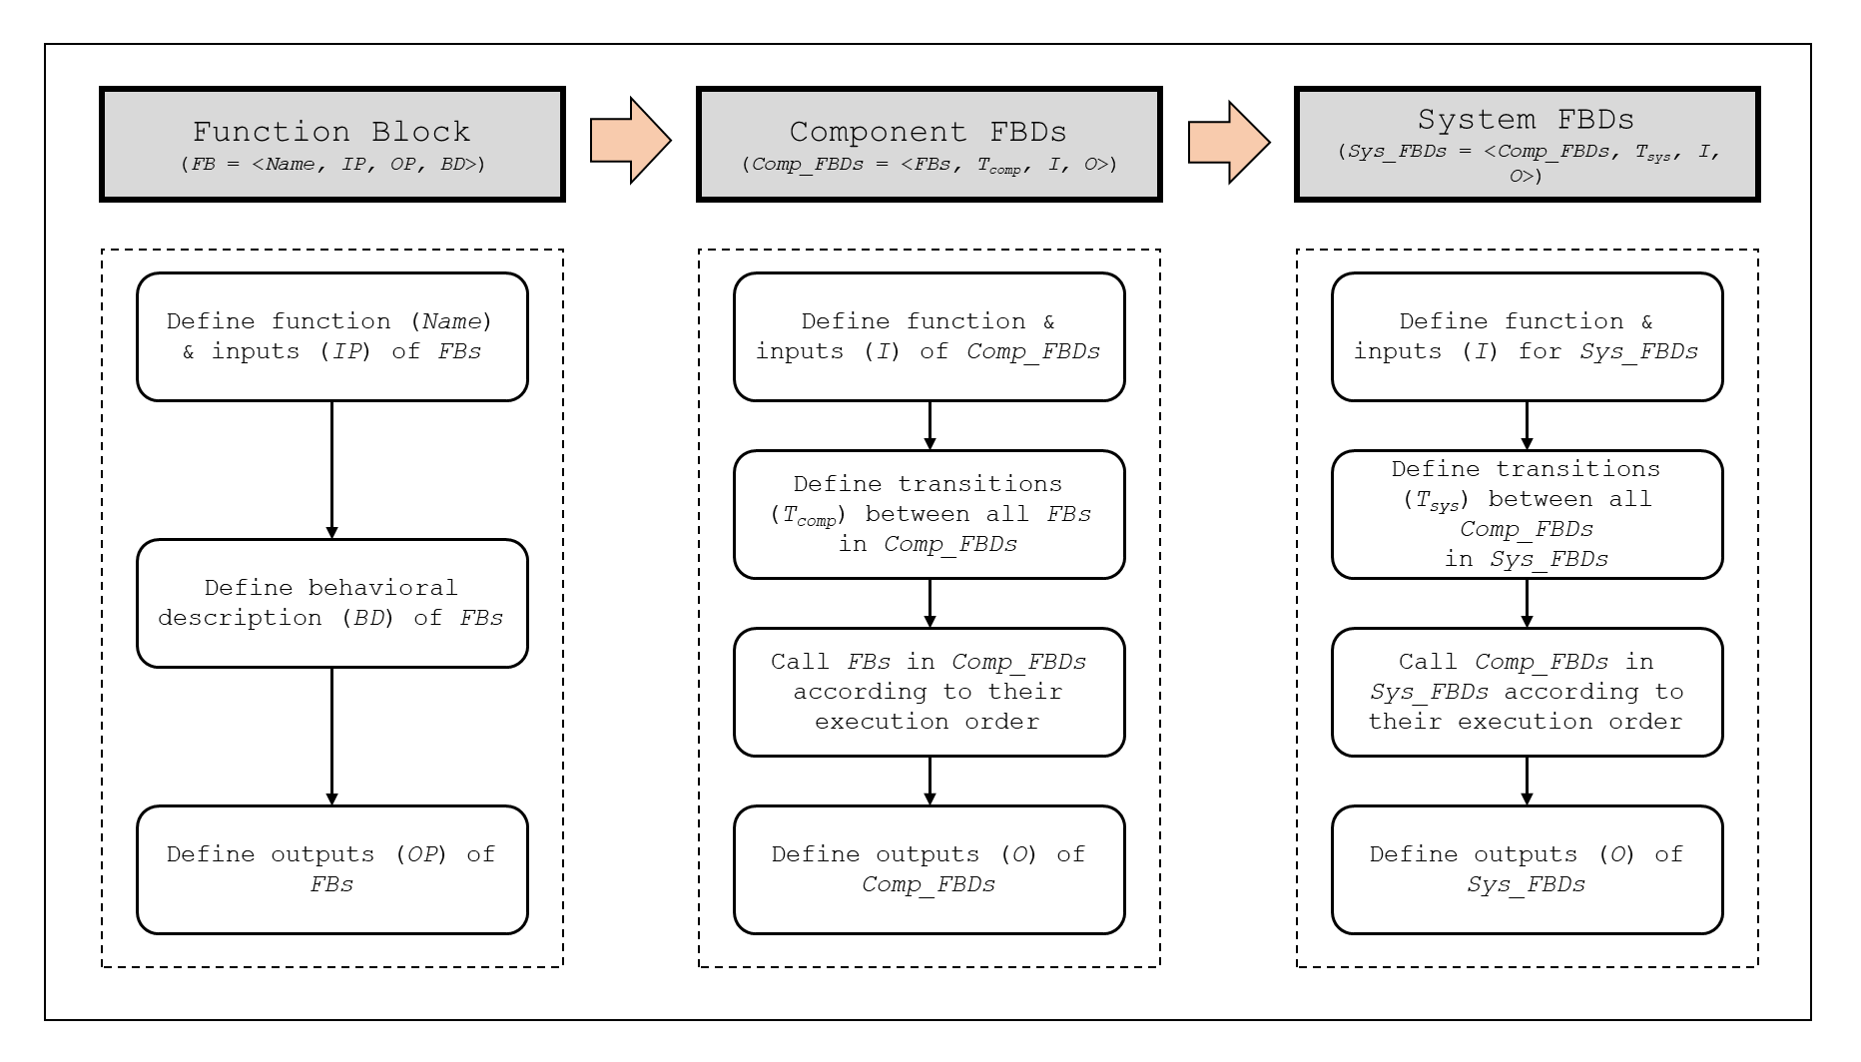

Figure 3.1: An overview of the FBD-to-SMT translation scheme

* + - 1. *Function Block Translation*

The FB is the basic POU for structuring PLC programs that has input parameters and static variables assigned to memory. The FBs are called by the program or other FBs in the program. A FB is defined as a tuple of a name (*Name*), input ports (*IP*), output ports (*OP*), and its behavior description (*BD*), as defined in Definition 1.

The semantics of a FB are defined as a function from a set of FB input variables $V_{FB-I}=\{v_{fi,1},v_{fi,2},…v_{fi,n}\}$ and a set of FB output variables $V_{FB-O}=\left\{v_{fo,1},v_{fo,2},…v_{fo,m}\right\}$. The variables in $V_{FB-I}$ and $V_{FB-O}$ are assigned to input ports IP and output ports OP, respectively. If we define $I_{i}$ and $O_{j}$ as a set of input domains of the inputs variable $v_{fi,i}$ ($1≤i≤n$) and output variable $v_{fo,j}$ ($1≤j≤m$) and the input and output space is defined as $I_{FB}=I_{1}×I_{2}×…×I_{n}$ and $O_{FB}=O_{1}×O_{2}×…×O_{m}$. Then, the FB is mathematically defined as following function: $f_{FB}:I_{FB}→O_{FB}$.

* **Definition 1 (Function Block)** *FB = <Name, IP, OP, BD>*, where
  + *Name*: a name of *FB*
  + *IP* : a set of input ports, $\{{ip}_{1},…,{ip}_{i},…,{ip}_{n}\}$ assigned by $V_{FB-I}$
  + OP : a set of output ports, $\{{op}_{1},…,{op}_{j},…,{op}_{m}\}$ assigned by $V_{FB-O}$
  + BD : behavioral description $\sum{(p_{FB},a_{FB})}$, where
    - $p_{FB}$: a predicate on *IP*
    - $a_{FB}$: assignments on *OP*

The behavior of a FB (*BD*) is defined as a set of predicates and assignments on input and output ports, respectively. The FB is a function from a set of input variables, which are assigned to input ports of the FB, to one output variable in most cases, which is assigned to one output port. Among the FB groups mentioned in IEC 61131-3 [100], five categories of FBs that are pertinent to the NPP safety software are illustrated in Figure 3.2. The behavior of a FB is intuitive as their names imply; for example, ADD2_DINT denotes the operation of adding two double integer values, AND2_BOOL denotes the bitwise-and operation of two Boolean values, SEL_BOOL denotes the operation to select either from two Boolean inputs, TON denotes the time on delay operation.

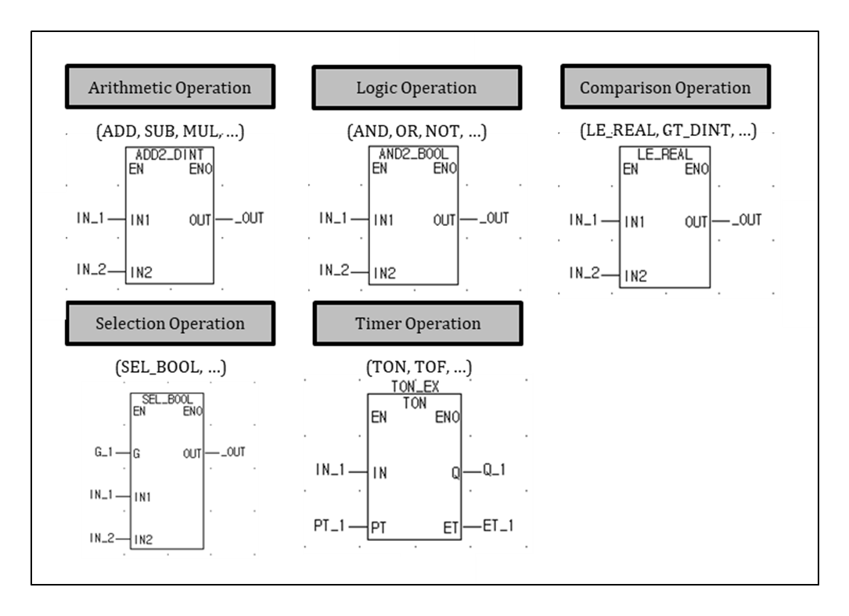

Figure 3.2: Examples of function blocks defined in IEC 61131-3

The input ports and output ports usually include Enable In (EN) which enables a FB when EN is true and Enable Out (ENO) which has the same value as EN as a result of a FB execution, respectively. As shown in Table 3.2, EN and ENO in the FBD program are used to determine the control flow that is logically distinguished from the FBD operations that represent the data flow of the PLC program by means of conditional function execution and error handling in case of abnormal termination [100]. It is notable that the use of these additional inputs and outputs for control flow operation is not included in the other PLC languages such as IL or ST.

Table 3.2: Definition of EN and ENO used in function block for FBD program

|  |  |  |
| --- | --- | --- |
| Enable In (EN) | Enable Out (ENO) | Description |
| EN = False | ENO = False | If EN is false when calling the function, the code-part of the function is not executed. In this case, ENO is set to false upon exiting in order to indicate that the function is not executed. |
| EN = True | ENO = True | If EN is true when calling the function, the code-part of the function is executed. In this case, ENO is set to true before starting the execution. |
| ENO = value | ENO can be set to true or false based on the execution result from the code-part of the function. |
| ENO = False | If a program or system error such as run time error or no system response occurs while executing the function, ENO will be set to false by the PLC. |

The rules shown in Figure 3.3 define how FB can be translated into an equivalent SMT formula. For each FB, a name of the function is defined which can be called in higher-level FBDs such as component or system FBDs several times according to its execution order and the components of FB are declared, as described in **Rule 1**. The value of the output variable is assigned by the behavioral description according to their types of operation (i.e., arithmetic and logical, comparison, selection, and timer operation), as defined in **Rule 2** and **Rule 3**, respectively. A function definition ends with returning the output variables of FB, as described in **Rule 4**.

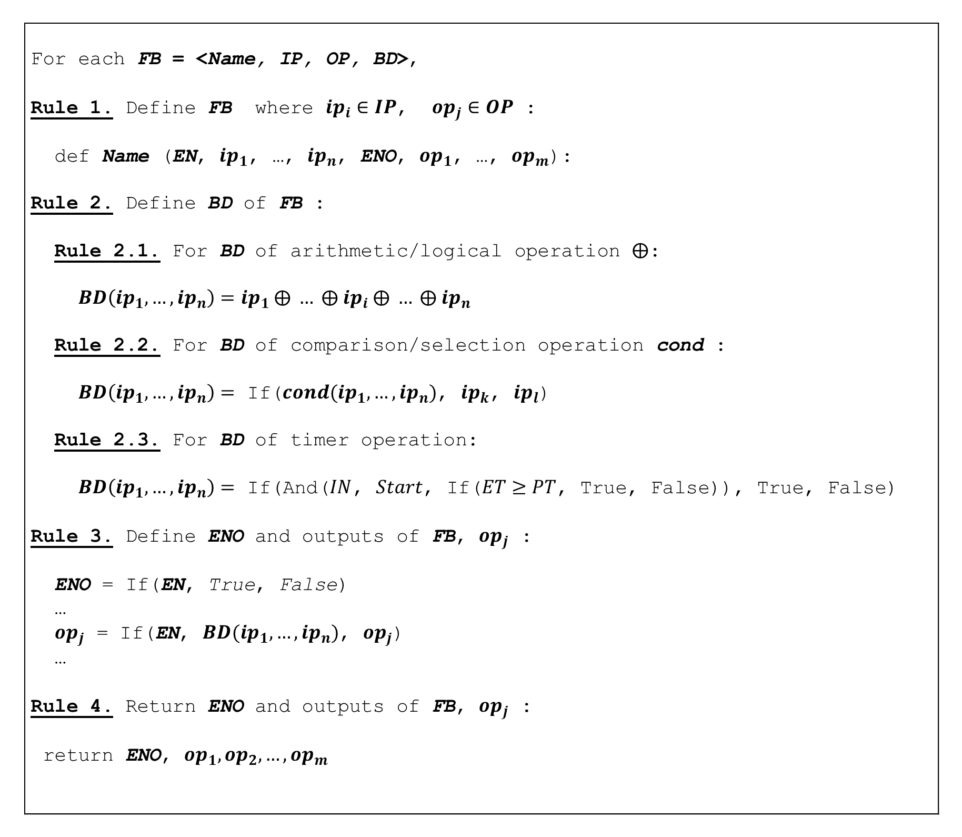

Figure 3.3: FBD-to-SMT translation rules for function blocks

The timer operation defined in **Rule 2.3** in Figure 3.3 has more complex control than other FBs. Timer FBs (e.g., TOF, TON) have internal variables such as the variable *Start* to store the status of edge detection and the variable *Residue* to store the time when the status changes. In case of TON FB, the output variable *Q* is trueonly if the input variable *IN* and the internal variable *Start* are true after at least *PT* time is elapsed (i.e., *ET* >= *PT*). The elapsed time *ET* is calculated from the system clock *clk* and the local clock *Residue* in timer FBs. The detailed behavior of timer operation can be found in [100]. Since the internal variables contribute to generating output for timer FBs, the internal variables are modeled with the input variables as arguments of timer FBs. Figure 3.4 shows an example of translating ADD4_DINT, SEL_BOOL, TON FBs. Other FBs which are not introduced in Figure 3.4 can be translated into equivalent SMT formulas based on the FB to SMT translation rules shown in Figure 3.3.

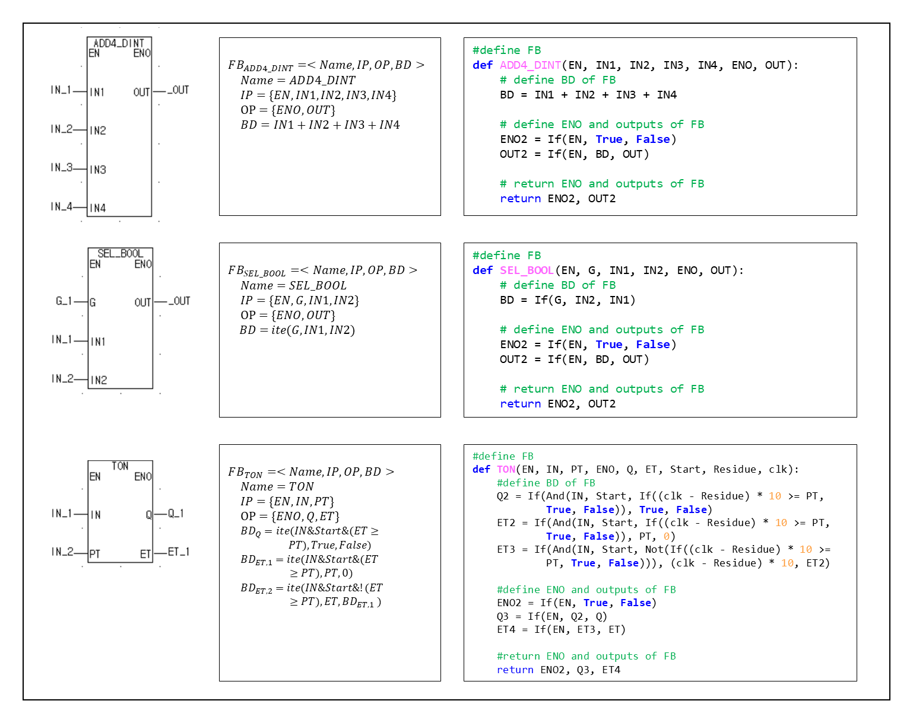

Figure 3.4: Formal definitions and translations for example function blocks

* + - 1. *Component FBD Translation*

A component FBD (*Comp_FBD*) is a logical block of independent FBs where a number of FBs are interconnected according to their sequential execution orders to generate meaningful outputs. Taken from the KNICS project [79], Figure 3.5 shows an example of a component FBD which is a part of reactor trip logic software that calculates an intermediate trip output variable *TRIP_LOGIC*. Each block, either a function or FB, implements a fundamental operation (e.g., LE_REAL, ADD2_REAL, MOVE_BOOL, and WORD_TO_REAL). The operation of FBDs is defined by the ladder logic where FBs and contacts are connected with a series of horizontal rungs [105]. The outputs from FBs at each rung are processed based on the connected ladder logic and used as inputs to the following FBs. When the PLC is in its run mode, it executes the entire FBD program to the end rung of the program and then resumes at the start. Each rung starts with at least one input and ends with at least one output. For example, the output variable *TRIP_LOGIC* in Figure 3.5 becomes true when the plant process variable *PV_OUT* is less than or equal to the trip set-point *TSP* and *TRIP_LOGIC* was false at previous scan time. At the same time, the trip set-point *TSP* is increased by the hysteresis *HYS*.

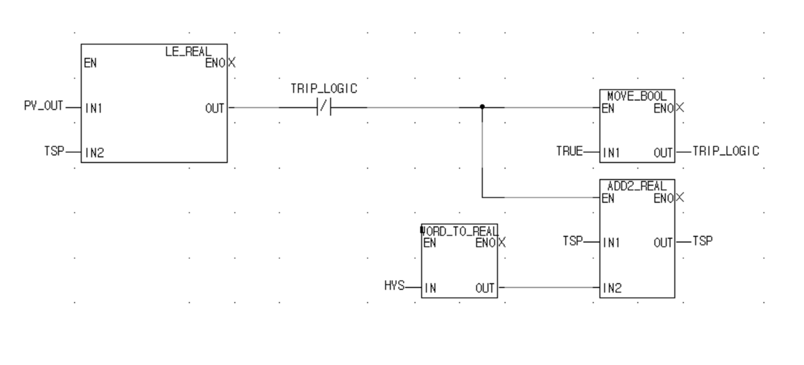

Figure 3.5: An example FBD program for generating *TRIP_LOGIC* signal

A component FBD is defined as a tuple composed of a set of FBs that consists of a component FBD, a set of transitions ($T_{comp}$) between the FBs in component FBD, a set of input ports (*I*), and a set of output ports (*O*). A component FBD shown in Figure 3.5 is composed of four FBs with three transition relations. It is notable that inputs to a component FBD can come from other component FBDs or system input variables defined in system FBDs.

The semantics of a component FBD is defined as a function from a set of input variables to a set of output variables. A set of input variables entering the component FBD, $V_{Comp_FBD-I}=\{v_{ci,1},…,v_{ci,i},…,v_{ci,n}\}$, are assigned to input ports (*I*) and a set of output variables outgoing from the component FBD, $V_{Comp_FBD-O}=\{v_{co,1},…,v_{co,j},…,v_{co,m}\}$, are assigned to output ports (*O*). A set of input domain of input variables $v_{ci,i}$ ($1≤i≤n$) and output variables $v_{co,j}$ ($1≤j≤m$) can be defined as $I_{Comp_FBD}=I_{1}×I_{2}×…×I_{n}$ and $O_{Comp_FBD}=O_{1}×O_{2}×…×O_{m}$, respectively. As similar to the FB, a component FBD is mathematically defined as the following function: $f_{Comp_FBD}:I_{Comp_FBD}→O_{Comp_FBD}$. Here, the input and output ports include *EN* and *ENO* respectively as similar to FBs.

* **Definition 2 (Component FBD)** *Comp_FBD = <FBs, Tcomp, I, O*, where
  + *FBs*: a set of function blocks
  + *Tcomp*: a set of transitions, (${FB}_{k}.OP_{q},FB_{l}.IP_{p}$) between function blocks ${FB}_{k}$ and ${FB}_{l}$ in *FBs* ($k≠l$), where
    - $FB_{l}.IP_{p}$: p-th input port of function block $FB_{l}$
    - $FB_{k}.OP_{q}$: q-th output port of function block $FB_{k}$
    - $∀(FB_{k}.OP_{q},FB_{l}.IP_{p})∈$*T*, where ${FB}_{k}$ has sequential execution precedence on $FB_{l}$
  + *I*: a set of input ports, $FB.IP$, which do not appear in *Tcomp* and are assigned by $V_{Comp_FBD-I}$
  + *O*: a set of output ports, $FB.OP$, which do not appear in *Tcomp* and are assigned by $V_{Comp_FBD-O}$

Figure 3.6 shows the FBD-to-SMT translation rules for component FBDs. First, the elements of component FBD are defined as in **Rule 5**. As the behavior of component FBD is defined as sequential calls of FBs defined in *Tcomp*, **Rules 6~7** define the program flow by calling FBs according to their execution order. Here, we define temporary variables (*tempcomp* in Figure 3.6) to model a set of transitions between FBs. The operation of FBDs is described by the ladder logic where FBs and contacts are connected with a series of horizontal rungs [105]. The outputs from FBs at each rung are processed based on the connected ladder logic and used as inputs to the following FBs. For example, the output of *LE_REAL* FB in Figure 3.5 is serially connected with the closed contact of input *TRIP_LOGIC*; thus, the logical conjunction of the output of *LE_REAL* FB and the negation of *TRIP_LOGIC* is used as an input to the *MOVE_BOOL* and *ADD2_REAL* FBs. Considering this execution characteristic of FBD program, temporary variables are used in the FBD-to-SMT translation rules for component FBD to store the value of the output ports of FBs or the vertical connections and assign those to the inputs of following FBs. The definition ends by returning the output ports as in **Rule 8**. When translating a component FBD, it is assumed that all FBs have already been translated into SMT formulas. It is notable that the FBs defined and translated in Section 3.4.1.1 are called in the component FBD according to their predefined execution order.

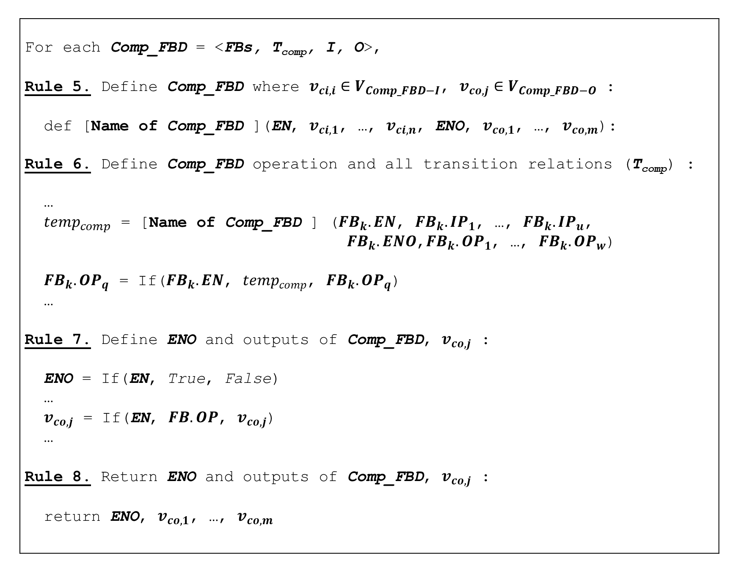

Figure 3.6: FBD-to-SMT translation rules for component FBDs

Figure 3.7 shows an example of the translated component FBD depicted in Figure 3.5. The input variables of FBD include Enable In (*EN*), hysteresis (*HYS*), process input (*PV_OUT*), trip set-point (*TSP*), trip signal (*TRIP_LOGIC*) and the output variables include Enable Out (*ENO*), trip signal (*TRIP_LOGIC*), trip set-point (*TSP*). Here, the input variables, *TRIP_LOGIC* and *TSP*, represent the outputs of each variable calculated at the previous PLC scan cycle. As the component FBD of Figure 3.5 is structured with four FBs and one junction with a vertical link which transfers left value to two diverging right sides of connection, a total of 9 temporary variables (one for vertical link and the others for the output ports of FBs) are defined as shown in lines 5~17 in Figure 3.7. The output ports of FBs are mapped to the temporary variables that are assigned to each FB and the variables connected to the output ports are updated. All FBs are executed according to predefined execution orders as shown in lines 18~44 in Figure 3.7. After executing the ladder logic and all FBs in component FBD, the output variables are assigned with the values as shown in line 45~48 in Figure 3.7.

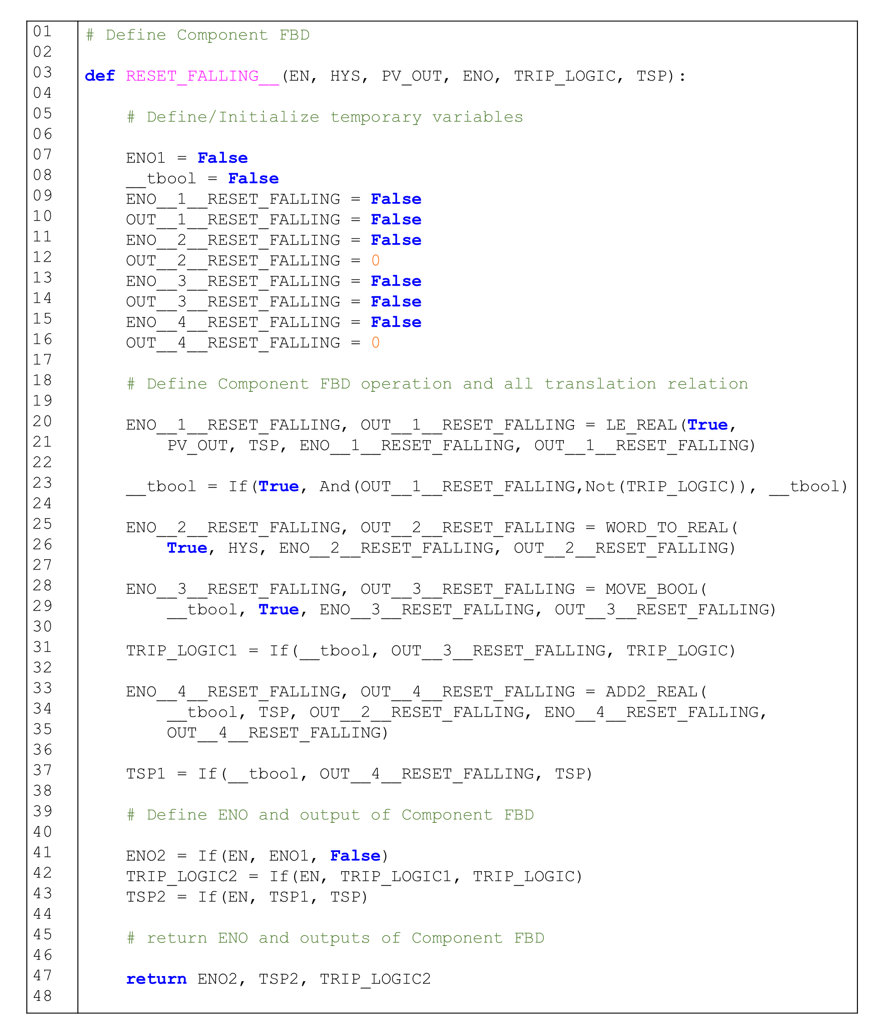

Figure 3.7: An example of FBD-to-SMT translation for the component FBD

* + - 1. *System FBD Translation*

A system FBD (*Sys_FBD*) is composed of a set of component FBDs connected according to their sequential execution orders. It is defined as a tuple of component FBDs (*Comp_FBD*), a set of transition between component FBDs in system FBD (*Tsys*), a set of input ports (*I*), and a set of output ports (*O*). Similar to component FBD, a system FBD is defined as a function from a set of system input variables $V_{Sys_FBD-I}=\{v_{si,1},…, v_{si,i},…,v_{si,n}\}$ to output variables $V_{Sys_FBD-O}=\{v_{so,1},…, v_{so,j},…,v_{so,m}\}$. In a mathematical form, the system FBD can be formulated as a function: $f_{Sys_FBD}:I_{Sys_FBD}→O_{Sys_FBD}$ where $I_{s,i}$ is a set of input domains of the input variables $v_{si,i}$ ($0≤i≤n$) and $O_{s,j}$ is that of the output variables $v_{so,j}$ ($0≤j≤m$) which constructs the input and output space of system FBD as $I_{Sys_FBD}=I_{s,1}×I_{s,2}×…×I_{s,n}$ and $O_{Sys_FBD}=O_{s,1}×O_{s,2}×…×O_{s,m}$, respectively. In this study, the whole NPP safety software is considered as one system FBD and the EN and ENO of the system FBD are not considered since the PLC executes a system FBD periodically with certain scan cycle.

* **Definition 3 (System FBD)** *Sys_FBD = <Comp_FBDs, Tsys, I, O>*, where
  + *Comp_FBDs*: a set of *Comp_FBDs*
  + *Tsys*: a set of transition, (${Comp_FBD}_{k}.O_{q},Comp_F{BD}_{l}.I_{p}$) between component FBDs ${Comp_FBD}_{k}$ and ${Comp_FBD}_{l}$ in *Comp_FBDs* ($k≠l$), where
    - $Comp_F{BD}_{l}.I_{p}$: p-th input port of $Comp_F{BD}_{l}$
    - $Comp_{FBD}_{k}.O_{q}$: q-th output port of $Comp_F{BD}_{k}$
    - $∀({Comp_FBD}_{k}.O_{q},Comp_F{BD}_{l}.I_{p})∈$*T*, where ${Comp_FBD}_{k}$ has sequential execution precedence on $Comp_F{BD}_{l}$
  + *I*: a set of input ports, $Comp_FBD.I$, which do not appear in *Tsys* and are assigned by $V_{Sys_FBD-I}$
  + *O*: a set of output ports, $Comp_FBD.O$, which do not appear in *Tsys* and are assigned by $V_{Sys_FBD-O}$

Figure 3.8 summarizes the translation rules for system FBDs. The translation rules for system FBDs are similar to those of component FBDs while it is composed of sequential calls of component FBDs instead of FBs and uses temporary variables to model a set of transitions between component FBDs. First, the elements of system FBD are defined as in **Rule 9**. As the behavior of system FBD is defined as sequential calls of component FBDs defined in *Tsys*, **Rules 10~11** define the program flow by calling component FBDs according to their execution order. Here, we define temporary variables (*tempsys* in Figure 3.8) to model a set of transitions between the component FBDs. The temporary variables are used in the translation rules for system FBD to store the value of the output ports of component FBDs or the vertical connections and assign those to the inputs of following FBDs. The definition ends by returning output ports as in **Rule 12**. When translating a system FBD, it is assumed that all FBs and component FBDs were already translated into SMT formulas. For example, FBs or component FBDs defined and translated in previous sections are called in the system FBD according to their predefined execution order.

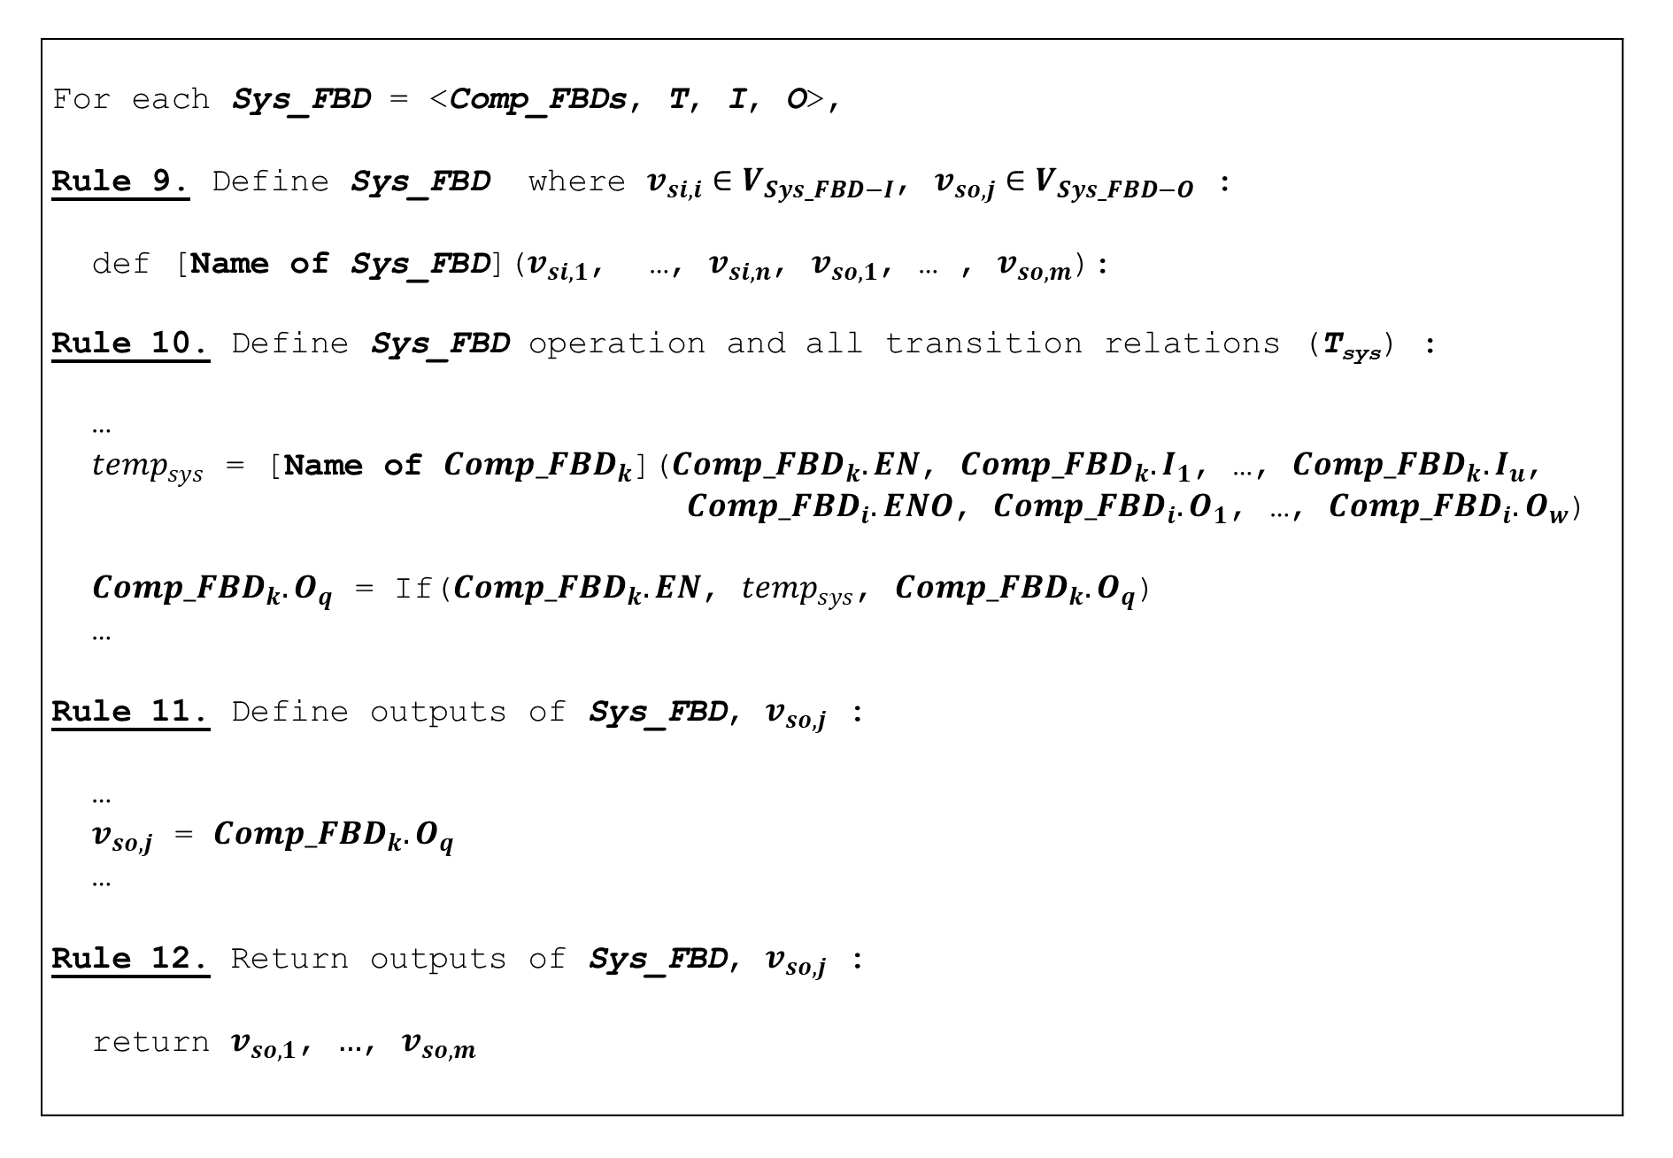

Figure 3.8: FBD-to-SMT translation rules for system FBD

Figure 3.10 shows the translated SMT formula for a part of *BP___k_Trip_LogicA* module, one of the modules of KNICS IDiPS-RPS BP trip logic [79] including the component FBDs *RESET_FALLING*, *TRIP_DECISION*, and *OUTPUT_SELC* shown in Figure 3.9. In Figure 3.9, the intermediate trip signal variable *_6_TRIP_LOGIC*, which is one of the outputs of *RESET_FALLING* component FBD becomes an input of the *TRIP_DECISION* component FBD. To model the transition relation between component FBDs in system FBD, the temporary variables for the outputs of component FBDs used as the inputs of other component FBDs are modeled (*_6_TRIP_LOGIC__2* in Figure 3.10). After executing the ladder logic and all FBDs in system FBD according to predefined execution orders as shown in lines 18~44 in Figure 3.10, the output variables are assigned with values as shown in line 45~48 at Figure 3.10.

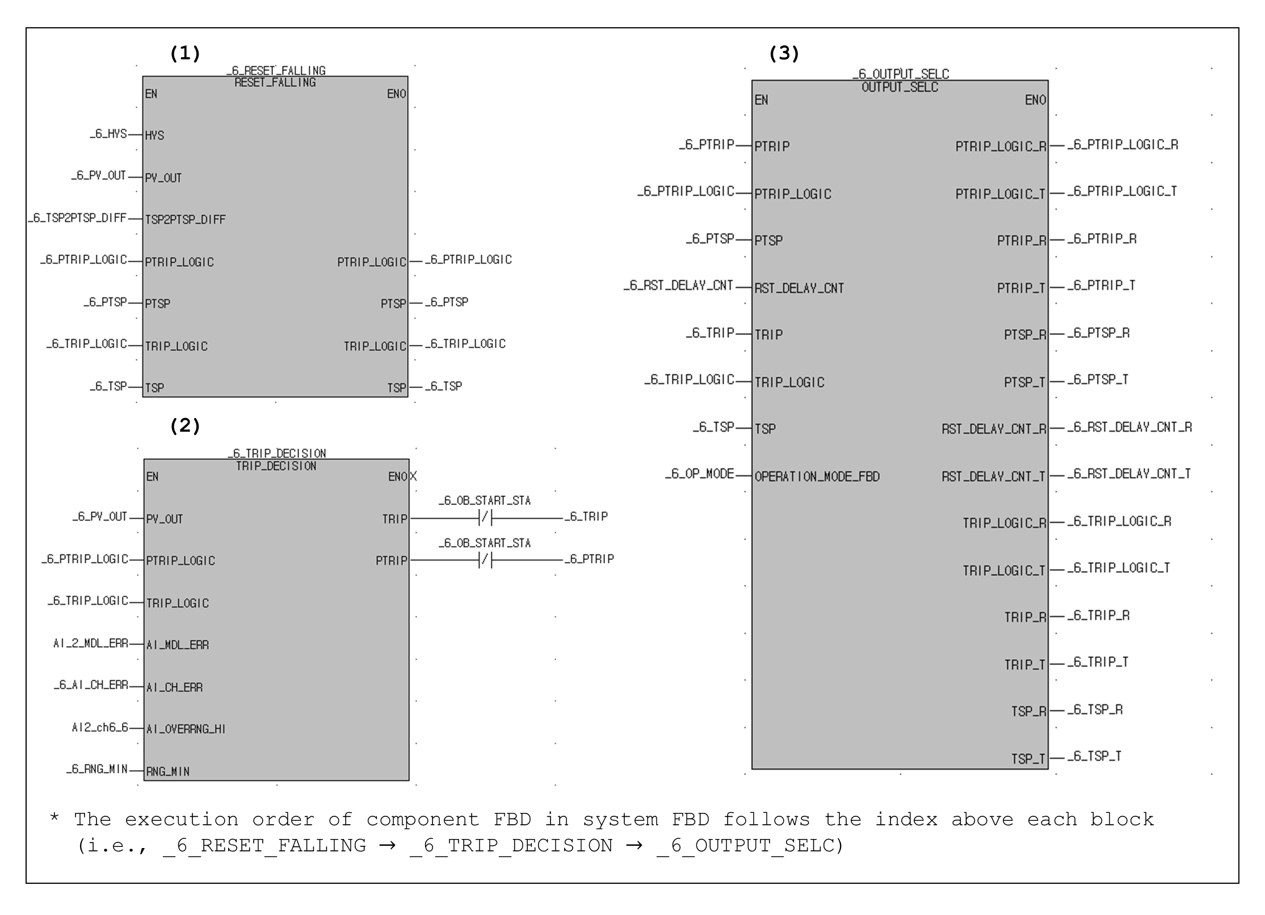

86

Figure 3.9: A part of the system FBD of KNICS IDiPS-RPS BP software

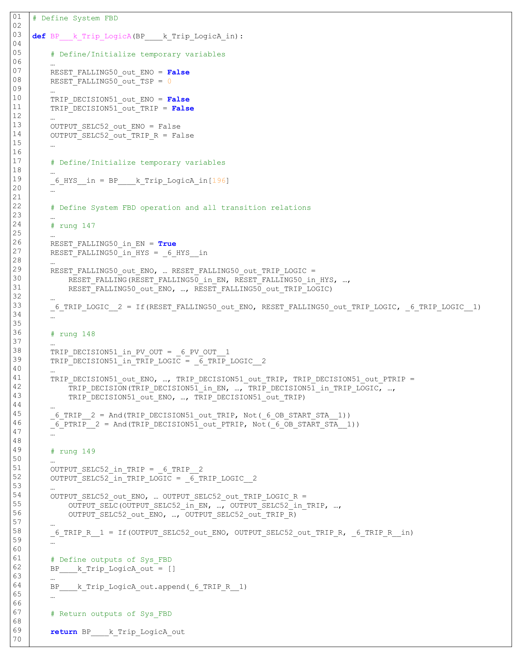

Figure 3.10: An example of FBD-to-SMT translation for the system FBD

* + 1. **Single Test Case Generation for FBD Program**

Given the SMT formulas translated from FBD program under test, a test case can be generated by finding the software input and internal variables’ states that satisfy the selected test requirement. The procedure for generating a test case for FBD program consists of three major parts: (1) defining the variables and FBD program under test, (2) defining test requirements, and (3) retrieving the model that satisfies test requirements. It is notable that the single test case generation procedure is utilized as a basis of exhaustive test case generation algorithm.

Figure 3.11 shows an overview of a single test case generation procedure. In the first part, the program information required for test case generation, such as program variables and the FBD programs, are defined. In the second part, the test requirement is set as the status of software output for which the test case for software input and internal variables is generated. For NPP safety software, the safety signal initiation by the FBD program (e.g., reactor trip signal) can be defined as the test requirement. Then, the test requirement is added as a set of constraints of the formula to be solved. In the third part, a model that satisfies the formula given test requirement is retrieved by satisfiability check using SMT solver. Figure 3.12 shows an input file to generate test cases satisfying the given test requirement (i.e., *TRIP_LOGIC* = true) for the FBD program shown in Figure 3.5. The input file generation steps are explained using the example shown in Figure 3.12:

1. *Environmental setting (lines 1~5)*: The commands for the application of Z3 SMT solver are defined. The Z3 module and *Solver()* which provide methods for implementing the basic SMT commands such as *push*, *pop*, *check*, *get-model* is defined. The *pset_func* and *RESET_FALLING*, which are the subroutines that specifies the operation of FBs and component FBD, respectively, are called.
2. *Declaration of the variables/constants of the FBD program (line 7~20)*: The names and possible ranges of all variables under test and constants in the FBD program are declared.
3. *Declaration of FBD program logic (line 22~37)*: The SMT formula translated based on FBD-to-SMT translation rules is called. In addition, the variables declared in step 2 are mapped with the inputs of the program.
4. *Definition of test requirement (line 39~40)*: The goal of test case generation (*TRIP_LOGIC* = true in Figure 3.5) is defined as a test requirement and added as a constraint of the SMT formula to be solved.
5. *Find an interpretation for FBD program (line 42~45)*: The command *check()* decides whether the formula is satisfiable given constraints. When the *check()* returns *sat*, the command *model()* is used to retrieve a model or solution for the software variables that makes the formulas true given constraint. The derived model is saved as a single test case of the FBD program under test.

Figure 3.13 shows the result of a single test case generation algorithm execution in Figure 3.12. The algorithm utilizes Z3 to check the satisfiability of the given SMT formula. If the formula is satisfiable meaning there exists at least one interpretation for the defined variables that evaluate a given formula to be true, *check()* returns *sat* as a satisfiability check result. If it is unsatisfiable, it returns *unsat*. If the formula is satisfiable, the model that makes formula true is retrieved and saved as a test case for the FBD program. For example, the states of input variables of FBD program in Figure 3.5 that generates the trip signal retrieved by the algorithm are derived as {*_6_TSP* = 17780, *_6_PV_OUT* = 17780, *_6_TRIP_LOGIC* = False}, as shown in Figure 3.13.

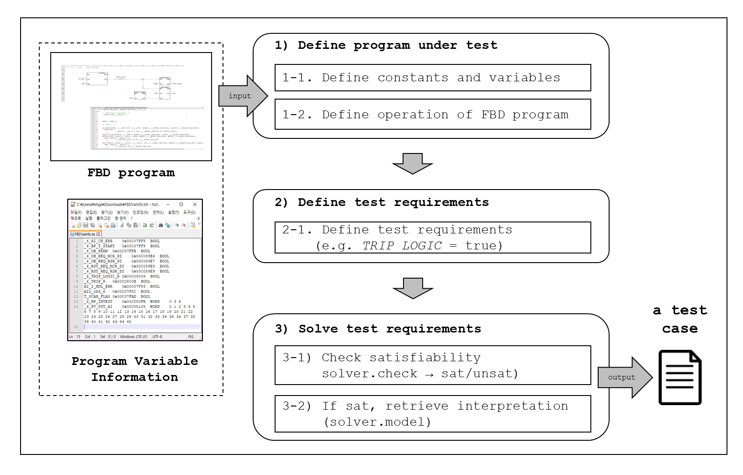

90

Figure 3.11: An overview of a single test case generation procedure

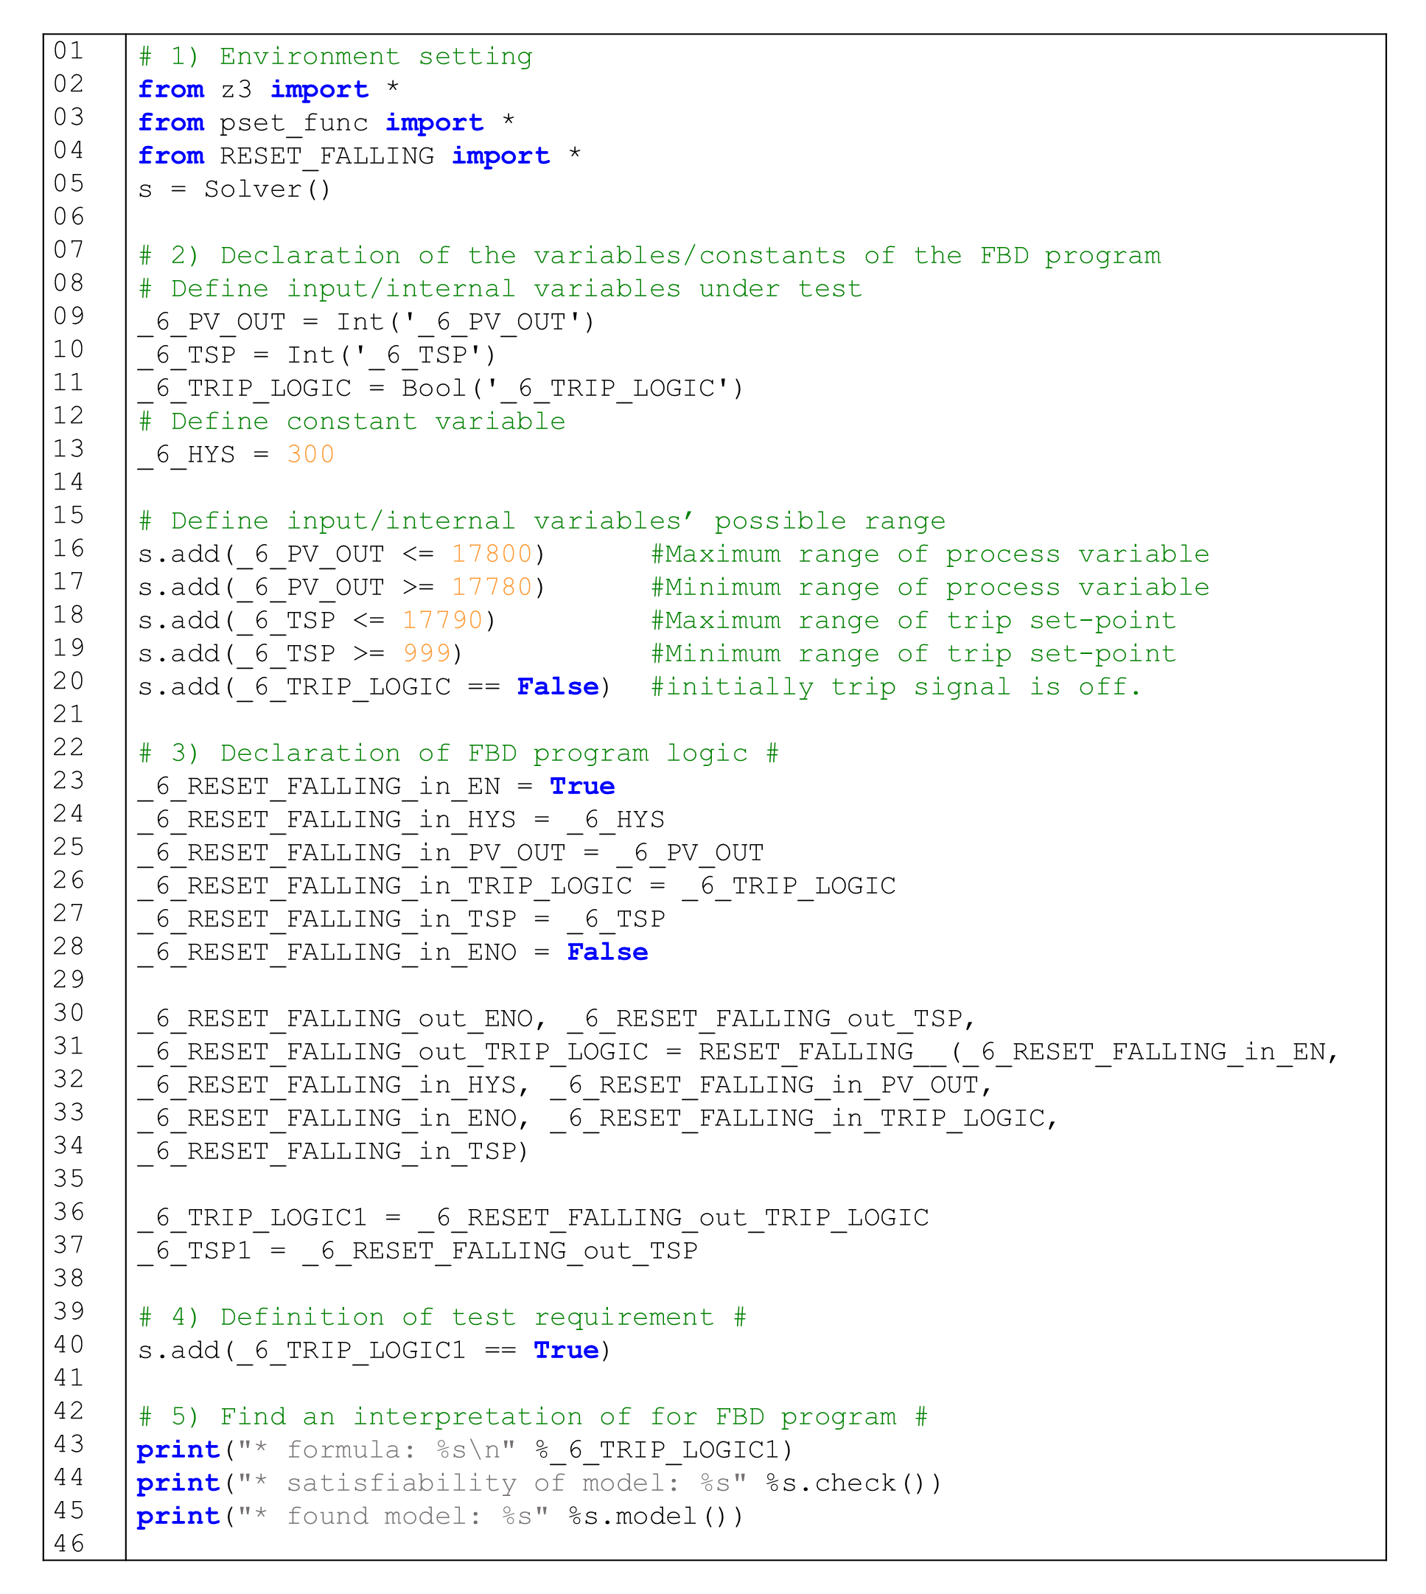

Figure 3.12: Input file for generating a single test case satisfying the test requirement (*TRIP_LOGIC* = true) for the example FBD program

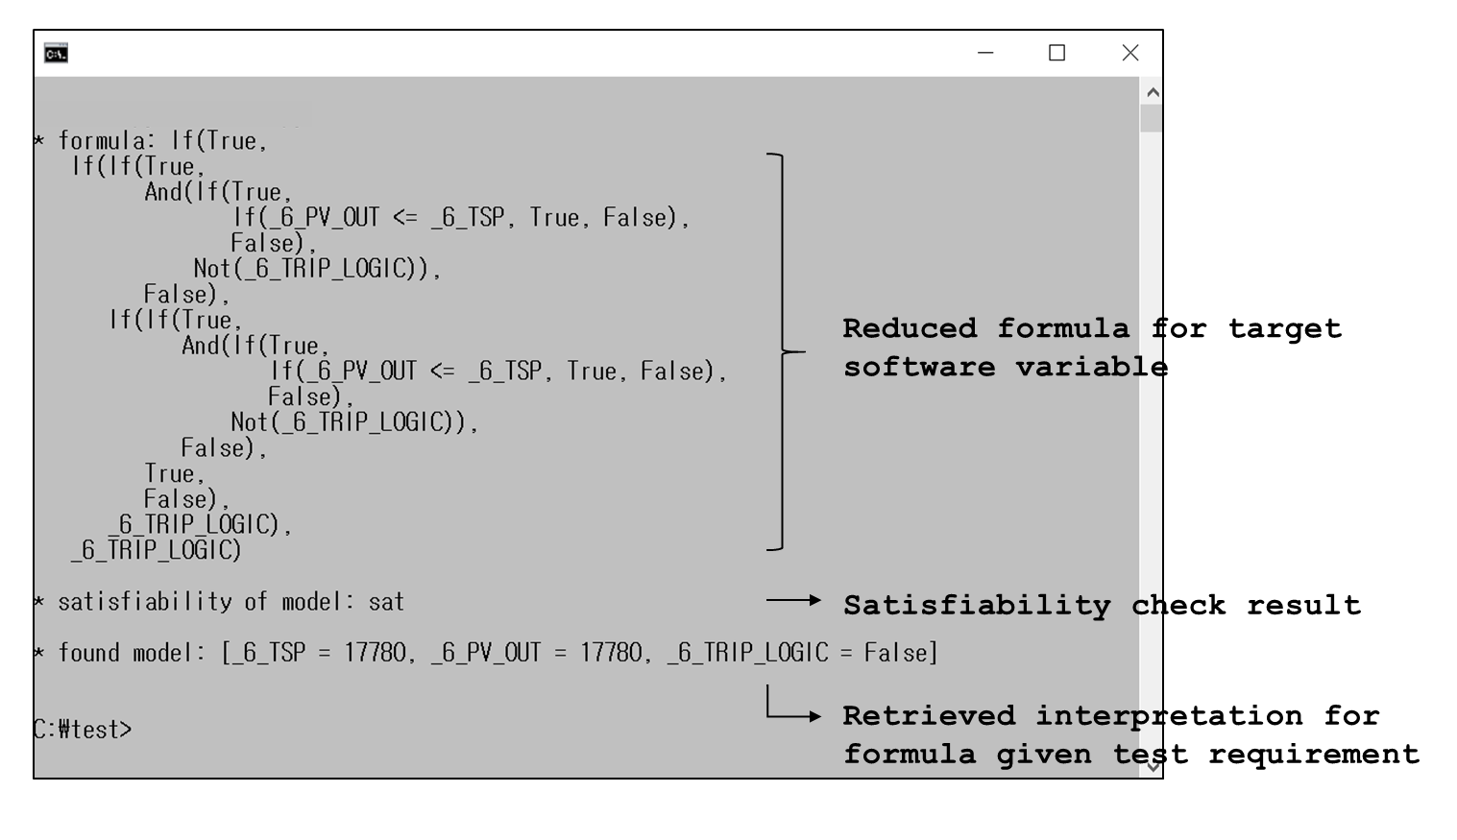

Figure 3.13: An example of a single test case generation result for FBD program

* + 1. **Exhaustive Test Case Generation for FBD Program**

As exhaustive testing is a test approach in which all possible cases of software demand are tested, the states of software input and internal variables that satisfy the test requirement (e.g., safety signal generation) must be derived for NPP safety software. In this study, FBDET algorithm is developed which utilizes SMT solver to check the satisfiability of the SMT formula translated from the FBD program and retrieve models for software input and internal variables while adding the negation of the last found models as a new constraint to the formula at each iteration. In the FBDET framework, a test case is generated by finding the software input and internal variables’ states that satisfy the selected test requirement given the SMT formulas translated from FBD program under test. The procedure for generating exhaustive test cases for FBD program consists of three major parts: (1) defining the software variables and FBD program under test, (2) defining the test requirements, and (3) retrieving the model for software variables that satisfies the test requirements. Figure 3.14 shows an overview of the exhaustive test case generation procedure.

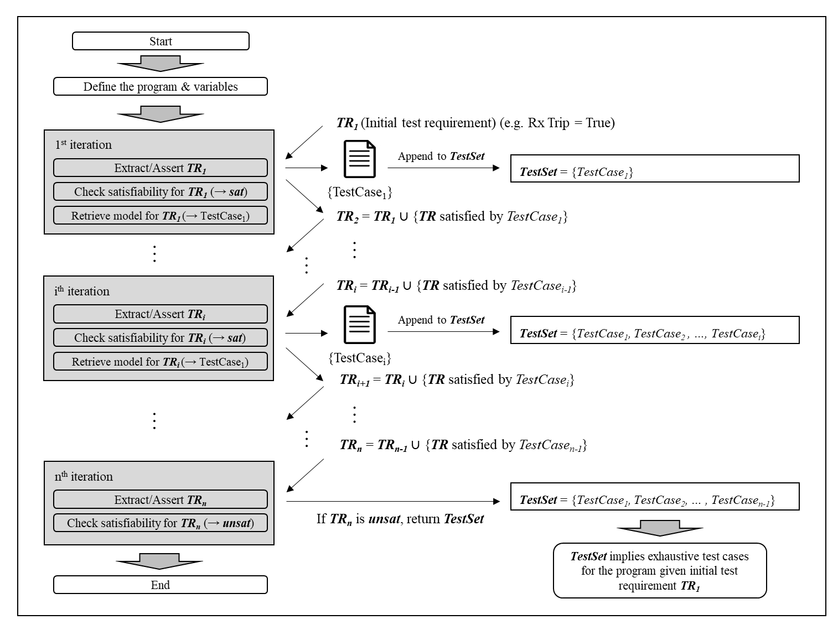

93

Figure 3.14: A flowchart of exhaustive test case generation for FBD program

In the first part, the program information required for test case generation, such as program variables and the FBD programs, is defined. Here, the names and possible ranges of all variables under test and constants as well as the SMT formula translated based on FBD-to-SMT translation rules are declared. In the second part, the initial test requirement (*TR1*) is defined and added as a set of constraints of the formula to be solved. For NPP safety software, the initial test requirement can be defined as the safety signal initiation (e.g., reactor trip signal = true) by the FBD program. In the third part, the algorithm invokes the SMT solver to derive the model that satisfies the SMT formula given test requirement. If the formula is satisfiable meaning there exists at least one interpretation for the defined variables that evaluate a given formula that satisfies test requirement, the SMT solverreturns *sat* as a satisfiability check result. If it is unsatisfiable, it returns *unsat*. If the formula is satisfiable, the model that makes the formula true is retrieved and saved as a single test case for the FBD program. In order to derive another model for the formula, the negation of the derived model at each iteration (*TestCasei* at *i*-th iteration) is added as a new constraint to the test requirement which will be used for next iteration (*TRi+1*). The new test requirement requires the SMT solver to find another solution at the next iteration (*TestCasei+1* at (*i+1*)-th iteration) for the formula except the ones found in previous iterations. At each iteration, the derived model is added to the *TestSet*. The process is repeated until the solver returns unsatisfiable (*unsat*) as a satisfiability check result for the formula given the test requirement. In result, the derived models, or *TestSet*, represent the exhaustive test cases for the initial test requirement where each test case is exclusive to each other. Figure 3.15 describes the *FBDET* algorithm developed based on the exhaustive test case generation procedure shown in Figure 3.16.

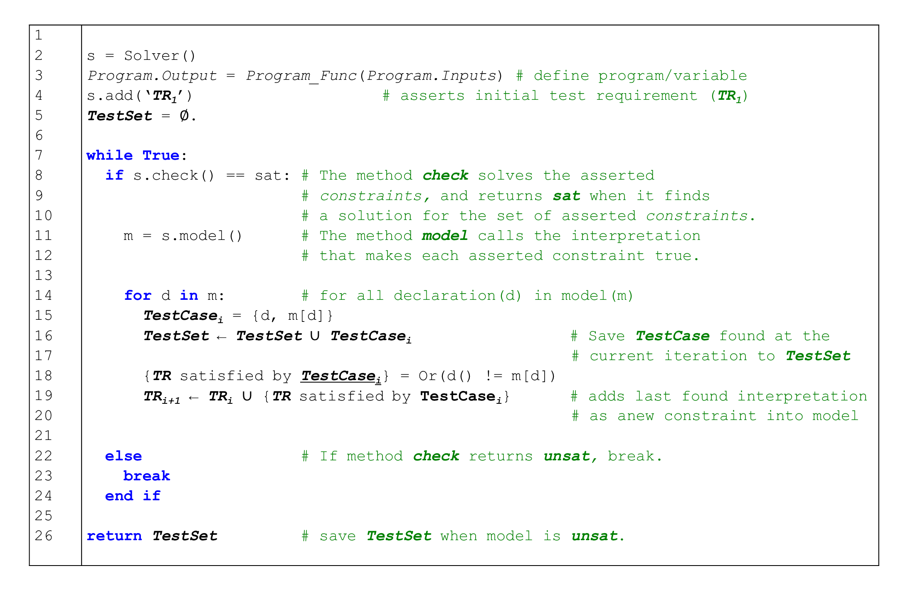

Figure 3.15: FBDET algorithm for exhaustive test case generation of the FBD program

Figure 3.16 illustrates how exhaustive test cases are being generated for the FBD program of Figure 3.5 by FBDET algorithm. The test modulefile which defines the SMT formula, program variables and the initial test requirement (*TR1 = {TRIP_LOGIC =* true}) is executed. At the first iteration, the FBDET invokes Z3 which generates *sat* as the satisfiability check result, which means there is a model for program variables that makes the *TR1* satisfiable for FBD program. Then, the solution for software input and internal variables {*PV_OUT* = 17780, *TSP* = 17780, *TRIP_LOGIC* = False} found at the first iteration becomes the first test case (*TestCase1*) and its negation is added to *TR1* as a new constraint which becomes a new test requirement for the next iteration (*TR2*). At the second iteration, FBDET again invokes Z3 to check the satisfiability of the formula given new test requirement (*TR2*) passed from the first iteration and retrieve a new model if the formula is satisfiable given *TR2*. The same process is repeated until the 67th iteration where Z3 returns *unsat* as its satisfiability check result given *TR67*, the iteration stops and returns the test cases (*TestSet*) saved from previous iterations. The derived test cases reflect the exhaustive test cases for software input and internal variables in terms of the initial test requirement (*TR1*) for the FBD program where each test cases are exclusive to each other.

The proposed framework was implemented to the FETCG shown in Figure 3.17, which automates the process from FBD-to-SMT translation to FBDET algorithm execution. The users can select the FBD programs to be tested and specify the desired software output for which the test cases are derived. Based on those inputs, the FETCG generates a test module file for FBD program, executes the FBDET algorithm, and derives the exhaustive test cases based on the variable information provided by the user which specifies the possible ranges or values of software input and internal variables.

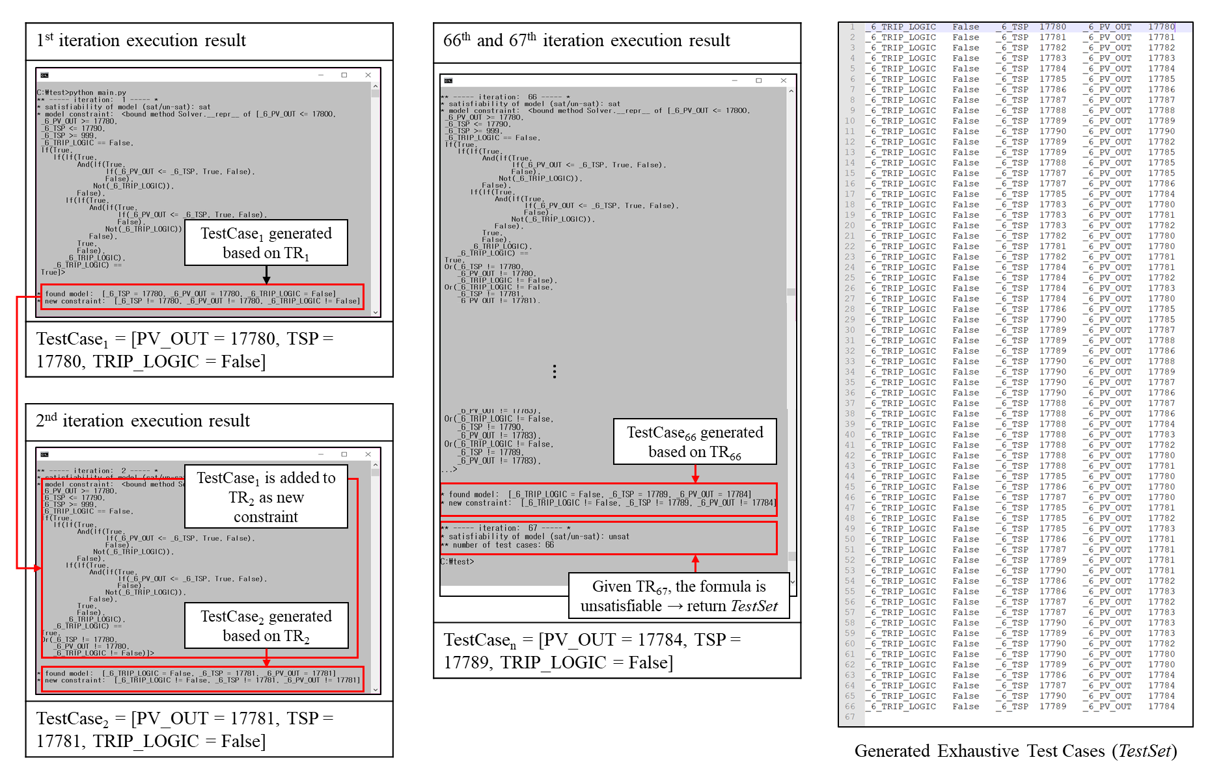

97

Figure 3.16: Execution screenshot of FBDET algorithm for an example FBD program

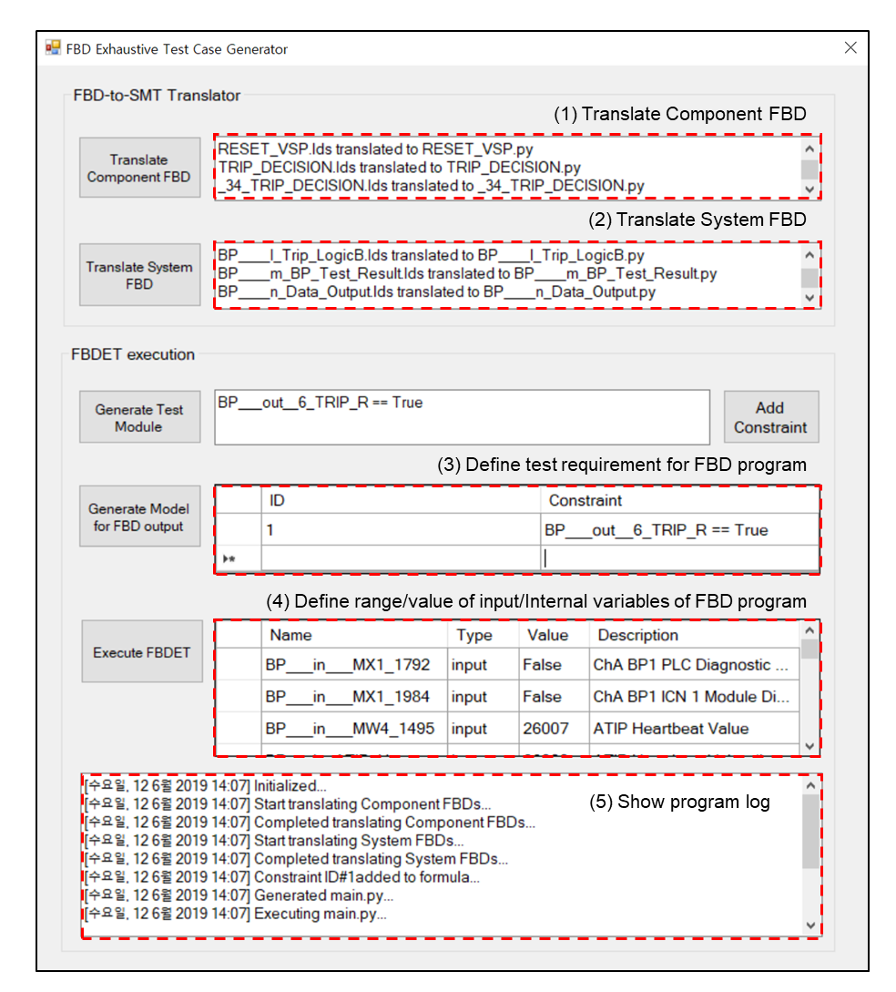

Figure 3.17: Screenshot of FETCG, a tool for FBD exhaustive test case generation

* 1. **Summary and Conclusions**

This Chapter describes a novel exhaustive test case generation framework for FBD programs, which is important in demonstrating the error-freeness of the NPP software in generating its dedicated safety function when demand comes. The proposed framework formally translates the FBD program to SMT formula and the FBDET algorithm is developed for the exhaustive test case generation. The FBD programs consisting of sub-components, including FB, component FBD, and system FBD are translated in a bottom-up manner to semantically-equivalent SMT formula which is later solved by SMT solver given the test requirement to generate exhaustive test cases. In doing so, FBD-to-SMT translation rules are developed based on the formal definition of FBDs. The FBDET algorithm utilizes SMT solver to check the satisfiability of the SMT formula translated from the FBD program and retrieve models for software input and internal variables while adding the negation of the last found models as a new constraint to the formula at each iteration. The proposed framework was implemented to the test case generation toolkit for FBD program, FETCG, which automates the processes from FBD-to-SMT translation to FBDET algorithm execution. The tester can select the software program written in FBD language to be tested and specify the desired software output. In result, the FETCG generates a test module file for the translated FBD program and derives the exhaustive test cases by FBDET algorithm based on the variable information provided by the tester which specifies the possible ranges or values of software input and internal variables.

In summary, the academic contributions made in this Chapter are as follows:

1. The translation rules from FBD to SMT formula are developed based on the formal semantics of FBD components and implemented to the FBD-to-SMT translator in FETCG.
2. The proposed test case generation framework provides a method to generate the exhaustive test cases of NPP safety software which can prove that the software is error-free in terms of its safety function
3. Combining the proposed method with the simulation-based software test-bed provides not only feasible but also effective testing for the FBD programs which have the size and complexity of safety software compared to the conventional test-based methods

# SIMULATION-BASED TEST-BED FOR NPP SAFETY SOFTWARE [2]

* 1. **Introduction**

In applying digital technologies to NPPs, the newly developed I&C system should be tested and verified using the prototype or mock-up environment. As the recent digital I&C functions have changed to become more integrated and diverse, it would be ideal to receive the input signals directly from the operating NPP that are continuous and provide a realistic operational profile to test and verify the I&C functions. However, it is almost impossible to conduct the testing in the operating NPP considering both test performance and plant safety. In the past, static or low-fidelity simulation testing before plant installation was conducted for I&C system replacements and upgrades followed by a lengthy start-up test to adjust the system tuning constants [217]. In this case, the plant is exposed to huge risks if the installation difficulties are encountered or if the system does not operate as anticipated. Therefore, a test-bed that can simulate the behavior of digital I&C system in NPP are now being used to test and verify the newly developed digital I&C systems instead of testing in an actual NPP.

While it is generally recognized that the original application software should be used in testing the software, the exact running environment, including both the hardware and software, has been adopted for the testing of the application software [72]. However, employing the hardware environment to the software testing poses difficulty in exhaustive testing in terms of time and cost, resulting in a limited number of software testing to verify high reliability software. Therefore, an efficient and effective software testing environment must be developed which can enable the exhaustive testing of the safety-critical software and further prove the integrity of the software or quantify the software reliability based on software test results. In this research, the test-bed is developed for the target NPP software, which emulates the behavior of a target PLC microprocessor where the application software is operated and runs the compiled machine code of FBD program for given test cases.

* 1. **Related Works**

Regarding the test-bed configuration, different test configurations represent different degrees of realism in simulating the operation of an I&C system and may have dissimilar capabilities in capturing potential faults in the software. Traditional approaches on NPP I&C testing insisted on using the original hardware because the performance of the hardware may be critical in determining the interaction between software and hardware even when using the same compiler and running environment for the software in the tests. This is based on the assumption that different piece of hardware or compilations and execution environments might change the triggering event of a software fault and the software’s responses. Such test configuration developed and operated for NPP I&C system testing and validation includes the test-bed for nuclear plant I&C validation at Pennsylvania State University [218], hardware-in-the-loop test-bed at Argonne National Laboratory [219], Nokia research simulator at OECD Halden reactor project [220], advanced controls research facility for liquid metal reactor power block at Oak Ridge National Laboratory [221], S3C control room simulator of French EdF N4 [222] and the functional test facility for advanced I&C system at KAERI [223].

However, employing the original hardware poses extra difficulties and costs in testing and limited accessibility to the internal states of the software and hardware is likely because the original hardware may not be designed to accommodate the test purpose. With the invent of Joint Test Action Group [224], which enabled verifying designs and testing printed circuit boards after manufacturing at the integrated circuit level, this difficulty may be alleviated. However, the system which generates and feeds the test cases manually or automatically to the hardware-based test-bed still needs to be further developed for the test purpose, which may cause difficulty for exhaustive testing of the software in terms of time and cost. For example, trajectory-input testing was conducted to digital computer controller which is one of the digital I&C systems in Wolsong unit 2, 3, and 4 in Korea in 2008 [225]; however, it took a long time even for testing a single test case because one needs to interrupt hardware-based test environment to check the test result and run another test case for every test cases. In result, the number of software testing to verify high software reliability and related confidence level on software reliability was limited using the hardware-based test environment. Regarding the NPP safety-critical software testing, Seo *et al.* [226] developed an experimental environment that consists of the basic components of a digital RPS (BP and CP) and the I/O simulator for APR-1400 RPS software testing. The I/O simulator was programmed using pSET-II, a software engineering tool for POSAFE-Q PLC and used to create an environment similar to the original RPS and to generate the input signals such as the value of analog detectors in NPPs and the operator decision to set-point algorithm manual reset, and to store the output signal such as reactor trip signal from CP. In terms of its test performance, the results showed that a time to execute a single test from configuring the input values in the I/O simulator to checking the output signal using the I/O simulator took few minutes.

Another example is the reliability tests of the LOCS of an ATR experimental loop at Idaho National Laboratory [50]. Idaho National Laboratory developed control software failure test signal simulator, a computerized system for simulating signals that produce 14 analog current output signals representing the instrument signals in a real-world NPP whose values were generated using a plant thermal-hydraulic simulation software, RELAP5, for the target system. The LabVIEW application software was used to reproduce the RELAP5-derived analog signals on National Instrument data acquisition rack in near-real-time and to provide inputs to LOCS and its software. The test result showed few seconds to few minutes (100 to 18,000 records per a scenario file) to complete one test scenario which is in feasible range in terms of the test performance for statistical testing but not for the exhaustive testing of NPP safety software.

Alternative to the conventional hardware-based test-bed, a test tool can be designed for software validation in a simulated environment, that is, without using the original hardware. Not using the original hardware means that either a simulation-based test-bed must be created or reconfigurable hardware such as a field programmable gate array to mimic the original hardware is required. One example of such simulated test-bed in the nuclear domain includes the SIVAT developed by AREVA for Teleperm XS systems [165], as shown in Figure 4.1.

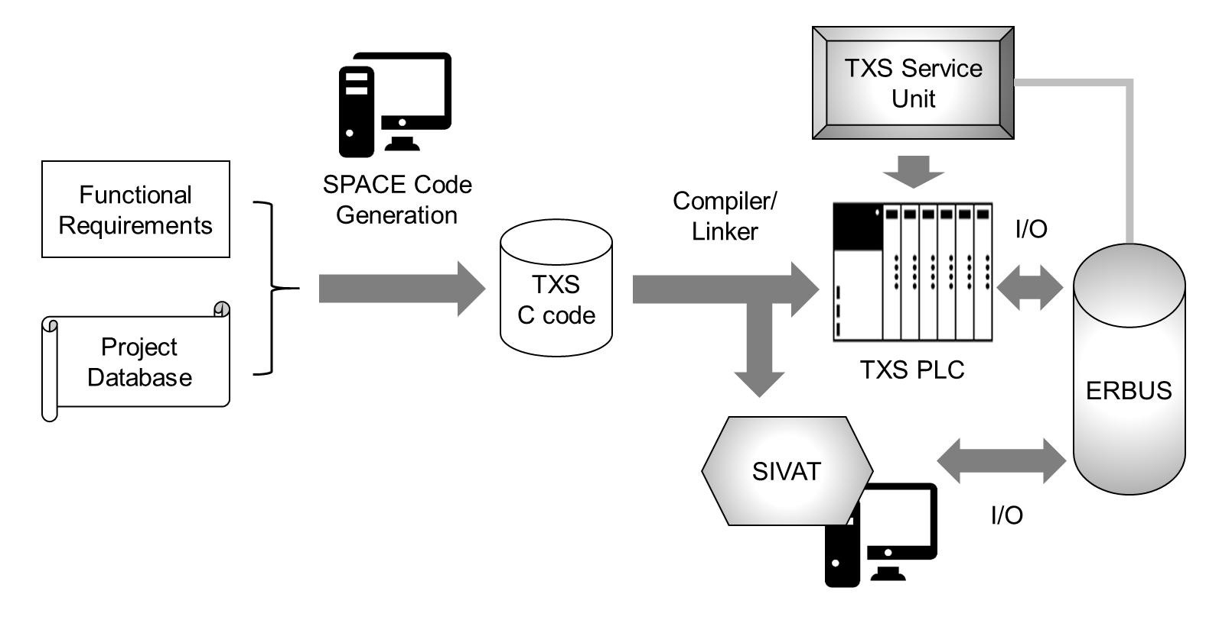

Figure 4.1: Illustration on the software validation using SIVAT test-bed

SIVAT performs the validation testing for the functional requirements of the application software in Teleperm XS platform in a simulation environment based on the models of CPUs, ensuring that all internal signals and variables of the model are stored in the simulator database, input and output models and the original code of the application software. After the Teleperm XS system and its project-specific software are manufactured, it is set up in the test field to test the overall system function. In this process, the application software is loaded into the CPU modules in the Teleperm XS system and the software inputs and outputs are linked with those of the ERBUS, which generates analog and digital signals which are wired directly into the Teleperm XS hardware during testing. The SIVAT conducts testing using the C code generated by the SPACE code generators, which is used to generate the code for the target system. The simulation results from the SIVAT can be used to compare the software prior to and after modification and verify that no inadvertent changes are introduced to the I&C functions.

However, the limitation of SIVAT test-bed for testing NPP safety software includes: (1) the models are used to define the process or system to be simulated rather than the component-level where the actual software will be running and (2) the testing is performed using an application software written in a high-level programming language (e.g., C or FORTRAN). While the SIVAT models the hardware and process as realistically as possible, it is difficult to verify whether the model used for the simulation represents the hardware operation in a detailed manner such as the change in CPU register values during software operation. In addition, SIVAT tool utilizes the intermediate C code generated by the SPACE code generator and modifies to run as a model for the software testing; however, the software testing must be done for the final product of the application software, or the machine code that is uploaded to the PLC as original application software to capture the software faults from the entire SDLC phases.

As shown in previous works, the main challenges with the simulation-based test-bed for NPP safety software testing lie in developing a simulation environment that mimics the original hardware that precisely simulates the software behavior, specifically machine code, that runs on the PLC platform. One solution to this problem is developing a PLC emulator that simulates the PLC behavior in microprocessor-level where the compiled machine code of the application software developed for NPP safety software is installed and executed directly by the CPU of the microprocessor. With the term PLC emulator, it is referred to a software that simulates the execution environment offered by a physical microprocessor in PLC. In general, the execution environment includes the internal components of the physical microprocessors [227] such as the memory map (an address space), general purposes registers, other classes of registers (e.g., management registers). The PLC emulator also needs to simulate a program by executing the machine instruction code in the emulated execution environment. Here, the emulated instruction sets must mimic in every detail the behavior of instructions executed directly by the physical CPU with the exception that the former operates on the resources of the emulated execution environment, while the latter operates on the resources of the physical execution environment.

* 1. **Microprocessor Architecture of NPP Safety PLC**

In order to develop the software test-bed which emulates the PLC microprocessor and executes the machine code, the microprocessor architecture of the PLC platform used in NPP safety systems must be first investigated. While the detailed architecture of the PLC microprocessor differs from the PLC vendors, the general architecture comprises of two basic subsystems: (1) the CPU that performs the necessary arithmetic and logic operations, and controls the timing and general operation of the complete system and (2) the memory which stores both the program to be executed and the data involved. The CPU reads each machine instruction from memory, decodes, and executes it. In doing so, the CPU processes the data as required in the instructions, which is retrieved from memory or taken from an input device and the result of processing is stored in the memory and delivered to an appropriate output device. In this Section, the most important parts of the target PLC microprocessor, the TMS320C32 microprocessor [228], [229] used for KNICS IDiPS-RPS, are investigated from the basic architecture including the CPU registers and memory to the microprocessor operation, including instruction set operation, and decoding and executing the machine code. Each part has been emulated and implemented in the developed PLC software test-bed [230] and the independent V&V for the test-bed was conducted to prove that the developed test-bed operates as designed.

* + 1. **TMS320C32 Microprocessor**

TMS320C32 microprocessor, a general-purpose digital signal processor, is a member of the third-generation family of floating-point processors, TMS320C3x [228]. Figure 4.2 shows the functional block diagram of the TMS320C31. The TMS320C31 includes CPU registers, 16Mbyte internal memory, 32-bit data busses, one serial port. The TMS320C32 is capable of performing floating-point, integer, and logical operations. With a 40-ns instruction cycle time, it provides capabilities for 50 million floating-point operations per second or 25 million instructions per second. It contains 2K words of internal or on-chip memory and has a 24-bit address bus, making it capable of addressing 16 million words (32-bit) of memory space for program, data, and input/output. With such features and special addressing modes, the C32 is used for the applications ranging from image processing to the communication and I&C systems.

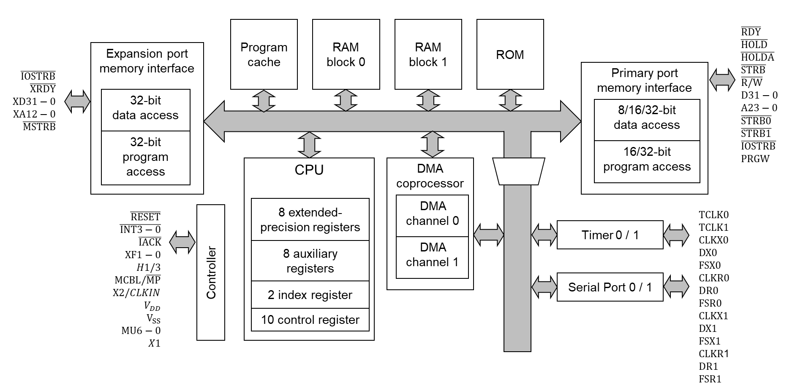

Figure 4.2: Functional block diagram of a TMS320C3x microprocessor

The TMS320C3x is based on a modified Harvard architecture with independent memory banks that allow for two memory accesses within one instruction cycle. Two independent memory banks can be accessed using two independent busses where one memory bank would hold either program while the other memory bank would hold data only. With separate buses for program, data, and direct memory access (DMA), the TMS320C32 can perform concurrent program fetches, data read and write, and DMA operations. The machine instructions of TMS320C32 include the basic operations such as addition, subtraction, and multiplication, and complicated operations such as accumulate, which are used for a number of applications requiring filtering, correlation.

* + 1. **CPU Registers**

The register is a small amount of memory integrated into the CPU that can be quickly accessible to the CPU for machine instruction operations. The TMS320C32 provides 28 registers that are tightly coupled and accessible by the CPUs. All primary registers can be operated upon by the multiplier and ALU and can be used as general-purpose registers. For example, the eight extended-precision registers are especially suited for maintaining extended-precision floating-point results. The eight auxiliary registers support a variety of indirect addressing modes and can be used as general-purpose 32-bit integer and logical registers. The remaining registers provide system functions such as addressing, stack management, processor status, interrupts, and block repeat. The following describes the details of TMS320C32 microprocessor register files:

1. Extended–precision registers (R0 – R7): Eight 40-bit long registers allow generating extended-precision results for floating-point numbers. These registers store 32-bit integer and 40-bit floating-point numbers. The extra bits for floating-point numbers provide more accuracy without risking overflow.
2. Auxiliary registers (AR0 – AR7): The auxiliary registers, which are 32-bit long, are commonly used for generating 24-bit addresses and indirect addressing modes for the instruction sets to be operated. They are also used as loop counters or as 32-bit general-purpose registers that are modified by the multiplier and ALU.
3. Data-page pointer (DP): The eight least significant bits (LSBs) of the data-page pointer are used for the direct addressing mode as a pointer to the page of data being addressed.
4. Index registers (IR0, IR1): The index registers, which is 32-bit long, contain the value used by the auxiliary register arithmetic unit to compute an indexed address.
5. Block Size register (BK): The block size register, which is 32-bit long, is used for circular addressing to specify the data block size.
6. System-stack pointer (SP): The stack pointer, which is a 32-bit register, contains the address of the top of the system stack. The stack pointer always points to the last element pushed onto the stack.
7. Status register (ST): The status register (ST), which is a 32-bit register, contains the global information relating to the CPU state. Operations usually set the condition flags in the status register according to the execution result of the instruction set.
8. Interrupt-enable/flag registers (IE/IF): The interrupt-enable register, which is a 32-bit, register indicates whether CPU or DMA interrupts are enabled or disabled.
9. I/O flag register (IOF): The I/O flag register, which is a 32-bit register, controls the function of the dedicated external pins.
10. Repeat counter/start-address/end-address register (RC/RS/RE): The repeat-counter is a 32-bit register that specifies the number of times to repeat a block of code when performing a block repeat. When the processor is operating in the repeat mode, the 32-bit repeat start-address register contains the starting address of the block of program memory to repeat and the 32-bit repeat end-address register contains the ending address of the block to repeat.
11. Program-counter register (PC): The program-counter register, which is a 32-bit register, contains the address of the next instruction to be fetched by the CPU. Although the program counter is not accessible by the CPU, it can be modified by the instruction such as branching or calling subroutines.
12. Instruction register (IR): Instruction register, which is a 32-bit register, holds the instruction opcode during the decode phase of the instruction.

The above CPU registers are used in the PLC microprocessor to load data from the memory element to registers where it is used for the arithmetic or logical operations and is manipulated by machine instructions. The manipulated data is then often stored back to the memory element, either by the same instruction or by subsequent ones.

* + 1. **Memory Organization**

The memory is an integrated circuit device capable of storing information temporarily in RAM, or permanently in ROM. Memory devices utilize integrated circuits and are used by the operating system software and the application software. Most memory is organized into memory cells or bistable flip-flops, each storing one bit (0 or 1). The total memory space of the TMS320C32 is 16 million 32-bit words. Within this address space, the program, data, and I/O space are contained, allowing the storage of tables, coefficients, program code, or data used by the program. The system stack, which is an abstract data type that serves as a collection of elements, is implemented in the memory. The system stack usually fills from low-memory address to high-memory address.

* + 1. **Addressing Modes**

Addressing modes are one aspect of the instruction set architectures in most CPU designs. The various addressing modes that are defined in a given instruction set architecture define how each machine instruction in that architecture identifies the operands of each instruction. An addressing mode specifies how to calculate the effective memory address of an operand by using information held in CPU registers or constants contained within a machine instruction. TMS320C32 processor supports five addressing modes for accessing data from memory, registers, and the instructions words: (1) register addressing, (2) direct addressing, (3) indirect addressing, (4) immediate addressing, and (5) PC-relative addressing. In this section, each addressing mode is explained with examples.

1. Register addressing mode: In register addressing, CPU registers contain the operand. For example, the instruction:

ADDI R3, R5

adds the two hexadecimal integer operands present in the extended-precision registers R3 and R5. Here, the source is the register R3 and the destination is the register R5. After instruction set execution, the result is stored in the register R5 and the content of the register R3 is unchanged.

1. Direct addressing mode: When operands are specified in memory addressing mode, direct access to main memory, usually to the data segment, is required. To locate the exact location of data in the memory, the segment start address which is found in the data-page pointer register and an offset value is required. In direct addressing mode, the 16 LSBs of the instruction code and the 8 LSBs of the data-page pointer are combined to form the 24-bit address of the data operand present in the data memory space. For example, the instruction:

LDI 80, DP

ADDI @1000h, R4

adds the two hexadecimal integer operands present in the registers R4 and in the memory address 0x801000. Here, the source refers to the memory address 0x801000 and the destination is the register R4. After instruction set execution, the result is stored in the register R4 and the content in the memory space is unchanged.

1. Indirect addressing mode: In indirect addressing mode, the address of an operand in memory is specified through the contents of an auxiliary register, optional displacements, and index registers. The instruction code format of the indirect addressing mode [228] is given in Figure 4.3. It consists of three field, modification (mod), auxiliary register (ARn), and displacement (disp) fields. The 5-bit modification field specifies the type of indirect addressing such as indirect addressing with pre-displacement add and indirect addressing with post-displacement subtract and modify. The 3-bit ARn field specifies the content of auxiliary register that is used as the operand address. The 24 LSBs of auxiliary register are used to specify the address and the rest of the bits are not modified by the instructions. A displacement field indicates either an explicit unsigned 8-bit integer contained in the instruction word or implicit displacement of 1. Two index registers (IR0 and IR1) can also be used in indirect addressing. For example, the instruction:

SUBI *AR2++(4), R6

subtracts the integer operand present in the data memory location pointed by AR2 from the content in the register R6. The result is stored in the destination, which is the register R6. Here, the syntax of the indirect addressing mode is defined as the indirect addressing with post-displacement add and modify. After subtraction, the new content of the register AR2 is changed to the sum of displacement and the old content in the register AR2.

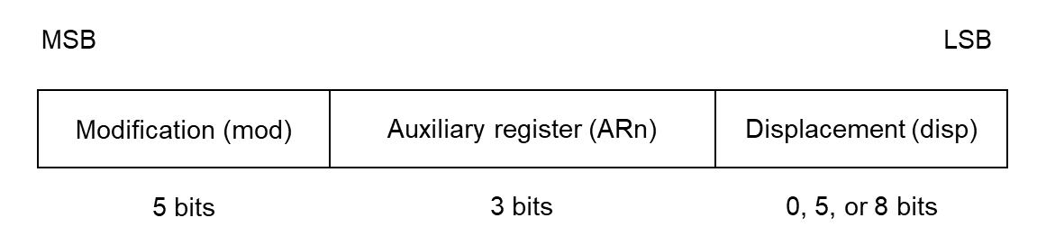

Figure 4.3: Encoding of TMS320C32 indirect addressing mode

1. Immediate addressing mode: In immediate addressing mode, the operand is given as a 16-bit (short) or 24-bit (long) value contained in the instruction word. Depending on the data types assumed for the instruction, the short-immediate operand can be either an integer or a floating-point number. For example, the instruction:

LDI 1000h, R7

loads an immediate value of 0x1000 to the register R7.

1. PC-relative addressing mode: Program counter-relative addressing is mostly used for branching. It adds the contents of the 16 or 24 LSBs of the instruction word to the register PC. The assembler takes the src (a label or address) and generates a displacement. For example, the instruction:

BR 8000h

loads an immediate value of 0x8000 to the program counter register PC and program branches to the program memory address of 0x8000.

* + 1. **Microprocessor Instruction Sets**

The instruction set is a part of a microprocessor that pertains to programming. The instruction set provides commands to the processor to instruct it what it needs to do. The general instruction syntax format of TMS320C32 microprocessor [228] is as follows:

INST src, dst

INST1 src2, dst1 || INST2 src3, dst2

Each instruction begins with an assembler syntax expression. The syntax examples illustrate the common one-line syntax for single addressing and parallel addressing. Note that the two vertical bars indicate a parallel addressing pair and can be placed anywhere before the mnemonic. The operands (src, src2, src3, dst, dst1, dst2) are defined according to the addressing mode and the type of addressing used. Figure 4.4 shows encoding examples using general addressing and parallel addressing for TMS320C32 microprocessor. The 7 or 9 most significant bits (MSBs) refer to the opcodes which are specific to each instruction set and others bits are dedicated to the addressing mode and operands.

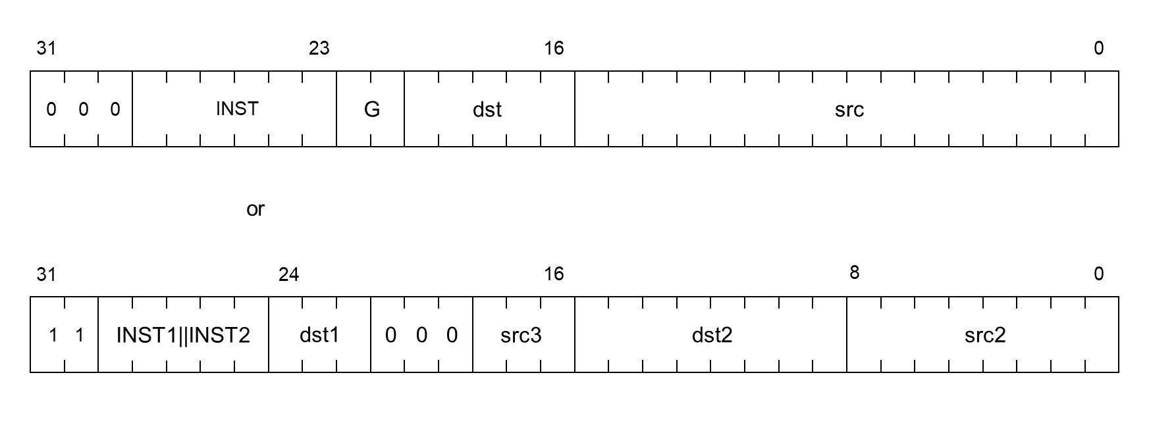

Figure 4.4: An example of TMS320C32 instruction set encoding

The instruction set of TMS320C32 contains a total of 118 instructions that can be categorized into six types according to their function. All instructions are a single machine word long (32-bit) and most instructions require one cycle to execute. Appendix A shows a full list of instruction sets includes its syntax, description, operation, and operands. In this Section, various types of TMS320C32 instruction sets are explained with examples.

1. Load and store operation: Load and store instructions can load a 32-bit word from memory into a register or store it from a register into memory or manipulate the data on the system stack. For example, the two instructions:

LDI @IN_ADDR, AR1

STF R0, *AR2++

load directly the address represented by a label IN_ADDR into the auxiliary register AR1 by LDI instruction, then stores a floating-point value in the register R0 into memory, whose address is specified by the register AR2 by STF instruction. Then, the register AR2 is post-incremented to point at the next-higher memory address (a displacement of one by default).

1. 2-operand arithmetic/logical operation: 2-operand arithmetic and logic instructions conduct basic calculation such as addition, subtraction, multiplication, shift, and rotate. The source operand can be a memory word, a register, or a part of the instruction word. The destination operand is always referred to a register. For example, the two instructions:

ADDI *AR4++(5), R1

MPYI R1, R2

add the integer operand present in the data memory address location pointed by the register AR4 with the integer content saved in the register R1 by ADDI instruction. The calculation result is then stored in the register R1 and the new address content of the register AR4 is updated as the sum of the old content and the displacement which is five. Then, the integer operand present in the register R1 is multiplied with the content of the register R2 and the result is stored in the register R2 by MPYI instruction.

1. 3-operand arithmetic/logical operation: Whereas 2-operand instructions have a single source operand and a destination operand, 3-operand instructions can have two source operands and a destination operand. Source operands can be a memory word or a register. The destination of a 3-operand instruction is always a register. For example, the instructions:

ADDF3 R0, R2, R1

MPYF3 *AR0++, *AR1++, R0

add the floating-point values in registers R0 and R2 and stores the resulting floating-point value in the register R1 by ADDF3 instruction. Replacing the instruction ADDF3 by SUBF3 would subtract the register R0 from the register R2, with the result stored in the register R1. The MPYF3 instruction multiplies the content in the memory (indirect addressing) with the address specified or pointed by the register AR0 by the content in memory whose address is specified by the register AR1 and stores the resulting floating-point value in the register R0. After the instruction execution, both auxiliary registers AR0 and AR1 are post-incremented by one (by default) or to the next-higher memory address.

1. Program control operation: Program control instruction group consists of the instruction sets which affect the program flow. Such instruction sets include the standard and delayed branch instructions, call and return instructions, and repeat instructions. Certain program control instructions support both conditional and unconditional operations. For example, the instruction:

LDI 10, RC

RPTB END_BLK

CALL FILTER

FIX R0, R1

END_BLK STI R1, *AR5

the starting address (address of RPTB instruction) of the code block to be repeatedly executed is loaded into a special repeat start address register RS and the ending address specified by the label END_BLK is loaded into the special repeat end address register RE. The repeat counter register RC is loaded first with the number of times the block of code is to be repeated. The code block starting with the CALL instruction and the STI instruction is executed 11 times (repeated RC = 10 times). Within this code block, a subroutine FILTER is called 11 times.

1. Interlocked operation: Interlocked operations are used to implement a busy-waiting loop, to manipulate a multiprocessor counter, to implement a simple semaphore mechanism, or to perform synchronization between two devices. This is commonly used for the application which uses multiple processors in the microprocessor sharing global memory. The interlocked operations use the two external flag pins, XF0 and XF1. For example, instructions:

LDII @COUNT, R1 ; Interlock begin

; Contents of COUNT → R1

SUBI 1, R1 ; Decrement R1

STII R1, @COUNT ; Update Count

; Interlock end

a COUNT contains a count of the number of times a particular operation must be performed. This operation may be performed by any processor in the system. If the count is 0, the pin XF0 is set to 0 (signals an interlock operation request) and the processor waits until it is nonzero before beginning processing. The STII instruction sets the pin XF0 to 1 and begins a write cycle.

1. Parallel operation: The parallel operation instructions offer parallel loading of registers, parallel arithmetic, or logical operations. The syntax is defined with two vertical symbols between the instructions and each instruction in a pair is entered as a separate source statement. For example, the instruction:

MPYF *AR0++, *AR1++, R0

|| ADDF3 R0, R2, R2

multiplies the content in the memory with the address specified or pointed by the register AR0 by the content in memory whose address is specified by the register AR1 and stores the resulting floating-point value in the register R0 by MPYF3 instruction. The content in the register R0 is then added with the register R2 by ADDF3 instruction and the resultant is saved in the register R2. The instruction is performed in parallel and all registers are read at the beginning and loaded at the end of the instruction execution cycle.

* 1. **Development of Simulation-based Software Test-bed**

In order to simulate the PLC software behavior given the states of software input and internal variables and to check whether the correct output is generated by the application software, a software test-bed is developed that captures both the architectural (e.g., CPU and memory architecture) and operational (e.g. assembly language instruction, addressing modes) aspects of the target PLC. In this study, the PLC software test-bed for the NPP safety software testing in machine language level is developed based on the available information on the target microprocessor (TMS320C32) [122], [228] and the PLC (POSAFE-Q) [108], [231] described in Section 4.3. The test-bed is developed in C code, which allows dynamic memory allocation and management that are essential for emulating the PLC microprocessor architecture. The development and compilation environment of the developed test-bed follows ANSI C standard [232]. In the following sections, the detailed requirements, the I/O structure, and the design of the PLC software test-bed are described.

* + 1. **Functional Requirements of the Software Test-bed**

Before the test-bed development, the requirements of the software test-bed are defined in consideration of testing PLC application software. Based on the requirements, the test-bed is designed and later verified whether the software test-bed works as initially designed. In this section, the functional requirements of the software test-bed are described as follows:

1. The test-bed must emulate the basic PLC microprocessor architecture that is used to execute the application software running on PLC such as CPU register and memory map and its operation such as instruction set decoding and execution.
2. The test-bed must emulate the basic operation of the PLC microprocessor which includes the process of [80], [228]: (1) fetch an instruction from the program memory unit, (2) read and decode the instruction, and (3) execute the instruction.
   * The test-bed must read the PLC executable code given by the user that is written in 8-bit hexadecimal (32-bit binary) format and write the program to the emulated memory map. At each instruction line, the next instruction must be fetched by the address stored in program counter register and the instruction fetching continues until the termination instruction is read.
   * The test-bed must read the application software formatted in 8-bit hexadecimal (32-bit binary) assembly and decode to its specific syntax and its related operands of the instruction set. The effective address given in instruction depending on the addressing mode must be read from the CPU registers or the memory and required data must be obtained.
   * The test-bed must access and read the contents in the source operands defined by the effective address either from CPU register or memory map, execute the operation of the instruction set and update the result to the destination operands.
3. The test-bed must conduct the software testing based on the input files provided by the tester such as test setting, test case files, and expected output files. In addition, the test-bed must analyze the test result after the program is executed until the program termination by the PLC emulator.
   * The test-bed must read the test setting file to set up various aspects of testing such as PLC executable codes to be loaded and the test start/end address.
   * The test-bed must read the test case file which specifies the memory address and values to be tested for PLC software testing and reflect it to the emulated PLC memory map in the test-bed.
   * The test-bed must save the final state of the PLC architecture, including CPU registers and memory map after the program execution is terminated.
4. The test-bed must analyze the test result and save it as a test output file.
   * Based on the expected output files given by the tester, the test-bed must be able to compare the final state of the PLC architecture with the expected output given by the tester by checking whether the same output was generated by the application software or not after the program is executed.
   * The test-bed must generate the test output file showing which test cases generated correct output or wrong output compared to the expected output file.
     1. **I/O Structure of the Software Test-bed**

As described in the functional requirements of the test-bed, the test-bed requires various files to conduct the test for NPP PLC safety software. The input files for the test-bed include: (1) the executable code of PLC application software which includes 32-bit long machine code compiled from the original FBD program by PLC software engineering tool, (2) the test setting file which includes various test setups such as test start and end address and test file directory, (3) the test case file which specifies test cases including the memory address and values for software input and internal variables to be tested, (4) the expected output file which includes the memory address and its expected values for specific software output variables, and (5) the test execution file which includes command arguments for test-bed executable. The output file for the test-bed includes the test result file which describes the detailed output for each test case and the summary for all test cases. The description for each input and output file of test-bed is as follows:

1. Executable code of PLC application software: The PLC software written in FBD/LD language is translated to intermediate C or Verilog code and then compiled to the assembly language or executable code in 32-bit long binary format. The PLC program file or executable code includes the program file which includes the actual application software to be executed by the microprocessor as shown in Figure 4.5-(a) and the constant file which includes the constants used by the application software as shown in Figure 4.5-(b). Both program and constant files contain the memory address and the value to be stored in the specific address in hexadecimal format. This format of the program file is commonly used by a typical PLC software engineering tool including the pSET for POSAFE-Q PLC programming and implementation.

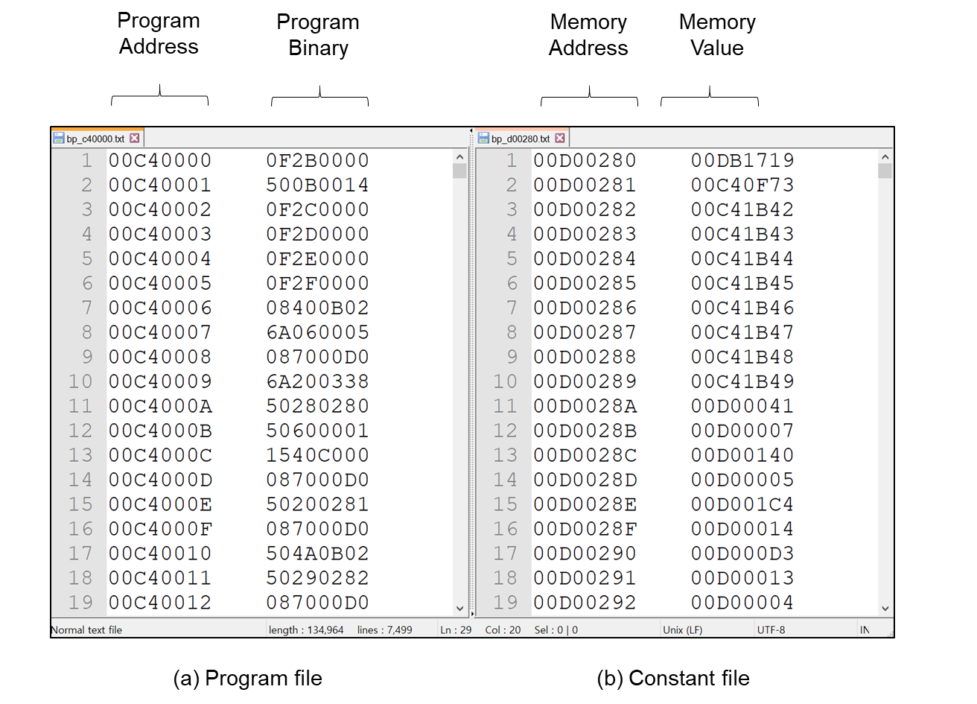

Figure 4.5: Input file of PLC software test-bed – PLC program file

1. Test setup file: In order to conduct testing on the executable code of PLC application software, it must be specified which executable code is tested and what is the characteristics of the code such as its program length and initial values in the memory before conducting testing. The test setup file contains eight cards to be specified, as shown in Figure 4.6 and the description for each card is as follows:
   * Program file (card 1): specifies the name of the program file of the executable codes to be tested.
   * Program size (card 2): specifies the length (line number) of the program file of the executable codes to be tested.
   * Program init – start address (card 3): specifies the start address of the initialization subroutine of the program file of the executable codes to be tested.
   * Program init – end address (card 4): specifies the end address of the initialization subroutine of the program file of the executable codes to be tested.
   * Program main – start address (card 5): specifies the start address of the main subroutine of the program file of the executable codes to be tested.
   * Program main – end address (card 6): specifies the end address of the main subroutine of the program file of the executable codes to be tested.
   * Constant file (card 7): specifies the name of the constant file of the executable code to be tested.
   * Memory setup (card 8): specifies the initial status of the memory address and value to be written in the memory map emulated in the test-bed before the executable code is executed.

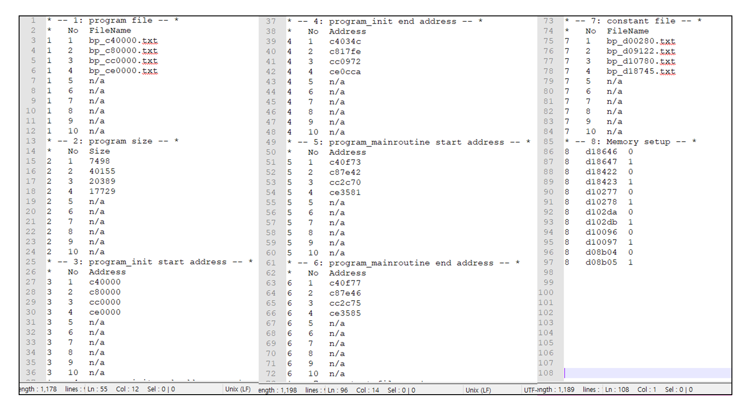

Figure 4.6: Input file of PLC software test-bed – test setup file

1. Test case file: For the testing of the PLC application software, the states of the software input and internal variables to be tested must be specified. Each software input and internal variable is saved as 32-bit format in the specific area of PLC memory map. The test case file contains the information on the memory address and the value in the address for each software variable. Figure 4.7 shows the example of the test case file. Each column of the file indicates a software input or internal variable to be tested and Each line of the file indicates a single test case to be tested. The first line (or row) indicates the memory address of the specific variable in hexadecimal format. Other lines from the second line indicate the specific value inside of each address. It is notable that the values in each row is different from each other meaning each test case is exclusive to each other.

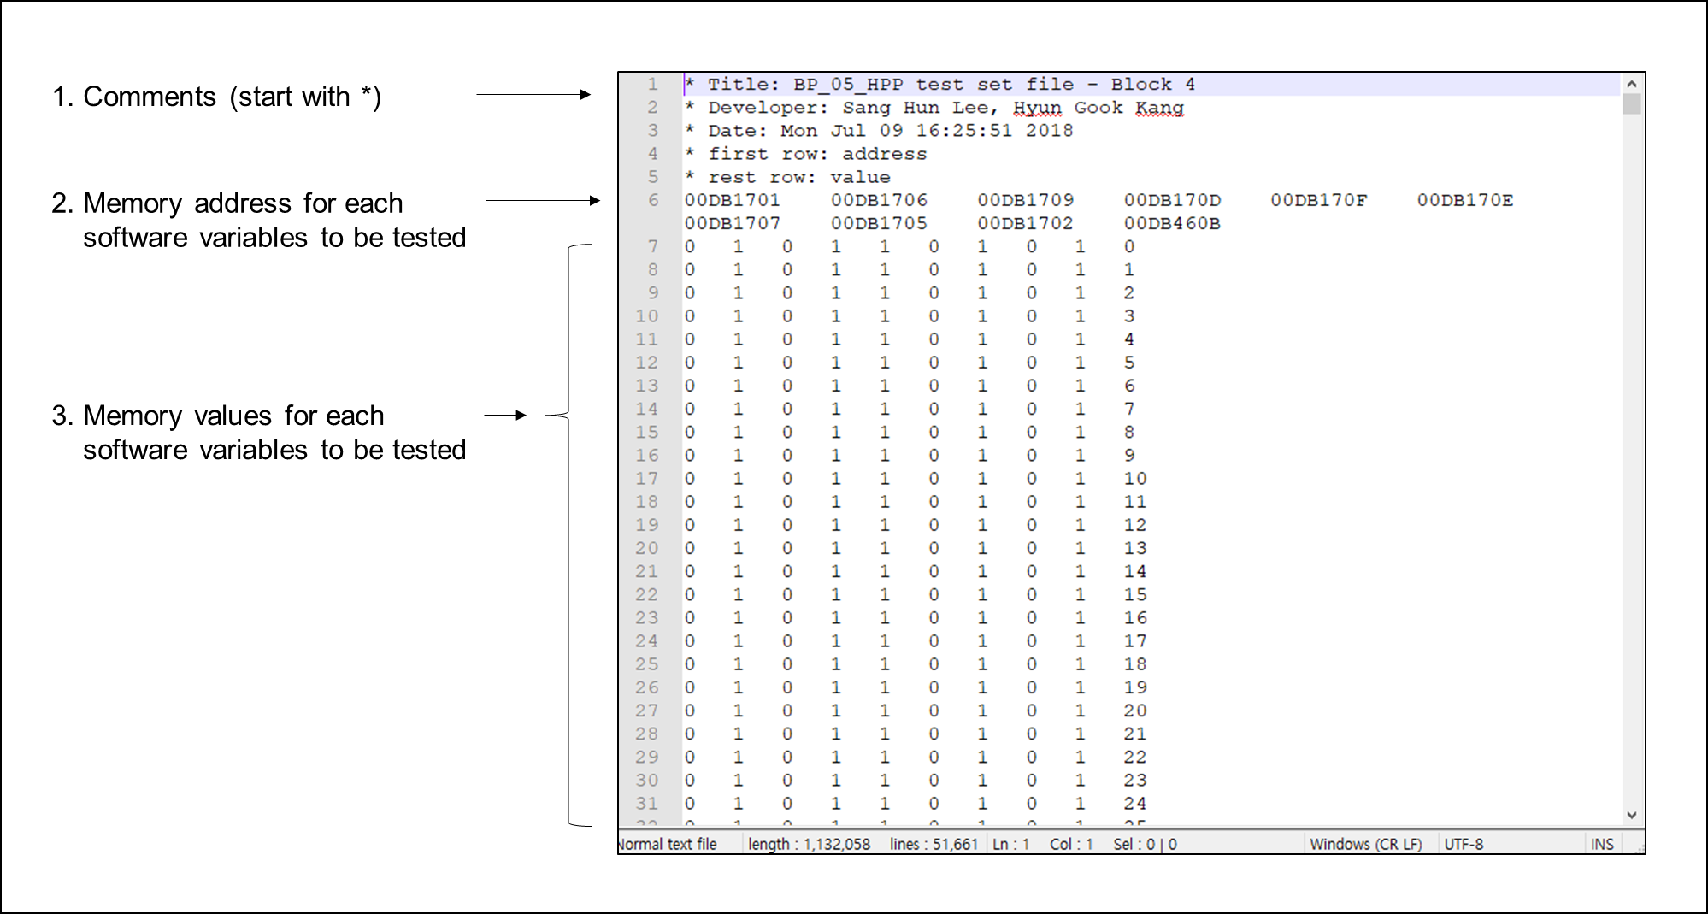

Figure 4.7: Input file of PLC software test-bed – test case file

1. Expected output file: The PLC software test-bed must analyze whether the software generated correct output for the software output being tested to generate the test result for the tester to review and debug if there is any test case that generated the wrong output. For this reason, the expected output must be provided, which is compared with the software output after the executable code is executed until its termination. Figure 4.8 shows the example of the expected output file, which contains the memory address and value to be compared. The type indicates whether a 32-bit integer is compared or a specific bit value when comparing the outputs. The expected value specifies the value that is expected in the specific memory address.

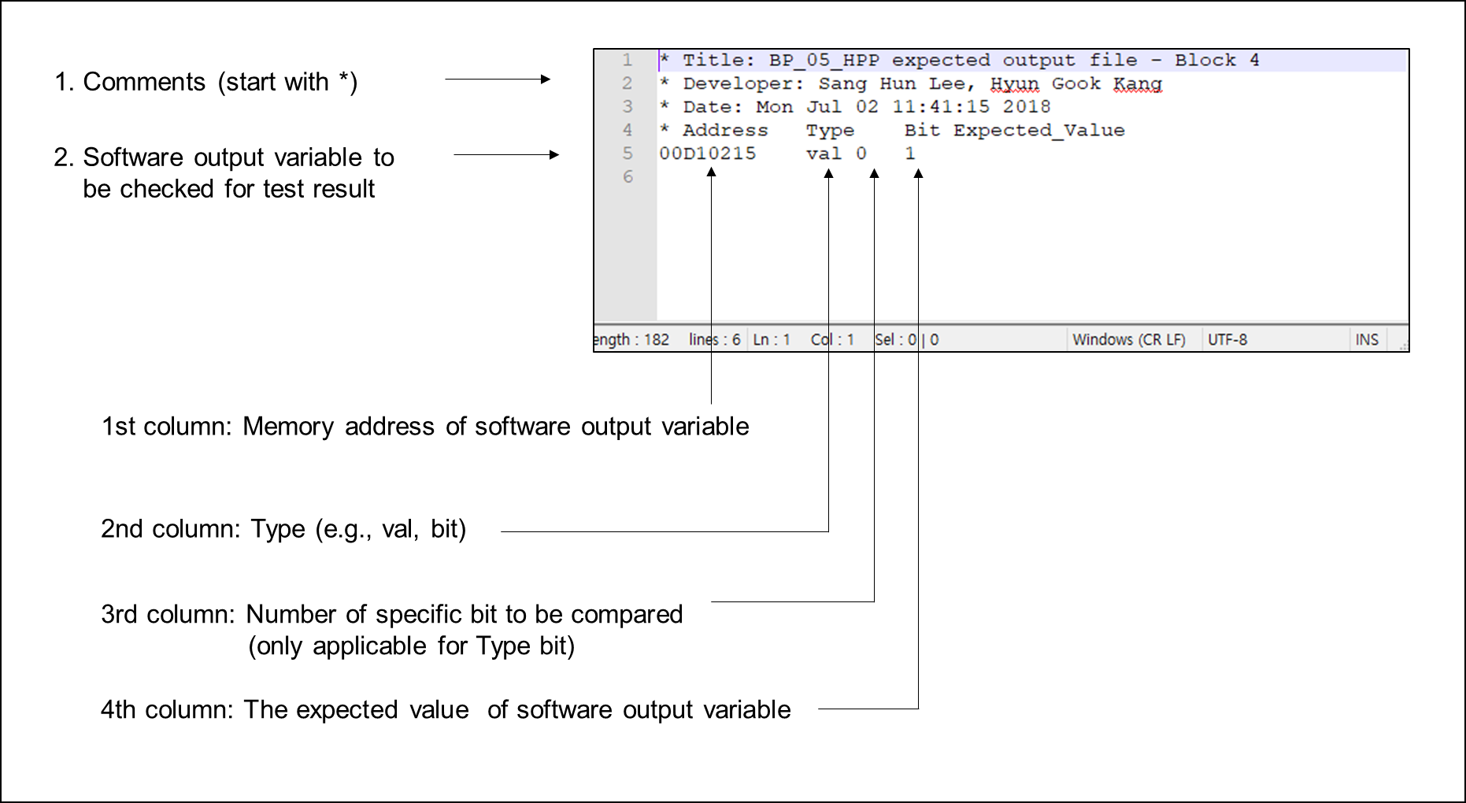

Figure 4.8: Input file of PLC software test-bed – expected output file

1. Test execution file: The test execution file specifies the address of the software test to be started and terminated. Figure 4.9 shows an example of the test execution file. The software test-bed is compiled to executable code that can be executed in the command window; therefore, the thread number and the name of software test-bed file in executable form are specified in the test execution file. The name of the folder that contains the test case file and expected output files are also specified in the test execution file. As the software test-bed tests the compiled machine code of the PLC application software, the start and end address of the software testing is specified. Then, the test starts from the test start address and continues until the value in the program counter register equals to the test end address.

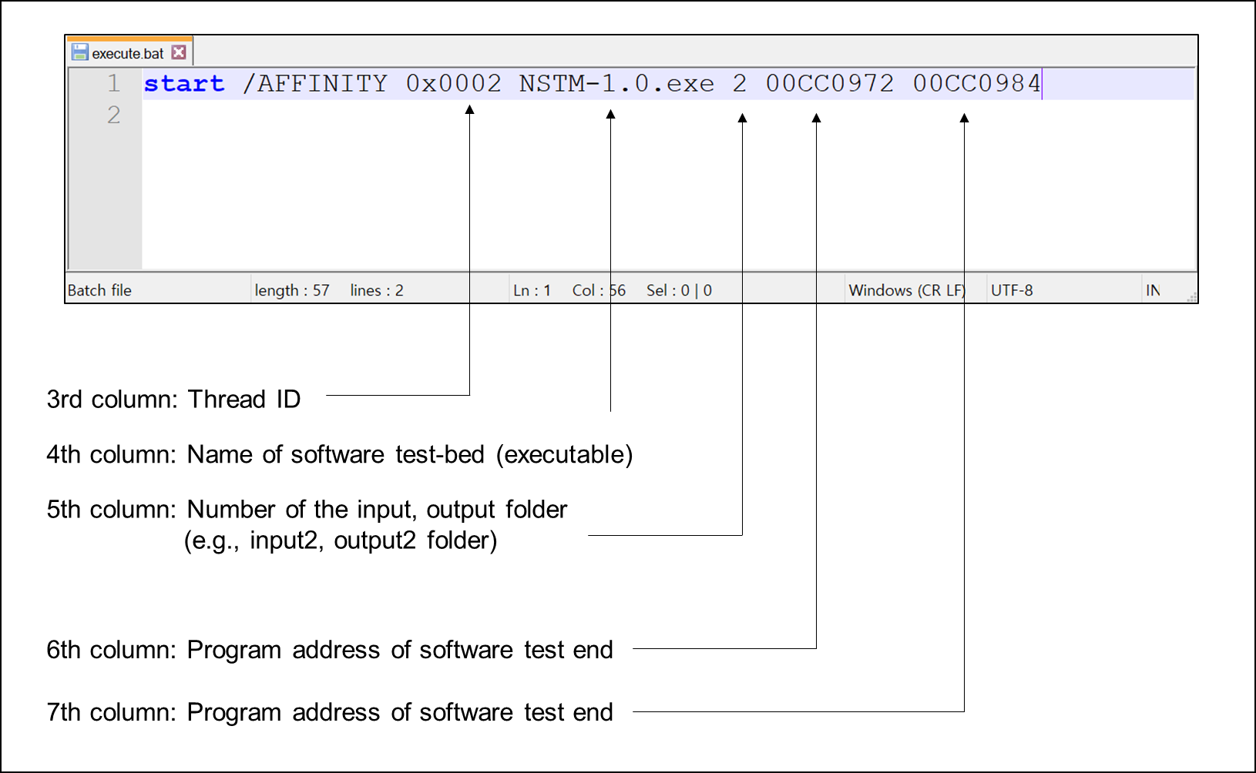

Figure 4.9: Input file of PLC software test-bed – test execution file

1. Test result file: The software test-bed must report the test result by comparing the value of the specific software output generated by the software and the expected output value. Based on the test result, the test-bed generates the test result file which contains the result generation date and time, the detailed output for each test case which shows the value of each software input and internal variables defined in the test case file and the value of each software output defined in the expected output file. Finally, the summary of the test result is reported which shows the total number of the correct output cases which the PLC application software generated the same output compared to the expected output and that of the wrong output cases which the application software generated the different output. Figure 4.10 shows an example of the generated test output file by the test-bed.

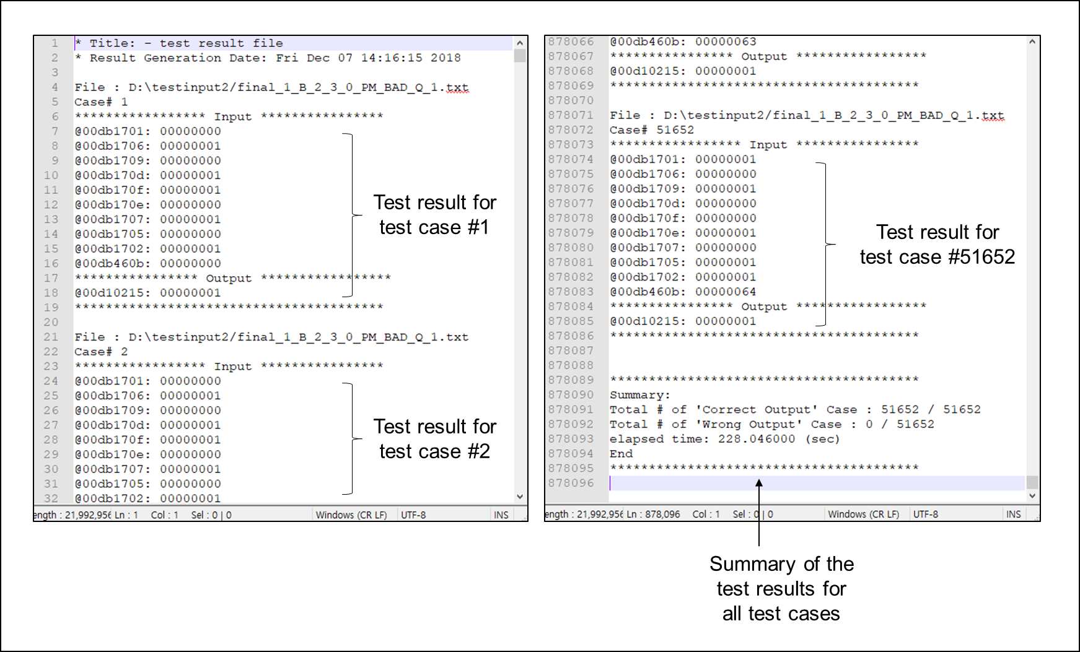

Figure 4.10: Input file of PLC software test-bed – test result file

* + 1. **Design of Software Test-bed**

The test-bed development consists of designing the overall functionality of the TMS320C32 emulator including the microprocessor architecture and the instruction sets and designing the software testing procedure such as the way the test-bed reads the input files required for software testing and output file for reporting test results described in Section 4.4.2. The PLC emulator is a part of the test-bed and the test-bed processes and passes the input files to the PLC emulator which moves them to the memory and executes the program. Figure 4.11 describes the high-level architecture of the test-bed operation. The test-bed consists of four different modules: (1) *Architecture module* which emulates the major components of the safety PLC microprocessor such as CPU registers and memory map, (2) *Assembler module* which decodes the PLC application software that contains binary-coded instructions and interpret the syntax of the instruction sets and the related source and destination operands to be processed for each line of machine code, (3) *Emulation module* which emulates the operation of a total of 118 instruction sets of TMS320C32 microprocessor described in Section 4.3.5 such as arithmetic/logical operations and load/store operations, (4) *Test module* which reads input files, writes the test cases to the emulated memory map, passes files to other modules for executing the PLC application software and generates the test result by comparing the software output to the expected output. The following sections describe the design and implementation of each module of software test-bed.

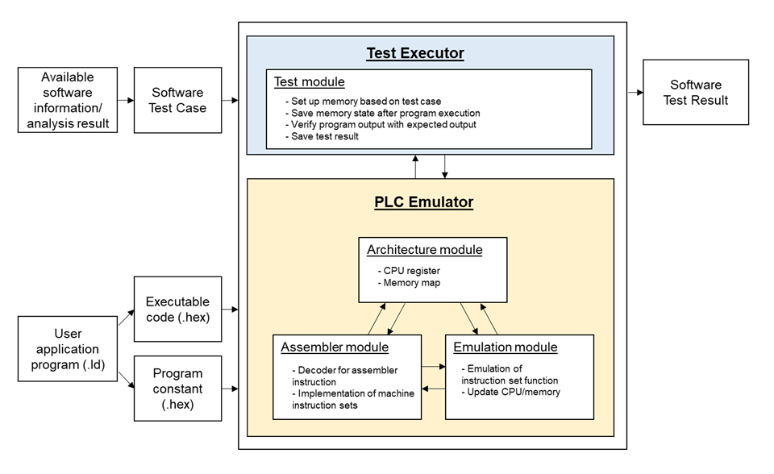

Figure 4.11: An overview of the simulation-based test-bed for PLC software testing

* + - 1. *Architecture Module*

The major components of the safety PLC microprocessor, such as 40-bit extended registers, 32-bit other registers, and 16Mbyte 32-bit word memory units that are accessible to the CPU, are emulated in the *Architecture module*. Within the 16Mbyte word address space, the program, data, and I/O space are contained, allowing the program code or data of the user application software to be stored in the memory map. Figure 4.12 shows the basic architecture of TMS320C32 microprocessor emulated in the test-bed.

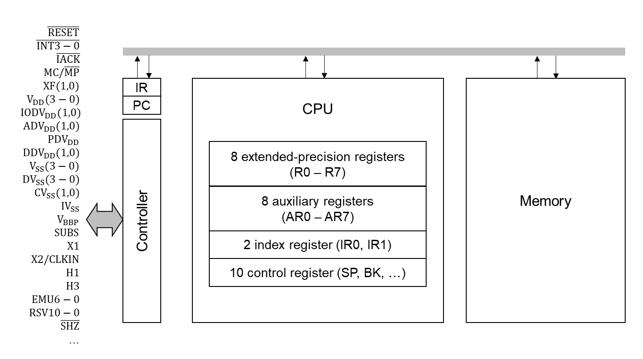

Figure 4.12: An overview of the simulation-based test-bed for PLC software testing

The registers are used to temporarily store the information in binary format and the information stored in registers is then processed by the microprocessor. For example, the eight extended-precision registers are especially suited for maintaining extended-precision floating-point results. The eight auxiliary registers support a variety of indirect addressing modes and can be used as general-purpose 32-bit integer and logical registers. The remaining registers provide system functions, such as addressing, stack management, processor status, interrupts, and block repeat. In the test-bed, the extended-precision registers whose length is 40-bits are modeled as 64-bit unsigned integer type variable and other registers whose length is 32-bits are modeled as 32-bit unsigned integer type variable. Depending on the signed or unsigned operations and integer or floating-point operations, the hexadecimal unsigned value inside the registers is interpreted to corresponding data types.

The memory is used to save data such as program, I/O data space of the PLC application software and is accessed by the microprocessor to process and store the data in the specific area in the memory map. In the test-bed, the memory map is emulated by the dynamic allocation of a total memory block with a size of 16Mbyte 32-bit words. Table B.1 shows the subroutines defined in the *Architecture module* to get or set the value of a register or memory map and to perform computations. Figure 4.13 shows the source code of how the PLC microprocessor is emulated in the simulation-based software test-bed.

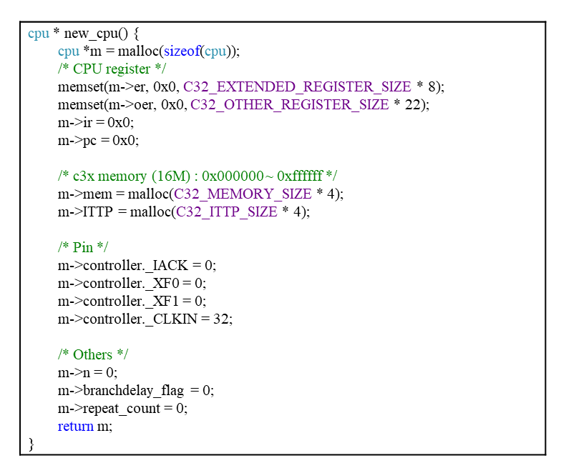

Figure 4.13: A part of CPU register and memory map emulation in Architecture module

Figure 4.14 shows a CPU register and memory read and write operations emulated in the test-bed. When executing the PLC application software, the microprocessor reads the value of the operands from its effective address which is usually from the CPU registers or the memory map by *readreg* or *readmem* subroutines depending on the types of data to be loaded. After instruction set execution, the result is updated to the CPU registers or the memory map by *writereg* or *writemem* subroutines depending on the types of data to be saved. For example, assume that the microprocessor executes the instruction set (ADDF @8098A1, R1) which loads the floating-point numbers for the source operand (memory address of 0x8098A1) and the destination operand (the register R1) and adds two values and overwrites the contents in the register R1 with the calculation result. The test-bed emulates this process by: (1) loading the hexadecimal numbers stored in register R0 and the hexadecimal numbers stored in the memory address of 0x8098A1, (2) converting hexadecimal numbers from the register and memory address by *readreg_float40()* and by *readmem_float32()*, respectively, and (3) saving the operation result to the destination operand (register R1) by converting the calculation result into appropriate format, either 40-bit or 32-bit format depending on the destination address.

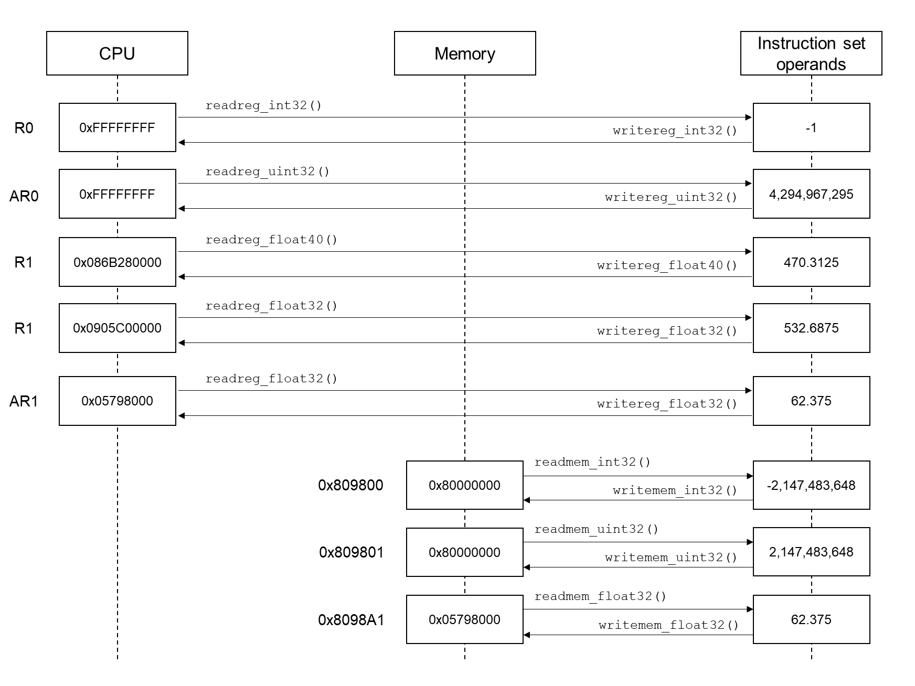

Figure 4.14: Read and write operation of CPU register and memory map

* + - 1. *Assembler Module*

A basic instruction execution of the PLC microprocessor has four cycles: (1) fetch, (2) decode, (3) read, (4) execute. During the decode stage, the fetched instruction in a binary format is interpreted by the decoder. Each instruction set has its specific instruction opcodes and the encoding of each instruction set is different. For example, Figure 4.15 shows the encoding of ADDF and ADDF3 instruction set. Each cell in a row indicates the value of the specific bit of machine code in binary format. In general, the instruction opcode is defined at bits 31 to 23 and the instruction opcode for ADDF and ADDF3 is ‘000000011’ and ‘001000001’, respectively. Each instruction set has specific bit locations dedicated to the addressing modes (e.g., register, direct, indirect, immediate addressing mode) and the destination and source operands (either from register or memory).

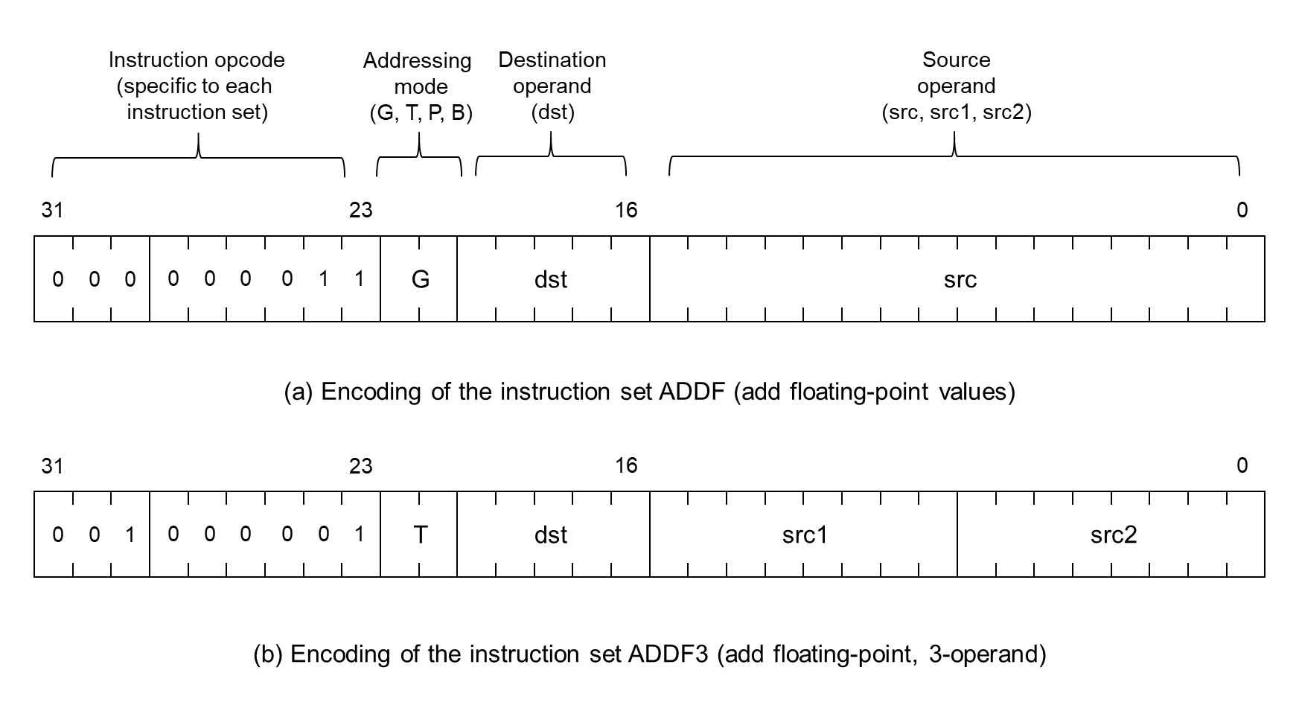

Figure 4.15: Process of decoding binary code into the instruction set

Based on the encoding of each instruction set, the *Assembler module* in the test-bed decodes the 32-bit long binary machine code of PLC application software which involves: (1) read fetch the instruction at the first line of the machine code, (2) decode the 8-digit hexadecimal machine code compiled from the PLC software engineering tool to 32-bit binary code, (3) match the instruction opcode with the TMS320C32 opcode library, (4) define the addressing mode and operands depending on the addressing modes, and (5) save the decoded result which contains the syntax (e.g. ADDF, ADDF3), the addressing mode (e.g. register addressing mode), the source and destination operands (e.g., R0, AR0). After decoding for the instruction at the current program counter is finished, the decoder in *Assembler module* goes to the next line of machine code and iterates the decoding process. Figure 4.16 shows the diagram of the decoding process implemented in the *Assembler module* in the software test-bed.

In the implementation, the *Assembler module* opens the machine code file of the PLC application software and decode to binary format. Based on the binary code, it finds a specific instruction set that matches the instruction opcode (bits 23 – 31) and generates source and destination operands which are defined depending on each instruction set and addressing modes. The result is saved in the internal data structure, which *Emulator module* (described in Section 4.4.3.3) uses when executing each instruction set. In the *Assembler module*, the syntaxes of a total of 118 instruction sets are defined to decode each line of PLC application software to its specific machine instruction. Figure 4.17 shows the implementation of the decoding logic in the *Assembler module* of the test-bed.

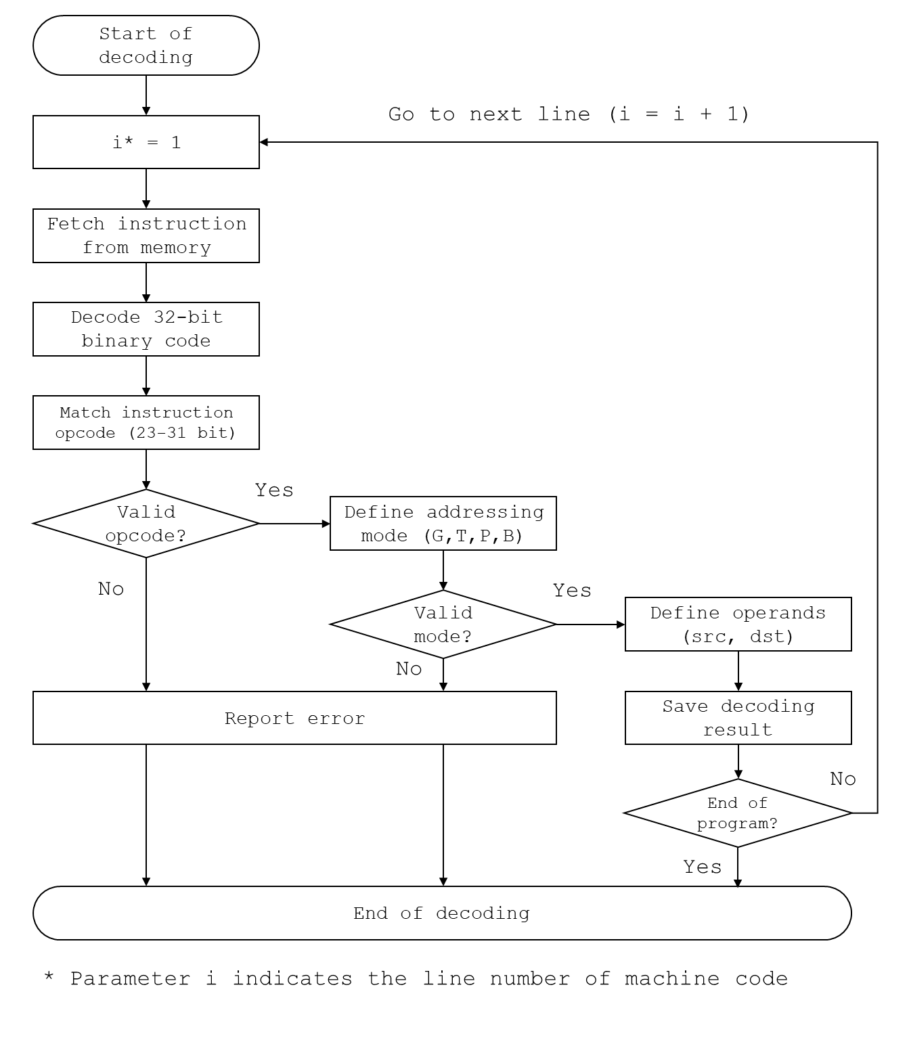

Figure 4.16: Process of decoding binary code into instruction set by Assembler module

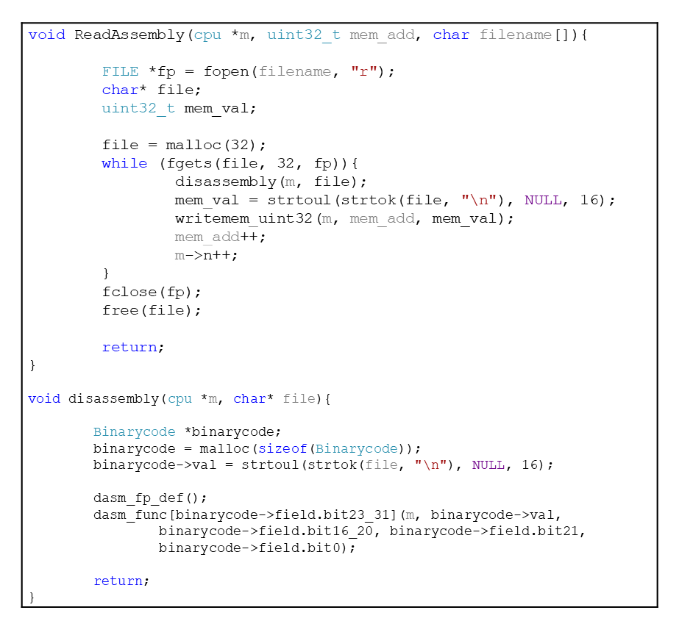

Figure 4.17: A part of machine code decoder in Assembler module

* + - 1. *Emulation Module*

Based on the instruction set decoded from the binary program file by the *Assembler module*, the operands of the instruction set are read from register files or memory map and the specific operation of the instruction set is performed. After executing the instruction, the operation result is written to the destination (to register files or memory map). Based on the operation result, the CPU registers, such as the system stack and the condition flags stored in the CPU status register, are updated. The status register contains the global information about the CPU state, such as carry flag (C), overflow flag (V), zero flag (Z). The condition flags of the status register are updated based on the instruction set operation result whether the result is 0 or negative.

Figure 4.18 shows an emulated operation of the LDI instruction. As shown in the description of TMS320C3x user’s guide [228] and in Appendix A, the function of LDI instruction is to load the content in the source operand and overwrite to the destination operand. Based on the operation description, the code was developed to read the content in the source operand (denoted as the variable *val_src* in the code) depending on the addressing mode (i.e., ‘00’, ’01, ‘10’, ‘11’ in binary format) and write the content to the destination operand (denoted as *val_dst* in the code). The calculation result is checked whether a negative result or zero result is generated and updates the condition flags in the status register. For example, if a zero value was in the source operand and loaded to the destination operand, the zero flag (Z) which is in the 3rd bit of status register is updated from zero to one, i.e., the value of status register changes from 0x0 to 0x3.

For each of the emulated operation of a total of 118 instruction sets of TMS320C3x microprocessor in the *Emulation module*, the effective address of the source and destination operand must be computed especially for both direct and indirect addressing mode. While the register and immediate addressing mode directly specifies the source or destination operands as either register or constant, the source or destination operands are indirectly referred to the specific memory address by the base, index, or displacement for direct and indirect addressing mode. For direct addressing mode, the data address is formed by concatenating the eight LSBs of the data-page (DP) register (acts as base and denoted as *page* in Figure 4.19) and the 16 LSBs of the instruction (acts as displacement and denoted as *expr* in Figure 4.19). In the test-bed, the content in the data-page pointer is added with the displacement defined in the instruction code to make the effective address and the operands are determined by reading the value in the memory address which the effective address is pointing at.

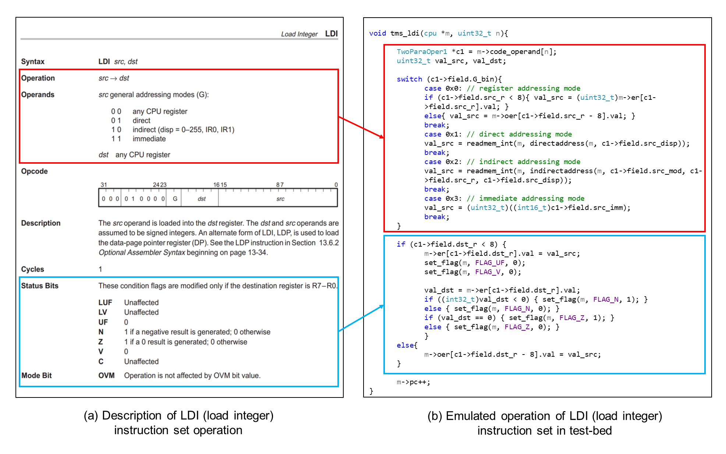

141

Figure 4.18: An example of instruction set operation emulation in Emulator module

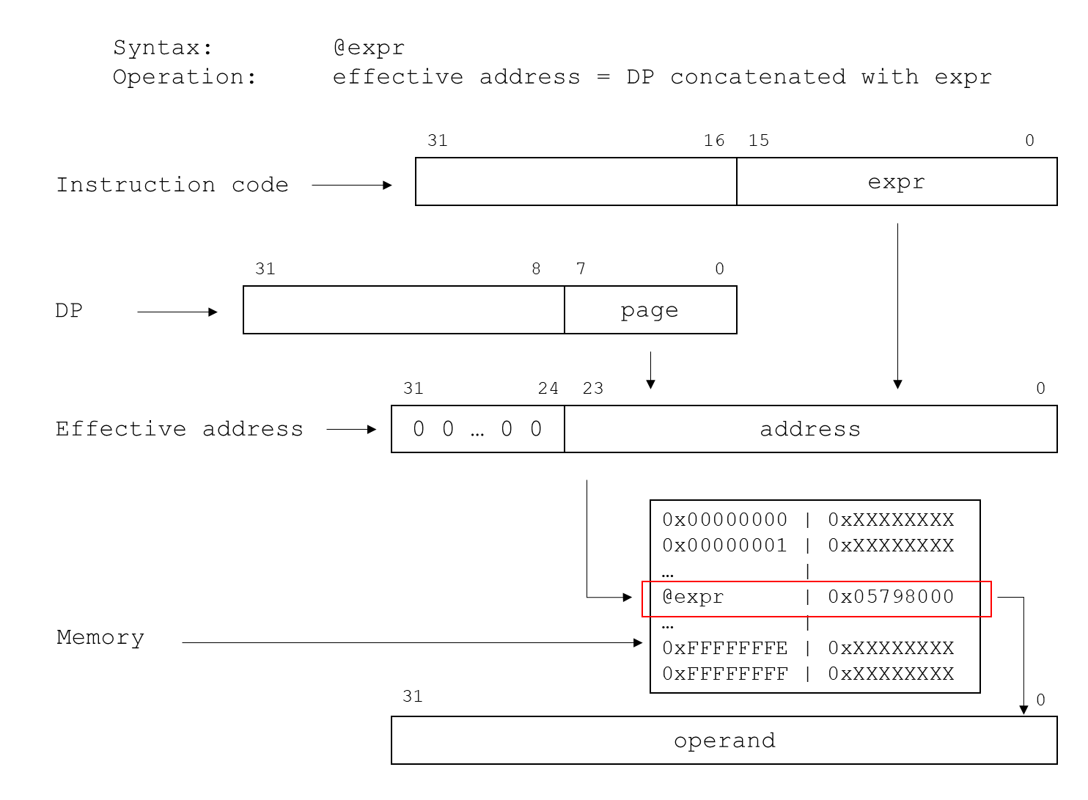

Figure 4.19: Direct addressing mode of TMS320C32 microprocessor

The indirect addressing mode specifies the address of an operand in memory through the contents of an auxiliary register, optional displacements, and index registers. There are 26 different indirect addressing modes and each addressing mode is defined with different modification (*mod*) field and the effective address is calculated based on the contents in the auxiliary register (*ARn*) and the displacement (disp). Figure 4.20 shows the example of retrieving the operand using indirect addressing with pre-displacement add. The address of the operand to fetch is the sum of an auxiliary register (ARn) and the displacement. The displacement is either an 8-bit unsigned integer contained in the instruction word or an implied value of 1. In the test-bed, the source or destination operand part of the instruction code is first decoded to determine the modification, auxiliary register, displacement field, and the effective address is calculated depending on different modification field. The operands are determined by reading the value in the memory address which the effective address is pointing at, as shown in Figure 4.21.

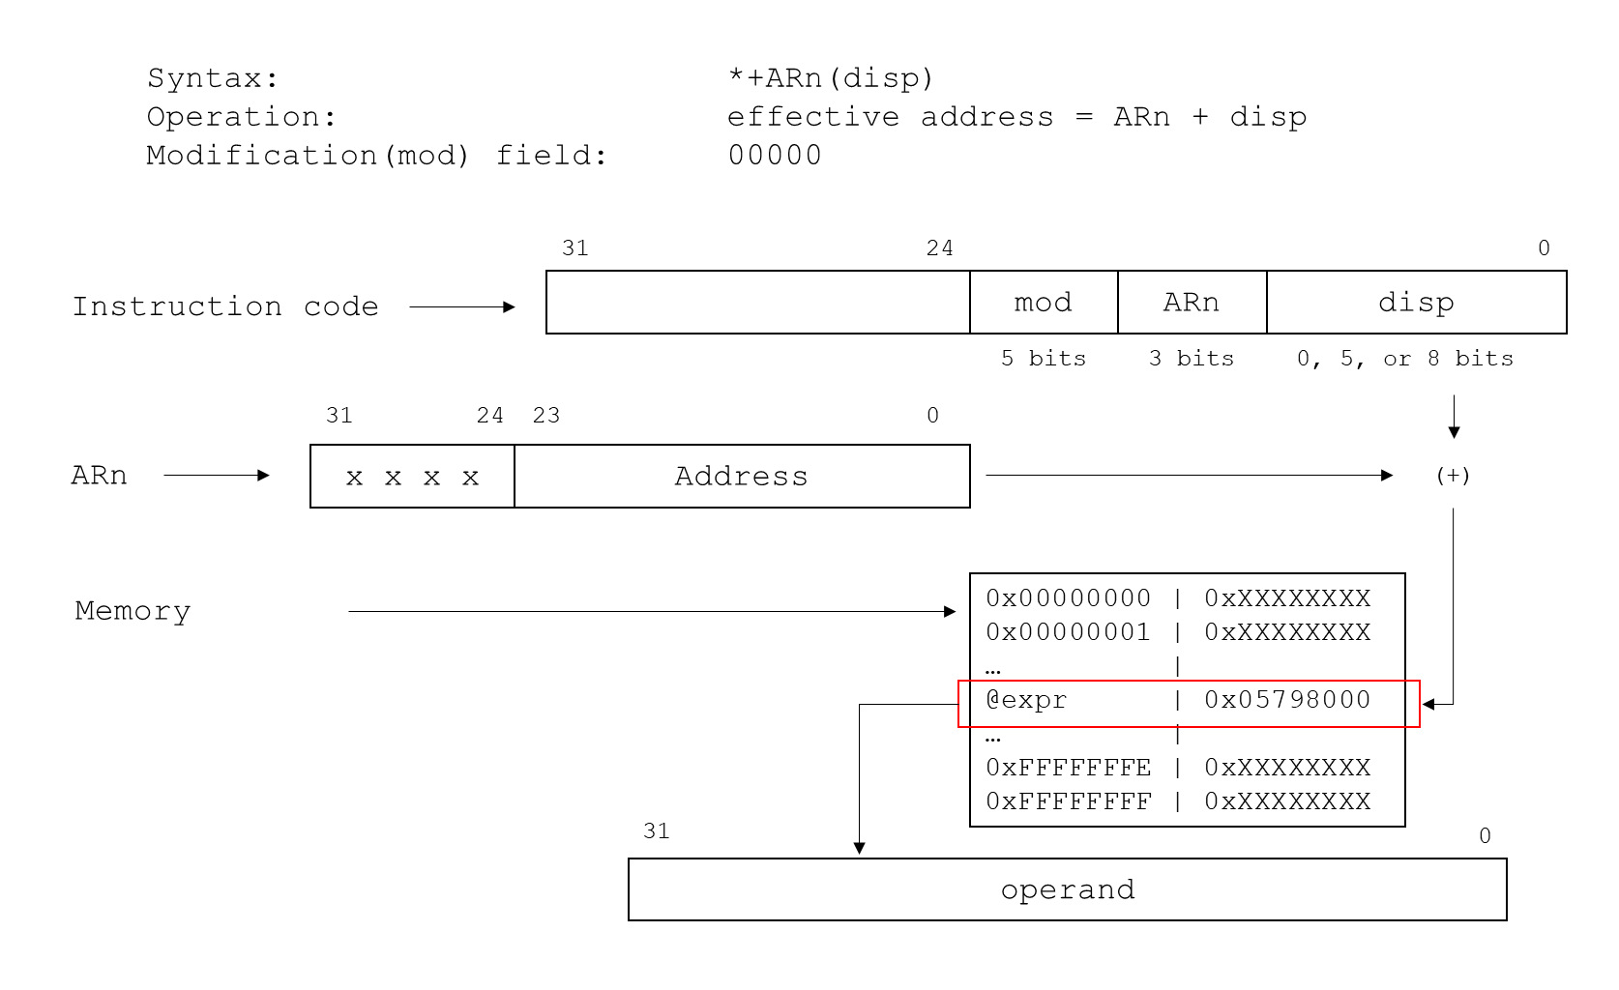

Figure 4.20: An example of indirect addressing of TMS320C32 microprocessor

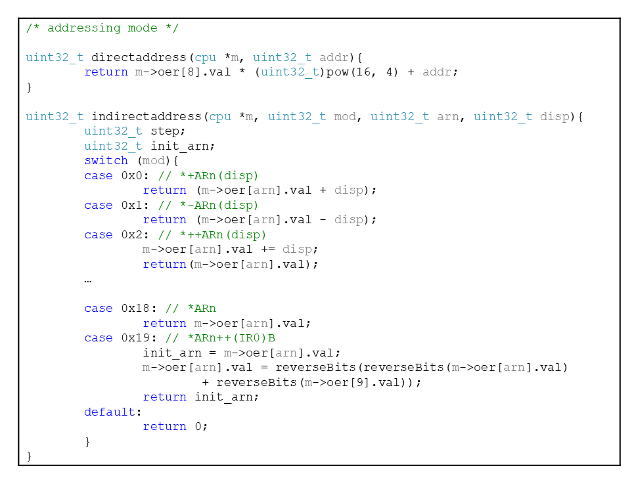

Figure 4.21: A part of addressing mode emulation in Emulation module

* + - 1. *Test Module*

The software testing must be conducted to verify whether the expected output was generated by the PLC application software in the test-bed given test cases. For this purpose, the testing process for PLC application software, which involves instruction set execution and test case and test result analysis is designed and implemented in the test-bed.

Figure 4.22 illustrates the procedure of software testing in the software test-bed with the test cases. The test process starts with initializing the software test-bed, which includes initializing the CPU registers and memory elements. Then, the input files of the test-bed including the test case files and the binary files of the PLC application software including the program file which consists of the 32-bit long binary code generated from the user application program written in FBD/LD programming language and the constant file which stores the memory map of the variables used in program are loaded to the test-bed. Regarding the instruction execution process, the test-bed executes the instruction sets based on four basic operation processes of the PLC microprocessor: (1) fetch, (2) decode, (3) read, and (4) execute. In the fetch phase, the executable code is fetched from the memory address that the program counter register PC is pointing at. In the decode phase, the fetched executable code in a binary form is decoded into specific instruction set by the *Assembler module*. In the read phase, the address generation is performed and the operands are read from the CPU registers or memory map by the *Emulation module*. In the execute phase, the simulated operation of the decoded instruction set is performed by the *Emulation module* and the operation results are stored in the CPU register or the memory. During the execute phase, the registers which represent the status of the microprocessor such as stack management are updated at each instruction line. Here, the test cases which includes the memory address and the values of software input and internal variables that should be tested are loaded in test-bed and overwrite the values in the emulated memory map when the program counter register PC reaches to the test injection address which is specified by the user. The fetch-decode-read-execute process is iterated until the value of program counter register PC reaches to the test end address defined by the user or the end of the program.

After the PLC application software is executed by the *Test module* until the test end address or the program end, the final status of CPU registers and memory map emulated in the *Architecture module* is captured to compare the output values with the expected output provided by the user. As the software variables including input and output variables are saved and allocated in the memory map, this comparison can be achieved by checking the specific memory address that corresponds to the software output to be tested and the test result can be verified by comparing the values saved in those memory address with the expected outputs. If both values are the same, it means that the software generated correct output given the test cases. However, if there is any test case that results in the value of output variable as different, it is saved as wrong output which should be reviewed and debugged and the test should be restarted from the beginning, if necessary. The *Test module* saves the result for each test case and generates the test result in a text format which can be revised by the tester and used to debug the software if there is any wrong output case.

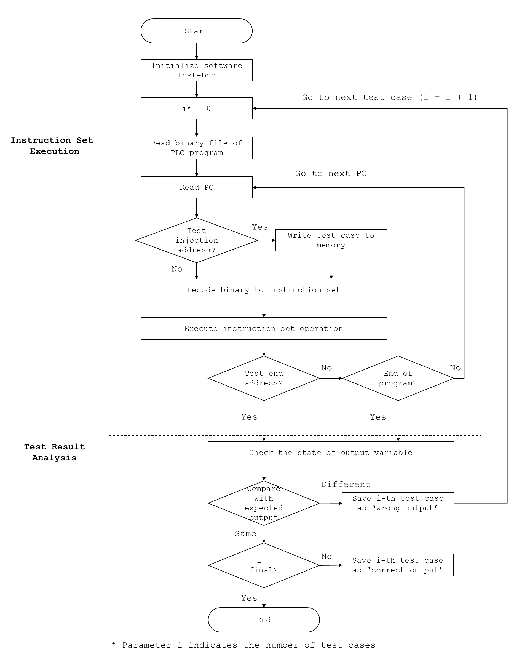

Figure 4.22: Process of instruction code execution and test result analysis in Test module

Figure 4.23 shows an instruction code execution in the *Test module*. For each program file, the initial value of the program counter register PC is set to the memory address where the main subroutine of the program begins. The test cases are written to the memory map with *writemem* subroutine when the program counter register PC reaches to the test injection address specified by the tester. Before the instruction code is executed by the *Emulator module*, the *Test module* calculates next program counter by checking whether there was any delayed branch or repeat mode defined at previous instruction codes by *CheckDelayBranchMode* and *CheckRepeatMode* subroutines. The *Test module* then passes the syntax and operands of instruction code at the next program counter decoded by the *Assembler module* to the *Emulator module*, which executes the emulated operation of the instruction code. The process is iterated until the program counter reaches to the test end address or the end address of the main subroutine. Here, the main subroutine is the code area that contains the actual PLC application software while the init subroutine of the application software initializes the software variables and the variables used by the FBs or FBDs in the software and is executed before the main subroutine in the *Test module*.

Figure 4.24 shows how the test result is generated in the *Test module*. The *Test module* reads the expected output file and saves the memory address and the expected value of software output variables being tested. After all instruction codes are executed, the *Test module* reads the value in that memory address and saves as a program output (denoted as *prog_val* in Figure 4.24). The value is compared with the expected output depending on the type of output whether the 32-bit word inside the memory address (denoted as *val* type in Figure 4.24) or a single bit value among 32-bit word (denoted as *bit* type in Figure 4.24) is compared. If any of the program outputs is not equal to the expected outputs, the *Test module* saves the test case as the wrong output and vice versa. For each test case, the number of the success and failure cases are updated and the result is reported after all test cases are tested by the *Test module*.

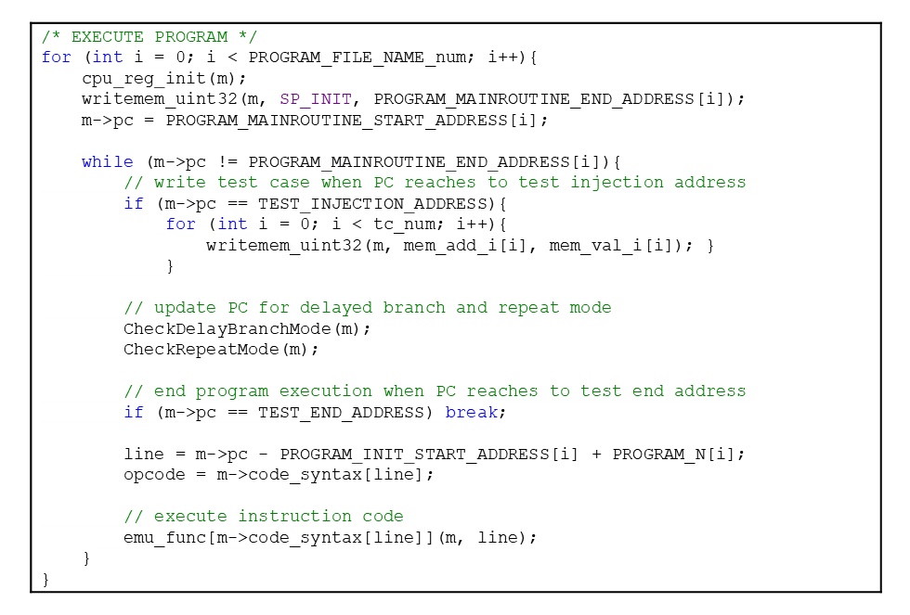

Figure 4.23: A part of instruction code execution in Test module

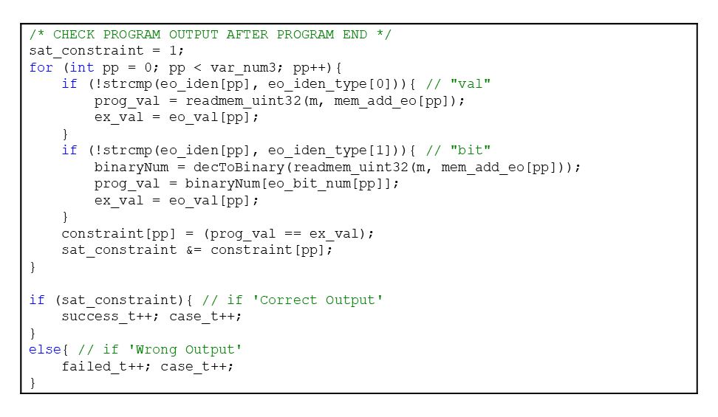

Figure 4.24: Process of test result analysis in Test module

* + 1. **Implementation of Software Test-bed**

The test-bed is executed in the form of executable file compiled from all four modules described in Section 4.4.3 which conducts PLC emulation and test execution. Table 4.1 and Table 4.2 show the list and description of header and source files that comprise the software test-bed. The header and source files were loaded into a solution in Visual Studio 2013 integrated development environment (IDE) and compiled to generate the executable file, as shown in Figure 4.25. The default compile option provided by the Visual Studio 2013 IDE for Win32-Release version was used to build the solution. The executable file of test-bed compiled from the IDE (denoted as NSTM-1.0.exe in Figure 4.25) reads the arguments from the test execution file and data from the test case files and is executed in the command prompt environment.

Table 4.1: Header files of simulation-based test-bed for PLC software testing

|  |  |
| --- | --- |
| Name | Description |
| cpu.h | Header file of Architecture module |
| dasm.h | Header file of Assembler module |
| emu.h | Header file of Emulation module |
| func.h | Header file for the subroutines used in test-bed |
| main.h | Header file of Test module |
| opcodes.h | Header file for the defined opcodes of TMS320C32 instruction sets |

Table 4.2: Source files of simulation-based test-bed for PLC software testing

|  |  |
| --- | --- |
| Name | Description |
| cpu.c | Source file of Architecture module |
| dasm.c | Source file of Assembler module |
| emu.c | Source file of Emulation module |
| func.c | Source file for the subroutines used in test-bed |
| main.c | Source file of Test module |

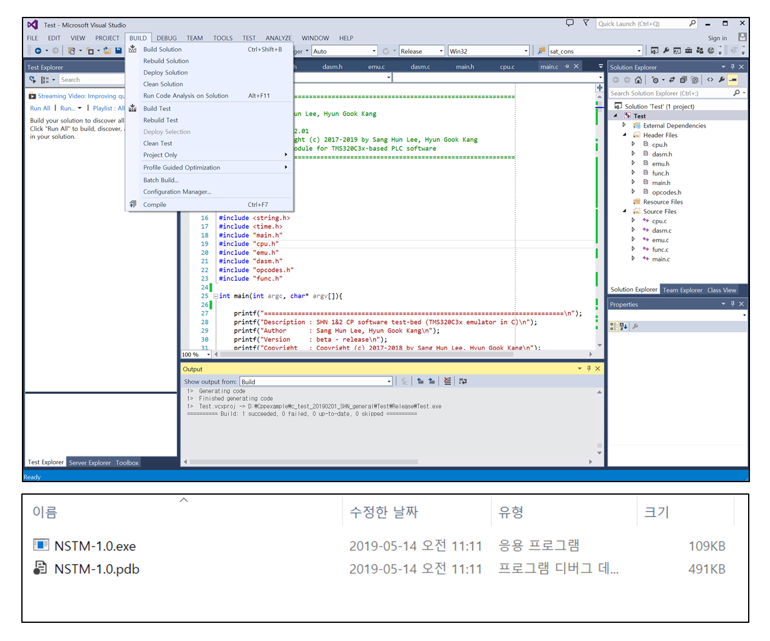

Figure 4.25: Compilation of the test-bed to executable code

* 1. **Verification of Simulation-based Software Test-bed**

In terms of software testing, some important aspects of the test-bed include: (1) precisely emulating the instruction set operation of the target microprocessor, and (2) generating an accurate result for the PLC application software. In order to validate the developed simulation-based software test-bed, the unit testing for the instruction sets emulated in the test-bed and the functional testing using the benchmark programs from as simple software which is Lamp On/Off software to a more complicated software which is KNICS IDiPS-RPS BP trip logic software was conducted. The verification activities for the PLC software test-bed are performed in accordance with the KAERI nuclear quality assurance specifications (QPS-N-002 Rev. 1) for software development. The QPS-N-002 standard follows the ASME nuclear quality assurance-1 endorsed by the U.S. NRC and Korea electric power industry code quality assurance plan. Figure 4.26 shows a verification and validation process throughout test-bed development. All SDLC documents related to the test-bed development are created and are reviewed by the independent reviewer according to SWQAM-02-02, which contains the review checklists for software verification processes based on QPS-N-002 standard. The following sections describe the V&V methods applied to the test-bed.

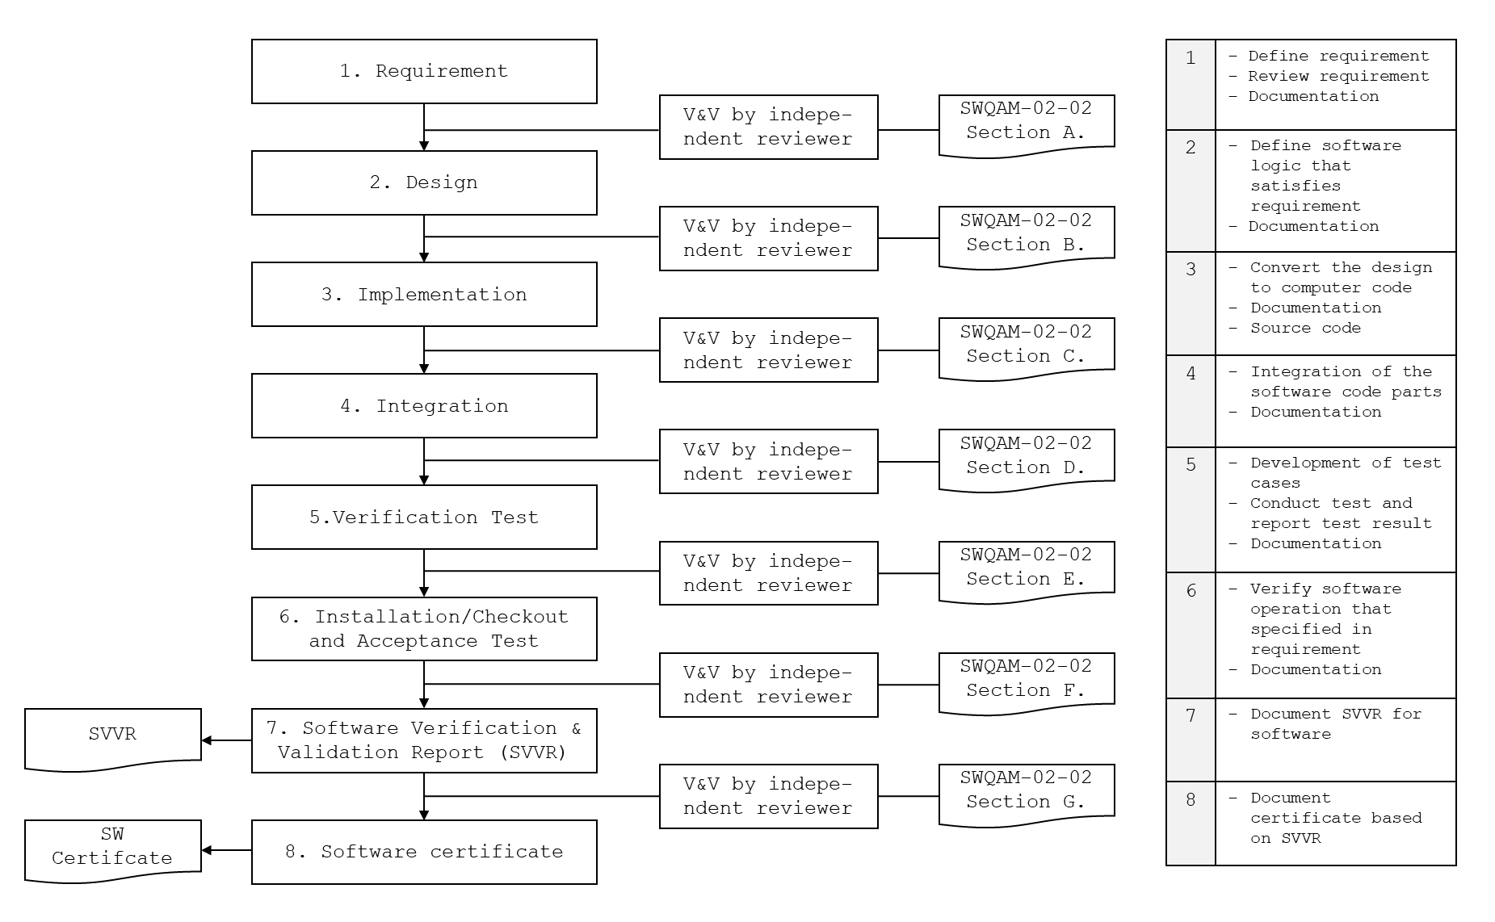

Figure 4.26: Verification and Validation activities throughout the software test-bed development life cycle

152

* + 1. **Unit Testing of Instruction Set Operation Emulated in Test-Bed**

In order to precisely emulate the target PLC microprocessor, the test-bed must emulate the exact operation of the instruction sets. The unit testing is a software testing method which the individual units of the source code, such as the associated functions, are tested to determine whether each unit of the code generates the precise expected output [233]. The goal of the software unit testing is to isolate each part or unit of the program and show that the individual parts perform as designed. A unit denotes the smallest testable part of any software which usually has one or a few inputs and usually a single output.

In this study, the unit test cases for each PLC microprocessor machine instruction set were developed and used to verify the correctness of the instruction set operations emulated in the test-bed. Figure 4.27 shows the procedure of software test-bed verification using the instruction unit test cases. The instruction unit test cases are developed in consideration of all possible addressing modes and the operands of the instruction sets based on the TMS320C32 specification documents [228] and converted into an equivalent 32-bit binary code. The initial states before instruction execution of the CPU register and memory map are defined in the unit test cases and the final state of the microprocessor after instruction execution is defined in the unit test cases and used to verify the result by comparing with the expected final state of CPU register or memory element.

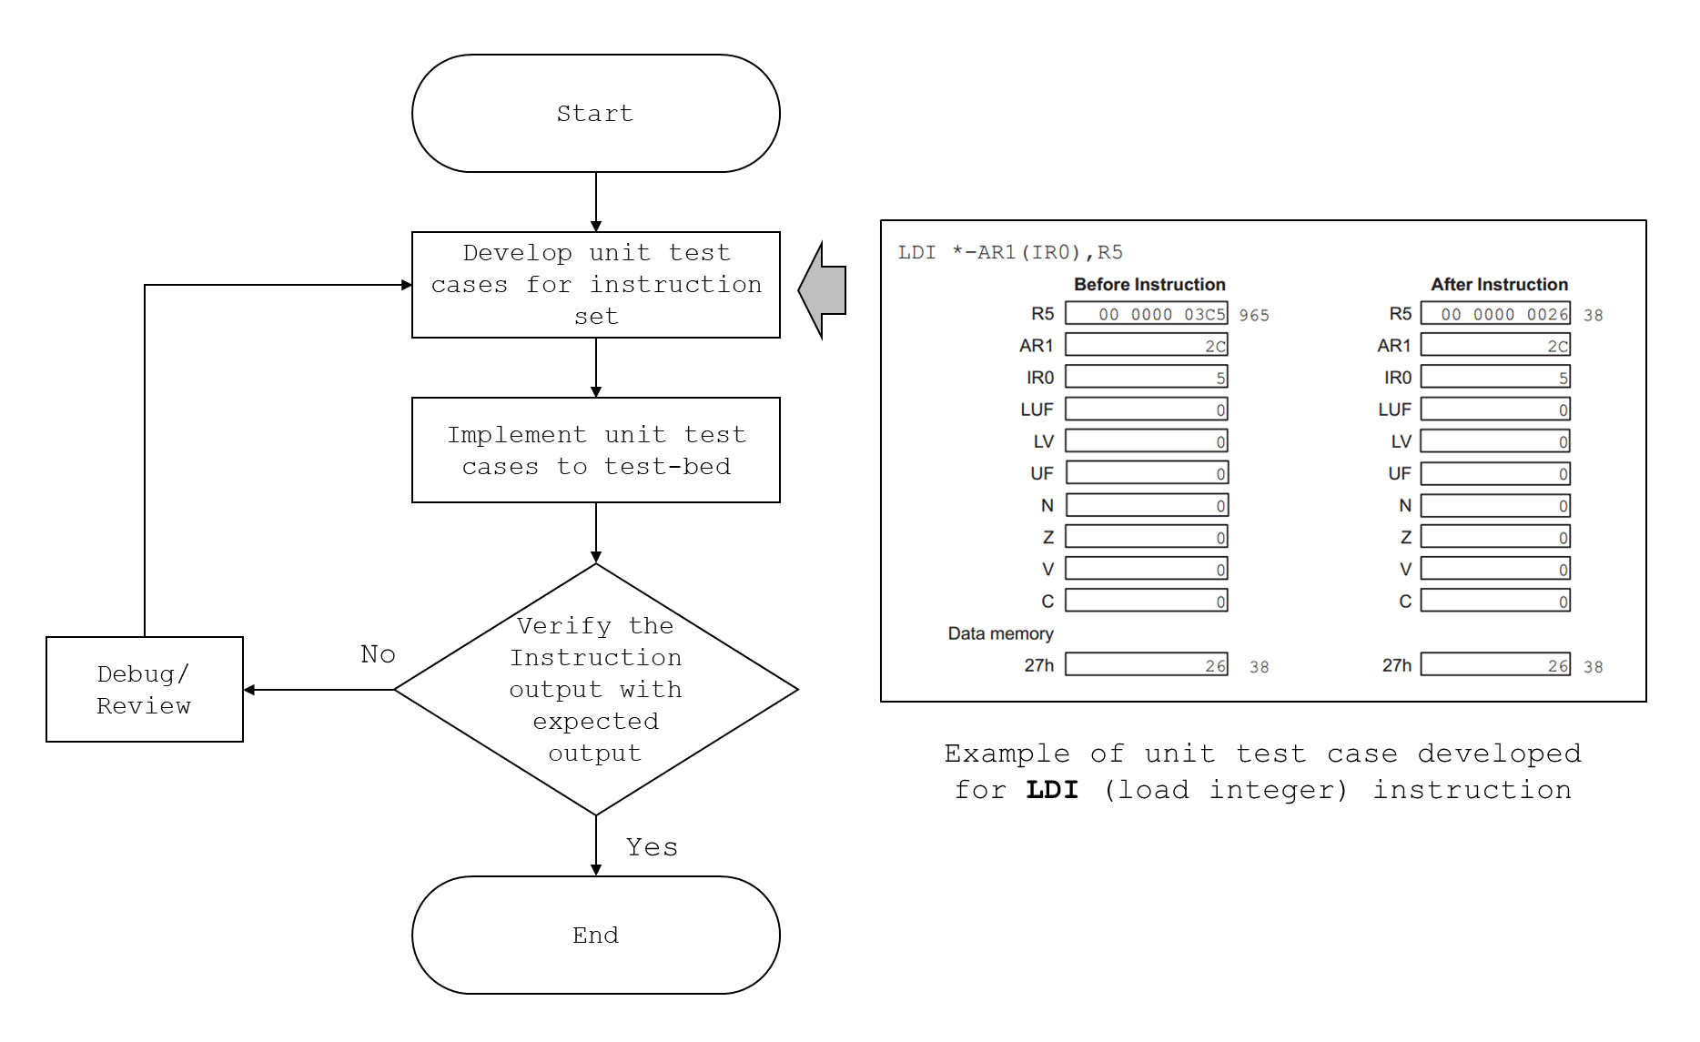

Figure 4.27: Verification of the software test-bed with instruction set unit test cases

* + - 1. *Unit Test Case Generation for Software Test-bed*

The unit test cases for the test-bed are generated considering all possible addressing modes and operands for each instruction set of PLC microprocessor. The purpose of the unit testing of the test-bed is to verify whether the calculation result is correctly reflected in the microprocessor architecture such as CPU registers and memory map and confirm that the operation of all instruction sets is correctly emulated in the test-bed. This can be verified by comparing the status of CPU registers and memory map with the expected output after each instruction set is executed. However, a full exploration of the possible combinations of the data being processed would result in an unreasonable number of unit tests. To limit the number of unit tests and to still achieve an acceptable testing status, the following considerations have been implemented in generating the unit test cases for each instruction set:

1. For most instruction set that supports addressing to any CPU register, there are a total of 28 registers available for register addressing modes. Testing all combinations of the 28 registers for source and destination operands would result in an unreasonable number of unit tests. Therefore, representative registers (e.g., the source operand is the register R7 and the destination is the register R3) were selected when testing the register addressing modes for the unit testing of developed test-bed. The rationale behind this choice is that the register implementations in the test-bed share the same source code part for register addressing modes.
2. For direct addressing mode, a possible size of memory address that can be accessed by direct addressing mode equals to a total size of the TMS320C32 memory map, which is 16Mbyte. Testing the whole space of the memory address by direct addressing would result in an unreasonable number of unit tests for each instruction set. For the test-bed unit testing, a representative value for data-page pointer register (e.g., DP = 0xD0) and the displacement (e.g., expr = 0x8900) to express the effective address is assumed. The rationale behind this choice is that any value of data-page pointer register and displacement share the same source code part for deciding the effective address of the direct addressing mode.
3. There are a total of 26 indirect addressing modes available for 2-operand instruction set and much more possible combination of indirect addressing modes for 3-operand instruction set and parallel instructions. In addition, there are seven possible ARn and up to 256 possible displacement values for each indirect addressing mode for each instruction set. Since testing all possible combinations of these variables would result in an unreasonable number of unit tests, a representative indirect addressing mode (e.g., the source operand is *+AR7(1) and the destination operand is *+AR6(1)) is assumed. In each unit test case, it checks whether both the operation result is correctly reflected in the CPU registers or memory map and the contents in the ARn is unchanged.
4. Since the size of each memory address is 32-bit, the number of possible integer and floating number contains $2^{32}$ cases (for example, $-2^{31}\sim 2^{31}-1$ for signed integer, $0\sim 2^{32}$ for unsigned integer and $-2*2^{127}\sim \left(-1-2^{-23}\right)*2^{-127}, 0, 2^{-127}\sim \left(2-2^{-23}\right)*2^{127}$ for single-precision (32-bit) floating-point format. However, testing all possible combinations of integer or floating-point number for source and destination operands would result in an unreasonable number for unit tests. Therefore, a representative integer and floating numbers for source and destination operands are selected which change the condition flags in the status register, rather than using random integer or floating-point number. In this way, all combinations of the condition flag update based on the calculation result is covered for any instruction set operation.

Based on these considerations, a total of 2090 unit test cases are developed for verifying that an emulated operation of instruction sets in test-bed generates correct output as described in the microprocessor specifications. For example, Figure 4.28 shows the unit test cases for the OR (bitwise-logical OR) instruction set. The OR instruction set is a 2-operand instruction whose addressing modes for source operand includes: (1) register addressing mode (any CPU register), (2) direct addressing mode, (3) indirect addressing mode (displacement = 0~255, IR0, IR1), and (4) immediate addressing mode. Based on the execution result, two condition flags, negative flag (N) and zero flag (Z), in the status registers are changed. Considering these characteristics of OR operation, 4 unit test cases were developed as follows:

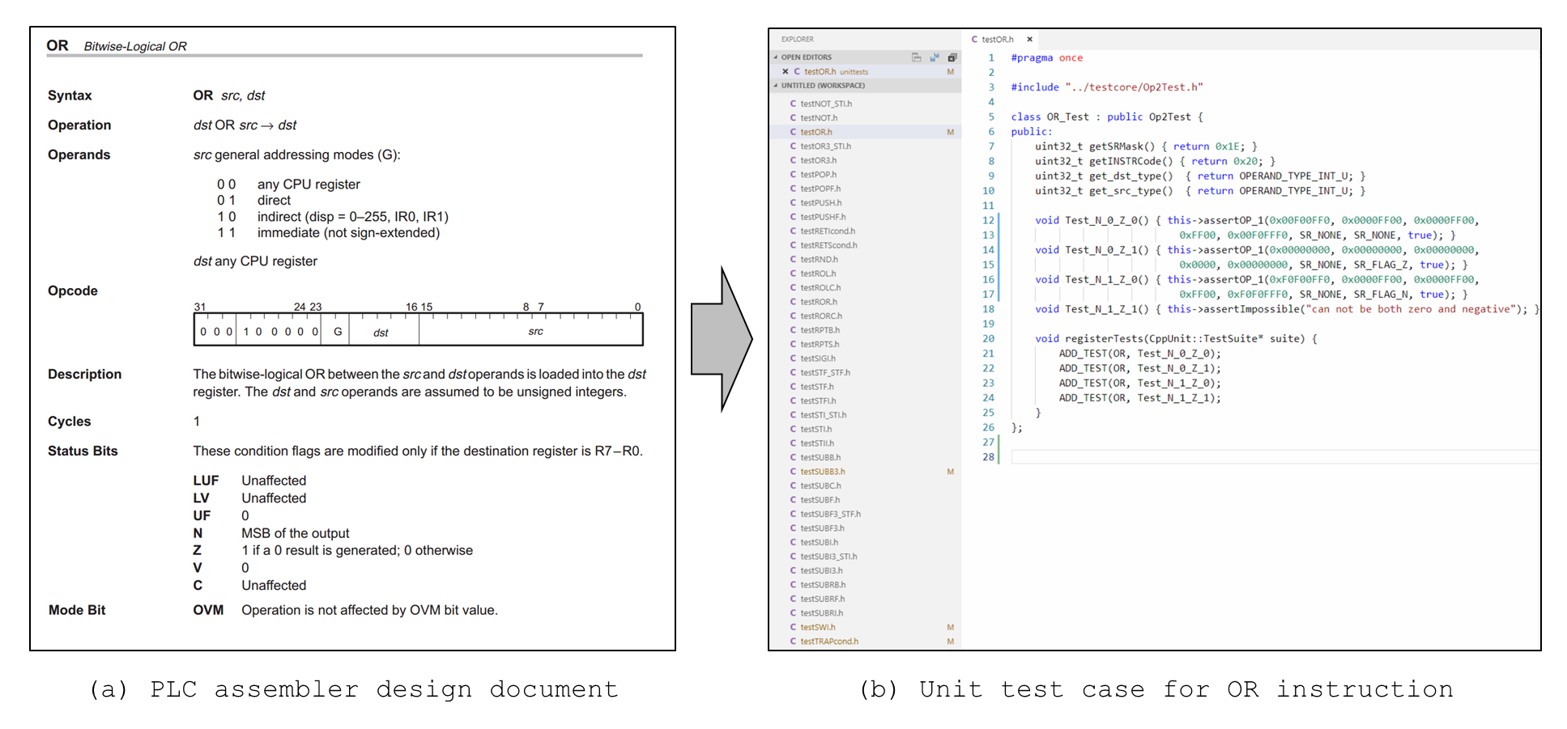

157

Figure 4.28: Unit test case development for PLC microprocessor instruction sets

1. Test_N_0_Z_0: The instruction execution output generates non-zero value for destination operand (Z = 0) and the MSB of the output is zero value (N = 0).
   * Before Instruction Operation
     + Status Register:
       - OVM = 0
       - LUF = 0
       - LV = 0
       - UF = 0
       - N = 0
       - Z = 0
       - V = 0
       - C = 0
     + Register/Memory State:
       - Register Addressing mode:
         * src (R7) = 0x0000FF00
         * dst (R3) = 0x00F00FF0
       - Direct Addressing mode:
         * src (@00D08900) = 0x0000FF00
         * dst (R3) = 0x00F00FF0
       - Indirect Addressing mode:
         * src (@00D09801) = 0x0000FF00
         * dst (R3) = 0x00F00FF0
       - Immediate Addressing mode:
         * src = 0x0000FF00
         * dst (R3) = 0xFF00
   * After Instruction Operation
     + Status Register:
       - OVM = 0
       - LUF = 0
       - LV = 0
       - UF = 0
       - N = 0
       - Z = 0
       - V = 0
       - C = 0
     + Register/Memory State:
       - dst (R3) = 0x00F0FFF0
2. Test_N_0_Z_1: The instruction execution output generates zero value for destination operand (Z = 1) and the MSB of the output is zero value (N = 0).
   * Before Instruction Operation
     + Status Register:
       - OVM = 0
       - LUF = 0
       - LV = 0
       - UF = 0
       - N = 0
       - Z = 0
       - V = 0
       - C = 0
     + Register/Memory State:
       - Register Addressing mode:
         * src (R7) = 0x00000000
         * dst (R3) = 0x00000000
       - Direct Addressing mode:
         * src (@00D08900) = 0x00000000
         * dst (R3) = 0x00000000
       - Indirect Addressing mode:
         * src (@00D09801) = 0x00000000
         * dst (R3) = 0x00000000
       - Immediate Addressing mode:
         * src = 0x00000000
         * dst (R3) = 0x0000
   * After Instruction Operation
     + Status Register:
       - OVM = 0
       - LUF = 0
       - LV = 0
       - UF = 0
       - N = 0
       - Z = 1
       - V = 0
       - C = 0
     + Register/Memory State:
       - dst (R3) = 0x00000000
3. Test_N_1_Z_0: The instruction execution output generates non-zero value for destination operands (Z = 0) and the MSB of the output is non-zero value (N = 1).
   * Before Instruction Operation
     + Status Register:
       - OVM = 0
       - LUF = 0
       - LV = 0
       - UF = 0
       - N = 0
       - Z = 0
       - V = 0
       - C = 0
     + Register/Memory State:
       - Register Addressing mode:
         * src (R7) = 0xF0F00FF0
         * dst (R3) = 0x0000FF00
       - Direct Addressing mode:
         * src (@00D08900) = 0xF0F00FF0
         * dst (R3) = 0x0000FF00
       - Indirect Addressing mode:
         * src (@00D09801) = 0xF0F00FF0
         * dst (R3) = 0x0000FF00
       - Immediate Addressing mode:
         * src = 0xF0F00FF0
         * dst (R3) = 0xFF00
   * After Instruction Operation
     + Status Register:
       - OVM = 0
       - LUF = 0
       - LV = 0
       - UF = 0
       - N = 1
       - Z = 0
       - V = 0
       - C = 0
     + Register/Memory State:
       - dst (R3) = 0xF0F0FFF0
4. Test_N_1_Z_1: The output generates zero value and the MSB of the output is a non-zero value. (This case is impossible as the MSB of the zero value (0x00000000) is always zero.)

As shown above, the fourth case (Test_N_1_Z_1) is impossible as the MSB of the zero value (0x00000000) is always zero, so the MSB of the output cannot have a non-zero value. Similar to the OR instruction example, the unit test cases for a total of 118 instruction sets of TMS320C32 microprocessors emulated in the test-bed were generated. The number of developed unit test cases is 1376 cases (except for 714 cases of impossible unit test sets among a total of 2090 test cases). Table C.1 shows a description of developed unit test cases for all instruction sets.

* + - 1. *Unit Test Procedure for Software Test-bed*

In order to verify the test-bed with unit test cases, CppUnit [234], a unit testing framework for C/C++ programming language was chosen in this study for the evaluation since it is presented as the C/C++ port of the xUnit-architecture in Hamil’s Unit Test Frameworks [235]. It also is the most widely used C/C++ unit testing tool. The framework is port of Java’s JUnit into C++ and uses the architecture of the xUnit model uses templates and standard template library.

The unit test module consists of (1) test drivers (*testcore*) which generate the opcode of each instruction set and set up the test environment such as defining and checking the status of registers and memory value before and after the instruction set execution and (2) unit test cases (*unittests*) where the unit test cases described in Section 4.5.1.1 are implemented as test suites in the CppUnit framework, as follows:

1. Test Driver (*testcore*)
   * Op0Test.h: unit test module for 0-operand instruction set
   * Op1Test.h: unit test module for 1-operand instruction set
   * Op2Test.h: unit test module for 2-operand instruction set
   * Op3Test.h: unit test module for 3-operand instruction set
   * Op4Test.h: unit test module for 4-operand instruction set
   * Op5Test.h: unit test module for 5-operand instruction set
   * Op6Test.h: unit test module for 6-operand instruction set
   * OpTest.h: functions used in Op0Test.h ~ Op6Test.h modules
   * OpVal.h: defining operand values used in unit test modules.
   * TestUtil.h: macros and constants used in unit test modules
   * TestEmu.cpp: main module for unit testing (calls and executes test suites)
2. Unit test cases (*unittests*) – a total of 118 files (one for each instruction set)
   * TestABSF.h: unit test cases for ABSF instruction set
   * TestABSF_STF.h: unit test cases for ABSF||STF instruction set
   * …
   * TestXOR3.h: unit test cases for XOR3 instruction set
   * TestXOR3_STI.h: unit test cases for XOR3||STI instruction set

The procedures for the unit testing of test-bed includes three steps: (1) calling the unit test cases written in CppUnit framework (*unittests*) and adds to the test runner to be executed, (2) executing the unit tests cases that was added to the test runner, and (3) reporting the unit test results by asserting the output of test-bed to the expected output. At the first step, the test suites are generated for each instruction set in the unit test cases (*unittests*) as shown in Figure 4.29. Each test suite contains unit test cases defined for all possible addressing modes and condition flag changes as described in Section 4.5.1.1 and is used to run several unit test cases at once for each instruction. This is done by adding the test suite to the test class that is called by the test fixture. The test caller objects parameters are the test name and the address of the test function to be executed. In the example of Figure 4.29, the test caller object is added to the test runner with *ADD_TEST* function and the test runner runs the unit test cases.

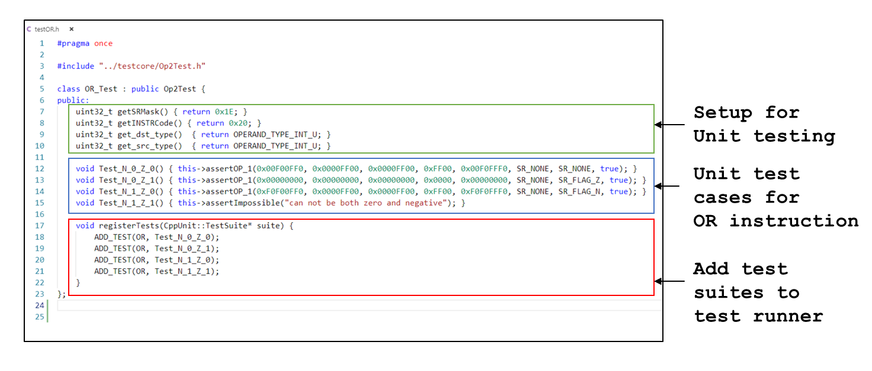

Figure 4.29: Implementation of unit test cases for instruction sets emulated in test-bed

At the second step, the unit test cases are written in the CPU registers and memory map and the 32-bit instruction code is defined according to the instruction-specific opcodes, addressing modes and the source and destination operands. The *Emulator module* then executes the 32-bit instruction code and updates the CPU register and memory map based on the instruction set execution result. At the third step, the output of the test-bed is compared with the expected output defined in the unit test cases by asserting whether two outputs are the same. If the output of the test-bed is equal to the expected output, the result of the unit testing is saved as “OK” while the result is saved as “Failed” with the error message in the opposite case. Figure 4.30 shows the procedure of unit test case execution for the test-bed using CppUnit framework.

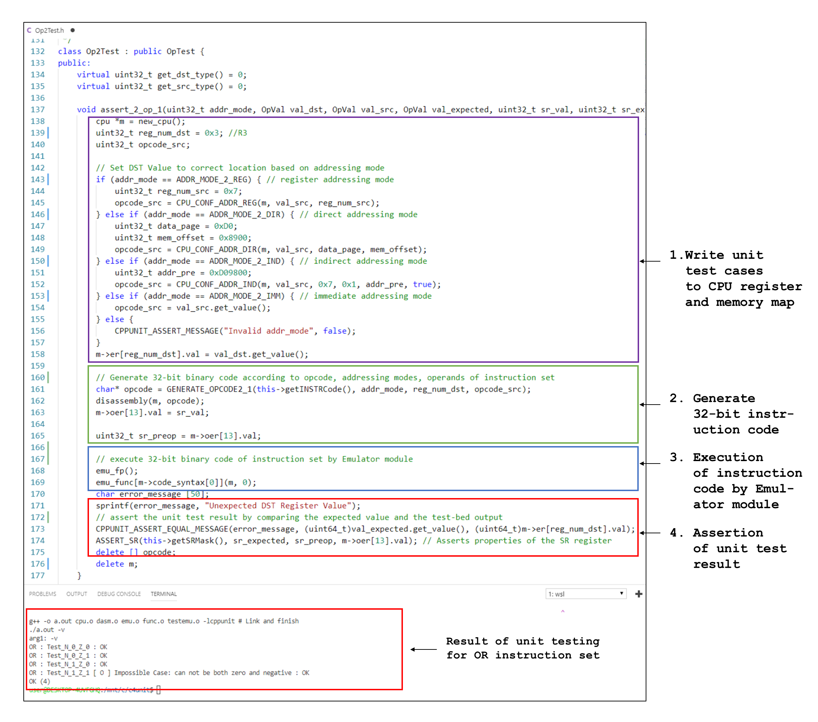

Figure 4.30: Process of unit testing for instruction sets emulated in test-bed

* + - 1. *Unit Test Result for Software Test-bed*

A total of 1376 unit test cases (except for 714 cases of impossible unit test sets among a total of 2090 unit test sets) developed for verifying the correct operation of the emulated instruction sets in the test-bed were tested. In result, all 118 instructions of TMS320C32 microprocessor emulated in the test-bed generated the correct output that specified in the microprocessor assembly specifications. Figure 4.31 shows the summary of the unit test results for test-bed and the detailed test results is shown in Table C.1.

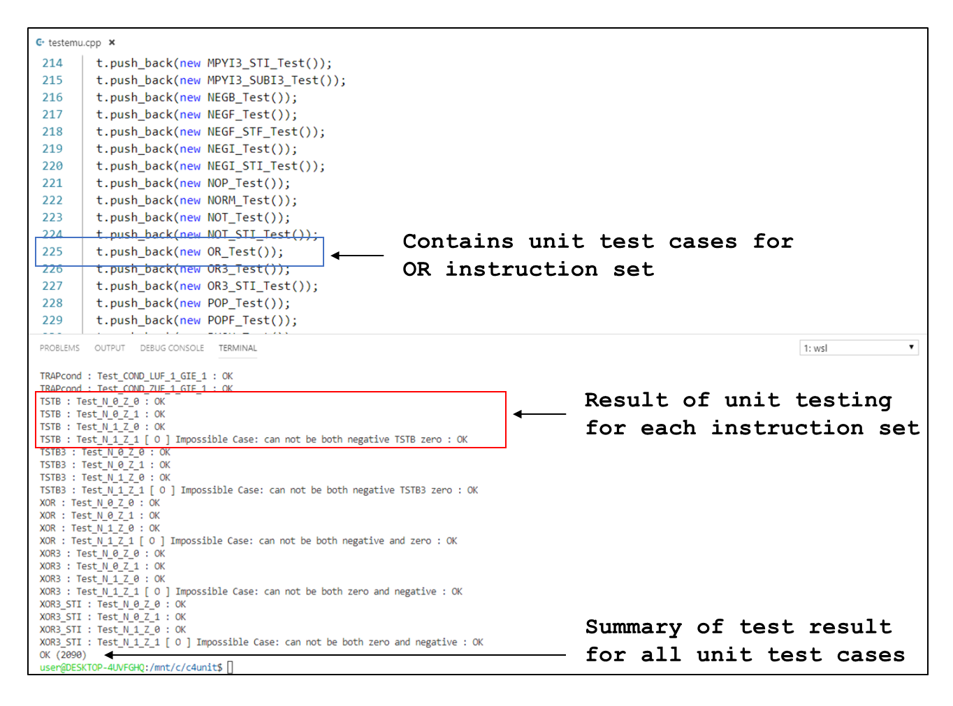

Figure 4.31: Result of unit testing for software test-bed

* + 1. **Functional Testing of Software Test-Bed**

A limitation of unit testing includes that it can only show the presence or absence of particular errors in the specific part of the code being tested as unit testing are done to test each program function, procedure, method, or object class inside the entire program. By unit testing, it is practically impossible to evaluate every execution path in a software application; therefore, the unit testing is done in conjunction with other software testing activities, such as functional testing [148]. The functional testing consists of test runs on the entire program and is a type of black-box testing that bases its test cases on the specifications of the software component under test. The functional testing usually describes what the software does and emphasizes on the behavior of the software entity. Therefore, the software is tested by providing input and then the results are examined that need to conform to the functionality it was intended for. The selection of test cases for functional testing is based on the requirement or design specification of the software entity under test.

This section presents the validation process of PLC software test-bed using some benchmarks to validate the overall functionality of the test-bed. For this purpose, two benchmark software was used for functional testing: (1) a Lamp On/Off software and (2) KNICS IDiPS-RPS BP trip logic software. The aim of the functional testing on the software test-bed is on verification of the entire cycle of software execution from reading required test-bed inputs such as test case, expected output, application program files to executing the program and generating the test results by comparing the test-bed output with the expected output for each test case. Figure 4.32 shows the procedure of software test-bed verification using the benchmark programs. The functional test cases are developed based on the available software specifications such as SRS and SDS of each benchmark. The benchmark programs were developed by an independent developer who is expert in NPP safety-critical application program development using pSET [231], a software engineering tool for POSAFE-Q. After the debugging processes by the developer, the FBD/LD programs were translated into ANSI C program to compile it into machine code for PLC. As functional testing, this machine code in 8-bit hexadecimal number (or 32-bit binary code) is uploaded to the test-bed and is executed by the test-bed given the functional test cases. Finally, the final state of output port (after program file execution) is then checked to verify whether the output generated by the test-bed is same as the expected output of the FBD/LD program.

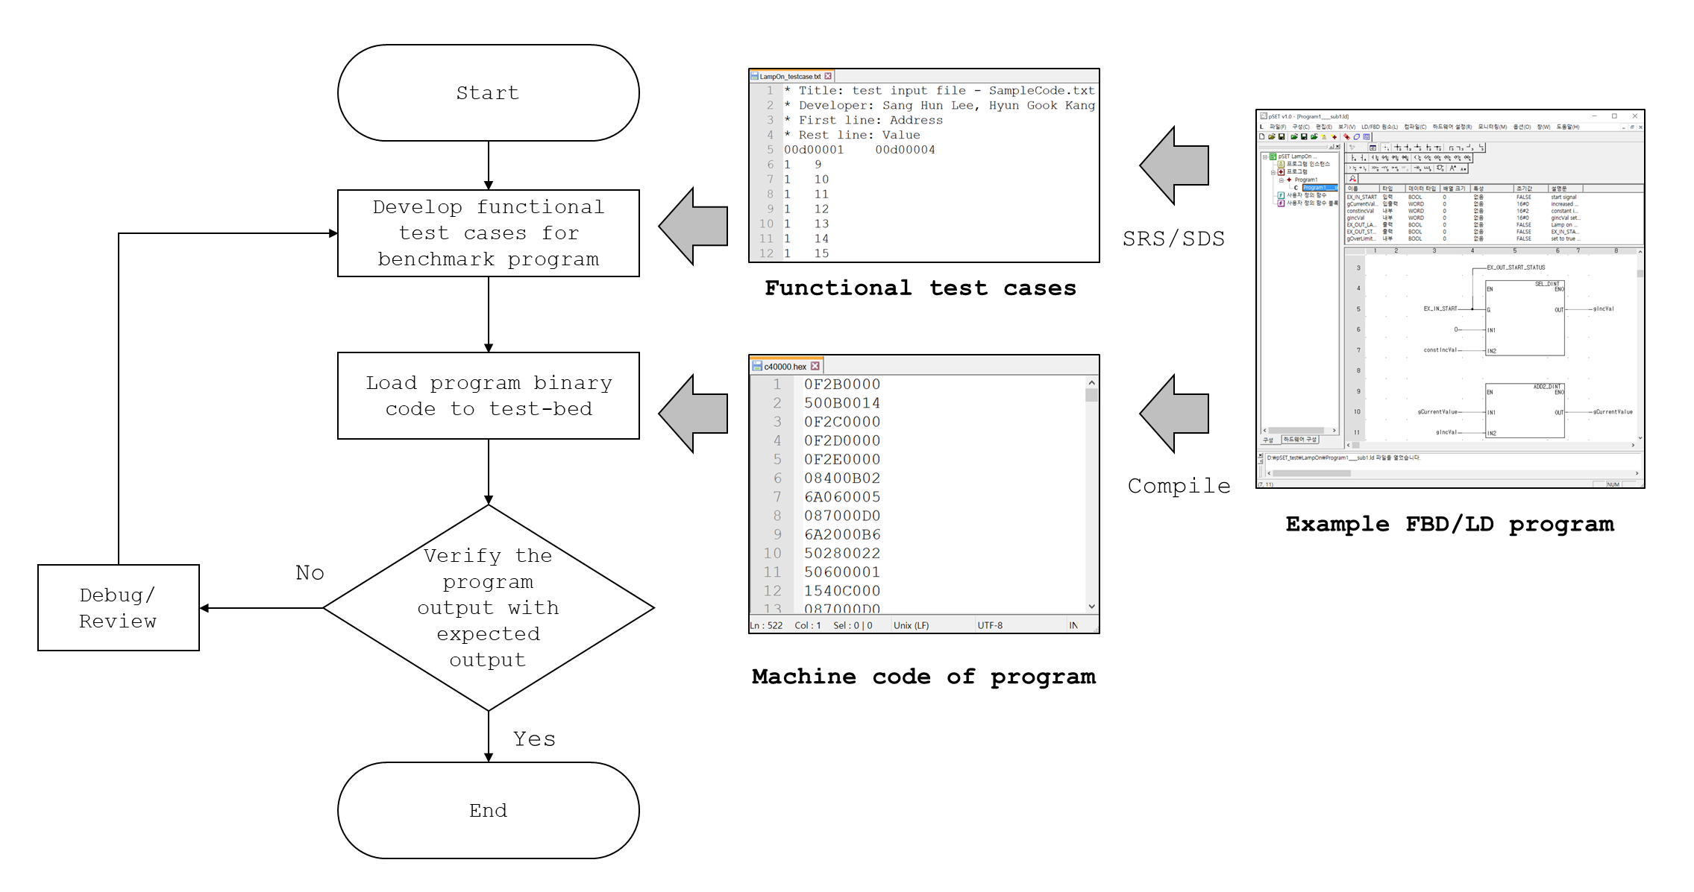

167

Figure 4.32: Verification of the software test-bed with functional testing using the benchmark programs

* + - 1. *Lamp On/Off Software*

The FBD program of a Lamp On/Off software is shown in Figure 4.33. The function of the software is to turn on the lamp on the PLC when an input status (*gCurrentValue*) exceeds the certain set-point. The input status increases by a constant value when the ‘lamp on’ request (*EX_IN_START*) is requested by the operators. The output of the software, *EX_OUT_LAMP*, becomes true when *gCurrentValue* (one of software input) has a higher value than the set-point (equals to 10). When *EX_IN_START* (another software input) is set to be true, the variable *gCurrentValue* increases by a constant value, *constIncVal*; otherwise, *gCurrentValue* remains the same value. If *gCurrentValue* exceeds a certain limit (equals to 20), the software resets the value to zero. Table 4.3 shows the description of the software variables used in an example software in Figure 4.33.

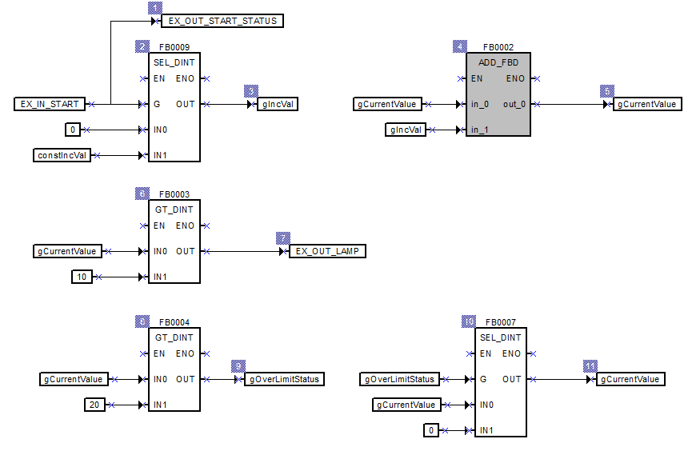

Figure 4.33: An FBD program for Lamp On/Off function

Table 4.3: Input/internal/output variables of Lamp On/Off program

|  |  |  |  |
| --- | --- | --- | --- |
| Name | Port | Type | Description |
| *EX_IN_START* | Input | BOOL | start signal. |
| *gCurrentValue* | InOut | DINT | increased by *constIncVal*(=2) when *EX_INT_START* is on, and set to 0 when the value exceeds 20. |
| *constIncVal* | Internal | DINT | constant increment value (= 2). |
| *gIncVal* | Internal | DINT | *gIncVal* set to *constIncVal* when *EX_INT_START* is set as true; else 0. |
| *EX_OUT_LAMP* | Output | BOOL | Lamp on when *gCurrentValue* exceeds 10 |
| *EX_OUT_START_STATUS* | Output | BOOL | *EX_IN_START* status |
| *gOverLimitStatus* | Output | BOOL | set to true when *gCurrentValue* exceeds 20. |

As shown in Table 4.3, the output variable that relates to the software function is *EX_OUT_LAMP* and the related input variables include the *EX_IN_START* and *gCurrentValue*. The functional test cases were generated considering various cases of ‘lamp on’ scenarios considering the safety function of the software. Figure 4.34 shows the test input and result files of Lamp On/Off benchmark program. In result, a total of 22 cases shown in Figure 4.34-(a) were for the functional testing of software test-bed for the Lamp On/Off software. The test execution file for the benchmark program is also provided so that the test-bed can run the executable code of the benchmark from the start address (@00CC0972) to the end address (@00CC0984) of the main routine of the program. After the program file is executed by the test-bed and the value in the memory address where the output variable is stored is compared with the expected output and saved as an output file of the test-bed. As shown in Figure 4.34-(e), all the test cases generated the correct output (‘Lamp On’), which implies the that software test-bed correctly works for the benchmark program.

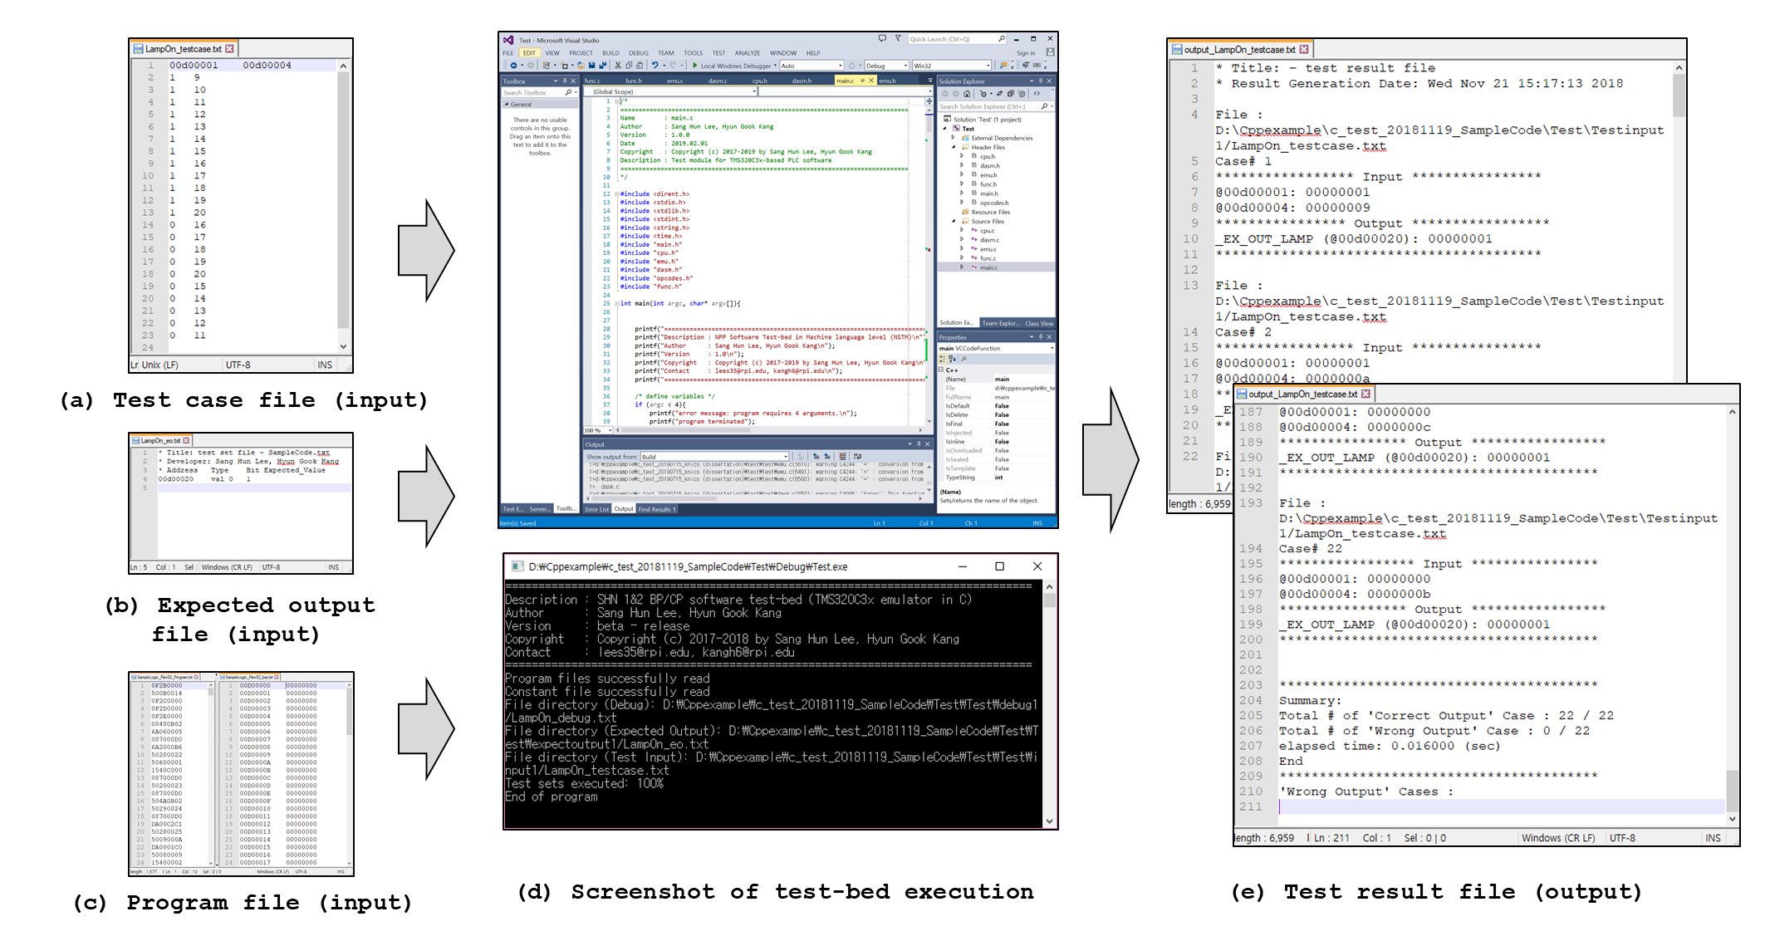

170

Figure 4.34: Functional testing of software test-bed for Lamp On/Off benchmark

* + - 1. *KNICS IDiPS-RPS BP Software*

Another benchmark program used to verify the functionality of the test-bed is selected as a BP trip logic software of KNICS IDiPS-RPS. The IDiPS-RPS is a digitalized RPS developed by KNICS project for newly constructed NPPs as well as for upgrading existing analog-based RPS. The safety function of RPS is to generate trip signals when the plant deviates from normal conditions. Especially, BP compares process variables with their trip set-point and generates a trip signal which is transmitted to CPs for the voting logic to determine whether the system generates a trip signal. The detailed specifications on the KNICS IDiPS-RPS BP trip logic software are described in Section 5.1.

In the BP trip logic software, 15 modules for trip signal generation are defined, such as pressurizer pressure high trip and steam generator low pressure trip. For example, the pressurizer pressure low trip generates a trip signal if the pressurizer pressure decreases below the trip set-point. When the plant is in full power mode, the trip set-point is fixed to 1762 psi. During shut-down and start-up processes, the trip set-point ranges between 1762 ~ 300 psi. The plant operator can manually decrease the trip set-point while the pressure slowly decreases during the shut-down process. The functional test cases for all 15 trip logics were generated based on the KNICS IDiPS-RPS SRS [236] and SDS [237]. In both specifications, the safety function of each trip logic is defined in natural language and the test cases were generated to confirm whether a KNICS RPS BP software will generate the trip signal using the test-bed. The software input and internal variables that contribute to generating the software output, or trip signal, for each trip module were investigated and the representative values of each variable were selected that generates the trip signal as true after BP software execution.

Table 4.4 shows the description of software variables that contribute to the PZR_PR_LO trip logic output (*_6_TRIP_R*) and the test cases generated for PZR_PR_LO trip signal generation (i.e., *_6_TRIP_R* = true). The specifications define that the PZR_PR_LO trip signal is generated when the pressurizer pressure is lower than the trip set-point. Based on the specification, the test cases, or the values of each variable, were selected that satisfies this condition. The case #1 in Table 4.4 represents the trip condition in full power operation (trip set-point equals to its maximum value), during shut-down operation (trip set-point is between its maximum and minimum value) and at the end of the shut-down operation (trip set-point equals to its minimum value).

The functional test cases of other trip logics were generated as similar to the pressurizer pressure low trip logic. Based on the specification description, the representative values of each software variable were identified and selected that generates the trip signal as true for each trip module. Tables D.1 ~ D.15 shows the description of software variables that contribute to the trip logic output and the representative test cases generated for the trip signal generation for each trip module. The functional test cases written for each trip module of KNICS IDiPS-RPS BP was converted to the format of test case file for the test-bed and the expected output files were generated for each case. After the program file is executed by the test-bed and the value in the memory address where output variable of each trip module is stored is compared with the expected output and saved as an output file of the test-bed. Figure 4.35 shows the test input and result files for pressurizer pressure low trip logic of the KNICS IDiPS-RPS BP software. As shown in Figure 4.35, all the test cases generated the correct output (i.e., _*6_TRIP_R* = true}. For other trip logic modules, the same test procedure was conducted and all functional test cases generated the correct output, which implies that software test-bed correctly works for the benchmark program. Table 4.5 shows the summary of the functional testing of the software test-bed for KNIC IDiPS-RPS benchmark.

Table 4.4: Functional test cases for test-bed regarding KNICS IDiPS-RPS BP pressurizer pressure low trip logic

173

|  |  |  |  |  |
| --- | --- | --- | --- | --- |
| Name | Description | Case #1 | Case #2 | Case #3 |
| __MX1_1792 | ChA BP1 PLC Diagnostic Error Signal | 0 | 0 | 0 |
| __MX1_1984 | ChA BP1 ICN 1 Module Diagnostic Error Signal | 0 | 0 | 0 |
| __MW4_1495 | ATIP Heartbeat Value | 26007 | 26007 | 26007 |
| HB_ATIP_Err_Max | ATIP Heartbeat Error Count Max Value until Error | 26000 | 26000 | 26000 |
| HB_ATIP_ERR_CNT | ATIP Heartbeat Error CountValue | 0 | 0 | 0 |
| AI1_STS0 | ChA BP1 AI 1 Module Shared Memory Error | 0 | 0 | 0 |
| _6_RST_DELAY_CNT_R | Delay Counter for TSP Reset by Operator | 0 | 0 | 0 |
| AI1_STS1 | ChA BP1 AI 1 Module Channel 01~ 08 Loop Back Check Error | 0 | 0 | 0 |
| __MW4_1532 | PAT Start Signal | 0 | 0 | 0 |
| TRIP_R_a | Trip A Signal (Real) | 0 | 0 | 0 |
| TRIP_R_b | Trip B Signal (Real) | 0 | 0 | 0 |
| PTRIP_R_a | Pre-Trip A Signal (Real) | 0 | 0 | 0 |
| PTRIP_R_b | Pre-Trip B Signal (Real) | 0 | 0 | 0 |
| AI_2_MDL_ERR | AI-2 Module Error | 0 | 0 | 0 |
| AI_3_MDL_ERR | AI-3 Module Error | 0 | 0 | 0 |
| __MW2_73 | ChA BP1 DI 1 Module Channel 01 ~ 16 Error | 0 | 0 | 0 |
| __MW2_75 | ChA BP1 DI 1 Module Process Voltage Error | 0 | 0 | 0 |
| __MW2_74 | ChA BP1 DI 1 Module Channel 17 ~ 32 Error | 0 | 0 | 0 |
| TON4_int_Start | PAT_TON.Start | 0 | 0 | 0 |
| clk | PLC internal clock | 0 | 0 | 0 |
| TON4_int_Residue | PAT_TON.Residue | 0 | 0 | 0 |
| T_SCAN_FLAG | Flag for Test/Operation Scan (before 1 scan time) | 1 | 1 | 1 |
| _6_TRIP_LOGIC_R | PZR_PR_LO (_6_) Trip Logic (Real) Signal (before 1 scan time) | 0 | 0 | 0 |
| _6_PV_OUT_AI | PZR_PR_LO (_6_) Trip Process Variable (from plant sensor) | 17776 | 13900 | 970 |
| _6_TSP_R | PZR_PR_LO (_6_) Trip set-point (Real) (before 1 scan time) | 17790 | 13960 | 999 |
| _6_OB_PERM | PZR_PR_LO (_6_) Operator Bypass Permission (before 1 scan time) | 0 | 0 | 0 |
| _6_RST_REQ_MCR_DI | PZR_PR_LO (_6_) TSP Reset Signal (from MCR) | 0 | 0 | 0 |
| _6_RST_REQ_RSR_DI | PZR_PR_LO (_6_) TSP Reset Signal (from RSR) | 0 | 0 | 0 |
| _6_OB_REQ_MCR_DI | PZR_PR_LO (_6_) Operator Bypass Request Signal (from MCR) | 0 | 0 | 0 |
| _6_OB_REQ_RSR_DI | PZR_PR_LO (_6_) Operator Bypass Request Signal (from RSR) | 0 | 0 | 0 |
| AI2_ch6_6 | PZR_PR_LO (_6_) Input Channel Hi Over Range Error Signal | 0 | 0 | 0 |
| _6_AI_CH_ERR | PZR_PR_LO (_6_) Input Channel Error Signal | 0 | 0 | 0 |

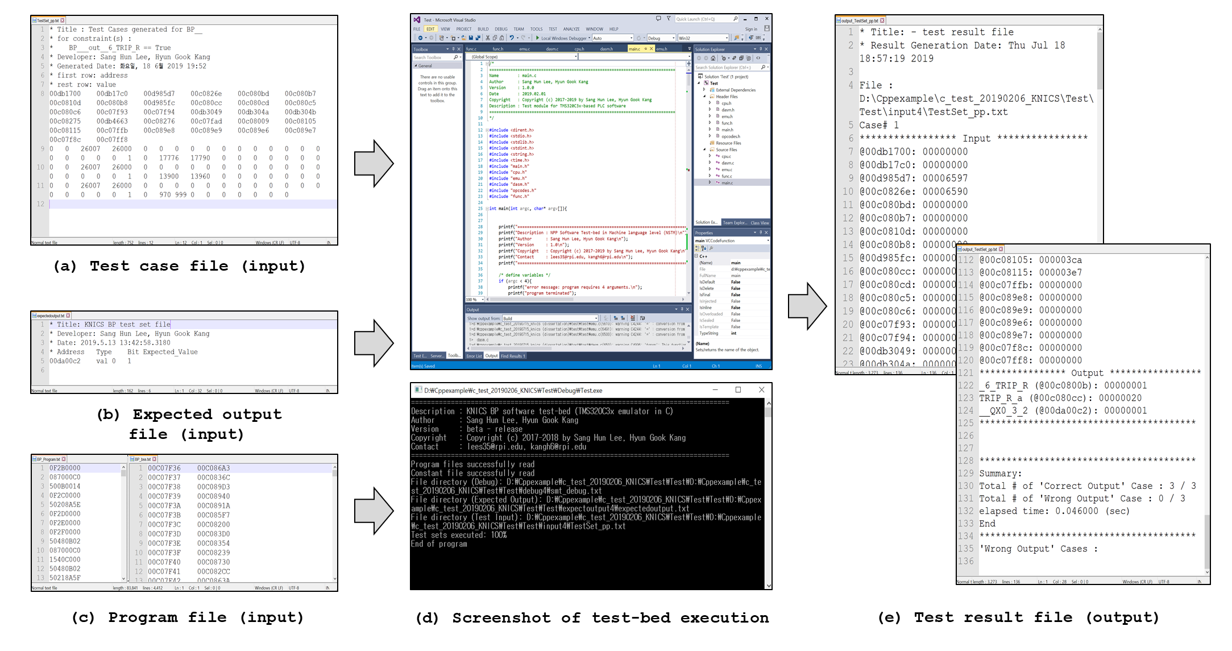

174

Figure 4.35: Functional testing of software test-bed for KNICS IDiPS-RPS BP benchmark

Table 4.5: Result of functional testing of test-bed for KNICS IDiPS-RPS BP trip logic software

|  |  |  |  |  |
| --- | --- | --- | --- | --- |
| Name of trip module | Description | Software output | Test result (Pass/Fail/Total) | Time per test case (ms) |
| PZR_PR_HI | Pressurizer Pressure High | _5_TRIP_R | 50/0/50 | 2.900 |
| SG1_LVL_LO_RPS | Steam generator-1 Level Low (RPS) | _7_TRIP_R | 50/0/50 | 2.940 |
| SG1_LVL_LO_ESF | Steam generator-1 Level Low (ESF) | _9_TRIP_R | 50/0/50 | 2.720 |
| SG1_LVL_HI | Steam Generator-1 Level High | _B_TRIP_R | 50/0/50 | 2.780 |
| SG1_PR_LO | Steam Generator-1 Pressure Low | _D_TRIP_R | 50/0/50 | 2.980 |
| CMT_PR_HI | Containment Pressure High | _F_TRIP_R | 50/0/50 | 3.254 |
| CMT_PR_HH | Containment Pressure High-High | _G_TRIP_R | 50/0/50 | 3.137 |
| PZR_PR_LO | Pressurizer Pressure Low | _6_TRIP_R | 50/0/50 | 2.800 |
| SG2_LVL_LO_RPS | Steam generator-1 Level Low (RPS) | _8_TRIP_R | 50/0/50 | 3.080 |
| SG2_LVL_LO_ESF | Steam generator-1 Level Low (ESF) | _A_TRIP_R | 50/0/50 | 2.920 |
| SG2_LVL_HI | Steam Generator-1 Level High | _C_TRIP_R | 50/0/50 | 2.880 |
| SG2_PR_LO | Steam Generator-1 Pressure Low | _E_TRIP_R | 50/0/50 | 2.840 |
| LOG_PWR_HI | Logarithmic Power Level High | _2_TRIP_R | 50/0/50 | 2.880 |
| DNBR_LO | Departure from Nuclear Boiling Ratio Low | _4_TRIP_R | 3/0/3 | 5.667 |
| LPD_HI | Local Power Density High | _3_TRIP_R | 3/0/3 | 6.333 |
| CWP | CEA Withdrawal Prohibit | _J_TRIP_R | 3/0/3 | 6.333 |

* 1. **Summary and Conclusions**

This Chapter proposed the software test method utilizing simulation-based software test-bed. As shown in previous studies, one of the limitations on the exhaustive testing on nuclear safety software came from the performance of the test-bed. While the hardware-based test-bed captures the exact running environment of the software itself, the test execution time per each test case is from few seconds to few minutes. The motivation of the simulation-based test-bed lies on the fact that the PLC microprocessor executes the application software downloaded from the PLC software engineering tools; therefore, the simulation-based test-bed is developed to realize the same environment where the application software is running by emulating the PLC architecture and instruction set operation. In the developed test-bed, the software testing processes, including inserting the test cases and analyzing the test results by comparing the output generated by the software in test-bed with the expected output are automated.

To ensure that the emulated components of PLC in the developed test-bed exactly does what the actual PLC microprocessor does, the verification activities for the software test-bed were performed in accordance with the nuclear domain standards. The unit testing regarding the function of instruction sets emulated in test-bed was conducted and verified. The functional testing was conducted by executing the test cases for two benchmark programs: (1) Lamp On/Off software and (2) KNICS IDiPS-RPS BP trip logic software. In summary, the novel contributions proposed in this Chapter were as follows:

1. The simulation-based test-bed was developed which simulates the behavior of PLC application software in machine language level by emulating the PLC microprocessor architecture (e.g., CPU registers and memory map) and execution characteristics (e.g., instruction set execution).
2. The simulation-based test-bed was verified for its accuracy on PLC microprocessor instruction execution and its functionality on the entire cycle of software testing based on the common software testing methods, which are unit testing and functional testing.
3. As shown in the benchmark result, the test-bed executes a single test case for a typical NPP RPS trip logic software and generates the test results in few milliseconds which is much faster than the conventional hardware-based test-beds used in the nuclear domain (up to few minutes). Leveraging this benefit, the test-bed is expected to enable the exhaustive testing for the NPP safety software.

# APPLICATION OF PROPOSED METHODOLOGY [3]

In this section, the effectiveness of the proposed software exhaustive testing framework is demonstrated with the KNICS IDiPS-RPS BP trip logic software. The BP trip logic software was developed by domain experts and was programmed using pSET, a software engineering tool for POSAFE-Q PLC. As a case study, the exhaustive test cases for pressurizer pressure low reactor trip logic among BP trip logics were derived. The test cases were developed by (1) deriving the software input and internal variables that contribute to generating the trip signal output, (2) obtaining the profile or the possible range of each variable, and (3) generating the exhaustive test cases for the trip initiation by the BP trip logic software using FBDET algorithm described in Section 3.4. The test cases were tested using a simulation-based test-bed described in Section 4.4 to validate whether the machine code of BP trip logic software generates a correct output for the derived exhaustive test cases.

* 1. **Target System: KNICS IDiPS-RPS BP**

In NPP, the RPS is a safety system that trips a reactor to prevent the development of an accident when the reactor deviates from normal operation. In Korea, the first application of a digital RPS was at Kori unit 1 to resolve an obsolescence problem of analog devices due to the accumulated years of operation. In order to achieve technical self-reliance in the area of nuclear I&C in Korea, an IDiPS-RPS was developed in Korea [79], [238] during the KNICS research project and Nu-Tech 2012 programs.

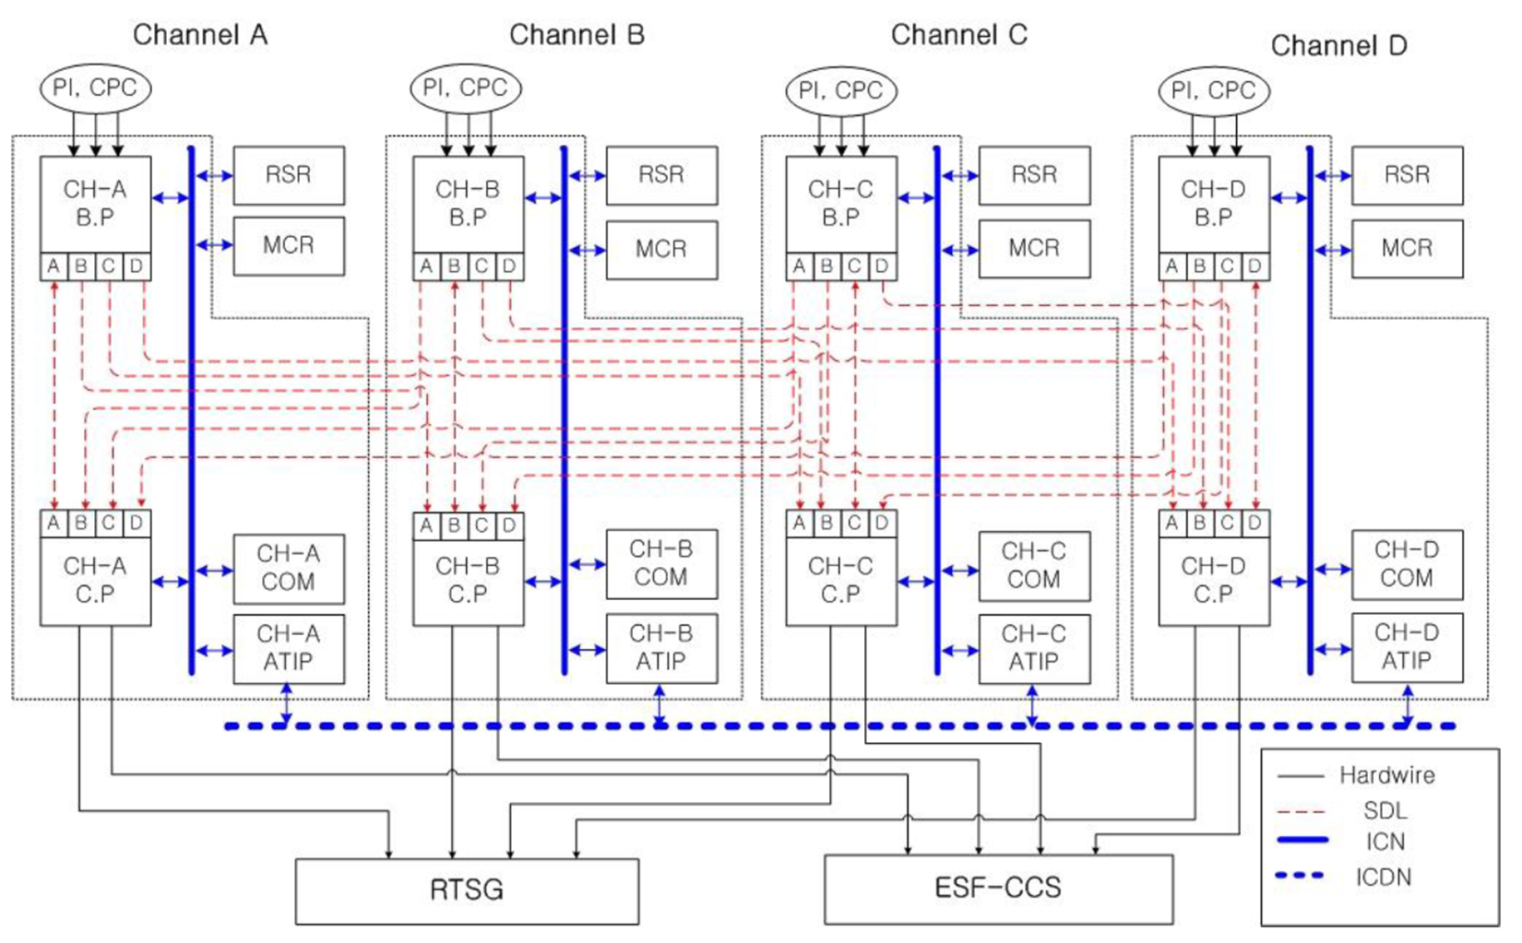

Figure 5.1: Architecture of four redundant channel IDiPS-RPS

The IDiPS-RPS generates the reactor trip signal and the engineered safety feature actuation signals automatically whenever the monitored plant processes such as pressurizer pressure and water level reach the predefined set-points. The IDiPS RPS has four redundant channels, where each channel consists of measurement channels, BP, CP, an automatic test and interface processor (ATIP), a cabinet operator module (COM), and other hardware components required to ensure a rapid and reliable reactor trip if the same parameter in two or more channels reaches a predefined limiting safety system setting, as shown in Figure 5.1. The measurement channels consist of sensors and signal conditioning equipment whose purpose is to convert the parameters being measured into signals usable to BP. The signals provided directly to the BP from the measurement channels are in the form of analog voltages which are transformed to the digital signals that BP can process. In each IDiPS-RPS channel, the BP generates a logic-level trip signals by comparing the process variables measured from the plant sensors with the predefined trip set-points. The logic-level trip signals generated in the BP module of each channel are transferred to the CP modules of all the channels via the High Reliability-Safety Data Link (HR-SDL). The CP module monitors the logic-level trip signals transferred from the four BP modules and generates a final hardware-actuating pre-trip or trip signal by conducting voting logic with the logic-level trip signals. The same parameter must indicate an unsafe condition on at least two of the four channels for the RPS to initiate the protective action. The ATIP generates various test signals for both manual and automatic tests. It also performs on-line testing for identifying the module integrity of the BPs and CPs. The COM displays the status information regarding the overall IDiPS-RPS processors to the plant operator. The trip functions are performed in the BPs and CPs and other processors are not directly related to the trip functions but with the test or monitoring functions.

For the platform used in the IDiPS RPS, the safety-grade PLC platform called POSAFE-Q was developed and adopted which meets the requirements of the Safety Class 1E, Quality Class 1, and Seismic Category I [231]. Figure 5.2 shows the overview of the POSAFE-Q hardware and software architecture and interfaces [239]. The PLC is composed of various modules such as a power module, a processor module, communication modules, digital input/output modules, analog input/output modules. The hardware modules are designed based on SMQ320C32-60 and connected with other modules through the backplane bus. Especially, the processor module consists of a TI C32 digital signal processor (DSP) CPU, or TMS320C32, [228] and various types of memories. The real-time operating system named pCOS [229] which includes the basic interrupt handling system (BIHS), real-time operating system (RTOS) kernel, and system task were developed based on the Micro-C real-time operating system. The pCOS provides a passage to transfer the input and output data between different hardware module according to the status of kernel, system task, and application task. The system task is a task that periodically operates on pCOS which includes the diagnosis task for self-diagnosis purpose, the shell task for display purpose, and the user task which executes the application software downloaded from the pSET. The pSET supports the programming of FBD/LD language based on IEC61131-3 standard and follows the software language guideline of NUREG/CR-6463 [240].

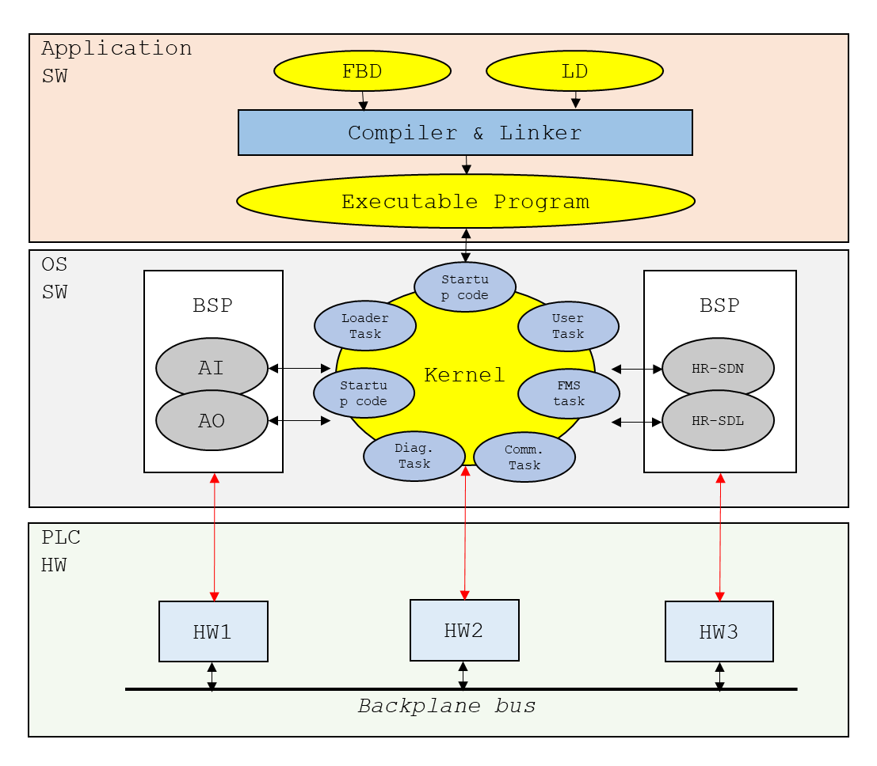

Figure 5.2: Hierarchical architecture of POSAFE-Q PLC

All of the trip functions executed by the BPs and CPs in IDiPS-RPS are implemented as software and the software used in the IDiPS-RPS was developed under a rigorous procedure with independent V&V [39], [119]. For the BP software, the SRS is first written in natural languages or formal specification languages [114], [115]. The requirements are then mechanically translated into FBD programs using NuSCRtoFBD [121] based on the NuSCR formal requirements specification [114] which are then compiled into a C program and executable machine code of a POSAFE-Q PLC using COTS software such as TI TMS320C3x C compiler. The compiled machine code is loaded to PLC memory area and is executed by the system task of the PLC microprocessor that executes the software program at fixed time interval allocated by the RTOS [231]. Figure 5.3 shows the compile procedure of the POSAFE-Q PLC to generate the machine code from the user application program written in the FBD/LD language.

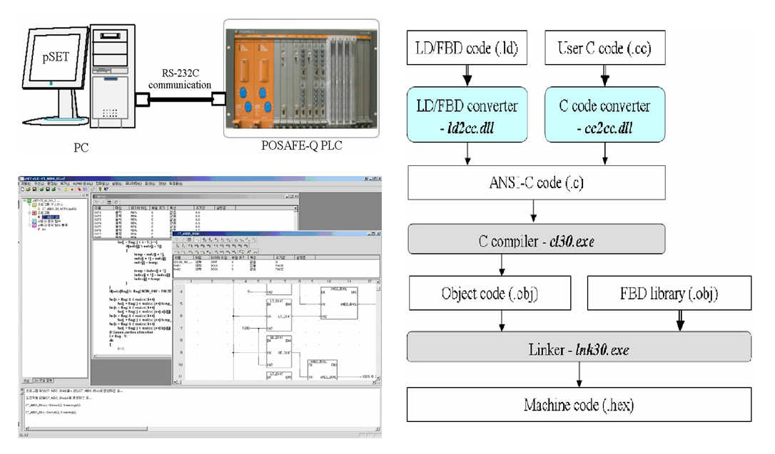

Figure 5.3: FBD program compile procedure of POSAFE-Q PLC

Figure 5.4 shows the SDLC phases and the V&V activities performed during the development of the IDiPS-RPS software [241]. The main activities of the V&V processes include the preparation of software planning documentation, verification of the SRS, software design specification and codes, and a software safety analysis. Detailed inspection of the SRS and the SDS was conducted by the Fagan inspection method [242], which focuses on the functional behavior of the software system. It evaluates development documents in various viewpoints such as their correctness, completeness, and consistency. Each viewpoint is divided into four sub-viewpoints: functional definition, input and output definitions, behavior specification, and interfaces. Analyses for evaluating licensing suitability together with the sub-viewpoints in the detailed inspection were undertaken based on the separate checklists. The software code and related documents were refined carefully with the aid of many software V&V experts based on various standards, guidelines, and V&V experience.

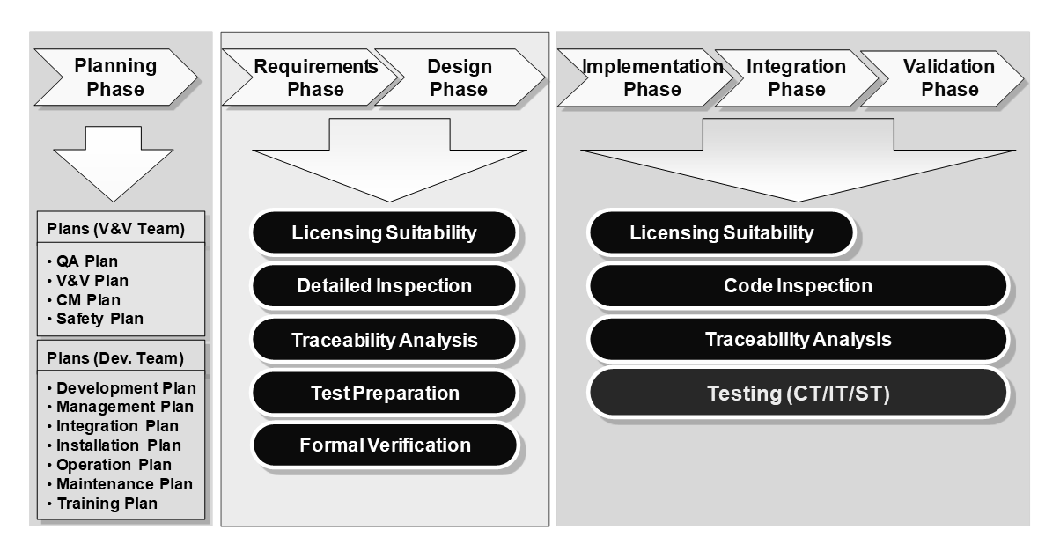

Figure 5.4: Software V&V activities for KNICS IDiPS-RPS BP software, reused with permission from [39]

Among the BP software modules, 15 modules for the trip logics are defined and the process variable of each module is compared against its predefined threshold values [237]. These trip logics are categorized into four types: (1) fixed set-point trip (8 modules), (2) variable set-point trip (2 modules), (3) manual reset trip (2 modules), and (4) digital trip (3 modules). Table 5.1 shows the BP trip logics of the IDiPS-RPS [243] and the description of each trip set-point type is as follows:

1. **Fixed set-point trip logic**: Figure 5.6 shows the fixed set-point trip logic configuration. As the process input signal rises or falls through the fixed pre-trip or trip set-point, the BP generates the pre-trip or trip signal and the trip set-point is decreased by the hysteresis. When BP is un-tripped, it restores the trip set-point value.
2. **Variable set-point trip logic**: Figure 5.7 shows the variable set-point trip logic configuration. BP generates a pre-trip or trip signal when the process input signal reaches the level of the trip or pre-trip set-point. In this logic, the set-point value can change depending on the rising or falling of the process input signal. The trip set-point tracks the process input signal using the difference of the step adjustment value if the process input signal changes at a rate that is less than the maximum preset rate. The trip set-point rises or falls at a fixed maximum preset rate when the process input signal changes with a rate greater than the maximum preset rate.
3. **Manual reset trip logic**: Figure 5.5 shows the manual reset trip logic configuration. The operation is identical to that of the bistable operation with a fixed set-point. The bistable will generate a pretrip or trip signal when the process input signal reaches the level of the trip or pretrip set-point that exists at that time. However, the set-point value will change depending on the process input signal and external manual reset by the operator in the MCR or RSR, as shown in Figure 5.5. The trip set-point will track the process input signal using the difference of the step adjustment value if the process input signal rises away from the trip. When the process input signal falls toward the trip, the set-point will be fixed but can be decreased by the amount of the preset step adjustment when the external manual set-point reset signal is asserted.
4. **Digital logic**: BP generates a pre-trip or trip signal based on the digital input signal (0 or 1) from other RPS modules such as core protection calculator.

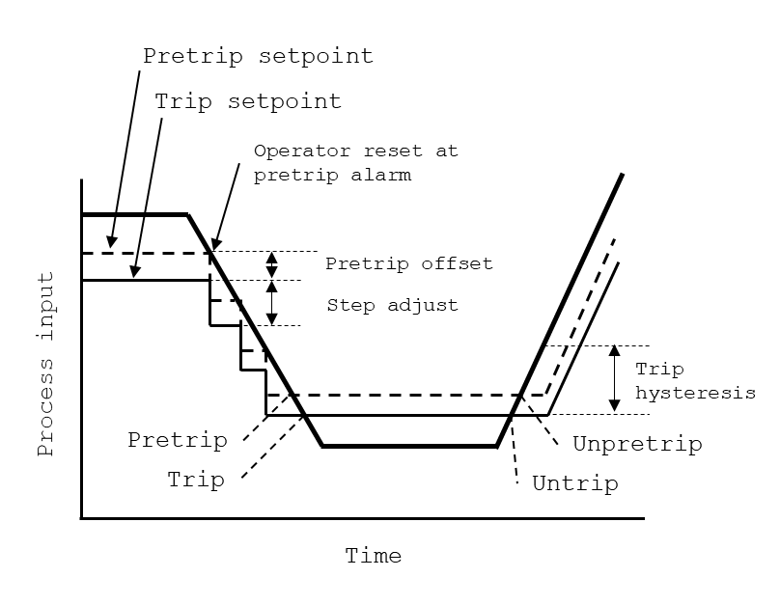

Figure 5.5: Manual reset trip logic configuration

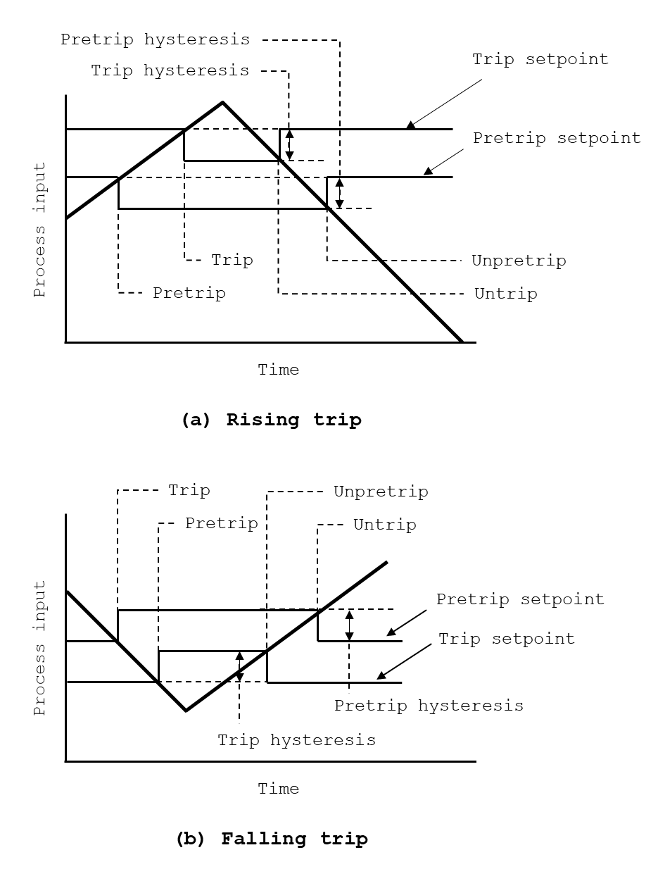

Figure 5.6: Fixed set-point trip logic configuration

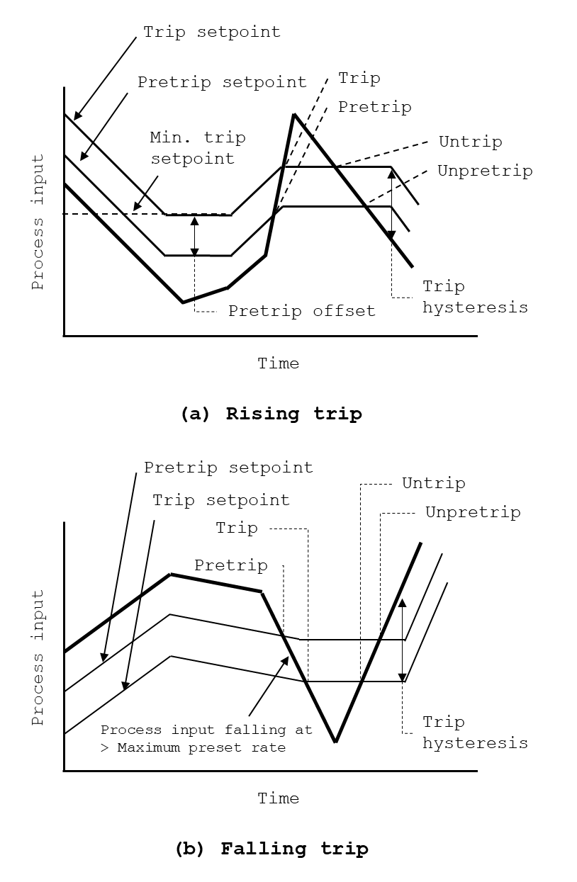

Figure 5.7: Variable set-point trip logic configuration

Table 5.1: KNICS IDiPS-RPS BP trip logic modules

188

|  |  |  |  |
| --- | --- | --- | --- |
| Software Modules | Description | OB | TSP type |
| LOG_PWR_HI Trip (_2_) | Logarithmic Power Hi Trip | Y | Fixed, Rising |
| LPD_HI Trip (_3_) | Local Power Density Hi Trip | - | Digital |
| DNBR_LO Trip (_4_) | Departure from Nucleate Boiling Ratio Low Trip | - | Digital |
| PZR_PR_HI Trip (_5_) | Pressurizer Pressure Hi Trip | - | Fixed, Rising |
| PZR_PR_LO Trip (_6_) | Pressurizer Pressure Low Trip | Y | MR, Falling |
| SG1_LVL_LO_RPS Trip (_7_) | SG-1 Low Level Trip | - | Fixed, Falling |
| SG2_LVL_LO_RPS Trip (_8_) | SG-2 Low Level Trip | - | Fixed, Falling |
| SG1_LVL_LO_ESF Trip (_9_) | SG-1 Low-Low Level Trip | - | Fixed, Falling |
| SG2_LVL_LO_ESF Trip (_A_) | SG-2 Low-Low Level Trip | - | Fixed, Falling |
| SG1_LVL_HI Trip (_B_) | SG-1 Hi Level Trip | - | Fixed, Rising |
| SG2_LVL_HI Trip (_C_) | SG-2 Hi Level Trip | - | Fixed, Rising |
| SG1_PR_LO Trip (_D_) | SG-1 Low Pressure Trip | - | MR, Falling |
| SG2_PR_LO Trip (_E_) | SG-2 Low Pressure Trip | - | MR, Falling |
| CMT_PR_HI Trip (_F_) | Containment Hi Pressure Trip | - | Fixed, Rising |
| CMT_PR_HH Trip (_G_) | Containment Hi-Hi Pressure Trip | - | Fixed, Rising |
| CWP Trip (_J_) | CPC-CWP | - | Digital |

* Fixed: Fixed trip set-point logic; RR: Variable trip set-point logic by automatic rate-limiting; MR: manual reset trip set-point logic; Digital: On/Off trip; OB: Operator bypass

Figure 5.8 shows a part of the KNICS IDiPS-RPS BP trip logic software. A system FBD of KNICS IDiPS-RPS BP trip logic software is composed of 13 different modules where a total of 475 rungs of ladder logic where 242 FBs and 122 component FBDs are defined. The description of each module of system FBD is as follows:

* **BP___a_AI_Config**: The analog input card and scan time of the BP software are determined.
* **BP___b_Self_Diag**: BP software collects the PLC self-diagnostics data and determines the BP integrity, which is transmitted to the ATIP. The self-diagnostics data is collected by reading the specific system memory address, which is allocated to specific faults such as CPU load error and analog input (AI)/digital input (DI) module error.
* **BP___c_Heart_Beat**: BP software collects the heartbeat signals which are transmitted from the ATIP and CP and analyze the integrity of each module. If the heartbeat signal of ATIP and CP are not in the normal range, the error count in increased. If the error count reaches to set-point, the ATIP and CP are considered to be failed. If the error count decreases to the half of the set-point, the ATIP and CP are considered to be normally operating.
* **BP___e_ICN_ATIP_INPUT**: BP generates a heartbeat signal which is transmitted to ATIP and CP. The BP heartbeat has a specific maximum and minimum value. The heartbeat starts from the minimum value and increases by one at every scan time until it reaches the maximum value. If the heartbeat value reaches its maximum value, the heartbeat starts from the minimum value. If the CPU module or HR-SDL module is failed, the heartbeat signal does not increase or is not transmitted to ATIP and CP.
* **BP___f_X_T_CHOISE**: BP conducts the manual test (MT), manual automatic test (MAT), and periodic automatic test (PAT) to check the integrity of the hardware modules in BP. The test is started when a specific condition is met for each test mode. If the condition indicates neither of test modes, the BP operates in its normal operation mode.
* **BP___g_X_T_START_MODE**: When BP is in the test modes, the test values for each process parameter are determined for the trip logics that utilizes input signals from an analog input module (e.g., PZR_PR_LO, SG1_LVL_LO_RPS Trip, SG1_FLW_LO Trip in Table 5.1). The test values are transmitted from the ATIP where the test values are set by the operator in MT or MAT modes and by the ATIP in PAT mode.
* **BP___h_D34_T_START_MODE**: When BP is in the test modes, the test values for each trip logics that uses digital signals from a digital input module (e.g., DNBR_LO, LDP_HI, CPC_CWP in Table 5.1) are determined. As same with the analog test values, the test values are transmitted from the ATIP.
* **BP___i_T_BAD_CONDI**: Based on the test mode determined in previous BP modules, BP checks the status of BP and generates the final test start signal. If ATIP transmitted the test start signal but the BP condition is not ready to start the specific test, the BP generates test termination signal to ATIP and operates in normal operational mode.
* **BP___j_IO_MDL_TEST**: BP checks the test signal transmitted from the ATIP and through the AI and DI modules and transmits the check result signals to ATIP for each input module.
* **BP___k_Trip_LogicA**: The trip logic part of the BP software is written in this module. Each trip logic follows either fixed set-point, variable set-point, manual reset, or digital trip logic and the process variable is compared with the predefined or variable set-point and generates an intermediate trip signal for each trip logic in BP___k_Trip_LogicA module.
* **BP___l_Trip_LogicB**: Another trip logic part of the BP software is written in this module. Each trip logic follows either fixed set-point, variable set-point, manual reset, or digital trip logic and the process variable is compared with the predefined or variable set-point and generates an intermediate trip signal for each trip logic in BP___l_Trip_LogicB module.
* **BP___m_BP_Test_Result**: The operational mode of BP (either normal or test mode) and the test values for both the manual and automatic test modes are transmitted to ATIP and CP. The ATIP acknowledges the test value from BP and transmits another test value to be tested by the BP software at next scan time.
* **BP___n_Data_Output**: BP transmits the trip signal, which integrates the intermediate trip signals calculated for each trip logic to CP through HR-SDL. In addition, the BP transmits the values of the parameters at current scan time such as process value, trip set-point, trip signal and operational mode to ATIP, COM, and operator module in MCR and RSR.

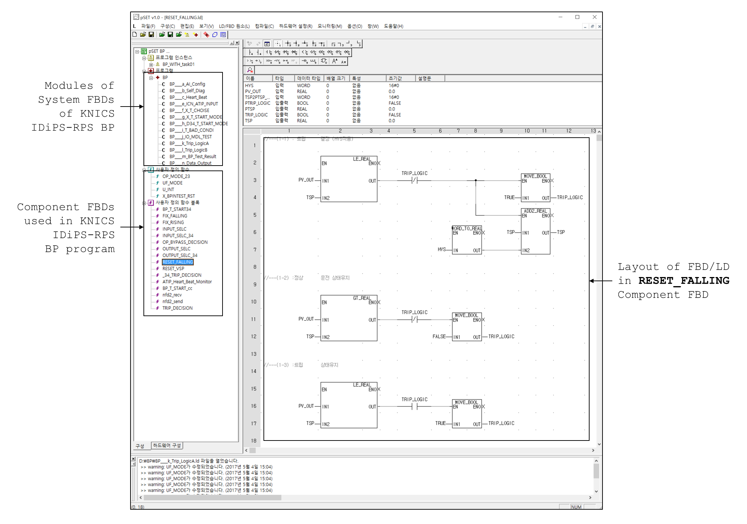

192

Figure 5.8: A part of KNICS IDiPS-RPS BP trip logic software

In this study, the pressurizer pressure low trip logic which has a variable trip set-point and operator bypass function was chosen among 15 trip logics as a case study to demonstrate the effectiveness of the proposed software test method. The pressurizer pressure low trip logic is one of the most complicated logics among BP trip logics which includes various functions such as operator bypass, reset delay timer and the set-point reset by operator, making it a good example to demonstrate the advantage of the suggested software testing method.

Figure 5.9 shows the operation logic of the pressurizer pressure low trip [244]. The process variables of pressurizer pressure low trip logic which is the pressurizer pressure from the measuring instruments (0 ~ 3,000 psi) are processed to analog signals in voltage (0~10 voltage) that are converted into digital signals (0~30,000 counts) by a 15-bit analog-digital-converter. The trip logic will generate a trip signal if the process variable decreases below the trip set-point. When the plant is in full power mode, the trip set-point is fixed to 1779 psi. The trip set-point ranges between 1779 psi and 300 psi during shut-down and start-up processes. The operator should manually decrease the trip set-point while the pressure slowly decreases during the shut-down process. When the pre-trip alarm occurs, where the pre-trip set-point is set to 70 psi above the trip set-point, the operator has to push the reset button after which the trip set-point decreases 400 psi below the current pressure. Further decrease of the trip set-point is not permitted within some delay time and bypass is permitted under 400 psi. When the pressurizer pressure increases as the plant starts up, the trip set-point is automatically set to 400 psi below the current pressure, where the trip set-point reset bypass is canceled from 500 psi.

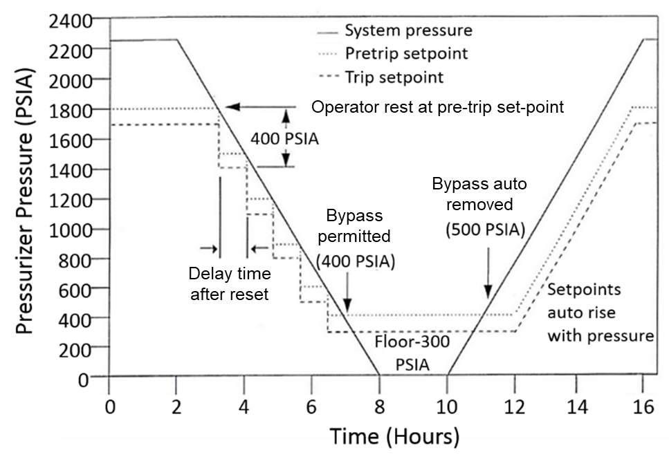

Figure 5.9: Illustration on the pressurizer pressure low trip logic

* 1. **Test Case Generation of Target Software**
     1. **Variables and States of the Target Software**

In order to apply the proposed framework to the KNICS IDiPS-RPS BP trip logic, the FBD program of BP software was loaded to the FETCG which generated the test module and the translated SMT formula, as shown in Figure 5.10. The test module generates exhaustive test cases from the defined test requirement for the FBD program based on the three levels of translated SMT files (i.e., FBs, component FBDs, and system FBD). All structure information of the FBD program is preserved in the translated SMT formula as the number of FBs and FBDs are the same for both cases, as shown in Table 5.2. While the BP trip logic software generates various external outputs including heartbeat and diagnostic signals, the number of system output variables is considered as one, the pressurizer pressure low trip signal, for the test case generation purpose in this study.

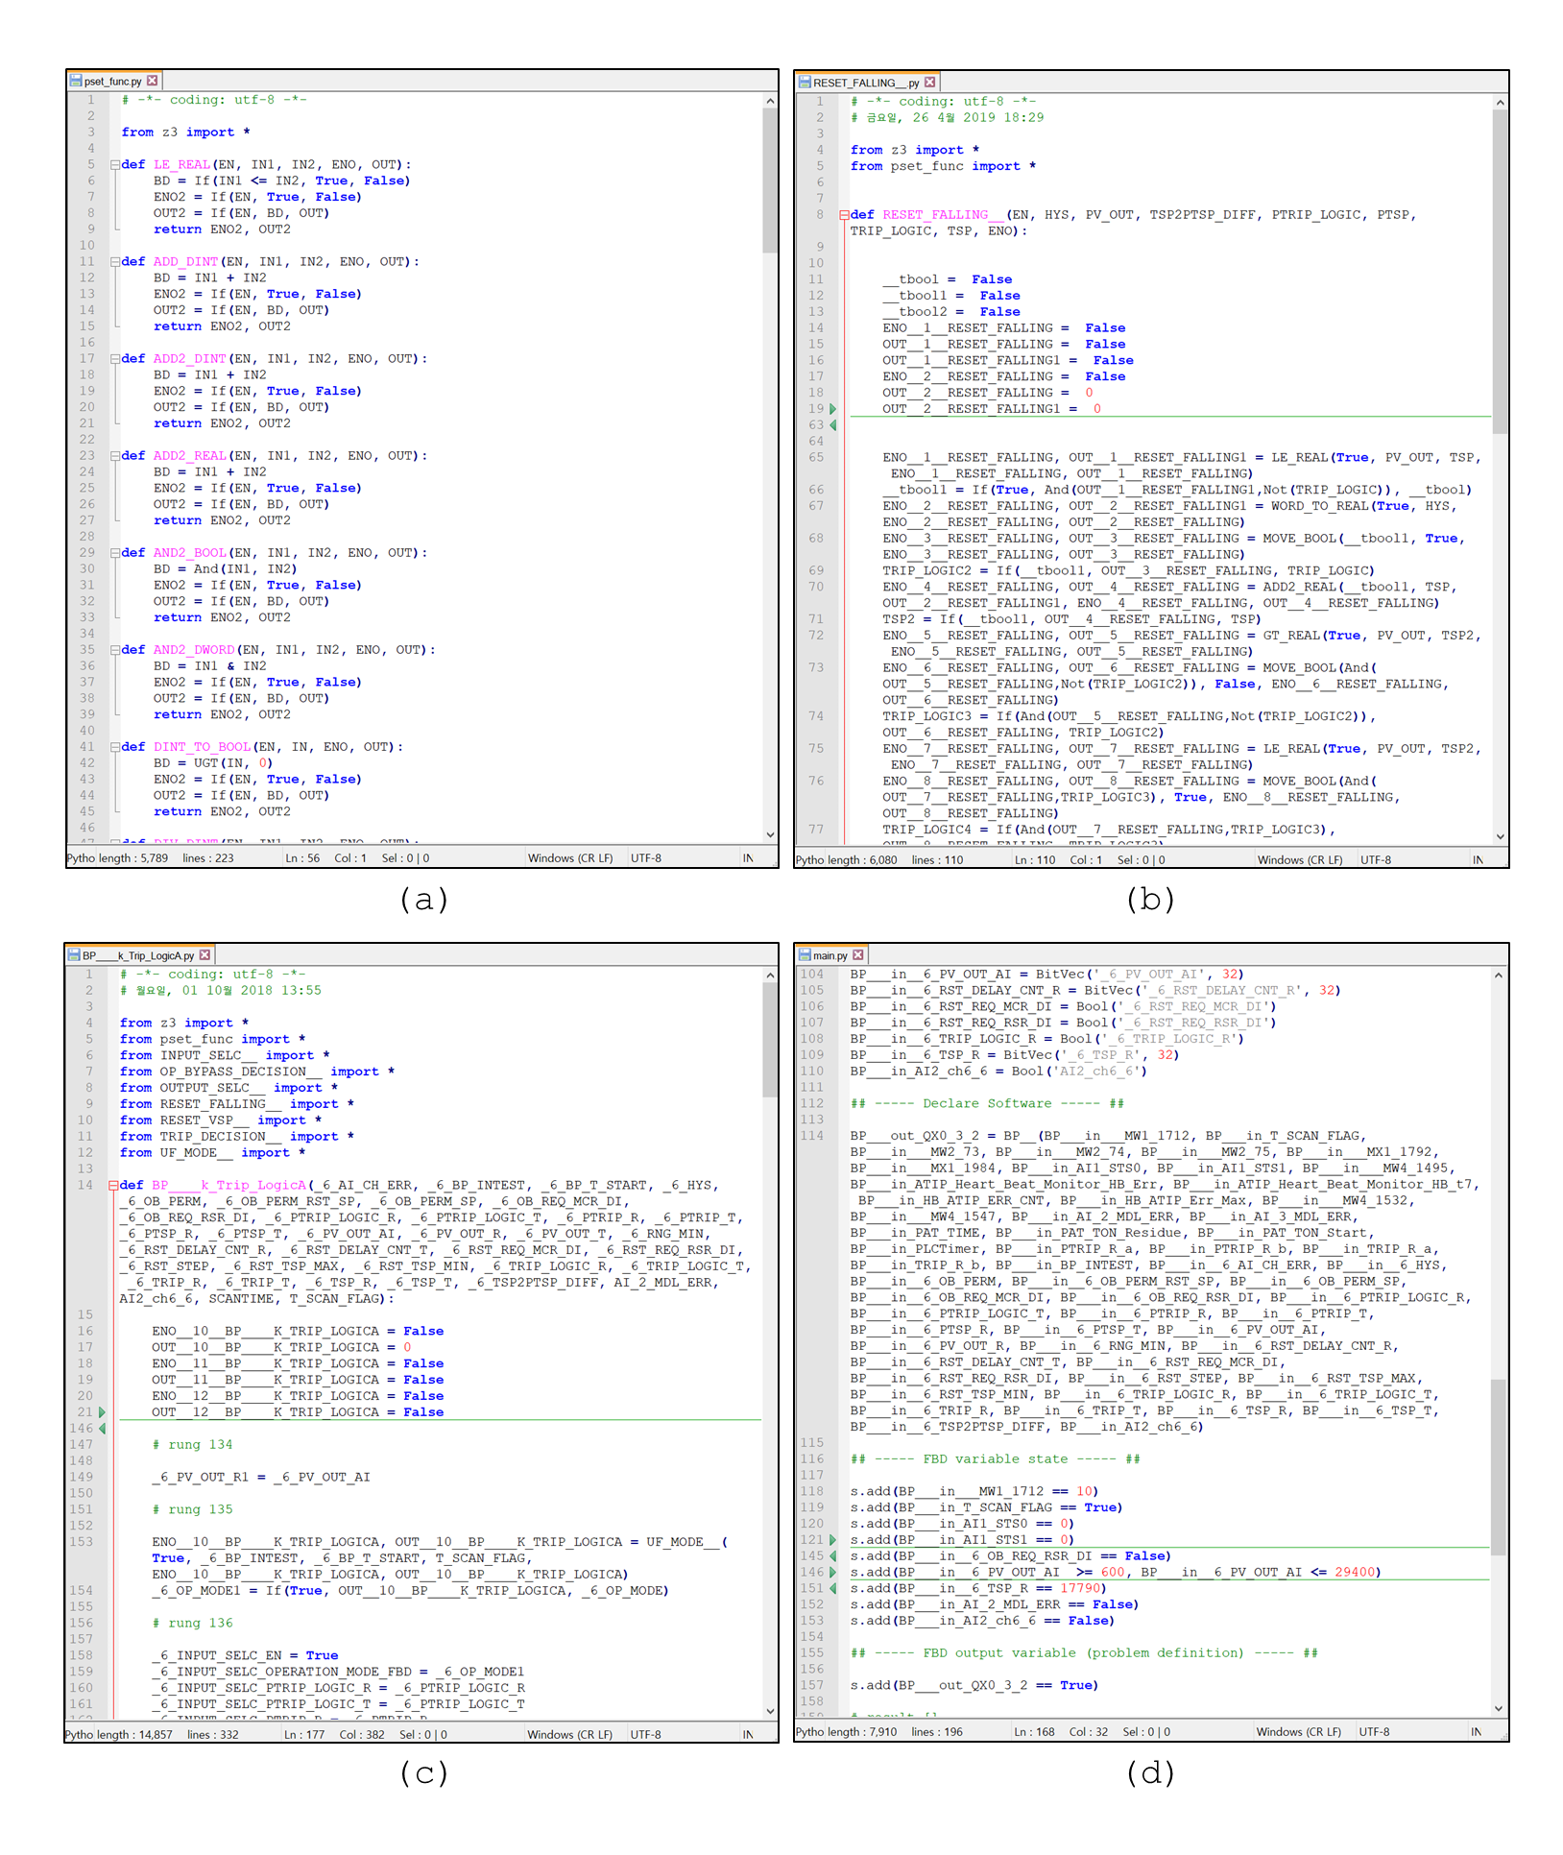

Figure 5.10: Generated files of the FETCG: (a) Function block, (b) Component FBDs, (c) System FBD, (d) Test module

Table 5.2: Information on the translated FBDs of BP pressurizer pressure low trip logic

|  |  |
| --- | --- |
| Category | Quantity |
| Function Blocks (FBs) | 242 |
| Component FBDs | 122 |
| System FBDs | 1 |
| System input/internal variable * | 32 |
| System output variable ** | 1 |
| Temporary variables used | 2,661 |

Based on the translated SMT files, the FETCG then generates the formula for the software output which the user provided and derives the software input and internal variables. In the case study, the desired software output was set to be the trip signal output of the pressurizer pressure low trip logic (*QX0_3_2*). Figure 5.11 shows the model generated for the software output in SMT-LIB format [245] by the FETCG. As shown in Figure 5.11, the FETCG derived 32 variables among a total of 612 variables defined in BP software as the software input and internal variables that contribute to generating the PZR_PR_LO trip signal. Table 5.3 shows the list of software variables related to the PZR_PR_LO trip signal generation derived from the FETCG.

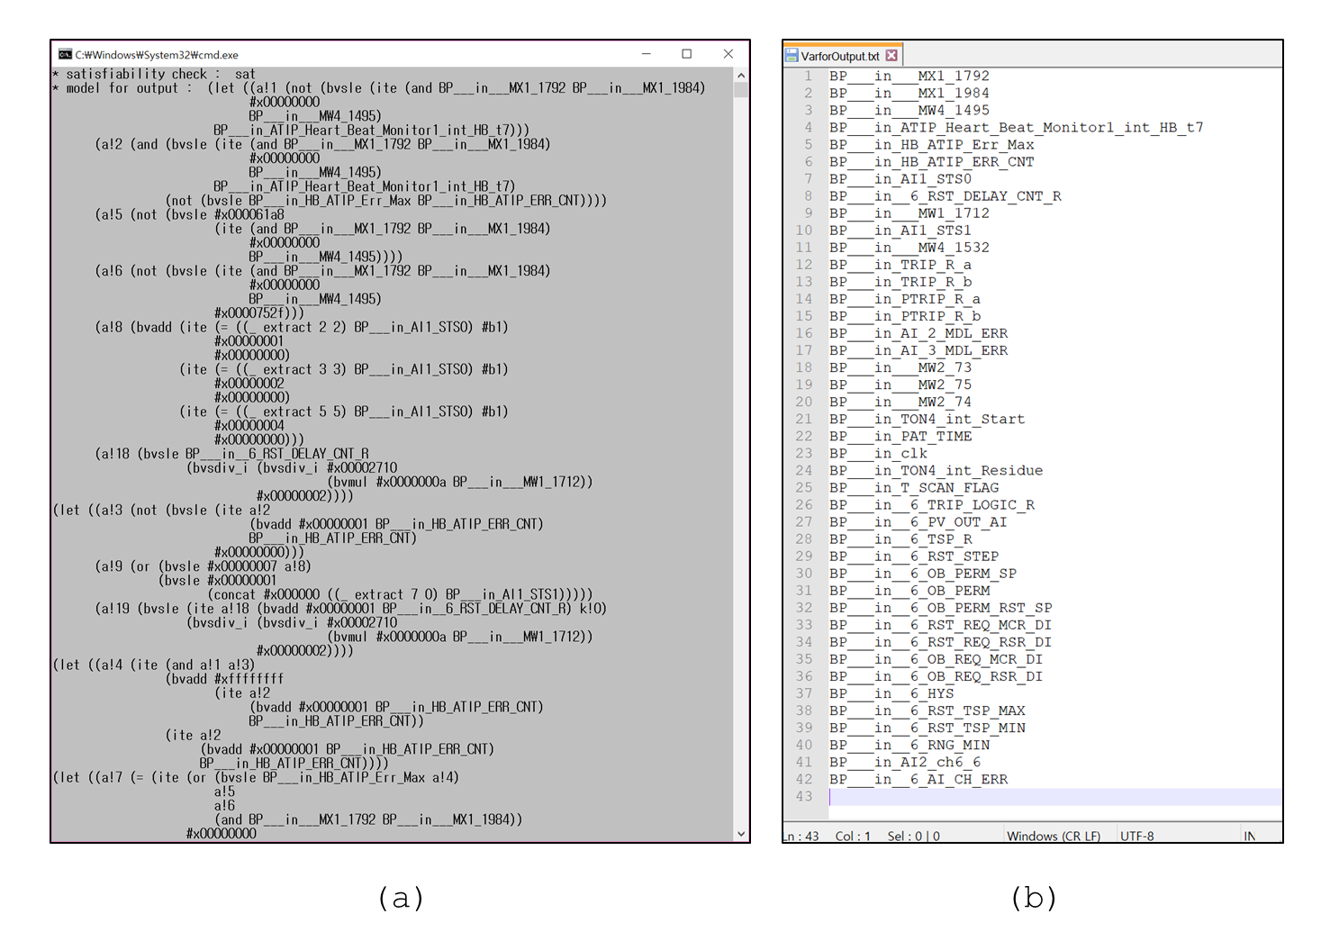

197

Figure 5.11: Execution of FBDET for the pressurizer pressure low trip logic output of KNICS IDiPS-RPS BP software: (a) Generated model for software output in SMT-LIB format, (b) Generated list of software variables that contributes to software output

Table 5.3: List of software input and internal variables for pressurizer pressure low trip logic output generation

|  |  |  |
| --- | --- | --- |
| * Name | Type | Description |
| __MX1_1792 | BOOL | ChA BP1 PLC Diagnostic Error Signal |
| __MX1_1984 | BOOL | ChA BP1 ICN 1 Module Diagnostic Error Signal |
| __MW4_1495 | DINT | ATIP Heartbeat Value |
| ATIP_Heart_Beat_Monitor1_int_HB_t7 | DINT | ATIP Heartbeat Value (before 7 scan time) |
| HB_ATIP_ERR_CNT | DINT | ATIP Heartbeat Error CountValue |
| AI1_STS0 | DINT | ChA BP1 AI 1 Module Shared Memory Error |
| _6_RST_DELAY_CNT_R | DINT | Delay Counter for TSP Reset by Operator |
| AI1_STS1 | DINT | ChA BP1 AI 1 Module Channel 01~ 08 Loop Back Check Error |
| __MW4_1532 | DINT | PAT Start Signal |
| TRIP_R_a | DINT | Trip A Signal (Real) |
| TRIP_R_b | DINT | Trip B Signal (Real) |
| PTRIP_R_a | DINT | Pre-Trip A Signal (Real) |
| PTRIP_R_b | DINT | Pre-Trip B Signal (Real) |
| AI_2_MDL_ERR | BOOL | AI-2 Module Error |
| AI_3_MDL_ERR | BOOL | AI-3 Module Error |
| __MW2_73 | DINT | ChA BP1 DI 1 Module Channel 01 ~ 16 Error |
| __MW2_75 | DINT | ChA BP1 DI 1 Module Process Voltage Error |
| __MW2_74 | DINT | ChA BP1 DI 1 Module Channel 17 ~ 32 Error |
| TON4_int_Start | BOOL | Start signal of the time on-delay FBD for BP PAT |
| clk | DINT | System clock of the PLC |
| TON4_int_Residue | DINT | Residue of the time on-delay FBD for BP PAT |
| T_SCAN_FLAG | BOOL | Flag for Test/Operation Scan (before 1 scan time) |
| _6_TRIP_LOGIC_R | BOOL | PZR_PR_LO (_6_) Trip Logic (Real) Signal (before 1 scan time) |
| _6_PV_OUT_AI | DINT | PZR_PR_LO (_6_) Trip Process Variable (from plant sensor) |
| _6_TSP_R | DINT | PZR_PR_LO (_6_) Trip set-point (Real) (before 1 scan time) |
| _6_OB_PERM | BOOL | PZR_PR_LO (_6_) Operator Bypass Permission (before 1 scan time) |
| _6_RST_REQ_MCR_DI | BOOL | PZR_PR_LO (_6_) TSP Reset Signal (from MCR) |
| _6_RST_REQ_RSR_DI | BOOL | PZR_PR_LO (_6_) TSP Reset Signal (from RSR) |
| _6_OB_REQ_MCR_DI | BOOL | PZR_PR_LO (_6_) Operator Bypass Request Signal (from MCR) |
| _6_OB_REQ_RSR_DI | BOOL | PZR_PR_LO (_6_) Operator Bypass Request Signal (from RSR) |
| AI2_ch6_6 | BOOL | PZR_PR_LO (_6_) Input Channel Hi Over Range Error Signal |
| _6_AI_CH_ERR | BOOL | PZR_PR_LO (_6_) Input Channel Error Signal |

The status of the BP module, whether it is in normal operation mode or manual or automated test mode, is determined by the BP scan flag variable (*T_SCAN_FLAG*), the BP test status variable (*BP_INTEST*) and the periodic automated test start signal (*MW4.1495*) transmitted from the ATIP. The process variable (*_6_PV_OUT_AI*) is obtained from the plant sensors and processed through the ADC of the BP. The trip set-point value *(_6_TSP_R*) of pressurizer pressure low trip logic changes depending on the process variable and set-point reset signal generated by an operator (*_6_RST_REQ_MCR_DI*, *_6_RST_REQ_RSR_DI*) when the reset delay counter (*_6_RST_DELAY_CNT_R*) exceeds the predefined maximum count value. When the process variable reaches below the level of the trip set-point, the BP software generates a pressurizer pressure low trip signal. The trip signal can also be generated if there is an error signal from BP analog input module or channel (*_6_AI_CH_ERR*, *AI_2_MDL_ERR*, *AI2_CH6_6*). The trip signal can be bypassed when the operator provides a bypass signal (*_6_OB_REQ_MCR_DI*, *_6_OB_REQ_RSR_DI*) when the operator bypass is permitted (*_6_OB_PERM*) in a specific condition. The detailed description of the software variables used for the test case generation for pressurizer pressure low trip logic is shown in Table 5.3.

* + 1. **Obtaining the Profile of the Target Software Variables**

From the viewpoint of NPP safety, the software testing of the BP trip logic needs to focus on the failure of its dedicated safety function, that is the failure of trip signal generation when demand comes. In this study, the test cases which include the states of input and internal variables that cover all possible safety signal demand situation of a target software are developed for the pressurizer pressure low trip logic considering the profile of each variable encountered in actual use during plant operation. The input variables represent the software input from various sources such as the pressure or water level signals from the measurement instruments in NPP, the operator action from the MCR or the RSR, and the error signals from other modules.

Figure 5.12 shows the general idea of the input-profile for plant process variables [52]. If a deviation happens in NPP, the plant process parameter will deviate from its normal value and the reactor trip signal will be generated if a process parameter goes beyond the set-point. In the real world, the process parameter exceeds the trip set-point at point A and B. However, as the digitalized system reads the digital value from the transmitted analog signal converted via the ADC, the digitalized system detects the demand at point A1, A2, B1, and B2. The points A1 and A2 denote the trip demand in case of slow transient (deviation A) and points B1 and B2 denote that of fast transient (deviation B).

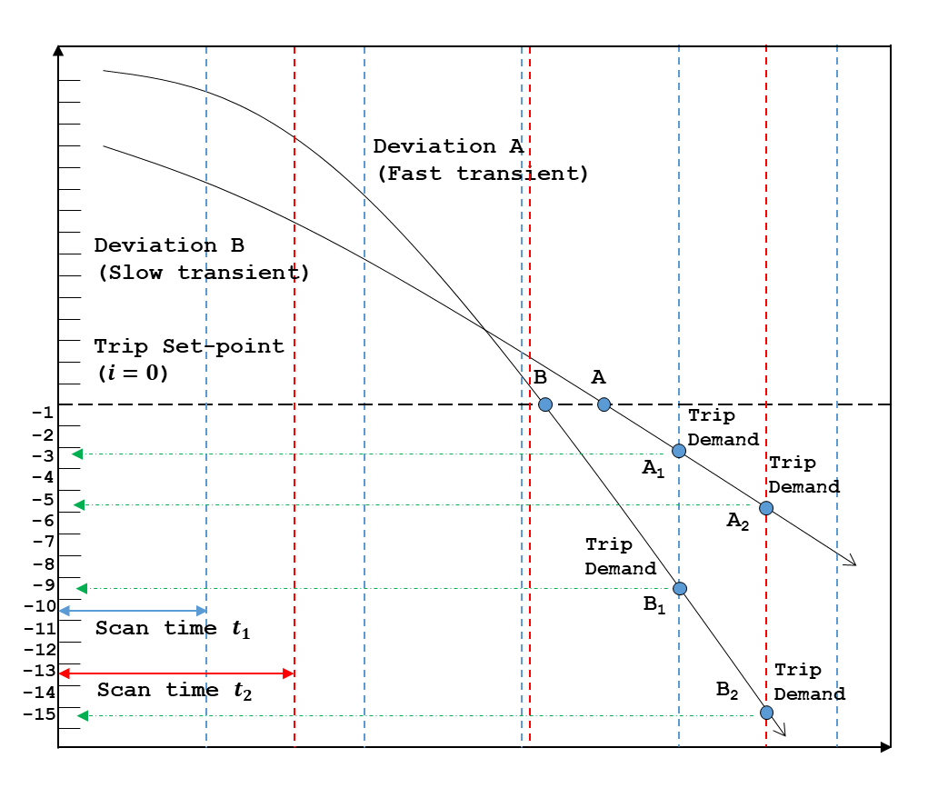

Figure 5.12: Illustration on the process parameter profile for trip demand generation in consideration of the plant dynamics and scan time of the NPP digital I&C system

As shown in Figure 5.12, the trip demand is generated at point A1 (*i* = -3) which is third digital value below trip set-point in case of slow transient and the trip demand is generated at point B1 (*i* = -9) for fast transient when the scan time is 𝑡1. As the process parameter moves faster in case of fast transient, the profile of the process variable that will generate the trip demand is larger than the case of slow transient. The profile of the process variable that represents the trip demand condition also depends on how often the digital system scans the input signals. For example, in deviation B of Figure 5.12, the trip demand is generated at point B1 (*i* = -9) for scan time 𝑡1 while it is generated at point B2 (*i* = -15) for scan time 𝑡2. Since the deviation of the plant process parameter is limited in a certain time interval, the deviation of process variable increases as the scan time of the digital system increases.

In the viewpoint of safety, digital system software testing is valid only for situations where a trip occurs. In other words, as no trip is expected for the values less than the trip set-point, the testing of such values is unnecessary from a safety perspective. In other words, the range of points from TSP to B1 (in case of scan time of t1) or B2 (in case of scan time of t2), representing the maximum change of plant variables during one scan time, is the primary concern in view of safety and thus is required for testing. It should be noted that the number of test cases depends on the plant transient rate, resolution, and scan interval. In particular, faster transient, higher resolutions, and reduced scan time intervals increase the number of test cases.

In order to obtain an exhaustive set of test cases for the plant process variable, all possible transients of plant variables in an abnormal situation that threatens plant safety should be considered. NPP accidents are typically divided into two categories: design-basis accidents (DBA) and beyond-DBA accidents (BDBA). The PRA model quantifies plant risk in consideration of both, by regarding all probable events and quantifying risk measures such as core damage frequency and large release frequency. Although very low-frequency events may be sorted and neglected in risk quantification, all probable and major abnormal accidents are considered in the PRA model. Accordingly, if a given input-profile is made for all initiating events and scenarios of NPP PRA model, then it can be said that it is an exhaustive test case for all plant process variables. As the main purpose of KNICS IDiPS-RPS development was to satisfy the I&C design requirements of APR-1400 NPP [246], the initiating events of APR-1400 NPP were considered when deriving the profile of a process variable of pressurizer pressure low trip logic (the pressurizer pressure) in this study. According to the PRA level 1 model of the APR-1400, there are 20 initiating events and categorized into two accident types [247]: (1) loss of coolant accidents which include large-break-size loss of coolant accidents (LLOCA), medium-break-size LOCA (MLOCA), small-break-size LOCA (SLOCA), steam generator tube rupture (SGTR), interfacing system LOCA (ISLOCA), reactor vessel rupture (RVR) and (2) transients which include large secondary side break (LSSB), loss of feed-water (LOFW), loss of condenser vacuum (LOCV), loss of instrument air (LOIA), loss of component cooling water (LOCCW), loss of 4.16 kV bus (LOKV), loss of 125V DC bus (LODC), loss of off-site power (LOOP), station black-out (SBO), general transients (GTRN), anticipated transients without scram (ATWS).

In this study, the profile of the process variable, which is the pressurizer pressure for pressurizer pressure low trip was obtained from the plant thermal-hydraulic simulation. To develop the input-profile for the initiating events of the APR-1400, the MARS-KS plant model of APR-1400 was used for estimating plant responses after each initiating event. The MARS-KS code [248], [249] was developed by the KAERI based on RELAP5/MOD3 [250] and COBRA-TF [251] codes. The governing equations developed in the MARS-KS code are one-dimensional conservation equations for the mass, momentum, and energy of the flow. It adopts a non-homogeneous, non-equilibrium two-fluid model for two-phase flow. The reactor kinetics model uses point kinetics with reactivity feedback coefficients and the decay power model. For the reasons outlined above, the MARS-KS code is currently being utilized as the best-estimate thermal-hydraulics code in the success criteria analyses of the PRA for Korean NPPs. KAERI has developed the MARS-KS input model of the APR-1400 was developed and prepared by KAERI [252], [253] and used for deriving the input-profile for the process variables of trip logic software based on the best-estimate analysis. Figure 5.13 shows the geometric nodalization of the MARS input model for the APR-1400 [254]. Table 5.4 shows the summary of the thermal-hydraulics results, which show the initial reactor trip signal generated by the RPS for various initiating events of APR-1400. In this study, the input-profiles of the below particular initiating events were excluded in the thermal-hydraulic analysis, for reasons as follows:

* LLOCA, MLOCA, RVR: A large release of coolant results in large negative void coefficients due to coolant voiding of the reactor core which allows nuclear fission power shutdown without the reactor trip. Therefore, the reactor trip signal is inherently not necessary for these initiating events.
* ISLOCA: The plant behavior is similar to the SLOCA, so it is regarded as SLOCA initiating event.
* ATWS: This initiating event happens if the scram system fails to work (e.g., malfunction of the reactor trip) during an anticipated transient.
* LOOP, SBO: These initiating events are not concerned as the RPS software will not activate the reactor trip signal due to loss of electricity provided to the RPS.

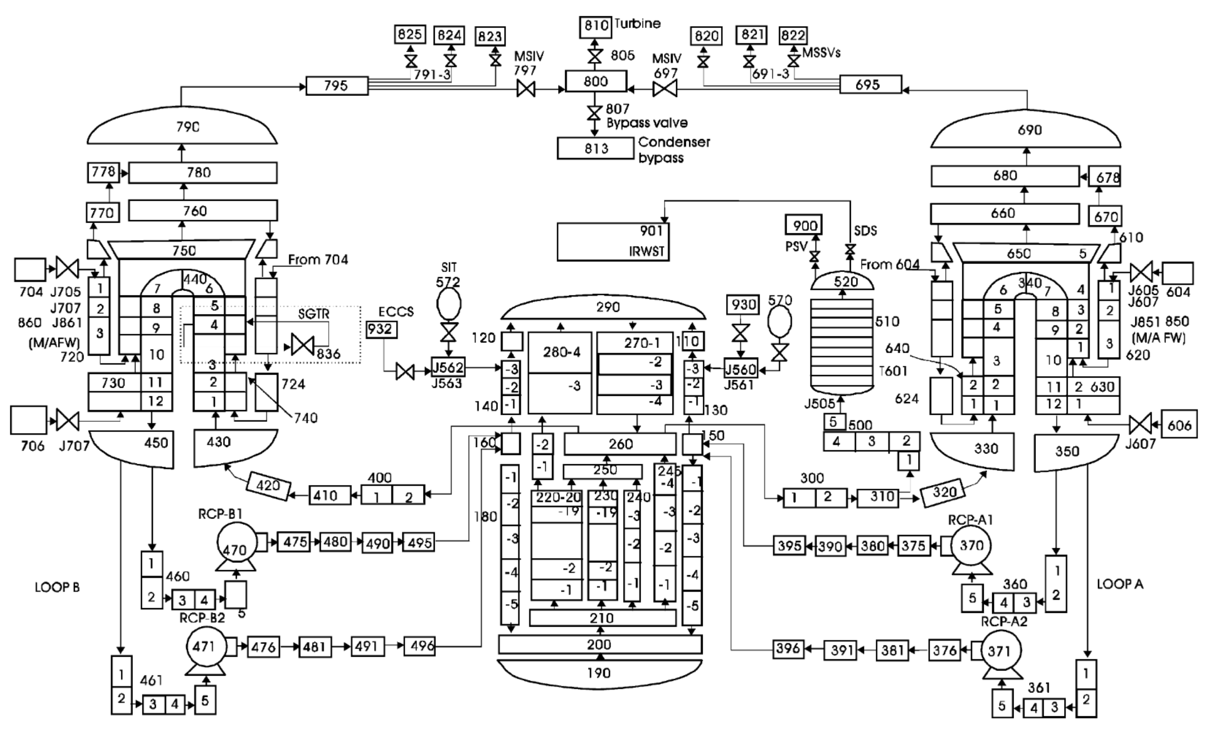

205

Figure 5.13: MARS-KS nodal diagram for APR-1400 thermal-hydraulic analysis, reused with permission from [254]

Table 5.4: Reactor trip signal actuated for various initiating events of APR-1400

|  |  |  |
| --- | --- | --- |
| Initiating event | Description | Reactor trip by RPS |
| SLOCA | Small-break-size LOCA | Pressurizer pressure low trip |
| SGTR | Steam generator tube rupture | Pressurizer pressure low trip |
| LSSB | Large secondary side break | Steam generator level low trip |
| GTRN | General transients | Steam generator level low trip |
| LOFW | Loss of feed-water | Steam generator level low trip |
| LOCV | Loss of condenser vacuum | Steam generator level low trip |
| LOCCW | Loss of component cooling water | Steam generator level low trip |
| LODC | Loss of 125V DC bus | Steam generator level low trip |
| LOKV | Loss of 4.16 kV bus | Steam generator level low trip |

For all scenarios in each initiating event, the same input-profile for the process variable was obtained because the time to reach the reactor trip always precedes the start time of any accident mitigation function. As shown in Table 5.4, the pressurizer pressure low trip logic is the first trip logic to be activated by the RPS in case of SLOCA and SGTR initiating events. Therefore, the input profile of the pressurizer pressure, which is the process variable for pressurizer pressure low trip logic is derived for the representative accidents of SLOCA and SGTR.

The SLOCA accident includes all reactor coolant system (RCS) ruptures in the primary system pressure boundary with an equivalent inside pipe diameter between 0.5 and 2 inches [247]. Due to its small break size, the control rods must be inserted in the reactor core to create negative reactivity in the core. As the decay heat cannot be fully removed due to small break size, the safety systems must be activated for the heat removal of reactor core including safety injection system, the auxiliary feed-water system, the systems for secondary steam removal, the shutdown cooling system, the safety depressurization system, and the systems for containment heat removal.

Figure 5.14 shows the input-profile of a 2.0 inch SLOCA is obtained by MARS-KS code simulation. At 87.7580 seconds after the SLOCA accident initiation, the simulation data reaches the pressurizer pressure low trip set-point. This does not mean that reactor trip occurs at exactly 87.7580 seconds though, due to scan timing and measuring resolution of the ADC of PLC. Figure 5.15 shows the input profile of a 0.5 inch SLOCA obtained by MARS-KS code simulation. Compared to 2.0 inch SLOCA, the transient for pressurizer pressure is much slower for 0.5 inch SLOCA as the break flow is smaller because of the smaller break size. For 0.5 inch SLOCA, pressurizer pressure low trip is reached at 1500.406 seconds from the SLOCA accident initiation.

Figure 5.16 shows the input-profile of the pressurizer pressure in case of the SGTR initiating event obtained by MARS-KS code simulation. The steam generator is a vertical inverse U-tube heat exchanger with an integral economizer, which operates with the RCS coolant in the tube side and secondary coolant in the shell side. The two steam generators are designed to transfer the heat of 4000 MWth from the RCS to the secondary system where each steam generator uses 13,102 U-tubes with Alloy 690 as tube material to improve the integrity of steam generator tube [255]. The SGTR accident is defined as an accident where the RCS coolant is leaked to the secondary side because there is a rupture in at least one u-tube in the steam generator. A representative scenario of APR-1400 SGTR accident is the double-ended guillotine break of a single u-tube in a single steam generator [247]. In the MARS-KS input model, the size of break equivalent to the guillotine break of the steam generator U-tubes with the diameter of 0.75 inch which is a typical diameter of U-tubes used for the steam generators in NPPs [256], [257]. As shown in Figure 5.16, at 508.7663 seconds from the accident initiation, the simulation data for the pressurizer pressure reaches the pressurizer pressure low trip set-point.

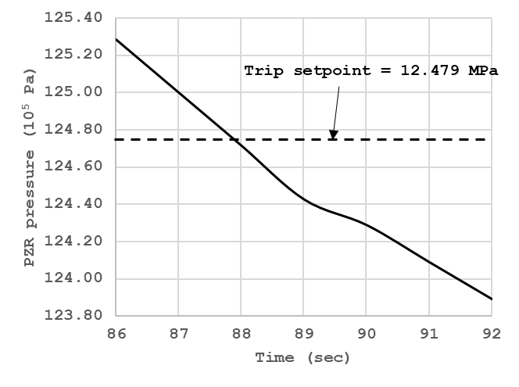

Figure 5.14: Input-profile of pressurizer pressure for a 2.0 inch small-break-size loss of coolant accident

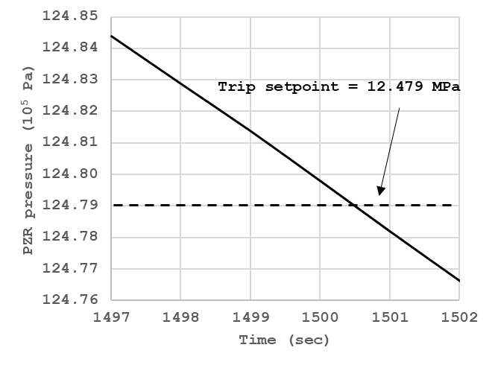

Figure 5.15: Input-profile of pressurizer pressure for a 0.5 inch small-break-size loss of coolant accident

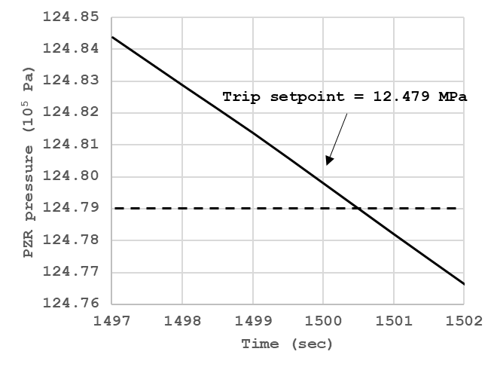

Figure 5.16: Input-profile of pressurizer pressure for steam generator tube rupture

As the design requirement of the IDiPS-RPS limits the scan time to less than 50 ms, the pressure deviation during the time interval between operational scan modes (100 ms) at the point of trip demand is derived based on the simulation result. Table 5.5 shows the $D_{max}$, which is the maximum $i$ (i-th digital value of the process variable below the trip set-point that can be changed in a single scan time of 100 ms) given 15-bit ADC resolution obtained from plant simulation results for various hole sizes of SLOCA. As shown in Table 5.5, one test case is required for 15-bit ADC with 100 milliseconds of scan interval for the process variable of pressurizer pressure low trip in case of 0.5 inch SLOCA because the rate of pressure decrease is so slow; however, five test cases are required for the process variable of pressurizer pressure low trip in case of 2.0 inch SLOCA which shows more rapid change in pressure decrease compared to 0.5 inch SLOCA. In case of SGTR accident, the plant transient is much slower compared to the same break size of SLOCA as the primary coolant is leaked through the secondary side; therefore, one test is required for the case of ADC resolution and the scan interval of IDiPS-RPS BP as similar to the 0.5 inch LOCA case.

Table 5.5: $D_{max}$ of the pressurizer pressure for APR-1400 initiating events

|  |  |  |  |
| --- | --- | --- | --- |
| ID | Category | Hole diameter (hole size) | $D_{max}$ (count) |
| 1 | SLOCA | 0.5 inch (0.0001267 m2) | 1 |
| 2 | SLOCA | 1 inch (0.0005067 m2) | 2 |
| 3 | SLOCA | 1.5 inch (0.001140 m2) | 3 |
| 4 | SLOCA | 2.0 inch (0.002026 m2) | 5 |
| 5 | SGTR | 0.75 x 2 inch * (0.000570 m2) | 1 |

* The scenario assumed that the 0.75-inch diameter u-tube pipe used in the steam generator undergoes a guillotine break.

The possible states or range of other software input and internal variables were identified based on the profile of each variable encountered in actual use during plant operation by inspecting the software logic and the other available information such as SRS and SDS documents [236], [237]. For example, the scan mode of BP software is determined by the state of two internal variables (*BP_INTEST*, *T_SCAN_FLAG*) and one input variable (*BP_T_START*), as shown in Table 5.6. While the BP_INTEST variable is a double integer (DINT) type variable and can have the value from 0 to 4,294,967,295 (maximum value for 32-bit signed integer); the BP software recognizes the error and resets the value of the variable *BP_INTEST* to zero at each scan time if the value does not correspond to the pre-defined values (0, 1, 3, 6 as shown in Table 5.6). Therefore, the possible states of the variable *BP_INTEST* is set to 0, 1, 3, 6 when generating the test cases. In case of trip bypass request and permission variables which are inputs from the operators, they are Boolean type variables so they can have the value of either true or false. The possible states of other software input and internal variables in Table 5.3 were derived in a similar manner.

Table 5.6: Truth table of BP scan mode decision

|  |  |  |  |  |
| --- | --- | --- | --- | --- |
| Case | BP_T_START | BP_INTEST | T_SCAN_FLAG | Result* |
| 1 | False | 0 | F | (1) |
| 2 | False | 0 | T | (4) |
| 3 | False | 1 | F | (5) |
| 4 | False | 1 | T | (4) |
| 5 | False | 3 | F | (1) |
| 6 | False | 3 | T | (6) |
| 7 | False | 6 | F | (1) |
| 8 | False | 6 | T | (6) |
| 9 | True | 0 | F | (1) |
| 10 | True | 0 | T | (4) |
| 11 | True | 1 | F | (2) |
| 12 | True | 1 | T | (4) |
| 13 | True | 3 | F | (1) |
| 14 | True | 3 | T | (3) |
| 15 | True | 6 | F | (1) |
| 16 | True | 6 | T | (3) |

* (1): Operational scan mode, (2): Manual test (MT) scan mode, (3): Automatic scan (AT) mode, (4): Idle scan mode, (5): Restore from MT scan mode, (6): Restore from AT scan mode.

* + 1. **Exhaustive Test Case Generation of the Target Software**

In this study, the exhaustive test cases are generated for the pressurizer pressure low trip logic of the KNICS IDiPS-RPS BP software based on the list of software input and internal variables derived in Section 5.2.1 and their profile derived in Section 5.2.2. Table 5.7 shows the summary of the states of software variables derived in Table 5.3 that contribute to generating pressurizer pressure low trip signal of BP software. In the case study, this study focuses on deriving the exhaustive test cases that represent the trip generation by the BP software given the test scope, as follows:

1. The BP software runs on various scan modes, including operational mode, manual test mode, automatic test mode, and others, as shown in Table 5.6. Since the purpose of the software testing is to ensure that software generates the trip signal when demand comes, the test cases are generated for the operational mode of the software. Therefore, the representative values are assumed for the software variables that indicate the test mode and conditions
2. The failure of BP modules such as BP analog input module shared memory error, loop back check error, digital module channel error is assumed. For example, if there is any error in the analog input channel that receives the process variable for each trip logic, the BP software generates the trip signal even if the process variable for the trip logic is in the normal range of operation and is not in trip initiation condition. In the case study, the states of the software variables that indicate the BP module error and others are identified based on the FMEA report of the POSAFE-Q PLC [258], [259].
3. The BP checks the heartbeat signal from ATIP and determines whether the ATIP is in good condition so that BP can initiate the periodic automatic test which utilizes the test signal from the ATIP. If there is any error in the heartbeat signal from ATIP, the BP doesn’t enter the test mode. Since the purpose of the software testing is to ensure that software generates the trip signal when demand comes, it is assumed that there is no error in the heartbeat signal, which is transmitted from the ATIP. Therefore, the test cases are generated focusing on the operational mode of the software; therefore, the representative values are assumed for the software variables that are related to the heartbeat error signal generation such as ATIP heartbeat and ATIP heartbeat error count.
4. For manual reset trip logics, the operator can request the trip set-point reset signal which decreases or increases the trip set-point by predefined step value and delay the trip generation by the trip software. This is conducted by the operator when the NPP is in its shutdown process where the process variable slowly decreases or increases to its shutdown state. For example, the operator can request a reset signal that decreases the pressurizer pressure low trip set-point during the plant shutdown phase where the pressurizer pressure decreases slowly for safe shutdown. While the trip set-point reset is not allowed to the operator during plant normal operation or accident condition, the operator can perform a wrong operation, or the error of commission [260], [261], such as pressing the reset request button. In the case study, the states of software variables that indicate the trip set-point reset for trip logic are identified.
5. The BP software generates a reactor trip bypass permit signal and indicates the operator in the MCR or RSR when the process variable reaches to the predefined reactor trip bypass permission set-point while the plant is in its shutdown state. In this case, the operator can bypass the reactor trip signal by generating the reactor trip bypass request signal. In the normal operation or accident condition, the operator is not allowed to request a reactor trip bypass signal; however, the operator can perform a wrong operation, the error of commission [260], [261], such as pressing the trip bypass request button. In the case study, the states of the software variables that indicate the trip bypass signal are identified.
6. In this study, the test cases are generated for the trip initiation by the BP software. Therefore, the states of the software variables that indicate trip signals at previous scan time are assumed to be false.
7. The range of the process variable and the trip set-point for pressurizer pressure low trip logic is identified based on the available software specification documents. In NPP digital systems, the ADC converts the analog signals from various sensors that monitor the plant transient to digital values that the trip logic software can use to compare it with the pre-defined trip set-point. The possible range of the process variable and trip set-point is limited with the resolution of the ADC and is rigorously specified in the SDS. For example, the minimum and maximum value of process variable and the trip set-point are from 600 to 29400 counts and from 999 to 17790 counts, respectively. In the case study, the profile of process variable derived in Section 5.2.2 is used in the test case generation.

To generate the exhaustive test cases for the target test scope, the states of software variables are defined in the test module in the FBDET framework, as shown in Figure 0.86. In the test module, the states of the software input and internal variables that contribute to the software output are defined. The test module then calls the FBD program and FBs used in the FBD program that is translated into the SMT format and generates the exhaustive test cases for the target scenario based on the FBDET algorithm described in Section 3.4. In the case study, the test requirement was set to be the PZR_PR_LO trip signal generation (*QX0_3_2* = True).

Table 5.7: Summary of the software variables’ states for KNICS IDiPS-RPS BP pressurizer pressure low trip logic software

215

|  |  |  |
| --- | --- | --- |
| * Name | Range or value | Description |
| __MX1_1792 | [false, true] | The variable __MX1_1792 is set to 0x1 when there is PLC diagnostic error and 0x0 when there is no such error. |
| __MX1_1984 | [false, true] | The variable __MX1_1984 is set to 0x1 when there is BP ICN 1module diagnostic error and 0x0 when there is no such error. |
| __MW4_1495 | 26007 | In the case study, it is assumed that there is no error in ATIP. In this study, representative value of ATIP heartbeat (at current scan time) is selected. It is notable that the normal range of ATIP heartbeat is from 25000 to 29999. |
| ATIP_Heart_Beat_Monitor1_int_HB_t7 | 26000 | In the case study, it is assumed that there is no error in ATIP. In this study, representative value of ATIP heartbeat (before 7 scan time) is selected. It is notable that the normal range of ATIP heartbeat is from 25000 to 29999. |
| HB_ATIP_ERR_CNT | 0 | In the case study, it is assumed that there is no error in ATIP. In this study, representative value of ATIP error count is selected. |
| AI1_STS0 | [0, 2C] | The variable AI1_STS0 is set to 0x2C when there is an error in the BP analog input module shared memory and 0x0 when there is no such error. |
| _6_RST_DELAY_CNT_R | 51 | The reset delay counter increases from zero to its maximum value (51) and resets to zero when the trip set-point reset signal is requested by the operators in MCR or RSR. In this study, the representative value of 51 for reset delay counter was selected as the reset delay counter remains its maximum value during software operation. |
| AI1_STS1 | [0, 1] | The variable AI1_STS1 is set to 0x1 when there is BP AI 1 module channel loop back check error and 0x0 when there is no such error. |
| __MW4_1532 | 0 | In the case study, the operational mode of the BP software is only considered, not test modes; thus, it is assumed that there is no PAT start signal transmitted from the operators or the ATIP. |
| TRIP_R_a | 0 | In this study, the trip initiation condition by the BP software is only considered; thus, the variable TRIP_R_a is assumed to be 0x0 which indicates that the trip signals were not generated by the BP software at previous scan time. |
| TRIP_R_b | 0 | In this study, the trip initiation condition by the BP software is only considered; thus, the variable TRIP_R_b is assumed to be 0x0 which indicates that the trip signals were not generated by the BP software at previous scan time. |
| PTRIP_R_a | 0x20 | In this study, the trip initiation condition by the BP software is only considered. The pre-trip signal is generated for each trip logic to alarm the operators that trip signal will be generated soon. The variables PTRIP_R_a contains the pre-trip information on the LOG_PWR_HI (_2_), LPD_HI (_3_), DNBR_LO (_4_), PZR_PR_HI (_5_), PZR_PR_LO (_6_), SG1_LVL_LO_RPS (_7_), SG2_LVL_LO_RPS (_8_), SG1_LVL_LO_ESF (_9_) trip logics. Therefore, the variable PTRIP_R_a is assumed to be 0x20 which indicates that the pre-trip signal for pressurizer pressure low trip logic is already generated. |
| PTRIP_R_b  216 | 0 | In this study, the trip initiation condition by the BP software is only considered. The pre-trip signal is generated for each trip logic to alarm the operators that trip signal will be generated soon. The variables PTRIP_R_b contains the pre-trip information on the SG2_LVL_LO_ESF (_A_), SG1_LVL_HI (_B_), SG2_LVL_HI (_C_), SG1_PR_LO (_D_), SG2_PR_LO (_E_), CMT_PR_HI (_F_), CMT_PR_HH (_G_) trip logics. trip logics. Therefore, the variable PTRIP_R_a is assumed to be 0x0 which indicates that no pre-trip signal except for the pressurizer pressure low trip logic is generated. |
| AI_2_MDL_ERR | [false, true] | The variable AI_2_MDL_ERR is set to 0x1 when there is AI-2 module error and 0x0 when there is no such error. |
| AI_3_MDL_ERR | [false, true] | The variable AI_3_MDL_ERR is set to 0x1 when there is AI-3 module error and 0x0 when there is no such error. |
| __MW2_73 | [0, 1] | The variable __MW2_73 is set to 0x1 when there is BP DI module channel error (in channel 1~16) and 0x0 when there is no such error. |
| __MW2_75 | [0, 1] | The variable __MW2_75 is set to 0x1 when there is BP DI module process voltage error and 0x0 when there is no such error. |
| __MW2_74 | [0, 1] | The variable __MW2_75 is set to 0x1 when there is BP DI module channel error (in channel 17~32) and 0x0 when there is no such error. |
| TON4_int_Start | false | In the case study, the operational mode of the BP software is only considered, not test modes; thus, it is assumed that the start signal of the time on-delay FBD for PAT mode is considered to be false. |
| clk | 0 | For timer FBD including TON and TOF, the difference between the PLC system clock and the residue of the timer FBD is compared with the preset timer (PT) of the timer FBD and generates a signal based on the result. In the case study, the operational mode of the BP software is only considered, not test modes. In this study, the representative value for the system clock of the PLC is set which disables the PAT mode. |
| TON4_int_Residue  217 | 0 | For timer FBD including TON and TOF, the difference between the PLC system clock and the residue of the timer FBD is compared with the preset timer (PT) of the timer FBD and generates a signal based on the result. In the case study, the operational mode of the BP software is only considered, not test modes. In this study, the representative value for the residue of the timer on-delay FBD for PAT enable is set to disable the PAT mode. |
| T_SCAN_FLAG | true | In the case study, the operational mode of the BP software is only considered, not test modes; thus, it is assumed that the flag for test/operation scan at previous scan time was true which indicates the operational scan mode for current scan time. |
| _6_TRIP_LOGIC_R | false | In this study, the trip initiation condition by the BP software is only considered; thus, the variable _6_TRIP_LOGIC_R is assumed to be false which indicates that the intermediate trip signal was not generated for the PZR_PR_LO trip logic (_6_) by the BP software at previous scan time. |
| _6_PV_OUT_AI | [_6_TSP_R – 4, _6_TSP_R] | The states of the process variable for PZR_PR_LO (_6_) trip (pressurizer pressure) were identified based on the simulation results of NPP DBAs discussed in Section 5.3.2. As discussed in Section 5.3.2, the maximum deviation of the pressurizer pressure is 5 counts during the time interval between operational scan modes (100 ms). As the case study focuses on the trip initiation condition, the variable _6_PV_OUT_AI is set to have the value ranging from the 4 counts below the trip set-point (maximum pressure drop) to the trip set-point (minimum pressure drop). |
| _6_TSP_R | [999, 17790] | The states of the trip set-point for PZR_PR_LO (_6_) trip were identified based on the software requirement and design specification documents. For PZR_PR_LO (_6_) trip, the trip set-point can be reset by the operator for NPP shutdown operation. The minimum (999 counts) and maximum (17790 counts) value for the trip set-point of PZR_PR_LO (_6_) trip is set to avoid any non-trip accidents during NPP shutdown. In this study, the trip set-point is assumed to have the values between the minimum and maximum values. |
| _6_OB_PERM | [false, true] | The variable _6_OB_PERM is set to true when the operator request the trip bypass permission signal and false when the operator does not request such signal. |
| _6_RST_REQ_MCR_DI | [false, true] | The variable _6_RST_REQ_MCR_DI is set to be true when the operator in MCR request the trip set-point reset signal and false when the operator in MCR does not request such signal. |
| _6_RST_REQ_RSR_DI | [false, true] | The variable _6_RST_REQ_RSR_DI is set to be true when the operator in RSR request the trip set-point reset signal and false when the operator in RSR does not request such signal. |
| _6_OB_REQ_MCR_DI | [false, true] | The variable _6_RST_REQ_MCR_DI is set to be true when the operator in MCR request the trip bypass request signal and false when the operator in MCR does not request such signal. |
| _6_OB_REQ_RSR_DI | [false, true] | The variable _6_RST_REQ_RSR_DI is set to be true when the operator in RSR request the trip bypass request signal and false when the operator in RSR does not request such signal. |
| AI2_ch6_6 | [false, true] | The variable AI2_ch6_6 is set to true when there is input channel high over range error and false when there is no such error. |
| _6_AI_CH_ERR | [false, true] | The variable _6_AI_CH_ERR is set to true when there is input channel error and false when there is no such error. |

218

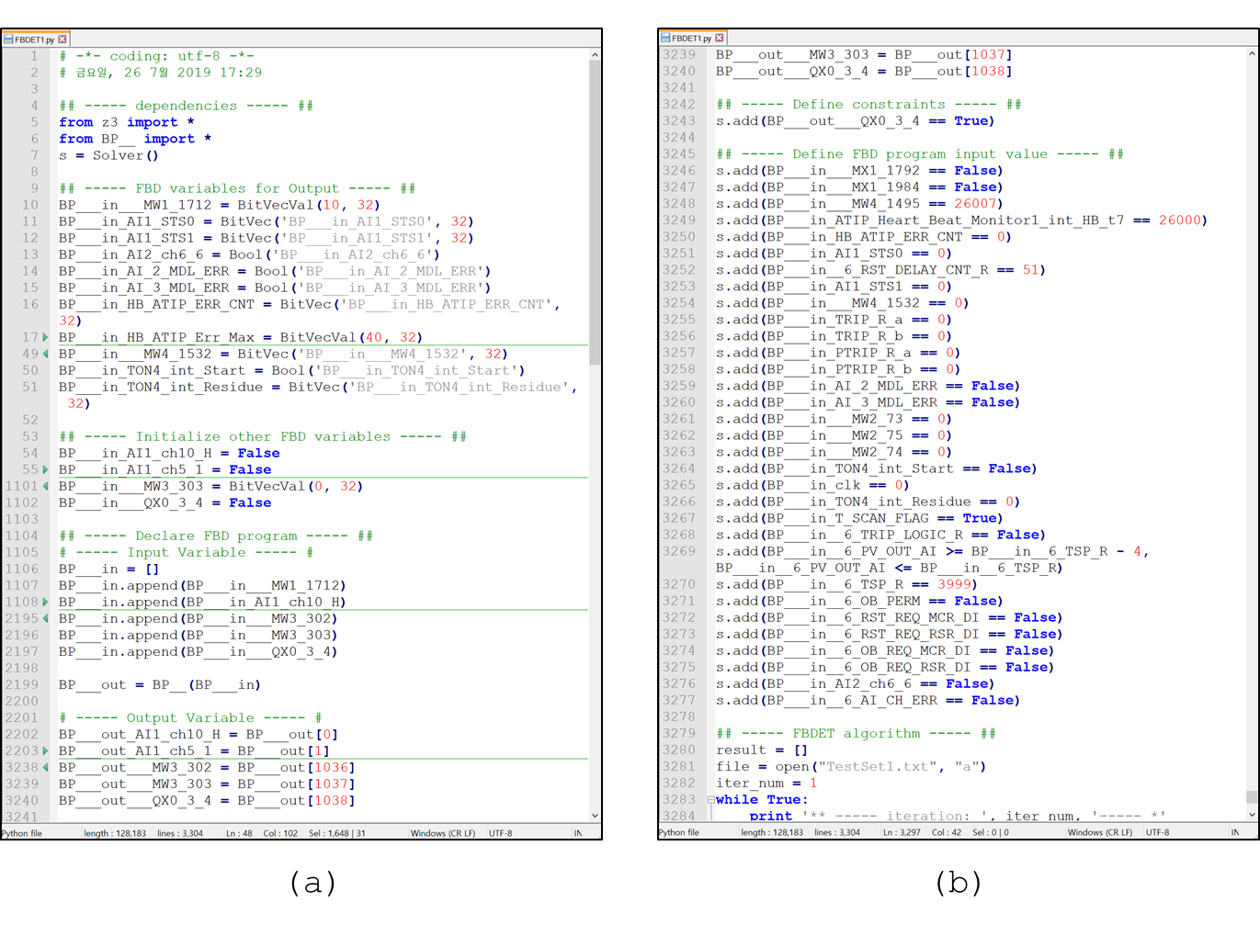

219

Figure 5.17: Test module for generating exhaustive test cases for BP PZR_PR_LO trip logic: (a) FBD program and variable definition, (b) test requirement and variable state definition

Figure 5.18 shows the generated exhaustive test cases by the test module shown in Figure 5.17. The test module invokes the SMT solver and derives the model that satisfies the test requirement given the conditions of the software variables’ states, as shown in Figure 5.18-(a). At each iteration, the SMT solver checks the satisfiability of a given formula. If the formula is satisfiable, the model that makes the formula true is retrieved and saved as a test case for the FBD program. In order to derive another model, the negations of the derived models at the previous iteration are added as a new constraint to the test requirement, which is used at the next iteration. The same process is repeated until the SMT solver return *unsat* as a satisfiability check result which indicates that there is no solution which satisfies the formula given constraints. Figure 5.18-(b) shows a part of exhaustive test cases where each line indicates a single test case containing the states of the software input and internal variables that make the trip logic output (*QX0_3_2*) to be true. As a result of the exhaustive test case generation for KNICS IDiPS-RPS BP PZR_PR_LO trip logic, 4,206,164,480 test cases were generated for the target test scope. Table 5.8 shows the summary of the generated exhaustive test cases for each trip set-point of pressurizer pressure low trip logic and the time to generate the test cases.

Table 5.9 shows some examples of the generated test cases for pressurizer pressure low trip logic. Each test case represents a single scenario where the combination of software input and internal variables’ states generate the pressurizer pressure low trip output by software and is exclusive to each other which together forms the exhaustive test cases for the target scenario.

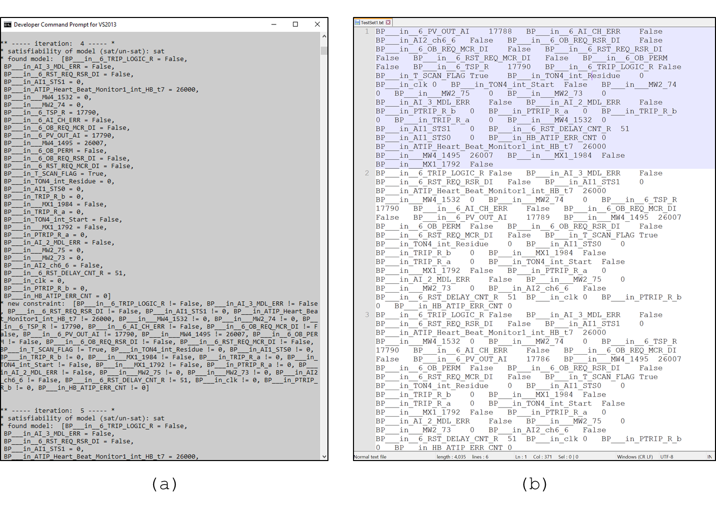

Figure 5.18: Exhaustive test case generation for BP PZR_PR_LO trip logic: (a) Screenshot of the FBDET execution, (b) A part of generated exhaustive test cases for target scenario

Table 5.8: Summary of the exhaustive test cases for pressurizer pressure low trip logic

|  |  |  |
| --- | --- | --- |
| Pressurizer pressure low trip set-point (*_6_TSP_R*) | Number of test cases | Test case generation time (seconds) |
| 17790 | 296,960 | 5776.40 |
| 17789 | 296,960 | 5614.85 |
| 17788 | 296,960 | 5814.18 |
| … | … | … |
| 5007 | 296,960 | 5897.13 |
| 5006 | 296,960 | 5807.73 |
| 5005 | 274,688 | 5380.97 |
| 5004 | 252,416 | 5056.38 |
| 5003 | 230,144 | 4677.61 |
| 5002 | 207,872 | 4319.25 |
| 5001 | 185,600 | 3578.32 |
| 5000 | 185,600 | 3614.95 |
| … | … | … |
| 4005 | 185,600 | 3565.35 |
| 4004 | 185,600 | 3655.24 |
| 4003 | 163,328 | 3472.09 |
| 4002 | 141,056 | 3173.10 |
| 4001 | 118,784 | 2863.62 |
| 4000 | 96,512 | 2674.47 |
| 3999 | 74,240 | 2071.97 |
| 3998 | 74,240 | 2065.98 |
| … | … | … |
| 1005 | 74,240 | 2059.04 |
| 1004 | 74,240 | 2042.99 |
| 1003 | 75,776 | 2140.69 |
| 1002 | 77,312 | 2131.77 |
| 1001 | 78,848 | 2133.27 |
| 1000 | 80,384 | 2136.62 |
| 999 | 81,920 | 2224.50 |
| total | 4,206,164,480 | 2325.94 (hrs) |

Table 5.9: An example of exhaustive test cases developed for pressurizer pressure low trip logic

|  |  |  |
| --- | --- | --- |
| ID | Input, internal variable state of test case | Description of test case |
| 1 | [__MX1_1792 = False,  __MX1_1984 = False,  __MW4_1495 = 26007,  ATIP_Heart_Beat_Monitor1_int_HB_t7 = 26000,  HB_ATIP_ERR_CNT = 0,  AI1_STS0 = 0,  _6_RST_DELAY_CNT_R = 51,  AI1_STS1 = 0,  __MW4_1532 = 0,  TRIP_R_a = 0,  TRIP_R_b = 0,  PTRIP_R_a = 0x20,  PTRIP_R_b = 0,  AI_2_MDL_ERR = True,  AI_3_MDL_ERR = False,  __MW2_73 = 0,  __MW2_75 = 0,  __MW2_74 = 0,  TON4_int_Start = False,  clk = 0,  TON4_int_Residue = 0,  T_SCAN_FLAG = True,  _6_TRIP_LOGIC_R = False,  _6_PV_OUT_AI = 17790,  _6_TSP_R = 17790,  _6_OB_PERM = False,  _6_RST_REQ_MCR_DI = False,  _6_RST_REQ_RSR_DI = False,  _6_OB_REQ_MCR_DI = False,  _6_OB_REQ_RSR_DI = False,  AI2_ch6_6 = False,  _6_AI_CH_ERR = False] | PZR_PR_LO trip signal is generated due to the AI-2 module error. |
| 2 | [__MX1_1792 = False,  __MX1_1984 = False,  __MW4_1495 = 26007,  ATIP_Heart_Beat_Monitor1_int_HB_t7 = 26000,  HB_ATIP_ERR_CNT = 0,  AI1_STS0 = 0,  _6_RST_DELAY_CNT_R = 51,  AI1_STS1 = 0,  __MW4_1532 = 0,  TRIP_R_a = 0,  TRIP_R_b = 0,  PTRIP_R_a = 0x20,  PTRIP_R_b = 0,  AI_2_MDL_ERR = False,  AI_3_MDL_ERR = False,  __MW2_73 = False,  __MW2_75 = False,  __MW2_74 = False,  TON4_int_Start = False,  clk = 0,  TON4_int_Residue = 0,  T_SCAN_FLAG = True,  _6_TRIP_LOGIC_R = False,  _6_PV_OUT_AI = 17790,  _6_TSP_R = 17790,  _6_OB_PERM = False,  _6_RST_REQ_MCR_DI = False,  _6_RST_REQ_RSR_DI = False,  _6_OB_REQ_MCR_DI = False,  _6_OB_REQ_RSR_DI = False,  AI2_ch6_6 = True,  _6_AI_CH_ERR = False] | PZR_PR_LO trip signal is generated due to the AI channel high over range error. |
| 3 | [__MX1_1792 = False,  __MX1_1984 = False,  __MW4_1495 = 26007,  ATIP_Heart_Beat_Monitor1_int_HB_t7 = 26000,  HB_ATIP_ERR_CNT = 0,  AI1_STS0 = 0,  _6_RST_DELAY_CNT_R = 51,  AI1_STS1 = 0,  __MW4_1532 = 0,  TRIP_R_a = 0,  TRIP_R_b = 0,  PTRIP_R_a = 0x20,  PTRIP_R_b = 0,  AI_2_MDL_ERR = False,  AI_3_MDL_ERR = False,  __MW2_73 = 0,  __MW2_75 = 0,  __MW2_74 = 0,  TON4_int_Start = False,  clk = 0,  TON4_int_Residue = 0,  T_SCAN_FLAG = True,  _6_TRIP_LOGIC_R = False,  _6_PV_OUT_AI = 17786,  _6_TSP_R = 17790,  _6_OB_PERM = False,  _6_RST_REQ_MCR_DI = False,  _6_RST_REQ_RSR_DI = False,  _6_OB_REQ_MCR_DI = True,  _6_OB_REQ_RSR_DI = False,  AI2_ch6_6 = False,  _6_AI_CH_ERR = False] | Operator from MCR requested the trip bypass signal, but it is not permitted because the process variable is over than bypass permission reset set-point (5001). PZR_PR_LO trip signal is generated because the process variable is below the trip set-point. |
| 4 | [__MX1_1792 = False,  __MX1_1984 = False,  __MW4_1495 = 26007,  ATIP_Heart_Beat_Monitor1_int_HB_t7 = 26000,  HB_ATIP_ERR_CNT = 0,  AI1_STS0 = 0,  _6_RST_DELAY_CNT_R = 51,  AI1_STS1 = 0,  __MW4_1532 = 0,  TRIP_R_a = 0,  TRIP_R_b = 0,  PTRIP_R_a = 0x20,  PTRIP_R_b = 0,  AI_2_MDL_ERR = False,  AI_3_MDL_ERR = False,  __MW2_73 = 0,  __MW2_75 = 0,  __MW2_74 = 0,  TON4_int_Start = False,  clk = 0,  TON4_int_Residue = 0,  T_SCAN_FLAG = True,  _6_TRIP_LOGIC_R = False,  _6_PV_OUT_AI = 997,  _6_TSP_R = 999,  _6_OB_PERM = False,  _6_RST_REQ_MCR_DI = False,  _6_RST_REQ_RSR_DI = False,  _6_OB_REQ_MCR_DI = False,  _6_OB_REQ_RSR_DI = False,  AI2_ch6_6 = False,  _6_AI_CH_ERR = False] | Trip bypass is permitted because the process variable below the bypass permission set-point (3999), but the operator doesn’t request the trip bypass signal from either MCR or RSR. Trip signal is generated since process variable is below the trip set-point. |

The case study result demonstrated how FBDET framework was able to reduce the time and cost of the exhaustive test case generation of PLC FBD program compared to the traditional approach to generate exhaustive test cases for the NPP safety software. The traditional approach involves constructing all possible combinations of the software variables and extract the software variables’ states that generate the desired software output [155]. The approach generally includes two steps: (1) run the formula with given software input and internal states, (2) check whether the software output for each input combination satisfies the initial test requirement (pressurizer pressure low trip signal generation in the case study) and save those combinations as test cases. Figure 5.19 shows an overview of the conventional exhaustive test case generation approach in generating exhaustive test cases. The test case generation time for the traditional approached was measured in the same environment with the FBDET algorithm.

Figure 5.20 shows the comparison between the FBDET algorithm and the conventional exhaustive test case generation method regarding the performance on generating each test case for the KNICS IDiPS-RPS BP pressurizer pressure low trip signal generation. As discussed in Section 3.4.3, the proposed FBDET algorithm includes three steps in generating exhaustive test cases: (1) check the satisfiability of a formula given the test requirement, (2) retrieve and save model of a formula, and (3) add a new constraint to the formula that negates the last found model. In the case study of pressurizer pressure low trip logic, FBDET algorithm (an average of 0.0199 seconds for each test case generation) showed 2.94 times better performance than the conventional method (an average of 0.0585 seconds for each test case generation) in generating a single test case for exhaustive testing of the software. This is because the SMT solver can conclude that the formula is satisfiable or unsatisfiable by DPLL-(T) algorithm earlier compared to the traditional approach which exercises all possible combination of software variables to check whether it satisfies the initial test requirement. However, it is notable that the SAT or SMT is NP-Complete problem [262]; therefore, the solver will experience the worst-case runtime of the exponential to the number of software variables for which the solutions to be found; for example, 2n for SAT problem).

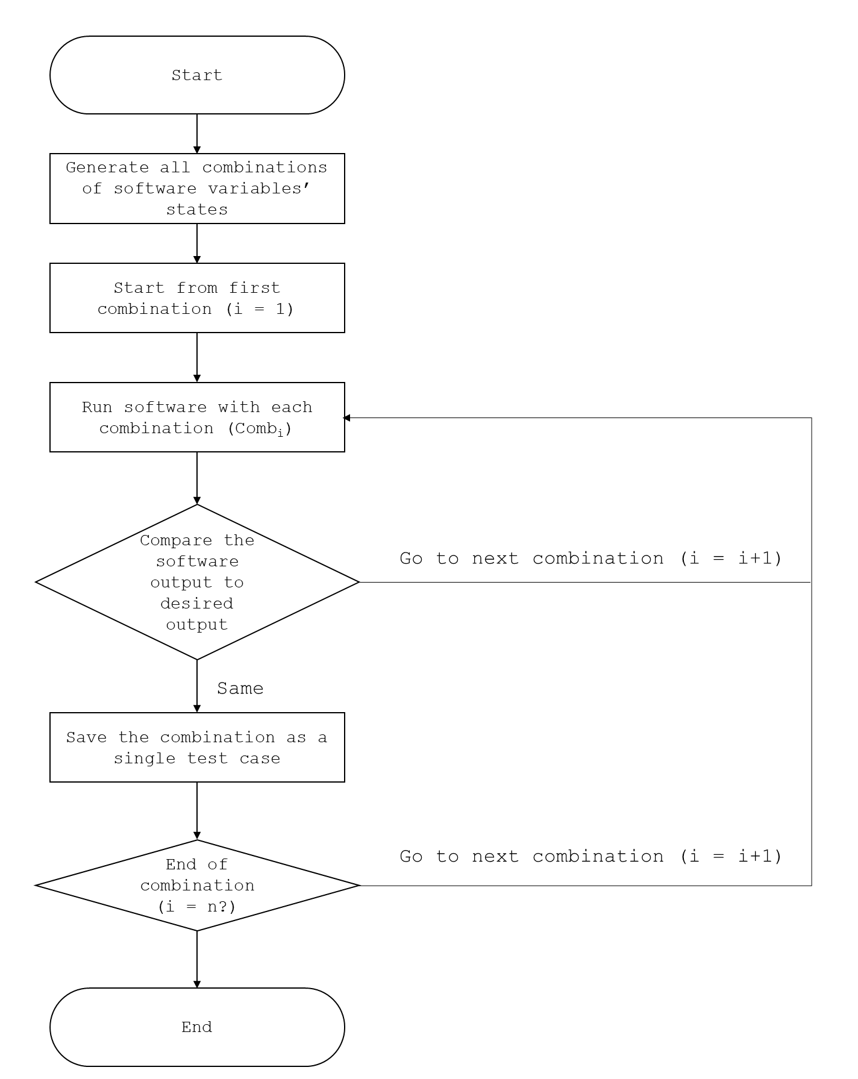

Figure 5.19: Conventional software exhaustive test case generation method

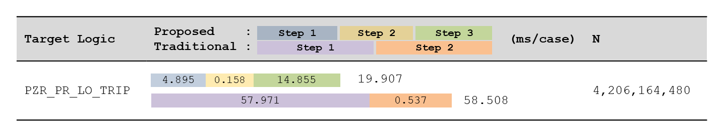

Figure 5.20: Comparison between the proposed and traditional approach on exhaustive test case generation time for KNICS IDiPS-RPS BP pressurizer pressure low trip logic

* 1. **Test Execution and Result Analysis of Target Software**

In order to simulate the software behavior given the states of software input and internal variables, a software test-bed developed in Section 4 which emulates the microprocessor architecture of PLC processor module and captures its behavior at each machine code line of FBD program is used to check whether the correct output is generated by an actual machine code of the KNICS IDiPS-RPS BP software given the exhaustive test cases derived for PZR_PR_LO trip logic in Section 5.3. The generated exhaustive test cases were first post-processed into the input format of software test-bed, as shown in Figure 5.21. In the test case file, the first line except for the comments which start with asterisk indicates the memory address and the rest of the lines indicates the value which will be overwritten in each memory address when the test starts. The program file of the FBD program in machine code format is generated by compiling the KNICS IDiPS-RPS BP software in pSET environment by the domain experts. The program file of the BP trip logic software consists of 32,566 lines of machine instruction and the constant file of the BP trip logic software includes 4,412 lines of data that is used by the program file. The section of the program file is divided into the initialization part, which defines the variables’ initial value defined in the FBD program and the main code part, which includes the FBD design, as shown in Figure 5.22. Other input files for software test-bed such as test setup file, expected output file, and test execution file are prepared, as shown in Figure 0.92, Figure 0.93, Figure 0.94.

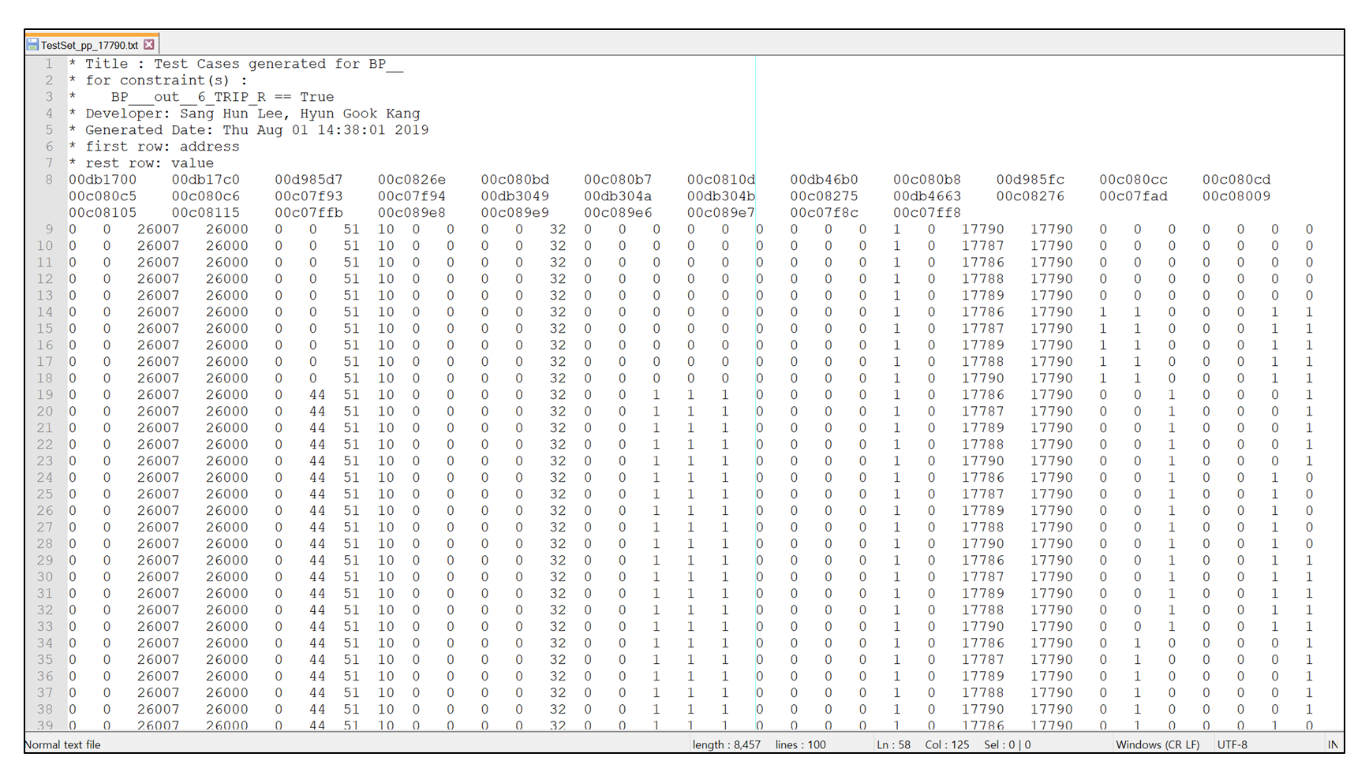

Figure 5.21: Test case file for KNICS IDiPS-RPS BP pressurizer pressure low trip logic

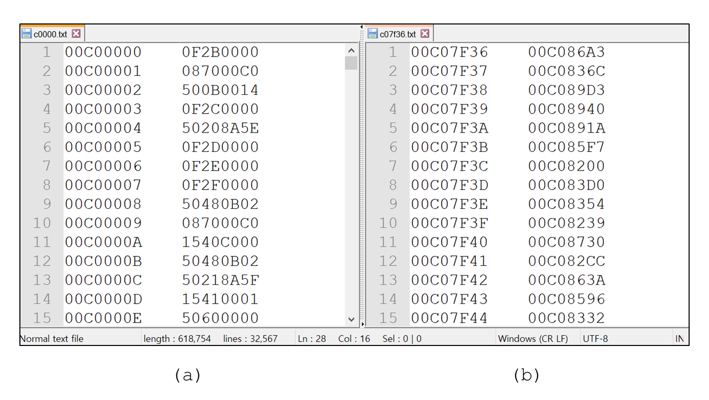

Figure 5.22: Program file of KNICS IDiPS-RPS BP software: (a) program file, (b) constant file

As discussed in Section 5.3, the target software output for which the exhaustive test cases are generated in the case study was set to be the trip signal output of the pressurizer pressure low trip logic (*QX0_3_2*). Therefore, the expected output file that specifies the address of the variable *QX0_3_2* (0xda00c2) and the state of the variable (0x1 or true), as shown in Figure 5.23. The type *val* indicates that the value inside the specified address generated by the software in the test-bed will be compared with the specified expected value. Figure 5.24 shows the test execution file, which specifies the name of the test-bed executable file and the test start and end address. The test start and end addresses were set as the first and last address of the code part of the BP program file. By executing the test execution file, the test-bed is executed with those arguments.

Based on the required input files for software test-bed, the test starts with initializing of the software test-bed, which includes emulating the CPU registers and memory elements of the target digital processor. Then, the binary files of the target application program, including the program file and the constant file are loaded into the test-bed. After reading the binary file of the target software, the test case file, which includes the memory address and the values of the software input and internal variables that should be tested, is loaded into test-bed and overwrites the values in the emulated memory map when the program counter reaches to the test start address. As the software test-bed executes the machine code of KNICS IDiPS-RPS BP software, the test-bed stops executing the machine code and checks whether correct output (i.e., pressurizer pressure low trip signal) was generated by the software test-bed given each test case based on the expected output file when the program counter reaches to the test end address. The detailed test procedure by the software test-bed is described in Section 4.4.3.4.

Table 5.10 shows some statistics of the BP trip logic software execution by the test-bed. The BP trip logic software consists of 32,566 lines of machine instruction and 98,775 lines were executed on average for a single test case. Among the executed instruction sets, LDIU (load integer unconditionally) and LDI (load integer) instructions were executed most frequently, 41,228 and 13,566 times, respectively. It was observed that 51.91% and 10.33% of the total execution time were spent by the LDIU and LDI instructions, where the execution time used per instruction were 0.0532 and 0.032 microseconds in the developed software test-bed, respectively. The longest execution time used per instruction included instructions related to the parallel operations which execute two instructions at one CPU cycle. For example, the CPU clocks used by LSH3||STI (parallel logical shift 3-operand and store integer) and NEGI||STI (parallel negate integer and store integer) were 3.9822 microseconds. In average, the execution time per each instruction operation was 0.0465 microseconds. It was shown that only 19.21% of the instruction sets provided by the TMS320C32 microprocessor (59 among a total of 307 instruction sets including the condition-based instructions such as BU, BZ) are used in the BP trip logic software.

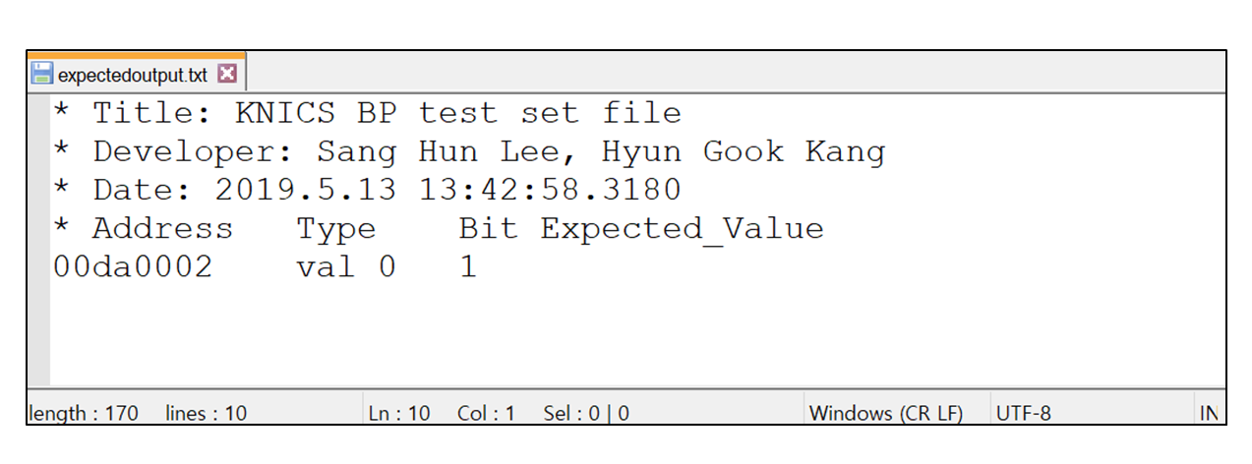

Figure 5.23: Expected output file for KNICS IDiPS-RPS BP pressurizer pressure low trip logic

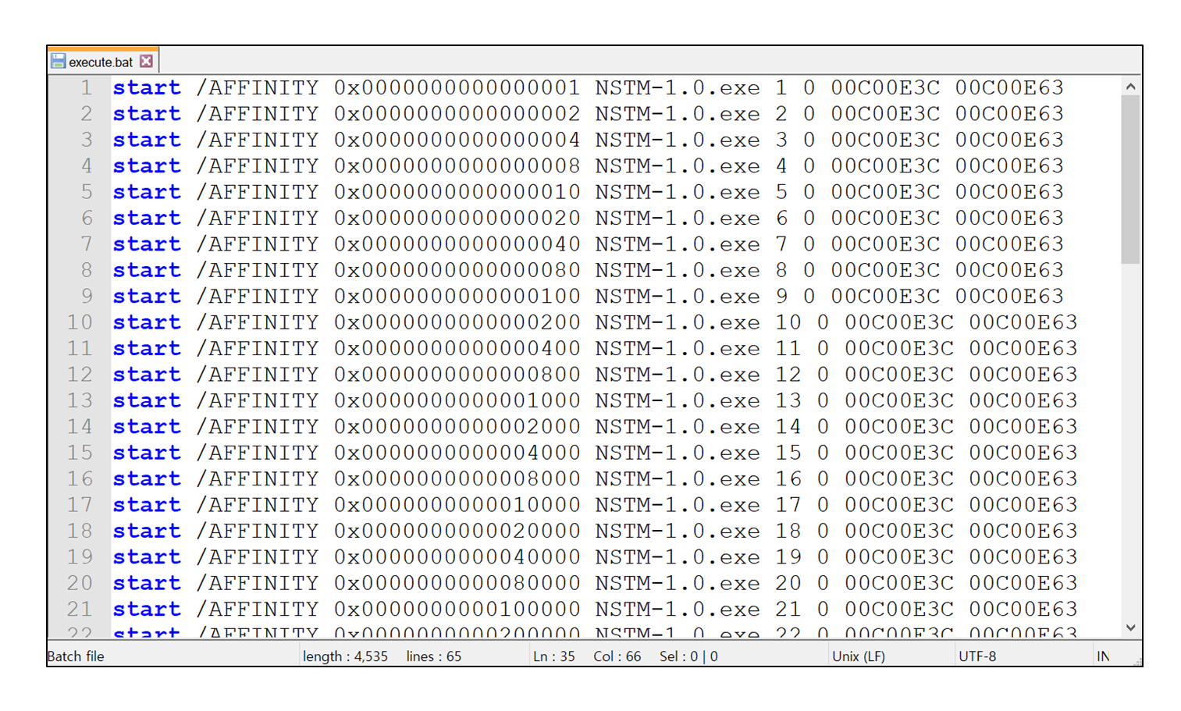

Figure 5.24: Test execution file for KNICS IDiPS-RPS BP pressurizer pressure low trip logic

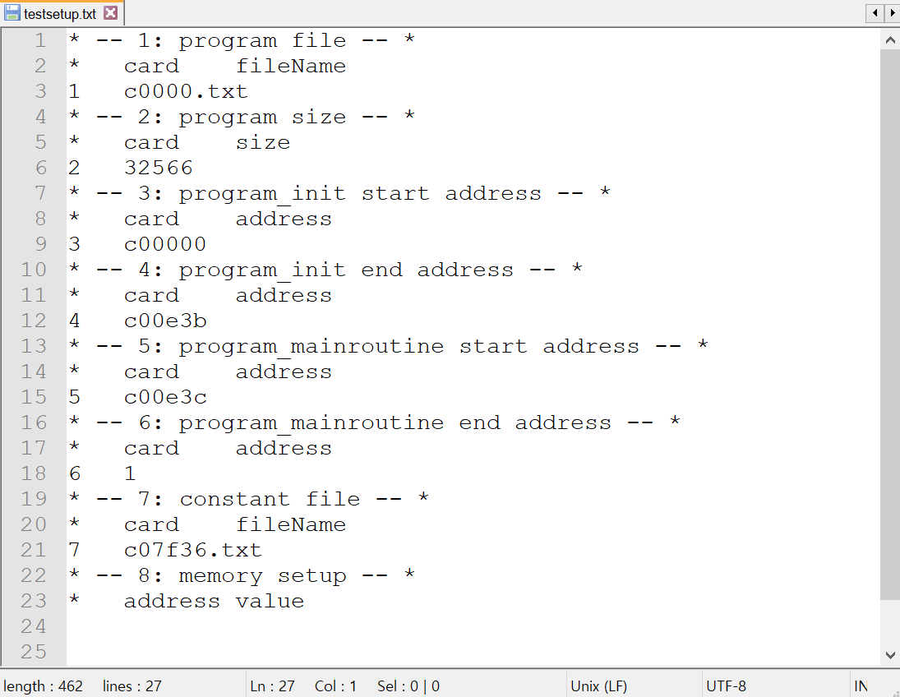

Figure 5.25: Test setup file for KNICS IDiPS-RPS BP pressurizer pressure low trip logic

Table 5.10: Statistics on KNICS IDiPS-RPS BP trip logic software execution by software test-bed

|  |  |  |  |
| --- | --- | --- | --- |
| Name of instruction set | Count | Total execution time ($μs$) | Execution time per count ($μs$) |
| LDIU | 41228 | 2193.353 | 0.053 |
| LDI | 13566 | 436.623 | 0.032 |
| PUSHF | 9292 | 262.258 | 0.028 |
| STI_STI | 6020 | 234.382 | 0.039 |
| SUBI3 | 3602 | 272.782 | 0.076 |
| BUD | 2798 | 75.947 | 0.027 |
| BEQ | 2067 | 46.080 | 0.022 |
| CMPI | 1862 | 170.098 | 0.091 |
| NORM | 1840 | 36.978 | 0.020 |
| CALLU | 1812 | 54.613 | 0.030 |
| BNE | 1463 | 39.253 | 0.027 |
| ADDI | 1300 | 128.853 | 0.099 |
| LDIEQ | 656 | 16.213 | 0.025 |
| LDI_STI | 510 | 13.938 | 0.027 |
| AND | 488 | 28.160 | 0.058 |
| OR3 | 452 | 13.653 | 0.030 |
| ASH | 362 | 26.453 | 0.073 |
| AND3 | 330 | 14.507 | 0.044 |
| OR3_STI | 159 | 13.369 | 0.084 |
| LDFU | 133 | 32.142 | 0.242 |
| LDILT | 98 | 2.844 | 0.029 |
| LDIGT | 94 | 4.836 | 0.051 |
| RETIU | 74 | 13.653 | 0.185 |
| XOR | 60 | 2.276 | 0.038 |
| POPF | 57 | 1.422 | 0.025 |
| BLE | 52 | 2.560 | 0.049 |
| SWI | 51 | 7.680 | 0.151 |
| CMPF | 35 | 12.516 | 0.358 |
| LDILE | 35 | 1.138 | 0.033 |
| LDIGE | 32 | 1.138 | 0.036 |
| LDFLT | 30 | 0.853 | 0.028 |
| LDFGE | 30 | 0.853 | 0.028 |
| STF_STF | 29 | 3.413 | 0.118 |
| BGE | 29 | 0.853 | 0.029 |
| FLOAT | 24 | 4.836 | 0.201 |
| ADDF3 | 21 | 10.524 | 0.501 |
| … | … | … | … |
| Total (on average) | 98775 | 4225.710 (ms) | 0.043 |

Figure 5.26 shows a part of the test results using the test cases developed for the trip initiation condition of the pressurizer pressure low trip logic software as a case study. The output variable of the BP trip logic software is the variable *QX0_3_2*, which is sent to CP as a trip signal for the voting logic. The variable *QX0_3_2* is determined by different trip state variables, the variables *TRIP_R_a* and *TRIP_R_b*, which contains the trip signal output of various trip logics. For example, the variable *_6_TRIP_R*, which is the trip signal for the pressurizer pressure low trip logic, is packed at the 5th bit of the variable *TRIP_R_a*. As shown in Figure 5.26, the test results showed that the states of the variables *QX0_3_2* and *TRIP_R_a* after the program execution are at 0x1 and 0x20, respectively which indicates that the 5th bit of the trip signal (pressurizer pressure low trip signal) is set to 0x1 meaning that the software generated correct output for the given test case. As a result of the testing of the exhaustive test cases derived for the pressurizer pressure low trip logic in the case study, all the 4,206,164,480 test cases developed from Section 5.3 generated trip signals for the pressurizer pressure low trip logic and the test was conducted in 12.08 hours using 600 3.60 GHz logical processors, that is, 6.205 milliseconds were spent per test case on average in the software test-bed.

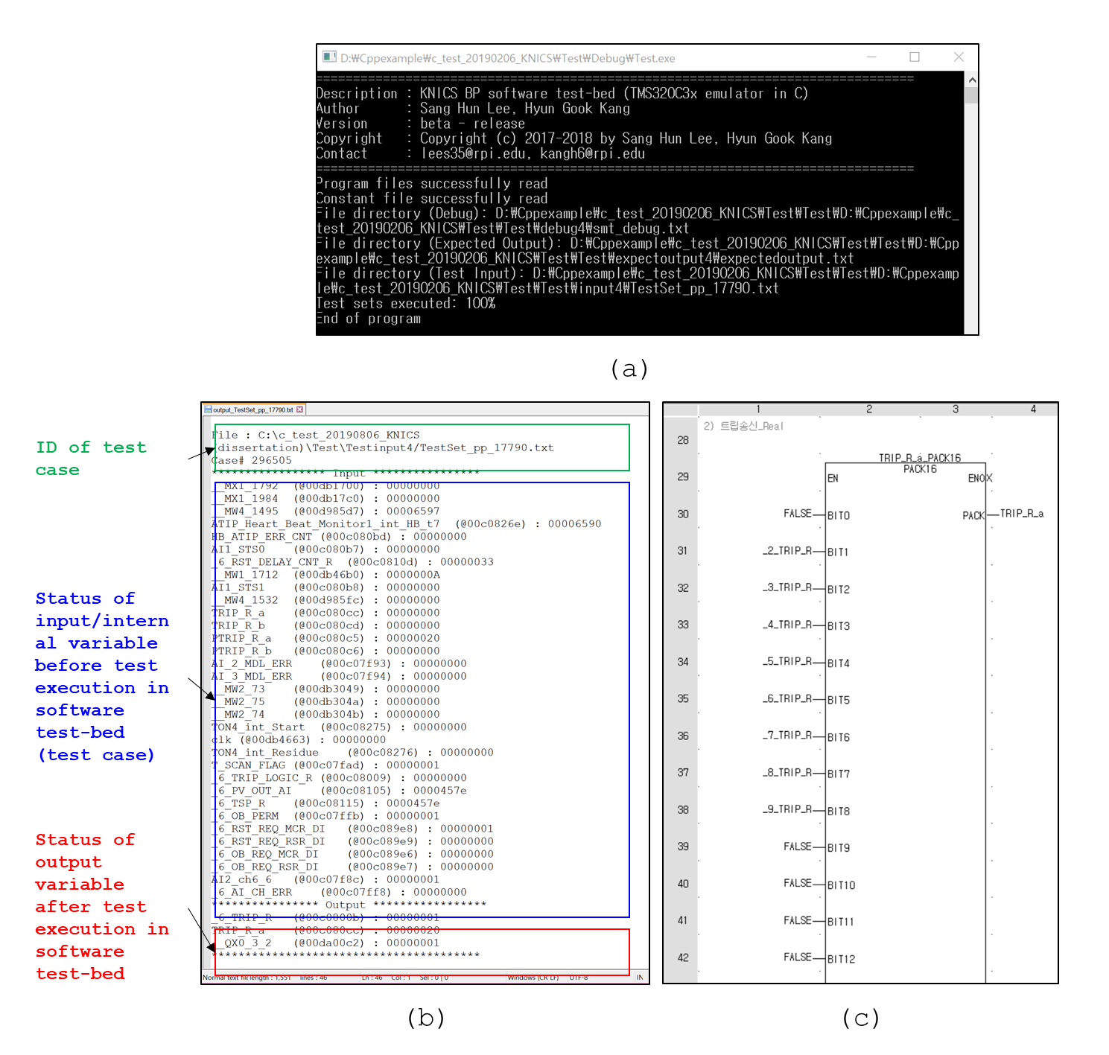

Figure 5.26: A part of the test result for KNICS IDiPS-RPS BP pressurizer pressure low trip logic software: (a) Screenshot of software test-bed execution, (b) test output file, (c) A part of BP FBD program

* 1. **Summary and Conclusions**

This Chapter demonstrates the application of the proposed software testing method on the KNICS IDiPS-RPS BP trip logic software. As a case study, the exhaustive test cases for the pressurizer pressure low trip logic which is one of the most complicated trip logic among BP trip logics which includes various functions such as operator bypass and trip set-point reset were generated. The test cases were developed by (1) translating the FBD program of the BP trip logic software into SMT formula, (2) deriving the software input and internal variables by finding the model for the desired software output, and (3) obtaining the profile and the possible range of each software variable by considering the plant dynamics and based on the available information on the software development such as software requirement and design specification, 4) and generating the exhaustive test cases by FBDET algorithm described in Section 3.4.

As a result, a total of 4,206,164,480 exhaustive test cases were generated for the case study. Compared to the traditional approach where all possible combinations of each software variable are processed by the software and the test cases are derived by extracting the cases which generate the desired software output, the FBDET algorithm showed 2.94 times faster performance in generating each exhaustive test case. The derived test cases for pressurizer pressure low trip logic were tested using a simulation-based test-bed to validate whether the machine code of target software generates a correct output. The case study result showed that the software test-bed developed in this study enables the exhaustive testing of the NPP safety software, which often involves testing a huge number of test cases.

An important characteristic of the proposed software test approach is that the test sets can be systematically and quantitatively derived to achieve exhaustive testing of the safety-critical software. In addition, the developed simulation-based test-bed can effectively reduce the software testing time per test case compared to the existing black-box testing from few minutes to few milliseconds by emulating the software behavior given the software input and internal states at the machine language level and automating the process from providing the software the test input to verifying the output. Thus, the proposed software test method can be used to support the software reliability quantification of NPP safety-critical I&C applications and further ensure the safety of software-based digital systems.

# SUMMARY AND CONCLUSIONS

This final Chapter includes the conclusions of this thesis, presenting the list of contributions, limitations, and benefits of this research. In addition, a brief discussion about the future work of this project is presented. This Chapter is divided into three sections:

* Section 6.1 presents a discussion about the summary of the thesis, from the initial research objective and scopes until the adopted solution to satisfy them.
* Section 6.2 presents the contributions, the limitations, and the benefits of this research.
* Finally, Section 6.3 suggests the potential future research lines of this thesis.
  1. **Discussion**

This thesis aims at resolving the major technical challenges in software testing in digital NPP PRA implementation: (1) the need for systematic test case generation method for ensuring the reliable nuclear safety software in terms of its safety function and (2) the need for a software test-bed that can effectively test the exhaustive test cases with reasonable time and cost. These challenges are particularly important for software reliability estimation to demonstrate a very low failure probability down to 10-5 of the safety software used in NPP digital safety systems such as RPS and ESF-CCS. However, the current state-of-the-art QSRM methods had limitations regarding the software reliability quantification or safety demonstration such as the uncertainty in model parameters or reliability estimates. Section 1.3 showed the related work and their limitation to this field. Recently in the nuclear domain, automated or manual testing of the PLC programs have been the most popular solutions adopted to show the software safety, but most of the software testing techniques have focused on coverage-based approaches to detect faults or mutants during its development process. While the test results from those approaches can be useful to demonstrate the rigorous software development and V&V life cycle, it cannot show whether the software will generate its dedicated safety function at its on-demand situation in terms of NPP risk.

This thesis provides a solution in applying an integrated software exhaustive testing framework to NPP safety software. As discussed in Section 1.4, two main goals were set to ensure the applicability of the proposed framework to an actual NPP safety software:

* To investigate an exhaustive set of software input and internal variables and their states that contributes to safety signal output generation.
* To construct the software test-bed that simulates the operation of safety software and further makes the software exhaustive testing practically achievable.

Satisfying those requirements implied to adopt the solutions presented in this thesis: (1) an automated exhaustive test case generation scheme and (2) a simulation-based software test-bed. For the first solution, the term “automated” indicates that the whole processes of exhaustive test case generation do not require any human intervention given the input files required to conduct the process. The term “exhaustive” indicates that the generated test cases represent the whole space of software input and internal variables that generates the desired software output where each test case is exclusive to each other and there is no redundant test case. The proposed exhaustive test case generation method includes translating FBD programs into SMT formula, generating a model for the software output and exhaustive test cases based on the possible states of each software variable that can occur during actual software operation. In doing so, the FBD-to-SMT translation rules were developed based on the formal definition of the components of the FBD program, i.e., FB, component FBD, system FBD. For generating exhaustive test cases, the FBDET algorithm was developed which generates test cases iteratively by satisfiability check aided by Z3 SMT solver while adding the negation of the last found models as a new constraint to the formula at each iteration. All steps of the methodology were presented in Chapter 3.

For the second solution, the term “simulation” means that the architecture and the instruction set operation of the PLC microprocessor which executes the compiled FBD program is emulated in a simulated environment and conducts the software testing in assembly language level which represents the actual environment where the software is running. The software test-bed is developed based on the technical specifications of the target PLC microprocessor and verified by the unit testing to ensure the correct execution of the emulated instruction set operations in the test-bed and functional testing to verify the test procedure implemented in the test-bed using an example of KNICS IDiPS-RPS BP trip logics. The detailed aspects of the developed test-bed were presented in Chapter 4.

The proposed NPP safety software testing framework was applied to the safety-critical trip logic software of a fully digitalized reactor protection system, IDiPS-RPS BP software, developed under the KNICS project. The experimental results presented in Chapter 5 showed the applicability of the proposed approach in NPP safety-critical software. Based on the FBD program of the BP trip logic developed by the domain expert, the software model was constructed in the SMT format and the exhaustive test cases were generated for a target scenario as a case study. Regarding with the efficiency in generating test cases, the FBDET algorithm was 2.94 times faster compared to the traditional approach. In addition, the test result using the test-bed showed that the testing of each test case took 6.205 milliseconds which is much comparable to the conventional hardware-based test-bed employed in the nuclear domain which takes from few seconds to few minutes to test single test case. The practical and theoretical contributions of this methodology are discussed in the following section.

* 1. **Contributions**

This paper is based on the test-based method for NPP software reliability quantification and this is the first attempt to provide a systematic approach to generate the exhaustive test cases and conduct software testing for the NPP safety software to the best of author’s knowledge. Sections 1.3, 3.2, and 4.2 described the related works to this field. However, none of the approaches satisfied completely the main goals set in this thesis, or strong limitations such as manual analysis on the FBD program were necessary to apply their solutions. The details about the contributions of this thesis are presented, sorted in descending order of significance, as follows:

* + 1. **FBD Exhaustive Test Case Generation Algorithm**

The first contribution is the adopted methodology for generating exhaustive test cases for FBD programs. The proposed approach aims to formally generate exhaustive test cases for NPP safety software, which cover all possible safety signal demand of the software. As the exhaustive test case generation problem can be formulated as the problem of finding all possible combinations of software variables’ states that generate the desired output, the adopted method generates the exhaustive test cases by finding the models of the translated SMT formula given test requirement by satisfiability check using SMT solver. While it is considered practically impossible to generate exhaustive test cases for large complex system, the experimental result showed that the proposed method can enable generating the exhaustive test cases for NPP safety software where the number of software inputs and internal variables is limited with finite resolution and operating condition of the software in a reasonable timeframe compared to the traditional approach. While the conventional test case generation in the nuclear domain involves much manual work and is prone to human error, the framework can provide a systematic and efficient method for nuclear software engineers and V&V experts to ensure software safety. In this thesis, the test cases are generated focusing on the safety function of the target software (trip signal generation); however, the proposed method can be applied in general for other purposes: such as generating unit test cases for each FB in the FBD program or the test cases that satisfy multiple requirements.

* + 1. **Simulation-based Test Environment**

The second contribution is the development of the simulation-based test-bed for PLC software testing. The most significant limitation on the exhaustive testing on the nuclear safety software came from the performance of the test-bed. While the hardware-based test-bed captures the exact running environment of the software itself, the test execution time per each test case is from few seconds to few minutes as the test cases are often inserted to the test-bed manually. The motivation of the simulation-based test-bed lies on the fact that the PLC microprocessor executes the application software downloaded from the PLC software engineering tools; therefore, by emulating the PLC architecture and instruction set operation, a very similar environment where the application software is running can be realized while the software testing process such as inserting the test cases and analyzing the test results can be automated. To ensure that the emulated components of PLC in the developed test-bed exactly does what the actual PLC microprocessor does, the verification activities for the software test-bed are performed in accordance with the nuclear domain standards. As shown in the experimental results, the simulation-based software test-bed enables the testing of a single test case in a few milliseconds for a typical RPS software. As the testing procedure modeled in the developed test-bed is general, it can be used for other safety software testing as well. While the test-bed is developed for the target PLC, POSAFE-Q PLC whose processor module consists of a TI C32 digital signal processor (DSP) CPU, the scheme and principles in this thesis can be applied to develop the test-bed for other safety PLCs in the nuclear domain such as Motorola MPC860 microprocessor implemented in Tricon PLC.

* + 1. **FBD-to-SMT Translation Rules**

The third contribution is the set of translation rules from the FBD program to the SMT formula. The proposed framework uses the SMT solver as the solvers of the equation representing a huge system such as BP trip logic software and finds exhaustive test cases by negating the last found models at each iteration until the SMT formula is unsatisfiable. This thesis developed the FBD-to-SMT translation rules based on the formal definition of FBDs including the FBs, the most fundamental element of FBD program, component FBDs, a user-defined FBD that contains several FBs, and system FBDs, whole software program. Although the full grammars in FETCG for FBD-to-SMT translations developed in this thesis are based on the FBD programs developed on pSET environment for POSAFE-Q PLC, the framework can be applied to any FBD program by any PLC vendors for safety and non-safety applications in a similar manner.

* 1. **Future Works**

This thesis focused on the exhaustive testing framework for the software used in NPP safety-critical applications such as RPS, ESF-CCS. The test result can be used to estimate the reliability of the software used in NPP safety systems and further to analyze the risk effect of software on the digital I&C system and on the NPP in terms of PRA. The following scopes exist for further work for more comprehensive reliability estimation related to the NPP safety software.

* Verification of the operating system and software/hardware interaction
  + Although the proposed framework focuses on verifying that the software logic is error-free when demand comes, other causes of software error should be investigated in consideration of the running environment. As shown in Figure 5.2, the environment in which the application software is running includes interaction with the operating system and hardware module. While the application software can be tested as error-free using the framework proposed in this study, the software will not generate a safety signal if the operating system kernel does not properly call the application software, or if there is any error in the hardware module that affects the application or the operating system software. While there is no consensus on how the software failure must be treated in the NPP PRA whether the application software failure probability and the operating software failure probability must be integrated or not, there is a need to combine the test results for the application software from this thesis with the SW/HW integration test to estimate the software failure probability in a more systematic manner. In addition, external causes of a potential software error, such as wrong input by operator mistake, or noise from sensors or the signal transmission path, also need to be considered to model the software failure completely.
* Verification of the FBD programs to be tested
  + The proposed framework in this study utilizes the FBD program to generate the exhaustive test cases for its safety function. In general, software defects may be inserted or removed by development or V&V activities in each of five different SDLC phases (i.e., requirement, design, implementation, test, and installation-and-checkout phases). As the software requirements are often written in manual based on the expert judgment and it is transformed into the FBD program using the automatic translator such as NuSCRtoFBD. The software test cases generated from the proposed method cannot detect the software faults due to faults in initial software requirement or the wrong translation from the requirement to the FBD program. Therefore, the proposed framework must be used along with the verification of the processes related to the FBD product so that the test result from the proposed method can detect the software failure in entire SDLC phases.
* Inclusion of digital I&C systems’ reliability into NPP PRA model.
  + Estimating the system reliability of digital I&C systems which uses the software and hardware is still an ongoing topic of research. One possible way to model the software and hardware failure is to model the failure probability of major components comprising the PLC platform: (1) the hardware components, (2) operating system software, and (3) application software. While the failure probability of the hardware component can be estimated using the conventional FMEA and failure rate result, the software failure probability must be estimated in a different way. The reliability of the application software can be estimated by exhaustive testing based on the proposed framework. As the operating system software executes the application software by software/hardware interaction, the reliability of the operating system can be estimated by finding the cases where the operating system does not initiate the application software on hardware. This requires different testing approaches such as testing the operating system using I/O simulator for PLC platform [226]. Combining those approaches with the proposed framework in this study is expected to enable more precise and systematic software failure modeling in the NPP PRA model compared to conventional QSRMs.

# REFERENCES

|  |  |
| --- | --- |
| [1] | International Atomic Energy Agency, "Core knowledge on instrumentation and control systems in nuclear power plants," IAEA, Vienna, Austria, IAEA NES NP-T-3.12, Dec. 2011. |
| [2] | M. Hassan and W. E. Vesely, "Digital I&C systems in nuclear power plants. Risk-screening of environmental stressors and a comparison of hardware unavailability with an existing analog system," U.S. NRC, Washington DC, USA, NUREG/CR-6579, Jan. 1998. |
| [3] | D. Lee and I. Kim, "Application of digital technology for the plant protection system in Ulchin nuclear nower plant units 5 and 6," in *Proceedings of the 2006 International Congress on Advances in Nuclear Power Plants (ICAPP'06)*, Reno, NV, USA, June 4-8, 2006. |
| [4] | S. S. Lee, S. H. Kim and K. Y. Suh, "The design features of the advanced power reactor 1400," *Nuclear Engineering and Technology,* vol. 41, no. 8, pp. 995-1004, Oct. 2009, doi: 10.5516/net.2009.41.8.995 . |
| [5] | J. Kirschenbaum, P. Bucci, M. Stovsky, D. Mandelli, T. Aldemir, M. Yau, S. Guarro, E.Ekici and S. Arndt, "A benchmark system for comparing reliability modeling approaches for digital instrumentation and control systems," *Nuclear Technology,* vol. 165, no. 1, pp. 53-95, Jan. 2009, doi: 10.13182/nt09-5 . |
| [6] | J. W. Lee, C. K. Lee, J. G. Song and D. Y. Lee, "Cyber security considerations in the development of I&C systems for nuclear power plants," in *Proceedings of the 2011 International Conference on Security and Management (SAM'11)*, Las Vagas, Nevada, USA, July 18-21, 2011. |
| [7] | S. H. Lee, H. E. Kim, K. S. Son, S. M. Shin, S. J. Lee and H. G. Kang, "Reliability modeling of safety-critical network communication in a digitalized nuclear power plant," *Reliability Engineering & System Safety,* vol. 144, pp. 285-295, Dec. 2015, doi: 10.1016/j.ress.2015.07.029. |
| [8] | Institute of Electrical and Electronics Engineers, "IEEE standard criteria for digital computers in safety systems of nuclear generating station," IEEE, New York, NY, USA, IEEE 7-4.3.2-2010, Aug. 2010. |
| [9] | U.S. Nuclear Regulatory Commission, "Criteria for use of computers in safety systems of nuclear power plants," U.S. NRC, Washington DC, USA, RG 1.152 Rev. 3, Jul. 2011. |
| [10] | U.S. Nuclear Regulatory Commission, "General design criteria for nuclear power plants," U.S. NRC, Washington DC, USA, 10 CFR Part 50.55a, Appendix A, 2001. |
| [11] | U.S. Nuclear Regulatory Commission, "WASH-1400: Reactor safety study," U.S. NRC, Washington DC, USA, NUREG-75/014, Oct. 1975. |
| [12] | S. Authen and J. E. Holmberg, "Reliability analysis of digital systems in a probabilistic risk analysis for nuclear power plants," *Nuclear Engineering and Technology,* vol. 44, no. 5, pp. 471-482, Jun. 2012, doi: 10.5516/net.03.2012.707 . |
| [13] | S. Authen, E. Wallgren and S. Eriksson, "Development of the Ringhals 1 PSA with regard to the implementation of a digital reactor protection system," in *Proceedings of 10th International Probabilitstic Safety Assessment & Management Conference (PSAM'10)*, Seattle, Washington, USA, Jun. 7-11, 2010. |
| [14] | L. Shi, R. Enzinna, S. Yang and S. Blodgett, "Probabilistic risk assessments of digital I&C in nuclear power plant," in *Proceedings of the 10th Probabilistic Safety Assessment & Management Conference (PSAM10)*, Seattle, Washington, USA, Jun. 7-11, 2010. |
| [15] | H. G. Kang and T. Sung, "An analysis of safety-critical digital systems for risk-informed design," *Reliability Engineering & System Safety,* vol. 78, no. 3, pp. 307-314, Dec. 2002, doi: 10.1016/s0951-8320(02)00176-x . |
| [16] | P. H. Seong, Reliability and risk issues in large scale safety-critical digital control systems, London: Springer-Verlag, 2009. |
| [17] | H. G. Kang and T. Sung, "A quantitative study on important factors of the PSA of safety-critical digital systems," *Nuclear Engineering and Technology,* vol. 33, no. 6, pp. 596-604, Jan. 2001. |
| [18] | E. J. Lee, "Computer-Based Digital System Failures," U.S. Nuclear Regulatory Commission, Washington DC, USA, AEOD/T94-03, Jul. 1994. |
| [19] | U.S. Nuclear Regulatory Commission, "Guidance for evaluation of diversity and defense-in-depth in digital computer-based instrumentation and control systems," U.S. NRC, Washington DC, USA, BTP 7-19 Rev. 5, Mar. 2007. |
| [20] | K. Korsah, M. D. Muhlheim and R. Wood, "A qualitative assessment of current CCF guidance based on a review of safety system digital implementation changes with evolving technology," Oak Ridge National Laboratory, Oak Ridge, TN, USA, ORNL/SR-2016/148, Apr. 2016. |
| [21] | S. Yamada and S. Osaki, "Software reliability growth modeling: Models and applications," *IEEE Transactions on Software Engineering,* Vols. SE-11, no. 12, pp. 1431-1437, Dec. 1985, doi: 10.1109/tse.1985.232179 . |
| [22] | Institute of Electrical and Electronics Engineers, "IEEE recommended practice on software reliability," IEEE, New York, NY, USA, IEEE 1633-2016, Jan. 2017. |
| [23] | M. R. Lyu, Handbook of software reliability engineering, Hightstown, NJ, USA: McGraw-Hill, 1996. |
| [24] | J. D. Musa, Software reliability engineering: More reliable software faster and cheaper, Bloomington, IN, USA: AuthorHouse, Sept. 2004. |
| [25] | M. C. Kim, S. C. Jang and J. Ha, "Possibilities and limitations of applying software reliability growth models to safety critical software," *Nuclear Engineering and Technology,* vol. 39, no. 2, pp. 129-132, Apr. 2007, doi: 10.5516/net.2007.39.2.129 . |
| [26] | G. Y. Park and S. C. Jang, "A software reliability estimation method to nuclear safety software," *Nuclear Engineering and Technology,* vol. 46, no. 1, pp. 55-62, Feb. 2014, doi: 10.5516/net.04.2012.067 . |
| [27] | D. Heckerman, "A tutorial on learning with bayesian networks," in *Innovations in bayesian networks*, Berlin, Heidelberg, Springer, 2008, pp. 33-82. |
| [28] | J. Pearl, Probabilistic reasoning in intelligent systems: Networks of plausible inference, San Francisco, CA, USA: Morgan Kaufmann Publishers, 1988. |
| [29] | H. S. Eom, G. Y. Park, H. G. Kang and H. S. Son, "Reliability assessment method of reactor protection system software by using V&V based bayesian nets," KAERI, Daejeon, Republic of Korea, KAERI/TR-4092/2010, Jul. 2010. |
| [30] | W. Marsh, "Safety and risk evaluation using bayesian nets: SERENE," ERA Technology Ltd., Leatherhead, Surrey, UK, SERENE/5.3/CSR/3053/R/1, 1999. |
| [31] | M. Neil and N. E. Fenton, "Improving the software process using bayesian networks," Queen Mary University of London, Bethnal Green, London, UK, Dec. 2000. |
| [32] | B. A. Gran and A. Helminen, "The BBN methodology: progress report and future work," OECD Halden Reactor Project, Halden, Norway, HWR-693, 2002. |
| [33] | B. A. Gran and A. Helminen, "A Bayesian belief network for reliability assessment," in *Proceedings of the 20th International Conference on Computer Safety, Reliability, and Security (SAFECOMP'01)*, Budapest, Hungary, Sept. 26-28, 2001. |
| [34] | N. Fenton and M. Neil, "A critique of software defect prediction models," *IEEE Transactions on Software Engineering,* vol. 25, no. 5, pp. 675-689, Sept. 1999, doi: 10.1109/32.815326 . |
| [35] | B. Littlewood and D. Wright, "A Bayesian model that combines disparate evidence for the quantitative assessment of system dependability," in *Proceedings of the 14th International Conference on Computer Safety, Reliability and Security (SAFECOMP’95)*, Belgirate, Italy, Oct. 11-13, 1995. |
| [36] | G. Johnson, D. Lawrence and H. Yu, "Conceptual software reliability prediction models for nuclear power plant safety systems," Lawrence Livermore National Laboratory, Livermore, CA, USA, UCRL-ID-138577, Apr. 2000. |
| [37] | H. S. Eom, G. Y. Park, H. G. Kang and S. C. Jang, "Reliability assessment of a safety-critical software by using generalized bayesian nets," in *Proceedings of the 6th ANS Topical Meeting on Nuclear Plant Instrumentation, Controls and Human-Machine Interfaces Technologies (NPIC&HMIT'09)*, Knoxville, Tennessee, USA, Apr. 5-9, 2009. |
| [38] | M. Bouissou, F. Martin and A. Ourghanlian, "Assessment of a safety-critical system including software: A Bayesian belief network for evidence sources," in *1999 Annual Reliability and Maintainability Symposium*, Washington DC, USA, Jan. 18-21, 1999. |
| [39] | H. G. Kang, S. H. Lee, S. J. Lee, T. L. Chu, A. Varuttamaseni, M. Yue, S. Yang, H. S. Eom, J. Cho and M. Li, "Development of a Bayesian belief network model for software reliability quantification of digital protection systems in nuclear power plants," *Annals of Nuclear Energy,* vol. 120, pp. 62-73, Oct. 2018, doi: 10.1016/j.anucene.2018.04.045 . |
| [40] | J. Cho, S. J. Lee and W. D. Jung, "Review of software reliability assessment methodologies for digital I&C software of nuclear power plants," in *Proceedings of the International Symposium on Future I&C for Nuclear Power Plants/International Symposium on Symbiotic Nuclear Power Systems 2014 (ISOFIC/ISSNP'14)*, Jeju, Republic of Korea, Aug. 24-28, 2014. |
| [41] | International Atomic Energy Agency, "Software for computer based systems important to safety in nuclear power plants," IAEA, Vienna, Austria, NS-G-1.1, Sept. 2000. |
| [42] | Institute of Electrical and Electronics Engineers, "IEEE standard for system and software verification and validation," IEEE, Piscataway, NJ, USA, IEEE 1012-2012, May 2012. |
| [43] | P. A. Babu, C. S. Kumar and N. Murali, "A hybrid approach to quantify software reliability in nuclear safety systems," *Annals of Nuclear Energy,* vol. 50, pp. 133-140, Dec. 2012, doi: 10.1016/j.anucene.2012.06.026. |
| [44] | S. J. Lee, S. H. Lee, T. L. Chu, A. Varuttamaseni, M. Yue, M. Li, J. Cho and H. G. Kang, "Bayesian belief network model quantification using distribution-based node probability and experienced data updates for software reliability assessment," *IEEE Access,* vol. 6, pp. 64556-64568, Oct. 2018, doi: 10.1109/access.2018.2878376 . |
| [45] | G. J. Myers, C. Sandler and T. Badgett, The art of software testing, Hoboken, NJ, USA: John Wiley & Sons, 2011. |
| [46] | T. L. Chu, M. Yue, M. Martinez-Guridi and J. Lehner, "Review of quantitative software reliability methods," Brookhaven National Laboratory, Upton, NY, USA, BNL-94047-2010, Dec. 2010. |
| [47] | G. Dahll, B. Liwang and U. Pulkkinen, "Software-based system reliability," Working Group on Risk Assessment (WGRISK) of the Nuclear Energy Agency, Paris, France, NEA/SEN/SIN/WGRISK(2007)1, Jan. 2007. |
| [48] | J. May, G. Hughes and A. D. Lunn, "Reliability estimation from appropriate testing of plant protection software," *Software Engineering Journal,* vol. 10, no. 6, pp. 206-218, Nov. 1995, doi: 10.1049/sej.1995.0026 . |
| [49] | S. Kuball and J. H. R. May, "A discussion of statistical testing on a safety-related application," *Proceedings of the Institution of Mechanical Engineers, Part O: Journal of Risk and Reliability,* vol. 221, no. 2, pp. 265-269, Jun. 2007, doi: 10.1177/1748006x0822200201 . |
| [50] | T. L. Chu, A. Varuttamaseni, J. S. Baek, M. Yue, T. Kaser, G. Marts, P. Murray, B. Harwood, N. Johnson and M. Li, "Development of a statistical testing approach for quantifying safety-related digital system on demand failure probability," U.S. NRC, Washington DC, USA, NUREG/CR-7234, May 2017. |
| [51] | T. L. Chu, A. Varuttamaseni and J. S. Baek, "A statistical testing approach for quantifying software reliability; Application to an example system," in *2016 ANS Winter Meeting and Nuclear Technology Expo*, Las Vegas, NV, USA, Nov. 6-10, 2016. |
| [52] | H. G. Kang, H. G. Lim, H. J. Lee, M. C. Kim and S. C. Jang, "Input-profile-based software failure probability quantification for safety signal generation systems," *Reliability Engineering & System Safety,* vol. 94, no. 10, pp. 1542-1546, Oct. 2009, doi: 10.1016/j.ress.2009.02.018 . |
| [53] | S. M. Shin, S. H. Lee, H. G. Kang, H. S. Son and S. J. Lee, "Test based reliability quantification method for a safety critical software using finite test sets," in *Proceedings of the 9th International Topical Meeting on Nuclear Plant Instrumentation, Control & Human-Machine Interface Technologies (NPIC&HMIT'15)*, Charlotte, NC, USA, Feb. 23-26, 2015. |
| [54] | H. E. Kim, H. S. Son, B. G. Kim, J. Cho, S. M. Shin and H. G. Kang, "Input-domain software testing for failure probability estimation of safety-critical applications in consideration of past input sequence," *IEEE Access,* vol. 6, pp. 8440-8451, Oct. 2017, doi: 10.1109/access.2017.2765698 . |
| [55] | J. Cho, S. M. Shin, S. J. Lee and W. Jung, "Exhaustive test cases for the software reliability of safety-critical digital systems in nuclear power plants," *Nuclear Engineering and Design,* vol. 352, p. 110151, Oct. 2019, doi: 10.1016/j.nucengdes.2019.110151. |
| [56] | N. D. Singpurwalla and S. P. Wilson, Statistical methods in software engineering – Reliability and risk, New York, NY, USA: Springer-Verlag, 1999. |
| [57] | K. W. Miller, L. J. Morell, R. E. Noonan, S. K. Park, D. M. Nicol, B. W. Murrill and M. Voas, "Estimating the probability of failure when testing reveals no failures," *IEEE transactions on Software Engineering,* vol. 18, no. 1, pp. 33-43, Jan. 1992, doi: 10.1109/32.120314 . |
| [58] | J. Seo and S. J. Lee, "Optimization of test cases for experimental reliability evaluation of digital reactor protection system," in *Proceedings of the 14th Probabilistic Safety Assessment and Management Conference (PSAM14)*, Los Angeles, CA, USA, Sept. 16-21, 2018. |
| [59] | H. K. Shin, S. K. Na, S. D. Sohn and H. B. Kim, "Digital system reliability test for the evaluation of safety critical software of digital reactor protection system," *Journal of Systemics, Cybernetics and Informatics,* vol. 4, no. 4, pp. 30-35, 2006. |
| [60] | M. E. Khan, "Different approaches to white box testing technique for finding errors," *International Journal of Software Engineering & Applications,* vol. 5, no. 3, pp. 1-14, Jul. 2011. |
| [61] | K. J. Hayhurst, D. S. Veerhusen, J. J. Chilenski and L. K. Rierson, "A practical tutorial on modified condition/decision coverage," NASA, Washington DC, USA, NASA/TM-2001-210876, May 2001. |
| [62] | M. A. Hennell, M. R. Woodward and D. Hedley, "On program analysis," *Information Processing Letters,* vol. 5, no. 5, pp. 136-140, Nov. 1976, doi: 10.1016/0020-0190(76)90059-4 . |
| [63] | M. Woodward, D. Hedley and M. Hennell, "Experience with path analysis and testing of programs," *IEEE Transactions on Software Engineering,* vol. 6, no. 3, pp. 278-286, May 1980, doi: 10.1109/tse.1980.230473 . |
| [64] | E. Jee, S. Kim, S. Ch and I. Lee, "Automated test coverage measurement for reactor protection system software implemented in function block diagram," in *Proceedings of the 29th International Conference on Computer Safety, Reliability, and Security (SAFECOMP'10)*, Vienna, Austria, Sept. 14-17, 2010. |
| [65] | Y. Wu and C. Fan, "Automatic test case generation for structural testing of function block diagrams," *Information and Software Technology,* vol. 56, no. 10, pp. 1360-1376, Oct. 2014, doi: 10.1016/j.infsof.2014.04.016 . |
| [66] | J. Lahtinen, "Automatic test set generation for function block based systems using model checking," in *Proceedings of the 9th International Conference on the Quality of Information and Communications Technology (QUATIC'14)*, Guimaraes, Portugal, Sept. 23-26, 2014. |
| [67] | E. P. Enoiu, D. Sundmark and P. Pettersson, "Model-based test suite generation for function block diagrams using the uppaal model checker," in *Proceedings of the 6th IEEE International Conference on Software Testing, Verification and Validation Workshops (ICST'13)*, Luxembourg, Luxembourg, Mar. 18-22, 2013. |
| [68] | C. Wang, F. Pastore, A. Goknil, L. Briand and Z. Iqbal, "Automatic generation of system test cases from use case specifications," in *Proceedings of the 2015 International Symposium on Software Testing and Analysis (ISSTA'15)*, Baltimore, MD, USA, Jul. 13-17, 2015. |
| [69] | W. H. Tseng and C. F. Fan, "Systematic scenario test case generation for nuclear safety systems," *Information and Software Technology,* vol. 55, no. 2, pp. 344-356, Feb. 2013, doi: 10.1016/j.infsof.2012.08.016 . |
| [70] | J. Song, E. Jee and D. H. Bae, "FBDTester 2.0: Automated test sequence generation for FBD programs with internal memory states," *Science of Computer Programming,* vol. 163, pp. 115-137, Oct. 2018, doi: 10.1016/j.scico.2018.04.005 . |
| [71] | K. Goševa-Popstojanova and K. S. Trivedi, "Architecture-based approach to reliability assessment of software systems," *Performance Evaluation,* vol. 45, no. 2-3, pp. 179-204, Jul. 2001, doi: 10.1016/s0166-5316(01)00034-7 . |
| [72] | T. L. Chu, M. Yue, G. Martinez-Guridi and J. Lehner, "Development of quantitative software reliability models for digital protection systems of nuclear power plants," U.S. NRC, Washington DC, USA, NUREG/CR-7044, Jul. 2011. |
| [73] | T. L. Chu, G. Martinez-Guridi, M. Yue, P. Samanta, G. Vinod and J. Lehner, "Workshop on philosophical basis for incorporating software failures in a probabilistic risk assessment," Brookhaven National Laboratory, Upton, NY, USA, BNL-90571-2009-IR, Nov. 2009. |
| [74] | International Atomic Energy Agency, "Software important to safety in nuclear power plants," IAEA, Vienna, Austria, TRS No. 367, 1994. |
| [75] | International Atomic Energy Agency, "Solutions for cost effective assessment of software based instrumentation and control systems in nuclear power plants," IAEA, Vienna, Austria, IAEA-TECDOC-1328, Dec. 2002. |
| [76] | W. Geiger, L. Gmeiner, H. Trauboth and U. Voges, "Program testing techniques for nuclear reactor protection systems," *Computer,* vol. 12, no. 8, pp. 10-18, Aug. 1979, doi: 10.1109/mc.1979.1658847 . |
| [77] | Institute of Electrical and Electronics Engineers, "Software and systems engineering - Software testing - Part 1: concepts and definitions," IEEE, Piscataway, NJ, USA, ISO/IEC/IEEE 29119-1-2013, Sept. 2013. |
| [78] | T. L. Chu, A. Varuttamaseni, M. Yue, S. J. Lee, H. G. Kang, J. Cho and S. Yang, "Developing a bayesian belief network model for quantifying the probability of software failure of a protection system," U.S. NRC, Washington DC, USA, NUREG/CR-7233, Jan. 2018. |
| [79] | K. C. Kwon and M. S. Lee, "Technical review on the localized digital instrumentation and control systems," *Nuclear Engineering and Technology,* vol. 41, no. 4, pp. 447-454, May 2009, doi: 10.5516/net.2009.41.4.447 . |
| [80] | J. Palomar and R. Wyman, "The programmable logic controller and its application in nuclear reactor systems," U.S. NRC, Washington DC, USA, NUREG/CR-6090, Sept. 1993. |
| [81] | K. Korsah, D. Holcomb, M. Muhlheim, J. Mullens, A. Loebla, M. Bobrek, M. Howladera, S. Killough, M. Moore, P. Ewing, M. Sharpe, A. Shourbaji, S. Cetinera, J. T.L. Wilson and R. Kisner, "Instrumentation and controls in nuclear power plants: An emerging technologies update," U.S. NRC, Washington DC, USA, NUREG/CR-6992, Oct. 2009. |
| [82] | R. A. Kisner, J. A. Mullens and A. Loebl, "Safety and nonsafety communications and interactions in international nuclear power plants," Oak Ridge National Laboratory, Oak Ridge, TN, USA, ORNL/NRC/LTR-07/05, Jul. 2007. |
| [83] | International Atomic Energy Agency, "Verification and validation of software related to nuclear power plant control and instrumentation," IAEA, Vienna, Austria, TRS-384, May 1999. |
| [84] | S. Seth, W. Bail, D. Cleaves, H. Cohen, D. Hybertson, C. Schaefer, G. Stark, A. Ta and B. Ulery, "High integrity software for nuclear power plants: Candidate guidelines, technical basis and research needs," U.S. NRC, Washington DC. USA, NUREG/CR-6263, Jun. 1995. |
| [85] | G. Preckshot, "Reviewing real-time performance of nuclear reactor safety systems," U.S. NRC, Washington DC, USA, NUREG/CR-6083, Aug. 1993. |
| [86] | J. D. Lawrence, "Software reliability and safety in nuclear reactor protection systems," U.S. NRC, Washington DC, USA, NUREG/CR–6101, Jun. 1993. |
| [87] | G. Carvalho, D. Falcao, F. Barros, A. Sampaio, A. Mota, L. Motta and M. Blackburn, "NAT2TESTSCR: Test case generation from natural language requirements based on SCR specifications," *Science of Computer Programming,* vol. 95, no. 3, pp. 275-297, Dec. 2014, doi: 10.1016/j.scico.2014.06.007 . |
| [88] | G. Carvalho, D. Falcao, F. Barros, A. Sampaio, A. Mota, L. Motta and M. Blackburn, "Test case generation from natural language requirements based on SCR specifications," in *Proceedings of the 28th Annual ACM Symposium on Applied Computing (SAC'13)*, Coimbra, Portugal, Mar. 18-22, 2013. |
| [89] | National Research Council, Digital instrumentation and control systems in nuclear power plants: safety and reliability issues, Washington DC, USA: The National Academies Press, 1997. |
| [90] | C. Elks, C. Deloglos, A. Jayakumar, A. Tantawy, R. Hite and S. Guatham, "Specification of a bounded exhaustive testing study for a software-based embedded digital device," U.S. DOE, Washington DC, USA, INL/EXT-18-52032, Nov. 2018. |
| [91] | Westinghouse Electric Company, "Ulchin nuclear power plant units 5 and 6: digital plant protection system technical manual," Westinghouse Electric Company, Pittsburgh, PA, USA, 2002. |
| [92] | E. Hrynkiewicz and M. Chmiel, "Programmable logic controller - Basic structure and idea of programming," *Przeglad Elektrotechniczny,* vol. 88, no. 11, pp. 98-101, Jan 2012. |
| [93] | M. Chimiel, E. Hrynkiewicz, D. Polok and J. Mocha, "Popular microcontrollers execute IEC 61131-3 standard operators and functional blocks in simply automatic control tasks," in *Proceedings of the 20th International Conference on Methods and Models in Automation and Robotics (MMAR'15)*, Miedzyzdroje, Poland, Aug. 24-27, 2015. |
| [94] | S. W. Smith, The scientist and engineer's guide to digital signal processing, San Diego, CA, USA: California Technical Publishing, 1997. |
| [95] | M. Rajesh, PLCs & SCADA: Theory and practice, New Delhi, India: Laxmi Publications Pvt. Ltd., 2017. |
| [96] | M. Fabian and A. Hellgren, "PLC-based implementation of supervisory control for discrete event systems," in *Proceedings of the 37th IEEE Conference on Decision and Control (CDC'98)*, Tampa, FL, USA, Jan. 1998. |
| [97] | M. Chimiel, "On reducing PLC response time," *Bulletin of the Polish Academy of Sciences: Technical Sciences,* vol. 56, no. 3, pp. 229-238, 2008. |
| [98] | K. S. Son, D. H. Kim, J. Noh and J. Park, "Programmable controller with flexible redundancy for safety functions in a nuclear power plant," in *Proceedings of the 19th World Congress of the International Federation of Automatic Control (IFAC'14)*, Cape Town, South Africa, Aug. 24-29, 2014. |
| [99] | S. H. Lee, S. J. Lee, S. M. Shin, E. Lee and H. G. Kang, "Development of software test-based reliability assessment method for nuclear power plant safety-critical software," in *Proceedings of the 14th Probabilistic Safety Assesment and Management Conference (PSAM14)*, Los Angeles, CA, USA, Sept. 16-21, 2018. |
| [100] | International Electrotechnical Commission, "Programmable controllers - Part 3: Programming languages," IEC, Geneva, Switzerland, IEC 61131-3:2013, Feb. 2013. |
| [101] | International Electrotechnical Commission, "Programmable controllers - Part 8: Guidelines for the application and implementation of programming languages," IEC, Geneva, Switzerland, IEC 61131-8:2017, Nov. 2017. |
| [102] | I. Plaza, C. Medrano and A. Blesa, "Analysis and implementation of the IEC 61131-3 software model under POSIX Real-Time operating systems," *Microprocessors and Microsystems,* vol. 30, no. 8, pp. 497-508, Dec. 2006, doi: 10.1016/j.micpro.2006.06.001 . |
| [103] | Schneider Electric, "Unity Pro program languages and structure reference manual," Schneider Electric, Rueil-Malmaison, France, Dec. 2018. |
| [104] | N. Roos, "Programming PLCs using Structured Text," in *Proceedings of the 2008 International Multiconference on Computer Science and Information Technology (IMCSIT’08)*, Wisła, Poland, Oct. 18-20, 2008. |
| [105] | W. Bolton, Programmable logic controllers, Boston, MA, USA: Newnes, 2009. |
| [106] | J. A. Rehg, "Structured PLC Programming with Sequential Function Charts," in *Proceedings of the 2001 American Society for Engineering Education Annual Conference & Exposition (ASEE'01)*, Albuquerque, New Mexico, USA, Jun. 24-27, 2001. |
| [107] | PLCopen - Technical Committee 5, "Safety software technical specification - Part 1: concepts and function blocks," PLCopen, Gorinchem, Netherlands, Jul. 2018. |
| [108] | M. K. Lee, S. W. Song and D. H. Yun, "Development and application of POSAFE-Q PLC platform," in *Proceedings of the 3rd International Conference on NPP Life Management for Long Term Operations*, Salt Lake City, UT, USA, May 14-18, 2012. |
| [109] | Siemens, "Space, engineering system of Teleperm XS PLC," Siemens, München, Germany, KWU NLL1-1026-76-V1.0/11.96, 1996. |
| [110] | Siemens, "Teleperm XS, brief description," Siemens, München, Germany, KWU NLL1-1004-76-V2.2/04.98, 1998. |
| [111] | Invensys, "Tristation 1131 developer's workbench: developer’s guide Tristation 1131, Version 4.1," Invensys, London, UK, Aug. 2006. |
| [112] | J. Yoo, S. Cha and E. Jee, "A verification framework for fbd based software in nuclear power plants," in *Proceedings of the 15th Asia-Pacific Software Engineering Conference (APSEC'08)*, Beijing, China, Dec. 3-5, 2008. |
| [113] | C. L. Heitmeyer, R. D. Jeffords and B. G. Labaw, "Automated consistency checking of requirements specifications," *ACM Transactions on Software Engineering and Methodology,* vol. 5, no. 3, pp. 231-261, Jul. 1996, doi: 10.1145/234426.234431 . |
| [114] | J. Yoo, T. Kim, S. Cha, J. S. Lee and H. S. Son, "A formal software requirements specification method for digital nuclear plant protection systems," *Journal of Systems and Software,* vol. 74, no. 1, pp. 73-83, Jan. 2005, doi: 10.1016/j.jss.2003.10.018 . |
| [115] | J. Yoo, E. Jee and S. Cha, "Formal modeling and verification of safety-critical software," *IEEE software,* vol. 26, no. 3, pp. 42-49, Apr. 2009, doi: 10.1109/ms.2009.67 . |
| [116] | G. Kotonya and I. Sommerville, Requirements egineering: Processes and techniques, Hoboken, NJ, USA: Wiley Publishing, 1998. |
| [117] | Institute of Electrical and Electronics Engineers, "IEEE standard for developing a software project life cycle process," IEEE, Piscataway, NJ, USA, IEEE 1074-2006, Mar. 2006. |
| [118] | U. S. Nuclear Regulatory Commission, "Developing software life-cycle processes for digital computer software used in safety systems of nuclear power plants," U. S. NRC, Washington DC, USA, RG 1.173 Rev. 1, Jul. 2013. |
| [119] | H. S. Eom, G. Y. Park, S. C. Jang, S. H. S. and H. G. Kang, "V&V-based remaining fault estimation model for safety–critical software of a nuclear power plant," *Annals of Nuclear Energy, doi: 10.1016/j.anucene.2012.06.030 ,* vol. 51, pp. 38-49, Jan. 2013. |
| [120] | W. W. Royce, "Managing the development of large software systems: concepts and techniques," in *Proceedings of the 9th international conference on Software Engineering (ICSE'87)*, Monterey, California, USA, Mar. 1987. |
| [121] | J. Yoo, S. Cha, C. H. Kim and D. Y. Song, "Synthesis of FBD-based PLC design from NuSCR formal specification," *Reliability Engineering & System Safety,* vol. 87, no. 2, pp. 287-294, Feb. 2005, doi: 10.1016/j.ress.2004.05.005 . |
| [122] | Texas Instruments, "TMS320C3x/4x optimizing C compiler users guide," Texas Instruments, Dallas, TX, USA, Jun. 1998. |
| [123] | M. Pezze and M. Young, Software testing and analysis: Process, principles, and techniques, Hoboken, NJ, USA: John Wiley & Sons, 2008. |
| [124] | E. Jee, J. Yoo, S. Cha and D. Bae, "A data flow-based structural testing technique for FBD programs," *Information and Software Technology,* vol. 51, no. 7, pp. 1131-1139, Jul. 2009, doi: 10.1016/j.infsof.2009.01.003 . |
| [125] | D. Shin, E. Jee and D. H. Bae, "Comprehensive analysis of FBD test coverage criteria using mutants," *Software & Systems Modeling,* vol. 15, no. 3, pp. 631-645, Jul. 2016, doi: 10.1007/s10270-014-0428-y . |
| [126] | A. Pakonen, T. Tahvonen, M. Hartikainen and M. Pihlanko, "Practical applications of model checkingPractical applications of model checking in the Finnish nuclear industry," in *Proceedings of the 10th International Topical Meeting on Nuclear Plant Instrumentation, Control and Human Machine Interface Technologies (NPIC&HMIT'17)*, San Francisco, CA, USA, Jun. 11-15, 2017. |
| [127] | D. A. Lee, J. Yoo and J. S. Lee, "Equivalence checking between function block diagrams and C programs using HW-CBMC," in *Proceedings of the 30th International Conference on Computer Safety, Reliability and Security (SAFECOMP'11)*, Naples, Italy, Sept. 19-21, 2011. |
| [128] | E. Jee, J. Yoo, J. S. Lee and Y. J. Lee, "State-of-the-art report for the testing and formal verification methods for FBD program," Korea Atomic Energy Research Institute, Daejeon, Republic of Korea, KAERI/AR-901/2011, Oct. 2011. |
| [129] | J. H. Kim, D. Y. Oh, N. H. Lee, C. H. Kim and J. H. Kim, "A nuclear safety system based on industrial computer," in *Proceedings of the 2011 Korea Nuclear Society Spring Meeting*, Taebaek, Republic of Korea, May 26-27, 2011. |
| [130] | H. Hecht, M. Hecht, G. Dinsmore, S. Hecht and D. Tang, "Verification and validation guidelines for high integrity systems," U. S. NRC, Washington DC, USA, NUREG/CR-6293, Mar. 1995. |
| [131] | E. S. Kim, D. A. Lee, S. Jung, J. Too, J. G. Choi and J. S. Lee, "NuDE 2.0: A formal method-based software development, verification and safety analysis environment for digital I&Cs in NPPs.," *Journal of Computing Science and Engineering,* vol. 11, no. 1, pp. 9-23, Mar. 2017, doi: 10.5626/jcse.2017.11.1.9 . |
| [132] | T. Hoare, "The verifying compiler: A grand challenge for computing research," *Journal of the ACM,* vol. 50, no. 1, pp. 63-69, Jan. 2003, doi: 10.1145/602382.602403 . |
| [133] | International Atomic Energy Agency, "Protecting against common cause failures in digital I&C systems of nuclear power plants," IAEA, Vienna, Austria, NP-T-1.5, Nov. 2009. |
| [134] | U.S. Nuclear Regulatory Commission, "Guidance on software reviews for digital computer based instrumentation and control systems," U.S. NRC, Washington DC, USA, BTP 7-14 Rev. 5, Mar. 2007. |
| [135] | O. Ozmen, J. J. Nutaro, M. S. Cetiner and M. D. Muhlheim, "Simulation-based testing for instrumentation and control systems," in *Proceedings of the 2017 ANS Winter Meeting and Nuclear Technology Expo*, Washington DC, USA, Oct. 29 - Nov. 2, 2017. |
| [136] | J. C. Knight and N. G. Leveson, "An experimental evaluation of the assumption of independence in multiversion programming," *IEEE Transactions on Software Engineering,* Vols. SE-12, no. 1, pp. 96-109, Jan. 1986, doi: 10.1109/tse.1986.6312924 . |
| [137] | P. Ammann and J. Knight, "Data diversity: An approach to software fault tolerance," *IEEE Transactions on Computers,* vol. 37, no. 4, pp. 418-425, Apr. 1988, doi: 10.1109/12.2185. |
| [138] | G. B. Finelli, "NASA software failure characterization experiments," *Reliability Engineering & System Safety,* vol. 32, no. 1-2, pp. 155-169, Jan. 1991, doi: 10.1016/0951-8320(91)90052-9 . |
| [139] | D. Hamlet, "Keeping the "engineering" in software engineering," in *Proceedings of the 10th International Software Quality Week (QW '97)*, San Francisco, CA, USA, May 27-30, 1997. |
| [140] | S. Brown, "Overview of IEC 61508. Design of electrical/electronic/programmable electronic safety-related systems," *Computing & Control Engineering Journal,* vol. 11, no. 1, pp. 6-12, Feb. 2000, doi: 10.1049/cce:20000101. |
| [141] | International Electrotechnical Commission, "Functional safety of electrical/electronic/programmable electronic safety-related systems - Part 3: Software requirements," IEC, Geneva, Switzerland, IEC 61508-3:2010, 2010. |
| [142] | International Electrotechnical Commission, "Nuclear power plants - Instrumentation and control important to safety - Classification of instrumentation and control functions," IEC, Geneva, Switzerland, IEC 61226:2009, Jul. 2009. |
| [143] | S. Reid, "The new software testing standard," in *Achieving Systems Safety*, London, UK, Springer, 2012, pp. 237-255. |
| [144] | International Organization for Standardization, "Software and systems engineering - Software testing - Part 4: test techniques," ISO, Geneva, Switzerland, ISO/IEC/IEEE 29119-4:2015, Dec. 2015. |
| [145] | U.S. Nuclear Regulatory Commission, "Test documentation for digital computer software used in safety systems of nuclear power plants," U.S. NRC, Washington DC, USA, RG 1.170 Rev. 1, Jul. 2013. |
| [146] | G. G. Preckshot and J. A. Scott, "A proposed acceptance process for commercial off-the-shelf (COTS) software in reactor applications," U.S. NRC, Washington DC, USA, NUREG/CR-6421, Mar. 1996. |
| [147] | T. L. Chu, G. Martinez-Guridi, M. Yue, J. Lehner and P. Samanta, "Traditional probabilistic risk assessment methods for digital systems," U.S. NRC, Washington DC, USA, NUREG/CR-6962, Oct. 2008. |
| [148] | P. C. Jorgensen, Software testing: A craftsman's approach, Boca Raton, FL, USA: Auerbach Publications, May 2013. |
| [149] | C. Kaner, J. Falk and H. Q. Nguyen, Testing Computer Software, New Delhi, India: Dreamtech Press, 2000. |
| [150] | B. Beizer, Software testing techniques, New Dehli, India: Dreamtech Press, 2003. |
| [151] | S. L. Pfleeger and J. M. Atlee, Software engineering: Theory and practice, London, UK: Pearson, 2009. |
| [152] | S. Jeong, C. Yoo and H. Noh, "State transition based test model and test case generation technique for embedded system: An empirical approach," *International Journal of Software Engineering and Its Applications,* vol. 10, no. 11, pp. 233-254, Nov. 2016, doi: 10.14257/ijseia.2016.10.11.20 . |
| [153] | C. Elks, A. Tantawy, R. Hite, A. Jayakumar and S. Gautham, "Defining and characterizing methods, tools, and computing resources to support pseudo exhaustive testability of software based i&c devices," Idaho National Laboratory, Idaho Falls, ID, USA, INL/EXT-18-51521, Sept. 2018. |
| [154] | M. Grochtmann and K. Grimm, "Classification trees for partition testing," *Software: Testing, Verification and Reliability,* vol. 3, no. 2, pp. 63-82, Jun. 1993, doi: 10.1002/stvr.4370030203 . |
| [155] | R. C. Bryce, Y. Lei, D. R. Kuhn and R. Kacker, "Combinatorial testing," in *Handbook of Research on Software Engineering and Productivity Technologies: Implications of Globalization*, Hershey, PA USA, IGI Global, 2010, pp. 196-208. |
| [156] | M. B. Cohen and S. Ur, "Combinatorial test design in practice," in *Proceedings of the 32nd ACM/IEEE International Conference on Software Engineering (ICSE'10)*, Cape Town, South Africa, May 1-8, 2010. |
| [157] | R. Butler and G. Finelli, "The infeasibility of quantifying the reliability of life-critical real-time software," *IEEE Transactions on Software Engineering,* vol. 19, no. 1, pp. 3-12, Jan. 1993, doi: 10.1109/32.210303 . |
| [158] | P. Ammann and J. Offutt, Introduction to software testing, Cambridge, UK: Cambridge University Press, 2008. |
| [159] | J. B. Goodenough and S. L. Gerhart, "Toward a theory of test data selection," *IEEE Transactions on Software Engineering,* Vols. SE-1, no. 2, pp. 156-173, Jun. 1975, doi: 10.1109/TSE.1975.6312836. |
| [160] | J. C. Knight, K. G. Wika and S. Wrege, "Exhaustive testing as a verification technique," in *Proceedings of the 1996 ACM SIGSOFT International Symposium on Software Testing and Analysis (ISSTA'96)*, San Diego, CA, USA, Jan. 8-10, 1996. |
| [161] | J. Yoo, S. Cha and E. Jee, "Verification of PLC programs written in FBD with VIS," *Nuclear Engineering and Technology,* vol. 41, no. 1, pp. 79-90, Feb. 2009, doi: 10.5516/net.2009.41.1.079 . |
| [162] | P. S. Acharyulu and P. Seetharamaiah, "A framework for safety automation of safety-critical systems operations," *Safety Science,* vol. 77, pp. 133-142, Aug. 2015, doi:10.1016/j.ssci.2015.03.017. |
| [163] | J. Yoo, S. Park, H. Bang, T. Kim and S. Cha, "Direct control flow testing on functionblock diagrams," in *Proceedings of the 6th International Conference on Nuclear Thermal Hydraulics, Operations and Safety (NUTHOS-6)*, Nara, Japan, Oct. 4-8, 2004. |
| [164] | L. Baresi, M. Mauri, A. Monti and M. Pezze, "PLCTOOLS: design, formal validation, and code generation for programmable controllers," in *Proceedings of the IEEE International Conference on Systems, Man, and Cybernetics (SMC'00)*, Nashville, TN, USA, Oct. 8-11, 2000. |
| [165] | AREVA, "SIVAT: Teleperm XS simulation validation test tool," AREVA, Paris, France, ANP-10303NP Rev. 0, Jun. 2009. |
| [166] | S. Mahdi, "Evaluation of structural testing effectiveness in industrial model-driven software development," M.S. Thesis, School of Innovation, Design and Engineering, Malardalen University, Västerås, Sweden, Jun. 2012. |
| [167] | P. McMinn, "Search-based software testing: Past, present and future," in *Proceedings of the 4th IEEE International Conference on Software Testing, Verification and Validation (ICST'11)*, Berlin, Germany, Mar. 21-25, 2011. |
| [168] | T. Yueh, F. C. Kuo, R. G. Merkela and T. H. Tse, "Adaptive random testing: The art of test case diversity," *Journal of Systems and Software,* vol. 83, no. 1, pp. 60-66, Jan. 2010, doi: 10.1016/j.jss.2009.02.022 . |
| [169] | G. Fraser and A. Zeller, "Mutation-driven generation of unit tests and oracles," *IEEE Transactions on Software Engineering,* vol. 38, no. 2, pp. 278-292, Mar. 2012, doi: 10.1109/tse.2011.93 . |
| [170] | M. W. Whalen and M. Heimdahl, "Programs, tests, and oracles: The foundations of testing revisited," in *Proceedings of the 33rd International Conference on Software Engineering (ICSE'11)*, Honolulu, HI, USA, May 21-28, 2011. |
| [171] | J. Edvardsson, "A survey on automatic test data generation," in *Proceedings of the 2nd Conference on Computer Science and Engineering (CCSSE'99)*, Linkoping, Sweden, Oct. 1999. |
| [172] | C. S. Păsăreanu and W. Visser, "A survey of new trends in symbolic execution for software testing and analysis," *International Journal on Software Tools for Technology Transfer,* vol. 11, no. 4, p. 339, Oct. 2009, doi: 10.1007/s10009-009-0118-1 . |
| [173] | S. Bucur, V. Ureche, C. Zamfir and G. Candea, "Parallel symbolic execution for automated real-world software testing," in *Proceedings of the 6th conference on Computer systems (EuroSys'11)*, Salzburg, Austria, Apr. 10-13, 2011. |
| [174] | S. Person, G. Yang, N. Rungta and S. Khurshid, "Directed incremental symbolic execution," in *Proceedings of the 32nd ACM SIGPLAN Conference on Programming Language Design and Implementation (PLDI'11)*, San Jose, CA, USA, Jun. 4-8, 2011. |
| [175] | J. Geldenhuys, M. B. Dwyer and W. Visser, "Probabilistic symbolic execution," in *Proceedings of the 2012 International Symposium on Software Testing and Analysis (ISSTA'12)*, Minneapolis, MN, USA, Jul. 15-20, 2012. |
| [176] | P. Godefroid, N. Klarlund and K. Sen, "DART: Directed automated random testing," in *Proceedings of the 2005 ACM SIGPLAN conference on Programming language design and implementation (PLDI'05)*, Chicago, IL, USA, Jun. 12-15, 2005. |
| [177] | T. Xie, D. Marinov, W. Schulte and D. Notkin, "Symstra: A framework for generating object-oriented unit tests using symbolic execution," in *Proceedings of the 11th International Conference on Tools and Algorithms for the Construction and Analysis of Systems (TACAS'05)*, Edinburgh, UK, Apr. 4-8, 2005. |
| [178] | V. Vyatkin, "Software engineering in industrial automation: State-of-the-art review," *IEEE Transactions on Industrial Informatic,* vol. 9, no. 3, pp. 1234-1249, Aug. 2013, doi: 10.1109/tii.2013.2258165 . |
| [179] | K. Thramboulidis and G. Frey, "An MDD process for IEC 61131-based industrial automation systems," in *Proceedings of the 16th International Conference on Emerging Technologies and Factory Automation (ETFA'11)*, Toulouse, France, Sept. 5-9, 2011. |
| [180] | L. D. d. Silva, L. P. d. A. Barbosa, K. Gorgonio, A. Perkusich and A. M. N. Lima, "On the automatic generation of timed automata models from Function Block Diagrams for safety instrumented systems," in *Proceedings of the 34th Annual Conference of IEEE Industrial Electronics*, Orlando, FL, USA, Nov. 10-13, 2008. |
| [181] | B. Kormann and B. Vogel-Heuser, "Automated test case generation approach for PLC control software exception handling using fault injection," in *Proceedings of the 37th Annual Conference of the IEEE Industrial Electronics Society (IECON'11)*, Melbourne, VIC, Australia, Nov. 7-10, 2011. |
| [182] | R. Hametner, B. Kormann, B. Vogel-Heuser, D. Winkler and A. Zoitl, "Test case generation approach for industrial automation systems," in *Proceedings of the 5th International Conference on Automation, Robotics and Applications (ICARA'11)*, Wellington, New Zealand, Dec. 6-8, 2011. |
| [183] | S. Magnus, J. Krause and C. Diedrich, "Test generation for model based fieldbus profiles," in *Proceedings of the 2012 IEEE International Conference on Industrial Technology (ICIT 2012)*, Athens, Greece, Mar. 19-21, 2012. |
| [184] | T. Hussain and G. Frey, "UML-based development process for IEC 61499 with automatic test-case generation," in *Proceedings of the 2006 IEEE Conference on Emerging Technologies and Factory Automation (ETFA'06)*, Prague, Czech Republic, Sept. 20-22, 2006. |
| [185] | E. P. Enoiu, A. Causevic, T. Ostrand, E. Weyuker, D. Sundmark and P. Pettersson, "Automated test generation using model checking: an industrial evaluation," *International Journal on Software Tools for Technology Transfer (STTT),* vol. 18, no. 3, pp. 335-353, Jun. 2016, doi: 10.1007/s10009-014-0355-9 . |
| [186] | S. Rösch, D. Tikhonov, D. Schütz and B. Vogel-Heuser, "Model-based testing of PLC software: test of plants' reliability by using fault injection on component level," in *Proceedings of the 19th World CongressThe International Federation of Automatic Control (IFAC'14)*, Cape Town, South Africa, Aug. 24-29, 2014. |
| [187] | E. Jee, J. Yoo and S. Cha, "Control and data flow testing on function block diagrams," in *Proceedings of the 24th International Conference on Computer Safety, Reliability, and Security (SAFECOMP'05)*, Fredrikstad, Norway, Sept. 28-30, 2005. |
| [188] | S. K. Lahiri, R. Nieuwenhuis and A. Oliveras, "SMT techniques for fast predicate abstraction," in *Proceedings of the 18th International Conference on Computer Aided Verification (CAV'06)*, Seattle, WA, USA, Aug. 17-20, 2006. |
| [189] | P. Tendulkar, P. Poplavko, I. Galanommatis and O. Maler, "Many-core scheduling of data parallel applications using SMT solvers," in *Proceedings of the 17th Euromicro Conference on Digital System Design (DSD'14)*, Verona, Italy, Aug. 27-29, 2014. |
| [190] | L. Cordeiro, B. Fischer and J. Marques-Silva, "SMT-Based bounded model checking for embedded ANSI-C software," in *Proceedings of the 2009 IEEE/ACM International Conference on Automated Software Engineering (ASE'09)*, Auckland, New Zealand, Nov. 16-20, 2009. |
| [191] | A. Komuravelli, A. Gurfinkel and S. Chaki, "SMT-based model checking for recursive programs," *Formal Methods in System Design,* vol. 48, no. 3, pp. 175-205, Jun. 2016, doi: 10.1007/s10703-016-0249-4 . |
| [192] | G. Hagen and C. Tinelli, "Scaling up the formal verification of Lustre programs with SMT-based techniques," in *Proceedings of the 2008 International Conference on Formal Methods in Computer-Aided Design (FMCAD'08)*, Portland, Oregon, Nov. 17-20, 2008. |
| [193] | A. Gargantini and G. Fraser, "Generating minimal fault detecting test suites for general Boolean specifications," *Information and Software Technology,* vol. 53, no. 11, pp. 1263-1273, Nov. 2011, doi: 10.1016/j.infsof.2011.06.008 . |
| [194] | A. Calvagna and A. Gargantini, "A formal logic approach to constrained combinatorial testing," *Journal of Automated Reasoning,* vol. 45, no. 4, pp. 331-358, Dec. 2010, doi: 10.1007/s10817-010-9171-4 . |
| [195] | C. Barrett and C. Tinelli, "Satisfiability modulo theories," in *Handbook of Model Checking*, Cham, Switzerland, Springer, 2018, pp. 305-343. |
| [196] | S. Ranise and C. Tinelli, "Satisfiability modulo theories," *Trends and Controversies - IEEE Intelligent Systems Magazine,* vol. 21, no. 6, pp. 71-81, 2006. |
| [197] | C. Barrett, C. L. Conway, M. Deters, L. Hadarean, D. Jovanović, T. King, A. Reynolds and C. Tinelli, "CVC4," in *Proceedings of the International Conference on Computer Aided Verification (CAV'11)*, Snowbird, UT, USA, Jul. 14-20, 2011. |
| [198] | A. Cimatti, A. Griggio, B. J. Schaafsma and R. Sebastiani, "The MathSAT5 SMT solver," in *Proceedings of the International Conference on Tools and Algorithms for the Construction and Analysis of Systems (TACAS'13)*, Rome, Italy, Mar. 16-24, 2013. |
| [199] | B. Dutertre, "Yices 2.2," in *Proceedings of the International Conference on Computer Aided Verification (CAV'14)*, Vienna, Austria, Jul. 18-22, 2014. |
| [200] | L. d. Moura and N. Bjørner, "Z3: An efficient SMT solver," in *Proceedings of the 14th International Conference on Tools and Algorithms for the Construction and Analysis of Systems (TACAS 2008)*, Budapest, Hungary, Mar. 29 - Apr. 6, 2008. |
| [201] | H. Ren, D. Bhatt and J. Hvozdovic, "Improving an industrial test generation tool using SMT solver," in *Proceedings of the 8th NASA Formal Methods Symposium (NFM'16)*, Minneapolis, MN, USA, Jun. 7-9, 2016. |
| [202] | R. Nieuwenhuis, A. Oliveras and C. Tinelli, "Solving SAT and SAT modulo theories," *Journal of the ACM,* vol. 53, no. 6, pp. 937-977, Nov. 2006, doi: 10.1145/1217856.1217859 . |
| [203] | B. Dutertre and L. d. Moura, "A fast linear-arithmetic solver for DPLL(T)," in *Proceedings of the International Conference on Computer Aided Verification (CAV'06)*, Seattle, WA, USA, Aug. 17-20, 2006. |
| [204] | M. Davis and H. Putnam, "A computing procedure for quantification theory," *Journal of the ACM,* vol. 7, no. 3, pp. 201-215, Jul. 1960, doi: 10.1145/321033.321034. |
| [205] | M. Davis, G. Logemann and D. Loveland, "A machine program for theorem-proving," *Communications of the ACM,* vol. 5, no. 7, pp. 394-397, Jul. 1962, doi: 10.1145/368273.368557 . |
| [206] | V. W. Marek, Introduction to mathematics of satisfiability, Boca Raton, FL, USA: Chapman & Hall/CRC, 2009. |
| [207] | H. Rueß and N. Shankar, "Solving linear arithmetic constraints," SRI International, Menlo Park, CA, USA, CSL-SRI-04-01, Jan. 2004. |
| [208] | D. Detlefs, G. Nelson and J. B. Saxe, "Simplify: A theorem prover for program checking," *Journal of the ACM,* vol. 52, no. 3, pp. 365-473, May 2005, doi: 10.1145/1066100.1066102 . |
| [209] | G. C. Necula, "Compiling with proofs," Ph.D. Thesis, School of Computer Science, Carnegie Mellon University, Pittsburgh, PA, USA, Sept. 1998. |
| [210] | G. J. Badros, A. Borning and P. J. Stuckey, "The cassowary linear arithmetic constraint solving algorithm," *ACM Transactions on Computer-Human Interaction,* vol. 8, no. 4, pp. 267-306, Dec. 2001, doi: 10.1145/504704.504705. |
| [211] | L. d. Moura, B. Dutertre and N. Shankar, "A tutorial on satisfiability modulo theories," in *Proceedings of the 19th International Conference on Computer Aided Verification (CAV'07)*, Berlin, Germany, Jul. 3-7, 2007. |
| [212] | L. d. Moura and N. Bjørner, "Satisfiability modulo theories: Introduction and applications," *Communications of the ACM,* vol. 54, no. 9, pp. 69-77, Sept. 2011, doi: 10.1145/1995376.1995394. |
| [213] | M. Khalaquzzaman, S. J. Lee, J. Cho and W. Jung, "Reactor protection system software test-case selection based on input-profile considering concurrent events and uncertainties," *Journal of Nuclear Science and Technology,* vol. 53, no. 8, pp. 1077-1085, Aug. 2016, doi: 10.1080/00223131.2015.1091751. |
| [214] | M. Khalaquzzaman, H. G. Kang, M. C. Kim and P. H. Seong, "A model for estimation of reactor spurious shutdown rate considering maintenance human errors in reactor protection system of nuclear power plants," *Nuclear Engineering and Design,* vol. 240, no. 10, pp. 2963-2971, Oct. 2010, doi: 10.1016/j.nucengdes.2010.05.031 . |
| [215] | O. Bäckström and J. E. Holmberg, "Use of IEC 61508 in nuclear applications regarding software reliability," in *Proceedings of 11th International Probabilistic Safety Assessment and Management Conference and The Annual European Safety and Reliability Conference (PSAM11 ESREL 2012)*, Helsinki, Finland, Jun. 25-29, 2012. |
| [216] | J. Yoo, E. S. Kim and J. S. Lee, "A behavior-preserving translation from FBD design to C implementation for reactor protection system software," *Nuclear Engineering and Technology,* vol. 45, no. 4, pp. 489-504, Aug. 2013, doi: 10.5516/net.04.2012.085 . |
| [217] | M. D. Lord, "Simulator testing of digital control systems," *Nuclear News,* vol. 37, no. 11, pp. 35-38, Sept. 1994. |
| [218] | R. M. Edwards, K. Y. Lee and D. E. Hughes, "Testbed for nuclear plant instrumentation and control validation," in *Proceedings of the 1996 American Nuclear Society International Topical Meeting on Nuclear Plant Instrumentation, Control and Human Machine Interface Technologies (NPIC&HMIT'96)*, University Park, PA, USA, May 6-9, 1996. |
| [219] | H. E. Garcia, R. B. Vilim and E. M. Dean, "Hierarchical control of reactor inlet temperature in pool-type plants - II: Implementation and results," *Nuclear Science and Engineering,* vol. 125, no. 3, pp. 337-347, Mar. 1997, doi: 10.13182/nse97-a24279 . |
| [220] | R. Craig and M. Edward, "Evaluating operator support systems in realistic conditions at HAMMLAB," *Nuclear Engineering International,* vol. 33, no. 402, pp. 39-41, Jan. 1988. |
| [221] | P. J. Otaduy, C. R. Brittain, L. A. Rovere and N. B. Gove, "Supervisory control: Conceptual design and testing in ORNL's advanced controls research facility," in *Proceedings of the International Conference on Frontiers in Innovative Computing for the Nuclear Industry*, Jackson, WY, USA, Sept. 15-18 1991. |
| [222] | International Atomic Energy Agency, "Control rooms and man–machine interface in nuclear power plants," IAEA, Vienna, Austria, IAEA-TECDOC-565, 1990. |
| [223] | K. C. Kwon, S. J. Song, W. M. Park and S. P. Lyu, "The real-time functional test facility for advanced instrumentation and control in nuclear power plants," *IEEE Transactions on Nuclear Science,* vol. 46, no. 2, pp. 92-99, Apr. 1999, doi: 10.1109/23.757194 . |
| [224] | M. Winters, "Using IEEE-1149.1 for in-circuit emulation," in *Proceedings of the WESCON 1994 Idea/microelectronics Conference*, Anaheim , CA, USA, Sept. 27-29, 1994. |
| [225] | Organization for Economic Co-operation and Development/Nuclear Energy Agency, "Operating and maintenance experience with computer-based systems in nuclear power plants," OECD/NEA, Boulogne-Billancourt, France, NEA/CSNI/R(1997)23, Sept. 1998. |
| [226] | J. Seo and S. J. Lee, "Experimental evaluation of the reliability of digitalized reactor protection system," in *Proceedings of the 2017 American Nuclear Society Winter Meeting*, Washington DC, USA, Oct. 29 - Nov. 2, 2017. |
| [227] | L. Martignoni, R. Paleari, G. F. Roglial and D. Bruschi, "Testing CPU emulators," in *Proceedings of the 18th International Symposium on Software Testing and Analysis (ISSTA'09)*, Chicago, IL, USA, Jul. 19-23, 2009. |
| [228] | Texas Instruments, "TMS320C3x general-purpose applications - User's guide," Texas Instruments, Dallas, TX, USA, Jan. 1998. |
| [229] | D. Y. Lee, C. K. Lee, I. G. Hwang, I. S. Oh, H. C. Lee, W. M. Park, J. T. Kim, J. C. Park, C. H. Kim, D. H. Kim, S. Heo, J. W. Lee, J. G. Choi, Y. J. Lee, T. I. Jang and Y. H. Lee, "Development of the digital reactor safety system," KAERI, Daejeon, Republic of Korea, KAERI/RR-2914/2007, Apr. 2008. |
| [230] | S. H. Lee, S. J. Lee, J. Park, E. Lee and H. G. Kang, "Development of simulation-based testing environment for safety-critical software," *Nuclear Engineering and Technology,* vol. 50, no. 4, pp. 570-581, May 2018, doi: 10.1016/j.net.2018.02.007 . |
| [231] | K. Koo, B. You, T. W. Kim, S. Cho and J. S. Lee, "Development of application programming tool for safety grade PLC (POSAFE-Q)," in *Proceedings of the 2006 Korean Nuclear Society Spring Meeting*, Gapyoung, Republic of Korea, May 25-26, 2006. |
| [232] | International Organization for Standardization, "Information technology - Programming languages - C," ISO, London. UK, ISO/IEC 9899:2018, Jun. 2018. |
| [233] | D. Huizinga and A. Kolawa, Automated defect prevention: Best practices in software management, Hoboken, NJ, USA: Wiley-IEEE Press, 2007. |
| [234] | M. Feathers and B. Lepilleur, "Cppunit cookbook," 22 9 2000. [Online]. Available: https://sourceforge.net/projects/cppunit/. [Accessed 1 9 2018]. |
| [235] | P. Hamill, Unit test frameworks: Tools for high-quality software development, Sebastopol, CA, USA: O'Reilly Media, Inc., 2009. |
| [236] | Korea Atomic Energy Research Institute, "Software requirement specifications for reactor protection system," KAERI, Daejeon, Republic of Korea, KNICS-RPS-SRS101, 2003. |
| [237] | Y. H. Koo, S. H. Yim and S. J. Lee, "Software design specifications for reactor protection system," Doosan Heavy Industries and Construction Co., Ltd, Changwon, Republic of Korea, KNICS-RPS-SDS231 Rev. 3, 2008. |
| [238] | J. H. Park, D. Y. Lee and C. H. Kim, "Development of KNICS RPS prototype," in *Proceedings of the International Symposium on the Future I&C for NPPs (ISOFIC'05)*, Tongyeong, Republic of Korea, Nov. 1-4, 2005. |
| [239] | H. S. Son, D. Y. Song, D. S. Son and J. H. Kim, "High-reliable PLC RTOS development and RPS structure analysis," Korea Atomic Energy Research Institute, Daejeon, Republic of Korea, KAERI/CM-1069/2007, 2008. |
| [240] | H. Hecht, M. Hecht, S. Graff, W. Green and D. Lin, "Review guidelines on software languages for use in nuclear power plant safety systems," U.S. NRC, Washington DC, USA, NUREG/CR-6463, Jun. 1996. |
| [241] | G. Y. Park, H. S. Eom, S. C. Jang and H. G. Kang, "Software failure probability assessment by Bayesian inference," *Nuclear Technology,* vol. 183, no. 1, pp. 107-118, Jun. 2013, doi: 10.13182/nt13-a16996 . |
| [242] | M. E. Fagan, "Design and code inspections to reduce errors in program development," *IBM Systems Journal, doi: 10.1147/sj.153.0182 ,* vol. 15, no. 3, pp. 182-211, 1976. |
| [243] | G. Y. Park, K. Y. Koh, P. H. Seong, K. C. Kwon and D. H. Lee, "Fault tree analysis of KNICS RPS software," *Nuclear Engineering and Technology,* vol. 40, no. 5, pp. 397-408, Aug. 2008, doi: 10.5516/net.2008.40.5.397 . |
| [244] | J. G. Choi and D. Y. Lee, "Development of RPS trip logic based on PLD technology," *Nuclear Engineering and Technology,* vol. 44, no. 6, pp. 697-708, Aug. 2012, doi: 10.5516/net.04.2011.004 . |
| [245] | C. Barrett, A. Stump and C. Tinelli, "The smt-lib standard: Version 2.0," in *Proceedings of the 8th International Workshop on Satisfiability Modulo Theories (SMT'10)*, Edinburgh, Scotland, Jul. 14–15, 2010. |
| [246] | J. H. Park, D. Y. Lee and C. H. Kim, "Development and EQ test of the KNICS RPS prototype," in *Proceedings of the 2005 Nuclear Science Symposium and Medical Imaging Conference (NSS&MIC'05)*, Fajardo, Puerto Rico, Oct. 23-29, 2005. |
| [247] | Korea Hydro and Nuclear Power, "Shin Kori 3&4 probabilistic safety assessment report," KHNP, Gyeongju, Republic of Korea, 2011. |
| [248] | J. J. Jeong, K. S. Ha, B. D. Chung and W. J. Lee, "Development of a multi-dimensional thermal-hydraulic system code, MARS 1.3.1," *Annals of Nuclear Energy,* vol. 26, no. 18, pp. 1611-1642, Dec. 1999, doi: 10.1016/s0306-4549(99)00039-0 . |
| [249] | W. J. Lee, B. D. Jung, G. D. Kim, M. G. Hwang, J. J. Jung, G. S. Ha, S. G. Jee, B. O. Cho, H. G. Ju, H. I. Kim, G. Y. Han, C. Park, S. J. Lee, H. C. Kim, B. C. Yoon, S. K. Moon, J. S. Kim, S. G. Sim, H. G. Lim, J. H. Jeon, M. S. Jeong, I. Jung, D. Y. Lee and C. H. Lee, "Development of realistic thermal hydraulic system analysis code," Korea Atomic Energy Research Institute, Daejeon, Republic of Korea, KAERI/RR-2235/2001, May 2002. |
| [250] | Information Systems Laboratories, Inc., "RELAP5/MOD3.3 code manual volume I: code structure, system models, and solution methods," Information Systems Laboratories, Inc., Idaho Falls, ID, USA, Dec. 2001. |
| [251] | M. J. Thurgood, J. M. Kelly, T. E. Guidotti, R. J. Kohrt and K. R. Crowell, "COBRA/TRAC: A thermal-hydraulics code for transient analysis of nuclear reactor vessels and primary coolant systems," U.S. Nuclear Regulatory Commission, Washington DC, USA, NUREG/CR-3046, Mar. 1983. |
| [252] | K. H. Lee, B. U. Bae, Y. S. Kim, B. J. Yun, J. H. Chun and G. C. Park, "An integral loop test and MARS code analysis for a DVI line break LOCA in the APR1400," *Nuclear Engineering and Design,* vol. 238, no. 12, pp. 3336-3347, Dec. 2008, doi: 10.1016/j.nucengdes.2008.06.018 . |
| [253] | H. W. Jang, S. Y. Lee, S. J. Oh and W. B. Kim, "The sensitivity analysis for APR1400 nodalization under large break LOCA condition based on MARS code," *Nuclear Technology and Radiation Protection,* vol. 32, no. 1, pp. 10-17, Dec. 2016, doi: 10.2298/ntrp1701010j . |
| [254] | J. H. Jeong and K. Y. Choi, "Effects of tube rupture modeling and the parameters on the analysis of multiple steam generator tube rupture event progression in APR1400," *Nuclear Engineering and Design,* vol. 224, no. 3, pp. 313-336, Oct. 2003, doi: 10.1016/s0029-5493(03)00132-8 . |
| [255] | H. G. Kim, "The design characteristics of the advanced power reactor 1400," in *Proceedings of the 13th International Conference on Nuclear Energy (ICONE-13)*, Beijing, China, May 16-20, 2005. |
| [256] | P. E. MacDonald, V. N. Shah, L. W. Ward and P. G. Ellison, "Steam generator tube failures," U.S. Nuclear Regulatory Commission, Washington DC, USA, NUREG/CR-6365, 1996. |
| [257] | U.S. Nuclear Regulatory Commission, "Risk assessment of severe accident-induced steam generator tube rupture," U.S. NRC, Washington DC, USA, NUREG-1570, Mar. 1998. |
| [258] | J. G. Choi, C. H. Kim and D. Y. Lee, "Safety graded PLC failure mode and effect analysis report," KAERI, Daejeon, Republic of Korea, KNICS-PLC-AR102 (Rev. 01), 2008. |
| [259] | J. G. Choi, C. H. Kim and D. Y. Lee, "Safety graded PLC reliability analysis report," KAERI, Daejeon, Republic of Korea, KNICS-PLC-AR103 (Rev. 02), 2008. |
| [260] | S. J. Lee, J. Kim and S. C. Jang, "Human error mode identification for NPP main control room operations using soft controls," *Journal of Nuclear Science and Technology,* vol. 48, no. 6, pp. 902-910, Jan, 2011, doi: 10.1080/18811248.2011.9711776 . |
| [261] | A. R. Kim, J. T. Kim, Y. H. Chae, P. H. Seong and I. Jang, "Study on the assessment method for human error probabilities in the digitalized main control room," in *Proceedings of the 10th International Topical Meeting on Nuclear Plant Instrumentation, Control and Human Machine Interface Technologies (NPIC&HMIT'17)*, San Francisco, CA, USA, Jun. 11-15, 2017. |
| [262] | S. A. Cook, "The complexity of theorem-proving procedures," in *Proceedings of the 3rd annual ACM symposium on Theory of computing (STOC'71)*, Shaker Heights, OH, USA, May 3-5, 1971. |

# APPENDICES

# List of TMS320C32 Instruction Sets

Table A.1: List of TMS320C32 instruction sets

|  |  |  |  |
| --- | --- | --- | --- |
| Instruction set | Type | Operation | Description |
| ABSF | 2-operand arithmetic/logical | |src| "dst | Absolute Value of Floating Point |
| ABSF||STF | Parallel operations | |src2| "dst1 || src3 "dst2 | Parallel ABSF and STF |
| ABSI | 2-operand arithmetic/logical | |src| "dst | Absolute Value of Integer |
| ABSI||STI | Parallel operations | |src2| "dst1 || src3 "dst2 | Parallel ABSI and STI |
| ADDC | 2-operand arithmetic/logical | dst + src + C "dst | Add Integer With Carry |
| ADDC3 | 3-operand arithmetic/logical | src1 + src2 + C "dst | Add Integer With Carry, 3-Operand |
| ADDF | 2-operand arithmetic/logical | dst + src "dst | Add Floating-Point Values |
| ADDF3 | 3-operand arithmetic/logical | src1 + src2 "dst | Add Floating Point, 3-Operand |
| ADDF3||STF | Parallel operations | src1 + src2 "dst1 || src3 "dst2 | Parallel ADDF3 and STF |
| ADDI | 2-operand arithmetic/logical | dst + src "dst | Add Integer |
| ADDI3 | 3-operand arithmetic/logical | src1 + src2 "dst | Add Integer, 3-Operand |
| ADDI3||STI | Parallel operations | src1 + src2 "dst1 || src3 "dst2 | Parallel ADDI3 and STI |
| AND | 2-operand arithmetic/logical | dst AND src "dst | Bitwise-Logical AND |
| AND3 | 3-operand arithmetic/logical | src1 AND src2 "dst | Bitwise-Logical AND, 3-Operand |
| AND3||STI | Parallel operations | src1 AND src2 "dst1 || src3 "dst2 | Parallel AND3 and STI |
| ANDN | 2-operand arithmetic/logical | dst AND ~src "dst | Bitwise-Logical AND With Complement |
| ANDN3 | 3-operand arithmetic/logical | src1 AND ~src2 "dst | Bitwise-Logical ANDN, 3-Operand |
| ASH | 2-operand arithmetic/logical | If (count >= 0): dst <<count "dst Else: dst >>|count | "dst | Arithmetic Shift |
| ASH3 | 3-operand arithmetic/logical | If (count >= 0): src <<count "dst Else: src >>|count | "dst | Arithmetic Shift, 3-Operand |
| ASH3||STI | Parallel operations | If (count >= 0): src2 <<count "dst1 Else: src2 >>|count| "dst1 || src3 "dst2 | Parallel ASH3 and STI |
| Bcond | Program control | If cond is true: If src is in register-addressing mode (Rn, 0 <= n <= 27), src "PC. If src is in PC-relative mode (label or address), displacement + PC + 1 "PC. Else, continue | Branch Conditionally (Standard) |
| BcondD | Program control | If cond is true: If src is in register-addressing mode (Rn, 0 <= n <= 27), src "PC. If src is in PC-relative mode (label or address), displacement + PC + 3 "PC. Else, continue | Branch Conditionally (Delayed) |
| BR | Program control | src "PC | Branch Unconditionally (Standard) |
| BRD | Program control | src "PC | Branch Unconditionally (Delayed) |
| CALL | Program control | Next PC "*++SP src "PC | Call Subroutine |
| CALLcond | Program control | If cond is true: Next PC "*++SP If src is in register addressing mode (Rn, 0 3 n 3 27), src "PC. If src is in PC-relative mode (label or address), displacement + PC + 1 "PC. Else, continue | Call Subroutine Conditionally |
| CMPF | 2-operand arithmetic/logical | dst – src | Compare Floating-Point Value |
| CMPF3 | 3-operand arithmetic/logical | src1 – src2 | Compare Floating-Point Value, 3-Operand |
| CMPI | 2-operand arithmetic/logical | dst – src | Compare Integer |
| CMPI3 | 3-operand arithmetic/logical | src1 – src2 | Compare Integer, 3-Operand |
| DBcond | Program control | ARn – 1 "ARn If cond is true and ARn . 0 : If src is in register addressing mode (Rn, 0 3 n 3 27), src "PC. If src is in PC-relative mode (label or address), displacement + PC + 1 "PC. Else, continue | Decrement and Branch Conditionally (Standard) |
| DBcondD | Program control | ARn – 1 "ARn If cond is true and ARn >= 0: If src is in register addressing mode (Rn, 0 <= n <= 27) src "PC If src is in PC-relative mode (label or address) displacement + PC + 3 "PC. Else, continue | Decrement and Branch Conditionally (Delayed) |
| FIX | 2-operand arithmetic/logical | fix(src) "dst | Floating-Point-to-Integer Conversion |
| FIX||STI | Parallel operations | fix(src2) "dst1 || src3 "dst2 | Parallel FIX and STI |
| FLOAT | 2-operand arithmetic/logical | float (src) "dst | Integer-to-Floating-Point Conversion |
| FLOAT||STF | Parallel operations | float(src2 ) "dst1 || src3 "dst2 | Parallel FLOAT and STF |
| IACK | Program control | Perform a dummy read operation with IACK = 0. At end of dummy read, set IACK to 1. | Interrupt Acknowledge |
| IDLE | Program control | 1 "ST(GIE) Next PC "PC Idle until interrupt. | Idle Until Interrupt |
| IDLE2 | Low-Power Control | 1 "ST(GIE) Next PC "PC Idle until interrupt. | Low-Power Idle |
| LDE | Load and Store | src(exp) ->dst(exp) | Load Floating-Point Exponent |
| LDF | Load and Store | src -> dst | Load Floating-Point Value |
| LDF||LDF | Parallel operations | src2 "dst2 || src1 "dst1 | Parallel LDF and LDF |
| LDF||STF | Parallel operations | src2 "dst1 || src3 "dst2 | Parallel LDF and STF |
| LDFcond | Load and Store | If cond is true: src ->dst, | Load Floating-Point Value Conditionally |
| LDFI | Interlocked operations | Signal interlocked operation, src "dst | Load Floating-Point Value, Interlocked |
| LDI | Load and Store | src -> dst | Load Integer |
| LDI||LDI | Parallel operations | src2 "dst2 || src1 "dst1 | Parallel LDI and LDI |
| LDI||STI | Parallel operations | src2 "dst1 || src3 "dst2 | Parallel LDI and STI |
| LDIcond | Load and Store | If cond is true: src ->dst, | Load Integer Conditionally |
| LDII | Interlocked operations | Signal interlocked operation, src "dst | Load Integer, Interlocked |
| LDM | Load and Store | src (man) ->dst (man) | Load Floating-Point Mantissa |
| LDP | Load and Store | src -> data-page pointer | Load Data-Page Pointer |
| LOPOWER | Low-Power Control | H1 "H1/16 | Divide Clock by 16 |
| LSH | 2-operand arithmetic/logical | If count >= 0: dst <<count "dst Else: dst >>|count | "dst | Logical Shift |
| LSH3 | 3-operand arithmetic/logical | If count >= 0: src <<count "dst Else: src >>|count | "dst | Logical Shift, 3-Operand |
| LSH3||STI | Parallel operations | If count >= 0: src2 <<count "dst1 Else: src2 >>|count| "dst1 || src3 "dst2 | Parallel LSH3 and STI |
| MAXSPEED | Low-Power Control | H1/16 "H1 | Restore Clock to Regular Speed |
| MPYF | 2-operand arithmetic/logical | dst × src "dst | Multiply Floating-Point Value |
| MPYF3 | 3-operand arithmetic/logical | src1 × src2 "dst | Multiply Floating-Point Value, 3-Operand |
| MPYF3||ADDF3 | Parallel operations | srcA × srcB "dst1 || srcC + srcD "dst2 | Parallel MPYF3 and ADDF3 |
| MPYF3||STF | Parallel operations | src1 × src2 "dst1 || src3 "dst2 | Parallel MPYF3 and STF |
| MPYF3||SUBF3 | Parallel operations | srcA × srcB "dst1 || srcD – srcC "dst2 | Parallel MPYF3 and SUBF3 |
| MPYI | 2-operand arithmetic/logical | dst × src "dst | Multiply Integer |
| MPYI3 | 3-operand arithmetic/logical | src1 × src2 "dst | Multiply Integer, 3-Operand |
| MPYI3||ADDI3 | Parallel operations | srcA × srcB "dst1 || srcD + srcC "dst2 | Parallel MPYI3 and ADDI3 |
| MPYI3||STI | Parallel operations | src1 × src2 "dst1 || src3 "dst2 | Parallel MPYI3 and STI |
| MPYI3||SUBI3 | Parallel operations | srcA × srcB "dst1 || srcD – srcC "dst2 | Parallel MPYI3 and SUBI3 |
| NEGB | 2-operand arithmetic/logical | 0 – src – C "dst | Negative Integer With Borrow |
| NEGF | 2-operand arithmetic/logical | 0 – src "dst | Negate Floating-Point Value |
| NEGF||STF | Parallel operations | 0 – src2 "dst1 || src3 "dst2 | Parallel NEGF and STF |
| NEGI | 2-operand arithmetic/logical | 0 – src "dst | Negate Integer |
| NEGI||STI | Parallel operations | 0 – src2 "dst1 || src3 "dst2 | Parallel NEGI and STI |
| NOP | Program control | No ALU or multiplier operations. ARn is modified if src is specified in indirect mode. | No Operation |
| NORM | 2-operand arithmetic/logical | norm (src) "dst | Normalize |
| NOT | 2-operand arithmetic/logical | ~src "dst | Bitwise-Logical Complement |
| NOT||STI | Parallel operations | ~src2 "dst1 || src3 "dst2 | Parallel NOT and STI |
| OR | 2-operand arithmetic/logical | dst OR src "dst | Bitwise-Logical OR |
| OR3 | 3-operand arithmetic/logical | src1 OR src2 "dst | Bitwise-Logical OR, 3-Operand |
| OR3||STI | Parallel operations | src1 OR src2 "dst1 || src3 "dst2 | Parallel OR3 and STI |
| POP | Load and Store | *SP–– -> dst | Pop Integer |
| POPF | Load and Store | *SP–– -> dst1 | Pop Floating-Point Value |
| PUSH | Load and Store | src "*++SP | PUSH Integer |
| PUSHF | Load and Store | src -> *++SP | PUSH Floating-Point Value |
| RETIcond | Program control | If cond is true: *SP–– "PC, 1 "ST (GIE). Else, continue. | Return From Interrupt Conditionally |
| RETScond | Program control | If cond is true: *SP–– "PC. Else, continue. | Return From Subroutine Conditionally |
| RND | 2-operand arithmetic/logical | rnd(src) "dst | Round Floating-Point Value |
| ROL | 2-operand arithmetic/logical | dst left-rotated 1 bit "dst | Rotate Left |
| ROLC | 2-operand arithmetic/logical | dst left-rotated one bit through carry bit "dst | Rotate Left Through Carry |
| ROR | 2-operand arithmetic/logical | dst right-rotated one bit through carry bit "dst | Rotate Right |
| RORC | 2-operand arithmetic/logical | dst right-rotated one bit through carry bit "dst | Rotate Right Through Carry |
| RPTB | Program control | src "RE, 1 "ST (RM) Next PC "RS | Repeat Block |
| RPTS | Program control | src "RC, 1 "ST (RM), 1 "S Next PC "RS, Next PC "RE | Repeat Single Instruction |
| SIGI | Interlocked operations | Signal interlocked operation. Wait for interlock acknowledge. Clear interlock. | Signal, Interlocked |
| STF | Load and Store | src ->dst | Store Floating-Point Value |
| STF||STF | Parallel operations | src2 "dst2 || src1 "dst1 | Parallel Store Floating-Point Value |
| STFI | Interlocked operations | Signal end of interlocked operation. src "dst | Store Floating-Point Value, Interlocked |
| STI | Load and Store | src ->dst | Store Integer |
| STI||STI | Parallel operations | src2 "dst2 || src1 "dst1 | Parallel STI and STI |
| STII | Interlocked operations | Signal end of interlocked operation. src "dst | Store Integer, Interlocked |
| SUBB | 2-operand arithmetic/logical | dst – src – C "dst | Subtract Integer With Borrow |
| SUBB3 | 3-operand arithmetic/logical | src1 – src2 – C "dst | Subtract Integer With Borrow, 3-Operand |
| SUBC | 2-operand arithmetic/logical | If (dst – src >= 0): (dst – src <<1) OR 1 "dst Else: dst <<1 "dst | Subtract Integer Conditionally |
| SUBF | 2-operand arithmetic/logical | dst – src "dst | Subtract Floating-Point Value |
| SUBF3 | 3-operand arithmetic/logical | src1 – src2 "dst | Subtract Floating-Point Value, 3-Operand |
| SUBF3||STF | Parallel operations | src2 – src1 "dst1 || src3 "dst2 | Parallel SUBF3 and STF |
| SUBI | 2-operand arithmetic/logical | dst – src "dst | Subtract Integer |
| SUBI3 | 3-operand arithmetic/logical | src1 – src2 "dst | Subtract Integer, 3-Operand |
| SUBI3||STI | Parallel operations | src2 – src1 "dst1 || src3 "dst2 | Parallel SUBI3 and STI |
| SUBRB | 2-operand arithmetic/logical | src – dst – C "dst | Subtract Reverse Integer With Borrow |
| SUBRF | 2-operand arithmetic/logical | src – dst "dst | Subtract Reverse Floating-Point Value |
| SUBRI | 2-operand arithmetic/logical | src – dst "dst | Subtract Reverse Integer |
| SWI | Program control | Performs an emulation interrupt | Software Interrupt |
| TRAPcond | Program control | 0 "ST(GIE) If cond is true: Next PC "*++SP, Trap vector N "PC. Else: Set ST(GIE) to original state, Continue. | Trap Conditionally |
| TSTB | 2-operand arithmetic/logical | dst AND src | Test Bit Fields |
| TSTB3 | 3-operand arithmetic/logical | src1 AND src2 | Test Bit Fields, 3-Operand |
| XOR | 2-operand arithmetic/logical | dst XOR src "dst | Bitwise-Exclusive OR |
| XOR3 | 3-operand arithmetic/logical | src1 XOR src2 "dst | Bitwise-Exclusive OR, 3-Operand |
| XOR3||STI | Parallel operations | src1 XOR src2 "dst1 || src3 "dst2 | Parallel XOR3 and STI |

# Subroutines of Software Test-bed

Table B.1: Subroutines defined in Architecture module

|  |  |
| --- | --- |
| **Subroutine Name:**  new_cpu | **Return Type:**  cpu (structure which contains the CPU architecture) |
| **Description:**  The subroutine defines the TMS320C32 architecture including the CPU registers (40-bit extended registers and 32-bit other registers), 16Mbyte memory map, pin. | |
| **Subroutine Name:**  reg_init | **Return Type:**  void |
| **Description:**  The subroutine defines the initial status of the CPU registers. | |
| **Subroutine Name:**  stat_init | **Return Type:**  void |

Table B.2: Subroutines defined in Assembler module

|  |  |  |
| --- | --- | --- |
| **Subroutine Name:**  ReadAssembly | | **Return Type:**  void |
| **Description:**  The subroutine reads the program file and overwrites to the emulated memory map. In addition, the subroutine calls the disassembly subroutine to disassemble each line of 8-bit hexadecimal code to identify specific instruction code of TM320C32 microprocessor. | | |
| **Subroutine Name:**  disassembly | | **Return Type:**  void |
| **Description:**  The subroutine reads the 8-bit hexadecimal code and first decode to 32-bit binary code. The subroutine then analyzes the opcode to identify the specific instruction code. | | |
| **Subroutine Name:**  ABSF_dasm  ABSF_STF_dasm  …  XOR3_dasm  XOR3_STI_dasm | **Return Type:**  void | |
| **Description:**  The subroutine defines the code syntax and identifies the addressing mode, source and destination operands for each instruction code | | |
| **Subroutine Name:**  dasm_fp_def | **Return Type:**  void | |
| **Description:**  The subroutine defines the function pointer of the subroutines for disassembly of each instruction set (e.g., ABSF_dasm, ABSF_STF_dasm, …, XOR3_dasm, XOR3_STI_dasm). | | |
| **Subroutine Name:**  one_para_oper1  …  one_para_oper7 | **Return Type:**  void | |
| **Description:**  The subroutine defines the disassembly operation for the instruction set that has one parameter operand (e.g., Bcond, BR, CALLcond) | | |
| **Subroutine Name:**  two_para_oper1  …  two_para_oper4 | **Return Type:**  void | |
| **Description:**  The subroutine defines the disassembly operation for the instruction set that has two parameter operand (e.g., CMPF, CMPI, FIX) | | |
| **Subroutine Name:**  three_para_oper1  three_para_oper2 | **Return Type:**  void | |
| **Description:**  The subroutine defines the disassembly operation for the instruction set that has three parameter operand (e.g., ADDC3, ADDF3, ADDI3) | | |
| **Subroutine Name:**  four_para_oper1  …  four_para_oper3 | **Return Type:**  void | |
| **Description:**  The subroutine defines the disassembly operation for the instruction set that has four parameter operand (e.g., ABSF||STF, ABSI||STI, FIX||STI) | | |
| **Subroutine Name:**  five_para_oper1  five _para_oper2 | **Return Type:**  void | |
| **Description:**  The subroutine defines the disassembly operation for the instruction set that has five parameter operand (e.g., ADDF3||STF, ADDI3||STI, AND3||STI) | | |
| **Subroutine Name:**  six_para_oper | **Return Type:**  void | |
| **Description:**  The subroutine defines the disassembly operation for the instruction set that has six parameter operand (e.g., MPYF3||ADDF3, MPYF3||SUBF3, MPYI3||ADDI3) | | |

Table B.3: Subroutines defined in Emulation module

|  |  |  |
| --- | --- | --- |
| **Subroutine Name:**  tms_absf  tms_absf_stf  …  tms_xor3  tms_xor3_sti | | **Return Type:**  void |
| **Description:**  The subroutine is for emulating the operation of each TMS320C32 instruction set. The subroutine reads the value from the source register or memory map and calculates the result and writes the result to the destination the register or memory map. In addition, the states of status bits in status register is updated at each instruction set execution. | | |
| **Subroutine Name:**  emu_fp_def | **Return Type:**  void | |
| **Description:**  The subroutine defines the function pointer of the subroutines for the emulated operation of each instruction set (e.g., tms_absf, tms_absf_stf, …, tms_xor3, tms_xor3_sti). | | |
| **Subroutine Name:**  readreg_int32 | **Return Type:**  int32_t | |
| **Description:**  The subroutine returns the 32-bit integer value inside the registers. | | |
| **Subroutine Name:**  readreg_uint32 | **Return Type:**  uint32_t | |
| **Description:**  The subroutine returns the 32-bit unsigned integer value inside the registers. | | |
| **Subroutine Name:**  readreg_float32 | **Return Type:**  double | |
| **Description:**  The subroutine returns the 32-bit floating point value inside the registers. | | |
| **Subroutine Name:**  readmem_int32 | **Return Type:**  int32_t | |
| **Description:**  The subroutine returns the 32-bit integer value inside the emulated memory address. | | |
| **Subroutine Name:**  readmem_uint32 | **Return Type:**  uint32_t | |
| **Description:**  The subroutine returns the 32-bit unsigned integer value inside the emulated memory address. | | |
| **Subroutine Name:**  readmem_float32 | **Return Type:**  double | |
| **Description:**  The subroutine reads the 32-bit integer value inside the emulated memory address and converts to the floating-point number based on the TMS320C32 floating-point format. | | |
| **Subroutine Name:**  writemem_int32 | **Return Type:**  void | |
| **Description:**  The subroutine writes the 32-bit integer value to the emulated memory address. | | |
| **Subroutine Name:**  writemem_uint32 | **Return Type:**  void | |
| **Description:**  The subroutine writes the 32-bit unsigned integer value to the emulated memory address. | | |
| **Subroutine Name:**  writemem_float32 | **Return Type:**  void | |
| **Description:**  The subroutine writes the 32-bit floating point value to the emulated memory address. | | |
| **Subroutine Name:**  directaddress | **Return Type:**  uint32_t | |
| **Description:**  The subroutine returns the effective address of the direct addressing mode for TMS320C32. | | |
| **Subroutine Name:**  indirectaddress | **Return Type:**  uint32_t | |
| **Description:**  The subroutine returns the effective address of the indirect addressing mode for TMS320C32. | | |
| **Subroutine Name:**  int24 | **Return Type:**  int32_t | |
| **Description:**  The subroutine returns the 24-bit integer value converted from the 32-bit integer value. | | |
| **Subroutine Name:**  int7 | **Return Type:**  int8 | |
| **Description:**  The subroutine returns the 7-bit integer value converted from the 32-bit integer value. | | |
| **Subroutine Name:**  _10hex2dbl | **Return Type:**  double | |
| **Description:**  The subroutine converts the 40-bit integer value to the floating-point value according to the TMS320C32 floating-point format. | | |
| **Subroutine Name:**  _8hex2dbl | **Return Type:**  double | |
| **Description:**  The subroutine converts the 32-bit integer value to the floating-point value according to the TMS320C32 floating-point format. | | |
| **Subroutine Name:**  _4hex2dbl | **Return Type:**  double | |
| **Description:**  The subroutine converts the 16-bit integer value to the floating-point value according to the TMS320C32 floating-point format. | | |
| **Subroutine Name:**  dbl2hex8 | **Return Type:**  uint32_t | |
| **Description:**  The subroutine converts the floating-point value to the 32-bit integer value according to the TMS320C32 floating-point format. | | |
| **Subroutine Name:**  dbl2hex10 | **Return Type:**  uint64_t | |
| **Description:**  The subroutine converts the floating-point value to the 40-bit integer value according to the TMS320C32 floating-point format. | | |
| **Subroutine Name:**  ExtFltOverflow | **Return Type:**  int | |
| **Description:**  The subroutine checks whether the floating-point value is in overflow range according to the TMS320C32 floating-point format. | | |
| **Subroutine Name:**  ExtFltUnderflow | **Return Type:**  int | |
| **Description:**  The subroutine checks whether the floating-point value is in underflow range according to the TMS320C32 floating-point format. | | |
| **Subroutine Name:**  IntOverflow | **Return Type:**  int | |
| **Description:**  The subroutine checks whether the integer value is in overflow range according to the TMS320C32 integer format. | | |
| **Subroutine Name:**  setflag | **Return Type:**  void | |
| **Description:**  The subroutine updates the status flags (e.g., Z, C, V flags) in the status register according to the result from each instruction set execeution. | | |
| **Subroutine Name:**  CheckDelayBranchMode | **Return Type:**  void | |
| **Description:**  The subroutine checks whether there was a delayed branch mode (by BcondD, DBcondD) before instruction set execution at each program counter. | | |
| **Subroutine Name:**  CheckRepeatMode | **Return Type:**  void | |
| **Description:**  The subroutine checks whether there was a repeat mode (by RPTB, RPTS) before instruction set execution at each program counter. | | |

Table B.4: Subroutines defined in Test module

|  |  |
| --- | --- |
| **Subroutine Name:**  ReadTSFile | **Return Type:**  Void |
| **Description:**  The subroutine reads the test setting file and retrieves the program information related to testing including program file name, program size, program init start address, program end start address, program main start address, program main end address, constant file name, memory setup information. | |
| **Subroutine Name:**  ReadPRFile | **Return Type:**  Void |
| **Description:**  The subroutine reads the program file and writes the code part of the program to the emulated memory map and calls the ReadAssembly subroutine to disassemble the 8-digit hexadecimal code to instruction set. | |
| **Subroutine Name:**  ReadCSFile | **Return Type:**  void |
| **Description:**  The subroutine reads the constant file and writes the data part of the program to the emulated memory map. | |
| **Subroutine Name:**  ReadEOFile | **Return Type:**  void |
| **Description:**  The subroutine reads the expected output file and saves the memory address and memory value to be compared with the software output after the instruction code is executed until the test end address. | |
| **Subroutine Name:**  ExecutePRInit | **Return Type:**  void |
| **Description:**  The subroutine executes the initialization part of the program that initializes the variables used in the code. | |
| **Subroutine Name:**  TestMemSet | **Return Type:**  void |
| **Description:**  The subroutine writes the memory value to the memory address which was specified in the test setting file by the user. | |
| **Subroutine Name:**  ExecutePRMain | **Return Type:**  void |
| **Description:**  The subroutine executes the main part of the program that holds the actual code. In doing so, the test input is written to the emulated memory map when the program counter is equal to the test start address. The subroutine executes the code until the program counter reaches to the test end address. | |
| **Subroutine Name:**  CheckPROut | **Return Type:**  void |
| **Description:**  The subroutine reads the value in the memory address of the software output generated by the program and it is compared with the expected output value. If both values are the same, it is considered that the program generated the correct output, and wrong output otherwise. | |
| **Subroutine Name:**  WriteOutFile | **Return Type:**  void |
| **Description:**  The subroutine writes the output file which reports the test input and the test output. | |
| **Subroutine Name:**  WriteSumFile | **Return Type:**  Void |
| **Description:**  The subroutine generates the output file and reports the summary of the test output including the total number of correct and wrong output and the execution time for all test cases specified in the test input file. | |

# Unit Test Result of Software Test-bed

Table C.1: Result of instruction set unit testing of software test-bed

|  |  |  |
| --- | --- | --- |
| Instruction set | Test case and result | Number of Test Cases |
| ABSF | void Test_Z_0_V_0() { this->assertOP_1(0x0000000000, 0x0080000000, 0x00800000, 0x0800, 0x0100000000, SR_NONE, SR_NONE, true); } : OK  void Test_Z_0_V_1() { this->assertOP_1(0x0000000000, 0x7F80000000, 0x7F800000, VAL_UNUSED, 0x7F7FFFFFFF, SR_NONE, SR_FLAG_V_LV, false); } : OK  void Test_Z_1_V_0() { this->assertOP_1(0x0000000000, 0x8000000000, 0x80000000, 0x8000, 0x8000000000, SR_NONE, SR_FLAG_Z, true); } : OK  void Test_Z_1_V_1() { this->assertImpossible("can not be both zero and overflow"); } : OK | 4 |
| ABSF||  STF | void Test_Z_0_V_0() { this->assertOP_1(VAL_UNUSED, VAL_UNUSED, 0x00800000, 0x052C501900, 0x0100000000, 0x052C5019, SR_NONE, SR_NONE); } : OK  void Test_Z_0_V_1() { this->assertOP_1(VAL_UNUSED, VAL_UNUSED, 0x7F800000, 0x052C501900, 0x7F7FFFFFFF, 0x052C5019, SR_NONE, SR_FLAG_V_LV); } : OK  void Test_Z_1_V_0() { this->assertOP_1(VAL_UNUSED, VAL_UNUSED, 0x80000000, 0x052C501900, 0x8000000000, 0x052C5019, SR_NONE, SR_FLAG_Z); } : OK  void Test_Z_1_V_1() { this->assertImpossible("can not be both zero and overflow"); } : OK | 4 |
| ABSI | void Test_OVM_0_Z_0_V_0() { this->assertOP_1(VAL_UNUSED, 0x0000000002, 0x00000002, 0x0002, 0x0000000002, SR_NONE, SR_NONE, true); } : OK  void Test_OVM_0_Z_0_V_1() { this->assertOP_1(VAL_UNUSED, 0x0080000000, 0x80000000, VAL_UNUSED, 0x0080000000, SR_NONE, SR_FLAG_V_LV, false); } : OK  void Test_OVM_0_Z_1_V_0() { this->assertOP_1(VAL_UNUSED, 0x0000000000, 0x00000000, 0x0000, 0x0000000000, SR_NONE, SR_FLAG_Z, true); } : OK  void Test_OVM_0_Z_1_V_1() { this->assertImpossible("can not be both zero and overflow"); } : OK  void Test_OVM_1_Z_0_V_0() { this->assertOP_1(VAL_UNUSED, 0x0000000002, 0x00000002, 0x0002, 0x0000000002, SR_FLAG_OVM, SR_FLAG_OVM, true); } : OK  void Test_OVM_1_Z_0_V_1() { this->assertOP_1(VAL_UNUSED, 0x0080000000, 0x80000000, VAL_UNUSED, 0x007FFFFFFF, SR_FLAG_OVM, SR_FLAG_OVM + SR_FLAG_V_LV, false); } : OK  void Test_OVM_1_Z_1_V_0() { this->assertOP_1(VAL_UNUSED, 0x0000000000, 0x00000000, 0x0000, 0x0000000000, SR_FLAG_OVM, SR_FLAG_OVM + SR_FLAG_Z, true); } : OK  void Test_OVM_1_Z_1_V_1() { this->assertImpossible("can not be both zero and overflow"); } : OK | 8 |
| ABSI||  STI | void Test_OVM_0_Z_0_V_0() { this->assertOP_1(VAL_UNUSED, VAL_UNUSED, 0xFFFFFFCB, 0x00000042, 0x00000035, 0x00000042, SR_NONE, SR_NONE); } : OK  void Test_OVM_0_Z_0_V_1() { this->assertOP_1(VAL_UNUSED, VAL_UNUSED, 0x80000000, 0x00001111, 0x80000000, 0x00001111, SR_NONE, SR_FLAG_V_LV); } : OK  void Test_OVM_0_Z_1_V_0() { this->assertOP_1(VAL_UNUSED, VAL_UNUSED, 0x00000000, 0x00001111, 0x00000000, 0x00001111, SR_NONE, SR_FLAG_Z); } : OK  void Test_OVM_0_Z_1_V_1() { this->assertImpossible("can not be both zero and overflow"); } : OK  void Test_OVM_1_Z_0_V_0() { this->assertOP_1(VAL_UNUSED, VAL_UNUSED, 0x00000002, 0x00001111, 0x00000002, 0x00001111, SR_FLAG_OVM, SR_FLAG_OVM); } : OK  void Test_OVM_1_Z_0_V_1() { this->assertOP_1(VAL_UNUSED, VAL_UNUSED, 0x80000000, 0x00001111, 0x7FFFFFFF, 0x00001111, SR_FLAG_OVM, SR_FLAG_OVM + SR_FLAG_V_LV); } : OK  void Test_OVM_1_Z_1_V_0() { this->assertOP_1(VAL_UNUSED, VAL_UNUSED, 0x00000000, 0x00001111, 0x00000000, 0x00001111, SR_FLAG_OVM, SR_FLAG_OVM + SR_FLAG_Z); } : OK  void Test_OVM_1_Z_1_V_1() { this->assertImpossible("can not be both zero and overflow"); } : OK | 8 |
| ADDC | void Test_OVM_0_C_0_N_0_Z_0_V_0_C_0() { this->assertOP_1(0x0000000003, 0x0000000004, 0x00000004, 0x0004, 0x0000000007, SR_NONE, SR_NONE, true); } : OK  void Test_OVM_0_C_1_N_0_Z_0_V_0_C_0() { this->assertOP_1(0x0000000003, 0x0000000004, 0x00000004, 0x0004, 0x0000000008, SR_FLAG_C, SR_NONE, true); } : OK  void Test_OVM_0_C_0_N_0_Z_0_V_0_C_1() { this->assertOP_1(0x00FFFFFFFF, 0x0000000002, 0x00000002, 0x0002, 0x0000000001, SR_NONE, SR_FLAG_C, true); } : OK  void Test_OVM_0_C_1_N_0_Z_0_V_0_C_1() { this->assertOP_1(0x00FFFFFFFF, 0x0000000002, 0x00000002, 0x0002, 0x0000000002, SR_FLAG_C, SR_FLAG_C, true); } : OK  void Test_OVM_0_C_0_N_0_Z_0_V_1_C_0() { this->assertImpossible("non negative overflow requires carry"); } : OK  void Test_OVM_0_C_1_N_0_Z_0_V_1_C_0() { this->assertImpossible("non negative overflow requires carry"); } : OK  void Test_OVM_0_C_0_N_0_Z_0_V_1_C_1() { this->assertOP_1(0x0080000000, 0x00FFFFFFFE, 0xFFFFFFFE, 0xFFFE, 0x007FFFFFFE, SR_NONE, SR_FLAG_V_LV + SR_FLAG_C, true); } : OK  void Test_OVM_0_C_1_N_0_Z_0_V_1_C_1() { this->assertOP_1(0x0080000000, 0x00FFFFFFFE, 0xFFFFFFFE, 0xFFFE, 0x007FFFFFFF, SR_FLAG_C, SR_FLAG_V_LV + SR_FLAG_C, true); } : OK  void Test_OVM_0_C_0_N_0_Z_1_V_0_C_0() { this->assertOP_1(0x0000000000, 0x0000000000, 0x00000000, 0x0000, 0x0000000000, SR_NONE, SR_FLAG_Z, true); } : OK  void Test_OVM_0_C_1_N_0_Z_1_V_0_C_0() { this->assertImpossible("can not be zero without triggering carry"); } : OK  void Test_OVM_0_C_0_N_0_Z_1_V_0_C_1() { this->assertOP_1(0x00FFFFFFFF, 0x0000000001, 0x00000001, 0x0001, 0x0000000000, SR_NONE, SR_FLAG_Z + SR_FLAG_C, true); } : OK  void Test_OVM_0_C_1_N_0_Z_1_V_0_C_1() { this->assertOP_1(0x00FFFFFFFF, 0x0000000000, 0x00000000, 0x0000, 0x0000000000, SR_FLAG_C, SR_FLAG_Z + SR_FLAG_C, true); } : OK  void Test_OVM_0_C_0_N_0_Z_1_V_1_C_0() { this->assertImpossible("can not overflow to 0 w/o carry"); } : OK  void Test_OVM_0_C_1_N_0_Z_1_V_1_C_0() { this->assertImpossible("can not overflow to 0 w/o carry"); } : OK  void Test_OVM_0_C_0_N_0_Z_1_V_1_C_1() { this->assertOP_1(0x0080000000, 0x0080000000, 0x80000000, VAL_UNUSED, 0x0000000000, SR_NONE, SR_FLAG_Z + SR_FLAG_V_LV + SR_FLAG_C, false); } : OK  void Test_OVM_0_C_1_N_0_Z_1_V_1_C_1() { this->assertImpossible("can not be both zero and overflow with carry on"); } : OK  void Test_OVM_0_C_0_N_1_Z_0_V_0_C_0() { this->assertOP_1(0x00FFFFFFFD, 0x0000000001, 0x00000001, 0x0001, 0x00FFFFFFFE, SR_NONE, SR_FLAG_N, true); } : OK  void Test_OVM_0_C_1_N_1_Z_0_V_0_C_0() { this->assertOP_1(0x00FFFFFFFD, 0x0000000001, 0x00000001, 0x0001, 0x00FFFFFFFF, SR_FLAG_C, SR_FLAG_N, true); } : OK  void Test_OVM_0_C_0_N_1_Z_0_V_0_C_1() { this->assertOP_1(0x00FFFFFFFF, 0x00FFFFFFFF, 0xFFFFFFFF, 0xFFFF, 0x00FFFFFFFE, SR_NONE, SR_FLAG_N + SR_FLAG_C, true); } : OK  void Test_OVM_0_C_1_N_1_Z_0_V_0_C_1() { this->assertOP_1(0x00FFFFFFFF, 0x00FFFFFFFF, 0xFFFFFFFF, 0xFFFF, 0x00FFFFFFFF, SR_FLAG_C, SR_FLAG_N + SR_FLAG_C, true); } : OK  void Test_OVM_0_C_0_N_1_Z_0_V_1_C_0() { this->assertOP_1(0x007FFFFFFF, 0x0000000001, 0x00000001, 0x0001, 0x0080000000, SR_NONE, SR_FLAG_N + SR_FLAG_V_LV, true); } : OK  void Test_OVM_0_C_1_N_1_Z_0_V_1_C_0() { this->assertOP_1(0x007FFFFFFE, 0x0000000001, 0x00000001, 0x0001, 0x0080000000, SR_FLAG_C, SR_FLAG_N + SR_FLAG_V_LV, true); } : OK  void Test_OVM_0_C_0_N_1_Z_0_V_1_C_1() { this->assertImpossible("can not generate negative overflow while triggering carry"); } : OK  void Test_OVM_0_C_1_N_1_Z_0_V_1_C_1() { this->assertImpossible("can not generate negative overflow while triggering carry"); } : OK  void Test_OVM_0_C_0_N_1_Z_1_V_0_C_0() { this->assertImpossible("can not be both negative and zero"); } : OK  void Test_OVM_0_C_1_N_1_Z_1_V_0_C_0() { this->assertImpossible("can not be both negative and zero"); } : OK  void Test_OVM_0_C_0_N_1_Z_1_V_0_C_1() { this->assertImpossible("can not be both negative and zero"); } : OK  void Test_OVM_0_C_1_N_1_Z_1_V_0_C_1() { this->assertImpossible("can not be both negative and zero"); } : OK  void Test_OVM_0_C_0_N_1_Z_1_V_1_C_0() { this->assertImpossible("can not be both negative and zero"); } : OK  void Test_OVM_0_C_1_N_1_Z_1_V_1_C_0() { this->assertImpossible("can not be both negative and zero"); } : OK  void Test_OVM_0_C_0_N_1_Z_1_V_1_C_1() { this->assertImpossible("can not be both negative and zero"); } : OK  void Test_OVM_0_C_1_N_1_Z_1_V_1_C_1() { this->assertImpossible("can not be both negative and zero"); } : OK  void Test_OVM_1_C_0_N_0_Z_0_V_0_C_0() { this->assertOP_1(0x0000000003, 0x0000000004, 0x00000004, 0x0004, 0x0000000007, SR_FLAG_OVM, SR_FLAG_OVM, true); } : OK  void Test_OVM_1_C_1_N_0_Z_0_V_0_C_0() { this->assertOP_1(0x0000000003, 0x0000000004, 0x00000004, 0x0004, 0x0000000008, SR_FLAG_OVM + SR_FLAG_C, SR_FLAG_OVM, true); } : OK  void Test_OVM_1_C_0_N_0_Z_0_V_0_C_1() { this->assertOP_1(0x00FFFFFFFF, 0x0000000002, 0x00000002, 0x0002, 0x0000000001, SR_FLAG_OVM, SR_FLAG_OVM + SR_FLAG_C, true); } : OK  void Test_OVM_1_C_1_N_0_Z_0_V_0_C_1() { this->assertOP_1(0x00FFFFFFFF, 0x0000000002, 0x00000002, 0x0002, 0x0000000002, SR_FLAG_OVM + SR_FLAG_C, SR_FLAG_OVM + SR_FLAG_C, true); } : OK  void Test_OVM_1_C_0_N_0_Z_0_V_1_C_0() { this->assertImpossible("non negative overflow requires carry"); } : OK  void Test_OVM_1_C_1_N_0_Z_0_V_1_C_0() { this->assertImpossible("non negative overflow requires carry"); } : OK  void Test_OVM_1_C_0_N_0_Z_0_V_1_C_1() { this->assertImpossible("can not have positive overflow with OVM on"); } : OK  void Test_OVM_1_C_1_N_0_Z_0_V_1_C_1() { this->assertImpossible("can not have positive overflow with OVM on"); } : OK  void Test_OVM_1_C_0_N_0_Z_1_V_0_C_0() { this->assertOP_1(0x0000000000, 0x0000000000, 0x00000000, 0x0000, 0x0000000000, SR_FLAG_OVM, SR_FLAG_OVM + SR_FLAG_Z, true); } : OK  void Test_OVM_1_C_1_N_0_Z_1_V_0_C_0() { this->assertImpossible("can not be zero w/o carry"); } : OK  void Test_OVM_1_C_0_N_0_Z_1_V_0_C_1() { this->assertOP_1(0x00FFFFFFFF, 0x0000000001, 0x00000001, 0x0001, 0x0000000000, SR_FLAG_OVM, SR_FLAG_OVM + SR_FLAG_Z + SR_FLAG_C, true); } : OK  void Test_OVM_1_C_1_N_0_Z_1_V_0_C_1() { this->assertOP_1(0x00FFFFFFFF, 0x0000000000, 0x00000000, 0x0000, 0x0000000000, SR_FLAG_OVM + SR_FLAG_C, SR_FLAG_OVM + SR_FLAG_Z + SR_FLAG_C, true); } : OK  void Test_OVM_1_C_0_N_0_Z_1_V_1_C_0() { this->assertImpossible("can not overflow to 0 w/o carry"); } : OK  void Test_OVM_1_C_1_N_0_Z_1_V_1_C_0() { this->assertImpossible("can not overflow to 0 w/o carry"); } : OK  void Test_OVM_1_C_0_N_0_Z_1_V_1_C_1() { this->assertImpossible("can not be both zero and overflow"); } : OK  void Test_OVM_1_C_1_N_0_Z_1_V_1_C_1() { this->assertImpossible("can not be both zero and overflow"); } : OK  void Test_OVM_1_C_0_N_1_Z_0_V_0_C_0() { this->assertOP_1(0x00FFFFFFFD, 0x0000000001, 0x00000001, 0x0001, 0x00FFFFFFFE, SR_FLAG_OVM, SR_FLAG_OVM + SR_FLAG_N, true); } : OK  void Test_OVM_1_C_1_N_1_Z_0_V_0_C_0() { this->assertOP_1(0x00FFFFFFFD, 0x0000000001, 0x00000001, 0x0001, 0x00FFFFFFFF, SR_FLAG_OVM + SR_FLAG_C, SR_FLAG_OVM + SR_FLAG_N, true); } : OK  void Test_OVM_1_C_0_N_1_Z_0_V_0_C_1() { this->assertOP_1(0x00FFFFFFFF, 0x00FFFFFFFF, 0xFFFFFFFF, 0xFFFF, 0x00FFFFFFFE, SR_FLAG_OVM, SR_FLAG_OVM + SR_FLAG_N + SR_FLAG_C, true); } : OK  void Test_OVM_1_C_1_N_1_Z_0_V_0_C_1() { this->assertOP_1(0x00FFFFFFFF, 0x00FFFFFFFF, 0xFFFFFFFF, 0xFFFF, 0x00FFFFFFFF, SR_FLAG_OVM + SR_FLAG_C, SR_FLAG_OVM + SR_FLAG_N + SR_FLAG_C, true); } : OK  void Test_OVM_1_C_0_N_1_Z_0_V_1_C_0() { this->assertImpossible("can not have negative overflow w/o carry"); } : OK  void Test_OVM_1_C_1_N_1_Z_0_V_1_C_0() { this->assertImpossible("can not have negative overflow w/o carry"); } : OK  void Test_OVM_1_C_0_N_1_Z_0_V_1_C_1() { this->assertOP_1(0x0080000000, 0xFFFFFFFF, 0xFFFFFFFF, VAL_UNUSED, 0x80000000, SR_FLAG_OVM, SR_FLAG_OVM + SR_FLAG_N + SR_FLAG_V_LV + SR_FLAG_C, false); } : OK  void Test_OVM_1_C_1_N_1_Z_0_V_1_C_1() { this->assertOP_1(0x0080000000, 0xFFFFFFFE, 0xFFFFFFFE, VAL_UNUSED, 0x80000000, SR_FLAG_OVM + SR_FLAG_C, SR_FLAG_OVM + SR_FLAG_N + SR_FLAG_V_LV + SR_FLAG_C, false); } : OK  void Test_OVM_1_C_0_N_1_Z_1_V_0_C_0() { this->assertImpossible("can not be both negative and zero"); } : OK  void Test_OVM_1_C_1_N_1_Z_1_V_0_C_0() { this->assertImpossible("can not be both negative and zero"); } : OK  void Test_OVM_1_C_0_N_1_Z_1_V_0_C_1() { this->assertImpossible("can not be both negative and zero"); } : OK  void Test_OVM_1_C_1_N_1_Z_1_V_0_C_1() { this->assertImpossible("can not be both negative and zero"); } : OK  void Test_OVM_1_C_0_N_1_Z_1_V_1_C_0() { this->assertImpossible("can not be both negative and zero"); } : OK  void Test_OVM_1_C_1_N_1_Z_1_V_1_C_0() { this->assertImpossible("can not be both negative and zero"); } : OK  void Test_OVM_1_C_0_N_1_Z_1_V_1_C_1() { this->assertImpossible("can not be both negative and zero"); } : OK  void Test_OVM_1_C_1_N_1_Z_1_V_1_C_1() { this->assertImpossible("can not be both negative and zero"); } : OK | 64 |
| ADDC3 | void Test_OVM_0_C_0_N_0_Z_0_V_0_C_0() { this->assertOP(VAL_UNUSED, 0x00000003, 0x00000003, 0x00000004, 0x00000004, 0x00000007, SR_NONE, SR_NONE); } : OK  void Test_OVM_0_C_1_N_0_Z_0_V_0_C_0() { this->assertOP(VAL_UNUSED, 0x00000003, 0x00000003, 0x00000004, 0x00000004, 0x00000008, SR_FLAG_C, SR_NONE); } : OK  void Test_OVM_0_C_0_N_0_Z_0_V_0_C_1() { this->assertOP(VAL_UNUSED, 0xFFFFFFFF, 0xFFFFFFFF, 0x00000002, 0x00000002, 0x00000001, SR_NONE, SR_FLAG_C); } : OK  void Test_OVM_0_C_1_N_0_Z_0_V_0_C_1() { this->assertOP(VAL_UNUSED, 0xFFFFFFFF, 0xFFFFFFFF, 0x00000002, 0x00000002, 0x00000002, SR_FLAG_C, SR_FLAG_C); } : OK  void Test_OVM_0_C_0_N_0_Z_0_V_1_C_0() { this->assertImpossible("non negative overflow requires carry"); } : OK  void Test_OVM_0_C_1_N_0_Z_0_V_1_C_0() { this->assertImpossible("non negative overflow requires carry"); } : OK  void Test_OVM_0_C_0_N_0_Z_0_V_1_C_1() { this->assertOP(VAL_UNUSED, 0x80000000, 0x80000000, 0xFFFFFFFE, 0xFFFFFFFE, 0x7FFFFFFE, SR_NONE, SR_FLAG_V_LV + SR_FLAG_C); } : OK  void Test_OVM_0_C_1_N_0_Z_0_V_1_C_1() { this->assertOP(VAL_UNUSED, 0x80000000, 0x80000000, 0xFFFFFFFE, 0xFFFFFFFE, 0x7FFFFFFF, SR_FLAG_C, SR_FLAG_V_LV + SR_FLAG_C); } : OK  void Test_OVM_0_C_0_N_0_Z_1_V_0_C_0() { this->assertOP(VAL_UNUSED, 0x00000000, 0x00000000, 0x00000000, 0x00000000, 0x00000000, SR_NONE, SR_FLAG_Z); } : OK  void Test_OVM_0_C_1_N_0_Z_1_V_0_C_0() { this->assertImpossible("can not be zero without triggering carry"); } : OK  void Test_OVM_0_C_0_N_0_Z_1_V_0_C_1() { this->assertOP(VAL_UNUSED, 0xFFFFFFFF, 0xFFFFFFFF, 0x00000001, 0x00000001, 0x00000000, SR_NONE, SR_FLAG_Z + SR_FLAG_C); } : OK  void Test_OVM_0_C_1_N_0_Z_1_V_0_C_1() { this->assertOP(VAL_UNUSED, 0xFFFFFFFF, 0xFFFFFFFF, 0x00000000, 0x00000000, 0x00000000, SR_FLAG_C, SR_FLAG_Z + SR_FLAG_C); } : OK  void Test_OVM_0_C_0_N_0_Z_1_V_1_C_0() { this->assertImpossible("cant overflow to 0 w/o carry"); } : OK  void Test_OVM_0_C_1_N_0_Z_1_V_1_C_0() { this->assertImpossible("cant overflow to 0 w/o carry"); } : OK  void Test_OVM_0_C_0_N_0_Z_1_V_1_C_1() { this->assertOP(VAL_UNUSED, 0x80000000, 0x80000000, 0x80000000, 0x80000000, 0x00000000, SR_NONE, SR_FLAG_Z + SR_FLAG_V_LV + SR_FLAG_C); } : OK  void Test_OVM_0_C_1_N_0_Z_1_V_1_C_1() { this->assertImpossible("can not be both zero and overflow with carry on"); } : OK  void Test_OVM_0_C_0_N_1_Z_0_V_0_C_0() { this->assertOP(VAL_UNUSED, 0xFFFFFFFD, 0xFFFFFFFD, 0x00000001, 0x00000001, 0xFFFFFFFE, SR_NONE, SR_FLAG_N); } : OK  void Test_OVM_0_C_1_N_1_Z_0_V_0_C_0() { this->assertOP(VAL_UNUSED, 0xFFFFFFFD, 0xFFFFFFFD, 0x00000001, 0x00000001, 0xFFFFFFFF, SR_FLAG_C, SR_FLAG_N); } : OK  void Test_OVM_0_C_0_N_1_Z_0_V_0_C_1() { this->assertOP(VAL_UNUSED, 0xFFFFFFFF, 0xFFFFFFFF, 0xFFFFFFFF, 0xFFFFFFFF, 0xFFFFFFFE, SR_NONE, SR_FLAG_N + SR_FLAG_C); } : OK  void Test_OVM_0_C_1_N_1_Z_0_V_0_C_1() { this->assertOP(VAL_UNUSED, 0xFFFFFFFF, 0xFFFFFFFF, 0xFFFFFFFF, 0xFFFFFFFF, 0xFFFFFFFF, SR_FLAG_C, SR_FLAG_N + SR_FLAG_C); } : OK  void Test_OVM_0_C_0_N_1_Z_0_V_1_C_0() { this->assertOP(VAL_UNUSED, 0x7FFFFFFF, 0x7FFFFFFF, 0x00000001, 0x00000001, 0x80000000, SR_NONE, SR_FLAG_N + SR_FLAG_V_LV); } : OK  void Test_OVM_0_C_1_N_1_Z_0_V_1_C_0() { this->assertOP(VAL_UNUSED, 0x7FFFFFFE, 0x7FFFFFFE, 0x00000001, 0x00000001, 0x80000000, SR_FLAG_C, SR_FLAG_N + SR_FLAG_V_LV); } : OK  void Test_OVM_0_C_0_N_1_Z_0_V_1_C_1() { this->assertImpossible("can not generate negative overflow while triggering carry"); } : OK  void Test_OVM_0_C_1_N_1_Z_0_V_1_C_1() { this->assertImpossible("can not generate negative overflow while triggering carry"); } : OK  void Test_OVM_0_C_0_N_1_Z_1_V_0_C_0() { this->assertImpossible("can not be both zero and negative"); } : OK  void Test_OVM_0_C_1_N_1_Z_1_V_0_C_0() { this->assertImpossible("can not be both zero and negative"); } : OK  void Test_OVM_0_C_0_N_1_Z_1_V_0_C_1() { this->assertImpossible("can not be both zero and negative"); } : OK  void Test_OVM_0_C_1_N_1_Z_1_V_0_C_1() { this->assertImpossible("can not be both zero and negative"); } : OK  void Test_OVM_0_C_0_N_1_Z_1_V_1_C_0() { this->assertImpossible("can not be both zero and negative"); } : OK  void Test_OVM_0_C_1_N_1_Z_1_V_1_C_0() { this->assertImpossible("can not be both zero and negative"); } : OK  void Test_OVM_0_C_0_N_1_Z_1_V_1_C_1() { this->assertImpossible("can not be both zero and negative"); } : OK  void Test_OVM_0_C_1_N_1_Z_1_V_1_C_1() { this->assertImpossible("can not be both zero and negative"); } : OK  void Test_OVM_1_C_0_N_0_Z_0_V_0_C_0() { this->assertOP(VAL_UNUSED, 0x00000003, 0x00000003, 0x00000004, 0x00000004, 0x00000007, SR_FLAG_OVM, SR_FLAG_OVM); } : OK  void Test_OVM_1_C_1_N_0_Z_0_V_0_C_0() { this->assertOP(VAL_UNUSED, 0x00000003, 0x00000003, 0x00000004, 0x00000004, 0x00000008, SR_FLAG_OVM + SR_FLAG_C, SR_FLAG_OVM); } : OK  void Test_OVM_1_C_0_N_0_Z_0_V_0_C_1() { this->assertOP(VAL_UNUSED, 0xFFFFFFFF, 0xFFFFFFFF, 0x00000002, 0x00000002, 0x00000001, SR_FLAG_OVM, SR_FLAG_OVM + SR_FLAG_C); } : OK  void Test_OVM_1_C_1_N_0_Z_0_V_0_C_1() { this->assertOP(VAL_UNUSED, 0xFFFFFFFF, 0xFFFFFFFF, 0x00000002, 0x00000002, 0x00000002, SR_FLAG_OVM + SR_FLAG_C, SR_FLAG_OVM + SR_FLAG_C); } : OK  void Test_OVM_1_C_0_N_0_Z_0_V_1_C_0() { this->assertOP(VAL_UNUSED, 0x7FFFFFFF, 0x7FFFFFFF, 0x00000001, 0x00000001, 0x7FFFFFFF, SR_FLAG_OVM, SR_FLAG_OVM + SR_FLAG_V_LV); } : OK  void Test_OVM_1_C_1_N_0_Z_0_V_1_C_0() { this->assertOP(VAL_UNUSED, 0x7FFFFFFE, 0x7FFFFFFE, 0x00000001, 0x00000001, 0x7FFFFFFF, SR_FLAG_OVM + SR_FLAG_C, SR_FLAG_OVM + SR_FLAG_V_LV); } : OK  void Test_OVM_1_C_0_N_0_Z_0_V_1_C_1() { this->assertImpossible("postivie overflow do not generate carry"); } : OK  void Test_OVM_1_C_1_N_0_Z_0_V_1_C_1() { this->assertImpossible("postivie overflow do not generate carry"); } : OK  void Test_OVM_1_C_0_N_0_Z_1_V_0_C_0() { this->assertOP(VAL_UNUSED, 0x00000000, 0x00000000, 0x00000000, 0x00000000, 0x00000000, SR_FLAG_OVM, SR_FLAG_OVM + SR_FLAG_Z); } : OK  void Test_OVM_1_C_1_N_0_Z_1_V_0_C_0() { this->assertImpossible("can not be zero with carry on"); } : OK  void Test_OVM_1_C_0_N_0_Z_1_V_0_C_1() { this->assertOP(VAL_UNUSED, 0xFFFFFFFF, 0xFFFFFFFF, 0x00000001, 0x00000001, 0x00000000, SR_FLAG_OVM, SR_FLAG_OVM + SR_FLAG_Z + SR_FLAG_C); } : OK  void Test_OVM_1_C_1_N_0_Z_1_V_0_C_1() { this->assertOP(VAL_UNUSED, 0xFFFFFFFF, 0xFFFFFFFF, 0x00000000, 0x00000000, 0x00000000, SR_FLAG_OVM + SR_FLAG_C, SR_FLAG_OVM + SR_FLAG_Z + SR_FLAG_C); } : OK  void Test_OVM_1_C_0_N_0_Z_1_V_1_C_0() { this->assertImpossible("cant overflow to zero w/ ovm set"); } : OK  void Test_OVM_1_C_1_N_0_Z_1_V_1_C_0() { this->assertImpossible("cant overflow to zero w/ ovm set"); } : OK  void Test_OVM_1_C_0_N_0_Z_1_V_1_C_1() { this->assertImpossible("need to overflow from neg to positive to generate carry"); } : OK  void Test_OVM_1_C_1_N_0_Z_1_V_1_C_1() { this->assertImpossible("need to overflow from neg to positive to generate carry"); } : OK  void Test_OVM_1_C_0_N_1_Z_0_V_0_C_0() { this->assertOP(VAL_UNUSED, 0xFFFFFFFD, 0xFFFFFFFD, 0x00000001, 0x00000001, 0xFFFFFFFE, SR_FLAG_OVM, SR_FLAG_OVM + SR_FLAG_N); } : OK  void Test_OVM_1_C_1_N_1_Z_0_V_0_C_0() { this->assertOP(VAL_UNUSED, 0xFFFFFFFD, 0xFFFFFFFD, 0x00000001, 0x00000001, 0xFFFFFFFF, SR_FLAG_OVM + SR_FLAG_C, SR_FLAG_OVM + SR_FLAG_N); } : OK  void Test_OVM_1_C_0_N_1_Z_0_V_0_C_1() { this->assertOP(VAL_UNUSED, 0xFFFFFFFF, 0xFFFFFFFF, 0xFFFFFFFF, 0xFFFFFFFF, 0xFFFFFFFE, SR_FLAG_OVM, SR_FLAG_OVM + SR_FLAG_N + SR_FLAG_C); } : OK  void Test_OVM_1_C_1_N_1_Z_0_V_0_C_1() { this->assertOP(VAL_UNUSED, 0xFFFFFFFF, 0xFFFFFFFF, 0xFFFFFFFF, 0xFFFFFFFF, 0xFFFFFFFF, SR_FLAG_OVM + SR_FLAG_C, SR_FLAG_OVM + SR_FLAG_N + SR_FLAG_C); } : OK  void Test_OVM_1_C_0_N_1_Z_0_V_1_C_0() { this->assertImpossible("impossible? ovm prevents overflow to negative w/o carry"); } : OK  void Test_OVM_1_C_1_N_1_Z_0_V_1_C_0() { this->assertImpossible("impossible? ovm prevents overflow to negative w/o carry"); } : OK  void Test_OVM_1_C_0_N_1_Z_0_V_1_C_1() { this->assertOP(VAL_UNUSED, 0x80000000, 0x80000000, 0xFFFFFFFF, 0xFFFFFFFF, 0x80000000, SR_FLAG_OVM, SR_FLAG_OVM + SR_FLAG_N + SR_FLAG_V_LV + SR_FLAG_C); } : OK  void Test_OVM_1_C_1_N_1_Z_0_V_1_C_1() { this->assertOP(VAL_UNUSED, 0x80000000, 0x80000000, 0xFFFFFFFE, 0xFFFFFFFE, 0x80000000, SR_FLAG_OVM + SR_FLAG_C, SR_FLAG_OVM + SR_FLAG_N + SR_FLAG_V_LV + SR_FLAG_C); } : OK  void Test_OVM_C_0_1_N_1_Z_1_V_0_C_0() { this->assertImpossible("can not be both zero and negative"); } : OK  void Test_OVM_C_1_1_N_1_Z_1_V_0_C_0() { this->assertImpossible("can not be both zero and negative"); } : OK  void Test_OVM_1_C_0_N_1_Z_1_V_0_C_1() { this->assertImpossible("can not be both zero and negative"); } : OK  void Test_OVM_1_C_1_N_1_Z_1_V_0_C_1() { this->assertImpossible("can not be both zero and negative"); } : OK  void Test_OVM_1_C_0_N_1_Z_1_V_1_C_0() { this->assertImpossible("can not be both zero and negative"); } : OK  void Test_OVM_1_C_1_N_1_Z_1_V_1_C_0() { this->assertImpossible("can not be both zero and negative"); } : OK  void Test_OVM_1_C_0_N_1_Z_1_V_1_C_1() { this->assertImpossible("can not be both zero and negative"); } : OK  void Test_OVM_1_C_1_N_1_Z_1_V_1_C_1() { this->assertImpossible("can not be both zero and negative"); } : OK | 64 |
| ADDF | void Test_UF_0_N_0_Z_0_V_0() { this->assertOP_1(0x0100000000, 0x0140000000, 0x01400000, 0x1400, 0x0220000000, SR_NONE, SR_NONE, true); } : OK  void Test_UF_0_N_0_Z_0_V_1() { this->assertOP_1(0x7f7fffffff, 0x7f00000000, 0x7F000000, VAL_UNUSED, 0x7f7fffffff, SR_NONE, SR_FLAG_V_LV, false); } : OK  void Test_UF_0_N_0_Z_1_V_0() { this->assertOP_1(0x0100000000, 0x0080000000, 0x00800000, 0x0800, 0x8000000000, SR_NONE, SR_FLAG_Z, true); } : OK  void Test_UF_0_N_0_Z_1_V_1() { this->assertImpossible("can not be both zero and overflow"); } : OK  void Test_UF_0_N_1_Z_0_V_0() { this->assertOP_1(0x0080000000, 0x01C0000000, 0x01C00000, 0x1C00, 0x02E0000000, SR_NONE, SR_FLAG_N, true); } : OK  void Test_UF_0_N_1_Z_0_V_1() { this->assertOP_1(0x7f80000000, 0x7f80000000, 0x7f800000, VAL_UNUSED, 0x7f80000000, SR_NONE, SR_FLAG_N + SR_FLAG_V_LV, false); } : OK  void Test_UF_0_N_1_Z_1_V_0() { this->assertImpossible("can not be both negative and zero"); } : OK  void Test_UF_0_N_1_Z_1_V_1() { this->assertImpossible("can not be both negative and zero and overflow"); } : OK  void Test_UF_1_N_0_Z_0_V_0() { this->assertImpossible("If underflow, dst is set to zero"); } : OK  void Test_UF_1_N_0_Z_0_V_1() { this->assertImpossible("can not be both underflow and overflow"); } : OK  void Test_UF_1_N_0_Z_1_V_0() { this->assertOP_1(0x8100000200, 0x81ffffff00, 0x81ffffff, VAL_UNUSED, 0x8000000000, SR_NONE, SR_FLAG_Z + SR_FLAG_UF_LUF, false); } : OK  void Test_UF_1_N_0_Z_1_V_1() { this->assertImpossible("can not be both underflow and zero and overflow"); } : OK  void Test_UF_1_N_1_Z_0_V_0() { this->assertImpossible("If underflow, dst is set to zero"); } : OK  void Test_UF_1_N_1_Z_0_V_1() { this->assertImpossible("can not be both underflow and overflow"); } : OK  void Test_UF_1_N_1_Z_1_V_0() { this->assertImpossible("can not be both underflow and negative and zero"); } : OK  void Test_UF_1_N_1_Z_1_V_1() { this->assertImpossible("can not be both underflow and negative and zero and overflow"); } : OK | 16 |
| ADDF3 | void Test_UF_0_N_0_Z_0_V_0() { this->assertOP_1(VAL_UNUSED, VAL_UNUSED, 0x0100000000, 0x01400000, 0x052C501900, 0x0220000000, 0x052C5019, SR_NONE, SR_NONE); } : OK  void Test_UF_0_N_0_Z_0_V_1() { this->assertOP_1(VAL_UNUSED, VAL_UNUSED, 0x7f7fffff00, 0x7f000000, 0x052C501900, 0x7f7fffffff, 0x052C5019, SR_NONE, SR_FLAG_V_LV); } : OK  void Test_UF_0_N_0_Z_1_V_0() { this->assertOP_1(VAL_UNUSED, VAL_UNUSED, 0x0100000000, 0x00800000, 0x052C501900, 0x8000000000, 0x052C5019, SR_NONE, SR_FLAG_Z); } : OK  void Test_UF_0_N_0_Z_1_V_1() { this->assertImpossible("can not be both zero and overflow"); } : OK  void Test_UF_0_N_1_Z_0_V_0() { this->assertOP_1(VAL_UNUSED, VAL_UNUSED, 0x0080000000, 0x01C00000, 0x052C501900, 0x02E0000000, 0x052C5019, SR_NONE, SR_FLAG_N); } : OK  void Test_UF_0_N_1_Z_0_V_1() { this->assertOP_1(VAL_UNUSED, VAL_UNUSED, 0x7f80000000, 0x7f800000, 0x052C501900, 0x7f80000000, 0x052C5019, SR_NONE, SR_FLAG_N + SR_FLAG_V_LV); } : OK  void Test_UF_0_N_1_Z_1_V_0() { this->assertImpossible("can not be both negative and zero"); } : OK  void Test_UF_0_N_1_Z_1_V_1() { this->assertImpossible("can not be both negative and zero and overflow"); } : OK  void Test_UF_1_N_0_Z_0_V_0() { this->assertImpossible("If underflow, dst is set to zero"); } : OK  void Test_UF_1_N_0_Z_0_V_1() { this->assertImpossible("can not be both underflow and overflow"); } : OK  void Test_UF_1_N_0_Z_1_V_0() { this->assertOP_1(VAL_UNUSED, VAL_UNUSED, 0x8100000200, 0x81ffffff, 0x052C501900, 0x8000000000, 0x052C5019, SR_NONE, SR_FLAG_UF_LUF); } : OK  void Test_UF_1_N_0_Z_1_V_1() { this->assertImpossible("can not be both underflow and zero and overflow"); } : OK  void Test_UF_1_N_1_Z_0_V_0() { this->assertImpossible("If underflow, dst is set to zero"); } : OK  void Test_UF_1_N_1_Z_0_V_1() { this->assertImpossible("can not be both underflow and overflow"); } : OK  void Test_UF_1_N_1_Z_1_V_0() { this->assertImpossible("can not be both underflow and negative and zero"); } : OK  void Test_UF_1_N_1_Z_1_V_1() { this->assertImpossible("can not be both underflow and negative and zero and overflow"); } : OK | 16 |
| ADDF3||  STF | void Test_UF_0_N_0_Z_0_V_0() { this->assertOP_1(VAL_UNUSED, VAL_UNUSED, 0x0100000000, 0x01400000, 0x052C501900, 0x0220000000, 0x052C5019, SR_NONE, SR_NONE); } : OK  void Test_UF_0_N_0_Z_0_V_1() { this->assertOP_1(VAL_UNUSED, VAL_UNUSED, 0x7f7fffff00, 0x7f000000, 0x052C501900, 0x7f7fffffff, 0x052C5019, SR_NONE, SR_FLAG_V_LV); } : OK  void Test_UF_0_N_0_Z_1_V_0() { this->assertOP_1(VAL_UNUSED, VAL_UNUSED, 0x0100000000, 0x00800000, 0x052C501900, 0x8000000000, 0x052C5019, SR_NONE, SR_FLAG_Z); } : OK  void Test_UF_0_N_0_Z_1_V_1() { this->assertImpossible("can not be both zero and overflow"); } : OK  void Test_UF_0_N_1_Z_0_V_0() { this->assertOP_1(VAL_UNUSED, VAL_UNUSED, 0x0080000000, 0x01C00000, 0x052C501900, 0x02E0000000, 0x052C5019, SR_NONE, SR_FLAG_N); } : OK  void Test_UF_0_N_1_Z_0_V_1() { this->assertOP_1(VAL_UNUSED, VAL_UNUSED, 0x7f80000000, 0x7f800000, 0x052C501900, 0x7f80000000, 0x052C5019, SR_NONE, SR_FLAG_N + SR_FLAG_V_LV); } : OK  void Test_UF_0_N_1_Z_1_V_0() { this->assertImpossible("can not be both negative and zero"); } : OK  void Test_UF_0_N_1_Z_1_V_1() { this->assertImpossible("can not be both negative and zero and overflow"); } : OK  void Test_UF_1_N_0_Z_0_V_0() { this->assertImpossible("If underflow, dst is set to zero"); } : OK  void Test_UF_1_N_0_Z_0_V_1() { this->assertImpossible("can not be both underflow and overflow"); } : OK  void Test_UF_1_N_0_Z_1_V_0() { this->assertOP_1(VAL_UNUSED, VAL_UNUSED, 0x8100000200, 0x81ffffff, 0x052C501900, 0x8000000000, 0x052C5019, SR_NONE, SR_FLAG_UF_LUF); } : OK  void Test_UF_1_N_0_Z_1_V_1() { this->assertImpossible("can not be both underflow and zero and overflow"); } : OK  void Test_UF_1_N_1_Z_0_V_0() { this->assertImpossible("If underflow, dst is set to zero"); } : OK  void Test_UF_1_N_1_Z_0_V_1() { this->assertImpossible("can not be both underflow and overflow"); } : OK  void Test_UF_1_N_1_Z_1_V_0() { this->assertImpossible("can not be both underflow and negative and zero"); } : OK  void Test_UF_1_N_1_Z_1_V_1() { this->assertImpossible("can not be both underflow and negative and zero and overflow"); } : OK | 16 |
| ADDI | void Test_OVM_0_N_0_Z_0_V_0_C_0() { this->assertOP_1(0x0000000002, 0x0000000001, 0x00000001, 0x0001, 0x0000000003, SR_NONE, SR_NONE, true); } : OK  void Test_OVM_0_N_0_Z_0_V_0_C_1() { this->assertOP_1(0x00FFFFFFFF, 0x0000000002, 0x00000002, 0x0002, 0x0000000001, SR_NONE, SR_FLAG_C, true); } : OK  void Test_OVM_0_N_0_Z_0_V_1_C_0() { this->assertImpossible("can not both overflow with OVM off"); } : OK  void Test_OVM_0_N_0_Z_0_V_1_C_1() { this->assertImpossible("can not both non-negative and overflow and carry"); } : OK  void Test_OVM_0_N_0_Z_1_V_0_C_0() { this->assertOP_1(0x0000000000, 0x0000000000, 0x00000000, 0x0000, 0x00000000, SR_NONE, SR_FLAG_Z, true); } : OK  void Test_OVM_0_N_0_Z_1_V_0_C_1() { this->assertOP_1(0x00FFFFFFFF, 0x0000000001, 0x00000001, 0x0001, 0x00000000, SR_NONE, SR_FLAG_Z + SR_FLAG_C, true); } : OK  void Test_OVM_0_N_0_Z_1_V_1_C_0() { this->assertImpossible("only unsigned value can overflow to zero"); } : OK  void Test_OVM_0_N_0_Z_1_V_1_C_1() { this->assertImpossible("only unsigned value can overflow to zero"); } : OK  void Test_OVM_0_N_1_Z_0_V_0_C_0() { this->assertOP_1(0x00FFFFFFFD, 0x0000000001, 0x00000001, 0x0001, 0xFFFFFFFE, SR_NONE, SR_FLAG_N, true); } : OK  void Test_OVM_0_N_1_Z_0_V_0_C_1() { this->assertOP_1(0x00FFFFFFFD, 0x00FFFFFFFF, 0xFFFFFFFF, 0xFFFF, 0xFFFFFFFC, SR_NONE, SR_FLAG_N + SR_FLAG_C, true); } : OK  void Test_OVM_0_N_1_Z_0_V_1_C_0() { this->assertOP_1(0x007FFFFFFF, 0x0000000001, 0x00000001, 0x0001, 0x80000000, SR_NONE, SR_FLAG_N + SR_FLAG_V_LV, true); } : OK  void Test_OVM_0_N_1_Z_0_V_1_C_1() { this->assertImpossible("can not both overflow with OVM off"); } : OK  void Test_OVM_0_N_1_Z_1_V_0_C_0() { this->assertImpossible("can not both negative and zero"); } : OK  void Test_OVM_0_N_1_Z_1_V_0_C_1() { this->assertImpossible("can not both negative and zero"); } : OK  void Test_OVM_0_N_1_Z_1_V_1_C_0() { this->assertImpossible("can not both negative and zero"); } : OK  void Test_OVM_0_N_1_Z_1_V_1_C_1() { this->assertImpossible("can not both negative and zero"); } : OK  void Test_OVM_1_N_0_Z_0_V_0_C_0() { this->assertOP_1(0x0000000002, 0x0000000001, 0x00000001, 0x0001, 0x0000000003, SR_FLAG_OVM, SR_FLAG_OVM, true); } : OK  void Test_OVM_1_N_0_Z_0_V_0_C_1() { this->assertOP_1(0x00FFFFFFFF, 0x0000000002, 0x00000002, 0x0002, 0x0000000001, SR_FLAG_OVM, SR_FLAG_OVM + SR_FLAG_C, true); } : OK  void Test_OVM_1_N_0_Z_0_V_1_C_0() { this->assertOP_1(0x007FFFFFFF, 0x0000000001, 0x00000001, 0x0001, 0x007FFFFFFF, SR_FLAG_OVM, SR_FLAG_OVM + SR_FLAG_V_LV, true); } : OK  void Test_OVM_1_N_0_Z_0_V_1_C_1() { this->assertImpossible("can not both non-negative and overflow and carry"); } : OK  void Test_OVM_1_N_0_Z_1_V_0_C_0() { this->assertOP_1(0x0000000000, 0x0000000000, 0x00000000, 0x0000, 0x00000000, SR_FLAG_OVM, SR_FLAG_OVM + SR_FLAG_Z, true); } : OK  void Test_OVM_1_N_0_Z_1_V_0_C_1() { this->assertOP_1(0x00FFFFFFFF, 0x0000000001, 0x00000001, 0x0001, 0x00000000, SR_FLAG_OVM, SR_FLAG_OVM + SR_FLAG_Z + SR_FLAG_C, true); } : OK  void Test_OVM_1_N_0_Z_1_V_1_C_0() { this->assertImpossible("only unsigned value can overflow to zero"); } : OK  void Test_OVM_1_N_0_Z_1_V_1_C_1() { this->assertImpossible("only unsigned value can overflow to zero"); } : OK  void Test_OVM_1_N_1_Z_0_V_0_C_0() { this->assertOP_1(0x00FFFFFFFD, 0x0000000001, 0x00000001, 0x0001, 0xFFFFFFFE, SR_FLAG_OVM, SR_FLAG_OVM + SR_FLAG_N, true); } : OK  void Test_OVM_1_N_1_Z_0_V_0_C_1() { this->assertOP_1(0x00FFFFFFFD, 0x00FFFFFFFF, 0xFFFFFFFF, 0xFFFF, 0xFFFFFFFC, SR_FLAG_OVM, SR_FLAG_OVM + SR_FLAG_N + SR_FLAG_C, true); } : OK  void Test_OVM_1_N_1_Z_0_V_1_C_0() { this->assertImpossible("can not both negative and overflow w/o carry"); } : OK  void Test_OVM_1_N_1_Z_0_V_1_C_1() { this->assertOP_1(0x0080000000, 0x00FFFFFFFF, 0xFFFFFFFF, VAL_UNUSED, 0x0080000000, SR_FLAG_OVM, SR_FLAG_OVM + SR_FLAG_N + SR_FLAG_V_LV + SR_FLAG_C, false); } : OK  void Test_OVM_1_N_1_Z_1_V_0_C_0() { this->assertImpossible("can not both negative and zero"); } : OK  void Test_OVM_1_N_1_Z_1_V_0_C_1() { this->assertImpossible("can not both negative and zero"); } : OK  void Test_OVM_1_N_1_Z_1_V_1_C_0() { this->assertImpossible("can not both negative and zero"); } : OK  void Test_OVM_1_N_1_Z_1_V_1_C_1() { this->assertImpossible("can not both negative and zero"); } : OK | 32 |
| ADDI3 | void Test_OVM_0_N_0_Z_0_V_0_C_0() { this->assertOP(VAL_UNUSED, 0x00000002, 0x00000002, 0x00000001, 0x00000001, 0x00000003, SR_NONE, SR_NONE); } : OK  void Test_OVM_0_N_0_Z_0_V_0_C_1() { this->assertOP(VAL_UNUSED, 0xFFFFFFFF, 0xFFFFFFFF, 0x00000002, 0x00000002, 0x00000001, SR_NONE, SR_FLAG_C); } : OK  void Test_OVM_0_N_0_Z_0_V_1_C_0() { this->assertImpossible("can not both overflow with OVM off"); } : OK  void Test_OVM_0_N_0_Z_0_V_1_C_1() { this->assertImpossible("can not both non-negative and overflow and carry"); } : OK  void Test_OVM_0_N_0_Z_1_V_0_C_0() { this->assertOP(VAL_UNUSED, 0x00000000, 0x00000000, 0x00000000, 0x00000000, 0x00000000, SR_NONE, SR_FLAG_Z); } : OK  void Test_OVM_0_N_0_Z_1_V_0_C_1() { this->assertOP(VAL_UNUSED, 0xFFFFFFFF, 0xFFFFFFFF, 0x00000001, 0x00000001, 0x00000000, SR_NONE, SR_FLAG_Z + SR_FLAG_C); } : OK  void Test_OVM_0_N_0_Z_1_V_1_C_0() { this->assertImpossible("only unsigned value can overflow to zero"); } : OK  void Test_OVM_0_N_0_Z_1_V_1_C_1() { this->assertImpossible("only unsigned value can overflow to zero"); } : OK  void Test_OVM_0_N_1_Z_0_V_0_C_0() { this->assertOP(VAL_UNUSED, 0xFFFFFFFD, 0xFFFFFFFD, 0x00000001, 0x00000001, 0xFFFFFFFE, SR_NONE, SR_FLAG_N); } : OK  void Test_OVM_0_N_1_Z_0_V_0_C_1() { this->assertOP(VAL_UNUSED, 0xFFFFFFFD, 0xFFFFFFFD, 0xFFFFFFFF, 0xFFFFFFFF, 0xFFFFFFFC, SR_NONE, SR_FLAG_N + SR_FLAG_C); } : OK  void Test_OVM_0_N_1_Z_0_V_1_C_0() { this->assertOP(VAL_UNUSED, 0x7FFFFFFF, 0x7FFFFFFF, 0x00000001, 0x00000001, 0x80000000, SR_NONE, SR_FLAG_N + SR_FLAG_V_LV); } : OK  void Test_OVM_0_N_1_Z_0_V_1_C_1() { this->assertImpossible("can not both overflow with OVM off"); } : OK  void Test_OVM_0_N_1_Z_1_V_0_C_0() { this->assertImpossible("can not be both zero and negative"); } : OK  void Test_OVM_0_N_1_Z_1_V_0_C_1() { this->assertImpossible("can not be both zero and negative"); } : OK  void Test_OVM_0_N_1_Z_1_V_1_C_0() { this->assertImpossible("can not be both zero and negative"); } : OK  void Test_OVM_0_N_1_Z_1_V_1_C_1() { this->assertImpossible("can not be both zero and negative"); } : OK  void Test_OVM_1_N_0_Z_0_V_0_C_0() { this->assertOP(VAL_UNUSED, 0x00000002, 0x00000002, 0x00000001, 0x00000001, 0x00000003, SR_FLAG_OVM, SR_FLAG_OVM); } : OK  void Test_OVM_1_N_0_Z_0_V_0_C_1() { this->assertOP(VAL_UNUSED, 0xFFFFFFFF, 0xFFFFFFFF, 0x00000002, 0x00000002, 0x00000001, SR_FLAG_OVM, SR_FLAG_OVM + SR_FLAG_C); } : OK  void Test_OVM_1_N_0_Z_0_V_1_C_0() { this->assertOP(VAL_UNUSED, 0x7FFFFFFF, 0x7FFFFFFF, 0x00000001, 0x00000001, 0x7FFFFFFF, SR_FLAG_OVM, SR_FLAG_OVM + SR_FLAG_V_LV); } : OK  void Test_OVM_1_N_0_Z_0_V_1_C_1() { this->assertImpossible("can not both non-negative and overflow and carry"); } : OK  void Test_OVM_1_N_0_Z_1_V_0_C_0() { this->assertOP(VAL_UNUSED, 0x00000000, 0x00000000, 0x00000000, 0x00000000, 0x00000000, SR_FLAG_OVM, SR_FLAG_OVM + SR_FLAG_Z); } : OK  void Test_OVM_1_N_0_Z_1_V_0_C_1() { this->assertOP(VAL_UNUSED, 0xFFFFFFFF, 0xFFFFFFFF, 0x00000001, 0x00000001, 0x00000000, SR_FLAG_OVM, SR_FLAG_OVM + SR_FLAG_Z + SR_FLAG_C); } : OK  void Test_OVM_1_N_0_Z_1_V_1_C_0() { this->assertImpossible("only unsigned value can overflow to zero"); } : OK  void Test_OVM_1_N_0_Z_1_V_1_C_1() { this->assertImpossible("only unsigned value can overflow to zero"); } : OK  void Test_OVM_1_N_1_Z_0_V_0_C_0() { this->assertOP(VAL_UNUSED, 0xFFFFFFFD, 0xFFFFFFFD, 0x00000001, 0x00000001, 0xFFFFFFFE, SR_FLAG_OVM, SR_FLAG_OVM + SR_FLAG_N); } : OK  void Test_OVM_1_N_1_Z_0_V_0_C_1() { this->assertOP(VAL_UNUSED, 0xFFFFFFFD, 0xFFFFFFFD, 0xFFFFFFFF, 0xFFFFFFFF, 0xFFFFFFFC, SR_FLAG_OVM, SR_FLAG_OVM + SR_FLAG_N + SR_FLAG_C); } : OK  void Test_OVM_1_N_1_Z_0_V_1_C_0() { this->assertImpossible("can not both negative and overflow w/o carry"); } : OK  void Test_OVM_1_N_1_Z_0_V_1_C_1() { this->assertOP(VAL_UNUSED, 0x80000000, 0x80000000, 0xFFFFFFFF, 0xFFFFFFFF, 0x80000000, SR_FLAG_OVM, SR_FLAG_OVM + SR_FLAG_N + SR_FLAG_V_LV + SR_FLAG_C); } : OK  void Test_OVM_1_N_1_Z_1_V_0_C_0() { this->assertImpossible("can not be both zero and negative"); } : OK  void Test_OVM_1_N_1_Z_1_V_0_C_1() { this->assertImpossible("can not be both zero and negative"); } : OK  void Test_OVM_1_N_1_Z_1_V_1_C_1() { this->assertImpossible("can not be both zero and negative"); } : OK  void Test_OVM_1_N_1_Z_1_V_1_C_0() { this->assertImpossible("can not be both zero and negative"); } : OK | 32 |
| ADDI3||  STI | void Test_OVM_0_N_0_Z_0_V_0_C_0() { this->assertOP_1(VAL_UNUSED, VAL_UNUSED, 0x00000002, 0x00000001, 0x35, 0x00000003, 0x35, SR_NONE, SR_NONE); } : OK  void Test_OVM_0_N_0_Z_0_V_0_C_1() { this->assertOP_1(VAL_UNUSED, VAL_UNUSED, 0xFFFFFFFF, 0x00000002, 0x35, 0x00000001, 0x35, SR_NONE, SR_FLAG_C); } : OK  void Test_OVM_0_N_0_Z_0_V_1_C_0() { this->assertImpossible("can not both overflow with OVM off"); } : OK  void Test_OVM_0_N_0_Z_0_V_1_C_1() { this->assertImpossible("can not both non-negative and overflow and carry"); } : OK  void Test_OVM_0_N_0_Z_1_V_0_C_0() { this->assertOP_1(VAL_UNUSED, VAL_UNUSED, 0x00000000, 0x00000000, 0x35, 0x00000000, 0x35, SR_NONE, SR_FLAG_Z); } : OK  void Test_OVM_0_N_0_Z_1_V_0_C_1() { this->assertOP_1(VAL_UNUSED, VAL_UNUSED, 0xFFFFFFFF, 0x00000001, 0x35, 0x00000000, 0x35,SR_NONE, SR_FLAG_Z + SR_FLAG_C); } : OK  void Test_OVM_0_N_0_Z_1_V_1_C_0() { this->assertImpossible("only unsigned value can overflow to zero"); } : OK  void Test_OVM_0_N_0_Z_1_V_1_C_1() { this->assertImpossible("only unsigned value can overflow to zero"); } : OK  void Test_OVM_0_N_1_Z_0_V_0_C_0() { this->assertOP_1(VAL_UNUSED, VAL_UNUSED, 0xFFFFFFFD, 0x00000001, 0x35, 0xFFFFFFFE, 0x35, SR_NONE, SR_FLAG_N); } : OK  void Test_OVM_0_N_1_Z_0_V_0_C_1() { this->assertOP_1(VAL_UNUSED, VAL_UNUSED, 0xFFFFFFFD, 0xFFFFFFFF, 0x35, 0xFFFFFFFC, 0x35, SR_NONE, SR_FLAG_N + SR_FLAG_C); } : OK  void Test_OVM_0_N_1_Z_0_V_1_C_0() { this->assertOP_1(VAL_UNUSED, VAL_UNUSED, 0x7FFFFFFF, 0x00000001, 0x35, 0x80000000, 0x35, SR_NONE, SR_FLAG_N + SR_FLAG_V_LV); } : OK  void Test_OVM_0_N_1_Z_0_V_1_C_1() { this->assertImpossible("can not both overflow with OVM off"); } : OK  void Test_OVM_0_N_1_Z_1_V_0_C_0() { this->assertImpossible("can not be both zero and negative"); } : OK  void Test_OVM_0_N_1_Z_1_V_0_C_1() { this->assertImpossible("can not be both zero and negative"); } : OK  void Test_OVM_0_N_1_Z_1_V_1_C_0() { this->assertImpossible("can not be both zero and negative"); } : OK  void Test_OVM_0_N_1_Z_1_V_1_C_1() { this->assertImpossible("can not be both zero and negative"); } : OK  void Test_OVM_1_N_0_Z_0_V_0_C_0() { this->assertOP_1(VAL_UNUSED, VAL_UNUSED, 0x00000002, 0x00000001, 0x35, 0x00000003, 0x35, SR_FLAG_OVM, SR_FLAG_OVM); } : OK  void Test_OVM_1_N_0_Z_0_V_0_C_1() { this->assertOP_1(VAL_UNUSED, VAL_UNUSED, 0xFFFFFFFF, 0x00000002, 0x35, 0x00000001, 0x35, SR_FLAG_OVM, SR_FLAG_OVM + SR_FLAG_C); } : OK  void Test_OVM_1_N_0_Z_0_V_1_C_0() { this->assertOP_1(VAL_UNUSED, VAL_UNUSED, 0x7FFFFFFF, 0x00000001, 0x35, 0x7FFFFFFF, 0x35, SR_FLAG_OVM, SR_FLAG_OVM + SR_FLAG_V_LV); } : OK  void Test_OVM_1_N_0_Z_0_V_1_C_1() { this->assertImpossible("can not both non-negative and overflow and carry"); } : OK  void Test_OVM_1_N_0_Z_1_V_0_C_0() { this->assertOP_1(VAL_UNUSED, VAL_UNUSED, 0x00000000, 0x00000000, 0x35, 0x00000000, 0x35, SR_FLAG_OVM, SR_FLAG_OVM + SR_FLAG_Z); } : OK  void Test_OVM_1_N_0_Z_1_V_0_C_1() { this->assertOP_1(VAL_UNUSED, VAL_UNUSED, 0xFFFFFFFF, 0x00000001, 0x35, 0x00000000, 0x35, SR_FLAG_OVM, SR_FLAG_OVM + SR_FLAG_Z + SR_FLAG_C); } : OK  void Test_OVM_1_N_0_Z_1_V_1_C_0() { this->assertImpossible("only unsigned value can overflow to zero"); } : OK  void Test_OVM_1_N_0_Z_1_V_1_C_1() { this->assertImpossible("only unsigned value can overflow to zero"); } : OK  void Test_OVM_1_N_1_Z_0_V_0_C_0() { this->assertOP_1(VAL_UNUSED, VAL_UNUSED, 0xFFFFFFFD, 0x00000001, 0x35, 0xFFFFFFFE, 0x35, SR_FLAG_OVM, SR_FLAG_OVM + SR_FLAG_N); } : OK  void Test_OVM_1_N_1_Z_0_V_0_C_1() { this->assertOP_1(VAL_UNUSED, VAL_UNUSED, 0xFFFFFFFD, 0xFFFFFFFF, 0x35, 0xFFFFFFFC, 0x35, SR_FLAG_OVM, SR_FLAG_OVM + SR_FLAG_N + SR_FLAG_C); } : OK  void Test_OVM_1_N_1_Z_0_V_1_C_0() { this->assertImpossible("can not both negative and overflow w/o carry"); } : OK  void Test_OVM_1_N_1_Z_0_V_1_C_1() { this->assertOP_1(VAL_UNUSED, VAL_UNUSED, 0x80000000, 0xFFFFFFFF, 0x35, 0x80000000, 0x35, SR_FLAG_OVM, SR_FLAG_OVM + SR_FLAG_N + SR_FLAG_V_LV + SR_FLAG_C); } : OK  void Test_OVM_1_N_1_Z_1_V_0_C_0() { this->assertImpossible("can not be both zero and negative"); } : OK  void Test_OVM_1_N_1_Z_1_V_0_C_1() { this->assertImpossible("can not be both zero and negative"); } : OK  void Test_OVM_1_N_1_Z_1_V_1_C_1() { this->assertImpossible("can not be both zero and negative"); } : OK  void Test_OVM_1_N_1_Z_1_V_1_C_0() { this->assertImpossible("can not be both zero and negative"); } : OK | 32 |
| AND | void Test_N_0_Z_0() { this->assertOP_1(0x0001010101, 0x0000001111, 0x00001111, 0x1111, 0x0000000101, SR_NONE, SR_NONE, true); } : OK  void Test_N_0_Z_1() { this->assertOP_1(0x0011111111, 0x0000000000, 0x00000000, 0x0000, 0x0000000000, SR_NONE, SR_FLAG_Z, true); } : OK  void Test_N_1_Z_0() { this->assertOP_1(0x00F1111113, 0x00F0000001, 0xF0000001, VAL_UNUSED, 0x00F0000001, SR_NONE, SR_FLAG_N, false); } : OK  void Test_N_1_Z_1() { this->assertImpossible("can not be both negative and zero"); } : OK | 4 |
| AND3 | void Test_N_0_Z_0() { this->assertOP(VAL_UNUSED, 0x00000001, 0x00000001, 0x00100001, 0x00100001, 0x00000001, SR_NONE, SR_NONE); } : OK  void Test_N_0_Z_1() { this->assertOP(VAL_UNUSED, 0xFFFFFFFF, 0xFFFFFFFF, 0x00000000, 0x00000000, 0x00000000, SR_NONE, SR_FLAG_Z); } : OK  void Test_N_1_Z_0() { this->assertOP(VAL_UNUSED, 0x80000000, 0x80000000, 0x80000001, 0x80000001, 0x80000000, SR_NONE, SR_FLAG_N); } : OK  void Test_N_1_Z_1() { this->assertImpossible("can not be both zero and negative"); } : OK | 4 |
| AND3||  STI | void Test_N_0_Z_0() { this->assertOP_1(VAL_UNUSED, VAL_UNUSED, 0x00000001, 0x00100001, 0x35, 0x00000001, 0x35, SR_NONE, SR_NONE); } : OK  void Test_N_0_Z_1() { this->assertOP_1(VAL_UNUSED, VAL_UNUSED, 0xFFFFFFFF, 0x00000000, 0x35, 0x00000000, 0x35, SR_NONE, SR_FLAG_Z); } : OK  void Test_N_1_Z_0() { this->assertOP_1(VAL_UNUSED, VAL_UNUSED, 0x80000000, 0x80000001, 0x35, 0x80000000, 0x35, SR_NONE, SR_FLAG_N); } : OK  void Test_N_1_Z_1() { this->assertImpossible("can not be both zero and negative"); } : OK | 4 |
| ANDN | void Test_N_0_Z_0() { this->assertOP_1(0x000000FFFF, 0x0000000000, 0x00000000, 0x0000, 0x000000FFFF, SR_NONE, SR_NONE, true); } : OK  void Test_N_0_Z_1() { this->assertOP_1(0x0000000000, 0x00FFFFFFFF, 0xFFFFFFFF, 0xFFFF, 0x0000000000, SR_NONE, SR_FLAG_Z, true); } : OK  void Test_N_1_Z_0() { this->assertOP_1(0x00FFFFFFFF, 0x000000FFFF, 0x0000FFFF, 0xFFFF, 0xFFFF0000, SR_NONE, SR_FLAG_N, true); } : OK  void Test_N_1_Z_1() { this->assertImpossible("can not be both negative and zero"); } : OK | 4 |
| ANDN3 | void Test_N_0_Z_0() { this->assertOP(VAL_UNUSED, 0x00000001, 0x00000001, 0x00100000, 0x00100000, 0x00000001, SR_NONE, SR_NONE); } : OK  void Test_N_0_Z_1() { this->assertOP(VAL_UNUSED, 0xFFFFFFFF, 0xFFFFFFFF, 0xFFFFFFFF, 0xFFFFFFFF, 0x00000000, SR_NONE, SR_FLAG_Z); } : OK  void Test_N_1_Z_0() { this->assertOP(VAL_UNUSED, 0x80000000, 0x80000000, 0x7FFFFFFF, 0x7FFFFFFF, 0x80000000, SR_NONE, SR_FLAG_N); } : OK  void Test_N_1_Z_1() { this->assertImpossible("can not be both zero and negative"); } : OK | 4 |
| ASH | void Test_N_0_Z_0_V_0_C_0() { this->assertOP_1(0x00000002, 0x04, 0x04, 0x04, 0x00000020, SR_NONE, SR_NONE, true); } : OK  void Test_N_0_Z_0_V_0_C_1() { this->assertOP_1(0x00000003, 0x7F, 0x7F, 0x7F, 0x00000001, SR_NONE, SR_FLAG_C, true); } : OK  void Test_N_0_Z_0_V_1_C_0() { this->assertOP_1(0x80000001, 0x02, 0x02, 0x02, 0x00000004, SR_NONE, SR_FLAG_V_LV, true); } : OK  void Test_N_0_Z_0_V_1_C_1() { this->assertOP_1(0x01000001, 0x08, 0x08, 0x08, 0x00000100, SR_NONE, SR_FLAG_V_LV + SR_FLAG_C, true); } : OK  void Test_N_0_Z_1_V_0_C_0() { this->assertOP_1(0x00000000, 0x00, 0x00, 0x00, 0x00000000, SR_NONE, SR_FLAG_Z, true); } : OK  void Test_N_0_Z_1_V_0_C_1() { this->assertOP_1(0x00000001, 0x7F, 0x7F, 0x7F, 0x00000000, SR_NONE, SR_FLAG_Z + SR_FLAG_C, true); } : OK  void Test_N_0_Z_1_V_1_C_0() { this->assertOP_1(0x80000000, 0x02, 0x02, 0x02, 0x00000000, SR_NONE, SR_FLAG_Z + SR_FLAG_V_LV, true); } : OK  void Test_N_0_Z_1_V_1_C_1() { this->assertOP_1(0x80000000, 0x01, 0x01, 0x01, 0x00000000, SR_NONE, SR_FLAG_Z + SR_FLAG_V_LV + SR_FLAG_C, true); } : OK  void Test_N_1_Z_0_V_0_C_0() { this->assertOP_1(0x00000001, 0x1F, 0x1F, 0x1F, 0x80000000, SR_NONE, SR_FLAG_N, true); } : OK  void Test_N_1_Z_0_V_0_C_1() { this->assertImpossible("cant generate negative value from carry w/o triggering overflow"); } : OK  void Test_N_1_Z_0_V_1_C_0() { this->assertOP_1(0x00000005, 0x1F, 0x1F, 0x1F, 0x80000000, SR_NONE, SR_FLAG_N + SR_FLAG_V_LV, true); } : OK  void Test_N_1_Z_0_V_1_C_1() { this->assertOP_1(0x00000003, 0x1F, 0x1F, 0x1F, 0x80000000, SR_NONE, SR_FLAG_N + SR_FLAG_V_LV + SR_FLAG_C, true); } : OK  void Test_N_1_Z_1_V_0_C_0() { this->assertImpossible("can not be both negative and zero"); } : OK  void Test_N_1_Z_1_V_0_C_1() { this->assertImpossible("can not be both negative and zero"); } : OK  void Test_N_1_Z_1_V_1_C_0() { this->assertImpossible("can not be both negative and zero"); } : OK  void Test_N_1_Z_1_V_1_C_1() { this->assertImpossible("can not be both negative and zero"); } : OK | 16 |
| ASH3 | void Test_N_0_Z_0_V_0_C_0() { this->assertOP(VAL_UNUSED, 0x00000002, 0x00000002, 0x04, 0x04, 0x00000020, SR_NONE, SR_NONE); } : OK  void Test_N_0_Z_0_V_0_C_1() { this->assertOP(VAL_UNUSED, 0x00000003, 0x00000003, 0x7F, 0x7F, 0x00000001, SR_NONE, SR_FLAG_C); } : OK  void Test_N_0_Z_0_V_1_C_0() { this->assertOP(VAL_UNUSED, 0x80000001, 0x80000001, 0x02, 0x02, 0x00000004, SR_NONE, SR_FLAG_V_LV); } : OK  void Test_N_0_Z_0_V_1_C_1() { this->assertOP(VAL_UNUSED, 0x01000001, 0x01000001, 0x08, 0x08, 0x00000100, SR_NONE, SR_FLAG_V_LV + SR_FLAG_C); } : OK  void Test_N_0_Z_1_V_0_C_0() { this->assertOP(VAL_UNUSED, 0x00000000, 0x00000000, 0x00, 0x00, 0x00000000, SR_NONE, SR_FLAG_Z); } : OK  void Test_N_0_Z_1_V_0_C_1() { this->assertOP(VAL_UNUSED, 0x00000001, 0x00000001, 0x7F, 0x7F, 0x00000000, SR_NONE, SR_FLAG_Z + SR_FLAG_C); } : OK  void Test_N_0_Z_1_V_1_C_0() { this->assertOP(VAL_UNUSED, 0x80000000, 0x80000000, 0x02, 0x02, 0x00000000, SR_NONE, SR_FLAG_Z + SR_FLAG_V_LV); } : OK  void Test_N_0_Z_1_V_1_C_1() { this->assertOP(VAL_UNUSED, 0x80000000, 0x80000000, 0x01, 0x01, 0x00000000, SR_NONE, SR_FLAG_Z + SR_FLAG_V_LV + SR_FLAG_C); } : OK  void Test_N_1_Z_0_V_0_C_0() { this->assertOP(VAL_UNUSED, 0x00000001, 0x00000001, 0x1F, 0x1F, 0x80000000, SR_NONE, SR_FLAG_N); } : OK  void Test_N_1_Z_0_V_0_C_1() { this->assertImpossible("cant generate negative value from carry w/o triggering overflow"); } : OK  void Test_N_1_Z_0_V_1_C_0() { this->assertOP(VAL_UNUSED, 0x00000005, 0x00000005, 0x1F, 0x1F, 0x80000000, SR_NONE, SR_FLAG_N + SR_FLAG_V_LV); } : OK  void Test_N_1_Z_0_V_1_C_1() { this->assertOP(VAL_UNUSED, 0x00000003, 0x00000003, 0x1F, 0x1F, 0x80000000, SR_NONE, SR_FLAG_N + SR_FLAG_V_LV + SR_FLAG_C); } : OK  void Test_N_1_Z_1_V_0_C_0() { this->assertImpossible("can not be both zero and negative"); } : OK  void Test_N_1_Z_1_V_0_C_1() { this->assertImpossible("can not be both zero and negative"); } : OK  void Test_N_1_Z_1_V_1_C_0() { this->assertImpossible("can not be both zero and negative"); } : OK  void Test_N_1_Z_1_V_1_C_1() { this->assertImpossible("can not be both zero and negative"); } : OK | 16 |
| ASH3||  STI | void Test_N_0_Z_0_V_0_C_0() { this->assertOP_2(VAL_UNUSED, VAL_UNUSED, 0x04, 0x00000002, 0x35, 0x00000020, 0x35, SR_NONE, SR_NONE); } : OK  void Test_N_0_Z_0_V_0_C_1() { this->assertOP_2(VAL_UNUSED, VAL_UNUSED, 0x7F, 0x00000003, 0x35, 0x00000001, 0x35, SR_NONE, SR_FLAG_C); } : OK  void Test_N_0_Z_0_V_1_C_0() { this->assertOP_2(VAL_UNUSED, VAL_UNUSED, 0x02, 0x80000001, 0x35, 0x00000004, 0x35, SR_NONE, SR_FLAG_V_LV); } : OK  void Test_N_0_Z_0_V_1_C_1() { this->assertOP_2(VAL_UNUSED, VAL_UNUSED, 0x08, 0x01000001, 0x35, 0x00000100, 0x35, SR_NONE, SR_FLAG_V_LV + SR_FLAG_C); } : OK  void Test_N_0_Z_1_V_0_C_0() { this->assertOP_2(VAL_UNUSED, VAL_UNUSED, 0x00, 0x00000000, 0x35, 0x00000000, 0x35, SR_NONE, SR_FLAG_Z); } : OK  void Test_N_0_Z_1_V_0_C_1() { this->assertOP_2(VAL_UNUSED, VAL_UNUSED, 0x7F, 0x00000001, 0x35, 0x00000000, 0x35, SR_NONE, SR_FLAG_Z + SR_FLAG_C); } : OK  void Test_N_0_Z_1_V_1_C_0() { this->assertOP_2(VAL_UNUSED, VAL_UNUSED, 0x02, 0x80000000, 0x35, 0x00000000, 0x35, SR_NONE, SR_FLAG_Z + SR_FLAG_V_LV); } : OK  void Test_N_0_Z_1_V_1_C_1() { this->assertOP_2(VAL_UNUSED, VAL_UNUSED, 0x01, 0x80000000, 0x35, 0x00000000, 0x35, SR_NONE, SR_FLAG_Z + SR_FLAG_V_LV + SR_FLAG_C); } : OK  void Test_N_1_Z_0_V_0_C_0() { this->assertOP_2(VAL_UNUSED, VAL_UNUSED, 0x1F, 0x00000001, 0x35, 0x80000000, 0x35, SR_NONE, SR_FLAG_N); } : OK  void Test_N_1_Z_0_V_0_C_1() { this->assertImpossible("cant generate negative value from carry w/o triggering overflow"); } : OK  void Test_N_1_Z_0_V_1_C_0() { this->assertOP_2(VAL_UNUSED, VAL_UNUSED, 0x1F, 0x00000005, 0x35, 0x80000000, 0x35, SR_NONE, SR_FLAG_N + SR_FLAG_V_LV); } : OK  void Test_N_1_Z_0_V_1_C_1() { this->assertOP_2(VAL_UNUSED, VAL_UNUSED, 0x1F, 0x00000003, 0x35, 0x80000000, 0x35, SR_NONE, SR_FLAG_N + SR_FLAG_V_LV + SR_FLAG_C); } : OK  void Test_N_1_Z_1_V_0_C_0() { this->assertImpossible("can not be both zero and negative"); } : OK  void Test_N_1_Z_1_V_0_C_1() { this->assertImpossible("can not be both zero and negative"); } : OK  void Test_N_1_Z_1_V_1_C_0() { this->assertImpossible("can not be both zero and negative"); } : OK  void Test_N_1_Z_1_V_1_C_1() { this->assertImpossible("can not be both zero and negative"); } : OK | 16 |
| Bcond | void Test_COND_U_REG() {this->assertOP_Bcond_reg(0, 0x3FF00, 0x2B00, 0x3FF00, SR_NONE, SR_NONE); } : OK  void Test_COND_LO_REG_0() { this->assertOP_Bcond_reg(1, 0x3FF00, 0x2B00, 0x2B01, SR_NONE, SR_NONE); } : OK  void Test_COND_LS_REG_0() { this->assertOP_Bcond_reg(2, 0x3FF00, 0x2B00, 0x2B01, SR_NONE, SR_NONE); } : OK  void Test_COND_HI_REG_0() { this->assertOP_Bcond_reg(3, 0x3FF00, 0x2B00, 0x2B01, SR_FLAG_C + SR_FLAG_Z, SR_FLAG_C + SR_FLAG_Z); } : OK  void Test_COND_HS_REG_0() { this->assertOP_Bcond_reg(4, 0x3FF00, 0x2B00, 0x2B01, SR_FLAG_C, SR_FLAG_C); } : OK  void Test_COND_EQ_REG_0() { this->assertOP_Bcond_reg(5, 0x3FF00, 0x2B00, 0x2B01, SR_NONE, SR_NONE); } : OK  void Test_COND_NE_REG_0() { this->assertOP_Bcond_reg(6, 0x3FF00, 0x2B00, 0x2B01, SR_FLAG_Z, SR_FLAG_Z); } : OK  void Test_COND_LT_REG_0() { this->assertOP_Bcond_reg(7, 0x3FF00, 0x2B00, 0x2B01, SR_NONE, SR_NONE); } : OK  void Test_COND_LE_REG_0() { this->assertOP_Bcond_reg(8, 0x3FF00, 0x2B00, 0x2B01, SR_NONE, SR_NONE); } : OK  void Test_COND_GT_REG_0() { this->assertOP_Bcond_reg(9, 0x3FF00, 0x2B00, 0x2B01, SR_FLAG_N + SR_FLAG_Z, SR_FLAG_N + SR_FLAG_Z); } : OK  void Test_COND_GE_REG_0() { this->assertOP_Bcond_reg(10, 0x3FF00, 0x2B00, 0x2B01, SR_FLAG_N, SR_FLAG_N); } : OK  void Test_COND_NV_REG_0() { this->assertOP_Bcond_reg(12, 0x3FF00, 0x2B00, 0x2B01, SR_FLAG_V, SR_FLAG_V); } : OK  void Test_COND_V_REG_0() { this->assertOP_Bcond_reg(13, 0x3FF00, 0x2B00, 0x2B01, SR_NONE, SR_NONE); } : OK  void Test_COND_NUF_REG_0() { this->assertOP_Bcond_reg(14, 0x3FF00, 0x2B00, 0x2B01, SR_FLAG_UF, SR_FLAG_UF); } : OK  void Test_COND_UF_REG_0() { this->assertOP_Bcond_reg(15, 0x3FF00, 0x2B00, 0x2B01, SR_NONE, SR_NONE); } : OK  void Test_COND_NLV_REG_0() { this->assertOP_Bcond_reg(16, 0x3FF00, 0x2B00, 0x2B01, SR_FLAG_LV, SR_FLAG_LV); } : OK  void Test_COND_LV_REG_0() { this->assertOP_Bcond_reg(17, 0x3FF00, 0x2B00, 0x2B01, SR_NONE, SR_NONE); } : OK  void Test_COND_NLUF_REG_0() { this->assertOP_Bcond_reg(18, 0x3FF00, 0x2B00, 0x2B01, SR_FLAG_LUF, SR_FLAG_LUF); } : OK  void Test_COND_LUF_REG_0() { this->assertOP_Bcond_reg(19, 0x3FF00, 0x2B00, 0x2B01, SR_NONE, SR_NONE); } : OK  void Test_COND_ZUF_REG_0() { this->assertOP_Bcond_reg(20, 0x3FF00, 0x2B00, 0x2B01, SR_NONE, SR_NONE); } : OK  void Test_COND_LO_REG_1() { this->assertOP_Bcond_reg(1, 0x3FF00, 0x2B00, 0x3FF00, SR_FLAG_C, SR_FLAG_C); } : OK  void Test_COND_LS_REG_1() { this->assertOP_Bcond_reg(2, 0x3FF00, 0x2B00, 0x3FF00, SR_FLAG_C + SR_FLAG_Z, SR_FLAG_C + SR_FLAG_Z); } : OK  void Test_COND_HI_REG_1() { this->assertOP_Bcond_reg(3, 0x3FF00, 0x2B00, 0x3FF00, SR_NONE, SR_NONE); } : OK  void Test_COND_HS_REG_1() { this->assertOP_Bcond_reg(4, 0x3FF00, 0x2B00, 0x3FF00, SR_NONE, SR_NONE); } : OK  void Test_COND_EQ_REG_1() { this->assertOP_Bcond_reg(5, 0x3FF00, 0x2B00, 0x3FF00, SR_FLAG_Z, SR_FLAG_Z); } : OK  void Test_COND_NE_REG_1() { this->assertOP_Bcond_reg(6, 0x3FF00, 0x2B00, 0x3FF00, SR_NONE, SR_NONE); } : OK  void Test_COND_LT_REG_1() { this->assertOP_Bcond_reg(7, 0x3FF00, 0x2B00, 0x3FF00, SR_FLAG_N, SR_FLAG_N); } : OK  void Test_COND_LE_REG_1() { this->assertOP_Bcond_reg(8, 0x3FF00, 0x2B00, 0x3FF00, SR_FLAG_N + SR_FLAG_Z, SR_FLAG_N + SR_FLAG_Z); } : OK  void Test_COND_GT_REG_1() { this->assertOP_Bcond_reg(9, 0x3FF00, 0x2B00, 0x3FF00, SR_NONE, SR_NONE); } : OK  void Test_COND_GE_REG_1() { this->assertOP_Bcond_reg(10, 0x3FF00, 0x2B00, 0x3FF00, SR_NONE, SR_NONE); } : OK  void Test_COND_NV_REG_1() { this->assertOP_Bcond_reg(12, 0x3FF00, 0x2B00, 0x3FF00, SR_NONE, SR_NONE); } : OK  void Test_COND_V_REG_1() { this->assertOP_Bcond_reg(13, 0x3FF00, 0x2B00, 0x3FF00, SR_FLAG_V, SR_FLAG_V); } : OK  void Test_COND_NUF_REG_1() { this->assertOP_Bcond_reg(14, 0x3FF00, 0x2B00, 0x3FF00, SR_NONE, SR_NONE); } : OK  void Test_COND_UF_REG_1() { this->assertOP_Bcond_reg(15, 0x3FF00, 0x2B00, 0x3FF00, SR_FLAG_UF, SR_FLAG_UF); } : OK  void Test_COND_NLV_REG_1() { this->assertOP_Bcond_reg(16, 0x3FF00, 0x2B00, 0x3FF00, SR_NONE, SR_NONE); } : OK  void Test_COND_LV_REG_1() { this->assertOP_Bcond_reg(17, 0x3FF00, 0x2B00, 0x3FF00, SR_FLAG_LV, SR_FLAG_LV); } : OK  void Test_COND_NLUF_REG_1() { this->assertOP_Bcond_reg(18, 0x3FF00, 0x2B00, 0x3FF00, SR_NONE, SR_NONE); } : OK  void Test_COND_LUF_REG_1() { this->assertOP_Bcond_reg(19, 0x3FF00, 0x2B00, 0x3FF00, SR_FLAG_LUF, SR_FLAG_LUF); } : OK  void Test_COND_ZUF_REG_1() { this->assertOP_Bcond_reg(20, 0x3FF00, 0x2B00, 0x3FF00, SR_FLAG_Z + SR_FLAG_UF, SR_FLAG_Z + SR_FLAG_UF); } : OK  void Test_COND_U_PC() {this->assertOP_Bcond_pc(0, 0x24, 0x50, 0x75, SR_NONE, SR_NONE); } : OK  void Test_COND_LO_PC_0() { this->assertOP_Bcond_pc(1, 0x24, 0x50, 0x51, SR_NONE, SR_NONE); } : OK  void Test_COND_LS_PC_0() { this->assertOP_Bcond_pc(2, 0x24, 0x50, 0x51, SR_NONE, SR_NONE); } : OK  void Test_COND_HI_PC_0() { this->assertOP_Bcond_pc(3, 0x24, 0x50, 0x51, SR_FLAG_C + SR_FLAG_Z, SR_FLAG_C + SR_FLAG_Z); } : OK  void Test_COND_HS_PC_0() { this->assertOP_Bcond_pc(4, 0x24, 0x50, 0x51, SR_FLAG_C, SR_FLAG_C); } : OK  void Test_COND_EQ_PC_0() { this->assertOP_Bcond_pc(5, 0x24, 0x50, 0x51, SR_NONE, SR_NONE); } : OK  void Test_COND_NE_PC_0() { this->assertOP_Bcond_pc(6, 0x24, 0x50, 0x51, SR_FLAG_Z, SR_FLAG_Z); } : OK  void Test_COND_LT_PC_0() { this->assertOP_Bcond_pc(7, 0x24, 0x50, 0x51, SR_NONE, SR_NONE); } : OK  void Test_COND_LE_PC_0() { this->assertOP_Bcond_pc(8, 0x24, 0x50, 0x51, SR_NONE, SR_NONE); } : OK  void Test_COND_GT_PC_0() { this->assertOP_Bcond_pc(9, 0x24, 0x50, 0x51, SR_FLAG_N + SR_FLAG_Z, SR_FLAG_N + SR_FLAG_Z); } : OK  void Test_COND_GE_PC_0() { this->assertOP_Bcond_pc(10, 0x24, 0x50, 0x51, SR_FLAG_N, SR_FLAG_N); } : OK  void Test_COND_NV_PC_0() { this->assertOP_Bcond_pc(12, 0x24, 0x50, 0x51, SR_FLAG_V, SR_FLAG_V); } : OK  void Test_COND_V_PC_0() { this->assertOP_Bcond_pc(13, 0x24, 0x50, 0x51, SR_NONE, SR_NONE); } : OK  void Test_COND_NUF_PC_0() { this->assertOP_Bcond_pc(14, 0x24, 0x50, 0x51, SR_FLAG_UF, SR_FLAG_UF); } : OK  void Test_COND_UF_PC_0() { this->assertOP_Bcond_pc(15, 0x24, 0x50, 0x51, SR_NONE, SR_NONE); } : OK  void Test_COND_NLV_PC_0() { this->assertOP_Bcond_pc(16, 0x24, 0x50, 0x51, SR_FLAG_LV, SR_FLAG_LV); } : OK  void Test_COND_LV_PC_0() { this->assertOP_Bcond_pc(17, 0x24, 0x50, 0x51, SR_NONE, SR_NONE); } : OK  void Test_COND_NLUF_PC_0() { this->assertOP_Bcond_pc(18, 0x24, 0x50, 0x51, SR_FLAG_LUF, SR_FLAG_LUF); } : OK  void Test_COND_LUF_PC_0() { this->assertOP_Bcond_pc(19, 0x24, 0x50, 0x51, SR_NONE, SR_NONE); } : OK  void Test_COND_ZUF_PC_0() { this->assertOP_Bcond_pc(20, 0x24, 0x50, 0x51, SR_NONE, SR_NONE); } : OK  void Test_COND_LO_PC_1() { this->assertOP_Bcond_pc(1, 0x24, 0x50, 0x75, SR_FLAG_C, SR_FLAG_C); } : OK  void Test_COND_LS_PC_1() { this->assertOP_Bcond_pc(2, 0x24, 0x50, 0x75, SR_FLAG_C + SR_FLAG_Z, SR_FLAG_C + SR_FLAG_Z); } : OK  void Test_COND_HI_PC_1() { this->assertOP_Bcond_pc(3, 0x24, 0x50, 0x75, SR_NONE, SR_NONE); } : OK  void Test_COND_HS_PC_1() { this->assertOP_Bcond_pc(4, 0x24, 0x50, 0x75, SR_NONE, SR_NONE); } : OK  void Test_COND_EQ_PC_1() { this->assertOP_Bcond_pc(5, 0x24, 0x50, 0x75, SR_FLAG_Z, SR_FLAG_Z); } : OK  void Test_COND_NE_PC_1() { this->assertOP_Bcond_pc(6, 0x24, 0x50, 0x75, SR_NONE, SR_NONE); } : OK  void Test_COND_LT_PC_1() { this->assertOP_Bcond_pc(7, 0x24, 0x50, 0x75, SR_FLAG_N, SR_FLAG_N); } : OK  void Test_COND_LE_PC_1() { this->assertOP_Bcond_pc(8, 0x24, 0x50, 0x75, SR_FLAG_N + SR_FLAG_Z, SR_FLAG_N + SR_FLAG_Z); } : OK  void Test_COND_GT_PC_1() { this->assertOP_Bcond_pc(9, 0x24, 0x50, 0x75, SR_NONE, SR_NONE); } : OK  void Test_COND_GE_PC_1() { this->assertOP_Bcond_pc(10, 0x24, 0x50, 0x75, SR_NONE, SR_NONE); } : OK  void Test_COND_NV_PC_1() { this->assertOP_Bcond_pc(12, 0x24, 0x50, 0x75, SR_NONE, SR_NONE); } : OK  void Test_COND_V_PC_1() { this->assertOP_Bcond_pc(13, 0x24, 0x50, 0x75, SR_FLAG_V, SR_FLAG_V); } : OK  void Test_COND_NUF_PC_1() { this->assertOP_Bcond_pc(14, 0x24, 0x50, 0x75, SR_NONE, SR_NONE); } : OK  void Test_COND_UF_PC_1() { this->assertOP_Bcond_pc(15, 0x24, 0x50, 0x75, SR_FLAG_UF, SR_FLAG_UF); } : OK  void Test_COND_NLV_PC_1() { this->assertOP_Bcond_pc(16, 0x24, 0x50, 0x75, SR_NONE, SR_NONE); } : OK  void Test_COND_LV_PC_1() { this->assertOP_Bcond_pc(17, 0x24, 0x50, 0x75, SR_FLAG_LV, SR_FLAG_LV); } : OK  void Test_COND_NLUF_PC_1() { this->assertOP_Bcond_pc(18, 0x24, 0x50, 0x75, SR_NONE, SR_NONE); } : OK  void Test_COND_LUF_PC_1() { this->assertOP_Bcond_pc(19, 0x24, 0x50, 0x75, SR_FLAG_LUF, SR_FLAG_LUF); } : OK  void Test_COND_ZUF_PC_1() { this->assertOP_Bcond_pc(20, 0x24, 0x50, 0x75, SR_FLAG_Z + SR_FLAG_UF, SR_FLAG_Z + SR_FLAG_UF); } : OK | 78 |
| BcondD | void Test_COND_U_REG() {this->assertOP_BcondD_reg1(0, 0x3FF00, 0x2B00, 0x3FF00, SR_NONE, SR_NONE); } : OK  void Test_COND_LO_REG_0() { this->assertOP_BcondD_reg2(1, 0x3FF00, 0x2B00, 0x2B01, SR_NONE, SR_NONE); } : OK  void Test_COND_LS_REG_0() { this->assertOP_BcondD_reg2(2, 0x3FF00, 0x2B00, 0x2B01, SR_NONE, SR_NONE); } : OK  void Test_COND_HI_REG_0() { this->assertOP_BcondD_reg2(3, 0x3FF00, 0x2B00, 0x2B01, SR_FLAG_C + SR_FLAG_Z, SR_FLAG_C + SR_FLAG_Z); } : OK  void Test_COND_HS_REG_0() { this->assertOP_BcondD_reg2(4, 0x3FF00, 0x2B00, 0x2B01, SR_FLAG_C, SR_FLAG_C); } : OK  void Test_COND_EQ_REG_0() { this->assertOP_BcondD_reg2(5, 0x3FF00, 0x2B00, 0x2B01, SR_NONE, SR_NONE); } : OK  void Test_COND_NE_REG_0() { this->assertOP_BcondD_reg2(6, 0x3FF00, 0x2B00, 0x2B01, SR_FLAG_Z, SR_FLAG_Z); } : OK  void Test_COND_LT_REG_0() { this->assertOP_BcondD_reg2(7, 0x3FF00, 0x2B00, 0x2B01, SR_NONE, SR_NONE); } : OK  void Test_COND_LE_REG_0() { this->assertOP_BcondD_reg2(8, 0x3FF00, 0x2B00, 0x2B01, SR_NONE, SR_NONE); } : OK  void Test_COND_GT_REG_0() { this->assertOP_BcondD_reg2(9, 0x3FF00, 0x2B00, 0x2B01, SR_FLAG_N + SR_FLAG_Z, SR_FLAG_N + SR_FLAG_Z); } : OK  void Test_COND_GE_REG_0() { this->assertOP_BcondD_reg2(10, 0x3FF00, 0x2B00, 0x2B01, SR_FLAG_N, SR_FLAG_N); } : OK  void Test_COND_NV_REG_0() { this->assertOP_BcondD_reg2(12, 0x3FF00, 0x2B00, 0x2B01, SR_FLAG_V, SR_FLAG_V); } : OK  void Test_COND_V_REG_0() { this->assertOP_BcondD_reg2(13, 0x3FF00, 0x2B00, 0x2B01, SR_NONE, SR_NONE); } : OK  void Test_COND_NUF_REG_0() { this->assertOP_BcondD_reg2(14, 0x3FF00, 0x2B00, 0x2B01, SR_FLAG_UF, SR_FLAG_UF); } : OK  void Test_COND_UF_REG_0() { this->assertOP_BcondD_reg2(15, 0x3FF00, 0x2B00, 0x2B01, SR_NONE, SR_NONE); } : OK  void Test_COND_NLV_REG_0() { this->assertOP_BcondD_reg2(16, 0x3FF00, 0x2B00, 0x2B01, SR_FLAG_LV, SR_FLAG_LV); } : OK  void Test_COND_LV_REG_0() { this->assertOP_BcondD_reg2(17, 0x3FF00, 0x2B00, 0x2B01, SR_NONE, SR_NONE); } : OK  void Test_COND_NLUF_REG_0() { this->assertOP_BcondD_reg2(18, 0x3FF00, 0x2B00, 0x2B01, SR_FLAG_LUF, SR_FLAG_LUF); } : OK  void Test_COND_LUF_REG_0() { this->assertOP_BcondD_reg2(19, 0x3FF00, 0x2B00, 0x2B01, SR_NONE, SR_NONE); } : OK  void Test_COND_ZUF_REG_0() { this->assertOP_BcondD_reg2(20, 0x3FF00, 0x2B00, 0x2B01, SR_NONE, SR_NONE); } : OK  void Test_COND_LO_REG_1() { this->assertOP_BcondD_reg1(1, 0x3FF00, 0x2B00, 0x3FF00, SR_FLAG_C, SR_FLAG_C); } : OK  void Test_COND_LS_REG_1() { this->assertOP_BcondD_reg1(2, 0x3FF00, 0x2B00, 0x3FF00, SR_FLAG_C + SR_FLAG_Z, SR_FLAG_C + SR_FLAG_Z); } : OK  void Test_COND_HI_REG_1() { this->assertOP_BcondD_reg1(3, 0x3FF00, 0x2B00, 0x3FF00, SR_NONE, SR_NONE); } : OK  void Test_COND_HS_REG_1() { this->assertOP_BcondD_reg1(4, 0x3FF00, 0x2B00, 0x3FF00, SR_NONE, SR_NONE); } : OK  void Test_COND_EQ_REG_1() { this->assertOP_BcondD_reg1(5, 0x3FF00, 0x2B00, 0x3FF00, SR_FLAG_Z, SR_FLAG_Z); } : OK  void Test_COND_NE_REG_1() { this->assertOP_BcondD_reg1(6, 0x3FF00, 0x2B00, 0x3FF00, SR_NONE, SR_NONE); } : OK  void Test_COND_LT_REG_1() { this->assertOP_BcondD_reg1(7, 0x3FF00, 0x2B00, 0x3FF00, SR_FLAG_N, SR_FLAG_N); } : OK  void Test_COND_LE_REG_1() { this->assertOP_BcondD_reg1(8, 0x3FF00, 0x2B00, 0x3FF00, SR_FLAG_N + SR_FLAG_Z, SR_FLAG_N + SR_FLAG_Z); } : OK  void Test_COND_GT_REG_1() { this->assertOP_BcondD_reg1(9, 0x3FF00, 0x2B00, 0x3FF00, SR_NONE, SR_NONE); } : OK  void Test_COND_GE_REG_1() { this->assertOP_BcondD_reg1(10, 0x3FF00, 0x2B00, 0x3FF00, SR_NONE, SR_NONE); } : OK  void Test_COND_NV_REG_1() { this->assertOP_BcondD_reg1(12, 0x3FF00, 0x2B00, 0x3FF00, SR_NONE, SR_NONE); } : OK  void Test_COND_V_REG_1() { this->assertOP_BcondD_reg1(13, 0x3FF00, 0x2B00, 0x3FF00, SR_FLAG_V, SR_FLAG_V); } : OK  void Test_COND_NUF_REG_1() { this->assertOP_BcondD_reg1(14, 0x3FF00, 0x2B00, 0x3FF00, SR_NONE, SR_NONE); } : OK  void Test_COND_UF_REG_1() { this->assertOP_BcondD_reg1(15, 0x3FF00, 0x2B00, 0x3FF00, SR_FLAG_UF, SR_FLAG_UF); } : OK  void Test_COND_NLV_REG_1() { this->assertOP_BcondD_reg1(16, 0x3FF00, 0x2B00, 0x3FF00, SR_NONE, SR_NONE); } : OK  void Test_COND_LV_REG_1() { this->assertOP_BcondD_reg1(17, 0x3FF00, 0x2B00, 0x3FF00, SR_FLAG_LV, SR_FLAG_LV); } : OK  void Test_COND_NLUF_REG_1() { this->assertOP_BcondD_reg1(18, 0x3FF00, 0x2B00, 0x3FF00, SR_NONE, SR_NONE); } : OK  void Test_COND_LUF_REG_1() { this->assertOP_BcondD_reg1(19, 0x3FF00, 0x2B00, 0x3FF00, SR_FLAG_LUF, SR_FLAG_LUF); } : OK  void Test_COND_ZUF_REG_1() { this->assertOP_BcondD_reg1(20, 0x3FF00, 0x2B00, 0x3FF00, SR_FLAG_Z + SR_FLAG_UF, SR_FLAG_Z + SR_FLAG_UF); } : OK  void Test_COND_U_PC() {this->assertOP_BcondD_pc1(0, 0x24, 0x50, 0x77, SR_NONE, SR_NONE); } : OK  void Test_COND_LO_PC_0() { this->assertOP_BcondD_pc2(1, 0x24, 0x50, 0x51, SR_NONE, SR_NONE); } : OK  void Test_COND_LS_PC_0() { this->assertOP_BcondD_pc2(2, 0x24, 0x50, 0x51, SR_NONE, SR_NONE); } : OK  void Test_COND_HI_PC_0() { this->assertOP_BcondD_pc2(3, 0x24, 0x50, 0x51, SR_FLAG_C + SR_FLAG_Z, SR_FLAG_C + SR_FLAG_Z); } : OK  void Test_COND_HS_PC_0() { this->assertOP_BcondD_pc2(4, 0x24, 0x50, 0x51, SR_FLAG_C, SR_FLAG_C); } : OK  void Test_COND_EQ_PC_0() { this->assertOP_BcondD_pc2(5, 0x24, 0x50, 0x51, SR_NONE, SR_NONE); } : OK  void Test_COND_NE_PC_0() { this->assertOP_BcondD_pc2(6, 0x24, 0x50, 0x51, SR_FLAG_Z, SR_FLAG_Z); } : OK  void Test_COND_LT_PC_0() { this->assertOP_BcondD_pc2(7, 0x24, 0x50, 0x51, SR_NONE, SR_NONE); } : OK  void Test_COND_LE_PC_0() { this->assertOP_BcondD_pc2(8, 0x24, 0x50, 0x51, SR_NONE, SR_NONE); } : OK  void Test_COND_GT_PC_0() { this->assertOP_BcondD_pc2(9, 0x24, 0x50, 0x51, SR_FLAG_N + SR_FLAG_Z, SR_FLAG_N + SR_FLAG_Z); } : OK  void Test_COND_GE_PC_0() { this->assertOP_BcondD_pc2(10, 0x24, 0x50, 0x51, SR_FLAG_N, SR_FLAG_N); } : OK  void Test_COND_NV_PC_0() { this->assertOP_BcondD_pc2(12, 0x24, 0x50, 0x51, SR_FLAG_V, SR_FLAG_V); } : OK  void Test_COND_V_PC_0() { this->assertOP_BcondD_pc2(13, 0x24, 0x50, 0x51, SR_NONE, SR_NONE); } : OK  void Test_COND_NUF_PC_0() { this->assertOP_BcondD_pc2(14, 0x24, 0x50, 0x51, SR_FLAG_UF, SR_FLAG_UF); } : OK  void Test_COND_UF_PC_0() { this->assertOP_BcondD_pc2(15, 0x24, 0x50, 0x51, SR_NONE, SR_NONE); } : OK  void Test_COND_NLV_PC_0() { this->assertOP_BcondD_pc2(16, 0x24, 0x50, 0x51, SR_FLAG_LV, SR_FLAG_LV); } : OK  void Test_COND_LV_PC_0() { this->assertOP_BcondD_pc2(17, 0x24, 0x50, 0x51, SR_NONE, SR_NONE); } : OK  void Test_COND_NLUF_PC_0() { this->assertOP_BcondD_pc2(18, 0x24, 0x50, 0x51, SR_FLAG_LUF, SR_FLAG_LUF); } : OK  void Test_COND_LUF_PC_0() { this->assertOP_BcondD_pc2(19, 0x24, 0x50, 0x51, SR_NONE, SR_NONE); } : OK  void Test_COND_ZUF_PC_0() { this->assertOP_BcondD_pc2(20, 0x24, 0x50, 0x51, SR_NONE, SR_NONE); } : OK  void Test_COND_LO_PC_1() { this->assertOP_BcondD_pc1(1, 0x24, 0x50, 0x77, SR_FLAG_C, SR_FLAG_C); } : OK  void Test_COND_LS_PC_1() { this->assertOP_BcondD_pc1(2, 0x24, 0x50, 0x77, SR_FLAG_C + SR_FLAG_Z, SR_FLAG_C + SR_FLAG_Z); } : OK  void Test_COND_HI_PC_1() { this->assertOP_BcondD_pc1(3, 0x24, 0x50, 0x77, SR_NONE, SR_NONE); } : OK  void Test_COND_HS_PC_1() { this->assertOP_BcondD_pc1(4, 0x24, 0x50, 0x77, SR_NONE, SR_NONE); } : OK  void Test_COND_EQ_PC_1() { this->assertOP_BcondD_pc1(5, 0x24, 0x50, 0x77, SR_FLAG_Z, SR_FLAG_Z); } : OK  void Test_COND_NE_PC_1() { this->assertOP_BcondD_pc1(6, 0x24, 0x50, 0x77, SR_NONE, SR_NONE); } : OK  void Test_COND_LT_PC_1() { this->assertOP_BcondD_pc1(7, 0x24, 0x50, 0x77, SR_FLAG_N, SR_FLAG_N); } : OK  void Test_COND_LE_PC_1() { this->assertOP_BcondD_pc1(8, 0x24, 0x50, 0x77, SR_FLAG_N + SR_FLAG_Z, SR_FLAG_N + SR_FLAG_Z); } : OK  void Test_COND_GT_PC_1() { this->assertOP_BcondD_pc1(9, 0x24, 0x50, 0x77, SR_NONE, SR_NONE); } : OK  void Test_COND_GE_PC_1() { this->assertOP_BcondD_pc1(10, 0x24, 0x50, 0x77, SR_NONE, SR_NONE); } : OK  void Test_COND_NV_PC_1() { this->assertOP_BcondD_pc1(12, 0x24, 0x50, 0x77, SR_NONE, SR_NONE); } : OK  void Test_COND_V_PC_1() { this->assertOP_BcondD_pc1(13, 0x24, 0x50, 0x77, SR_FLAG_V, SR_FLAG_V); } : OK  void Test_COND_NUF_PC_1() { this->assertOP_BcondD_pc1(14, 0x24, 0x50, 0x77, SR_NONE, SR_NONE); } : OK  void Test_COND_UF_PC_1() { this->assertOP_BcondD_pc1(15, 0x24, 0x50, 0x77, SR_FLAG_UF, SR_FLAG_UF); } : OK  void Test_COND_NLV_PC_1() { this->assertOP_BcondD_pc1(16, 0x24, 0x50, 0x77, SR_NONE, SR_NONE); } : OK  void Test_COND_LV_PC_1() { this->assertOP_BcondD_pc1(17, 0x24, 0x50, 0x77, SR_FLAG_LV, SR_FLAG_LV); } : OK  void Test_COND_NLUF_PC_1() { this->assertOP_BcondD_pc1(18, 0x24, 0x50, 0x77, SR_NONE, SR_NONE); } : OK  void Test_COND_LUF_PC_1() { this->assertOP_BcondD_pc1(19, 0x24, 0x50, 0x77, SR_FLAG_LUF, SR_FLAG_LUF); } : OK  void Test_COND_ZUF_PC_1() { this->assertOP_BcondD_pc1(20, 0x24, 0x50, 0x77, SR_FLAG_Z + SR_FLAG_UF, SR_FLAG_Z + SR_FLAG_UF);} : OK | 78 |
| BR | void Test() { this->assertOP_BR(0x805C, 0x80, 0x805C, SR_NONE, SR_NONE); } : OK | 1 |
| BRD | void Test() { this->assertOP_BRD(0x2C, 0x1B, 0x2C, SR_NONE, SR_NONE); } : OK | 1 |
| CALL | void Test() { this->assertOP_CALL(0x123456, 0x5, 0x123456, 0x809801, 0x809802, SR_NONE, SR_NONE); } : OK | 1 |
| CALLcond | void Test_COND_U_REG() {this->assertOP_CALLcond_reg1(0, 0x789, 0x456, 0x789, 0x809835, 0x809836, SR_NONE, SR_NONE); } : OK  void Test_COND_LO_REG_0() { this->assertOP_CALLcond_reg2(1, 0x789, 0x456, 0x457, 0x809835, 0x809835, SR_NONE, SR_NONE); } : OK  void Test_COND_LS_REG_0() { this->assertOP_CALLcond_reg2(2, 0x789, 0x456, 0x457, 0x809835, 0x809835, SR_NONE, SR_NONE); } : OK  void Test_COND_HI_REG_0() { this->assertOP_CALLcond_reg2(3, 0x789, 0x456, 0x457, 0x809835, 0x809835, SR_FLAG_C + SR_FLAG_Z, SR_FLAG_C + SR_FLAG_Z); } : OK  void Test_COND_HS_REG_0() { this->assertOP_CALLcond_reg2(4, 0x789, 0x456, 0x457, 0x809835, 0x809835, SR_FLAG_C, SR_FLAG_C); } : OK  void Test_COND_EQ_REG_0() { this->assertOP_CALLcond_reg2(5, 0x789, 0x456, 0x457, 0x809835, 0x809835, SR_NONE, SR_NONE); } : OK  void Test_COND_NE_REG_0() { this->assertOP_CALLcond_reg2(6, 0x789, 0x456, 0x457, 0x809835, 0x809835, SR_FLAG_Z, SR_FLAG_Z); } : OK  void Test_COND_LT_REG_0() { this->assertOP_CALLcond_reg2(7, 0x789, 0x456, 0x457, 0x809835, 0x809835, SR_NONE, SR_NONE); } : OK  void Test_COND_LE_REG_0() { this->assertOP_CALLcond_reg2(8, 0x789, 0x456, 0x457, 0x809835, 0x809835, SR_NONE, SR_NONE); } : OK  void Test_COND_GT_REG_0() { this->assertOP_CALLcond_reg2(9, 0x789, 0x456, 0x457, 0x809835, 0x809835, SR_FLAG_N + SR_FLAG_Z, SR_FLAG_N + SR_FLAG_Z); } : OK  void Test_COND_GE_REG_0() { this->assertOP_CALLcond_reg2(10, 0x789, 0x456, 0x457, 0x809835, 0x809835, SR_FLAG_N, SR_FLAG_N); } : OK  void Test_COND_NV_REG_0() { this->assertOP_CALLcond_reg2(12, 0x789, 0x456, 0x457, 0x809835, 0x809835, SR_FLAG_V, SR_FLAG_V); } : OK  void Test_COND_V_REG_0() { this->assertOP_CALLcond_reg2(13, 0x789, 0x456, 0x457, 0x809835, 0x809835, SR_NONE, SR_NONE); } : OK  void Test_COND_NUF_REG_0() { this->assertOP_CALLcond_reg2(14, 0x789, 0x456, 0x457, 0x809835, 0x809835, SR_FLAG_UF, SR_FLAG_UF); } : OK  void Test_COND_UF_REG_0() { this->assertOP_CALLcond_reg2(15, 0x789, 0x456, 0x457, 0x809835, 0x809835, SR_NONE, SR_NONE); } : OK  void Test_COND_NLV_REG_0() { this->assertOP_CALLcond_reg2(16, 0x789, 0x456, 0x457, 0x809835, 0x809835, SR_FLAG_LV, SR_FLAG_LV); } : OK  void Test_COND_LV_REG_0() { this->assertOP_CALLcond_reg2(17, 0x789, 0x456, 0x457, 0x809835, 0x809835, SR_NONE, SR_NONE); } : OK  void Test_COND_NLUF_REG_0() { this->assertOP_CALLcond_reg2(18, 0x789, 0x456, 0x457, 0x809835, 0x809835, SR_FLAG_LUF, SR_FLAG_LUF); } : OK  void Test_COND_LUF_REG_0() { this->assertOP_CALLcond_reg2(19, 0x789, 0x456, 0x457, 0x809835, 0x809835, SR_NONE, SR_NONE); } : OK  void Test_COND_ZUF_REG_0() { this->assertOP_CALLcond_reg2(20, 0x789, 0x456, 0x457, 0x809835, 0x809835, SR_NONE, SR_NONE); } : OK  void Test_COND_LO_REG_1() { this->assertOP_CALLcond_reg1(1, 0x789, 0x456, 0x789, 0x809835, 0x809836, SR_FLAG_C, SR_FLAG_C); } : OK  void Test_COND_LS_REG_1() { this->assertOP_CALLcond_reg1(2, 0x789, 0x456, 0x789, 0x809835, 0x809836, SR_FLAG_C + SR_FLAG_Z, SR_FLAG_C + SR_FLAG_Z); } : OK  void Test_COND_HI_REG_1() { this->assertOP_CALLcond_reg1(3, 0x789, 0x456, 0x789, 0x809835, 0x809836, SR_NONE, SR_NONE); } : OK  void Test_COND_HS_REG_1() { this->assertOP_CALLcond_reg1(4, 0x789, 0x456, 0x789, 0x809835, 0x809836, SR_NONE, SR_NONE); } : OK  void Test_COND_EQ_REG_1() { this->assertOP_CALLcond_reg1(5, 0x789, 0x456, 0x789, 0x809835, 0x809836, SR_FLAG_Z, SR_FLAG_Z); } : OK  void Test_COND_NE_REG_1() { this->assertOP_CALLcond_reg1(6, 0x789, 0x456, 0x789, 0x809835, 0x809836, SR_NONE, SR_NONE); } : OK  void Test_COND_LT_REG_1() { this->assertOP_CALLcond_reg1(7, 0x789, 0x456, 0x789, 0x809835, 0x809836, SR_FLAG_N, SR_FLAG_N); } : OK  void Test_COND_LE_REG_1() { this->assertOP_CALLcond_reg1(8, 0x789, 0x456, 0x789, 0x809835, 0x809836, SR_FLAG_N + SR_FLAG_Z, SR_FLAG_N + SR_FLAG_Z); } : OK  void Test_COND_GT_REG_1() { this->assertOP_CALLcond_reg1(9, 0x789, 0x456, 0x789, 0x809835, 0x809836, SR_NONE, SR_NONE); } : OK  void Test_COND_GE_REG_1() { this->assertOP_CALLcond_reg1(10, 0x789, 0x456, 0x789, 0x809835, 0x809836, SR_NONE, SR_NONE); } : OK  void Test_COND_NV_REG_1() { this->assertOP_CALLcond_reg1(12, 0x789, 0x456, 0x789, 0x809835, 0x809836, SR_NONE, SR_NONE); } : OK  void Test_COND_V_REG_1() { this->assertOP_CALLcond_reg1(13, 0x789, 0x456, 0x789, 0x809835, 0x809836, SR_FLAG_V, SR_FLAG_V); } : OK  void Test_COND_NUF_REG_1() { this->assertOP_CALLcond_reg1(14, 0x789, 0x456, 0x789, 0x809835, 0x809836, SR_NONE, SR_NONE); } : OK  void Test_COND_UF_REG_1() { this->assertOP_CALLcond_reg1(15, 0x789, 0x456, 0x789, 0x809835, 0x809836, SR_FLAG_UF, SR_FLAG_UF); } : OK  void Test_COND_NLV_REG_1() { this->assertOP_CALLcond_reg1(16, 0x789, 0x456, 0x789, 0x809835, 0x809836, SR_NONE, SR_NONE); } : OK  void Test_COND_LV_REG_1() { this->assertOP_CALLcond_reg1(17, 0x789, 0x456, 0x789, 0x809835, 0x809836, SR_FLAG_LV, SR_FLAG_LV); } : OK  void Test_COND_NLUF_REG_1() { this->assertOP_CALLcond_reg1(18, 0x789, 0x456, 0x789, 0x809835, 0x809836, SR_NONE, SR_NONE); } : OK  void Test_COND_LUF_REG_1() { this->assertOP_CALLcond_reg1(19, 0x789, 0x456, 0x789, 0x809835, 0x809836, SR_FLAG_LUF, SR_FLAG_LUF); } : OK  void Test_COND_ZUF_REG_1() { this->assertOP_CALLcond_reg1(20, 0x789, 0x456, 0x789, 0x809835, 0x809836, SR_FLAG_Z + SR_FLAG_UF, SR_FLAG_Z + SR_FLAG_UF); } : OK  void Test_COND_U_PC() {this->assertOP_CALLcond_pc1(0, 0x5, 0x456, 0x45C, 0x809835, 0x809836, SR_NONE, SR_NONE); } : OK  void Test_COND_LO_PC_0() { this->assertOP_CALLcond_pc2(1, 0x5, 0x456, 0x457, 0x809835, 0x809835, SR_NONE, SR_NONE); } : OK  void Test_COND_LS_PC_0() { this->assertOP_CALLcond_pc2(2, 0x5, 0x456, 0x457, 0x809835, 0x809835, SR_NONE, SR_NONE); } : OK  void Test_COND_HI_PC_0() { this->assertOP_CALLcond_pc2(3, 0x5, 0x456, 0x457, 0x809835, 0x809835, SR_FLAG_C + SR_FLAG_Z, SR_FLAG_C + SR_FLAG_Z); } : OK  void Test_COND_HS_PC_0() { this->assertOP_CALLcond_pc2(4, 0x5, 0x456, 0x457, 0x809835, 0x809835, SR_FLAG_C, SR_FLAG_C); } : OK  void Test_COND_EQ_PC_0() { this->assertOP_CALLcond_pc2(5, 0x5, 0x456, 0x457, 0x809835, 0x809835, SR_NONE, SR_NONE); } : OK  void Test_COND_NE_PC_0() { this->assertOP_CALLcond_pc2(6, 0x5, 0x456, 0x457, 0x809835, 0x809835, SR_FLAG_Z, SR_FLAG_Z); } : OK  void Test_COND_LT_PC_0() { this->assertOP_CALLcond_pc2(7, 0x5, 0x456, 0x457, 0x809835, 0x809835, SR_NONE, SR_NONE); } : OK  void Test_COND_LE_PC_0() { this->assertOP_CALLcond_pc2(8, 0x5, 0x456, 0x457, 0x809835, 0x809835, SR_NONE, SR_NONE); } : OK  void Test_COND_GT_PC_0() { this->assertOP_CALLcond_pc2(9, 0x5, 0x456, 0x457, 0x809835, 0x809835, SR_FLAG_N + SR_FLAG_Z, SR_FLAG_N + SR_FLAG_Z); } : OK  void Test_COND_GE_PC_0() { this->assertOP_CALLcond_pc2(10, 0x5, 0x456, 0x457, 0x809835, 0x809835, SR_FLAG_N, SR_FLAG_N); } : OK  void Test_COND_NV_PC_0() { this->assertOP_CALLcond_pc2(12, 0x5, 0x456, 0x457, 0x809835, 0x809835, SR_FLAG_V, SR_FLAG_V); } : OK  void Test_COND_V_PC_0() { this->assertOP_CALLcond_pc2(13, 0x5, 0x456, 0x457, 0x809835, 0x809835, SR_NONE, SR_NONE); } : OK  void Test_COND_NUF_PC_0() { this->assertOP_CALLcond_pc2(14, 0x5, 0x456, 0x457, 0x809835, 0x809835, SR_FLAG_UF, SR_FLAG_UF); } : OK  void Test_COND_UF_PC_0() { this->assertOP_CALLcond_pc2(15, 0x5, 0x456, 0x457, 0x809835, 0x809835, SR_NONE, SR_NONE); } : OK  void Test_COND_NLV_PC_0() { this->assertOP_CALLcond_pc2(16, 0x5, 0x456, 0x457, 0x809835, 0x809835, SR_FLAG_LV, SR_FLAG_LV); } : OK  void Test_COND_LV_PC_0() { this->assertOP_CALLcond_pc2(17, 0x5, 0x456, 0x457, 0x809835, 0x809835, SR_NONE, SR_NONE); } : OK  void Test_COND_NLUF_PC_0() { this->assertOP_CALLcond_pc2(18, 0x5, 0x456, 0x457, 0x809835, 0x809835, SR_FLAG_LUF, SR_FLAG_LUF); } : OK  void Test_COND_LUF_PC_0() { this->assertOP_CALLcond_pc2(19, 0x5, 0x456, 0x457, 0x809835, 0x809835, SR_NONE, SR_NONE); } : OK  void Test_COND_ZUF_PC_0() { this->assertOP_CALLcond_pc2(20, 0x5, 0x456, 0x457, 0x809835, 0x809835, SR_NONE, SR_NONE); } : OK  void Test_COND_LO_PC_1() { this->assertOP_CALLcond_pc1(1, 0x5, 0x456, 0x45C, 0x809835, 0x809836, SR_FLAG_C, SR_FLAG_C); } : OK  void Test_COND_LS_PC_1() { this->assertOP_CALLcond_pc1(2, 0x5, 0x456, 0x45C, 0x809835, 0x809836, SR_FLAG_C + SR_FLAG_Z, SR_FLAG_C + SR_FLAG_Z); } : OK  void Test_COND_HI_PC_1() { this->assertOP_CALLcond_pc1(3, 0x5, 0x456, 0x45C, 0x809835, 0x809836, SR_NONE, SR_NONE); } : OK  void Test_COND_HS_PC_1() { this->assertOP_CALLcond_pc1(4, 0x5, 0x456, 0x45C, 0x809835, 0x809836, SR_NONE, SR_NONE); } : OK  void Test_COND_EQ_PC_1() { this->assertOP_CALLcond_pc1(5, 0x5, 0x456, 0x45C, 0x809835, 0x809836, SR_FLAG_Z, SR_FLAG_Z); } : OK  void Test_COND_NE_PC_1() { this->assertOP_CALLcond_pc1(6, 0x5, 0x456, 0x45C, 0x809835, 0x809836, SR_NONE, SR_NONE); } : OK  void Test_COND_LT_PC_1() { this->assertOP_CALLcond_pc1(7, 0x5, 0x456, 0x45C, 0x809835, 0x809836, SR_FLAG_N, SR_FLAG_N); } : OK  void Test_COND_LE_PC_1() { this->assertOP_CALLcond_pc1(8, 0x5, 0x456, 0x45C, 0x809835, 0x809836, SR_FLAG_N + SR_FLAG_Z, SR_FLAG_N + SR_FLAG_Z); } : OK  void Test_COND_GT_PC_1() { this->assertOP_CALLcond_pc1(9, 0x5, 0x456, 0x45C, 0x809835, 0x809836, SR_NONE, SR_NONE); } : OK  void Test_COND_GE_PC_1() { this->assertOP_CALLcond_pc1(10, 0x5, 0x456, 0x45C, 0x809835, 0x809836, SR_NONE, SR_NONE); } : OK  void Test_COND_NV_PC_1() { this->assertOP_CALLcond_pc1(12, 0x5, 0x456, 0x45C, 0x809835, 0x809836, SR_NONE, SR_NONE); } : OK  void Test_COND_V_PC_1() { this->assertOP_CALLcond_pc1(13, 0x5, 0x456, 0x45C, 0x809835, 0x809836, SR_FLAG_V, SR_FLAG_V); } : OK  void Test_COND_NUF_PC_1() { this->assertOP_CALLcond_pc1(14, 0x5, 0x456, 0x45C, 0x809835, 0x809836, SR_NONE, SR_NONE); } : OK  void Test_COND_UF_PC_1() { this->assertOP_CALLcond_pc1(15, 0x5, 0x456, 0x45C, 0x809835, 0x809836, SR_FLAG_UF, SR_FLAG_UF); } : OK  void Test_COND_NLV_PC_1() { this->assertOP_CALLcond_pc1(16, 0x5, 0x456, 0x45C, 0x809835, 0x809836, SR_NONE, SR_NONE); } : OK  void Test_COND_LV_PC_1() { this->assertOP_CALLcond_pc1(17, 0x5, 0x456, 0x45C, 0x809835, 0x809836, SR_FLAG_LV, SR_FLAG_LV); } : OK  void Test_COND_NLUF_PC_1() { this->assertOP_CALLcond_pc1(18, 0x5, 0x456, 0x45C, 0x809835, 0x809836, SR_NONE, SR_NONE); } : OK  void Test_COND_LUF_PC_1() { this->assertOP_CALLcond_pc1(19, 0x5, 0x456, 0x45C, 0x809835, 0x809836, SR_FLAG_LUF, SR_FLAG_LUF); } : OK  void Test_COND_ZUF_PC_1() { this->assertOP_CALLcond_pc1(20, 0x5, 0x456, 0x45C, 0x809835, 0x809836, SR_FLAG_Z + SR_FLAG_UF, SR_FLAG_Z + SR_FLAG_UF); } : OK | 78 |
| CMPF | void Test_UF_0_N_0_Z_0_V_0() { this->assertOP_1(0x0140000000, 0x0100000000, 0x01000000, 0x1000, 0x0140000000, SR_NONE, SR_NONE, true); } : OK  void Test_UF_0_N_0_Z_0_V_1() { this->assertOP_1(0x7F7FFFFFFF, 0x7080000000, 0x70800000, VAL_UNUSED, 0x7F7FFFFFFF, SR_NONE, SR_FLAG_V_LV, false); } : OK  void Test_UF_0_N_0_Z_1_V_0() { this->assertOP_1(0x0140000000, 0x0140000000, 0x01400000, 0x1400, 0x0140000000, SR_NONE, SR_FLAG_Z, true); } : OK  void Test_UF_0_N_0_Z_1_V_1() { this->assertImpossible("can not be both zero and overflow"); } : OK  void Test_UF_0_N_1_Z_0_V_0() { this->assertOP_1(0x0100000000, 0x0140000000, 0x01400000, 0x1400, 0x0100000000, SR_NONE, SR_FLAG_N, true); } : OK  void Test_UF_0_N_1_Z_0_V_1() { this->assertOP_1(0x7F80000000, 0x7070000000, 0x70700000, VAL_UNUSED, 0x7F80000000, SR_NONE, SR_FLAG_N + SR_FLAG_V_LV, false); } : OK  void Test_UF_0_N_1_Z_1_V_0() { this->assertImpossible("can not be both negative and zero"); } : OK  void Test_UF_0_N_1_Z_1_V_1() { this->assertImpossible("can not be both zero and overflow"); } : OK  void Test_UF_1_N_0_Z_0_V_0() { this->assertOP_1(0x8100000100, 0x8100000000, 0x81000000, VAL_UNUSED, 0x8100000100, SR_NONE, SR_FLAG_UF_LUF, false); } : OK  void Test_UF_1_N_0_Z_0_V_1() { this->assertImpossible("can not be both underflow and overflow"); } : OK  void Test_UF_1_N_0_Z_1_V_0() { this->assertImpossible("can not be both underflow and zero"); } : OK  void Test_UF_1_N_0_Z_1_V_1() { this->assertImpossible("can not be both underflow and overflow"); } : OK  void Test_UF_1_N_1_Z_0_V_0() { this->assertOP_1(0x81FFFFFE00, 0x81FFFFFF00, 0x81FFFFFF, VAL_UNUSED, 0x81FFFFFE00, SR_NONE, SR_FLAG_UF_LUF + SR_FLAG_N, false); } : OK  void Test_UF_1_N_1_Z_0_V_1() { this->assertImpossible("can not be both underflow and overflow"); } : OK  void Test_UF_1_N_1_Z_1_V_0() { this->assertImpossible("can not be both negative and zero"); } : OK  void Test_UF_1_N_1_Z_1_V_1() { this->assertImpossible("can not be both underflow and overflow"); } : OK | 16 |
| CMPF3 | void Test_UF_0_N_0_Z_0_V_0() { this->assertOP(VAL_UNUSED, 0x0140000000, 0x01400000, 0x0100000000, 0x01000000, VAL_UNUSED, SR_NONE, SR_NONE); } : OK  void Test_UF_0_N_0_Z_0_V_1() { this->assertOP(VAL_UNUSED, 0x7F7FFFFF00, 0x7F7FFFFF, 0x7080000000, 0x70800000, VAL_UNUSED, SR_NONE, SR_FLAG_V_LV); } : OK  void Test_UF_0_N_0_Z_1_V_0() { this->assertOP(VAL_UNUSED, 0x0140000000, 0x01400000, 0x0140000000, 0x01400000, VAL_UNUSED, SR_NONE, SR_FLAG_Z); } : OK  void Test_UF_0_N_0_Z_1_V_1() { this->assertImpossible("can not be both zero and overflow"); } : OK  void Test_UF_0_N_1_Z_0_V_0() { this->assertOP(VAL_UNUSED, 0x0100000000, 0x01000000, 0x0140000000, 0x01400000, VAL_UNUSED, SR_NONE, SR_FLAG_N); } : OK  void Test_UF_0_N_1_Z_0_V_1() { this->assertOP(VAL_UNUSED, 0x7F80000000, 0x7F800000, 0x7070000000, 0x70700000, VAL_UNUSED, SR_NONE, SR_FLAG_N + SR_FLAG_V_LV); } : OK  void Test_UF_0_N_1_Z_1_V_0() { this->assertImpossible("can not be both negative and zero"); } : OK  void Test_UF_0_N_1_Z_1_V_1() { this->assertImpossible("can not be both zero and overflow"); } : OK  void Test_UF_1_N_0_Z_0_V_0() { this->assertOP(VAL_UNUSED, 0x8100000100, 0x81000001, 0x8100000000, 0x81000000, VAL_UNUSED, SR_NONE, SR_FLAG_UF_LUF); } : OK  void Test_UF_1_N_0_Z_0_V_1() { this->assertImpossible("can not be both underflow and overflow"); } : OK  void Test_UF_1_N_0_Z_1_V_0() { this->assertImpossible("can not be both underflow and zero"); } : OK  void Test_UF_1_N_0_Z_1_V_1() { this->assertImpossible("can not be both underflow and overflow"); } : OK  void Test_UF_1_N_1_Z_0_V_0() { this->assertOP(VAL_UNUSED, 0x81FFFFFE00, 0x81FFFFFE, 0x81FFFFFF00, 0x81FFFFFF, VAL_UNUSED, SR_NONE, SR_FLAG_UF_LUF + SR_FLAG_N); } : OK  void Test_UF_1_N_1_Z_0_V_1() { this->assertImpossible("can not be both underflow and overflow"); } : OK  void Test_UF_1_N_1_Z_1_V_0() { this->assertImpossible("can not be both negative and zero"); } : OK  void Test_UF_1_N_1_Z_1_V_1() { this->assertImpossible("can not be both underflow and overflow"); } : OK | 16 |
| CMPI | void Test_N_0_Z_0_V_0_C_0() { this->assertOP_1(0x0000000003, 0x0000000002, 0x00000002, 0x0002, 0x00000003, SR_NONE, SR_NONE, true); } : OK  void Test_N_0_Z_0_V_0_C_1() { this->assertOP_1(0x0000000000, 0x00FFFFFFFF, 0xFFFFFFFF, VAL_UNUSED, 0x00000000, SR_NONE, SR_FLAG_C, false); } : OK  void Test_N_0_Z_0_V_1_C_0() { this->assertImpossible("can not trigger overflow without carry"); } : OK  void Test_N_0_Z_0_V_1_C_1() { this->assertOP_1(0x007FFFFFFF, 0x0080000000, 0x80000000, VAL_UNUSED, 0x007FFFFFFF, SR_NONE, SR_FLAG_C + SR_FLAG_V_LV, false); } : OK  void Test_N_0_Z_1_V_0_C_0() { this->assertOP_1(0x0000000000, 0x0000000000, 0x00000000, 0x0000, 0x00000000, SR_NONE, SR_FLAG_Z, true); } : OK  void Test_N_0_Z_1_V_0_C_1() { this->assertImpossible("Cant create zero with carry"); } : OK  void Test_N_0_Z_1_V_1_C_0() { this->assertImpossible("can not be both zero and overflow"); } : OK  void Test_N_0_Z_1_V_1_C_1() { this->assertImpossible("min negative to zero is not considered overflow"); } : OK  void Test_N_1_Z_0_V_0_C_0() { this->assertOP_1(0x00FFFFFFFE, 0x00000000, 0x00000000, 0x0000, 0xFFFFFFFE, SR_NONE, SR_FLAG_N, true); } : OK  void Test_N_1_Z_0_V_0_C_1() { this->assertOP_1(0x0000000003, 0x00000004, 0x00000004, 0x0004, 0x00000003, SR_NONE, SR_FLAG_N + SR_FLAG_C, true); } : OK  void Test_N_1_Z_0_V_1_C_0() { this->assertImpossible("x - x = neg cannot occure w/ overflow and w/o carry"); } : OK  void Test_N_1_Z_0_V_1_C_1() { this->assertOP_1(0x0000000000, 0x00000001, 0x00000001, 0x0001, 0x00000000, SR_NONE, SR_FLAG_N + SR_FLAG_C, true); } : OK  void Test_N_1_Z_1_V_0_C_0() { this->assertImpossible("can not be both negative and zero"); } : OK  void Test_N_1_Z_1_V_0_C_1() { this->assertImpossible("can not be both negative and zero"); } : OK  void Test_N_1_Z_1_V_1_C_0() { this->assertImpossible("can not be both negative and zero"); } : OK  void Test_N_1_Z_1_V_1_C_1() { this->assertImpossible("can not be both negative and zero"); } : OK | 16 |
| CMPI3 | void Test_N_0_Z_0_V_0_C_0() { this->assertOP(VAL_UNUSED, 0x00000003, 0x00000003, 0x00000002, 0x00000002, VAL_UNUSED, SR_NONE, SR_NONE); } : OK  void Test_N_0_Z_0_V_0_C_1() { this->assertOP(VAL_UNUSED, 0x00000000, 0x00000000, 0xFFFFFFFF, 0xFFFFFFFF, VAL_UNUSED, SR_NONE, SR_FLAG_C); } : OK  void Test_N_0_Z_0_V_1_C_0() { this->assertImpossible("can not trigger overflow without carry"); } : OK  void Test_N_0_Z_0_V_1_C_1() { this->assertOP(VAL_UNUSED, 0x7FFFFFFF, 0x7FFFFFFF, 0x80000000, 0x80000000, VAL_UNUSED, SR_NONE, SR_FLAG_V_LV + SR_FLAG_C); } : OK  void Test_N_0_Z_1_V_0_C_0() { this->assertOP(VAL_UNUSED, 0x00000000, 0x00000000, 0x00000000, 0x00000000, VAL_UNUSED, SR_NONE, SR_FLAG_Z); } : OK  void Test_N_0_Z_1_V_0_C_1() { this->assertImpossible("Cant create zero with carry"); } : OK  void Test_N_0_Z_1_V_1_C_0() { this->assertImpossible("can not be both zero and overflow"); } : OK  void Test_N_0_Z_1_V_1_C_1() { this->assertImpossible("min negative to zero is not considered overflow"); } : OK  void Test_N_1_Z_0_V_0_C_0() { this->assertOP(VAL_UNUSED, 0xFFFFFFFE, 0xFFFFFFFE, 0x00000000, 0x00000000, VAL_UNUSED, SR_NONE, SR_FLAG_N); } : OK  void Test_N_1_Z_0_V_0_C_1() { this->assertOP(VAL_UNUSED, 0x00000003, 0x00000003, 0x00000004, 0x00000004, VAL_UNUSED, SR_NONE, SR_FLAG_N + SR_FLAG_C); } : OK  void Test_N_1_Z_0_V_1_C_0() { this->assertImpossible("x - x = neg cannot occure w/ overflow and w/o carry"); } : OK  void Test_N_1_Z_0_V_1_C_1() { this->assertOP(VAL_UNUSED, 0x00000000, 0x00000000, 0x00000001, 0x00000001, VAL_UNUSED, SR_NONE, SR_FLAG_N + SR_FLAG_C); } : OK  void Test_N_1_Z_1_V_0_C_0() { this->assertImpossible("can not be both zero and negative"); } : OK  void Test_N_1_Z_1_V_0_C_1() { this->assertImpossible("can not be both zero and negative"); } : OK  void Test_N_1_Z_1_V_1_C_0() { this->assertImpossible("can not be both zero and negative"); } : OK  void Test_N_1_Z_1_V_1_C_1() { this->assertImpossible("can not be both zero and negative"); } : OK | 16 |
| DBcond | void Test_COND_U_REG() {this->assertOP_3_DBcond_reg(0, 0x12, 0x9F, 0x5F, 0x9F, SR_NONE, SR_NONE); } : OK  void Test_COND_LO_REG_0() { this->assertOP_3_DBcond_reg(1, 0x12, 0x9F, 0x5F, 0x60, SR_NONE, SR_NONE); } : OK  void Test_COND_LS_REG_0() { this->assertOP_3_DBcond_reg(2, 0x12, 0x9F, 0x5F, 0x60, SR_NONE, SR_NONE); } : OK  void Test_COND_HI_REG_0() { this->assertOP_3_DBcond_reg(3, 0x12, 0x9F, 0x5F, 0x60, SR_FLAG_C + SR_FLAG_Z, SR_FLAG_C + SR_FLAG_Z); } : OK  void Test_COND_HS_REG_0() { this->assertOP_3_DBcond_reg(4, 0x12, 0x9F, 0x5F, 0x60, SR_FLAG_C, SR_FLAG_C); } : OK  void Test_COND_EQ_REG_0() { this->assertOP_3_DBcond_reg(5, 0x12, 0x9F, 0x5F, 0x60, SR_NONE, SR_NONE); } : OK  void Test_COND_NE_REG_0() { this->assertOP_3_DBcond_reg(6, 0x12, 0x9F, 0x5F, 0x60, SR_FLAG_Z, SR_FLAG_Z); } : OK  void Test_COND_LT_REG_0() { this->assertOP_3_DBcond_reg(7, 0x12, 0x9F, 0x5F, 0x60, SR_NONE, SR_NONE); } : OK  void Test_COND_LE_REG_0() { this->assertOP_3_DBcond_reg(8, 0x12, 0x9F, 0x5F, 0x60, SR_NONE, SR_NONE); } : OK  void Test_COND_GT_REG_0() { this->assertOP_3_DBcond_reg(9, 0x12, 0x9F, 0x5F, 0x60, SR_FLAG_N + SR_FLAG_Z, SR_FLAG_N + SR_FLAG_Z); } : OK  void Test_COND_GE_REG_0() { this->assertOP_3_DBcond_reg(10, 0x12, 0x9F, 0x5F, 0x60, SR_FLAG_N, SR_FLAG_N); } : OK  void Test_COND_NV_REG_0() { this->assertOP_3_DBcond_reg(12, 0x12, 0x9F, 0x5F, 0x60, SR_FLAG_V, SR_FLAG_V); } : OK  void Test_COND_V_REG_0() { this->assertOP_3_DBcond_reg(13, 0x12, 0x9F, 0x5F, 0x60, SR_NONE, SR_NONE); } : OK  void Test_COND_NUF_REG_0() { this->assertOP_3_DBcond_reg(14, 0x12, 0x9F, 0x5F, 0x60, SR_FLAG_UF, SR_FLAG_UF); } : OK  void Test_COND_UF_REG_0() { this->assertOP_3_DBcond_reg(15, 0x12, 0x9F, 0x5F, 0x60, SR_NONE, SR_NONE); } : OK  void Test_COND_NLV_REG_0() { this->assertOP_3_DBcond_reg(16, 0x12, 0x9F, 0x5F, 0x60, SR_FLAG_LV, SR_FLAG_LV); } : OK  void Test_COND_LV_REG_0() { this->assertOP_3_DBcond_reg(17, 0x12, 0x9F, 0x5F, 0x60, SR_NONE, SR_NONE); } : OK  void Test_COND_NLUF_REG_0() { this->assertOP_3_DBcond_reg(18, 0x12, 0x9F, 0x5F, 0x60, SR_FLAG_LUF, SR_FLAG_LUF); } : OK  void Test_COND_LUF_REG_0() { this->assertOP_3_DBcond_reg(19, 0x12, 0x9F, 0x5F, 0x60, SR_NONE, SR_NONE); } : OK  void Test_COND_ZUF_REG_0() { this->assertOP_3_DBcond_reg(20, 0x12, 0x9F, 0x5F, 0x60, SR_NONE, SR_NONE); } : OK  void Test_COND_LO_REG_1() { this->assertOP_3_DBcond_reg(1, 0x12, 0x9F, 0x5F, 0x9F, SR_FLAG_C, SR_FLAG_C); } : OK  void Test_COND_LS_REG_1() { this->assertOP_3_DBcond_reg(2, 0x12, 0x9F, 0x5F, 0x9F, SR_FLAG_C + SR_FLAG_Z, SR_FLAG_C + SR_FLAG_Z); } : OK  void Test_COND_HI_REG_1() { this->assertOP_3_DBcond_reg(3, 0x12, 0x9F, 0x5F, 0x9F, SR_NONE, SR_NONE); } : OK  void Test_COND_HS_REG_1() { this->assertOP_3_DBcond_reg(4, 0x12, 0x9F, 0x5F, 0x9F, SR_NONE, SR_NONE); } : OK  void Test_COND_EQ_REG_1() { this->assertOP_3_DBcond_reg(5, 0x12, 0x9F, 0x5F, 0x9F, SR_FLAG_Z, SR_FLAG_Z); } : OK  void Test_COND_NE_REG_1() { this->assertOP_3_DBcond_reg(6, 0x12, 0x9F, 0x5F, 0x9F, SR_NONE, SR_NONE); } : OK  void Test_COND_LT_REG_1() { this->assertOP_3_DBcond_reg(7, 0x12, 0x9F, 0x5F, 0x9F, SR_FLAG_N, SR_FLAG_N); } : OK  void Test_COND_LE_REG_1() { this->assertOP_3_DBcond_reg(8, 0x12, 0x9F, 0x5F, 0x9F, SR_FLAG_N + SR_FLAG_Z, SR_FLAG_N + SR_FLAG_Z); } : OK  void Test_COND_GT_REG_1() { this->assertOP_3_DBcond_reg(9, 0x12, 0x9F, 0x5F, 0x9F, SR_NONE, SR_NONE); } : OK  void Test_COND_GE_REG_1() { this->assertOP_3_DBcond_reg(10, 0x12, 0x9F, 0x5F, 0x9F, SR_NONE, SR_NONE); } : OK  void Test_COND_NV_REG_1() { this->assertOP_3_DBcond_reg(12, 0x12, 0x9F, 0x5F, 0x9F, SR_NONE, SR_NONE); } : OK  void Test_COND_V_REG_1() { this->assertOP_3_DBcond_reg(13, 0x12, 0x9F, 0x5F, 0x9F, SR_FLAG_V, SR_FLAG_V); } : OK  void Test_COND_NUF_REG_1() { this->assertOP_3_DBcond_reg(14, 0x12, 0x9F, 0x5F, 0x9F, SR_NONE, SR_NONE); } : OK  void Test_COND_UF_REG_1() { this->assertOP_3_DBcond_reg(15, 0x12, 0x9F, 0x5F, 0x9F, SR_FLAG_UF, SR_FLAG_UF); } : OK  void Test_COND_NLV_REG_1() { this->assertOP_3_DBcond_reg(16, 0x12, 0x9F, 0x5F, 0x9F, SR_NONE, SR_NONE); } : OK  void Test_COND_LV_REG_1() { this->assertOP_3_DBcond_reg(17, 0x12, 0x9F, 0x5F, 0x9F, SR_FLAG_LV, SR_FLAG_LV); } : OK  void Test_COND_NLUF_REG_1() { this->assertOP_3_DBcond_reg(18, 0x12, 0x9F, 0x5F, 0x9F, SR_NONE, SR_NONE); } : OK  void Test_COND_LUF_REG_1() { this->assertOP_3_DBcond_reg(19, 0x12, 0x9F, 0x5F, 0x9F, SR_FLAG_LUF, SR_FLAG_LUF); } : OK  void Test_COND_ZUF_REG_1() { this->assertOP_3_DBcond_reg(20, 0x12, 0x9F, 0x5F, 0x9F, SR_FLAG_Z + SR_FLAG_UF, SR_FLAG_Z + SR_FLAG_UF); } : OK  void Test_COND_U_PC() {this->assertOP_3_DBcond_pc(0, 0x12, 0x9F, 0x5F, 0xFF, SR_NONE, SR_NONE); } : OK  void Test_COND_LO_PC_0() { this->assertOP_3_DBcond_pc(1, 0x12, 0x9F, 0x5F, 0x60, SR_NONE, SR_NONE); } : OK  void Test_COND_LS_PC_0() { this->assertOP_3_DBcond_pc(2, 0x12, 0x9F, 0x5F, 0x60, SR_NONE, SR_NONE); } : OK  void Test_COND_HI_PC_0() { this->assertOP_3_DBcond_pc(3, 0x12, 0x9F, 0x5F, 0x60, SR_FLAG_C + SR_FLAG_Z, SR_FLAG_C + SR_FLAG_Z); } : OK  void Test_COND_HS_PC_0() { this->assertOP_3_DBcond_pc(4, 0x12, 0x9F, 0x5F, 0x60, SR_FLAG_C, SR_FLAG_C); } : OK  void Test_COND_EQ_PC_0() { this->assertOP_3_DBcond_pc(5, 0x12, 0x9F, 0x5F, 0x60, SR_NONE, SR_NONE); } : OK  void Test_COND_NE_PC_0() { this->assertOP_3_DBcond_pc(6, 0x12, 0x9F, 0x5F, 0x60, SR_FLAG_Z, SR_FLAG_Z); } : OK  void Test_COND_LT_PC_0() { this->assertOP_3_DBcond_pc(7, 0x12, 0x9F, 0x5F, 0x60, SR_NONE, SR_NONE); } : OK  void Test_COND_LE_PC_0() { this->assertOP_3_DBcond_pc(8, 0x12, 0x9F, 0x5F, 0x60, SR_NONE, SR_NONE); } : OK  void Test_COND_GT_PC_0() { this->assertOP_3_DBcond_pc(9, 0x12, 0x9F, 0x5F, 0x60, SR_FLAG_N + SR_FLAG_Z, SR_FLAG_N + SR_FLAG_Z); } : OK  void Test_COND_GE_PC_0() { this->assertOP_3_DBcond_pc(10, 0x12, 0x9F, 0x5F, 0x60, SR_FLAG_N, SR_FLAG_N); } : OK  void Test_COND_NV_PC_0() { this->assertOP_3_DBcond_pc(12, 0x12, 0x9F, 0x5F, 0x60, SR_FLAG_V, SR_FLAG_V); } : OK  void Test_COND_V_PC_0() { this->assertOP_3_DBcond_pc(13, 0x12, 0x9F, 0x5F, 0x60, SR_NONE, SR_NONE); } : OK  void Test_COND_NUF_PC_0() { this->assertOP_3_DBcond_pc(14, 0x12, 0x9F, 0x5F, 0x60, SR_FLAG_UF, SR_FLAG_UF); } : OK  void Test_COND_UF_PC_0() { this->assertOP_3_DBcond_pc(15, 0x12, 0x9F, 0x5F, 0x60, SR_NONE, SR_NONE); } : OK  void Test_COND_NLV_PC_0() { this->assertOP_3_DBcond_pc(16, 0x12, 0x9F, 0x5F, 0x60, SR_FLAG_LV, SR_FLAG_LV); } : OK  void Test_COND_LV_PC_0() { this->assertOP_3_DBcond_pc(17, 0x12, 0x9F, 0x5F, 0x60, SR_NONE, SR_NONE); } : OK  void Test_COND_NLUF_PC_0() { this->assertOP_3_DBcond_pc(18, 0x12, 0x9F, 0x5F, 0x60, SR_FLAG_LUF, SR_FLAG_LUF); } : OK  void Test_COND_LUF_PC_0() { this->assertOP_3_DBcond_pc(19, 0x12, 0x9F, 0x5F, 0x60, SR_NONE, SR_NONE); } : OK  void Test_COND_ZUF_PC_0() { this->assertOP_3_DBcond_pc(20, 0x12, 0x9F, 0x5F, 0x60, SR_NONE, SR_NONE); } : OK  void Test_COND_LO_PC_1() { this->assertOP_3_DBcond_pc(1, 0x12, 0x9F, 0x5F, 0xFF, SR_FLAG_C, SR_FLAG_C); } : OK  void Test_COND_LS_PC_1() { this->assertOP_3_DBcond_pc(2, 0x12, 0x9F, 0x5F, 0xFF, SR_FLAG_C + SR_FLAG_Z, SR_FLAG_C + SR_FLAG_Z); } : OK  void Test_COND_HI_PC_1() { this->assertOP_3_DBcond_pc(3, 0x12, 0x9F, 0x5F, 0xFF, SR_NONE, SR_NONE); } : OK  void Test_COND_HS_PC_1() { this->assertOP_3_DBcond_pc(4, 0x12, 0x9F, 0x5F, 0xFF, SR_NONE, SR_NONE); } : OK  void Test_COND_EQ_PC_1() { this->assertOP_3_DBcond_pc(5, 0x12, 0x9F, 0x5F, 0xFF, SR_FLAG_Z, SR_FLAG_Z); } : OK  void Test_COND_NE_PC_1() { this->assertOP_3_DBcond_pc(6, 0x12, 0x9F, 0x5F, 0xFF, SR_NONE, SR_NONE); } : OK  void Test_COND_LT_PC_1() { this->assertOP_3_DBcond_pc(7, 0x12, 0x9F, 0x5F, 0xFF, SR_FLAG_N, SR_FLAG_N); } : OK  void Test_COND_LE_PC_1() { this->assertOP_3_DBcond_pc(8, 0x12, 0x9F, 0x5F, 0xFF, SR_FLAG_N + SR_FLAG_Z, SR_FLAG_N + SR_FLAG_Z); } : OK  void Test_COND_GT_PC_1() { this->assertOP_3_DBcond_pc(9, 0x12, 0x9F, 0x5F, 0xFF, SR_NONE, SR_NONE); } : OK  void Test_COND_GE_PC_1() { this->assertOP_3_DBcond_pc(10, 0x12, 0x9F, 0x5F, 0xFF, SR_NONE, SR_NONE); } : OK  void Test_COND_NV_PC_1() { this->assertOP_3_DBcond_pc(12, 0x12, 0x9F, 0x5F, 0xFF, SR_NONE, SR_NONE); } : OK  void Test_COND_V_PC_1() { this->assertOP_3_DBcond_pc(13, 0x12, 0x9F, 0x5F, 0xFF, SR_FLAG_V, SR_FLAG_V); } : OK  void Test_COND_NUF_PC_1() { this->assertOP_3_DBcond_pc(14, 0x12, 0x9F, 0x5F, 0xFF, SR_NONE, SR_NONE); } : OK  void Test_COND_UF_PC_1() { this->assertOP_3_DBcond_pc(15, 0x12, 0x9F, 0x5F, 0xFF, SR_FLAG_UF, SR_FLAG_UF); } : OK  void Test_COND_NLV_PC_1() { this->assertOP_3_DBcond_pc(16, 0x12, 0x9F, 0x5F, 0xFF, SR_NONE, SR_NONE); } : OK  void Test_COND_LV_PC_1() { this->assertOP_3_DBcond_pc(17, 0x12, 0x9F, 0x5F, 0xFF, SR_FLAG_LV, SR_FLAG_LV); } : OK  void Test_COND_NLUF_PC_1() { this->assertOP_3_DBcond_pc(18, 0x12, 0x9F, 0x5F, 0xFF, SR_NONE, SR_NONE); } : OK  void Test_COND_LUF_PC_1() { this->assertOP_3_DBcond_pc(19, 0x12, 0x9F, 0x5F, 0xFF, SR_FLAG_LUF, SR_FLAG_LUF); } : OK  void Test_COND_ZUF_PC_1() { this->assertOP_3_DBcond_pc(20, 0x12, 0x9F, 0x5F, 0xFF, SR_FLAG_Z + SR_FLAG_UF, SR_FLAG_Z + SR_FLAG_UF); } : OK | 78 |
| DBcondD | void Test_COND_U_REG() {this->assertOP_3_DBcondD_reg1(0, 0x67, 0x110, 0x100, 0x110, SR_NONE, SR_NONE); } : OK  void Test_COND_LO_REG_0() { this->assertOP_3_DBcondD_reg2(1, 0x67, 0x110, 0x100, 0x101, SR_NONE, SR_NONE); } : OK  void Test_COND_LS_REG_0() { this->assertOP_3_DBcondD_reg2(2, 0x67, 0x110, 0x100, 0x101, SR_NONE, SR_NONE); } : OK  void Test_COND_HI_REG_0() { this->assertOP_3_DBcondD_reg2(3, 0x67, 0x110, 0x100, 0x101, SR_FLAG_C + SR_FLAG_Z, SR_FLAG_C + SR_FLAG_Z); } : OK  void Test_COND_HS_REG_0() { this->assertOP_3_DBcondD_reg2(4, 0x67, 0x110, 0x100, 0x101, SR_FLAG_C, SR_FLAG_C); } : OK  void Test_COND_EQ_REG_0() { this->assertOP_3_DBcondD_reg2(5, 0x67, 0x110, 0x100, 0x101, SR_NONE, SR_NONE); } : OK  void Test_COND_NE_REG_0() { this->assertOP_3_DBcondD_reg2(6, 0x67, 0x110, 0x100, 0x101, SR_FLAG_Z, SR_FLAG_Z); } : OK  void Test_COND_LT_REG_0() { this->assertOP_3_DBcondD_reg2(7, 0x67, 0x110, 0x100, 0x101, SR_NONE, SR_NONE); } : OK  void Test_COND_LE_REG_0() { this->assertOP_3_DBcondD_reg2(8, 0x67, 0x110, 0x100, 0x101, SR_NONE, SR_NONE); } : OK  void Test_COND_GT_REG_0() { this->assertOP_3_DBcondD_reg2(9, 0x67, 0x110, 0x100, 0x101, SR_FLAG_N + SR_FLAG_Z, SR_FLAG_N + SR_FLAG_Z); } : OK  void Test_COND_GE_REG_0() { this->assertOP_3_DBcondD_reg2(10, 0x67, 0x110, 0x100, 0x101, SR_FLAG_N, SR_FLAG_N); } : OK  void Test_COND_NV_REG_0() { this->assertOP_3_DBcondD_reg2(12, 0x67, 0x110, 0x100, 0x101, SR_FLAG_V, SR_FLAG_V); } : OK  void Test_COND_V_REG_0() { this->assertOP_3_DBcondD_reg2(13, 0x67, 0x110, 0x100, 0x101, SR_NONE, SR_NONE); } : OK  void Test_COND_NUF_REG_0() { this->assertOP_3_DBcondD_reg2(14, 0x67, 0x110, 0x100, 0x101, SR_FLAG_UF, SR_FLAG_UF); } : OK  void Test_COND_UF_REG_0() { this->assertOP_3_DBcondD_reg2(15, 0x67, 0x110, 0x100, 0x101, SR_NONE, SR_NONE); } : OK  void Test_COND_NLV_REG_0() { this->assertOP_3_DBcondD_reg2(16, 0x67, 0x110, 0x100, 0x101, SR_FLAG_LV, SR_FLAG_LV); } : OK  void Test_COND_LV_REG_0() { this->assertOP_3_DBcondD_reg2(17, 0x67, 0x110, 0x100, 0x101, SR_NONE, SR_NONE); } : OK  void Test_COND_NLUF_REG_0() { this->assertOP_3_DBcondD_reg2(18, 0x67, 0x110, 0x100, 0x101, SR_FLAG_LUF, SR_FLAG_LUF); } : OK  void Test_COND_LUF_REG_0() { this->assertOP_3_DBcondD_reg2(19, 0x67, 0x110, 0x100, 0x101, SR_NONE, SR_NONE); } : OK  void Test_COND_ZUF_REG_0() { this->assertOP_3_DBcondD_reg2(20, 0x67, 0x110, 0x100, 0x101, SR_NONE, SR_NONE); } : OK  void Test_COND_LO_REG_1() { this->assertOP_3_DBcondD_reg1(1, 0x67, 0x110, 0x100, 0x110, SR_FLAG_C, SR_FLAG_C); } : OK  void Test_COND_LS_REG_1() { this->assertOP_3_DBcondD_reg1(2, 0x67, 0x110, 0x100, 0x110, SR_FLAG_C + SR_FLAG_Z, SR_FLAG_C + SR_FLAG_Z); } : OK  void Test_COND_HI_REG_1() { this->assertOP_3_DBcondD_reg1(3, 0x67, 0x110, 0x100, 0x110, SR_NONE, SR_NONE); } : OK  void Test_COND_HS_REG_1() { this->assertOP_3_DBcondD_reg1(4, 0x67, 0x110, 0x100, 0x110, SR_NONE, SR_NONE); } : OK  void Test_COND_EQ_REG_1() { this->assertOP_3_DBcondD_reg1(5, 0x67, 0x110, 0x100, 0x110, SR_FLAG_Z, SR_FLAG_Z); } : OK  void Test_COND_NE_REG_1() { this->assertOP_3_DBcondD_reg1(6, 0x67, 0x110, 0x100, 0x110, SR_NONE, SR_NONE); } : OK  void Test_COND_LT_REG_1() { this->assertOP_3_DBcondD_reg1(7, 0x67, 0x110, 0x100, 0x110, SR_FLAG_N, SR_FLAG_N); } : OK  void Test_COND_LE_REG_1() { this->assertOP_3_DBcondD_reg1(8, 0x67, 0x110, 0x100, 0x110, SR_FLAG_N + SR_FLAG_Z, SR_FLAG_N + SR_FLAG_Z); } : OK  void Test_COND_GT_REG_1() { this->assertOP_3_DBcondD_reg1(9, 0x67, 0x110, 0x100, 0x110, SR_NONE, SR_NONE); } : OK  void Test_COND_GE_REG_1() { this->assertOP_3_DBcondD_reg1(10, 0x67, 0x110, 0x100, 0x110, SR_NONE, SR_NONE); } : OK  void Test_COND_NV_REG_1() { this->assertOP_3_DBcondD_reg1(12, 0x67, 0x110, 0x100, 0x110, SR_NONE, SR_NONE); } : OK  void Test_COND_V_REG_1() { this->assertOP_3_DBcondD_reg1(13, 0x67, 0x110, 0x100, 0x110, SR_FLAG_V, SR_FLAG_V); } : OK  void Test_COND_NUF_REG_1() { this->assertOP_3_DBcondD_reg1(14, 0x67, 0x110, 0x100, 0x110, SR_NONE, SR_NONE); } : OK  void Test_COND_UF_REG_1() { this->assertOP_3_DBcondD_reg1(15, 0x67, 0x110, 0x100, 0x110, SR_FLAG_UF, SR_FLAG_UF); } : OK  void Test_COND_NLV_REG_1() { this->assertOP_3_DBcondD_reg1(16, 0x67, 0x110, 0x100, 0x110, SR_NONE, SR_NONE); } : OK  void Test_COND_LV_REG_1() { this->assertOP_3_DBcondD_reg1(17, 0x67, 0x110, 0x100, 0x110, SR_FLAG_LV, SR_FLAG_LV); } : OK  void Test_COND_NLUF_REG_1() { this->assertOP_3_DBcondD_reg1(18, 0x67, 0x110, 0x100, 0x110, SR_NONE, SR_NONE); } : OK  void Test_COND_LUF_REG_1() { this->assertOP_3_DBcondD_reg1(19, 0x67, 0x110, 0x100, 0x110, SR_FLAG_LUF, SR_FLAG_LUF); } : OK  void Test_COND_ZUF_REG_1() { this->assertOP_3_DBcondD_reg1(20, 0x67, 0x110, 0x100, 0x110, SR_FLAG_Z + SR_FLAG_UF, SR_FLAG_Z + SR_FLAG_UF); } : OK  void Test_COND_U_PC() {this->assertOP_3_DBcondD_pc1(0, 0x67, 0x110, 0x100, 0x213, SR_NONE, SR_NONE); } : OK  void Test_COND_LO_PC_0() { this->assertOP_3_DBcondD_pc2(1, 0x67, 0x110, 0x100, 0x101, SR_NONE, SR_NONE); } : OK  void Test_COND_LS_PC_0() { this->assertOP_3_DBcondD_pc2(2, 0x67, 0x110, 0x100, 0x101, SR_NONE, SR_NONE); } : OK  void Test_COND_HI_PC_0() { this->assertOP_3_DBcondD_pc2(3, 0x67, 0x110, 0x100, 0x101, SR_FLAG_C + SR_FLAG_Z, SR_FLAG_C + SR_FLAG_Z); } : OK  void Test_COND_HS_PC_0() { this->assertOP_3_DBcondD_pc2(4, 0x67, 0x110, 0x100, 0x101, SR_FLAG_C, SR_FLAG_C); } : OK  void Test_COND_EQ_PC_0() { this->assertOP_3_DBcondD_pc2(5, 0x67, 0x110, 0x100, 0x101, SR_NONE, SR_NONE); } : OK  void Test_COND_NE_PC_0() { this->assertOP_3_DBcondD_pc2(6, 0x67, 0x110, 0x100, 0x101, SR_FLAG_Z, SR_FLAG_Z); } : OK  void Test_COND_LT_PC_0() { this->assertOP_3_DBcondD_pc2(7, 0x67, 0x110, 0x100, 0x101, SR_NONE, SR_NONE); } : OK  void Test_COND_LE_PC_0() { this->assertOP_3_DBcondD_pc2(8, 0x67, 0x110, 0x100, 0x101, SR_NONE, SR_NONE); } : OK  void Test_COND_GT_PC_0() { this->assertOP_3_DBcondD_pc2(9, 0x67, 0x110, 0x100, 0x101, SR_FLAG_N + SR_FLAG_Z, SR_FLAG_N + SR_FLAG_Z); } : OK  void Test_COND_GE_PC_0() { this->assertOP_3_DBcondD_pc2(10, 0x67, 0x110, 0x100, 0x101, SR_FLAG_N, SR_FLAG_N); } : OK  void Test_COND_NV_PC_0() { this->assertOP_3_DBcondD_pc2(12, 0x67, 0x110, 0x100, 0x101, SR_FLAG_V, SR_FLAG_V); } : OK  void Test_COND_V_PC_0() { this->assertOP_3_DBcondD_pc2(13, 0x67, 0x110, 0x100, 0x101, SR_NONE, SR_NONE); } : OK  void Test_COND_NUF_PC_0() { this->assertOP_3_DBcondD_pc2(14, 0x67, 0x110, 0x100, 0x101, SR_FLAG_UF, SR_FLAG_UF); } : OK  void Test_COND_UF_PC_0() { this->assertOP_3_DBcondD_pc2(15, 0x67, 0x110, 0x100, 0x101, SR_NONE, SR_NONE); } : OK  void Test_COND_NLV_PC_0() { this->assertOP_3_DBcondD_pc2(16, 0x67, 0x110, 0x100, 0x101, SR_FLAG_LV, SR_FLAG_LV); } : OK  void Test_COND_LV_PC_0() { this->assertOP_3_DBcondD_pc2(17, 0x67, 0x110, 0x100, 0x101, SR_NONE, SR_NONE); } : OK  void Test_COND_NLUF_PC_0() { this->assertOP_3_DBcondD_pc2(18, 0x67, 0x110, 0x100, 0x101, SR_FLAG_LUF, SR_FLAG_LUF); } : OK  void Test_COND_LUF_PC_0() { this->assertOP_3_DBcondD_pc2(19, 0x67, 0x110, 0x100, 0x101, SR_NONE, SR_NONE); } : OK  void Test_COND_ZUF_PC_0() { this->assertOP_3_DBcondD_pc2(20, 0x67, 0x110, 0x100, 0x101, SR_NONE, SR_NONE); } : OK  void Test_COND_LO_PC_1() { this->assertOP_3_DBcondD_pc1(1, 0x67, 0x110, 0x100, 0x213, SR_FLAG_C, SR_FLAG_C); } : OK  void Test_COND_LS_PC_1() { this->assertOP_3_DBcondD_pc1(2, 0x67, 0x110, 0x100, 0x213, SR_FLAG_C + SR_FLAG_Z, SR_FLAG_C + SR_FLAG_Z); } : OK  void Test_COND_HI_PC_1() { this->assertOP_3_DBcondD_pc1(3, 0x67, 0x110, 0x100, 0x213, SR_NONE, SR_NONE); } : OK  void Test_COND_HS_PC_1() { this->assertOP_3_DBcondD_pc1(4, 0x67, 0x110, 0x100, 0x213, SR_NONE, SR_NONE); } : OK  void Test_COND_EQ_PC_1() { this->assertOP_3_DBcondD_pc1(5, 0x67, 0x110, 0x100, 0x213, SR_FLAG_Z, SR_FLAG_Z); } : OK  void Test_COND_NE_PC_1() { this->assertOP_3_DBcondD_pc1(6, 0x67, 0x110, 0x100, 0x213, SR_NONE, SR_NONE); } : OK  void Test_COND_LT_PC_1() { this->assertOP_3_DBcondD_pc1(7, 0x67, 0x110, 0x100, 0x213, SR_FLAG_N, SR_FLAG_N); } : OK  void Test_COND_LE_PC_1() { this->assertOP_3_DBcondD_pc1(8, 0x67, 0x110, 0x100, 0x213, SR_FLAG_N + SR_FLAG_Z, SR_FLAG_N + SR_FLAG_Z); } : OK  void Test_COND_GT_PC_1() { this->assertOP_3_DBcondD_pc1(9, 0x67, 0x110, 0x100, 0x213, SR_NONE, SR_NONE); } : OK  void Test_COND_GE_PC_1() { this->assertOP_3_DBcondD_pc1(10, 0x67, 0x110, 0x100, 0x213, SR_NONE, SR_NONE); } : OK  void Test_COND_NV_PC_1() { this->assertOP_3_DBcondD_pc1(12, 0x67, 0x110, 0x100, 0x213, SR_NONE, SR_NONE); } : OK  void Test_COND_V_PC_1() { this->assertOP_3_DBcondD_pc1(13, 0x67, 0x110, 0x100, 0x213, SR_FLAG_V, SR_FLAG_V); } : OK  void Test_COND_NUF_PC_1() { this->assertOP_3_DBcondD_pc1(14, 0x67, 0x110, 0x100, 0x213, SR_NONE, SR_NONE); } : OK  void Test_COND_UF_PC_1() { this->assertOP_3_DBcondD_pc1(15, 0x67, 0x110, 0x100, 0x213, SR_FLAG_UF, SR_FLAG_UF); } : OK  void Test_COND_NLV_PC_1() { this->assertOP_3_DBcondD_pc1(16, 0x67, 0x110, 0x100, 0x213, SR_NONE, SR_NONE); } : OK  void Test_COND_LV_PC_1() { this->assertOP_3_DBcondD_pc1(17, 0x67, 0x110, 0x100, 0x213, SR_FLAG_LV, SR_FLAG_LV); } : OK  void Test_COND_NLUF_PC_1() { this->assertOP_3_DBcondD_pc1(18, 0x67, 0x110, 0x100, 0x213, SR_NONE, SR_NONE); } : OK  void Test_COND_LUF_PC_1() { this->assertOP_3_DBcondD_pc1(19, 0x67, 0x110, 0x100, 0x213, SR_FLAG_LUF, SR_FLAG_LUF); } : OK  void Test_COND_ZUF_PC_1() { this->assertOP_3_DBcondD_pc1(20, 0x67, 0x110, 0x100, 0x213, SR_FLAG_Z + SR_FLAG_UF, SR_FLAG_Z + SR_FLAG_UF);} : OK | 78 |
| FIX | void Test_N_0_Z_0_V_0() { this->assertOP_1(VAL_UNUSED, 0x0170000000, 0x01700000, 0x1700, 0x00000003, SR_NONE, SR_NONE, true); } : OK  void Test_N_0_Z_0_V_1() { this->assertOP_1(VAL_UNUSED, 0x1FCD2FA200, 0x1FCD2FA2, VAL_UNUSED, 0x4D2FA200, SR_NONE, SR_FLAG_V_LV, false); } : OK  void Test_N_0_Z_1_V_0() { this->assertOP_1(VAL_UNUSED, 0x8000000000, 0x80000000, 0x8000, 0x00000000, SR_NONE, SR_FLAG_Z, true); } : OK  void Test_N_0_Z_1_V_1() { this->assertImpossible("can not be both zero and overflow"); } : OK  void Test_N_1_Z_0_V_0() { this->assertOP_1(VAL_UNUSED, 0x0190000000, 0x01900000, 0x1900, 0xFFFFFFFC, SR_NONE, SR_FLAG_N, true); } : OK  void Test_N_1_Z_0_V_1() { this->assertOP_1(VAL_UNUSED, 0x1F32D05E00, 0x1F32D05E, VAL_UNUSED, 0xB2D05E00, SR_NONE, SR_FLAG_N + SR_FLAG_V_LV, false); } : OK  void Test_N_1_Z_1_V_0() { this->assertImpossible("can not be both zero and negative"); } : OK  void Test_N_1_Z_1_V_1() { this->assertImpossible("can not be both zero and negative"); } : OK | 8 |
| FIX||  STI | void Test_N_0_Z_0_V_0() { this->assertOP_1(VAL_UNUSED, VAL_UNUSED, 0x01700000, 0x00000042, 0x00000003, 0x00000042, SR_NONE, SR_NONE); } : OK  void Test_N_0_Z_0_V_1() { this->assertOP_1(VAL_UNUSED, VAL_UNUSED, 0x1FCD2FA2, 0x00001111, 0x4D2FA200, 0x00001111, SR_NONE, SR_FLAG_V_LV); } : OK  void Test_N_0_Z_1_V_0() { this->assertOP_1(VAL_UNUSED, VAL_UNUSED, 0x80000000, 0x00001111, 0x00000000, 0x00001111, SR_NONE, SR_FLAG_Z); } : OK  void Test_N_0_Z_1_V_1() { this->assertImpossible("can not be both zero and overflow"); } : OK  void Test_N_1_Z_0_V_0() { this->assertOP_1(VAL_UNUSED, VAL_UNUSED, 0x01900000, 0x00001111, 0xFFFFFFFC, 0x00001111, SR_NONE, SR_FLAG_N); } : OK  void Test_N_1_Z_0_V_1() { this->assertOP_1(VAL_UNUSED, VAL_UNUSED, 0x1F32D05E, 0x00001111, 0xB2D05E00, 0x00001111, SR_NONE, SR_FLAG_N + SR_FLAG_V_LV); } : OK  void Test_N_1_Z_1_V_0() { this->assertImpossible("can not be both zero and negative"); } : OK  void Test_N_1_Z_1_V_1() { this->assertImpossible("can not be both zero and overflow"); } : OK | 8 |
| FLOAT | void Test_N_0_Z_0() { this->assertOP_1(VAL_UNUSED, 0x3C, 0x3C, 0x3C, 0x0570000000, SR_NONE, SR_NONE, true); } : OK  void Test_N_0_Z_1() { this->assertOP_1(VAL_UNUSED, 0x0, 0x0, 0x0, 0x8000000000, SR_NONE, SR_FLAG_Z, true); } : OK  void Test_N_1_Z_0() { this->assertOP_1(VAL_UNUSED, 0xFFFFFFFF, 0xFFFFFFFF, 0xFFFF, 0xFF80000000, SR_NONE, SR_FLAG_N, true); } : OK  void Test_N_1_Z_1() { this->assertImpossible("can not be both zero and negative"); } : OK | 4 |
| FLOAT||  STF | void Test_N_0_Z_0() { this->assertOP_1(VAL_UNUSED, VAL_UNUSED, 0x0000003C, 0x052C501900, 0x0570000000, 0x052C5019, SR_NONE, SR_NONE); } : OK  void Test_N_0_Z_1() { this->assertOP_1(VAL_UNUSED, VAL_UNUSED, 0x00000000, 0x052C501900, 0x8000000000, 0x052C5019, SR_NONE, SR_FLAG_Z); } : OK  void Test_N_1_Z_0() { this->assertOP_1(VAL_UNUSED, VAL_UNUSED, 0xFFFFFFFF, 0x052C501900, 0xFF80000000, 0x052C5019, SR_NONE, SR_FLAG_N); } : OK  void Test_N_1_Z_1() { this->assertImpossible("can not be both zero and negative"); } : OK | 4 |
| IACK | void Test() { this->assertOP_IACK(0x300, SR_NONE, SR_NONE); } : OK | 1 |
| IDLE | void Test() { this->assertOP_IDLE(0x00C00000, 0x00C00001, SR_NONE, SR_FLAG_GIE); } : OK | 1 |
| IDLE2 | void Test() { this->assertOP_IDLE(0x00C00000, 0x00C00001, SR_NONE, SR_FLAG_GIE); } : OK | 1 |
| LDE | void Test() { this->assertOP_1(0x0A056FE332, 0x0200056F30, 0x0200056F, 0x2000, 0x02056FE332, SR_NONE, SR_NONE, true); } : OK | 1 |
| LDF | void Test_N_0_Z_0() { this->assertOP_1(VAL_UNUSED, 0x010C000000, 0x010C0000, 0x10C0, 0x010C000000, SR_NONE, SR_NONE, true); } : OK  void Test_N_0_Z_1() { this->assertOP_1(VAL_UNUSED, 0x8000000000, 0x80000000, 0x8000, 0x8000000000, SR_NONE, SR_FLAG_Z, true); } : OK  void Test_N_1_Z_0() { this->assertOP_1(VAL_UNUSED, 0xFF80000000, 0xFF800000, 0xF800, 0xFF80000000, SR_NONE, SR_FLAG_N, true); } : OK  void Test_N_1_Z_1() { this->assertImpossible("can not be both zero and negative"); } : OK | 4 |
| LDF||  LDF | void Test() { this->assertOP_2(VAL_UNUSED, VAL_UNUSED, 0x070C8000, 0x057B4000, 0x070C800000, 0x057B400000, SR_NONE, SR_NONE); } : OK | 1 |
| LDF||  STF | void Test() { this->assertOP_1(VAL_UNUSED, VAL_UNUSED, 0x070C8000, 0x057B400000, 0x070C800000, 0x057B4000, SR_NONE, SR_NONE); } : OK | 1 |
| LDFcond | void Test_COND_U() {this->assertOP_1_cond(0, 0x2CFF2CD500, 0x010C000000, 0x010C0000, 0x10C0, 0x010C000000, SR_NONE, SR_NONE, true); } : OK  void Test_COND_LO_0() { this->assertOP_1_cond(1, 0x2CFF2CD500, 0x010C000000, 0x010C0000, 0x10C0, 0x2CFF2CD500, SR_NONE, SR_NONE, true); } : OK  void Test_COND_LS_0() { this->assertOP_1_cond(2, 0x2CFF2CD500, 0x010C000000, 0x010C0000, 0x10C0, 0x2CFF2CD500, SR_NONE, SR_NONE, true); } : OK  void Test_COND_HI_0() { this->assertOP_1_cond(3, 0x2CFF2CD500, 0x010C000000, 0x010C0000, 0x10C0, 0x2CFF2CD500, SR_FLAG_C + SR_FLAG_Z, SR_FLAG_C + SR_FLAG_Z, true); } : OK  void Test_COND_HS_0() { this->assertOP_1_cond(4, 0x2CFF2CD500, 0x010C000000, 0x010C0000, 0x10C0, 0x2CFF2CD500, SR_FLAG_C, SR_FLAG_C, true); } : OK  void Test_COND_EQ_0() { this->assertOP_1_cond(5, 0x2CFF2CD500, 0x010C000000, 0x010C0000, 0x10C0, 0x2CFF2CD500, SR_NONE, SR_NONE, true); } : OK  void Test_COND_NE_0() { this->assertOP_1_cond(6, 0x2CFF2CD500, 0x010C000000, 0x010C0000, 0x10C0, 0x2CFF2CD500, SR_FLAG_Z, SR_FLAG_Z, true); } : OK  void Test_COND_LT_0() { this->assertOP_1_cond(7, 0x2CFF2CD500, 0x010C000000, 0x010C0000, 0x10C0, 0x2CFF2CD500, SR_NONE, SR_NONE, true); } : OK  void Test_COND_LE_0() { this->assertOP_1_cond(8, 0x2CFF2CD500, 0x010C000000, 0x010C0000, 0x10C0, 0x2CFF2CD500, SR_NONE, SR_NONE, true); } : OK  void Test_COND_GT_0() { this->assertOP_1_cond(9, 0x2CFF2CD500, 0x010C000000, 0x010C0000, 0x10C0, 0x2CFF2CD500, SR_FLAG_N + SR_FLAG_Z, SR_FLAG_N + SR_FLAG_Z, true); } : OK  void Test_COND_GE_0() { this->assertOP_1_cond(10, 0x2CFF2CD500, 0x010C000000, 0x010C0000, 0x10C0, 0x2CFF2CD500, SR_FLAG_N, SR_FLAG_N, true); } : OK  void Test_COND_NV_0() { this->assertOP_1_cond(12, 0x2CFF2CD500, 0x010C000000, 0x010C0000, 0x10C0, 0x2CFF2CD500, SR_FLAG_V, SR_FLAG_V, true); } : OK  void Test_COND_V_0() { this->assertOP_1_cond(13, 0x2CFF2CD500, 0x010C000000, 0x010C0000, 0x10C0, 0x2CFF2CD500, SR_NONE, SR_NONE, true); } : OK  void Test_COND_NUF_0() { this->assertOP_1_cond(14, 0x2CFF2CD500, 0x010C000000, 0x010C0000, 0x10C0, 0x2CFF2CD500, SR_FLAG_UF, SR_FLAG_UF, true); } : OK  void Test_COND_UF_0() { this->assertOP_1_cond(15, 0x2CFF2CD500, 0x010C000000, 0x010C0000, 0x10C0, 0x2CFF2CD500, SR_NONE, SR_NONE, true); } : OK  void Test_COND_NLV_0() { this->assertOP_1_cond(16, 0x2CFF2CD500, 0x010C000000, 0x010C0000, 0x10C0, 0x2CFF2CD500, SR_FLAG_LV, SR_FLAG_LV, true); } : OK  void Test_COND_LV_0() { this->assertOP_1_cond(17, 0x2CFF2CD500, 0x010C000000, 0x010C0000, 0x10C0, 0x2CFF2CD500, SR_NONE, SR_NONE, true); } : OK  void Test_COND_NLUF_0() { this->assertOP_1_cond(18, 0x2CFF2CD500, 0x010C000000, 0x010C0000, 0x10C0, 0x2CFF2CD500, SR_FLAG_LUF, SR_FLAG_LUF, true); } : OK  void Test_COND_LUF_0() { this->assertOP_1_cond(19, 0x2CFF2CD500, 0x010C000000, 0x010C0000, 0x10C0, 0x2CFF2CD500, SR_NONE, SR_NONE, true); } : OK  void Test_COND_ZUF_0() { this->assertOP_1_cond(20, 0x2CFF2CD500, 0x010C000000, 0x010C0000, 0x10C0, 0x2CFF2CD500, SR_NONE, SR_NONE, true); } : OK  void Test_COND_LO_1() { this->assertOP_1_cond(1, 0x2CFF2CD500, 0x010C000000, 0x010C0000, 0x10C0, 0x010C000000, SR_FLAG_C, SR_FLAG_C, true); } : OK  void Test_COND_LS_1() { this->assertOP_1_cond(2, 0x2CFF2CD500, 0x010C000000, 0x010C0000, 0x10C0, 0x010C000000, SR_FLAG_C + SR_FLAG_Z, SR_FLAG_C + SR_FLAG_Z, true); } : OK  void Test_COND_HI_1() { this->assertOP_1_cond(3, 0x2CFF2CD500, 0x010C000000, 0x010C0000, 0x10C0, 0x010C000000, SR_NONE, SR_NONE, true); } : OK  void Test_COND_HS_1() { this->assertOP_1_cond(4, 0x2CFF2CD500, 0x010C000000, 0x010C0000, 0x10C0, 0x010C000000, SR_NONE, SR_NONE, true); } : OK  void Test_COND_EQ_1() { this->assertOP_1_cond(5, 0x2CFF2CD500, 0x010C000000, 0x010C0000, 0x10C0, 0x010C000000, SR_FLAG_Z, SR_FLAG_Z, true); } : OK  void Test_COND_NE_1() { this->assertOP_1_cond(6, 0x2CFF2CD500, 0x010C000000, 0x010C0000, 0x10C0, 0x010C000000, SR_NONE, SR_NONE, true); } : OK  void Test_COND_LT_1() { this->assertOP_1_cond(7, 0x2CFF2CD500, 0x010C000000, 0x010C0000, 0x10C0, 0x010C000000, SR_FLAG_N, SR_FLAG_N, true); } : OK  void Test_COND_LE_1() { this->assertOP_1_cond(8, 0x2CFF2CD500, 0x010C000000, 0x010C0000, 0x10C0, 0x010C000000, SR_FLAG_N + SR_FLAG_Z, SR_FLAG_N + SR_FLAG_Z, true); } : OK  void Test_COND_GT_1() { this->assertOP_1_cond(9, 0x2CFF2CD500, 0x010C000000, 0x010C0000, 0x10C0, 0x010C000000, SR_NONE, SR_NONE, true); } : OK  void Test_COND_GE_1() { this->assertOP_1_cond(10, 0x2CFF2CD500, 0x010C000000, 0x010C0000, 0x10C0, 0x010C000000, SR_NONE, SR_NONE, true); } : OK  void Test_COND_NV_1() { this->assertOP_1_cond(12, 0x2CFF2CD500, 0x010C000000, 0x010C0000, 0x10C0, 0x010C000000, SR_NONE, SR_NONE, true); } : OK  void Test_COND_V_1() { this->assertOP_1_cond(13, 0x2CFF2CD500, 0x010C000000, 0x010C0000, 0x10C0, 0x010C000000, SR_FLAG_V, SR_FLAG_V, true); } : OK  void Test_COND_NUF_1() { this->assertOP_1_cond(14, 0x2CFF2CD500, 0x010C000000, 0x010C0000, 0x10C0, 0x010C000000, SR_NONE, SR_NONE, true); } : OK  void Test_COND_UF_1() { this->assertOP_1_cond(15, 0x2CFF2CD500, 0x010C000000, 0x010C0000, 0x10C0, 0x010C000000, SR_FLAG_UF, SR_FLAG_UF, true); } : OK  void Test_COND_NLV_1() { this->assertOP_1_cond(16, 0x2CFF2CD500, 0x010C000000, 0x010C0000, 0x10C0, 0x010C000000, SR_NONE, SR_NONE, true); } : OK  void Test_COND_LV_1() { this->assertOP_1_cond(17, 0x2CFF2CD500, 0x010C000000, 0x010C0000, 0x10C0, 0x010C000000, SR_FLAG_LV, SR_FLAG_LV, true); } : OK  void Test_COND_NLUF_1() { this->assertOP_1_cond(18, 0x2CFF2CD500, 0x010C000000, 0x010C0000, 0x10C0, 0x010C000000, SR_NONE, SR_NONE, true); } : OK  void Test_COND_LUF_1() { this->assertOP_1_cond(19, 0x2CFF2CD500, 0x010C000000, 0x010C0000, 0x10C0, 0x010C000000, SR_FLAG_LUF, SR_FLAG_LUF, true); } : OK  void Test_COND_ZUF_1() { this->assertOP_1_cond(20, 0x2CFF2CD500, 0x010C000000, 0x010C0000, 0x10C0, 0x010C000000, SR_FLAG_Z + SR_FLAG_UF, SR_FLAG_Z + SR_FLAG_UF, true); } : OK | 39 |
| LDFI | void Test_N_0_Z_0() { this->assertOP_1_interlock(VAL_UNUSED, 0x010C000000, 0x010C0000, 0x10C0, 0x010C000000, SR_NONE, SR_NONE, true); } : OK  void Test_N_0_Z_1() { this->assertOP_1_interlock(VAL_UNUSED, 0x8000000000, 0x80000000, 0x8000, 0x8000000000, SR_NONE, SR_FLAG_Z, true); } : OK  void Test_N_1_Z_0() { this->assertOP_1_interlock(VAL_UNUSED, 0xFF80000000, 0xFF800000, 0xF800, 0xFF80000000, SR_NONE, SR_FLAG_N, true); } : OK  void Test_N_1_Z_1() { this->assertImpossible("can not be both zero and negative"); } : OK | 4 |
| LDI | void Test_N_0_Z_0() { this->assertOP_1(VAL_UNUSED, 0x000000FC, 0x000000FC, 0x00FC, 0x000000FC, SR_NONE, SR_NONE, true); } : OK  void Test_N_0_Z_1() { this->assertOP_1(VAL_UNUSED, 0x00000000, 0x00000000, 0x0000, 0x00000000, SR_NONE, SR_FLAG_Z, true); } : OK  void Test_N_1_Z_0() { this->assertOP_1(VAL_UNUSED, 0x80000000, 0x80000000, 0x8000, 0x80000000, SR_NONE, SR_FLAG_N, false); } : OK  void Test_N_1_Z_1() { this->assertImpossible("can not be both negative and zero"); } : OK | 4 |
| LDI||  LDI | void Test() { this->assertOP_2(VAL_UNUSED, VAL_UNUSED, 0x2EE, 0xFA, 0x2EE, 0xFA, SR_NONE, SR_NONE); } : OK | 1 |
| LDI||  STI | void Test() { this->assertOP_1(VAL_UNUSED, VAL_UNUSED, 0xDC, 0x35, 0xDC, 0x35, SR_NONE, SR_NONE); } : OK | 1 |
| LDIcond | void Test_COND_U() {this->assertOP_1_cond(0, 0xFE2, 0x27C, 0x27C, 0x27C, 0x27C, SR_NONE, SR_NONE, true); } : OK  void Test_COND_LO_0() { this->assertOP_1_cond(1, 0xFE2, 0x27C, 0x27C, 0x27C, 0xFE2, SR_NONE, SR_NONE, true); } : OK  void Test_COND_LS_0() { this->assertOP_1_cond(2, 0xFE2, 0x27C, 0x27C, 0x27C, 0xFE2, SR_NONE, SR_NONE, true); } : OK  void Test_COND_HI_0() { this->assertOP_1_cond(3, 0xFE2, 0x27C, 0x27C, 0x27C, 0xFE2, SR_FLAG_C + SR_FLAG_Z, SR_FLAG_C + SR_FLAG_Z, true); } : OK  void Test_COND_HS_0() { this->assertOP_1_cond(4, 0xFE2, 0x27C, 0x27C, 0x27C, 0xFE2, SR_FLAG_C, SR_FLAG_C, true); } : OK  void Test_COND_EQ_0() { this->assertOP_1_cond(5, 0xFE2, 0x27C, 0x27C, 0x27C, 0xFE2, SR_NONE, SR_NONE, true); } : OK  void Test_COND_NE_0() { this->assertOP_1_cond(6, 0xFE2, 0x27C, 0x27C, 0x27C, 0xFE2, SR_FLAG_Z, SR_FLAG_Z, true); } : OK  void Test_COND_LT_0() { this->assertOP_1_cond(7, 0xFE2, 0x27C, 0x27C, 0x27C, 0xFE2, SR_NONE, SR_NONE, true); } : OK  void Test_COND_LE_0() { this->assertOP_1_cond(8, 0xFE2, 0x27C, 0x27C, 0x27C, 0xFE2, SR_NONE, SR_NONE, true); } : OK  void Test_COND_GT_0() { this->assertOP_1_cond(9, 0xFE2, 0x27C, 0x27C, 0x27C, 0xFE2, SR_FLAG_N + SR_FLAG_Z, SR_FLAG_N + SR_FLAG_Z, true); } : OK  void Test_COND_GE_0() { this->assertOP_1_cond(10, 0xFE2, 0x27C, 0x27C, 0x27C, 0xFE2, SR_FLAG_N, SR_FLAG_N, true); } : OK  void Test_COND_NV_0() { this->assertOP_1_cond(12, 0xFE2, 0x27C, 0x27C, 0x27C, 0xFE2, SR_FLAG_V, SR_FLAG_V, true); } : OK  void Test_COND_V_0() { this->assertOP_1_cond(13, 0xFE2, 0x27C, 0x27C, 0x27C, 0xFE2, SR_NONE, SR_NONE, true); } : OK  void Test_COND_NUF_0() { this->assertOP_1_cond(14, 0xFE2, 0x27C, 0x27C, 0x27C, 0xFE2, SR_FLAG_UF, SR_FLAG_UF, true); } : OK  void Test_COND_UF_0() { this->assertOP_1_cond(15, 0xFE2, 0x27C, 0x27C, 0x27C, 0xFE2, SR_NONE, SR_NONE, true); } : OK  void Test_COND_NLV_0() { this->assertOP_1_cond(16, 0xFE2, 0x27C, 0x27C, 0x27C, 0xFE2, SR_FLAG_LV, SR_FLAG_LV, true); } : OK  void Test_COND_LV_0() { this->assertOP_1_cond(17, 0xFE2, 0x27C, 0x27C, 0x27C, 0xFE2, SR_NONE, SR_NONE, true); } : OK  void Test_COND_NLUF_0() { this->assertOP_1_cond(18, 0xFE2, 0x27C, 0x27C, 0x27C, 0xFE2, SR_FLAG_LUF, SR_FLAG_LUF, true); } : OK  void Test_COND_LUF_0() { this->assertOP_1_cond(19, 0xFE2, 0x27C, 0x27C, 0x27C, 0xFE2, SR_NONE, SR_NONE, true); } : OK  void Test_COND_ZUF_0() { this->assertOP_1_cond(20, 0xFE2, 0x27C, 0x27C, 0x27C, 0xFE2, SR_NONE, SR_NONE, true); } : OK  void Test_COND_LO_1() { this->assertOP_1_cond(1, 0xFE2, 0x27C, 0x27C, 0x27C, 0x27C, SR_FLAG_C, SR_FLAG_C, true); } : OK  void Test_COND_LS_1() { this->assertOP_1_cond(2, 0xFE2, 0x27C, 0x27C, 0x27C, 0x27C, SR_FLAG_C + SR_FLAG_Z, SR_FLAG_C + SR_FLAG_Z, true); } : OK  void Test_COND_HI_1() { this->assertOP_1_cond(3, 0xFE2, 0x27C, 0x27C, 0x27C, 0x27C, SR_NONE, SR_NONE, true); } : OK  void Test_COND_HS_1() { this->assertOP_1_cond(4, 0xFE2, 0x27C, 0x27C, 0x27C, 0x27C, SR_NONE, SR_NONE, true); } : OK  void Test_COND_EQ_1() { this->assertOP_1_cond(5, 0xFE2, 0x27C, 0x27C, 0x27C, 0x27C, SR_FLAG_Z, SR_FLAG_Z, true); } : OK  void Test_COND_NE_1() { this->assertOP_1_cond(6, 0xFE2, 0x27C, 0x27C, 0x27C, 0x27C, SR_NONE, SR_NONE, true); } : OK  void Test_COND_LT_1() { this->assertOP_1_cond(7, 0xFE2, 0x27C, 0x27C, 0x27C, 0x27C, SR_FLAG_N, SR_FLAG_N, true); } : OK  void Test_COND_LE_1() { this->assertOP_1_cond(8, 0xFE2, 0x27C, 0x27C, 0x27C, 0x27C, SR_FLAG_N + SR_FLAG_Z, SR_FLAG_N + SR_FLAG_Z, true); } : OK  void Test_COND_GT_1() { this->assertOP_1_cond(9, 0xFE2, 0x27C, 0x27C, 0x27C, 0x27C, SR_NONE, SR_NONE, true); } : OK  void Test_COND_GE_1() { this->assertOP_1_cond(10, 0xFE2, 0x27C, 0x27C, 0x27C, 0x27C, SR_NONE, SR_NONE, true); } : OK  void Test_COND_NV_1() { this->assertOP_1_cond(12, 0xFE2, 0x27C, 0x27C, 0x27C, 0x27C, SR_NONE, SR_NONE, true); } : OK  void Test_COND_V_1() { this->assertOP_1_cond(13, 0xFE2, 0x27C, 0x27C, 0x27C, 0x27C, SR_FLAG_V, SR_FLAG_V, true); } : OK  void Test_COND_NUF_1() { this->assertOP_1_cond(14, 0xFE2, 0x27C, 0x27C, 0x27C, 0x27C, SR_NONE, SR_NONE, true); } : OK  void Test_COND_UF_1() { this->assertOP_1_cond(15, 0xFE2, 0x27C, 0x27C, 0x27C, 0x27C, SR_FLAG_UF, SR_FLAG_UF, true); } : OK  void Test_COND_NLV_1() { this->assertOP_1_cond(16, 0xFE2, 0x27C, 0x27C, 0x27C, 0x27C, SR_NONE, SR_NONE, true); } : OK  void Test_COND_LV_1() { this->assertOP_1_cond(17, 0xFE2, 0x27C, 0x27C, 0x27C, 0x27C, SR_FLAG_LV, SR_FLAG_LV, true); } : OK  void Test_COND_NLUF_1() { this->assertOP_1_cond(18, 0xFE2, 0x27C, 0x27C, 0x27C, 0x27C, SR_NONE, SR_NONE, true); } : OK  void Test_COND_LUF_1() { this->assertOP_1_cond(19, 0xFE2, 0x27C, 0x27C, 0x27C, 0x27C, SR_FLAG_LUF, SR_FLAG_LUF, true); } : OK  void Test_COND_ZUF_1() { this->assertOP_1_cond(20, 0xFE2, 0x27C, 0x27C, 0x27C, 0x27C, SR_FLAG_Z + SR_FLAG_UF, SR_FLAG_Z + SR_FLAG_UF, true); } : OK | 39 |
| LDII | void Test_N_0_Z_0() { this->assertOP_1_interlock(VAL_UNUSED, 0xDC, 0xDC, 0xDC, 0xDC, SR_NONE, SR_NONE, true); } : OK  void Test_N_0_Z_1() { this->assertOP_1_interlock(VAL_UNUSED, 0x0, 0x0, 0x0, 0x0, SR_NONE, SR_FLAG_Z, true); } : OK  void Test_N_1_Z_0() { this->assertOP_1_interlock(VAL_UNUSED, 0xFFFFFFFF, 0xFFFFFFFF, 0xFFFF, 0xFFFFFFFF, SR_NONE, SR_FLAG_N, true); } : OK  void Test_N_1_Z_1() { this->assertImpossible("can not be both zero and negative"); } : OK | 4 |
| LDM | void Test() { this->assertOP_1(0x0000000000, 0x071CC00000, 0x071CC000, 0x71CC, 0x001CC00000, SR_NONE, SR_NONE, true); } : OK | 1 |
| LDP | void Test() { this->assertOP_LDP(VAL_UNUSED, 0x80, 0x80, SR_NONE, SR_NONE); } : OK | 1 |
| LOPOWER | void Test() { this->assertOP_POWER(32, 2, SR_NONE, SR_NONE); } : OK | 1 |
| LSH | void Test_N_0_Z_0_C_0() { this->assertOP_1(0x00000001, 0x01, 0x01, 0x01, 0x00000002, SR_NONE, SR_NONE, true); } : OK  void Test_N_0_Z_0_C_1() { this->assertOP_1(0x00000003, 0x7F, 0x7F, 0x7F, 0x00000001, SR_NONE, SR_FLAG_C, true); } : OK  void Test_N_0_Z_1_C_0() { this->assertOP_1(0x00000000, 0x00, 0x00, 0x00, 0x00000000, SR_NONE, SR_FLAG_Z, true); } : OK  void Test_N_0_Z_1_C_1() { this->assertOP_1(0x80000000, 0x01, 0x01, 0x01, 0x00000000, SR_NONE, SR_FLAG_Z + SR_FLAG_C, true); } : OK  void Test_N_1_Z_0_C_0() { this->assertOP_1(0x40000001, 0x01, 0x01, 0x01, 0x80000002, SR_NONE, SR_FLAG_N, true); } : OK  void Test_N_1_Z_0_C_1() { this->assertOP_1(0xC0000001, 0x01, 0x01, 0x01, 0x80000002, SR_NONE, SR_FLAG_N + SR_FLAG_C, true); } : OK  void Test_N_1_Z_1_C_0() { this->assertImpossible("can not be both zero and negative"); } : OK  void Test_N_1_Z_1_C_1() { this->assertImpossible("can not be both zero and negative"); } : OK | 8 |
| LSH3 | void Test_N_0_Z_0_C_0() { this->assertOP(VAL_UNUSED, 0x00000001, 0x00000001, 0x01, 0x01, 0x00000002, SR_NONE, SR_NONE); } : OK  void Test_N_0_Z_0_C_1() { this->assertOP(VAL_UNUSED, 0x00000003, 0x00000003, 0x7F, 0x7F, 0x00000001, SR_NONE, SR_FLAG_C); } : OK  void Test_N_0_Z_1_C_0() { this->assertOP(VAL_UNUSED, 0x00000000, 0x00000000, 0x00, 0x00, 0x00000000, SR_NONE, SR_FLAG_Z); } : OK  void Test_N_0_Z_1_C_1() { this->assertOP(VAL_UNUSED, 0x80000000, 0x80000000, 0x01, 0x01, 0x00000000, SR_NONE, SR_FLAG_Z + SR_FLAG_C); } : OK  void Test_N_1_Z_0_C_0() { this->assertOP(VAL_UNUSED, 0x40000001, 0x40000001, 0x01, 0x01, 0x80000002, SR_NONE, SR_FLAG_N); } : OK  void Test_N_1_Z_0_C_1() { this->assertOP(VAL_UNUSED, 0xC0000001, 0xC0000001, 0x01, 0x01, 0x80000002, SR_NONE, SR_FLAG_N + SR_FLAG_C); } : OK  void Test_N_1_Z_1_C_0() { this->assertImpossible("can not be both zero and negative"); } : OK  void Test_N_1_Z_1_C_1() { this->assertImpossible("can not be both zero and negative"); } : OK | 8 |
| LSH3||  STI | void Test_N_0_Z_0_C_0() { this->assertOP_2(VAL_UNUSED, VAL_UNUSED, 0x01, 0x00000001, 0x35, 0x00000002, 0x35, SR_NONE, SR_NONE); } : OK  void Test_N_0_Z_0_C_1() { this->assertOP_2(VAL_UNUSED, VAL_UNUSED, 0x7F, 0x00000003, 0x35, 0x00000001, 0x35, SR_NONE, SR_FLAG_C); } : OK  void Test_N_0_Z_1_C_0() { this->assertOP_2(VAL_UNUSED, VAL_UNUSED, 0x00, 0x00000000, 0x35, 0x00000000, 0x35, SR_NONE, SR_FLAG_Z); } : OK  void Test_N_0_Z_1_C_1() { this->assertOP_2(VAL_UNUSED, VAL_UNUSED, 0x01, 0x80000000, 0x35, 0x00000000, 0x35, SR_NONE, SR_FLAG_Z + SR_FLAG_C); } : OK  void Test_N_1_Z_0_C_0() { this->assertOP_2(VAL_UNUSED, VAL_UNUSED, 0x01, 0x40000001, 0x35, 0x80000002, 0x35, SR_NONE, SR_FLAG_N); } : OK  void Test_N_1_Z_0_C_1() { this->assertOP_2(VAL_UNUSED, VAL_UNUSED, 0x01, 0xC0000001, 0x35, 0x80000002, 0x35, SR_NONE, SR_FLAG_N + SR_FLAG_C); } : OK  void Test_N_1_Z_1_C_0() { this->assertImpossible("can not be both zero and negative"); } : OK  void Test_N_1_Z_1_C_1() { this->assertImpossible("can not be both zero and negative"); } : OK | 8 |
| MAXSPEED | void Test() { this->assertOP_POWER(2, 32, SR_NONE, SR_NONE); } : OK | 1 |
| MPYF | void Test_UF_0_N_0_Z_0_V_0() { this->assertOP_1(0x0100000000, 0x0100000000, 0x01000000, 0x1000, 0x0200000000, SR_NONE, SR_NONE, true); } : OK  void Test_UF_0_N_0_Z_0_V_1() { this->assertOP_1(0x7f7fffffff, 0x0200000000, 0x02000000, 0x2000, 0x7f7fffffff, SR_NONE, SR_FLAG_V_LV, true); } : OK  void Test_UF_0_N_0_Z_1_V_0() { this->assertOP_1(0x8000000000, 0x0080000000, 0x00800000, 0x0800, 0x8000000000, SR_NONE, SR_FLAG_Z, true); } : OK  void Test_UF_0_N_0_Z_1_V_1() { this->assertImpossible("can not be both zero and overflow"); } : OK  void Test_UF_0_N_1_Z_0_V_0() { this->assertOP_1(0x0100000000, 0x0080000000, 0x00800000, 0x0800, 0x0180000000, SR_NONE, SR_FLAG_N, true); } : OK  void Test_UF_0_N_1_Z_0_V_1() { this->assertOP_1(0x7f80000000, 0x0200000000, 0x02000000, 0x2000, 0x7f80000000, SR_NONE, SR_FLAG_N + SR_FLAG_V_LV, true); } : OK  void Test_UF_0_N_1_Z_1_V_0() { this->assertImpossible("can not be both negative and zero"); } : OK  void Test_UF_0_N_1_Z_1_V_1() { this->assertImpossible("can not be both negative and zero and overflow"); } : OK  void Test_UF_1_N_0_Z_0_V_0() { this->assertImpossible("can not be both underflow and zero and overflow"); } : OK  void Test_UF_1_N_0_Z_0_V_1() { this->assertImpossible("can not be both underflow and overflow"); } : OK  void Test_UF_1_N_0_Z_1_V_0() { this->assertOP_1(0x8100000000, 0x8100000000, 0x81000000, VAL_UNUSED, 0x8000000000, SR_NONE, SR_FLAG_UF_LUF + SR_FLAG_Z, false); } : OK  void Test_UF_1_N_0_Z_1_V_1() { this->assertImpossible("can not be both underflow and zero and overflow"); } : OK  void Test_UF_1_N_1_Z_0_V_0() { this->assertImpossible("can not be both underflow and zero and overflow"); } : OK  void Test_UF_1_N_1_Z_0_V_1() { this->assertImpossible("can not be both underflow and overflow"); } : OK  void Test_UF_1_N_1_Z_1_V_0() { this->assertImpossible("can not be both negative and zero"); } : OK  void Test_UF_1_N_1_Z_1_V_1() { this->assertImpossible("can not be both underflow and negative and zero and overflow"); } : OK | 16 |
| MPYF3 | void Test_UF_0_N_0_Z_0_V_0() { this->assertOP(VAL_UNUSED, 0x0100000000, 0x01000000, 0x0100000000, 0x01000000, 0x0200000000, SR_NONE, SR_NONE); } : OK  void Test_UF_0_N_0_Z_0_V_1() { this->assertOP(VAL_UNUSED, 0x7f7fffff00, 0x7f7fffff, 0x0200000000, 0x02000000, 0x7f7fffffff, SR_NONE, SR_FLAG_V_LV); } : OK  void Test_UF_0_N_0_Z_1_V_0() { this->assertOP(VAL_UNUSED, 0x8000000000, 0x80000000, 0x0080000000, 0x00800000, 0x8000000000, SR_NONE, SR_FLAG_Z); } : OK  void Test_UF_0_N_0_Z_1_V_1() { this->assertImpossible("can not be both zero and overflow"); } : OK  void Test_UF_0_N_1_Z_0_V_0() { this->assertOP(VAL_UNUSED, 0x0100000000, 0x01000000, 0x0080000000, 0x00800000, 0x0180000000, SR_NONE, SR_FLAG_N); } : OK  void Test_UF_0_N_1_Z_0_V_1() { this->assertOP(VAL_UNUSED, 0x7f80000000, 0x7f800000, 0x0200000000, 0x02000000, 0x7f80000000, SR_NONE, SR_FLAG_N + SR_FLAG_V_LV); } : OK  void Test_UF_0_N_1_Z_1_V_0() { this->assertImpossible("can not be both negative and zero"); } : OK  void Test_UF_0_N_1_Z_1_V_1() { this->assertImpossible("can not be both negative and zero and overflow"); } : OK  void Test_UF_1_N_0_Z_0_V_0() { this->assertImpossible("If underflow, result is zero");  void Test_UF_1_N_0_Z_0_V_1() { this->assertImpossible("If underflow, result is zero"); } : OK  void Test_UF_1_N_0_Z_1_V_0() { this->assertOP(VAL_UNUSED, 0x8100000000, 0x81000000, 0x8100000000, 0x81000000, 0x8000000000, SR_NONE, SR_FLAG_UF_LUF + SR_FLAG_Z); } : OK  void Test_UF_1_N_0_Z_1_V_1() { this->assertImpossible("can not be both underflow and zero and overflow"); } : OK  void Test_UF_1_N_1_Z_0_V_0() { this->assertImpossible("can not be both underflow and zero and overflow"); } : OK  void Test_UF_1_N_1_Z_0_V_1() { this->assertImpossible("can not be both underflow and overflow"); } : OK  void Test_UF_1_N_1_Z_1_V_0() { this->assertImpossible("can not be both negative and zero"); } : OK  void Test_UF_1_N_1_Z_1_V_1() { this->assertImpossible("can not be both underflow and negative and zero and overflow"); } : OK | 16 |
| MPYF3||  ADDF3 | void Test_MPYF3_UF_0_V_0_ADDF3_UF_0_V_0_34_12() { this->assertOP_1_34_12(VAL_UNUSED, VAL_UNUSED, 0x0100000000, 0x0140000000, 0x01000000, 0x01000000, 0x0200000000, 0x0220000000, SR_NONE, SR_NONE); } : OK  void Test_MPYF3_UF_0_V_0_ADDF3_UF_0_V_1_34_12() { this->assertOP_1_34_12(VAL_UNUSED, VAL_UNUSED, 0x7f7fffff00, 0x7f00000000, 0x01000000, 0x01000000, 0x0200000000, 0x7f7fffffff, SR_NONE, SR_FLAG_V_LV); } : OK  void Test_MPYF3_UF_0_V_0_ADDF3_UF_1_V_0_34_12() { this->assertOP_1_34_12(VAL_UNUSED, VAL_UNUSED, 0x8100000200, 0x81ffffff00, 0x01000000, 0x01000000, 0x0200000000, 0x8000000000, SR_NONE, SR_FLAG_UF_LUF); } : OK  void Test_MPYF3_UF_0_V_0_ADDF3_UF_1_V_1_34_12() { this->assertImpossible("ADDF3: can not be both underflow and overflow"); } : OK  void Test_MPYF3_UF_0_V_1_ADDF3_UF_0_V_0_34_12() { this->assertOP_1_34_12(VAL_UNUSED, VAL_UNUSED, 0x0100000000, 0x0140000000, 0x7f7fffff, 0x02000000, 0x7f7fffffff, 0x0220000000, SR_NONE, SR_FLAG_V_LV); } : OK  void Test_MPYF3_UF_0_V_1_ADDF3_UF_0_V_1_34_12() { this->assertOP_1_34_12(VAL_UNUSED, VAL_UNUSED, 0x7f7fffff00, 0x7f00000000, 0x7f7fffff, 0x02000000, 0x7f7fffffff, 0x7f7fffffff, SR_NONE, SR_FLAG_V_LV); } : OK  void Test_MPYF3_UF_0_V_1_ADDF3_UF_1_V_0_34_12() { this->assertOP_1_34_12(VAL_UNUSED, VAL_UNUSED, 0x8100000200, 0x81ffffff00, 0x7f7fffff, 0x02000000, 0x7f7fffffff, 0x8000000000, SR_NONE, SR_FLAG_V_LV + SR_FLAG_UF_LUF); } : OK  void Test_MPYF3_UF_0_V_1_ADDF3_UF_1_V_1_34_12() { this->assertImpossible("ADDF3: can not be both underflow and overflow"); } : OK  void Test_MPYF3_UF_1_V_0_ADDF3_UF_0_V_0_34_12() { this->assertOP_1_34_12(VAL_UNUSED, VAL_UNUSED, 0x0100000000, 0x0140000000, 0x81000000, 0x81000000, 0x8000000000, 0x0220000000, SR_NONE, SR_FLAG_UF_LUF); } : OK  void Test_MPYF3_UF_1_V_0_ADDF3_UF_0_V_1_34_12() { this->assertOP_1_34_12(VAL_UNUSED, VAL_UNUSED, 0x7f7fffff00, 0x7f00000000, 0x81000000, 0x81000000, 0x8000000000, 0x7f7fffffff, SR_NONE, SR_FLAG_UF_LUF + SR_FLAG_V_LV); } : OK  void Test_MPYF3_UF_1_V_0_ADDF3_UF_1_V_0_34_12() { this->assertOP_1_34_12(VAL_UNUSED, VAL_UNUSED, 0x8100000200, 0x81ffffff00, 0x81000000, 0x81000000, 0x8000000000, 0x8000000000, SR_NONE, SR_FLAG_UF_LUF); } : OK  void Test_MPYF3_UF_1_V_0_ADDF3_UF_1_V_1_34_12() { this->assertImpossible("ADDF3: can not be both underflow and overflow"); } : OK  void Test_MPYF3_UF_1_V_1_ADDF3_UF_0_V_0_34_12() { this->assertImpossible("MPYF3: can not be both underflow and overflow"); } : OK  void Test_MPYF3_UF_1_V_1_ADDF3_UF_0_V_1_34_12() { this->assertImpossible("MPYF3: can not be both underflow and overflow"); } : OK  void Test_MPYF3_UF_1_V_1_ADDF3_UF_1_V_0_34_12() { this->assertImpossible("MPYF3: can not be both underflow and overflow"); } : OK  void Test_MPYF3_UF_1_V_1_ADDF3_UF_1_V_1_34_12() { this->assertImpossible("MPYF3, ADDF3: can not be both underflow and overflow"); } : OK  void Test_MPYF3_UF_0_V_0_ADDF3_UF_0_V_0_31_42() { this->assertOP_1_31_42(VAL_UNUSED, VAL_UNUSED, 0x0100000000, 0x0140000000, 0x01000000, 0x01000000, 0x0200000000, 0x0220000000, SR_NONE, SR_NONE); } : OK  void Test_MPYF3_UF_0_V_0_ADDF3_UF_0_V_1_31_42() { this->assertOP_1_31_42(VAL_UNUSED, VAL_UNUSED, 0x0100000000, 0x7f00000000, 0x01000000, 0x7f7fffff, 0x0200000000, 0x7f7fffffff, SR_NONE, SR_FLAG_V_LV); } : OK  void Test_MPYF3_UF_0_V_0_ADDF3_UF_1_V_0_31_42() { this->assertOP_1_31_42(VAL_UNUSED, VAL_UNUSED, 0x0100000000, 0x81ffffff00, 0x01000000, 0x81000002, 0x0200000000, 0x8000000000, SR_NONE, SR_FLAG_UF_LUF); } : OK  void Test_MPYF3_UF_0_V_0_ADDF3_UF_1_V_1_31_42() { this->assertImpossible("ADDF3: can not be both underflow and overflow"); } : OK  void Test_MPYF3_UF_0_V_1_ADDF3_UF_0_V_0_31_42() { this->assertOP_1_31_42(VAL_UNUSED, VAL_UNUSED, 0x0200000000, 0x0140000000, 0x7f7fffff, 0x01000000, 0x7f7fffffff, 0x0220000000, SR_NONE, SR_FLAG_V_LV); } : OK  void Test_MPYF3_UF_0_V_1_ADDF3_UF_0_V_1_31_42() { this->assertOP_1_31_42(VAL_UNUSED, VAL_UNUSED, 0x0200000000, 0x7f00000000, 0x7f7fffff, 0x7f7fffff, 0x7f7fffffff, 0x7f7fffffff, SR_NONE, SR_FLAG_V_LV); } : OK  void Test_MPYF3_UF_0_V_1_ADDF3_UF_1_V_0_31_42() { this->assertOP_1_31_42(VAL_UNUSED, VAL_UNUSED, 0x0200000000, 0x81ffffff00, 0x7f7fffff, 0x81000002, 0x7f7fffffff, 0x8000000000, SR_NONE, SR_FLAG_V_LV + SR_FLAG_UF_LUF); } : OK  void Test_MPYF3_UF_0_V_1_ADDF3_UF_1_V_1_31_42() { this->assertImpossible("ADDF3: can not be both underflow and overflow"); } : OK  void Test_MPYF3_UF_1_V_0_ADDF3_UF_0_V_0_31_42() { this->assertOP_1_31_42(VAL_UNUSED, VAL_UNUSED, 0x8100000000, 0x0140000000, 0x81000000, 0x01000000, 0x8000000000, 0x0220000000, SR_NONE, SR_FLAG_UF_LUF); } : OK  void Test_MPYF3_UF_1_V_0_ADDF3_UF_0_V_1_31_42() { this->assertOP_1_31_42(VAL_UNUSED, VAL_UNUSED, 0x8100000000, 0x7f00000000, 0x81000000, 0x7f7fffff, 0x8000000000, 0x7f7fffffff, SR_NONE, SR_FLAG_UF_LUF + SR_FLAG_V_LV); } : OK  void Test_MPYF3_UF_1_V_0_ADDF3_UF_1_V_0_31_42() { this->assertOP_1_31_42(VAL_UNUSED, VAL_UNUSED, 0x8100000000, 0x81ffffff00, 0x81000000, 0x81000002, 0x8000000000, 0x8000000000, SR_NONE, SR_FLAG_UF_LUF); } : OK  void Test_MPYF3_UF_1_V_0_ADDF3_UF_1_V_1_31_42() { this->assertImpossible("ADDF3: can not be both underflow and overflow"); } : OK  void Test_MPYF3_UF_1_V_1_ADDF3_UF_0_V_0_31_42() { this->assertImpossible("MPYF3: can not be both underflow and overflow"); } : OK  void Test_MPYF3_UF_1_V_1_ADDF3_UF_0_V_1_31_42() { this->assertImpossible("MPYF3: can not be both underflow and overflow"); } : OK  void Test_MPYF3_UF_1_V_1_ADDF3_UF_1_V_0_31_42() { this->assertImpossible("MPYF3: can not be both underflow and overflow"); } : OK  void Test_MPYF3_UF_1_V_1_ADDF3_UF_1_V_1_31_42() { this->assertImpossible("MPYF3, ADDF3: can not be both underflow and overflow"); } : OK  void Test_MPYF3_UF_0_V_0_ADDF3_UF_0_V_0_12_34() { this->assertOP_1_12_34(VAL_UNUSED, VAL_UNUSED, 0x0100000000, 0x0100000000, 0x01000000, 0x01400000, 0x0200000000, 0x0220000000, SR_NONE, SR_NONE); } : OK  void Test_MPYF3_UF_0_V_0_ADDF3_UF_0_V_1_12_34() { this->assertOP_1_12_34(VAL_UNUSED, VAL_UNUSED, 0x0100000000, 0x0100000000, 0x7f7fffff, 0x7f000000, 0x0200000000, 0x7f7fffffff, SR_NONE, SR_FLAG_V_LV); } : OK  void Test_MPYF3_UF_0_V_0_ADDF3_UF_1_V_0_12_34() { this->assertOP_1_12_34(VAL_UNUSED, VAL_UNUSED, 0x0100000000, 0x0100000000, 0x81000002, 0x81ffffff, 0x0200000000, 0x8000000000, SR_NONE, SR_FLAG_UF_LUF); } : OK  void Test_MPYF3_UF_0_V_0_ADDF3_UF_1_V_1_12_34() { this->assertImpossible("ADDF3: can not be both underflow and overflow"); } : OK  void Test_MPYF3_UF_0_V_1_ADDF3_UF_0_V_0_12_34() { this->assertOP_1_12_34(VAL_UNUSED, VAL_UNUSED, 0x7f7fffff00, 0x0200000000, 0x01000000, 0x01400000, 0x7f7fffffff, 0x0220000000, SR_NONE, SR_FLAG_V_LV); } : OK  void Test_MPYF3_UF_0_V_1_ADDF3_UF_0_V_1_12_34() { this->assertOP_1_12_34(VAL_UNUSED, VAL_UNUSED, 0x7f7fffff00, 0x0200000000, 0x7f7fffff, 0x7f000000, 0x7f7fffffff, 0x7f7fffffff, SR_NONE, SR_FLAG_V_LV); } : OK  void Test_MPYF3_UF_0_V_1_ADDF3_UF_1_V_0_12_34() { this->assertOP_1_12_34(VAL_UNUSED, VAL_UNUSED, 0x7f7fffff00, 0x0200000000, 0x81000002, 0x81ffffff, 0x7f7fffffff, 0x8000000000, SR_NONE, SR_FLAG_V_LV + SR_FLAG_UF_LUF); } : OK  void Test_MPYF3_UF_0_V_1_ADDF3_UF_1_V_1_12_34() { this->assertImpossible("ADDF3: can not be both underflow and overflow"); } : OK  void Test_MPYF3_UF_1_V_0_ADDF3_UF_0_V_0_12_34() { this->assertOP_1_12_34(VAL_UNUSED, VAL_UNUSED, 0x8100000000, 0x8100000000, 0x01000000, 0x01400000, 0x8000000000, 0x0220000000, SR_NONE, SR_FLAG_UF_LUF); } : OK  void Test_MPYF3_UF_1_V_0_ADDF3_UF_0_V_1_12_34() { this->assertOP_1_12_34(VAL_UNUSED, VAL_UNUSED, 0x8100000000, 0x8100000000, 0x7f7fffff, 0x7f000000, 0x8000000000, 0x7f7fffffff, SR_NONE, SR_FLAG_UF_LUF + SR_FLAG_V_LV); } : OK  void Test_MPYF3_UF_1_V_0_ADDF3_UF_1_V_0_12_34() { this->assertOP_1_12_34(VAL_UNUSED, VAL_UNUSED, 0x8100000000, 0x8100000000, 0x81000002, 0x81ffffff, 0x8000000000, 0x8000000000, SR_NONE, SR_FLAG_UF_LUF); } : OK  void Test_MPYF3_UF_1_V_0_ADDF3_UF_1_V_1_12_34() { this->assertImpossible("ADDF3: can not be both underflow and overflow"); } : OK  void Test_MPYF3_UF_1_V_1_ADDF3_UF_0_V_0_12_34() { this->assertImpossible("MPYF3: can not be both underflow and overflow"); } : OK  void Test_MPYF3_UF_1_V_1_ADDF3_UF_0_V_1_12_34() { this->assertImpossible("MPYF3: can not be both underflow and overflow"); } : OK  void Test_MPYF3_UF_1_V_1_ADDF3_UF_1_V_0_12_34() { this->assertImpossible("MPYF3: can not be both underflow and overflow"); } : OK  void Test_MPYF3_UF_1_V_1_ADDF3_UF_1_V_1_12_34() { this->assertImpossible("MPYF3, ADDF3: can not be both underflow and overflow"); } : OK  void Test_MPYF3_UF_0_V_0_ADDF3_UF_0_V_0_31_24() { this->assertOP_1_31_24(VAL_UNUSED, VAL_UNUSED, 0x0100000000, 0x0140000000, 0x01000000, 0x01000000, 0x0200000000, 0x0220000000, SR_NONE, SR_NONE); } : OK  void Test_MPYF3_UF_0_V_0_ADDF3_UF_0_V_1_31_24() { this->assertOP_1_31_24(VAL_UNUSED, VAL_UNUSED, 0x0100000000, 0x7f00000000, 0x01000000, 0x7f7fffff, 0x0200000000, 0x7f7fffffff, SR_NONE, SR_FLAG_V_LV); } : OK  void Test_MPYF3_UF_0_V_0_ADDF3_UF_1_V_0_31_24() { this->assertOP_1_31_24(VAL_UNUSED, VAL_UNUSED, 0x0100000000, 0x81ffffff00, 0x01000000, 0x81000002, 0x0200000000, 0x8000000000, SR_NONE, SR_FLAG_UF_LUF); } : OK  void Test_MPYF3_UF_0_V_0_ADDF3_UF_1_V_1_31_24() { this->assertImpossible("ADDF3: can not be both underflow and overflow"); } : OK  void Test_MPYF3_UF_0_V_1_ADDF3_UF_0_V_0_31_24() { this->assertOP_1_31_24(VAL_UNUSED, VAL_UNUSED, 0x0200000000, 0x0140000000, 0x7f7fffff, 0x01000000, 0x7f7fffffff, 0x0220000000, SR_NONE, SR_FLAG_V_LV); } : OK  void Test_MPYF3_UF_0_V_1_ADDF3_UF_0_V_1_31_24() { this->assertOP_1_31_24(VAL_UNUSED, VAL_UNUSED, 0x0200000000, 0x7f00000000, 0x7f7fffff, 0x7f7fffff, 0x7f7fffffff, 0x7f7fffffff, SR_NONE, SR_FLAG_V_LV); } : OK  void Test_MPYF3_UF_0_V_1_ADDF3_UF_1_V_0_31_24() { this->assertOP_1_31_24(VAL_UNUSED, VAL_UNUSED, 0x0200000000, 0x81ffffff00, 0x7f7fffff, 0x81000002, 0x7f7fffffff, 0x8000000000, SR_NONE, SR_FLAG_V_LV + SR_FLAG_UF_LUF); } : OK  void Test_MPYF3_UF_0_V_1_ADDF3_UF_1_V_1_31_24() { this->assertImpossible("ADDF3: can not be both underflow and overflow"); } : OK  void Test_MPYF3_UF_1_V_0_ADDF3_UF_0_V_0_31_24() { this->assertOP_1_31_24(VAL_UNUSED, VAL_UNUSED, 0x8100000000, 0x0140000000, 0x81000000, 0x01000000, 0x8000000000, 0x0220000000, SR_NONE, SR_FLAG_UF_LUF); } : OK  void Test_MPYF3_UF_1_V_0_ADDF3_UF_0_V_1_31_24() { this->assertOP_1_31_24(VAL_UNUSED, VAL_UNUSED, 0x8100000000, 0x7f00000000, 0x81000000, 0x7f7fffff, 0x8000000000, 0x7f7fffffff, SR_NONE, SR_FLAG_UF_LUF + SR_FLAG_V_LV); } : OK  void Test_MPYF3_UF_1_V_0_ADDF3_UF_1_V_0_31_24() { this->assertOP_1_31_24(VAL_UNUSED, VAL_UNUSED, 0x8100000000, 0x81ffffff00, 0x81000000, 0x81000002, 0x8000000000, 0x8000000000, SR_NONE, SR_FLAG_UF_LUF); } : OK  void Test_MPYF3_UF_1_V_0_ADDF3_UF_1_V_1_31_24() { this->assertImpossible("ADDF3: can not be both underflow and overflow"); } : OK  void Test_MPYF3_UF_1_V_1_ADDF3_UF_0_V_0_31_24() { this->assertImpossible("MPYF3: can not be both underflow and overflow"); } : OK  void Test_MPYF3_UF_1_V_1_ADDF3_UF_0_V_1_31_24() { this->assertImpossible("MPYF3: can not be both underflow and overflow"); } : OK  void Test_MPYF3_UF_1_V_1_ADDF3_UF_1_V_0_31_24() { this->assertImpossible("MPYF3: can not be both underflow and overflow"); } : OK  void Test_MPYF3_UF_1_V_1_ADDF3_UF_1_V_1_31_24() { this->assertImpossible("MPYF3, ADDF3: can not be both underflow and overflow"); } : OK | 64 |
| MPYF3||  STF | void Test_UF_0_N_0_Z_0_V_0() { this->assertOP_1(VAL_UNUSED, VAL_UNUSED, 0x0100000000, 0x01000000, 0x052C501900, 0x0200000000, 0x052C5019, SR_NONE, SR_NONE); } : OK  void Test_UF_0_N_0_Z_0_V_1() { this->assertOP_1(VAL_UNUSED, VAL_UNUSED, 0x7f7fffff00, 0x02000000, 0x052C501900, 0x7f7fffffff, 0x052C5019, SR_NONE, SR_FLAG_V_LV); } : OK  void Test_UF_0_N_0_Z_1_V_0() { this->assertOP_1(VAL_UNUSED, VAL_UNUSED, 0x8000000000, 0x00800000, 0x052C501900, 0x8000000000, 0x052C5019, SR_NONE, SR_FLAG_Z); } : OK  void Test_UF_0_N_0_Z_1_V_1() { this->assertImpossible("can not be both zero and overflow"); } : OK  void Test_UF_0_N_1_Z_0_V_0() { this->assertOP_1(VAL_UNUSED, VAL_UNUSED, 0x0100000000, 0x00800000, 0x052C501900, 0x0180000000, 0x052C5019, SR_NONE, SR_FLAG_N); } : OK  void Test_UF_0_N_1_Z_0_V_1() { this->assertOP_1(VAL_UNUSED, VAL_UNUSED, 0x7f80000000, 0x02000000, 0x052C501900, 0x7f80000000, 0x052C5019, SR_NONE, SR_FLAG_N + SR_FLAG_V_LV); } : OK  void Test_UF_0_N_1_Z_1_V_0() { this->assertImpossible("can not be both negative and zero"); } : OK  void Test_UF_0_N_1_Z_1_V_1() { this->assertImpossible("can not be both negative and zero and overflow"); } : OK  void Test_UF_1_N_0_Z_0_V_0() { this->assertImpossible("If underflow, result is zero"); } : OK  void Test_UF_1_N_0_Z_0_V_1() { this->assertImpossible("If underflow, result is zero"); } : OK  void Test_UF_1_N_0_Z_1_V_0() { this->assertOP_1(VAL_UNUSED, VAL_UNUSED, 0x8100000000, 0x81000000, 0x052C501900, 0x8000000000, 0x052C5019, SR_NONE, SR_FLAG_UF_LUF + SR_FLAG_Z); } : OK  void Test_UF_1_N_0_Z_1_V_1() { this->assertImpossible("can not be both underflow and zero and overflow"); } : OK  void Test_UF_1_N_1_Z_0_V_0() { this->assertImpossible("can not be both underflow and zero and overflow"); } : OK  void Test_UF_1_N_1_Z_0_V_1() { this->assertImpossible("can not be both underflow and overflow"); } : OK  void Test_UF_1_N_1_Z_1_V_0() { this->assertImpossible("can not be both negative and zero"); } : OK  void Test_UF_1_N_1_Z_1_V_1() { this->assertImpossible("can not be both underflow and negative and zero and overflow"); } : OK | 16 |
| MPYF3||  SUBF3 | void Test_MPYF3_UF_0_V_0_SUBF3_UF_0_V_0_34_12() { this->assertOP_1_34_12(VAL_UNUSED, VAL_UNUSED, 0x0140000000, 0x0100000000, 0x01000000, 0x01000000, 0x0200000000, 0x0000000000, SR_NONE, SR_NONE); } : OK  void Test_MPYF3_UF_0_V_0_SUBF3_UF_0_V_1_34_12() { this->assertOP_1_34_12(VAL_UNUSED, VAL_UNUSED, 0x7f7fffff00, 0x7f80000000, 0x01000000, 0x01000000, 0x0200000000, 0x7f7fffffff, SR_NONE, SR_FLAG_V_LV); } : OK  void Test_MPYF3_UF_0_V_0_SUBF3_UF_1_V_0_34_12() { this->assertOP_1_34_12(VAL_UNUSED, VAL_UNUSED, 0x8100000100, 0x8100000000, 0x01000000, 0x01000000, 0x0200000000, 0x8000000000, SR_NONE, SR_FLAG_UF_LUF); } : OK  void Test_MPYF3_UF_0_V_0_SUBF3_UF_1_V_1_34_12() { this->assertImpossible("SUBF3: can not be both underflow and overflow"); } : OK  void Test_MPYF3_UF_0_V_1_SUBF3_UF_0_V_0_34_12() { this->assertOP_1_34_12(VAL_UNUSED, VAL_UNUSED, 0x0140000000, 0x0100000000, 0x7f7fffff, 0x7f7fffff, 0x7f7fffffff, 0x0000000000, SR_NONE, SR_FLAG_V_LV); } : OK  void Test_MPYF3_UF_0_V_1_SUBF3_UF_0_V_1_34_12() { this->assertOP_1_34_12(VAL_UNUSED, VAL_UNUSED, 0x7f7fffff00, 0x7f80000000, 0x7f7fffff, 0x7f7fffff, 0x7f7fffffff, 0x7f7fffffff, SR_NONE, SR_FLAG_V_LV); } : OK  void Test_MPYF3_UF_0_V_1_SUBF3_UF_1_V_0_34_12() { this->assertOP_1_34_12(VAL_UNUSED, VAL_UNUSED, 0x8100000100, 0x8100000000, 0x7f7fffff, 0x7f7fffff, 0x7f7fffffff, 0x8000000000, SR_NONE, SR_FLAG_V_LV + SR_FLAG_UF_LUF); } : OK  void Test_MPYF3_UF_0_V_1_SUBF3_UF_1_V_1_34_12() { this->assertImpossible("SUBF3: can not be both underflow and overflow"); } : OK  void Test_MPYF3_UF_1_V_0_SUBF3_UF_0_V_0_34_12() { this->assertOP_1_34_12(VAL_UNUSED, VAL_UNUSED, 0x0140000000, 0x0100000000, 0x81000000, 0x81000000, 0x8000000000, 0x0000000000, SR_NONE, SR_FLAG_UF_LUF); } : OK  void Test_MPYF3_UF_1_V_0_SUBF3_UF_0_V_1_34_12() { this->assertOP_1_34_12(VAL_UNUSED, VAL_UNUSED, 0x7f7fffff00, 0x7f80000000, 0x81000000, 0x81000000, 0x8000000000, 0x7f7fffffff, SR_NONE, SR_FLAG_UF_LUF + SR_FLAG_V_LV); } : OK  void Test_MPYF3_UF_1_V_0_SUBF3_UF_1_V_0_34_12() { this->assertOP_1_34_12(VAL_UNUSED, VAL_UNUSED, 0x8100000100, 0x8100000000, 0x81000000, 0x81000000, 0x8000000000, 0x8000000000, SR_NONE, SR_FLAG_UF_LUF); } : OK  void Test_MPYF3_UF_1_V_0_SUBF3_UF_1_V_1_34_12() { this->assertImpossible("SUBF3: can not be both underflow and overflow"); } : OK  void Test_MPYF3_UF_1_V_1_SUBF3_UF_0_V_0_34_12() { this->assertImpossible("MPYF3: can not be both underflow and overflow"); } : OK  void Test_MPYF3_UF_1_V_1_SUBF3_UF_0_V_1_34_12() { this->assertImpossible("MPYF3: can not be both underflow and overflow"); } : OK  void Test_MPYF3_UF_1_V_1_SUBF3_UF_1_V_0_34_12() { this->assertImpossible("MPYF3: can not be both underflow and overflow"); } : OK  void Test_MPYF3_UF_1_V_1_SUBF3_UF_1_V_1_34_12() { this->assertImpossible("MPYF3, SUBF3: can not be both underflow and overflow"); } : OK  void Test_MPYF3_UF_0_V_0_SUBF3_UF_0_V_0_31_42() { this->assertOP_1_31_42(VAL_UNUSED, VAL_UNUSED, 0x0100000000, 0x0100000000, 0x01000000, 0x01400000, 0x0200000000, 0x0000000000, SR_NONE, SR_NONE); } : OK  void Test_MPYF3_UF_0_V_0_SUBF3_UF_0_V_1_31_42() { this->assertOP_1_31_42(VAL_UNUSED, VAL_UNUSED, 0x0100000000, 0x7f80000000, 0x01000000, 0x7f7fffff, 0x0200000000, 0x7f7fffffff, SR_NONE, SR_FLAG_V_LV); } : OK  void Test_MPYF3_UF_0_V_0_SUBF3_UF_1_V_0_31_42() { this->assertOP_1_31_42(VAL_UNUSED, VAL_UNUSED, 0x0100000000, 0x8100000000, 0x01000000, 0x81000001, 0x0200000000, 0x8000000000, SR_NONE, SR_FLAG_UF_LUF); } : OK  void Test_MPYF3_UF_0_V_0_SUBF3_UF_1_V_1_31_42() { this->assertImpossible("SUBF3: can not be both underflow and overflow"); } : OK  void Test_MPYF3_UF_0_V_1_SUBF3_UF_0_V_0_31_42() { this->assertOP_1_31_42(VAL_UNUSED, VAL_UNUSED, 0x7f7fffff00, 0x0100000000, 0x7f7fffff, 0x01400000, 0x7f7fffffff, 0x0000000000, SR_NONE, SR_FLAG_V_LV); } : OK  void Test_MPYF3_UF_0_V_1_SUBF3_UF_0_V_1_31_42() { this->assertOP_1_31_42(VAL_UNUSED, VAL_UNUSED, 0x7f7fffff00, 0x7f80000000, 0x7f7fffff, 0x7f7fffff, 0x7f7fffffff, 0x7f7fffffff, SR_NONE, SR_FLAG_V_LV); } : OK  void Test_MPYF3_UF_0_V_1_SUBF3_UF_1_V_0_31_42() { this->assertOP_1_31_42(VAL_UNUSED, VAL_UNUSED, 0x7f7fffff00, 0x8100000000, 0x7f7fffff, 0x81000001, 0x7f7fffffff, 0x8000000000, SR_NONE, SR_FLAG_V_LV + SR_FLAG_UF_LUF); } : OK  void Test_MPYF3_UF_0_V_1_SUBF3_UF_1_V_1_31_42() { this->assertImpossible("SUBF3: can not be both underflow and overflow"); } : OK  void Test_MPYF3_UF_1_V_0_SUBF3_UF_0_V_0_31_42() { this->assertOP_1_31_42(VAL_UNUSED, VAL_UNUSED, 0x8100000000, 0x0100000000, 0x81000000, 0x01400000, 0x8000000000, 0x0000000000, SR_NONE, SR_FLAG_UF_LUF); } : OK  void Test_MPYF3_UF_1_V_0_SUBF3_UF_0_V_1_31_42() { this->assertOP_1_31_42(VAL_UNUSED, VAL_UNUSED, 0x8100000000, 0x7f80000000, 0x81000000, 0x7f7fffff, 0x8000000000, 0x7f7fffffff, SR_NONE, SR_FLAG_UF_LUF + SR_FLAG_V_LV); } : OK  void Test_MPYF3_UF_1_V_0_SUBF3_UF_1_V_0_31_42() { this->assertOP_1_31_42(VAL_UNUSED, VAL_UNUSED, 0x8100000000, 0x8100000000, 0x81000000, 0x81000001, 0x8000000000, 0x8000000000, SR_NONE, SR_FLAG_UF_LUF); } : OK  void Test_MPYF3_UF_1_V_0_SUBF3_UF_1_V_1_31_42() { this->assertImpossible("SUBF3: can not be both underflow and overflow"); } : OK  void Test_MPYF3_UF_1_V_1_SUBF3_UF_0_V_0_31_42() { this->assertImpossible("MPYF3: can not be both underflow and overflow"); } : OK  void Test_MPYF3_UF_1_V_1_SUBF3_UF_0_V_1_31_42() { this->assertImpossible("MPYF3: can not be both underflow and overflow"); } : OK  void Test_MPYF3_UF_1_V_1_SUBF3_UF_1_V_0_31_42() { this->assertImpossible("MPYF3: can not be both underflow and overflow"); } : OK  void Test_MPYF3_UF_1_V_1_SUBF3_UF_1_V_1_31_42() { this->assertImpossible("MPYF3, SUBF3: can not be both underflow and overflow"); } : OK  void Test_MPYF3_UF_0_V_0_SUBF3_UF_0_V_0_12_34() { this->assertOP_1_12_34(VAL_UNUSED, VAL_UNUSED, 0x0100000000, 0x0100000000, 0x01400000, 0x01000000, 0x0200000000, 0x0000000000, SR_NONE, SR_NONE); } : OK  void Test_MPYF3_UF_0_V_0_SUBF3_UF_0_V_1_12_34() { this->assertOP_1_12_34(VAL_UNUSED, VAL_UNUSED, 0x0100000000, 0x0100000000, 0x7f7fffff, 0x7f800000, 0x0200000000, 0x7f7fffffff, SR_NONE, SR_FLAG_V_LV); } : OK  void Test_MPYF3_UF_0_V_0_SUBF3_UF_1_V_0_12_34() { this->assertOP_1_12_34(VAL_UNUSED, VAL_UNUSED, 0x0100000000, 0x0100000000, 0x81000001, 0x81000000, 0x0200000000, 0x8000000000, SR_NONE, SR_FLAG_UF_LUF); } : OK  void Test_MPYF3_UF_0_V_0_SUBF3_UF_1_V_1_12_34() { this->assertImpossible("SUBF3: can not be both underflow and overflow"); } : OK  void Test_MPYF3_UF_0_V_1_SUBF3_UF_0_V_0_12_34() { this->assertOP_1_12_34(VAL_UNUSED, VAL_UNUSED, 0x7f7fffff00, 0x7f7fffff00, 0x01400000, 0x01000000, 0x7f7fffffff, 0x0000000000, SR_NONE, SR_FLAG_V_LV); } : OK  void Test_MPYF3_UF_0_V_1_SUBF3_UF_0_V_1_12_34() { this->assertOP_1_12_34(VAL_UNUSED, VAL_UNUSED, 0x7f7fffff00, 0x7f7fffff00, 0x7f7fffff, 0x7f800000, 0x7f7fffffff, 0x7f7fffffff, SR_NONE, SR_FLAG_V_LV); } : OK  void Test_MPYF3_UF_0_V_1_SUBF3_UF_1_V_0_12_34() { this->assertOP_1_12_34(VAL_UNUSED, VAL_UNUSED, 0x7f7fffff00, 0x7f7fffff00, 0x81000001, 0x81000000, 0x7f7fffffff, 0x8000000000, SR_NONE, SR_FLAG_V_LV + SR_FLAG_UF_LUF); } : OK  void Test_MPYF3_UF_0_V_1_SUBF3_UF_1_V_1_12_34() { this->assertImpossible("SUBF3: can not be both underflow and overflow"); } : OK  void Test_MPYF3_UF_1_V_0_SUBF3_UF_0_V_0_12_34() { this->assertOP_1_12_34(VAL_UNUSED, VAL_UNUSED, 0x8100000000, 0x8100000000, 0x01400000, 0x01000000, 0x8000000000, 0x0000000000, SR_NONE, SR_FLAG_UF_LUF); } : OK  void Test_MPYF3_UF_1_V_0_SUBF3_UF_0_V_1_12_34() { this->assertOP_1_12_34(VAL_UNUSED, VAL_UNUSED, 0x8100000000, 0x8100000000, 0x7f7fffff, 0x7f800000, 0x8000000000, 0x7f7fffffff, SR_NONE, SR_FLAG_UF_LUF + SR_FLAG_V_LV); } : OK  void Test_MPYF3_UF_1_V_0_SUBF3_UF_1_V_0_12_34() { this->assertOP_1_12_34(VAL_UNUSED, VAL_UNUSED, 0x8100000000, 0x8100000000, 0x81000001, 0x81000000, 0x8000000000, 0x8000000000, SR_NONE, SR_FLAG_UF_LUF); } : OK  void Test_MPYF3_UF_1_V_0_SUBF3_UF_1_V_1_12_34() { this->assertImpossible("SUBF3: can not be both underflow and overflow"); } : OK  void Test_MPYF3_UF_1_V_1_SUBF3_UF_0_V_0_12_34() { this->assertImpossible("MPYF3: can not be both underflow and overflow"); } : OK  void Test_MPYF3_UF_1_V_1_SUBF3_UF_0_V_1_12_34() { this->assertImpossible("MPYF3: can not be both underflow and overflow"); } : OK  void Test_MPYF3_UF_1_V_1_SUBF3_UF_1_V_0_12_34() { this->assertImpossible("MPYF3: can not be both underflow and overflow"); } : OK  void Test_MPYF3_UF_1_V_1_SUBF3_UF_1_V_1_12_34() { this->assertImpossible("MPYF3, SUBF3: can not be both underflow and overflow"); } : OK  void Test_MPYF3_UF_0_V_0_SUBF3_UF_0_V_0_31_24() { this->assertOP_1_31_24(VAL_UNUSED, VAL_UNUSED, 0x0100000000, 0x0140000000, 0x01000000, 0x01000000, 0x0200000000, 0x0000000000, SR_NONE, SR_NONE); } : OK  void Test_MPYF3_UF_0_V_0_SUBF3_UF_0_V_1_31_24() { this->assertOP_1_31_24(VAL_UNUSED, VAL_UNUSED, 0x0100000000, 0x7f7fffff00, 0x01000000, 0x7f800000, 0x0200000000, 0x7f7fffffff, SR_NONE, SR_FLAG_V_LV); } : OK  void Test_MPYF3_UF_0_V_0_SUBF3_UF_1_V_0_31_24() { this->assertOP_1_31_24(VAL_UNUSED, VAL_UNUSED, 0x0100000000, 0x8100000100, 0x01000000, 0x81000000, 0x0200000000, 0x8000000000, SR_NONE, SR_FLAG_UF_LUF); } : OK  void Test_MPYF3_UF_0_V_0_SUBF3_UF_1_V_1_31_24() { this->assertImpossible("SUBF3: can not be both underflow and overflow"); } : OK  void Test_MPYF3_UF_0_V_1_SUBF3_UF_0_V_0_31_24() { this->assertOP_1_31_24(VAL_UNUSED, VAL_UNUSED, 0x7f7fffff00, 0x0140000000, 0x7f7fffff, 0x01000000, 0x7f7fffffff, 0x0000000000, SR_NONE, SR_FLAG_V_LV); } : OK  void Test_MPYF3_UF_0_V_1_SUBF3_UF_0_V_1_31_24() { this->assertOP_1_31_24(VAL_UNUSED, VAL_UNUSED, 0x7f7fffff00, 0x7f7fffff00, 0x7f7fffff, 0x7f800000, 0x7f7fffffff, 0x7f7fffffff, SR_NONE, SR_FLAG_V_LV); } : OK  void Test_MPYF3_UF_0_V_1_SUBF3_UF_1_V_0_31_24() { this->assertOP_1_31_24(VAL_UNUSED, VAL_UNUSED, 0x7f7fffff00, 0x8100000100, 0x7f7fffff, 0x81000000, 0x7f7fffffff, 0x8000000000, SR_NONE, SR_FLAG_V_LV + SR_FLAG_UF_LUF); } : OK  void Test_MPYF3_UF_0_V_1_SUBF3_UF_1_V_1_31_24() { this->assertImpossible("SUBF3: can not be both underflow and overflow"); } : OK  void Test_MPYF3_UF_1_V_0_SUBF3_UF_0_V_0_31_24() { this->assertOP_1_31_24(VAL_UNUSED, VAL_UNUSED, 0x8100000000, 0x0140000000, 0x81000000, 0x01000000, 0x8000000000, 0x0000000000, SR_NONE, SR_FLAG_UF_LUF); } : OK  void Test_MPYF3_UF_1_V_0_SUBF3_UF_0_V_1_31_24() { this->assertOP_1_31_24(VAL_UNUSED, VAL_UNUSED, 0x8100000000, 0x7f7fffff00, 0x81000000, 0x7f800000, 0x8000000000, 0x7f7fffffff, SR_NONE, SR_FLAG_UF_LUF + SR_FLAG_V_LV); } : OK  void Test_MPYF3_UF_1_V_0_SUBF3_UF_1_V_0_31_24() { this->assertOP_1_31_24(VAL_UNUSED, VAL_UNUSED, 0x8100000000, 0x8100000100, 0x81000000, 0x81000000, 0x8000000000, 0x8000000000, SR_NONE, SR_FLAG_UF_LUF); } : OK  void Test_MPYF3_UF_1_V_0_SUBF3_UF_1_V_1_31_24() { this->assertImpossible("SUBF3: can not be both underflow and overflow"); } : OK  void Test_MPYF3_UF_1_V_1_SUBF3_UF_0_V_0_31_24() { this->assertImpossible("MPYF3: can not be both underflow and overflow"); } : OK  void Test_MPYF3_UF_1_V_1_SUBF3_UF_0_V_1_31_24() { this->assertImpossible("MPYF3: can not be both underflow and overflow"); } : OK  void Test_MPYF3_UF_1_V_1_SUBF3_UF_1_V_0_31_24() { this->assertImpossible("MPYF3: can not be both underflow and overflow"); } : OK  void Test_MPYF3_UF_1_V_1_SUBF3_UF_1_V_1_31_24() { this->assertImpossible("MPYF3, SUBF3: can not be both underflow and overflow"); } : OK | 64 |
| MPYI | void Test_OVM_0_N_0_Z_0_V_0() { this->assertOP_1(0x00000003, 0x00000004, 0x00000004, 0x0004, 0x0000000C, SR_NONE, SR_NONE, true); } : OK  void Test_OVM_0_N_0_Z_0_V_1() { this->assertOP_1(0x007FFFFF , 0x00000500, 0x00000500, 0x0500, 0x7FFFFB00, SR_NONE, SR_FLAG_V_LV, true); } : OK  void Test_OVM_0_N_0_Z_1_V_0() { this->assertOP_1(0x00000014, 0x00000000, 0x00000000, 0x0000, 0x00000000, SR_NONE, SR_FLAG_Z, true); } : OK  void Test_OVM_0_N_0_Z_1_V_1() { this->assertOP_1(0x00700000 , 0x00007000, 0x00007000, 0x7000, 0x00000000 , SR_NONE, SR_FLAG_Z + SR_FLAG_V_LV, true); } : OK  void Test_OVM_0_N_1_Z_0_V_0() { this->assertOP_1(0x00FFFFFF, 0x00000001, 0x00000001, 0x0001,0xFFFFFFFF, SR_NONE, SR_FLAG_N, true); } : OK  void Test_OVM_0_N_1_Z_0_V_1() { this->assertOP_1(0x00800000, 0x00000500, 0x00000500, 0x0500, 0x80000000, SR_NONE, SR_FLAG_N + SR_FLAG_V_LV, true); } : OK  void Test_OVM_0_N_1_Z_1_V_0() { this->assertImpossible("can not be both zero and negative"); } : OK  void Test_OVM_0_N_1_Z_1_V_1() { this->assertImpossible("can not be both zero and negative"); } : OK  void Test_OVM_1_N_0_Z_0_V_0() { this->assertOP_1(0x00000004, 0x00000003, 0x00000003, 0x0003, 0x0000000C, SR_FLAG_OVM, SR_FLAG_OVM, true); } : OK  void Test_OVM_1_N_0_Z_0_V_1() { this->assertOP_1(0x007FFFFF, 0x00000500, 0x00000500, 0x0500, 0x7FFFFFFF, SR_FLAG_OVM, SR_FLAG_OVM + SR_FLAG_V_LV, true); } : OK  void Test_OVM_1_N_0_Z_1_V_0() { this->assertOP_1(0x00000014, 0x00000000, 0x00000000, 0x0000, 0x00000000, SR_FLAG_OVM, SR_FLAG_OVM + SR_FLAG_Z, true); } : OK  void Test_OVM_1_N_0_Z_1_V_1() { this->assertImpossible("Cannot overflow to zero with ovm enabled"); } : OK  void Test_OVM_1_N_1_Z_0_V_0() { this->assertOP_1(0x00FFFFFF, 0x00000001, 0x00000001, 0x0001, 0xFFFFFFFF, SR_FLAG_OVM, SR_FLAG_OVM + SR_FLAG_N, true); } : OK  void Test_OVM_1_N_1_Z_0_V_1() { this->assertOP_1(0x00800000, 0x00000500, 0x00000500, 0x0500, 0x80000000, SR_FLAG_OVM, SR_FLAG_OVM + SR_FLAG_N + SR_FLAG_V_LV, true); } : OK  void Test_OVM_1_N_1_Z_1_V_0() { this->assertImpossible("can not be both zero and negative"); } : OK  void Test_OVM_1_N_1_Z_1_V_1() { this->assertImpossible("can not be both zero and negative"); } : OK | 16 |
| MPYI3 | void Test_OVM_0_N_0_Z_0_V_0() { this->assertOP(VAL_UNUSED, 0x00000003, 0x00000003, 0x00000004, 0x00000004, 0x0000000C, SR_NONE, SR_NONE); } : OK  void Test_OVM_0_N_0_Z_0_V_1() { this->assertOP(VAL_UNUSED, 0x007FFFFF, 0x007FFFFF, 0x00000500, 0x00000500, 0x7FFFFB00, SR_NONE, SR_FLAG_V_LV); } : OK  void Test_OVM_0_N_0_Z_1_V_0() { this->assertOP(VAL_UNUSED, 0x00000014, 0x00000014, 0x00000000, 0x00000000, 0x00000000, SR_NONE, SR_FLAG_Z); } : OK  void Test_OVM_0_N_0_Z_1_V_1() { this->assertOP(VAL_UNUSED, 0x00700000, 0x00700000, 0x00007000, 0x00007000, 0x00000000 , SR_NONE, SR_FLAG_Z + SR_FLAG_V_LV); } : OK  void Test_OVM_0_N_1_Z_0_V_0() { this->assertOP(VAL_UNUSED, 0x00FFFFFF, 0x00FFFFFF, 0x00000001, 0x00000001, 0xFFFFFFFF, SR_NONE, SR_FLAG_N); } : OK  void Test_OVM_0_N_1_Z_0_V_1() { this->assertOP(VAL_UNUSED, 0x00800000, 0x00800000, 0x00000500, 0x00000500, 0x80000000, SR_NONE, SR_FLAG_N + SR_FLAG_V_LV); } : OK  void Test_OVM_0_N_1_Z_1_V_0() { this->assertImpossible("can not be both zero and negative"); } : OK  void Test_OVM_0_N_1_Z_1_V_1() { this->assertImpossible("can not be both zero and negative"); } : OK  void Test_OVM_1_N_0_Z_0_V_0() { this->assertOP(VAL_UNUSED, 0x00000004, 0x00000004, 0x00000003, 0x00000003, 0x0000000C, SR_FLAG_OVM, SR_FLAG_OVM); } : OK  void Test_OVM_1_N_0_Z_0_V_1() { this->assertOP(VAL_UNUSED, 0x007FFFFF, 0x007FFFFF, 0x00000500, 0x00000500, 0x7FFFFFFF, SR_FLAG_OVM, SR_FLAG_OVM + SR_FLAG_V_LV); } : OK  void Test_OVM_1_N_0_Z_1_V_0() { this->assertOP(VAL_UNUSED, 0x00000014, 0x00000014, 0x00000000, 0x00000000, 0x00000000, SR_FLAG_OVM, SR_FLAG_OVM + SR_FLAG_Z); } : OK  void Test_OVM_1_N_0_Z_1_V_1() { this->assertImpossible("Cannot overflow to zero with ovm enabled"); } : OK  void Test_OVM_1_N_1_Z_0_V_0() { this->assertOP(VAL_UNUSED, 0x00FFFFFF, 0x00FFFFFF, 0x00000001, 0x00000001, 0xFFFFFFFF, SR_FLAG_OVM, SR_FLAG_OVM + SR_FLAG_N); } : OK  void Test_OVM_1_N_1_Z_0_V_1() { this->assertOP(VAL_UNUSED, 0x00800000, 0x00800000, 0x00000500, 0x00000500, 0x80000000, SR_FLAG_OVM, SR_FLAG_OVM + SR_FLAG_N + SR_FLAG_V_LV); } : OK  void Test_OVM_1_N_1_Z_1_V_0() { this->assertImpossible("can not be both zero and negative"); } : OK  void Test_OVM_1_N_1_Z_1_V_1() { this->assertImpossible("can not be both zero and negative"); } : OK | 16 |
| MPYI3||  ADDI3 | void Test_OVM_0_MPYI3_V_0_ADDI3_V_0_34_12() { this->assertOP_1_34_12(VAL_UNUSED, VAL_UNUSED, 0x00000002, 0x00000001, 0x00000003, 0x00000004, 0x0000000C, 0x00000003, SR_NONE, SR_NONE); } : OK  void Test_OVM_0_MPYI3_V_0_ADDI3_V_1_34_12() { this->assertOP_1_34_12(VAL_UNUSED, VAL_UNUSED, 0x7FFFFFFF, 0x00000001, 0x00000003, 0x00000004, 0x0000000C, 0x80000000, SR_NONE, SR_FLAG_V_LV); } : OK  void Test_OVM_0_MPYI3_V_1_ADDI3_V_0_34_12() { this->assertOP_1_34_12(VAL_UNUSED, VAL_UNUSED, 0x00000002, 0x00000001, 0x007FFFFF, 0x00000500, 0x7FFFFB00, 0x00000003, SR_NONE, SR_FLAG_V_LV); } : OK  void Test_OVM_0_MPYI3_V_1_ADDI3_V_1_34_12() { this->assertOP_1_34_12(VAL_UNUSED, VAL_UNUSED, 0x7FFFFFFF, 0x00000001, 0x007FFFFF, 0x00000500, 0x7FFFFB00, 0x80000000, SR_NONE, SR_FLAG_V_LV); } : OK  void Test_OVM_1_MPYI3_V_0_ADDI3_V_0_34_12() { this->assertOP_1_34_12(VAL_UNUSED, VAL_UNUSED, 0x00000002, 0x00000001, 0x00000003, 0x00000004, 0x0000000C, 0x00000003, SR_FLAG_OVM, SR_FLAG_OVM); } : OK  void Test_OVM_1_MPYI3_V_0_ADDI3_V_1_34_12() { this->assertOP_1_34_12(VAL_UNUSED, VAL_UNUSED, 0x7FFFFFFF, 0x00000001, 0x00000003, 0x00000004, 0x0000000C, 0x7FFFFFFF, SR_FLAG_OVM, SR_FLAG_OVM + SR_FLAG_V_LV); } : OK  void Test_OVM_1_MPYI3_V_1_ADDI3_V_0_34_12() { this->assertOP_1_34_12(VAL_UNUSED, VAL_UNUSED, 0x00000002, 0x00000001, 0x007FFFFF, 0x00000500, 0x7FFFFFFF, 0x00000003, SR_FLAG_OVM, SR_FLAG_OVM + SR_FLAG_V_LV); } : OK  void Test_OVM_1_MPYI3_V_1_ADDI3_V_1_34_12() { this->assertOP_1_34_12(VAL_UNUSED, VAL_UNUSED, 0x7FFFFFFF, 0x00000001, 0x007FFFFF, 0x00000500, 0x7FFFFFFF, 0x7FFFFFFF, SR_FLAG_OVM, SR_FLAG_OVM + SR_FLAG_V_LV); } : OK  void Test_OVM_0_MPYI3_V_0_ADDI3_V_0_31_42() { this->assertOP_1_31_42(VAL_UNUSED, VAL_UNUSED, 0x00000004, 0x00000001, 0x00000003, 0x00000002, 0x0000000C, 0x00000003, SR_NONE, SR_NONE); } : OK  void Test_OVM_0_MPYI3_V_0_ADDI3_V_1_31_42() { this->assertOP_1_31_42(VAL_UNUSED, VAL_UNUSED, 0x00000004, 0x00000001, 0x00000003, 0x7FFFFFFF, 0x0000000C, 0x80000000, SR_NONE, SR_FLAG_V_LV); } : OK  void Test_OVM_0_MPYI3_V_1_ADDI3_V_0_31_42() { this->assertOP_1_31_42(VAL_UNUSED, VAL_UNUSED, 0x00000500, 0x00000001, 0x007FFFFF, 0x00000002, 0x7FFFFB00, 0x00000003, SR_NONE, SR_FLAG_V_LV); } : OK  void Test_OVM_0_MPYI3_V_1_ADDI3_V_1_31_42() { this->assertOP_1_31_42(VAL_UNUSED, VAL_UNUSED, 0x00000500, 0x00000001, 0x007FFFFF, 0x7FFFFFFF, 0x7FFFFB00, 0x80000000, SR_NONE, SR_FLAG_V_LV); } : OK  void Test_OVM_1_MPYI3_V_0_ADDI3_V_0_31_42() { this->assertOP_1_31_42(VAL_UNUSED, VAL_UNUSED, 0x00000004, 0x00000001, 0x00000003, 0x00000002, 0x0000000C, 0x00000003, SR_FLAG_OVM, SR_FLAG_OVM); } : OK  void Test_OVM_1_MPYI3_V_0_ADDI3_V_1_31_42() { this->assertOP_1_31_42(VAL_UNUSED, VAL_UNUSED, 0x00000004, 0x00000001, 0x00000003, 0x7FFFFFFF, 0x0000000C, 0x7FFFFFFF, SR_FLAG_OVM, SR_FLAG_OVM + SR_FLAG_V_LV); } : OK  void Test_OVM_1_MPYI3_V_1_ADDI3_V_0_31_42() { this->assertOP_1_31_42(VAL_UNUSED, VAL_UNUSED, 0x00000500, 0x00000001, 0x007FFFFF, 0x00000002, 0x7FFFFFFF, 0x00000003, SR_FLAG_OVM, SR_FLAG_OVM + SR_FLAG_V_LV); } : OK  void Test_OVM_1_MPYI3_V_1_ADDI3_V_1_31_42() { this->assertOP_1_31_42(VAL_UNUSED, VAL_UNUSED, 0x00000500, 0x00000001, 0x007FFFFF, 0x7FFFFFFF, 0x7FFFFFFF, 0x7FFFFFFF, SR_FLAG_OVM, SR_FLAG_OVM + SR_FLAG_V_LV); } : OK  void Test_OVM_0_MPYI3_V_0_ADDI3_V_0_12_34() { this->assertOP_1_12_34(VAL_UNUSED, VAL_UNUSED, 0x00000003, 0x00000004, 0x00000002, 0x00000001, 0x0000000C, 0x00000003, SR_NONE, SR_NONE); } : OK  void Test_OVM_0_MPYI3_V_0_ADDI3_V_1_12_34() { this->assertOP_1_12_34(VAL_UNUSED, VAL_UNUSED, 0x00000003, 0x00000004, 0x7FFFFFFF, 0x00000001, 0x0000000C, 0x80000000, SR_NONE, SR_FLAG_V_LV); } : OK  void Test_OVM_0_MPYI3_V_1_ADDI3_V_0_12_34() { this->assertOP_1_12_34(VAL_UNUSED, VAL_UNUSED, 0x007FFFFF, 0x00000500, 0x00000002, 0x00000001, 0x7FFFFB00, 0x00000003, SR_NONE, SR_FLAG_V_LV); } : OK  void Test_OVM_0_MPYI3_V_1_ADDI3_V_1_12_34() { this->assertOP_1_12_34(VAL_UNUSED, VAL_UNUSED, 0x007FFFFF, 0x00000500, 0x7FFFFFFF, 0x00000001, 0x7FFFFB00, 0x80000000, SR_NONE, SR_FLAG_V_LV); } : OK  void Test_OVM_1_MPYI3_V_0_ADDI3_V_0_12_34() { this->assertOP_1_12_34(VAL_UNUSED, VAL_UNUSED, 0x00000003, 0x00000004, 0x00000002, 0x00000001, 0x0000000C, 0x00000003, SR_FLAG_OVM, SR_FLAG_OVM); } : OK  void Test_OVM_1_MPYI3_V_0_ADDI3_V_1_12_34() { this->assertOP_1_12_34(VAL_UNUSED, VAL_UNUSED, 0x00000003, 0x00000004, 0x7FFFFFFF, 0x00000001, 0x0000000C, 0x7FFFFFFF, SR_FLAG_OVM, SR_FLAG_OVM + SR_FLAG_V_LV); } : OK  void Test_OVM_1_MPYI3_V_1_ADDI3_V_0_12_34() { this->assertOP_1_12_34(VAL_UNUSED, VAL_UNUSED, 0x007FFFFF, 0x00000500, 0x00000002, 0x00000001, 0x7FFFFFFF, 0x00000003, SR_FLAG_OVM, SR_FLAG_OVM + SR_FLAG_V_LV); } : OK  void Test_OVM_1_MPYI3_V_1_ADDI3_V_1_12_34() { this->assertOP_1_12_34(VAL_UNUSED, VAL_UNUSED, 0x007FFFFF, 0x00000500, 0x7FFFFFFF, 0x00000001, 0x7FFFFFFF, 0x7FFFFFFF, SR_FLAG_OVM, SR_FLAG_OVM + SR_FLAG_V_LV); } : OK  void Test_OVM_0_MPYI3_V_0_ADDI3_V_0_31_24() { this->assertOP_1_31_24(VAL_UNUSED, VAL_UNUSED, 0x00000004, 0x00000001, 0x00000003, 0x00000002, 0x0000000C, 0x00000003, SR_NONE, SR_NONE); } : OK  void Test_OVM_0_MPYI3_V_0_ADDI3_V_1_31_24() { this->assertOP_1_31_24(VAL_UNUSED, VAL_UNUSED, 0x00000004, 0x00000001, 0x00000003, 0x7FFFFFFF, 0x0000000C, 0x80000000, SR_NONE, SR_FLAG_V_LV); } : OK  void Test_OVM_0_MPYI3_V_1_ADDI3_V_0_31_24() { this->assertOP_1_31_24(VAL_UNUSED, VAL_UNUSED, 0x00000500, 0x00000001, 0x007FFFFF, 0x00000002, 0x7FFFFB00, 0x00000003, SR_NONE, SR_FLAG_V_LV); } : OK  void Test_OVM_0_MPYI3_V_1_ADDI3_V_1_31_24() { this->assertOP_1_31_24(VAL_UNUSED, VAL_UNUSED, 0x00000500, 0x00000001, 0x007FFFFF, 0x7FFFFFFF, 0x7FFFFB00, 0x80000000, SR_NONE, SR_FLAG_V_LV); } : OK  void Test_OVM_1_MPYI3_V_0_ADDI3_V_0_31_24() { this->assertOP_1_31_24(VAL_UNUSED, VAL_UNUSED, 0x00000004, 0x00000001, 0x00000003, 0x00000002, 0x0000000C, 0x00000003, SR_FLAG_OVM, SR_FLAG_OVM); } : OK  void Test_OVM_1_MPYI3_V_0_ADDI3_V_1_31_24() { this->assertOP_1_31_24(VAL_UNUSED, VAL_UNUSED, 0x00000004, 0x00000001, 0x00000003, 0x7FFFFFFF, 0x0000000C, 0x7FFFFFFF, SR_FLAG_OVM, SR_FLAG_OVM + SR_FLAG_V_LV); } : OK  void Test_OVM_1_MPYI3_V_1_ADDI3_V_0_31_24() { this->assertOP_1_31_24(VAL_UNUSED, VAL_UNUSED, 0x00000500, 0x00000001, 0x007FFFFF, 0x00000002, 0x7FFFFFFF, 0x00000003, SR_FLAG_OVM, SR_FLAG_OVM + SR_FLAG_V_LV); } : OK  void Test_OVM_1_MPYI3_V_1_ADDI3_V_1_31_24() { this->assertOP_1_31_24(VAL_UNUSED, VAL_UNUSED, 0x00000500, 0x00000001, 0x007FFFFF, 0x7FFFFFFF, 0x7FFFFFFF, 0x7FFFFFFF, SR_FLAG_OVM, SR_FLAG_OVM + SR_FLAG_V_LV); } : OK | 32 |
| MPYI3||  STI | void Test_OVM_0_N_0_Z_0_V_0() { this->assertOP_1(VAL_UNUSED, VAL_UNUSED, 0x00000003, 0x00000004, 0x35, 0x0000000C, 0x35, SR_NONE, SR_NONE); } : OK  void Test_OVM_0_N_0_Z_0_V_1() { this->assertOP_1(VAL_UNUSED, VAL_UNUSED, 0x007FFFFF, 0x00000500, 0x35, 0x7FFFFB00, 0x35, SR_NONE, SR_FLAG_V_LV); } : OK  void Test_OVM_0_N_0_Z_1_V_0() { this->assertOP_1(VAL_UNUSED, VAL_UNUSED, 0x00000014, 0x00000000, 0x35, 0x00000000, 0x35, SR_NONE, SR_FLAG_Z); } : OK  void Test_OVM_0_N_0_Z_1_V_1() { this->assertOP_1(VAL_UNUSED, VAL_UNUSED, 0x00700000, 0x00007000, 0x35, 0x00000000, 0x35, SR_NONE, SR_FLAG_Z + SR_FLAG_V_LV); } : OK  void Test_OVM_0_N_1_Z_0_V_0() { this->assertOP_1(VAL_UNUSED, VAL_UNUSED, 0x00FFFFFF, 0x00000001, 0x35, 0xFFFFFFFF, 0x35, SR_NONE, SR_FLAG_N); } : OK  void Test_OVM_0_N_1_Z_0_V_1() { this->assertOP_1(VAL_UNUSED, VAL_UNUSED, 0x00800000, 0x00000500, 0x35, 0x80000000, 0x35, SR_NONE, SR_FLAG_N + SR_FLAG_V_LV); } : OK  void Test_OVM_0_N_1_Z_1_V_0() { this->assertImpossible("can not be both zero and negative"); } : OK  void Test_OVM_0_N_1_Z_1_V_1() { this->assertImpossible("can not be both zero and negative"); } : OK  void Test_OVM_1_N_0_Z_0_V_0() { this->assertOP_1(VAL_UNUSED, VAL_UNUSED, 0x00000004, 0x00000003, 0x35, 0x0000000C, 0x35, SR_FLAG_OVM, SR_FLAG_OVM); } : OK  void Test_OVM_1_N_0_Z_0_V_1() { this->assertOP_1(VAL_UNUSED, VAL_UNUSED, 0x007FFFFF, 0x00000500, 0x35, 0x7FFFFFFF, 0x35, SR_FLAG_OVM, SR_FLAG_OVM + SR_FLAG_V_LV); } : OK  void Test_OVM_1_N_0_Z_1_V_0() { this->assertOP_1(VAL_UNUSED, VAL_UNUSED, 0x00000014, 0x00000000, 0x35, 0x00000000, 0x35, SR_FLAG_OVM, SR_FLAG_OVM + SR_FLAG_Z); } : OK  void Test_OVM_1_N_0_Z_1_V_1() { this->assertImpossible("Cannot overflow to zero with ovm enabled"); } : OK  void Test_OVM_1_N_1_Z_0_V_0() { this->assertOP_1(VAL_UNUSED, VAL_UNUSED, 0x00FFFFFF, 0x00000001, 0x35, 0xFFFFFFFF, 0x35, SR_FLAG_OVM, SR_FLAG_OVM + SR_FLAG_N); } : OK  void Test_OVM_1_N_1_Z_0_V_1() { this->assertOP_1(VAL_UNUSED, VAL_UNUSED, 0x00800000, 0x00000500, 0x35, 0x80000000, 0x35, SR_FLAG_OVM, SR_FLAG_OVM + SR_FLAG_N + SR_FLAG_V_LV); } : OK  void Test_OVM_1_N_1_Z_1_V_0() { this->assertImpossible("can not be both zero and negative"); } : OK  void Test_OVM_1_N_1_Z_1_V_1() { this->assertImpossible("can not be both zero and negative"); } : OK | 16 |
| MPYI3||  SUBI3 | void Test_OVM_0_MPYI3_V_0_SUBI3_V_0_34_12() { this->assertOP_1_34_12(VAL_UNUSED, VAL_UNUSED, 0x00000008, 0x00000001, 0x00000003, 0x00000004, 0x0000000C, 0x00000007, SR_NONE, SR_NONE); } : OK  void Test_OVM_0_MPYI3_V_0_SUBI3_V_1_34_12() { this->assertOP_1_34_12(VAL_UNUSED, VAL_UNUSED, 0x80000000, 0x00000001, 0x00000003, 0x00000004, 0x0000000C, 0x7FFFFFFF, SR_NONE, SR_FLAG_V_LV); } : OK  void Test_OVM_0_MPYI3_V_1_SUBI3_V_0_34_12() { this->assertOP_1_34_12(VAL_UNUSED, VAL_UNUSED, 0x00000008, 0x00000001, 0x007FFFFF, 0x00000500, 0x7FFFFB00, 0x00000007, SR_NONE, SR_FLAG_V_LV); } : OK  void Test_OVM_0_MPYI3_V_1_SUBI3_V_1_34_12() { this->assertOP_1_34_12(VAL_UNUSED, VAL_UNUSED, 0x80000000, 0x00000001, 0x007FFFFF, 0x00000500, 0x7FFFFB00, 0x7FFFFFFF, SR_NONE, SR_FLAG_V_LV); } : OK  void Test_OVM_1_MPYI3_V_0_SUBI3_V_0_34_12() { this->assertOP_1_34_12(VAL_UNUSED, VAL_UNUSED, 0x00000008, 0x00000001, 0x00000003, 0x00000004, 0x0000000C, 0x00000007, SR_FLAG_OVM, SR_FLAG_OVM); } : OK  void Test_OVM_1_MPYI3_V_0_SUBI3_V_1_34_12() { this->assertOP_1_34_12(VAL_UNUSED, VAL_UNUSED, 0x80000000, 0x00000001, 0x00000003, 0x00000004, 0x0000000C, 0x80000000, SR_FLAG_OVM, SR_FLAG_OVM + SR_FLAG_V_LV); } : OK  void Test_OVM_1_MPYI3_V_1_SUBI3_V_0_34_12() { this->assertOP_1_34_12(VAL_UNUSED, VAL_UNUSED, 0x00000008, 0x00000001, 0x007FFFFF, 0x00000500, 0x7FFFFFFF, 0x00000007, SR_FLAG_OVM, SR_FLAG_OVM + SR_FLAG_V_LV); } : OK  void Test_OVM_1_MPYI3_V_1_SUBI3_V_1_34_12() { this->assertOP_1_34_12(VAL_UNUSED, VAL_UNUSED, 0x80000000, 0x00000001, 0x007FFFFF, 0x00000500, 0x7FFFFFFF, 0x80000000, SR_FLAG_OVM, SR_FLAG_OVM + SR_FLAG_V_LV); } : OK  void Test_OVM_0_MPYI3_V_0_SUBI3_V_0_31_42() { this->assertOP_1_31_42(VAL_UNUSED, VAL_UNUSED, 0x00000004, 0x00000001, 0x00000003, 0x00000008, 0x0000000C, 0x00000007, SR_NONE, SR_NONE); } : OK  void Test_OVM_0_MPYI3_V_0_SUBI3_V_1_31_42() { this->assertOP_1_31_42(VAL_UNUSED, VAL_UNUSED, 0x00000004, 0x00000001, 0x00000003, 0x80000000, 0x0000000C, 0x7FFFFFFF, SR_NONE, SR_FLAG_V_LV); } : OK  void Test_OVM_0_MPYI3_V_1_SUBI3_V_0_31_42() { this->assertOP_1_31_42(VAL_UNUSED, VAL_UNUSED, 0x00000500, 0x00000001, 0x007FFFFF, 0x00000008, 0x7FFFFB00, 0x00000007, SR_NONE, SR_FLAG_V_LV); } : OK  void Test_OVM_0_MPYI3_V_1_SUBI3_V_1_31_42() { this->assertOP_1_31_42(VAL_UNUSED, VAL_UNUSED, 0x00000500, 0x00000001, 0x007FFFFF, 0x80000000, 0x7FFFFB00, 0x7FFFFFFF, SR_NONE, SR_FLAG_V_LV); } : OK  void Test_OVM_1_MPYI3_V_0_SUBI3_V_0_31_42() { this->assertOP_1_31_42(VAL_UNUSED, VAL_UNUSED, 0x00000004, 0x00000001, 0x00000003, 0x00000008, 0x0000000C, 0x00000007, SR_FLAG_OVM, SR_FLAG_OVM); } : OK  void Test_OVM_1_MPYI3_V_0_SUBI3_V_1_31_42() { this->assertOP_1_31_42(VAL_UNUSED, VAL_UNUSED, 0x00000004, 0x00000001, 0x00000003, 0x80000000, 0x0000000C, 0x80000000, SR_FLAG_OVM, SR_FLAG_OVM + SR_FLAG_V_LV); } : OK  void Test_OVM_1_MPYI3_V_1_SUBI3_V_0_31_42() { this->assertOP_1_31_42(VAL_UNUSED, VAL_UNUSED, 0x00000500, 0x00000001, 0x007FFFFF, 0x00000008, 0x7FFFFFFF, 0x00000007, SR_FLAG_OVM, SR_FLAG_OVM + SR_FLAG_V_LV); } : OK  void Test_OVM_1_MPYI3_V_1_SUBI3_V_1_31_42() { this->assertOP_1_31_42(VAL_UNUSED, VAL_UNUSED, 0x00000500, 0x00000001, 0x007FFFFF, 0x80000000, 0x7FFFFFFF, 0x80000000, SR_FLAG_OVM, SR_FLAG_OVM + SR_FLAG_V_LV); } : OK  void Test_OVM_0_MPYI3_V_0_SUBI3_V_0_12_34() { this->assertOP_1_12_34(VAL_UNUSED, VAL_UNUSED, 0x00000003, 0x00000004, 0x00000008, 0x00000001, 0x0000000C, 0x00000007, SR_NONE, SR_NONE); } : OK  void Test_OVM_0_MPYI3_V_0_SUBI3_V_1_12_34() { this->assertOP_1_12_34(VAL_UNUSED, VAL_UNUSED, 0x00000003, 0x00000004, 0x80000000, 0x00000001, 0x0000000C, 0x7FFFFFFF, SR_NONE, SR_FLAG_V_LV); } : OK  void Test_OVM_0_MPYI3_V_1_SUBI3_V_0_12_34() { this->assertOP_1_12_34(VAL_UNUSED, VAL_UNUSED, 0x007FFFFF, 0x00000500, 0x00000008, 0x00000001, 0x7FFFFB00, 0x00000007, SR_NONE, SR_FLAG_V_LV); } : OK  void Test_OVM_0_MPYI3_V_1_SUBI3_V_1_12_34() { this->assertOP_1_12_34(VAL_UNUSED, VAL_UNUSED, 0x007FFFFF, 0x00000500, 0x80000000, 0x00000001, 0x7FFFFB00, 0x7FFFFFFF, SR_NONE, SR_FLAG_V_LV); } : OK  void Test_OVM_1_MPYI3_V_0_SUBI3_V_0_12_34() { this->assertOP_1_12_34(VAL_UNUSED, VAL_UNUSED, 0x00000003, 0x00000004, 0x00000008, 0x00000001, 0x0000000C, 0x00000007, SR_FLAG_OVM, SR_FLAG_OVM); } : OK  void Test_OVM_1_MPYI3_V_0_SUBI3_V_1_12_34() { this->assertOP_1_12_34(VAL_UNUSED, VAL_UNUSED, 0x00000003, 0x00000004, 0x80000000, 0x00000001, 0x0000000C, 0x80000000, SR_FLAG_OVM, SR_FLAG_OVM + SR_FLAG_V_LV); } : OK  void Test_OVM_1_MPYI3_V_1_SUBI3_V_0_12_34() { this->assertOP_1_12_34(VAL_UNUSED, VAL_UNUSED, 0x007FFFFF, 0x00000500, 0x00000008, 0x00000001, 0x7FFFFFFF, 0x00000007, SR_FLAG_OVM, SR_FLAG_OVM + SR_FLAG_V_LV); } : OK  void Test_OVM_1_MPYI3_V_1_SUBI3_V_1_12_34() { this->assertOP_1_12_34(VAL_UNUSED, VAL_UNUSED, 0x007FFFFF, 0x00000500, 0x80000000, 0x00000001, 0x7FFFFFFF, 0x80000000, SR_FLAG_OVM, SR_FLAG_OVM + SR_FLAG_V_LV); } : OK  void Test_OVM_0_MPYI3_V_0_SUBI3_V_0_31_24() { this->assertOP_1_31_24(VAL_UNUSED, VAL_UNUSED, 0x00000004, 0x00000008, 0x00000003, 0x00000001, 0x0000000C, 0x00000007, SR_NONE, SR_NONE); } : OK  void Test_OVM_0_MPYI3_V_0_SUBI3_V_1_31_24() { this->assertOP_1_31_24(VAL_UNUSED, VAL_UNUSED, 0x00000004, 0x80000000, 0x00000003, 0x00000001, 0x0000000C, 0x7FFFFFFF, SR_NONE, SR_FLAG_V_LV); } : OK  void Test_OVM_0_MPYI3_V_1_SUBI3_V_0_31_24() { this->assertOP_1_31_24(VAL_UNUSED, VAL_UNUSED, 0x00000500, 0x00000008, 0x007FFFFF, 0x00000001, 0x7FFFFB00, 0x00000007, SR_NONE, SR_FLAG_V_LV); } : OK  void Test_OVM_0_MPYI3_V_1_SUBI3_V_1_31_24() { this->assertOP_1_31_24(VAL_UNUSED, VAL_UNUSED, 0x00000500, 0x80000000, 0x007FFFFF, 0x00000001, 0x7FFFFB00, 0x7FFFFFFF, SR_NONE, SR_FLAG_V_LV); } : OK  void Test_OVM_1_MPYI3_V_0_SUBI3_V_0_31_24() { this->assertOP_1_31_24(VAL_UNUSED, VAL_UNUSED, 0x00000004, 0x00000008, 0x00000003, 0x00000001, 0x0000000C, 0x00000007, SR_FLAG_OVM, SR_FLAG_OVM); } : OK  void Test_OVM_1_MPYI3_V_0_SUBI3_V_1_31_24() { this->assertOP_1_31_24(VAL_UNUSED, VAL_UNUSED, 0x00000004, 0x80000000, 0x00000003, 0x00000001, 0x0000000C, 0x80000000, SR_FLAG_OVM, SR_FLAG_OVM + SR_FLAG_V_LV); } : OK  void Test_OVM_1_MPYI3_V_1_SUBI3_V_0_31_24() { this->assertOP_1_31_24(VAL_UNUSED, VAL_UNUSED, 0x00000500, 0x00000008, 0x007FFFFF, 0x00000001, 0x7FFFFFFF, 0x00000007, SR_FLAG_OVM, SR_FLAG_OVM + SR_FLAG_V_LV); } : OK  void Test_OVM_1_MPYI3_V_1_SUBI3_V_1_31_24() { this->assertOP_1_31_24(VAL_UNUSED, VAL_UNUSED, 0x00000500, 0x80000000, 0x007FFFFF, 0x00000001, 0x7FFFFFFF, 0x80000000, SR_FLAG_OVM, SR_FLAG_OVM + SR_FLAG_V_LV); } : OK | 32 |
| NEGB | void Test_OVM_0_C_0_N_0_Z_0_V_0_C_0() { this->assertImpossible("can not generate nonzero result without carry"); } : OK  void Test_OVM_0_C_0_N_0_Z_0_V_0_C_1() { this->assertOP_1(VAL_UNUSED, 0xFFFFFFFF, 0xFFFFFFFF, 0xFFFF, 0x00000001, SR_NONE, SR_FLAG_C, true); } : OK  void Test_OVM_0_C_0_N_0_Z_0_V_1_C_0() { this->assertImpossible("can not generate nonzero result without carry"); } : OK  void Test_OVM_0_C_0_N_0_Z_0_V_1_C_1() { this->assertImpossible("can not generate positive overflow without OVM on"); } : OK  void Test_OVM_0_C_0_N_0_Z_1_V_0_C_0() { this->assertOP_1(VAL_UNUSED, 0x00000000, 0x00000000, 0x0000, 0x00000000, SR_NONE, SR_FLAG_Z, true); } : OK  void Test_OVM_0_C_0_N_0_Z_1_V_0_C_1() { this->assertImpossible("can not produce a zero output with negative, overflow, or carry"); } : OK  void Test_OVM_0_C_0_N_0_Z_1_V_1_C_0() { this->assertImpossible("can not produce a zero output with negative, overflow, or carry"); } : OK  void Test_OVM_0_C_0_N_0_Z_1_V_1_C_1() { this->assertImpossible("can not produce a zero output with negative, overflow, or carry"); } : OK  void Test_OVM_0_C_0_N_1_Z_0_V_0_C_0() { this->assertImpossible("can not generate nonzero result without carry"); } : OK  void Test_OVM_0_C_0_N_1_Z_0_V_0_C_1() { this->assertOP_1(VAL_UNUSED, 0x00000001, 0x00000001, 0x0001, 0xFFFFFFFF, SR_NONE, SR_FLAG_N + SR_FLAG_C, true); } : OK  void Test_OVM_0_C_0_N_1_Z_0_V_1_C_0() { this->assertImpossible("can not generate nonzero result without carry"); } : OK  void Test_OVM_0_C_0_N_1_Z_0_V_1_C_1() { this->assertOP_1(VAL_UNUSED, 0x80000000, 0x80000000, VAL_UNUSED, 0x80000000, SR_NONE, SR_FLAG_N + SR_FLAG_V_LV + SR_FLAG_C, false); } : OK  void Test_OVM_0_C_0_N_1_Z_1_V_0_C_0() { this->assertImpossible("can not produce a zero output with negative, overflow, or carry"); } : OK  void Test_OVM_0_C_0_N_1_Z_1_V_0_C_1() { this->assertImpossible("can not produce a zero output with negative, overflow, or carry"); } : OK  void Test_OVM_0_C_0_N_1_Z_1_V_1_C_0() { this->assertImpossible("can not produce a zero output with negative, overflow, or carry"); } : OK  void Test_OVM_0_C_0_N_1_Z_1_V_1_C_1() { this->assertImpossible("can not produce a zero output with negative, overflow, or carry"); } : OK  void Test_OVM_0_C_1_N_0_Z_0_V_0_C_0() { this->assertImpossible("can not generate nonzero result without carry"); } : OK  void Test_OVM_0_C_1_N_0_Z_0_V_0_C_1() { this->assertOP_1(VAL_UNUSED, 0xFFFFFFFE, 0xFFFFFFFE, 0xFFFE, 0x00000001, SR_FLAG_C, SR_FLAG_C, true); } : OK  void Test_OVM_0_C_1_N_0_Z_0_V_1_C_0() { this->assertImpossible("can not generate nonzero result without carry"); } : OK  void Test_OVM_0_C_1_N_0_Z_0_V_1_C_1() { this->assertImpossible("can not generate positive overflow with carry on"); } : OK  void Test_OVM_0_C_1_N_0_Z_1_V_0_C_0() { this->assertImpossible("can not generate zero with carry on without triggering carry"); } : OK  void Test_OVM_0_C_1_N_0_Z_1_V_0_C_1() { this->assertOP_1(VAL_UNUSED, 0xFFFFFFFF, 0xFFFFFFFF, 0xFFFF, 0x00000000, SR_FLAG_C, SR_FLAG_Z + SR_FLAG_C, true); } : OK  void Test_OVM_0_C_1_N_0_Z_1_V_1_C_0() { this->assertImpossible("can not produce a zero output with negative, overflow, or carry"); } : OK  void Test_OVM_0_C_1_N_0_Z_1_V_1_C_1() { this->assertImpossible("can not produce a zero output with negative, overflow, or carry"); } : OK  void Test_OVM_0_C_1_N_1_Z_0_V_0_C_0() { this->assertImpossible("can not generate nonzero result without carry"); } : OK  void Test_OVM_0_C_1_N_1_Z_0_V_0_C_1() { this->assertOP_1(VAL_UNUSED, 0x00000001, 0x00000001, 0x0001, 0xFFFFFFFE, SR_FLAG_C, SR_FLAG_N + SR_FLAG_C, true); } : OK  void Test_OVM_0_C_1_N_1_Z_0_V_1_C_0() { this->assertImpossible("can not generate nonzero result without carry"); } : OK  void Test_OVM_0_C_1_N_1_Z_0_V_1_C_1() { this->assertImpossible("can not generate negative overflow with carry on"); } : OK  void Test_OVM_0_C_1_N_1_Z_1_V_0_C_0() { this->assertImpossible("Cannot have negative and zero result"); } : OK  void Test_OVM_0_C_1_N_1_Z_1_V_0_C_1() { this->assertImpossible("Cannot have negative and zero result"); } : OK  void Test_OVM_0_C_1_N_1_Z_1_V_1_C_0() { this->assertImpossible("Cannot have negative and zero result"); } : OK  void Test_OVM_0_C_1_N_1_Z_1_V_1_C_1() { this->assertImpossible("Cannot have negative and zero result"); } : OK  void Test_OVM_1_C_0_N_0_Z_0_V_0_C_0() { this->assertImpossible("can not generate nonzero result without carry"); } : OK  void Test_OVM_1_C_0_N_0_Z_0_V_0_C_1() { this->assertOP_1(VAL_UNUSED, 0xFFFFFFFF, 0xFFFFFFFF, 0xFFFF, 0x00000001, SR_FLAG_OVM, SR_FLAG_OVM + SR_FLAG_C, true); } : OK  void Test_OVM_1_C_0_N_0_Z_0_V_1_C_0() { this->assertImpossible("can not generate nonzero result without carry"); } : OK  void Test_OVM_1_C_0_N_0_Z_0_V_1_C_1() { this->assertOP_1(VAL_UNUSED, 0x80000000, 0x80000000, VAL_UNUSED, 0x7FFFFFFF, SR_FLAG_OVM, SR_FLAG_OVM + SR_FLAG_V_LV + SR_FLAG_C, false); } : OK  void Test_OVM_1_C_0_N_0_Z_1_V_0_C_0() { this->assertOP_1(VAL_UNUSED, 0x00000000, 0x00000000, 0x0000, 0x00000000, SR_FLAG_OVM, SR_FLAG_OVM + SR_FLAG_Z, true); } : OK  void Test_OVM_1_C_0_N_0_Z_1_V_0_C_1() { this->assertImpossible("can not produce a zero output with negative, overflow, or carry"); } : OK  void Test_OVM_1_C_0_N_0_Z_1_V_1_C_0() { this->assertImpossible("can not produce a zero output with negative, overflow, or carry"); } : OK  void Test_OVM_1_C_0_N_0_Z_1_V_1_C_1() { this->assertImpossible("can not produce a zero output with negative, overflow, or carry"); } : OK  void Test_OVM_1_C_0_N_1_Z_0_V_0_C_0() { this->assertImpossible("can not generate nonzero result without carry"); } : OK  void Test_OVM_1_C_0_N_1_Z_0_V_0_C_1() { this->assertOP_1(VAL_UNUSED, 0x00000001, 0x00000001, 0x0001, 0xFFFFFFFF, SR_FLAG_OVM, SR_FLAG_OVM + SR_FLAG_N + SR_FLAG_C, true); } : OK  void Test_OVM_1_C_0_N_1_Z_0_V_1_C_0() { this->assertImpossible("can not generate nonzero result without carry"); } : OK  void Test_OVM_1_C_0_N_1_Z_0_V_1_C_1() { this->assertImpossible("can not generate negative overflow"); } : OK  void Test_OVM_1_C_0_N_1_Z_1_V_0_C_0() { this->assertImpossible("can not produce a zero output with negative, overflow, or carry"); } : OK  void Test_OVM_1_C_0_N_1_Z_1_V_0_C_1() { this->assertImpossible("can not produce a zero output with negative, overflow, or carry"); } : OK  void Test_OVM_1_C_0_N_1_Z_1_V_1_C_0() { this->assertImpossible("can not produce a zero output with negative, overflow, or carry"); } : OK  void Test_OVM_1_C_0_N_1_Z_1_V_1_C_1() { this->assertImpossible("can not produce a zero output with negative, overflow, or carry"); } : OK  void Test_OVM_1_C_1_N_0_Z_0_V_0_C_0() { this->assertImpossible("can not generate nonzero result without carry"); } : OK  void Test_OVM_1_C_1_N_0_Z_0_V_0_C_1() { this->assertOP_1(VAL_UNUSED, 0xFFFFFFFE, 0xFFFFFFFE, 0xFFFE, 0x00000001, SR_FLAG_OVM + SR_FLAG_C, SR_FLAG_OVM + SR_FLAG_C, true); } : OK  void Test_OVM_1_C_1_N_0_Z_0_V_1_C_0() { this->assertImpossible("can not generate nonzero result without carry"); } : OK  void Test_OVM_1_C_1_N_0_Z_0_V_1_C_1() { this->assertImpossible("can not generate positive overflow with carry on without triggering carry"); } : OK  void Test_OVM_1_C_1_N_0_Z_1_V_0_C_0() { this->assertImpossible("can not generate zero with carry on without triggering carry"); } : OK  void Test_OVM_1_C_1_N_0_Z_1_V_0_C_1() { this->assertOP_1(VAL_UNUSED, 0xFFFFFFFF, 0xFFFFFFFF, 0xFFFF, 0x00000000, SR_FLAG_OVM + SR_FLAG_C, SR_FLAG_OVM + SR_FLAG_Z + SR_FLAG_C, true); } : OK  void Test_OVM_1_C_1_N_0_Z_1_V_1_C_0() { this->assertImpossible("can not produce a zero output with negative, overflow, or carry"); } : OK  void Test_OVM_1_C_1_N_0_Z_1_V_1_C_1() { this->assertImpossible("can not produce a zero output with negative, overflow, or carry"); } : OK  void Test_OVM_1_C_1_N_1_Z_0_V_0_C_0() { this->assertImpossible("can not generate nonzero result without carry"); } : OK  void Test_OVM_1_C_1_N_1_Z_0_V_0_C_1() { this->assertOP_1(VAL_UNUSED, 0x00000001, 0x00000001, 0x0001, 0xFFFFFFFE, SR_FLAG_OVM + SR_FLAG_C, SR_FLAG_OVM + SR_FLAG_N + SR_FLAG_C, true); } : OK  void Test_OVM_1_C_1_N_1_Z_0_V_1_C_0() { this->assertImpossible("can not generate nonzero result without carry"); } : OK  void Test_OVM_1_C_1_N_1_Z_0_V_1_C_1() { this->assertImpossible("can not generate negative overflow"); } : OK  void Test_OVM_1_C_1_N_1_Z_1_V_0_C_0() { this->assertImpossible("Cannot have negative and zero result"); } : OK  void Test_OVM_1_C_1_N_1_Z_1_V_0_C_1() { this->assertImpossible("Cannot have negative and zero result"); } : OK  void Test_OVM_1_C_1_N_1_Z_1_V_1_C_0() { this->assertImpossible("Cannot have negative and zero result"); } : OK  void Test_OVM_1_C_1_N_1_Z_1_V_1_C_1() { this->assertImpossible("Cannot have negative and zero result"); } : OK | 64 |
| NEGF | void Test_UF_0_N_0_Z_0_V_0() { this->assertOP_1(VAL_UNUSED, 0x01C0000000, 0x01C00000, 0x1C00, 0x0140000000, SR_NONE, SR_NONE, true); } : OK  void Test_UF_0_N_0_Z_0_V_1() { this->assertOP_1(VAL_UNUSED, 0x7F80000000, 0x7F800000, VAL_UNUSED, 0x7F7FFFFFFF, SR_NONE, SR_FLAG_V_LV, false); } : OK  void Test_UF_0_N_0_Z_1_V_0() { this->assertOP_1(VAL_UNUSED, 0x8000000000, 0x80000000, 0x8000, 0x8000000000, SR_NONE, SR_FLAG_Z, true); } : OK  void Test_UF_0_N_0_Z_1_V_1() { this->assertImpossible("can not be both zero and overflow"); } : OK  void Test_UF_0_N_1_Z_0_V_0() { this->assertOP_1(VAL_UNUSED, 0x0140000000, 0x01400000, 0x1400, 0x01C0000000, SR_NONE, SR_FLAG_N, true); } : OK  void Test_UF_0_N_1_Z_0_V_1() { this->assertImpossible("can not be both overflowed to negative"); } : OK  void Test_UF_0_N_1_Z_1_V_0() { this->assertImpossible("can not be both negative and zero"); } : OK  void Test_UF_0_N_1_Z_1_V_1() { this->assertImpossible("can not be both negative and zero and overflow"); } : OK  void Test_UF_1_N_0_Z_0_V_0() { this->assertImpossible("can not be underflowed to positive"); } : OK  void Test_UF_1_N_0_Z_0_V_1() { this->assertImpossible("can not be both underflow and overflow"); } : OK  void Test_UF_1_N_0_Z_1_V_0() { this->assertOP_1(VAL_UNUSED, 0x8100000000, 0x81000000, VAL_UNUSED, 0x8000000000, SR_NONE, SR_FLAG_UF_LUF + SR_FLAG_Z, false); } : OK  void Test_UF_1_N_0_Z_1_V_1() { this->assertImpossible("can not be both underflow and overflow"); } : OK  void Test_UF_1_N_1_Z_0_V_0() { this->assertImpossible("if underflowed, result is zero"); } : OK  void Test_UF_1_N_1_Z_0_V_1() { this->assertImpossible("can not be both underflow and overflow"); } : OK  void Test_UF_1_N_1_Z_1_V_0() { this->assertImpossible("can not be both negative and zero"); } : OK  void Test_UF_1_N_1_Z_1_V_1() { this->assertImpossible("can not be both negative and zero");} : OK | 16 |
| NEGF||  STF | void Test_UF_0_N_0_Z_0_V_0() { this->assertOP_1(VAL_UNUSED, VAL_UNUSED, 0x01C00000, 0x052C501900, 0x0140000000, 0x052C5019, SR_NONE, SR_NONE); } : OK  void Test_UF_0_N_0_Z_0_V_1() { this->assertOP_1(VAL_UNUSED, VAL_UNUSED, 0x7F800000, 0x052C501900, 0x7F7FFFFFFF, 0x052C5019, SR_NONE, SR_FLAG_V_LV); } : OK  void Test_UF_0_N_0_Z_1_V_0() { this->assertOP_1(VAL_UNUSED, VAL_UNUSED, 0x80000000, 0x052C501900, 0x8000000000, 0x052C5019, SR_NONE, SR_FLAG_Z); } : OK  void Test_UF_0_N_0_Z_1_V_1() { this->assertImpossible("can not be both zero and overflow"); } : OK  void Test_UF_0_N_1_Z_0_V_0() { this->assertOP_1(VAL_UNUSED, VAL_UNUSED, 0x01400000, 0x052C501900, 0x01C0000000, 0x052C5019, SR_NONE, SR_FLAG_N); } : OK  void Test_UF_0_N_1_Z_0_V_1() { this->assertImpossible("can not be both overflowed to negative"); } : OK  void Test_UF_0_N_1_Z_1_V_0() { this->assertImpossible("can not be both negative and zero"); } : OK  void Test_UF_0_N_1_Z_1_V_1() { this->assertImpossible("can not be both negative and zero and overflow"); } : OK  void Test_UF_1_N_0_Z_0_V_0() { this->assertImpossible("can not be underflowed to positive"); } : OK  void Test_UF_1_N_0_Z_0_V_1() { this->assertImpossible("can not be both underflow and overflow"); } : OK  void Test_UF_1_N_0_Z_1_V_0() { this->assertOP_1(VAL_UNUSED, VAL_UNUSED, 0x81000000, 0x052C501900, 0x8000000000, 0x052C5019, SR_NONE, SR_FLAG_UF_LUF + SR_FLAG_Z); } : OK  void Test_UF_1_N_0_Z_1_V_1() { this->assertImpossible("can not be both underflow and overflow"); } : OK  void Test_UF_1_N_1_Z_0_V_0() { this->assertImpossible("if underflowed, result is zero"); } : OK  void Test_UF_1_N_1_Z_0_V_1() { this->assertImpossible("can not be both underflow and overflow"); } : OK  void Test_UF_1_N_1_Z_1_V_0() { this->assertImpossible("can not be both negative and zero"); } : OK  void Test_UF_1_N_1_Z_1_V_1() { this->assertImpossible("can not be both negative and zero");} : OK | 16 |
| NEGI | void Test_OVM_0_N_0_Z_0_V_0_C_0() { this->assertImpossible("can not generate nonzero result without carry"); } : OK  void Test_OVM_0_N_0_Z_0_V_0_C_1() { this->assertOP_1(VAL_UNUSED, 0xFFFFFFFF, 0xFFFFFFFF, 0xFFFF, 0x00000001, SR_NONE, SR_FLAG_C, true); } : OK  void Test_OVM_0_N_0_Z_0_V_1_C_0() { this->assertImpossible("can not generate nonzero result without carry"); } : OK  void Test_OVM_0_N_0_Z_0_V_1_C_1() { this->assertImpossible("can not generate positive overflow without OVM on"); } : OK  void Test_OVM_0_N_0_Z_1_V_0_C_0() { this->assertOP_1(VAL_UNUSED, 0x00000000, 0x00000000, 0x0000, 0x00000000, SR_NONE, SR_FLAG_Z, true); } : OK  void Test_OVM_0_N_0_Z_1_V_0_C_1() { this->assertImpossible("can not produce a zero output with negative, overflow, or carry"); } : OK  void Test_OVM_0_N_0_Z_1_V_1_C_0() { this->assertImpossible("can not produce a zero output with negative, overflow, or carry"); } : OK  void Test_OVM_0_N_0_Z_1_V_1_C_1() { this->assertImpossible("can not produce a zero output with negative, overflow, or carry"); } : OK  void Test_OVM_0_N_1_Z_0_V_0_C_0() { this->assertImpossible("can not generate nonzero result without carry"); } : OK  void Test_OVM_0_N_1_Z_0_V_0_C_1() { this->assertOP_1(VAL_UNUSED, 0x00000001, 0x00000001, 0x0001, 0xFFFFFFFF, SR_NONE, SR_FLAG_N + SR_FLAG_C, true); } : OK  void Test_OVM_0_N_1_Z_0_V_1_C_0() { this->assertImpossible("can not generate nonzero result without carry"); } : OK  void Test_OVM_0_N_1_Z_0_V_1_C_1() { this->assertOP_1(VAL_UNUSED, 0x80000000, 0x80000000, VAL_UNUSED, 0x80000000, SR_NONE, SR_FLAG_N + SR_FLAG_V_LV + SR_FLAG_C, false); } : OK  void Test_OVM_0_N_1_Z_1_V_0_C_0() { this->assertImpossible("can not produce a zero output with negative, overflow, or carry"); } : OK  void Test_OVM_0_N_1_Z_1_V_0_C_1() { this->assertImpossible("can not produce a zero output with negative, overflow, or carry"); } : OK  void Test_OVM_0_N_1_Z_1_V_1_C_0() { this->assertImpossible("can not produce a zero output with negative, overflow, or carry"); } : OK  void Test_OVM_0_N_1_Z_1_V_1_C_1() { this->assertImpossible("can not produce a zero output with negative, overflow, or carry"); } : OK  void Test_OVM_1_N_0_Z_0_V_0_C_0() { this->assertImpossible("can not generate nonzero result without carry" ); } : OK  void Test_OVM_1_N_0_Z_0_V_0_C_1() { this->assertOP_1(VAL_UNUSED, 0xFFFFFFFF, 0xFFFFFFFF, 0xFFFF, 0x00000001, SR_FLAG_OVM, SR_FLAG_OVM + SR_FLAG_C, false); } : OK  void Test_OVM_1_N_0_Z_0_V_1_C_0() { this->assertImpossible("can not generate nonzero result without carry" ); } : OK  void Test_OVM_1_N_0_Z_0_V_1_C_1() { this->assertOP_1(VAL_UNUSED, 0x80000000, 0x80000000, VAL_UNUSED, 0x7FFFFFFF, SR_FLAG_OVM, SR_FLAG_OVM + SR_FLAG_V_LV + SR_FLAG_C, false); } : OK  void Test_OVM_1_N_0_Z_1_V_0_C_0() { this->assertOP_1(VAL_UNUSED, 0x00000000, 0x00000000, 0x0000, 0x00000000, SR_FLAG_OVM, SR_FLAG_OVM + SR_FLAG_Z, true); } : OK  void Test_OVM_1_N_0_Z_1_V_0_C_1() { this->assertImpossible("can not produce a zero output with negative, overflow, or carry"); } : OK  void Test_OVM_1_N_0_Z_1_V_1_C_0() { this->assertImpossible("ovm prevents overflow to zero"); } : OK  void Test_OVM_1_N_0_Z_1_V_1_C_1() { this->assertImpossible("can not produce a zero output with negative, overflow, or carry"); } : OK  void Test_OVM_1_N_1_Z_0_V_0_C_0() { this->assertImpossible("can not have negative result without carry"); } : OK  void Test_OVM_1_N_1_Z_0_V_0_C_1() { this->assertOP_1(VAL_UNUSED, 0x7FFFFFFF, 0x7FFFFFFF, VAL_UNUSED, 0x80000001, SR_FLAG_OVM, SR_FLAG_OVM + SR_FLAG_N + SR_FLAG_C, false); } : OK  void Test_OVM_1_N_1_Z_0_V_1_C_0() { this->assertImpossible("can not have negative result without carry"); } : OK  void Test_OVM_1_N_1_Z_0_V_1_C_1() { this->assertImpossible("can not generate negative overflow with OVM on"); } : OK  void Test_OVM_1_N_1_Z_1_V_0_C_0() { this->assertImpossible("can not produce a zero output with negative, overflow, or carry"); } : OK  void Test_OVM_1_N_1_Z_1_V_0_C_1() { this->assertImpossible("can not produce a zero output with negative, overflow, or carry"); } : OK  void Test_OVM_1_N_1_Z_1_V_1_C_0() { this->assertImpossible("can not produce a zero output with negative, overflow, or carry"); } : OK  void Test_OVM_1_N_1_Z_1_V_1_C_1() { this->assertImpossible("can not produce a zero output with negative, overflow, or carry"); } : OK | 32 |
| NEGI||  STI | void Test_OVM_0_N_0_Z_0_V_0_C_0() { this->assertImpossible("can not generate nonzero result without carry"); } : OK  void Test_OVM_0_N_0_Z_0_V_0_C_1() { this->assertOP_1(VAL_UNUSED, VAL_UNUSED, 0xFFFFFFFF, 0x42BD7, 0x00000001, 0x42BD7, SR_NONE, SR_FLAG_C); } : OK  void Test_OVM_0_N_0_Z_0_V_1_C_0() { this->assertImpossible("can not generate nonzero result without carry"); } : OK  void Test_OVM_0_N_0_Z_0_V_1_C_1() { this->assertImpossible("can not generate positive overflow without OVM on"); } : OK  void Test_OVM_0_N_0_Z_1_V_0_C_0() { this->assertOP_1(VAL_UNUSED, VAL_UNUSED, 0x00000000, 0x42BD7, 0x00000000, 0x42BD7, SR_NONE, SR_FLAG_Z); } : OK  void Test_OVM_0_N_0_Z_1_V_0_C_1() { this->assertImpossible("can not produce a zero output with negative, overflow, or carry"); } : OK  void Test_OVM_0_N_0_Z_1_V_1_C_0() { this->assertImpossible("can not produce a zero output with negative, overflow, or carry"); } : OK  void Test_OVM_0_N_0_Z_1_V_1_C_1() { this->assertImpossible("can not produce a zero output with negative, overflow, or carry"); } : OK  void Test_OVM_0_N_1_Z_0_V_0_C_0() { this->assertImpossible("can not generate nonzero result without carry"); } : OK  void Test_OVM_0_N_1_Z_0_V_0_C_1() { this->assertOP_1(VAL_UNUSED, VAL_UNUSED, 0x00000001, 0x42BD7, 0xFFFFFFFF, 0x42BD7, SR_NONE, SR_FLAG_N + SR_FLAG_C); } : OK  void Test_OVM_0_N_1_Z_0_V_1_C_0() { this->assertImpossible("can not generate nonzero result without carry"); } : OK  void Test_OVM_0_N_1_Z_0_V_1_C_1() { this->assertOP_1(VAL_UNUSED, VAL_UNUSED, 0x80000000, 0x42BD7, 0x80000000, 0x42BD7, SR_NONE, SR_FLAG_N + SR_FLAG_V_LV + SR_FLAG_C); } : OK  void Test_OVM_0_N_1_Z_1_V_0_C_0() { this->assertImpossible("can not produce a zero output with negative, overflow, or carry"); } : OK  void Test_OVM_0_N_1_Z_1_V_0_C_1() { this->assertImpossible("can not produce a zero output with negative, overflow, or carry"); } : OK  void Test_OVM_0_N_1_Z_1_V_1_C_0() { this->assertImpossible("can not produce a zero output with negative, overflow, or carry"); } : OK  void Test_OVM_0_N_1_Z_1_V_1_C_1() { this->assertImpossible("can not produce a zero output with negative, overflow, or carry"); } : OK  void Test_OVM_1_N_0_Z_0_V_0_C_0() { this->assertImpossible("can not generate nonzero result without carry" ); } : OK  void Test_OVM_1_N_0_Z_0_V_0_C_1() { this->assertOP_1(VAL_UNUSED, VAL_UNUSED, 0xFFFFFFFF, 0x42BD7, 0x00000001, 0x42BD7, SR_FLAG_OVM, SR_FLAG_OVM + SR_FLAG_C); } : OK  void Test_OVM_1_N_0_Z_0_V_1_C_0() { this->assertImpossible("can not generate nonzero result without carry" ); } : OK  void Test_OVM_1_N_0_Z_0_V_1_C_1() { this->assertOP_1(VAL_UNUSED, VAL_UNUSED, 0x80000000, 0x42BD7, 0x7FFFFFFF, 0x42BD7, SR_FLAG_OVM, SR_FLAG_OVM + SR_FLAG_V_LV + SR_FLAG_C); } : OK  void Test_OVM_1_N_0_Z_1_V_0_C_0() { this->assertOP_1(VAL_UNUSED, VAL_UNUSED, 0x00000000, 0x42BD7, 0x00000000, 0x42BD7, SR_FLAG_OVM, SR_FLAG_OVM + SR_FLAG_Z); } : OK  void Test_OVM_1_N_0_Z_1_V_0_C_1() { this->assertImpossible("can not produce a zero output with negative, overflow, or carry"); } : OK  void Test_OVM_1_N_0_Z_1_V_1_C_0() { this->assertImpossible("ovm prevents overflow to zero"); } : OK  void Test_OVM_1_N_0_Z_1_V_1_C_1() { this->assertImpossible("can not produce a zero output with negative, overflow, or carry"); } : OK  void Test_OVM_1_N_1_Z_0_V_0_C_0() { this->assertImpossible("can not have negative result without carry"); } : OK  void Test_OVM_1_N_1_Z_0_V_0_C_1() { this->assertOP_1(VAL_UNUSED, VAL_UNUSED, 0x7FFFFFFF, 0x42BD7, 0x80000001, 0x42BD7, SR_FLAG_OVM, SR_FLAG_OVM + SR_FLAG_N + SR_FLAG_C); } : OK  void Test_OVM_1_N_1_Z_0_V_1_C_0() { this->assertImpossible("can not have negative result without carry"); } : OK  void Test_OVM_1_N_1_Z_0_V_1_C_1() { this->assertImpossible("can not generate negative overflow with OVM on"); } : OK  void Test_OVM_1_N_1_Z_1_V_0_C_0() { this->assertImpossible("can not produce a zero output with negative, overflow, or carry"); } : OK  void Test_OVM_1_N_1_Z_1_V_0_C_1() { this->assertImpossible("can not produce a zero output with negative, overflow, or carry"); } : OK  void Test_OVM_1_N_1_Z_1_V_1_C_0() { this->assertImpossible("can not produce a zero output with negative, overflow, or carry"); } : OK  void Test_OVM_1_N_1_Z_1_V_1_C_1() { this->assertImpossible("can not produce a zero output with negative, overflow, or carry"); } : OK | 32 |
| NOP | void Test() { this->assertOP_NOP(0x0, 0x3A, SR_NONE, SR_NONE); } : OK | 1 |
| NORM | void Test_UF_0_N_0_Z_0() { this->assertOP_1(VAL_UNUSED, 0x0400003A00, 0x0400003A, VAL_UNUSED, 0xF268000000, SR_NONE, SR_NONE, false); } : OK  void Test_UF_0_N_0_Z_1() { this->assertOP_1(VAL_UNUSED, 0x8000000000, 0x80000000, VAL_UNUSED, 0x8000000000, SR_NONE, SR_FLAG_Z, true); } : OK  void Test_UF_0_N_1_Z_0() { this->assertOP_1(VAL_UNUSED, 0x01C0003A00, 0x01C0003A, VAL_UNUSED, 0xFF8000E800, SR_NONE, SR_FLAG_N, false); } : OK  void Test_UF_0_N_1_Z_1() { this->assertImpossible("can not be both negative and zero"); } : OK  void Test_UF_1_N_0_Z_0() { this->assertImpossible("if underflow, result is zero"); } : OK  void Test_UF_1_N_0_Z_1() { this->assertOP_1(VAL_UNUSED, 0x8000000100, 0x80000001, VAL_UNUSED, 0x8000000000, SR_NONE, SR_FLAG_UF_LUF + SR_FLAG_Z, false); } : OK  void Test_UF_1_N_1_Z_0() { this->assertImpossible("if underflow, result is zero"); } : OK  void Test_UF_1_N_1_Z_1() { this->assertImpossible("can not both zero and negative"); } : OK | 8 |
| NOT | void Test_N_0_Z_0() { this->assertOP_1(VAL_UNUSED, 0xF0005E2F, 0xF0005E2F, VAL_UNUSED, 0x0FFFA1D0, SR_NONE, SR_NONE, false); } : OK  void Test_N_0_Z_1() { this->assertOP_1(VAL_UNUSED, 0xFFFFFFFF, 0xFFFFFFFF, VAL_UNUSED, 0x00000000, SR_NONE, SR_FLAG_Z, false); } : OK  void Test_N_1_Z_0() { this->assertOP_1(VAL_UNUSED, 0x0000FFFF, 0x0000FFFF, 0xFFFF, 0xFFFF0000, SR_NONE, SR_FLAG_N, true); } : OK  void Test_N_1_Z_1() { this->assertImpossible("can not be both zero and negative"); } : OK | 4 |
| NOT||  STI | void Test_N_0_Z_0() { this->assertOP_1(VAL_UNUSED, VAL_UNUSED, 0xF0005E2F, 0x42BD7, 0x0FFFA1D0, 0x42BD7, SR_NONE, SR_NONE); } : OK  void Test_N_0_Z_1() { this->assertOP_1(VAL_UNUSED, VAL_UNUSED, 0xFFFFFFFF, 0x42BD7, 0x00000000, 0x42BD7, SR_NONE, SR_FLAG_Z); } : OK  void Test_N_1_Z_0() { this->assertOP_1(VAL_UNUSED, VAL_UNUSED, 0x0000FFFF, 0x42BD7, 0xFFFF0000, 0x42BD7, SR_NONE, SR_FLAG_N); } : OK  void Test_N_1_Z_1() { this->assertImpossible("can NOT_STI be both zero and negative"); } : OK | 4 |
| OR | void Test_N_0_Z_0() { this->assertOP_1(0x00F00FF0, 0x0000FF00, 0x0000FF00, 0xFF00, 0x00F0FFF0, SR_NONE, SR_NONE, true); } : OK  void Test_N_0_Z_1() { this->assertOP_1(0x00000000, 0x00000000, 0x00000000, 0x0000, 0x00000000, SR_NONE, SR_FLAG_Z, true); } : OK  void Test_N_1_Z_0() { this->assertOP_1(0xF0F00FF0, 0x0000FF00, 0x0000FF00, 0xFF00, 0xF0F0FFF0, SR_NONE, SR_FLAG_N, true); } : OK  void Test_N_1_Z_1() { this->assertImpossible("can not be both zero and negative"); } : OK | 4 |
| OR3 | void Test_N_0_Z_0() { this->assertOP(VAL_UNUSED, 0x00F00FF0, 0x00F00FF0, 0x00000F00, 0x00000F00, 0x00F00FF0, SR_NONE, SR_NONE); } : OK  void Test_N_0_Z_1() { this->assertOP(VAL_UNUSED, 0x00000000, 0x00000000, 0x00000000, 0x00000000, 0x00000000, SR_NONE, SR_FLAG_Z); } : OK  void Test_N_1_Z_0() { this->assertOP(VAL_UNUSED, 0x0000FF00, 0x0000FF00, 0xF0F00FF0, 0xF0F00FF0, 0xF0F0FFF0, SR_NONE, SR_FLAG_N); } : OK  void Test_N_1_Z_1() { this->assertImpossible("can not be both zero and negative"); } : OK | 4 |
| OR3||  STI | void Test_N_0_Z_0() { this->assertOP_1(VAL_UNUSED, VAL_UNUSED, 0x00F00FF0, 0x00000F00, 0x35, 0x00F00FF0, 0x35, SR_NONE, SR_NONE); } : OK  void Test_N_0_Z_1() { this->assertOP_1(VAL_UNUSED, VAL_UNUSED, 0x00000000, 0x00000000, 0x35, 0x00000000, 0x35, SR_NONE, SR_FLAG_Z); } : OK  void Test_N_1_Z_0() { this->assertOP_1(VAL_UNUSED, VAL_UNUSED, 0x0000FF00, 0xF0F00FF0, 0x35, 0xF0F0FFF0, 0x35, SR_NONE, SR_FLAG_N); } : OK  void Test_N_1_Z_1() { this->assertImpossible("can not be both zero and negative"); } : OK | 4 |
| POP | void Test_N_0_Z_0() { this->assertOP_POP(0x12DA, 0x809856, 0x00000DA4, SR_NONE, SR_NONE); } : OK  void Test_N_0_Z_1() { this->assertOP_POP(0x12DA, 0x809856, 0x0, SR_NONE, SR_FLAG_Z); } : OK  void Test_N_1_Z_0() { this->assertOP_POP(0x12DA, 0x809856, 0xFFFF0DA4, SR_NONE, SR_FLAG_N); } : OK  void Test_N_1_Z_1() { this->assertImpossible("can not both negative and zero"); } : OK | 4 |
| POPF | void Test_N_0_Z_0() { this->assertOP_POPF(0x025D2E0123, 0x80984A, 0x5F2C1302, SR_NONE, SR_NONE); } : OK  void Test_N_0_Z_1() { this->assertOP_POPF(0x025D2E0123, 0x80984A, 0x80000000, SR_NONE, SR_FLAG_Z); } : OK  void Test_N_1_Z_0() { this->assertOP_POPF(0x025D2E0123, 0x80984A, 0xFFFF0DA4, SR_NONE, SR_FLAG_N); } : OK  void Test_N_1_Z_1() { this->assertImpossible("can not both negative and zero"); } : OK | 4 |
| PUSH | void Test() { this->assertOP_PUSH(0x025C128081, 0x8098AE, SR_NONE, SR_NONE); } : OK | 1 |
| PUSHF | void Test() { this->assertOP_PUSHF(0x025C128081, 0x809801, SR_NONE, SR_NONE); } : OK | 1 |
| RETIcond | void Test_COND_U() {this->assertOP_RETURNcond(0, 0x456, 0x123, 0x123, 0x809830, 0x80982F, SR_NONE, SR_FLAG_GIE); } : OK  void Test_COND_LO_0() { this->assertOP_RETURNcond(1, 0x456, 0x123, 0x457, 0x809830, 0x809830, SR_NONE, SR_NONE); } : OK  void Test_COND_LS_0() { this->assertOP_RETURNcond(2, 0x456, 0x123, 0x457, 0x809830, 0x809830, SR_NONE, SR_NONE); } : OK  void Test_COND_HI_0() { this->assertOP_RETURNcond(3, 0x456, 0x123, 0x457, 0x809830, 0x809830, SR_FLAG_C + SR_FLAG_Z, SR_FLAG_C + SR_FLAG_Z); } : OK  void Test_COND_HS_0() { this->assertOP_RETURNcond(4, 0x456, 0x123, 0x457, 0x809830, 0x809830, SR_FLAG_C, SR_FLAG_C); } : OK  void Test_COND_EQ_0() { this->assertOP_RETURNcond(5, 0x456, 0x123, 0x457, 0x809830, 0x809830, SR_NONE, SR_NONE); } : OK  void Test_COND_NE_0() { this->assertOP_RETURNcond(6, 0x456, 0x123, 0x457, 0x809830, 0x809830, SR_FLAG_Z, SR_FLAG_Z); } : OK  void Test_COND_LT_0() { this->assertOP_RETURNcond(7, 0x456, 0x123, 0x457, 0x809830, 0x809830, SR_NONE, SR_NONE); } : OK  void Test_COND_LE_0() { this->assertOP_RETURNcond(8, 0x456, 0x123, 0x457, 0x809830, 0x809830, SR_NONE, SR_NONE); } : OK  void Test_COND_GT_0() { this->assertOP_RETURNcond(9, 0x456, 0x123, 0x457, 0x809830, 0x809830, SR_FLAG_N + SR_FLAG_Z, SR_FLAG_N + SR_FLAG_Z); } : OK  void Test_COND_GE_0() { this->assertOP_RETURNcond(10, 0x456, 0x123, 0x457, 0x809830, 0x809830, SR_FLAG_N, SR_FLAG_N); } : OK  void Test_COND_NV_0() { this->assertOP_RETURNcond(12, 0x456, 0x123, 0x457, 0x809830, 0x809830, SR_FLAG_V, SR_FLAG_V); } : OK  void Test_COND_V_0() { this->assertOP_RETURNcond(13, 0x456, 0x123, 0x457, 0x809830, 0x809830, SR_NONE, SR_NONE); } : OK  void Test_COND_NUF_0() { this->assertOP_RETURNcond(14, 0x456, 0x123, 0x457, 0x809830, 0x809830, SR_FLAG_UF, SR_FLAG_UF); } : OK  void Test_COND_UF_0() { this->assertOP_RETURNcond(15, 0x456, 0x123, 0x457, 0x809830, 0x809830, SR_NONE, SR_NONE); } : OK  void Test_COND_NLV_0() { this->assertOP_RETURNcond(16, 0x456, 0x123, 0x457, 0x809830, 0x809830, SR_FLAG_LV, SR_FLAG_LV); } : OK  void Test_COND_LV_0() { this->assertOP_RETURNcond(17, 0x456, 0x123, 0x457, 0x809830, 0x809830, SR_NONE, SR_NONE); } : OK  void Test_COND_NLUF_0() { this->assertOP_RETURNcond(18, 0x456, 0x123, 0x457, 0x809830, 0x809830, SR_FLAG_LUF, SR_FLAG_LUF); } : OK  void Test_COND_LUF_0() { this->assertOP_RETURNcond(19, 0x456, 0x123, 0x457, 0x809830, 0x809830, SR_NONE, SR_NONE); } : OK  void Test_COND_ZUF_0() { this->assertOP_RETURNcond(20, 0x456, 0x123, 0x457, 0x809830, 0x809830, SR_NONE, SR_NONE); } : OK  void Test_COND_LO_1() { this->assertOP_RETURNcond(1, 0x456, 0x123, 0x123, 0x809830, 0x80982F, SR_FLAG_C, SR_FLAG_C + SR_FLAG_GIE); } : OK  void Test_COND_LS_1() { this->assertOP_RETURNcond(2, 0x456, 0x123, 0x123, 0x809830, 0x80982F, SR_FLAG_C + SR_FLAG_Z, SR_FLAG_C + SR_FLAG_Z + SR_FLAG_GIE); } : OK  void Test_COND_HI_1() { this->assertOP_RETURNcond(3, 0x456, 0x123, 0x123, 0x809830, 0x80982F, SR_NONE, SR_FLAG_GIE); } : OK  void Test_COND_HS_1() { this->assertOP_RETURNcond(4, 0x456, 0x123, 0x123, 0x809830, 0x80982F, SR_NONE, SR_FLAG_GIE); } : OK  void Test_COND_EQ_1() { this->assertOP_RETURNcond(5, 0x456, 0x123, 0x123, 0x809830, 0x80982F, SR_FLAG_Z, SR_FLAG_Z + SR_FLAG_GIE); } : OK  void Test_COND_NE_1() { this->assertOP_RETURNcond(6, 0x456, 0x123, 0x123, 0x809830, 0x80982F, SR_NONE, SR_FLAG_GIE); } : OK  void Test_COND_LT_1() { this->assertOP_RETURNcond(7, 0x456, 0x123, 0x123, 0x809830, 0x80982F, SR_FLAG_N, SR_FLAG_N + SR_FLAG_GIE); } : OK  void Test_COND_LE_1() { this->assertOP_RETURNcond(8, 0x456, 0x123, 0x123, 0x809830, 0x80982F, SR_FLAG_N + SR_FLAG_Z, SR_FLAG_N + SR_FLAG_Z + SR_FLAG_GIE); } : OK  void Test_COND_GT_1() { this->assertOP_RETURNcond(9, 0x456, 0x123, 0x123, 0x809830, 0x80982F, SR_NONE, SR_FLAG_GIE); } : OK  void Test_COND_GE_1() { this->assertOP_RETURNcond(10, 0x456, 0x123, 0x123, 0x809830, 0x80982F, SR_NONE, SR_FLAG_GIE); } : OK  void Test_COND_NV_1() { this->assertOP_RETURNcond(12, 0x456, 0x123, 0x123, 0x809830, 0x80982F, SR_NONE, SR_FLAG_GIE); } : OK  void Test_COND_V_1() { this->assertOP_RETURNcond(13, 0x456, 0x123, 0x123, 0x809830, 0x80982F, SR_FLAG_V, SR_FLAG_V + SR_FLAG_GIE); } : OK  void Test_COND_NUF_1() { this->assertOP_RETURNcond(14, 0x456, 0x123, 0x123, 0x809830, 0x80982F, SR_NONE, SR_FLAG_GIE); } : OK  void Test_COND_UF_1() { this->assertOP_RETURNcond(15, 0x456, 0x123, 0x123, 0x809830, 0x80982F, SR_FLAG_UF, SR_FLAG_UF + SR_FLAG_GIE); } : OK  void Test_COND_NLV_1() { this->assertOP_RETURNcond(16, 0x456, 0x123, 0x123, 0x809830, 0x80982F, SR_NONE, SR_FLAG_GIE); } : OK  void Test_COND_LV_1() { this->assertOP_RETURNcond(17, 0x456, 0x123, 0x123, 0x809830, 0x80982F, SR_FLAG_LV, SR_FLAG_LV + SR_FLAG_GIE); } : OK  void Test_COND_NLUF_1() { this->assertOP_RETURNcond(18, 0x456, 0x123, 0x123, 0x809830, 0x80982F, SR_NONE, SR_FLAG_GIE); } : OK  void Test_COND_LUF_1() { this->assertOP_RETURNcond(19, 0x456, 0x123, 0x123, 0x809830, 0x80982F, SR_FLAG_LUF, SR_FLAG_LUF + SR_FLAG_GIE); } : OK  void Test_COND_ZUF_1() { this->assertOP_RETURNcond(20, 0x456, 0x123, 0x123, 0x809830, 0x80982F, SR_FLAG_Z + SR_FLAG_UF, SR_FLAG_Z + SR_FLAG_UF + SR_FLAG_GIE); } : OK | 39 |
| RETScond | void Test_COND_U() {this->assertOP_RETURNcond(0, 0x456, 0x123, 0x123, 0x809830, 0x80982F, SR_NONE, SR_NONE); } : OK  void Test_COND_LO_0() { this->assertOP_RETURNcond(1, 0x456, 0x123, 0x457, 0x809830, 0x809830, SR_NONE, SR_NONE); } : OK  void Test_COND_LS_0() { this->assertOP_RETURNcond(2, 0x456, 0x123, 0x457, 0x809830, 0x809830, SR_NONE, SR_NONE); } : OK  void Test_COND_HI_0() { this->assertOP_RETURNcond(3, 0x456, 0x123, 0x457, 0x809830, 0x809830, SR_FLAG_C + SR_FLAG_Z, SR_FLAG_C + SR_FLAG_Z); } : OK  void Test_COND_HS_0() { this->assertOP_RETURNcond(4, 0x456, 0x123, 0x457, 0x809830, 0x809830, SR_FLAG_C, SR_FLAG_C); } : OK  void Test_COND_EQ_0() { this->assertOP_RETURNcond(5, 0x456, 0x123, 0x457, 0x809830, 0x809830, SR_NONE, SR_NONE); } : OK  void Test_COND_NE_0() { this->assertOP_RETURNcond(6, 0x456, 0x123, 0x457, 0x809830, 0x809830, SR_FLAG_Z, SR_FLAG_Z); } : OK  void Test_COND_LT_0() { this->assertOP_RETURNcond(7, 0x456, 0x123, 0x457, 0x809830, 0x809830, SR_NONE, SR_NONE); } : OK  void Test_COND_LE_0() { this->assertOP_RETURNcond(8, 0x456, 0x123, 0x457, 0x809830, 0x809830, SR_NONE, SR_NONE); } : OK  void Test_COND_GT_0() { this->assertOP_RETURNcond(9, 0x456, 0x123, 0x457, 0x809830, 0x809830, SR_FLAG_N + SR_FLAG_Z, SR_FLAG_N + SR_FLAG_Z); } : OK  void Test_COND_GE_0() { this->assertOP_RETURNcond(10, 0x456, 0x123, 0x457, 0x809830, 0x809830, SR_FLAG_N, SR_FLAG_N); } : OK  void Test_COND_NV_0() { this->assertOP_RETURNcond(12, 0x456, 0x123, 0x457, 0x809830, 0x809830, SR_FLAG_V, SR_FLAG_V); } : OK  void Test_COND_V_0() { this->assertOP_RETURNcond(13, 0x456, 0x123, 0x457, 0x809830, 0x809830, SR_NONE, SR_NONE); } : OK  void Test_COND_NUF_0() { this->assertOP_RETURNcond(14, 0x456, 0x123, 0x457, 0x809830, 0x809830, SR_FLAG_UF, SR_FLAG_UF); } : OK  void Test_COND_UF_0() { this->assertOP_RETURNcond(15, 0x456, 0x123, 0x457, 0x809830, 0x809830, SR_NONE, SR_NONE); } : OK  void Test_COND_NLV_0() { this->assertOP_RETURNcond(16, 0x456, 0x123, 0x457, 0x809830, 0x809830, SR_FLAG_LV, SR_FLAG_LV); } : OK  void Test_COND_LV_0() { this->assertOP_RETURNcond(17, 0x456, 0x123, 0x457, 0x809830, 0x809830, SR_NONE, SR_NONE); } : OK  void Test_COND_NLUF_0() { this->assertOP_RETURNcond(18, 0x456, 0x123, 0x457, 0x809830, 0x809830, SR_FLAG_LUF, SR_FLAG_LUF); } : OK  void Test_COND_LUF_0() { this->assertOP_RETURNcond(19, 0x456, 0x123, 0x457, 0x809830, 0x809830, SR_NONE, SR_NONE); } : OK  void Test_COND_ZUF_0() { this->assertOP_RETURNcond(20, 0x456, 0x123, 0x457, 0x809830, 0x809830, SR_NONE, SR_NONE); } : OK  void Test_COND_LO_1() { this->assertOP_RETURNcond(1, 0x456, 0x123, 0x123, 0x809830, 0x80982F, SR_FLAG_C, SR_FLAG_C); } : OK  void Test_COND_LS_1() { this->assertOP_RETURNcond(2, 0x456, 0x123, 0x123, 0x809830, 0x80982F, SR_FLAG_C + SR_FLAG_Z, SR_FLAG_C + SR_FLAG_Z); } : OK  void Test_COND_HI_1() { this->assertOP_RETURNcond(3, 0x456, 0x123, 0x123, 0x809830, 0x80982F, SR_NONE, SR_NONE); } : OK  void Test_COND_HS_1() { this->assertOP_RETURNcond(4, 0x456, 0x123, 0x123, 0x809830, 0x80982F, SR_NONE, SR_NONE); } : OK  void Test_COND_EQ_1() { this->assertOP_RETURNcond(5, 0x456, 0x123, 0x123, 0x809830, 0x80982F, SR_FLAG_Z, SR_FLAG_Z); } : OK  void Test_COND_NE_1() { this->assertOP_RETURNcond(6, 0x456, 0x123, 0x123, 0x809830, 0x80982F, SR_NONE, SR_NONE); } : OK  void Test_COND_LT_1() { this->assertOP_RETURNcond(7, 0x456, 0x123, 0x123, 0x809830, 0x80982F, SR_FLAG_N, SR_FLAG_N); } : OK  void Test_COND_LE_1() { this->assertOP_RETURNcond(8, 0x456, 0x123, 0x123, 0x809830, 0x80982F, SR_FLAG_N + SR_FLAG_Z, SR_FLAG_N + SR_FLAG_Z); } : OK  void Test_COND_GT_1() { this->assertOP_RETURNcond(9, 0x456, 0x123, 0x123, 0x809830, 0x80982F, SR_NONE, SR_NONE); } : OK  void Test_COND_GE_1() { this->assertOP_RETURNcond(10, 0x456, 0x123, 0x123, 0x809830, 0x80982F, SR_NONE, SR_NONE); } : OK  void Test_COND_NV_1() { this->assertOP_RETURNcond(12, 0x456, 0x123, 0x123, 0x809830, 0x80982F, SR_NONE, SR_NONE); } : OK  void Test_COND_V_1() { this->assertOP_RETURNcond(13, 0x456, 0x123, 0x123, 0x809830, 0x80982F, SR_FLAG_V, SR_FLAG_V); } : OK  void Test_COND_NUF_1() { this->assertOP_RETURNcond(14, 0x456, 0x123, 0x123, 0x809830, 0x80982F, SR_NONE, SR_NONE); } : OK  void Test_COND_UF_1() { this->assertOP_RETURNcond(15, 0x456, 0x123, 0x123, 0x809830, 0x80982F, SR_FLAG_UF, SR_FLAG_UF); } : OK  void Test_COND_NLV_1() { this->assertOP_RETURNcond(16, 0x456, 0x123, 0x123, 0x809830, 0x80982F, SR_NONE, SR_NONE); } : OK  void Test_COND_LV_1() { this->assertOP_RETURNcond(17, 0x456, 0x123, 0x123, 0x809830, 0x80982F, SR_FLAG_LV, SR_FLAG_LV); } : OK  void Test_COND_NLUF_1() { this->assertOP_RETURNcond(18, 0x456, 0x123, 0x123, 0x809830, 0x80982F, SR_NONE, SR_NONE); } : OK  void Test_COND_LUF_1() { this->assertOP_RETURNcond(19, 0x456, 0x123, 0x123, 0x809830, 0x80982F, SR_FLAG_LUF, SR_FLAG_LUF); } : OK  void Test_COND_ZUF_1() { this->assertOP_RETURNcond(20, 0x456, 0x123, 0x123, 0x809830, 0x80982F, SR_FLAG_Z + SR_FLAG_UF, SR_FLAG_Z + SR_FLAG_UF); } : OK | 39 |
| RND | void Test_UF_0_N_0_V_0() { this->assertOP_1_2(VAL_UNUSED, 0x0733C16EEF, VAL_UNUSED, VAL_UNUSED, 0x0733C16F00, SR_NONE, SR_NONE, false, false); } : OK  void Test_UF_0_N_0_V_1() { this->assertOP_1_2(VAL_UNUSED, 0x7f7fffffff, VAL_UNUSED, VAL_UNUSED, 0x7f7fffffff, SR_NONE, SR_FLAG_V_LV, false, false); } : OK  void Test_UF_0_N_1_V_0() { this->assertOP_1_2(VAL_UNUSED, 0x01C00000EF, VAL_UNUSED, VAL_UNUSED, 0x01C0000100, SR_NONE, SR_FLAG_N, false, false); } : OK  void Test_UF_0_N_1_V_1() { this->assertImpossible("can not overflow to negative direction"); } : OK  void Test_UF_1_N_0_V_0() { this->assertOP_1_2(VAL_UNUSED, 0x8000000000, VAL_UNUSED, VAL_UNUSED, 0x8000000000, SR_NONE, SR_FLAG_UF, false, false); } : OK  void Test_UF_1_N_0_V_1() { this->assertImpossible("can not be both underflow and overflow"); } : OK  void Test_UF_1_N_1_V_0() { this->assertOP_1_2(VAL_UNUSED, 0x81ffffffff, VAL_UNUSED, VAL_UNUSED, 0x8000000000, SR_NONE, SR_FLAG_UF_LUF + SR_FLAG_N, false, false); } : OK  void Test_UF_1_N_1_V_1() { this->assertImpossible("can not be both underflow and overflow"); } : OK | 8 |
| ROL | void Test_N_0_Z_0_C_0() { this->assertOP_ROTATE(0x00000001, 0x00000002, SR_NONE, SR_NONE); } : OK  void Test_N_0_Z_0_C_1() { this->assertOP_ROTATE(0x80000001, 0x00000003, SR_NONE, SR_FLAG_C); } : OK  void Test_N_0_Z_1_C_0() { this->assertOP_ROTATE(0x00000000, 0x00000000, SR_NONE, SR_FLAG_Z); } : OK  void Test_N_0_Z_1_C_1() { this->assertImpossible("Cannot create zero result with carry"); } : OK  void Test_N_1_Z_0_C_0() { this->assertOP_ROTATE(0x40000000, 0x80000000, SR_NONE, SR_FLAG_N); } : OK  void Test_N_1_Z_0_C_1() { this->assertOP_ROTATE(0xFFFFFFFF, 0xFFFFFFFF, SR_NONE, SR_FLAG_N + SR_FLAG_C); } : OK  void Test_N_1_Z_1_C_0() { this->assertImpossible("can not be both zero and negative"); } : OK  void Test_N_1_Z_1_C_1() { this->assertImpossible("can not be both zero and negative"); } : OK | 8 |
| ROLC | void Test_C_0_N_0_Z_0_C_0() { this->assertOP_ROTATE(0x00000001, 0x00000002, SR_NONE, SR_NONE); } : OK  void Test_C_0_N_0_Z_0_C_1() { this->assertOP_ROTATE(0x80000001, 0x00000002, SR_NONE, SR_FLAG_C); } : OK  void Test_C_0_N_0_Z_1_C_0() { this->assertOP_ROTATE(0x00000000, 0x00000000, SR_NONE, SR_FLAG_Z); } : OK  void Test_C_0_N_0_Z_1_C_1() { this->assertOP_ROTATE(0x80000000, 0x00000000, SR_NONE, SR_FLAG_Z + SR_FLAG_C); } : OK  void Test_C_0_N_1_Z_0_C_0() { this->assertOP_ROTATE(0x40000000, 0x80000000, SR_NONE, SR_FLAG_N); } : OK  void Test_C_0_N_1_Z_0_C_1() { this->assertOP_ROTATE(0xC0000000, 0x80000000, SR_NONE, SR_FLAG_N + SR_FLAG_C); } : OK  void Test_C_0_N_1_Z_1_C_0() { this->assertImpossible("can not be both negative and zero"); } : OK  void Test_C_0_N_1_Z_1_C_1() { this->assertImpossible("can not be both negative and zero"); } : OK  void Test_C_1_N_0_Z_0_C_0() { this->assertOP_ROTATE(0x00000001, 0x00000003, SR_FLAG_C, SR_NONE); } : OK  void Test_C_1_N_0_Z_0_C_1() { this->assertOP_ROTATE(0x80000001, 0x00000003, SR_FLAG_C, SR_FLAG_C); } : OK  void Test_C_1_N_0_Z_1_C_0() { this->assertImpossible("can not be both zero with carry on"); } : OK  void Test_C_1_N_0_Z_1_C_1() { this->assertImpossible("can not be both zero with carry on"); } : OK  void Test_C_1_N_1_Z_0_C_0() { this->assertOP_ROTATE(0x40000000, 0x80000001, SR_FLAG_C, SR_FLAG_N); } : OK  void Test_C_1_N_1_Z_0_C_1() { this->assertOP_ROTATE(0xC0000000, 0x80000001, SR_FLAG_C, SR_FLAG_N + SR_FLAG_C); } : OK  void Test_C_1_N_1_Z_1_C_0() { this->assertImpossible("can not be both negative and zero"); } : OK  void Test_C_1_N_1_Z_1_C_1() { this->assertImpossible("can not be both negative and zero"); } : OK | 16 |
| ROR | void Test_N_0_Z_0_C_0() { this->assertOP_ROTATE(0x00000002, 0x00000001, SR_NONE, SR_NONE); } : OK  void Test_N_0_Z_0_C_1() { this->assertImpossible("cant have non negative carry value"); } : OK  void Test_N_0_Z_1_C_0() { this->assertOP_ROTATE(0x00000000, 0x00000000, SR_NONE, SR_FLAG_Z); } : OK  void Test_N_0_Z_1_C_1() { this->assertImpossible("cant have zero and carry"); } : OK  void Test_N_1_Z_0_C_0() { this->assertImpossible("negative and carry are mutually exclusive, will always shift sign bit and make value positive w/o carry"); } : OK  void Test_N_1_Z_0_C_1() { this->assertOP_ROTATE(0x00000001, 0x80000000, SR_NONE, SR_FLAG_N + SR_FLAG_C); } : OK  void Test_N_1_Z_1_C_0() { this->assertImpossible("can not be both negative and zero"); } : OK  void Test_N_1_Z_1_C_1() { this->assertImpossible("can not be both negative and zero"); } : OK | 8 |
| RORC | void Test_C_0_N_0_Z_0_C_0() { this->assertOP_ROTATE(0x00000002, 0x00000001, SR_NONE, SR_NONE); } : OK  void Test_C_0_N_0_Z_0_C_1() { this->assertOP_ROTATE(0x00000003, 0x00000001, SR_NONE, SR_FLAG_C); } : OK  void Test_C_0_N_0_Z_1_C_0() { this->assertOP_ROTATE(0x00000000, 0x00000000, SR_NONE, SR_FLAG_Z); } : OK  void Test_C_0_N_0_Z_1_C_1() { this->assertOP_ROTATE(0x00000001, 0x00000000, SR_NONE, SR_FLAG_Z + SR_FLAG_C); } : OK  void Test_C_0_N_1_Z_0_C_0() { this->assertImpossible("can not be negative w/o carry"); } : OK  void Test_C_0_N_1_Z_0_C_1() { this->assertImpossible("can not be negative w/o carry"); } : OK  void Test_C_0_N_1_Z_1_C_0() { this->assertImpossible("can not be both negative and zero"); } : OK  void Test_C_0_N_1_Z_1_C_1() { this->assertImpossible("can not be both negative and zero"); } : OK  void Test_C_1_N_0_Z_0_C_0() { this->assertImpossible("can not be positive with carry"); } : OK  void Test_C_1_N_0_Z_0_C_1() { this->assertImpossible("can not be positive with carry"); } : OK  void Test_C_1_N_0_Z_1_C_0() { this->assertImpossible("can not be positive with carry"); } : OK  void Test_C_1_N_0_Z_1_C_1() { this->assertImpossible("can not be positive with carry"); } : OK  void Test_C_1_N_1_Z_0_C_0() { this->assertOP_ROTATE(0x00000000, 0x80000000, SR_FLAG_C, SR_FLAG_N); } : OK  void Test_C_1_N_1_Z_0_C_1() { this->assertOP_ROTATE(0xFFFFFFFF, 0xFFFFFFFF, SR_FLAG_C, SR_FLAG_N + SR_FLAG_C); } : OK  void Test_C_1_N_1_Z_1_C_0() { this->assertImpossible("can not be both negative and zero"); } : OK  void Test_C_1_N_1_Z_1_C_1() { this->assertImpossible("can not be both negative and zero"); } : OK | 16 |
| RPTB | void Test() { this->assertOP_RPTB(0x127, 0x123, 0x127, 0x124, SR_NONE, SR_FLAG_RM); } : OK | 1 |
| RPTS | void Test() { this->assertOP_RPTS(0xFF, 0x123, 0xFF, 0x124, 0x124, SR_NONE, SR_FLAG_RM); } : OK | 1 |
| SIGI | void Test() { this->assertOP_SIGI(SR_NONE, SR_NONE); } : OK | 1 |
| STF | void Test() { this->assertOP_2_2(0x0, 0x052C501900, 0x052C5019, SR_NONE, SR_NONE); } : OK | 1 |
| STF||  STF | void Test() { this->assertOP_3(VAL_UNUSED, VAL_UNUSED, 0x070C800000, 0x0733C00000, 0x070C8000, 0x0733C000, SR_NONE, SR_NONE); } : OK | 1 |
| STFI | void Test() { this->assertOP_2_2_interlock(0x0, 0x052C501900, 0x052C5019, SR_NONE, SR_NONE); } : OK | 1 |
| STI | void Test() { this->assertOP_2_2(0x0, 0x42BD7, 0x42BD7, SR_NONE, SR_NONE); } : OK | 1 |
| STI||  STI | void Test() { this->assertOP_3(VAL_UNUSED, VAL_UNUSED, 0x35, 0xDC, 0x35, 0xDC, SR_NONE, SR_NONE); } : OK | 1 |
| STII | void Test() { this->assertOP_2_2_interlock(0x0, 0x42BD7, 0x42BD7, SR_NONE, SR_NONE); } : OK | 1 |
| SUBB | void Test_OVM_0_C_0_N_0_Z_0_V_0_C_0() { this->assertOP_1(0x00000008, 0x00000001, 0x00000001, 0x0001, 0x00000007, SR_NONE, SR_NONE, true); } : OK  void Test_OVM_0_C_0_N_0_Z_0_V_0_C_1() { this->assertOP_1(0x00000003, 0xFFFFFFFF, 0xFFFFFFFF, 0xFFFF, 0x00000004, SR_NONE, SR_FLAG_C, true); } : OK  void Test_OVM_0_C_0_N_0_Z_0_V_1_C_0() { this->assertOP_1(0x80000000, 0x00000001, 0x00000001, 0x0001, 0x7FFFFFFF, SR_NONE, SR_FLAG_V_LV, true); } : OK  void Test_OVM_0_C_0_N_0_Z_0_V_1_C_1() { this->assertImpossible("can not overflow to positive with carry"); } : OK  void Test_OVM_0_C_0_N_0_Z_1_V_0_C_0() { this->assertOP_1(0x00000000, 0x00000000, 0x00000000, 0x0000, 0x00000000, SR_NONE, SR_FLAG_Z, true); } : OK  void Test_OVM_0_C_0_N_0_Z_1_V_0_C_1() { this->assertImpossible("can not both carry and zero"); } : OK  void Test_OVM_0_C_0_N_0_Z_1_V_1_C_0() { this->assertImpossible("can not both overflow and zero"); } : OK  void Test_OVM_0_C_0_N_0_Z_1_V_1_C_1() { this->assertImpossible("can not both carry and zero"); } : OK  void Test_OVM_0_C_0_N_1_Z_0_V_0_C_0() { this->assertOP_1(0xFFFFFFFE, 0x00000000, 0x00000000, 0x0000, 0xFFFFFFFE, SR_NONE, SR_FLAG_N, true); } : OK  void Test_OVM_0_C_0_N_1_Z_0_V_0_C_1() { this->assertOP_1(0x00000001, 0x00000002, 0x00000002, 0x0002, 0xFFFFFFFF, SR_NONE, SR_FLAG_N + SR_FLAG_C, true); } : OK  void Test_OVM_0_C_0_N_1_Z_0_V_1_C_0() { this->assertImpossible("can not Overflow to negative without carry"); } : OK  void Test_OVM_0_C_0_N_1_Z_0_V_1_C_1() { this->assertOP_1(0x7FFFFFFF, 0xFFFFFFFF, 0xFFFFFFFF, VAL_UNUSED, 0x80000000, SR_NONE, SR_FLAG_C + SR_FLAG_V_LV + SR_FLAG_N, false); } : OK  void Test_OVM_0_C_0_N_1_Z_1_V_0_C_0() { this->assertImpossible("can not be negative and zero result"); } : OK  void Test_OVM_0_C_0_N_1_Z_1_V_0_C_1() { this->assertImpossible("can not be negative and zero result"); } : OK  void Test_OVM_0_C_0_N_1_Z_1_V_1_C_0() { this->assertImpossible("can not be negative and zero result"); } : OK  void Test_OVM_0_C_0_N_1_Z_1_V_1_C_1() { this->assertImpossible("can not be negative and zero result"); } : OK  void Test_OVM_1_C_0_N_0_Z_0_V_0_C_0() { this->assertOP_1(0x00000008, 0x00000001, 0x00000001, 0x0001, 0x00000007, SR_FLAG_OVM, SR_FLAG_OVM, true); } : OK  void Test_OVM_1_C_0_N_0_Z_0_V_0_C_1() { this->assertOP_1(0x00000003, 0xFFFFFFFF, 0xFFFFFFFF, 0xFFFF, 0x00000004, SR_FLAG_OVM, SR_FLAG_OVM + SR_FLAG_C, true); } : OK  void Test_OVM_1_C_0_N_0_Z_0_V_1_C_0() { this->assertImpossible("can not overflow to positive with carry"); } : OK  void Test_OVM_1_C_0_N_0_Z_0_V_1_C_1() { this->assertOP_1(0x7FFFFFFF, 0xFFFFFFFF, 0xFFFFFFFF, 0xFFFF, 0x7FFFFFFF, SR_FLAG_OVM, SR_FLAG_OVM + SR_FLAG_V_LV + SR_FLAG_C, true); } : OK  void Test_OVM_1_C_0_N_0_Z_1_V_0_C_0() { this->assertOP_1(0x00000000, 0x00000000, 0x00000000, 0x0000, 0x00000000, SR_FLAG_OVM, SR_FLAG_OVM + SR_FLAG_Z, true); } : OK  void Test_OVM_1_C_0_N_0_Z_1_V_0_C_1() { this->assertImpossible("can not both carry and zero"); } : OK  void Test_OVM_1_C_0_N_0_Z_1_V_1_C_0() { this->assertImpossible("can not both overflow and zero"); } : OK  void Test_OVM_1_C_0_N_0_Z_1_V_1_C_1() { this->assertImpossible("can not both carry and zero"); } : OK  void Test_OVM_1_C_0_N_1_Z_0_V_0_C_0() { this->assertOP_1(0xFFFFFFFE, 0x00000000, 0x00000000, 0x0000, 0xFFFFFFFE, SR_FLAG_OVM, SR_FLAG_OVM + SR_FLAG_N, true); } : OK  void Test_OVM_1_C_0_N_1_Z_0_V_0_C_1() { this->assertOP_1(0x00000001, 0x00000002, 0x00000002, 0x0002, 0xFFFFFFFF, SR_FLAG_OVM, SR_FLAG_OVM + SR_FLAG_N + SR_FLAG_C, true); } : OK  void Test_OVM_1_C_0_N_1_Z_0_V_1_C_0() { this->assertOP_1(0x80000000, 0x00000001, 0x00000001, 0x0001, 0x80000000, SR_FLAG_OVM, SR_FLAG_OVM + SR_FLAG_N + SR_FLAG_V_LV, true); } : OK  void Test_OVM_1_C_0_N_1_Z_0_V_1_C_1() { this->assertImpossible("Cannot carry to negative value with overflow"); } : OK  void Test_OVM_1_C_0_N_1_Z_1_V_0_C_0() { this->assertImpossible("can not be negative and zero result"); } : OK  void Test_OVM_1_C_0_N_1_Z_1_V_0_C_1() { this->assertImpossible("can not be negative and zero result"); } : OK  void Test_OVM_1_C_0_N_1_Z_1_V_1_C_0() { this->assertImpossible("can not be negative and zero result"); } : OK  void Test_OVM_1_C_0_N_1_Z_1_V_1_C_1() { this->assertImpossible("can not be negative and zero result"); } : OK  void Test_OVM_0_C_1_N_0_Z_0_V_0_C_0() { this->assertOP_1(0x00000008, 0x00000000, 0x00000000, 0x0000, 0x00000007, SR_FLAG_C, SR_NONE, true); } : OK  void Test_OVM_0_C_1_N_0_Z_0_V_0_C_1() { this->assertOP_1(0x00000003, 0xFFFFFFFF, 0xFFFFFFFF, 0xFFFF, 0x00000003, SR_FLAG_C, SR_FLAG_C, true); } : OK  void Test_OVM_0_C_1_N_0_Z_0_V_1_C_0() { this->assertOP_1(0x80000000, 0x00000001, 0x00000001, 0x0001, 0x7FFFFFFE, SR_FLAG_C, SR_FLAG_V_LV, true); } : OK  void Test_OVM_0_C_1_N_0_Z_0_V_1_C_1() { this->assertImpossible("can not overflow to positive with carry"); } : OK  void Test_OVM_0_C_1_N_0_Z_1_V_0_C_0() { this->assertOP_1(0x00000001, 0x00000000, 0x00000000, 0x0000, 0x00000000, SR_FLAG_C, SR_FLAG_Z, true); } : OK  void Test_OVM_0_C_1_N_0_Z_1_V_0_C_1() { this->assertImpossible("can not both carry and zero"); } : OK  void Test_OVM_0_C_1_N_0_Z_1_V_1_C_0() { this->assertImpossible("can not both overflow and zero"); } : OK  void Test_OVM_0_C_1_N_0_Z_1_V_1_C_1() { this->assertImpossible("can not both carry and zero"); } : OK  void Test_OVM_0_C_1_N_1_Z_0_V_0_C_0() { this->assertOP_1(0xFFFFFFFE, 0x00000000, 0x00000000, 0x0000, 0xFFFFFFFD, SR_FLAG_C, SR_FLAG_N, true); } : OK  void Test_OVM_0_C_1_N_1_Z_0_V_0_C_1() { this->assertOP_1(0x00000001, 0x00000002, 0x00000002, 0x0002, 0xFFFFFFFE, SR_FLAG_C, SR_FLAG_N + SR_FLAG_C, true); } : OK  void Test_OVM_0_C_1_N_1_Z_0_V_1_C_0() { this->assertImpossible("can not Overflow to negative without carry"); } : OK  void Test_OVM_0_C_1_N_1_Z_0_V_1_C_1() { this->assertOP_1(0x7FFFFFFF, 0xFFFFFFFE, 0xFFFFFFFE, VAL_UNUSED, 0x80000000, SR_FLAG_C, SR_FLAG_C + SR_FLAG_V_LV + SR_FLAG_N, false); } : OK  void Test_OVM_0_C_1_N_1_Z_1_V_0_C_0() { this->assertImpossible("can not be negative and zero result"); } : OK  void Test_OVM_0_C_1_N_1_Z_1_V_0_C_1() { this->assertImpossible("can not be negative and zero result"); } : OK  void Test_OVM_0_C_1_N_1_Z_1_V_1_C_0() { this->assertImpossible("can not be negative and zero result"); } : OK  void Test_OVM_0_C_1_N_1_Z_1_V_1_C_1() { this->assertImpossible("can not be negative and zero result"); } : OK  void Test_OVM_1_C_1_N_0_Z_0_V_0_C_0() { this->assertOP_1(0x00000008, 0x00000000, 0x00000000, 0x0000, 0x00000007, SR_FLAG_OVM + SR_FLAG_C, SR_FLAG_OVM, true); } : OK  void Test_OVM_1_C_1_N_0_Z_0_V_0_C_1() { this->assertOP_1(0x00000003, 0xFFFFFFFF, 0xFFFFFFFF, 0xFFFF, 0x00000003, SR_FLAG_OVM + SR_FLAG_C, SR_FLAG_OVM + SR_FLAG_C, true); } : OK  void Test_OVM_1_C_1_N_0_Z_0_V_1_C_0() { this->assertImpossible("can not overflow to positive with carry"); } : OK  void Test_OVM_1_C_1_N_0_Z_0_V_1_C_1() { this->assertOP_1(0x7FFFFFFF, 0xFFFFFFFE, 0xFFFFFFFE, 0xFFFE, 0x7FFFFFFF, SR_FLAG_OVM + SR_FLAG_C, SR_FLAG_OVM + SR_FLAG_V_LV + SR_FLAG_C, true); } : OK  void Test_OVM_1_C_1_N_0_Z_1_V_0_C_0() { this->assertOP_1(0x00000001, 0x00000000, 0x00000000, 0x0000, 0x00000000, SR_FLAG_OVM + SR_FLAG_C, SR_FLAG_OVM + SR_FLAG_Z, true); } : OK  void Test_OVM_1_C_1_N_0_Z_1_V_0_C_1() { this->assertImpossible("can not both carry and zero"); } : OK  void Test_OVM_1_C_1_N_0_Z_1_V_1_C_0() { this->assertImpossible("can not both overflow and zero"); } : OK  void Test_OVM_1_C_1_N_0_Z_1_V_1_C_1() { this->assertImpossible("can not both carry and zero"); } : OK  void Test_OVM_1_C_1_N_1_Z_0_V_0_C_0() { this->assertOP_1(0xFFFFFFFE, 0x00000000, 0x00000000, 0x0000, 0xFFFFFFFD, SR_FLAG_OVM + SR_FLAG_C, SR_FLAG_OVM + SR_FLAG_N, true); } : OK  void Test_OVM_1_C_1_N_1_Z_0_V_0_C_1() { this->assertOP_1(0x00000001, 0x00000002, 0x00000002, 0x0002, 0xFFFFFFFE, SR_FLAG_OVM + SR_FLAG_C, SR_FLAG_OVM + SR_FLAG_N + SR_FLAG_C, true); } : OK  void Test_OVM_1_C_1_N_1_Z_0_V_1_C_0() { this->assertOP_1(0x80000000, 0x00000001, 0x00000001, 0x0001, 0x80000000, SR_FLAG_OVM + SR_FLAG_C, SR_FLAG_OVM + SR_FLAG_N + SR_FLAG_V_LV, true); } : OK  void Test_OVM_1_C_1_N_1_Z_0_V_1_C_1() { this->assertImpossible("Cannot carry to negative value with overflow"); } : OK  void Test_OVM_1_C_1_N_1_Z_1_V_0_C_0() { this->assertImpossible("can not be negative and zero result"); } : OK  void Test_OVM_1_C_1_N_1_Z_1_V_0_C_1() { this->assertImpossible("can not be negative and zero result"); } : OK  void Test_OVM_1_C_1_N_1_Z_1_V_1_C_0() { this->assertImpossible("can not be negative and zero result"); } : OK  void Test_OVM_1_C_1_N_1_Z_1_V_1_C_1() { this->assertImpossible("can not be negative and zero result"); } : OK | 64 |
| SUBB3 | void Test_OVM_0_C_0_N_0_Z_0_V_0_C_0() { this->assertOP(VAL_UNUSED, 0x00000008, 0x00000008, 0x00000001, 0x00000001, 0x00000007, SR_NONE, SR_NONE); } : OK  void Test_OVM_0_C_0_N_0_Z_0_V_0_C_1() { this->assertOP(VAL_UNUSED, 0x00000003, 0x00000003, 0xFFFFFFFF, 0xFFFFFFFF, 0x00000004, SR_NONE, SR_FLAG_C); } : OK  void Test_OVM_0_C_0_N_0_Z_0_V_1_C_0() { this->assertOP(VAL_UNUSED, 0x80000000, 0x80000000, 0x00000001, 0x00000001, 0x7FFFFFFF, SR_NONE, SR_FLAG_V_LV); } : OK  void Test_OVM_0_C_0_N_0_Z_0_V_1_C_1() { this->assertImpossible("can not overflow to positive with carry"); } : OK  void Test_OVM_0_C_0_N_0_Z_1_V_0_C_0() { this->assertOP(VAL_UNUSED, 0x00000000, 0x00000000, 0x00000000, 0x00000000, 0x00000000, SR_NONE, SR_FLAG_Z); } : OK  void Test_OVM_0_C_0_N_0_Z_1_V_0_C_1() { this->assertImpossible("can not both carry and zero"); } : OK  void Test_OVM_0_C_0_N_0_Z_1_V_1_C_0() { this->assertImpossible("can not both overflow and zero"); } : OK  void Test_OVM_0_C_0_N_0_Z_1_V_1_C_1() { this->assertImpossible("can not both carry and zero"); } : OK  void Test_OVM_0_C_0_N_1_Z_0_V_0_C_0() { this->assertOP(VAL_UNUSED, 0xFFFFFFFE, 0xFFFFFFFE, 0x00000000, 0x00000000, 0xFFFFFFFE, SR_NONE, SR_FLAG_N); } : OK  void Test_OVM_0_C_0_N_1_Z_0_V_0_C_1() { this->assertOP(VAL_UNUSED, 0x00000001, 0x00000001, 0x00000002, 0x00000002, 0xFFFFFFFF, SR_NONE, SR_FLAG_N + SR_FLAG_C); } : OK  void Test_OVM_0_C_0_N_1_Z_0_V_1_C_0() { this->assertImpossible("can not Overflow to negative without carry"); } : OK  void Test_OVM_0_C_0_N_1_Z_0_V_1_C_1() { this->assertOP(VAL_UNUSED, 0x7FFFFFFF, 0x7FFFFFFF, 0xFFFFFFFF, 0xFFFFFFFF, 0x80000000, SR_NONE, SR_FLAG_C + SR_FLAG_V_LV + SR_FLAG_N); } : OK  void Test_OVM_0_C_0_N_1_Z_1_V_0_C_0() { this->assertImpossible("can not be negative and zero result"); } : OK  void Test_OVM_0_C_0_N_1_Z_1_V_0_C_1() { this->assertImpossible("can not be negative and zero result"); } : OK  void Test_OVM_0_C_0_N_1_Z_1_V_1_C_0() { this->assertImpossible("can not be negative and zero result"); } : OK  void Test_OVM_0_C_0_N_1_Z_1_V_1_C_1() { this->assertImpossible("can not be negative and zero result"); } : OK  void Test_OVM_1_C_0_N_0_Z_0_V_0_C_0() { this->assertOP(VAL_UNUSED, 0x00000008, 0x00000008, 0x00000001, 0x00000001, 0x00000007, SR_FLAG_OVM, SR_FLAG_OVM); } : OK  void Test_OVM_1_C_0_N_0_Z_0_V_0_C_1() { this->assertOP(VAL_UNUSED, 0x00000003, 0x00000003, 0xFFFFFFFF, 0xFFFFFFFF, 0x00000004, SR_FLAG_OVM, SR_FLAG_OVM + SR_FLAG_C); } : OK  void Test_OVM_1_C_0_N_0_Z_0_V_1_C_0() { this->assertImpossible("can not overflow to positive with carry"); } : OK  void Test_OVM_1_C_0_N_0_Z_0_V_1_C_1() { this->assertOP(VAL_UNUSED, 0x7FFFFFFF, 0x7FFFFFFF, 0xFFFFFFFF, 0xFFFFFFFF, 0x7FFFFFFF, SR_FLAG_OVM, SR_FLAG_OVM + SR_FLAG_V_LV + SR_FLAG_C); } : OK  void Test_OVM_1_C_0_N_0_Z_1_V_0_C_0() { this->assertOP(VAL_UNUSED, 0x00000000, 0x00000000, 0x00000000, 0x0000, 0x00000000, SR_FLAG_OVM, SR_FLAG_OVM + SR_FLAG_Z); } : OK  void Test_OVM_1_C_0_N_0_Z_1_V_0_C_1() { this->assertImpossible("can not both carry and zero"); } : OK  void Test_OVM_1_C_0_N_0_Z_1_V_1_C_0() { this->assertImpossible("can not both overflow and zero"); } : OK  void Test_OVM_1_C_0_N_0_Z_1_V_1_C_1() { this->assertImpossible("can not both carry and zero"); } : OK  void Test_OVM_1_C_0_N_1_Z_0_V_0_C_0() { this->assertOP(VAL_UNUSED, 0xFFFFFFFE, 0xFFFFFFFE, 0x00000000, 0x00000000, 0xFFFFFFFE, SR_FLAG_OVM, SR_FLAG_OVM + SR_FLAG_N); } : OK  void Test_OVM_1_C_0_N_1_Z_0_V_0_C_1() { this->assertOP(VAL_UNUSED, 0x00000001, 0x00000001, 0x00000002, 0x00000002, 0xFFFFFFFF, SR_FLAG_OVM, SR_FLAG_OVM + SR_FLAG_N + SR_FLAG_C); } : OK  void Test_OVM_1_C_0_N_1_Z_0_V_1_C_0() { this->assertOP(VAL_UNUSED, 0x80000000, 0x80000000, 0x00000001, 0x00000001, 0x80000000, SR_FLAG_OVM, SR_FLAG_OVM + SR_FLAG_N + SR_FLAG_V_LV); } : OK  void Test_OVM_1_C_0_N_1_Z_0_V_1_C_1() { this->assertImpossible("Cannot carry to negative value with overflow"); } : OK  void Test_OVM_1_C_0_N_1_Z_1_V_0_C_0() { this->assertImpossible("can not be negative and zero result"); } : OK  void Test_OVM_1_C_0_N_1_Z_1_V_0_C_1() { this->assertImpossible("can not be negative and zero result"); } : OK  void Test_OVM_1_C_0_N_1_Z_1_V_1_C_0() { this->assertImpossible("can not be negative and zero result"); } : OK  void Test_OVM_1_C_0_N_1_Z_1_V_1_C_1() { this->assertImpossible("can not be negative and zero result"); } : OK  void Test_OVM_0_C_1_N_0_Z_0_V_0_C_0() { this->assertOP(VAL_UNUSED, 0x00000008, 0x00000008, 0x00000000, 0x00000000, 0x00000007, SR_FLAG_C, SR_NONE); } : OK  void Test_OVM_0_C_1_N_0_Z_0_V_0_C_1() { this->assertOP(VAL_UNUSED, 0x00000003, 0x00000003, 0xFFFFFFFF, 0xFFFFFFFF, 0x00000003, SR_FLAG_C, SR_FLAG_C); } : OK  void Test_OVM_0_C_1_N_0_Z_0_V_1_C_0() { this->assertOP(VAL_UNUSED, 0x80000000, 0x80000000, 0x00000001, 0x00000001, 0x7FFFFFFE, SR_FLAG_C, SR_FLAG_V_LV); } : OK  void Test_OVM_0_C_1_N_0_Z_0_V_1_C_1() { this->assertImpossible("can not overflow to positive with carry"); } : OK  void Test_OVM_0_C_1_N_0_Z_1_V_0_C_0() { this->assertOP(VAL_UNUSED, 0x00000001, 0x00000001, 0x00000000, 0x00000000, 0x00000000, SR_FLAG_C, SR_FLAG_Z); } : OK  void Test_OVM_0_C_1_N_0_Z_1_V_0_C_1() { this->assertImpossible("can not both carry and zero"); } : OK  void Test_OVM_0_C_1_N_0_Z_1_V_1_C_0() { this->assertImpossible("can not both overflow and zero"); } : OK  void Test_OVM_0_C_1_N_0_Z_1_V_1_C_1() { this->assertImpossible("can not both carry and zero"); } : OK  void Test_OVM_0_C_1_N_1_Z_0_V_0_C_0() { this->assertOP(VAL_UNUSED, 0xFFFFFFFE, 0xFFFFFFFE, 0x00000000, 0x00000000, 0xFFFFFFFD, SR_FLAG_C, SR_FLAG_N); } : OK  void Test_OVM_0_C_1_N_1_Z_0_V_0_C_1() { this->assertOP(VAL_UNUSED, 0x00000001, 0x00000001, 0x00000002, 0x00000002, 0xFFFFFFFE, SR_FLAG_C, SR_FLAG_N + SR_FLAG_C); } : OK  void Test_OVM_0_C_1_N_1_Z_0_V_1_C_0() { this->assertImpossible("can not Overflow to negative without carry"); } : OK  void Test_OVM_0_C_1_N_1_Z_0_V_1_C_1() { this->assertOP(VAL_UNUSED, 0x7FFFFFFF, 0x7FFFFFFF, 0xFFFFFFFE, 0xFFFFFFFE, 0x80000000, SR_FLAG_C, SR_FLAG_C + SR_FLAG_V_LV + SR_FLAG_N); } : OK  void Test_OVM_0_C_1_N_1_Z_1_V_0_C_0() { this->assertImpossible("can not be negative and zero result"); } : OK  void Test_OVM_0_C_1_N_1_Z_1_V_0_C_1() { this->assertImpossible("can not be negative and zero result"); } : OK  void Test_OVM_0_C_1_N_1_Z_1_V_1_C_0() { this->assertImpossible("can not be negative and zero result"); } : OK  void Test_OVM_0_C_1_N_1_Z_1_V_1_C_1() { this->assertImpossible("can not be negative and zero result"); } : OK  void Test_OVM_1_C_1_N_0_Z_0_V_0_C_0() { this->assertOP(VAL_UNUSED, 0x00000008, 0x00000008, 0x00000000, 0x00000000, 0x00000007, SR_FLAG_OVM + SR_FLAG_C, SR_FLAG_OVM); } : OK  void Test_OVM_1_C_1_N_0_Z_0_V_0_C_1() { this->assertOP(VAL_UNUSED, 0x00000003, 0x00000003, 0xFFFFFFFF, 0xFFFFFFFF, 0x00000003, SR_FLAG_OVM + SR_FLAG_C, SR_FLAG_OVM + SR_FLAG_C); } : OK  void Test_OVM_1_C_1_N_0_Z_0_V_1_C_0() { this->assertImpossible("can not overflow to positive with carry"); } : OK  void Test_OVM_1_C_1_N_0_Z_0_V_1_C_1() { this->assertOP(VAL_UNUSED, 0x7FFFFFFF, 0x7FFFFFFF, 0xFFFFFFFE, 0xFFFFFFFE, 0x7FFFFFFF, SR_FLAG_OVM + SR_FLAG_C, SR_FLAG_OVM + SR_FLAG_V_LV + SR_FLAG_C); } : OK  void Test_OVM_1_C_1_N_0_Z_1_V_0_C_0() { this->assertOP(VAL_UNUSED, 0x00000001, 0x00000001, 0x00000000, 0x00000000, 0x00000000, SR_FLAG_OVM + SR_FLAG_C, SR_FLAG_OVM + SR_FLAG_Z); } : OK  void Test_OVM_1_C_1_N_0_Z_1_V_0_C_1() { this->assertImpossible("can not both carry and zero"); } : OK  void Test_OVM_1_C_1_N_0_Z_1_V_1_C_0() { this->assertImpossible("can not both overflow and zero"); } : OK  void Test_OVM_1_C_1_N_0_Z_1_V_1_C_1() { this->assertImpossible("can not both carry and zero"); } : OK  void Test_OVM_1_C_1_N_1_Z_0_V_0_C_0() { this->assertOP(VAL_UNUSED, 0xFFFFFFFE, 0xFFFFFFFE, 0x00000000, 0x00000000, 0xFFFFFFFD, SR_FLAG_OVM + SR_FLAG_C, SR_FLAG_OVM + SR_FLAG_N); } : OK  void Test_OVM_1_C_1_N_1_Z_0_V_0_C_1() { this->assertOP(VAL_UNUSED, 0x00000001, 0x00000001, 0x00000002, 0x00000002, 0xFFFFFFFE, SR_FLAG_OVM + SR_FLAG_C, SR_FLAG_OVM + SR_FLAG_N + SR_FLAG_C); } : OK  void Test_OVM_1_C_1_N_1_Z_0_V_1_C_0() { this->assertOP(VAL_UNUSED, 0x80000000, 0x80000000, 0x00000001, 0x00000001, 0x80000000, SR_FLAG_OVM + SR_FLAG_C, SR_FLAG_OVM + SR_FLAG_N + SR_FLAG_V_LV); } : OK  void Test_OVM_1_C_1_N_1_Z_0_V_1_C_1() { this->assertImpossible("Cannot carry to negative value with overflow"); } : OK  void Test_OVM_1_C_1_N_1_Z_1_V_0_C_0() { this->assertImpossible("can not be negative and zero result"); } : OK  void Test_OVM_1_C_1_N_1_Z_1_V_0_C_1() { this->assertImpossible("can not be negative and zero result"); } : OK  void Test_OVM_1_C_1_N_1_Z_1_V_1_C_0() { this->assertImpossible("can not be negative and zero result"); } : OK  void Test_OVM_1_C_1_N_1_Z_1_V_1_C_1() { this->assertImpossible("can not be negative and zero result"); } : OK | 64 |
| SUBC | void Test_DST_LE_SRC() { this->assertOP_1(0x4F6, 0x492, 0x492, 0x492, 0xC9, SR_NONE, SR_NONE, true); } : OK  void Test_DST_GT_SRC() { this->assertOP_1(0x7D0, 0x3000, 0x3000, 0x3000, 0xFA0, SR_NONE, SR_NONE, true); } : OK | 2 |
| SUBF | void Test_UF_0_N_0_Z_0_V_0() { this->assertOP_1(0x0140000000, 0x0100000000, 0x01000000, 0x1000, 0x0000000000, SR_NONE, SR_NONE, true); } : OK  void Test_UF_0_N_0_Z_0_V_1() { this->assertOP_1(0x7f7fffffff, 0x7f80000000, 0x7f800000, VAL_UNUSED, 0x7f7fffffff, SR_NONE, SR_FLAG_V_LV, false); } : OK  void Test_UF_0_N_0_Z_1_V_0() { this->assertOP_1(0x0100000000, 0x0100000000, 0x01000000, 0x1000, 0x8000000000, SR_NONE, SR_FLAG_Z, true); } : OK  void Test_UF_0_N_0_Z_1_V_1() { this->assertImpossible("can not be both zero and overflow"); } : OK  void Test_UF_0_N_1_Z_0_V_0() { this->assertOP_1(0x0100000000, 0x0140000000, 0x01400000, 0x1400, 0xFF80000000, SR_NONE, SR_FLAG_N, true); } : OK  void Test_UF_0_N_1_Z_0_V_1() { this->assertOP_1(0x7f80000000, 0x7f7fffffff, 0x7f7fffff, VAL_UNUSED, 0x7f80000000, SR_NONE, SR_FLAG_N + SR_FLAG_V_LV, false); } : OK  void Test_UF_0_N_1_Z_1_V_0() { this->assertImpossible("can not be both negative and zero"); } : OK  void Test_UF_0_N_1_Z_1_V_1() { this->assertImpossible("can not be both negative and zero and overflow"); } : OK  void Test_UF_1_N_0_Z_0_V_0() { this->assertImpossible("If underflow, dst is set to zero"); } : OK  void Test_UF_1_N_0_Z_0_V_1() { this->assertImpossible("can not be both underflow and overflow"); } : OK  void Test_UF_1_N_0_Z_1_V_0() { this->assertOP_1(0x8100000100, 0x8100000000, 0x81000000, VAL_UNUSED, 0x8000000000, SR_NONE, SR_FLAG_Z + SR_FLAG_UF_LUF, false); } : OK  void Test_UF_1_N_0_Z_1_V_1() { this->assertImpossible("can not be both underflow and zero and overflow"); } : OK  void Test_UF_1_N_1_Z_0_V_0() { this->assertImpossible("If underflow, dst is set to zero"); } : OK  void Test_UF_1_N_1_Z_0_V_1() { this->assertImpossible("can not be both underflow and overflow"); } : OK  void Test_UF_1_N_1_Z_1_V_0() { this->assertImpossible("can not be both underflow and negative and zero"); } : OK  void Test_UF_1_N_1_Z_1_V_1() { this->assertImpossible("can not be both underflow and negative and zero and overflow"); } : OK | 16 |
| SUBF3 | void Test_UF_0_N_0_Z_0_V_0() { this->assertOP(VAL_UNUSED, 0x0140000000, 0x01400000, 0x0100000000, 0x01000000, 0x0000000000, SR_NONE, SR_NONE); } : OK  void Test_UF_0_N_0_Z_0_V_1() { this->assertOP(VAL_UNUSED, 0x7f7fffff00, 0x7f7fffff, 0x7f80000000, 0x7f800000, 0x7f7fffffff, SR_NONE, SR_FLAG_V_LV); } : OK  void Test_UF_0_N_0_Z_1_V_0() { this->assertOP(VAL_UNUSED, 0x0100000000, 0x01000000, 0x0100000000, 0x01000000, 0x8000000000, SR_NONE, SR_FLAG_Z); } : OK  void Test_UF_0_N_0_Z_1_V_1() { this->assertImpossible("can not be both zero and overflow"); } : OK  void Test_UF_0_N_1_Z_0_V_0() { this->assertOP(VAL_UNUSED, 0x0100000000, 0x01000000, 0x0140000000, 0x01400000, 0xFF80000000, SR_NONE, SR_FLAG_N); } : OK  void Test_UF_0_N_1_Z_0_V_1() { this->assertOP(VAL_UNUSED, 0x7f80000000, 0x7f800000, 0x7f7fffff00, 0x7f7fffff, 0x7f80000000, SR_NONE, SR_FLAG_N + SR_FLAG_V_LV); } : OK  void Test_UF_0_N_1_Z_1_V_0() { this->assertImpossible("can not be both negative and zero"); } : OK  void Test_UF_0_N_1_Z_1_V_1() { this->assertImpossible("can not be both negative and zero and overflow"); } : OK  void Test_UF_1_N_0_Z_0_V_0() { this->assertImpossible("If underflow, dst is set to zero"); } : OK  void Test_UF_1_N_0_Z_0_V_1() { this->assertImpossible("can not be both underflow and overflow"); } : OK  void Test_UF_1_N_0_Z_1_V_0() { this->assertOP(VAL_UNUSED, 0x8100000100, 0x81000001, 0x8100000000, 0x81000000, 0x8000000000, SR_NONE, SR_FLAG_Z + SR_FLAG_UF_LUF); } : OK  void Test_UF_1_N_0_Z_1_V_1() { this->assertImpossible("can not be both underflow and zero and overflow"); } : OK  void Test_UF_1_N_1_Z_0_V_0() { this->assertImpossible("If underflow, dst is set to zero"); } : OK  void Test_UF_1_N_1_Z_0_V_1() { this->assertImpossible("can not be both underflow and overflow"); } : OK  void Test_UF_1_N_1_Z_1_V_0() { this->assertImpossible("can not be both underflow and negative and zero"); } : OK  void Test_UF_1_N_1_Z_1_V_1() { this->assertImpossible("can not be both underflow and negative and zero and overflow"); } : OK | 16 |
| SUBF3|| STF | void Test_UF_0_N_0_Z_0_V_0() { this->assertOP_1(VAL_UNUSED, VAL_UNUSED, 0x0100000000, 0x01400000, 0x052C501900, 0x0000000000, 0x052C5019, SR_NONE, SR_NONE); } : OK  void Test_UF_0_N_0_Z_0_V_1() { this->assertOP_1(VAL_UNUSED, VAL_UNUSED, 0x7f80000000, 0x7f7fffff, 0x052C501900, 0x7f7fffffff, 0x052C5019, SR_NONE, SR_FLAG_V_LV); } : OK  void Test_UF_0_N_0_Z_1_V_0() { this->assertOP_1(VAL_UNUSED, VAL_UNUSED, 0x0100000000, 0x01000000, 0x052C501900, 0x8000000000, 0x052C5019, SR_NONE, SR_FLAG_Z); } : OK  void Test_UF_0_N_0_Z_1_V_1() { this->assertImpossible("can not be both zero and overflow"); } : OK  void Test_UF_0_N_1_Z_0_V_0() { this->assertOP_1(VAL_UNUSED, VAL_UNUSED, 0x0140000000, 0x01000000, 0x052C501900, 0xFF80000000, 0x052C5019, SR_NONE, SR_FLAG_N); } : OK  void Test_UF_0_N_1_Z_0_V_1() { this->assertOP_1(VAL_UNUSED, VAL_UNUSED, 0x7f7fffff00, 0x7f800000, 0x052C501900, 0x7f80000000, 0x052C5019, SR_NONE, SR_FLAG_N + SR_FLAG_V_LV); } : OK  void Test_UF_0_N_1_Z_1_V_0() { this->assertImpossible("can not be both negative and zero"); } : OK  void Test_UF_0_N_1_Z_1_V_1() { this->assertImpossible("can not be both negative and zero and overflow"); } : OK  void Test_UF_1_N_0_Z_0_V_0() { this->assertImpossible("If underflow, dst is set to zero"); } : OK  void Test_UF_1_N_0_Z_0_V_1() { this->assertImpossible("can not be both underflow and overflow"); } : OK  void Test_UF_1_N_0_Z_1_V_0() { this->assertOP_1(VAL_UNUSED, VAL_UNUSED, 0x8100000000, 0x81000001, 0x052C501900, 0x8000000000, 0x052C5019, SR_NONE, SR_FLAG_Z + SR_FLAG_UF_LUF); } : OK  void Test_UF_1_N_0_Z_1_V_1() { this->assertImpossible("can not be both underflow and zero and overflow"); } : OK  void Test_UF_1_N_1_Z_0_V_0() { this->assertImpossible("If underflow, dst is set to zero"); } : OK  void Test_UF_1_N_1_Z_0_V_1() { this->assertImpossible("can not be both underflow and overflow"); } : OK  void Test_UF_1_N_1_Z_1_V_0() { this->assertImpossible("can not be both underflow and negative and zero"); } : OK  void Test_UF_1_N_1_Z_1_V_1() { this->assertImpossible("can not be both underflow and negative and zero and overflow"); } : OK | 16 |
| SUBI | void Test_OVM_0_N_0_Z_0_V_0_C_0() { this->assertOP_1(0x00000008, 0x00000001, 0x00000001, 0x0001, 0x00000007, SR_NONE, SR_NONE, true); } : OK  void Test_OVM_0_N_0_Z_0_V_0_C_1() { this->assertOP_1(0x00000003, 0xFFFFFFFF, 0xFFFFFFFF, 0xFFFF, 0x00000004, SR_NONE, SR_FLAG_C, true); } : OK  void Test_OVM_0_N_0_Z_0_V_1_C_0() { this->assertOP_1(0x80000000, 0x00000001, 0x00000001, 0x0001, 0x7FFFFFFF, SR_NONE, SR_FLAG_V_LV, true); } : OK  void Test_OVM_0_N_0_Z_0_V_1_C_1() { this->assertImpossible("can not overflow to positive with carry"); } : OK  void Test_OVM_0_N_0_Z_1_V_0_C_0() { this->assertOP_1(0x00000000, 0x00000000, 0x00000000, 0x0000, 0x00000000, SR_NONE, SR_FLAG_Z, true); } : OK  void Test_OVM_0_N_0_Z_1_V_0_C_1() { this->assertImpossible("can not both carry and zero"); } : OK  void Test_OVM_0_N_0_Z_1_V_1_C_0() { this->assertImpossible("can not both overflow and zero"); } : OK  void Test_OVM_0_N_0_Z_1_V_1_C_1() { this->assertImpossible("can not both carry and zero"); } : OK  void Test_OVM_0_N_1_Z_0_V_0_C_0() { this->assertOP_1(0xFFFFFFFE, 0x00000000, 0x00000000, 0x0000, 0xFFFFFFFE, SR_NONE, SR_FLAG_N, true); } : OK  void Test_OVM_0_N_1_Z_0_V_0_C_1() { this->assertOP_1(0x00000001, 0x00000002, 0x00000002, 0x0002, 0xFFFFFFFF, SR_NONE, SR_FLAG_N + SR_FLAG_C, true); } : OK  void Test_OVM_0_N_1_Z_0_V_1_C_0() { this->assertImpossible("can not Overflow to negative without carry"); } : OK  void Test_OVM_0_N_1_Z_0_V_1_C_1() { this->assertOP_1(0x7FFFFFFF, 0xFFFFFFFF, 0xFFFFFFFF, VAL_UNUSED, 0x80000000, SR_NONE, SR_FLAG_C + SR_FLAG_V_LV + SR_FLAG_N, false); } : OK  void Test_OVM_0_N_1_Z_1_V_0_C_0() { this->assertImpossible("can not be negative and zero result"); } : OK  void Test_OVM_0_N_1_Z_1_V_0_C_1() { this->assertImpossible("can not be negative and zero result"); } : OK  void Test_OVM_0_N_1_Z_1_V_1_C_0() { this->assertImpossible("can not be negative and zero result"); } : OK  void Test_OVM_0_N_1_Z_1_V_1_C_1() { this->assertImpossible("can not be negative and zero result"); } : OK    void Test_OVM_1_N_0_Z_0_V_0_C_0() { this->assertOP_1(0x00000008, 0x00000001, 0x00000001, 0x0001, 0x00000007, SR_FLAG_OVM, SR_FLAG_OVM, true); } : OK  void Test_OVM_1_N_0_Z_0_V_0_C_1() { this->assertOP_1(0x00000003, 0xFFFFFFFF, 0xFFFFFFFF, 0xFFFF, 0x00000004, SR_FLAG_OVM, SR_FLAG_OVM + SR_FLAG_C, true); } : OK  void Test_OVM_1_N_0_Z_0_V_1_C_0() { this->assertImpossible("can not overflow to positive with carry"); } : OK  void Test_OVM_1_N_0_Z_0_V_1_C_1() { this->assertOP_1(0x7FFFFFFF, 0xFFFFFFFF, 0xFFFFFFFF, 0xFFFF, 0x7FFFFFFF, SR_FLAG_OVM, SR_FLAG_OVM + SR_FLAG_V_LV + SR_FLAG_C, true); } : OK  void Test_OVM_1_N_0_Z_1_V_0_C_0() { this->assertOP_1(0x00000000, 0x00000000, 0x00000000, 0x0000, 0x00000000, SR_FLAG_OVM, SR_FLAG_OVM + SR_FLAG_Z, true); } : OK  void Test_OVM_1_N_0_Z_1_V_0_C_1() { this->assertImpossible("can not both carry and zero"); } : OK  void Test_OVM_1_N_0_Z_1_V_1_C_0() { this->assertImpossible("can not both overflow and zero"); } : OK  void Test_OVM_1_N_0_Z_1_V_1_C_1() { this->assertImpossible("can not both carry and zero"); } : OK  void Test_OVM_1_N_1_Z_0_V_0_C_0() { this->assertOP_1(0xFFFFFFFE, 0x00000000, 0x00000000, 0x0000, 0xFFFFFFFE, SR_FLAG_OVM, SR_FLAG_OVM + SR_FLAG_N, true); } : OK  void Test_OVM_1_N_1_Z_0_V_0_C_1() { this->assertOP_1(0x00000001, 0x00000002, 0x00000002, 0x0002, 0xFFFFFFFF, SR_FLAG_OVM, SR_FLAG_OVM + SR_FLAG_N + SR_FLAG_C, true); } : OK  void Test_OVM_1_N_1_Z_0_V_1_C_0() { this->assertOP_1(0x80000000, 0x00000001, 0x00000001, 0x0001, 0x80000000, SR_FLAG_OVM, SR_FLAG_OVM + SR_FLAG_N + SR_FLAG_V_LV, true); } : OK  void Test_OVM_1_N_1_Z_0_V_1_C_1() { this->assertImpossible("Cannot carry to negative value with overflow"); } : OK  void Test_OVM_1_N_1_Z_1_V_0_C_0() { this->assertImpossible("can not be negative and zero result"); } : OK  void Test_OVM_1_N_1_Z_1_V_0_C_1() { this->assertImpossible("can not be negative and zero result"); } : OK  void Test_OVM_1_N_1_Z_1_V_1_C_0() { this->assertImpossible("can not be negative and zero result"); } : OK  void Test_OVM_1_N_1_Z_1_V_1_C_1() { this->assertImpossible("can not be negative and zero result"); } : OK | 32 |
| SUBI3 | void Test_OVM_0_N_0_Z_0_V_0_C_0() { this->assertOP(VAL_UNUSED, 0x00000008, 0x00000008, 0x00000001, 0x00000001, 0x00000007, SR_NONE, SR_NONE); } : OK  void Test_OVM_0_N_0_Z_0_V_0_C_1() { this->assertOP(VAL_UNUSED, 0x00000003, 0x00000003, 0xFFFFFFFF, 0xFFFFFFFF, 0x00000004, SR_NONE, SR_FLAG_C); } : OK  void Test_OVM_0_N_0_Z_0_V_1_C_0() { this->assertOP(VAL_UNUSED, 0x80000000, 0x80000000, 0x00000001, 0x00000001, 0x7FFFFFFF, SR_NONE, SR_FLAG_V_LV); } : OK  void Test_OVM_0_N_0_Z_0_V_1_C_1() { this->assertImpossible("can not overflow to positive with carry"); } : OK  void Test_OVM_0_N_0_Z_1_V_0_C_0() { this->assertOP(VAL_UNUSED, 0x00000000, 0x00000000, 0x00000000, 0x00000000, 0x00000000, SR_NONE, SR_FLAG_Z); } : OK  void Test_OVM_0_N_0_Z_1_V_0_C_1() { this->assertImpossible("can not both carry and zero"); } : OK  void Test_OVM_0_N_0_Z_1_V_1_C_0() { this->assertImpossible("can not both overflow and zero"); } : OK  void Test_OVM_0_N_0_Z_1_V_1_C_1() { this->assertImpossible("can not both carry and zero"); } : OK  void Test_OVM_0_N_1_Z_0_V_0_C_0() { this->assertOP(VAL_UNUSED, 0xFFFFFFFE, 0xFFFFFFFE, 0x00000000, 0x00000000, 0xFFFFFFFE, SR_NONE, SR_FLAG_N); } : OK  void Test_OVM_0_N_1_Z_0_V_0_C_1() { this->assertOP(VAL_UNUSED, 0x00000001, 0x00000001, 0x00000002, 0x00000002, 0xFFFFFFFF, SR_NONE, SR_FLAG_N + SR_FLAG_C); } : OK  void Test_OVM_0_N_1_Z_0_V_1_C_0() { this->assertImpossible("can not Overflow to negative without carry"); } : OK  void Test_OVM_0_N_1_Z_0_V_1_C_1() { this->assertOP(VAL_UNUSED, 0x7FFFFFFF, 0x7FFFFFFF, 0xFFFFFFFF, 0xFFFFFFFF, 0x80000000, SR_NONE, SR_FLAG_C + SR_FLAG_V_LV + SR_FLAG_N); } : OK  void Test_OVM_0_N_1_Z_1_V_0_C_0() { this->assertImpossible("can not be negative and zero result"); } : OK  void Test_OVM_0_N_1_Z_1_V_0_C_1() { this->assertImpossible("can not be negative and zero result"); } : OK  void Test_OVM_0_N_1_Z_1_V_1_C_0() { this->assertImpossible("can not be negative and zero result"); } : OK  void Test_OVM_0_N_1_Z_1_V_1_C_1() { this->assertImpossible("can not be negative and zero result"); } : OK  void Test_OVM_1_N_0_Z_0_V_0_C_0() { this->assertOP(VAL_UNUSED, 0x00000008, 0x00000008, 0x00000001, 0x00000001, 0x00000007, SR_FLAG_OVM, SR_FLAG_OVM); } : OK  void Test_OVM_1_N_0_Z_0_V_0_C_1() { this->assertOP(VAL_UNUSED, 0x00000003, 0x00000003, 0xFFFFFFFF, 0xFFFFFFFF, 0x00000004, SR_FLAG_OVM, SR_FLAG_OVM + SR_FLAG_C); } : OK  void Test_OVM_1_N_0_Z_0_V_1_C_0() { this->assertImpossible("can not overflow to positive with carry"); } : OK  void Test_OVM_1_N_0_Z_0_V_1_C_1() { this->assertOP(VAL_UNUSED, 0x7FFFFFFF, 0x7FFFFFFF, 0xFFFFFFFF, 0xFFFFFFFF, 0x7FFFFFFF, SR_FLAG_OVM, SR_FLAG_OVM + SR_FLAG_V_LV + SR_FLAG_C); } : OK  void Test_OVM_1_N_0_Z_1_V_0_C_0() { this->assertOP(VAL_UNUSED, 0x00000000, 0x00000000, 0x00000000, 0x00000000, 0x00000000, SR_FLAG_OVM, SR_FLAG_OVM + SR_FLAG_Z); } : OK  void Test_OVM_1_N_0_Z_1_V_0_C_1() { this->assertImpossible("can not both carry and zero"); } : OK  void Test_OVM_1_N_0_Z_1_V_1_C_0() { this->assertImpossible("can not both overflow and zero"); } : OK  void Test_OVM_1_N_0_Z_1_V_1_C_1() { this->assertImpossible("can not both carry and zero"); } : OK  void Test_OVM_1_N_1_Z_0_V_0_C_0() { this->assertOP(VAL_UNUSED, 0xFFFFFFFE, 0xFFFFFFFE, 0x00000000, 0x00000000, 0xFFFFFFFE, SR_FLAG_OVM, SR_FLAG_OVM + SR_FLAG_N); } : OK  void Test_OVM_1_N_1_Z_0_V_0_C_1() { this->assertOP(VAL_UNUSED, 0x00000001, 0x00000001, 0x00000002, 0x00000002, 0xFFFFFFFF, SR_FLAG_OVM, SR_FLAG_OVM + SR_FLAG_N + SR_FLAG_C); } : OK  void Test_OVM_1_N_1_Z_0_V_1_C_0() { this->assertOP(VAL_UNUSED, 0x80000000, 0x80000000, 0x00000001, 0x00000001, 0x80000000, SR_FLAG_OVM, SR_FLAG_OVM + SR_FLAG_N + SR_FLAG_V_LV); } : OK  void Test_OVM_1_N_1_Z_0_V_1_C_1() { this->assertImpossible("Cannot carry to negative value with overflow"); } : OK  void Test_OVM_1_N_1_Z_1_V_0_C_0() { this->assertImpossible("can not be negative and zero result"); } : OK  void Test_OVM_1_N_1_Z_1_V_0_C_1() { this->assertImpossible("can not be negative and zero result"); } : OK  void Test_OVM_1_N_1_Z_1_V_1_C_0() { this->assertImpossible("can not be negative and zero result"); } : OK  void Test_OVM_1_N_1_Z_1_V_1_C_1() { this->assertImpossible("can not be negative and zero result"); } : OK | 32 |
| SUBI3||  STI | void Test_OVM_0_N_0_Z_0_V_0_C_0() { this->assertOP_1(VAL_UNUSED, VAL_UNUSED, 0x00000001, 0x00000008, 0x35, 0x00000007, 0x35, SR_NONE, SR_NONE); } : OK  void Test_OVM_0_N_0_Z_0_V_0_C_1() { this->assertOP_1(VAL_UNUSED, VAL_UNUSED, 0xFFFFFFFF, 0x00000003, 0x35, 0x00000004, 0x35, SR_NONE, SR_FLAG_C); } : OK  void Test_OVM_0_N_0_Z_0_V_1_C_0() { this->assertOP_1(VAL_UNUSED, VAL_UNUSED, 0x00000001, 0x80000000, 0x35, 0x7FFFFFFF, 0x35, SR_NONE, SR_FLAG_V_LV); } : OK  void Test_OVM_0_N_0_Z_0_V_1_C_1() { this->assertImpossible("can not overflow to positive with carry"); } : OK  void Test_OVM_0_N_0_Z_1_V_0_C_0() { this->assertOP_1(VAL_UNUSED, VAL_UNUSED, 0x00000000, 0x00000000, 0x35, 0x00000000, 0x35, SR_NONE, SR_FLAG_Z); } : OK  void Test_OVM_0_N_0_Z_1_V_0_C_1() { this->assertImpossible("can not both carry and zero"); } : OK  void Test_OVM_0_N_0_Z_1_V_1_C_0() { this->assertImpossible("can not both overflow and zero"); } : OK  void Test_OVM_0_N_0_Z_1_V_1_C_1() { this->assertImpossible("can not both carry and zero"); } : OK  void Test_OVM_0_N_1_Z_0_V_0_C_0() { this->assertOP_1(VAL_UNUSED, VAL_UNUSED, 0x00000000, 0xFFFFFFFE, 0x35, 0xFFFFFFFE, 0x35, SR_NONE, SR_FLAG_N); } : OK  void Test_OVM_0_N_1_Z_0_V_0_C_1() { this->assertOP_1(VAL_UNUSED, VAL_UNUSED, 0x00000002, 0x00000001, 0x35, 0xFFFFFFFF, 0x35, SR_NONE, SR_FLAG_N + SR_FLAG_C); } : OK  void Test_OVM_0_N_1_Z_0_V_1_C_0() { this->assertImpossible("can not Overflow to negative without carry"); } : OK  void Test_OVM_0_N_1_Z_0_V_1_C_1() { this->assertOP_1(VAL_UNUSED, VAL_UNUSED, 0xFFFFFFFF, 0x7FFFFFFF, 0x35, 0x80000000, 0x35, SR_NONE, SR_FLAG_C + SR_FLAG_V_LV + SR_FLAG_N); } : OK  void Test_OVM_0_N_1_Z_1_V_0_C_0() { this->assertImpossible("can not be negative and zero result"); } : OK  void Test_OVM_0_N_1_Z_1_V_0_C_1() { this->assertImpossible("can not be negative and zero result"); } : OK  void Test_OVM_0_N_1_Z_1_V_1_C_0() { this->assertImpossible("can not be negative and zero result"); } : OK  void Test_OVM_0_N_1_Z_1_V_1_C_1() { this->assertImpossible("can not be negative and zero result"); } : OK  void Test_OVM_1_N_0_Z_0_V_0_C_0() { this->assertOP_1(VAL_UNUSED, VAL_UNUSED, 0x00000001, 0x00000008, 0x35, 0x00000007, 0x35, SR_FLAG_OVM, SR_FLAG_OVM); } : OK  void Test_OVM_1_N_0_Z_0_V_0_C_1() { this->assertOP_1(VAL_UNUSED, VAL_UNUSED, 0xFFFFFFFF, 0x00000003, 0x35, 0x00000004, 0x35, SR_FLAG_OVM, SR_FLAG_OVM + SR_FLAG_C); } : OK  void Test_OVM_1_N_0_Z_0_V_1_C_0() { this->assertImpossible("can not overflow to positive with carry"); } : OK  void Test_OVM_1_N_0_Z_0_V_1_C_1() { this->assertOP_1(VAL_UNUSED, VAL_UNUSED, 0xFFFFFFFF, 0x7FFFFFFF, 0x35, 0x7FFFFFFF, 0x35, SR_FLAG_OVM, SR_FLAG_OVM + SR_FLAG_V_LV + SR_FLAG_C); } : OK  void Test_OVM_1_N_0_Z_1_V_0_C_0() { this->assertOP_1(VAL_UNUSED, VAL_UNUSED, 0x00000000, 0x00000000, 0x35, 0x00000000, 0x35, SR_FLAG_OVM, SR_FLAG_OVM + SR_FLAG_Z); } : OK  void Test_OVM_1_N_0_Z_1_V_0_C_1() { this->assertImpossible("can not both carry and zero"); } : OK  void Test_OVM_1_N_0_Z_1_V_1_C_0() { this->assertImpossible("can not both overflow and zero"); } : OK  void Test_OVM_1_N_0_Z_1_V_1_C_1() { this->assertImpossible("can not both carry and zero"); } : OK  void Test_OVM_1_N_1_Z_0_V_0_C_0() { this->assertOP_1(VAL_UNUSED, VAL_UNUSED, 0x00000000, 0xFFFFFFFE, 0x35, 0xFFFFFFFE, 0x35, SR_FLAG_OVM, SR_FLAG_OVM + SR_FLAG_N); } : OK  void Test_OVM_1_N_1_Z_0_V_0_C_1() { this->assertOP_1(VAL_UNUSED, VAL_UNUSED, 0x00000002, 0x00000001, 0x35, 0xFFFFFFFF, 0x35, SR_FLAG_OVM, SR_FLAG_OVM + SR_FLAG_N + SR_FLAG_C); } : OK  void Test_OVM_1_N_1_Z_0_V_1_C_0() { this->assertOP_1(VAL_UNUSED, VAL_UNUSED, 0x00000001, 0x80000000, 0x35, 0x80000000, 0x35, SR_FLAG_OVM, SR_FLAG_OVM + SR_FLAG_N + SR_FLAG_V_LV); } : OK  void Test_OVM_1_N_1_Z_0_V_1_C_1() { this->assertImpossible("Cannot carry to negative value with overflow"); } : OK  void Test_OVM_1_N_1_Z_1_V_0_C_0() { this->assertImpossible("can not be negative and zero result"); } : OK  void Test_OVM_1_N_1_Z_1_V_0_C_1() { this->assertImpossible("can not be negative and zero result"); } : OK  void Test_OVM_1_N_1_Z_1_V_1_C_0() { this->assertImpossible("can not be negative and zero result"); } : OK  void Test_OVM_1_N_1_Z_1_V_1_C_1() { this->assertImpossible("can not be negative and zero result"); } : OK | 32 |
| SUBRB | void Test_OVM_0_C_0_N_0_Z_0_V_0_C_0() { this->assertOP_1(0x00000001, 0x00000008, 0x00000008, 0x0008, 0x00000007, SR_NONE, SR_NONE, true); } : OK  void Test_OVM_0_C_0_N_0_Z_0_V_0_C_1() { this->assertOP_1(0xFFFFFFFF, 0x00000003, 0x00000003, 0x0003, 0x00000004, SR_NONE, SR_FLAG_C, true); } : OK  void Test_OVM_0_C_0_N_0_Z_0_V_1_C_0() { this->assertOP_1(0x00000001, 0x80000000, 0x80000000, 0x80000000, 0x7FFFFFFF, SR_NONE, SR_FLAG_V_LV, false); } : OK  void Test_OVM_0_C_0_N_0_Z_0_V_1_C_1() { this->assertImpossible("can not overflow to positive with carry"); } : OK  void Test_OVM_0_C_0_N_0_Z_1_V_0_C_0() { this->assertOP_1(0x00000000, 0x00000000, 0x00000000, 0x0000, 0x00000000, SR_NONE, SR_FLAG_Z, true); } : OK  void Test_OVM_0_C_0_N_0_Z_1_V_0_C_1() { this->assertImpossible("can not both carry and zero"); } : OK  void Test_OVM_0_C_0_N_0_Z_1_V_1_C_0() { this->assertImpossible("can not both overflow and zero"); } : OK  void Test_OVM_0_C_0_N_0_Z_1_V_1_C_1() { this->assertImpossible("can not both carry and zero"); } : OK  void Test_OVM_0_C_0_N_1_Z_0_V_0_C_0() { this->assertOP_1(0x00000000, 0xFFFFFFFE, 0xFFFFFFFE, 0xFFFE, 0xFFFFFFFE, SR_NONE, SR_FLAG_N, true); } : OK  void Test_OVM_0_C_0_N_1_Z_0_V_0_C_1() { this->assertOP_1(0x00000002, 0x00000001, 0x00000001, 0x0001, 0xFFFFFFFF, SR_NONE, SR_FLAG_N + SR_FLAG_C, true); } : OK  void Test_OVM_0_C_0_N_1_Z_0_V_1_C_0() { this->assertImpossible("can not Overflow to negative without carry"); } : OK  void Test_OVM_0_C_0_N_1_Z_0_V_1_C_1() { this->assertOP_1(0xFFFFFFFF, 0x7FFFFFFF, 0x7FFFFFFF, VAL_UNUSED, 0x80000000, SR_NONE, SR_FLAG_C + SR_FLAG_V_LV + SR_FLAG_N, false); } : OK  void Test_OVM_0_C_0_N_1_Z_1_V_0_C_0() { this->assertImpossible("can not be negative and zero result"); } : OK  void Test_OVM_0_C_0_N_1_Z_1_V_0_C_1() { this->assertImpossible("can not be negative and zero result"); } : OK  void Test_OVM_0_C_0_N_1_Z_1_V_1_C_0() { this->assertImpossible("can not be negative and zero result"); } : OK  void Test_OVM_0_C_0_N_1_Z_1_V_1_C_1() { this->assertImpossible("can not be negative and zero result"); } : OK  void Test_OVM_1_C_0_N_0_Z_0_V_0_C_0() { this->assertOP_1(0x00000001, 0x00000008, 0x00000008, 0x0008, 0x00000007, SR_FLAG_OVM, SR_FLAG_OVM, true); } : OK  void Test_OVM_1_C_0_N_0_Z_0_V_0_C_1() { this->assertOP_1(0xFFFFFFFF, 0x00000003, 0x00000003, 0x0003, 0x00000004, SR_FLAG_OVM, SR_FLAG_OVM + SR_FLAG_C, true); } : OK  void Test_OVM_1_C_0_N_0_Z_0_V_1_C_0() { this->assertImpossible("can not overflow to positive with carry"); } : OK  void Test_OVM_1_C_0_N_0_Z_0_V_1_C_1() { this->assertOP_1(0xFFFFFFFF, 0x7FFFFFFF, 0x7FFFFFFF, VAL_UNUSED, 0x7FFFFFFF, SR_FLAG_OVM, SR_FLAG_OVM + SR_FLAG_V_LV + SR_FLAG_C, false); } : OK  void Test_OVM_1_C_0_N_0_Z_1_V_0_C_0() { this->assertOP_1(0x00000000, 0x00000000, 0x00000000, 0x0000, 0x00000000, SR_FLAG_OVM, SR_FLAG_OVM + SR_FLAG_Z, true); } : OK  void Test_OVM_1_C_0_N_0_Z_1_V_0_C_1() { this->assertImpossible("can not both carry and zero"); } : OK  void Test_OVM_1_C_0_N_0_Z_1_V_1_C_0() { this->assertImpossible("can not both overflow and zero"); } : OK  void Test_OVM_1_C_0_N_0_Z_1_V_1_C_1() { this->assertImpossible("can not both carry and zero"); } : OK  void Test_OVM_1_C_0_N_1_Z_0_V_0_C_0() { this->assertOP_1(0x00000000, 0xFFFFFFFE, 0xFFFFFFFE, 0xFFFE, 0xFFFFFFFE, SR_FLAG_OVM, SR_FLAG_OVM + SR_FLAG_N, true); } : OK  void Test_OVM_1_C_0_N_1_Z_0_V_0_C_1() { this->assertOP_1(0x00000002, 0x00000001, 0x00000001, 0x0001, 0xFFFFFFFF, SR_FLAG_OVM, SR_FLAG_OVM + SR_FLAG_N + SR_FLAG_C, true); } : OK  void Test_OVM_1_C_0_N_1_Z_0_V_1_C_0() { this->assertOP_1(0x00000001, 0x80000000, 0x80000000, VAL_UNUSED, 0x80000000, SR_FLAG_OVM, SR_FLAG_OVM + SR_FLAG_N + SR_FLAG_V_LV, false); } : OK  void Test_OVM_1_C_0_N_1_Z_0_V_1_C_1() { this->assertImpossible("Cannot carry to negative value with overflow"); } : OK  void Test_OVM_1_C_0_N_1_Z_1_V_0_C_0() { this->assertImpossible("can not be negative and zero result"); } : OK  void Test_OVM_1_C_0_N_1_Z_1_V_0_C_1() { this->assertImpossible("can not be negative and zero result"); } : OK  void Test_OVM_1_C_0_N_1_Z_1_V_1_C_0() { this->assertImpossible("can not be negative and zero result"); } : OK  void Test_OVM_1_C_0_N_1_Z_1_V_1_C_1() { this->assertImpossible("can not be negative and zero result"); } : OK  void Test_OVM_0_C_1_N_0_Z_0_V_0_C_0() { this->assertOP_1(0x00000000, 0x00000008, 0x00000008, 0x00000008, 0x00000007, SR_FLAG_C, SR_NONE, true); } : OK  void Test_OVM_0_C_1_N_0_Z_0_V_0_C_1() { this->assertOP_1(0xFFFFFFFF, 0x00000003, 0x00000003, 0x0003, 0x00000003, SR_FLAG_C, SR_FLAG_C, true); } : OK  void Test_OVM_0_C_1_N_0_Z_0_V_1_C_0() { this->assertOP_1(0x00000001, 0x80000000, 0x80000000, VAL_UNUSED, 0x7FFFFFFE, SR_FLAG_C, SR_FLAG_V_LV, false); } : OK  void Test_OVM_0_C_1_N_0_Z_0_V_1_C_1() { this->assertImpossible("can not overflow to positive with carry"); } : OK  void Test_OVM_0_C_1_N_0_Z_1_V_0_C_0() { this->assertOP_1(0x00000000, 0x00000001, 0x00000001, 0x0001, 0x00000000, SR_FLAG_C, SR_FLAG_Z, true); } : OK  void Test_OVM_0_C_1_N_0_Z_1_V_0_C_1() { this->assertImpossible("can not both carry and zero"); } : OK  void Test_OVM_0_C_1_N_0_Z_1_V_1_C_0() { this->assertImpossible("can not both overflow and zero"); } : OK  void Test_OVM_0_C_1_N_0_Z_1_V_1_C_1() { this->assertImpossible("can not both carry and zero"); } : OK  void Test_OVM_0_C_1_N_1_Z_0_V_0_C_0() { this->assertOP_1(0x00000000, 0xFFFFFFFE, 0xFFFFFFFE, 0xFFFE, 0xFFFFFFFD, SR_FLAG_C, SR_FLAG_N, true); } : OK  void Test_OVM_0_C_1_N_1_Z_0_V_0_C_1() { this->assertOP_1(0x00000002, 0x00000001, 0x00000001, 0x0001, 0xFFFFFFFE, SR_FLAG_C, SR_FLAG_N + SR_FLAG_C, true); } : OK  void Test_OVM_0_C_1_N_1_Z_0_V_1_C_0() { this->assertImpossible("can not Overflow to negative without carry"); } : OK  void Test_OVM_0_C_1_N_1_Z_0_V_1_C_1() { this->assertOP_1(0xFFFFFFFE, 0x7FFFFFFF, 0x7FFFFFFF, VAL_UNUSED, 0x80000000, SR_FLAG_C, SR_FLAG_C + SR_FLAG_V_LV + SR_FLAG_N, false); } : OK  void Test_OVM_0_C_1_N_1_Z_1_V_0_C_0() { this->assertImpossible("can not be negative and zero result"); } : OK  void Test_OVM_0_C_1_N_1_Z_1_V_0_C_1() { this->assertImpossible("can not be negative and zero result"); } : OK  void Test_OVM_0_C_1_N_1_Z_1_V_1_C_0() { this->assertImpossible("can not be negative and zero result"); } : OK  void Test_OVM_0_C_1_N_1_Z_1_V_1_C_1() { this->assertImpossible("can not be negative and zero result"); } : OK  void Test_OVM_1_C_1_N_0_Z_0_V_0_C_0() { this->assertOP_1(0x00000000, 0x00000008, 0x00000008, 0x0008, 0x00000007, SR_FLAG_OVM + SR_FLAG_C, SR_FLAG_OVM, true); } : OK  void Test_OVM_1_C_1_N_0_Z_0_V_0_C_1() { this->assertOP_1(0xFFFFFFFF, 0x00000003, 0x00000003, 0x0003, 0x00000003, SR_FLAG_OVM + SR_FLAG_C, SR_FLAG_OVM + SR_FLAG_C, true); } : OK  void Test_OVM_1_C_1_N_0_Z_0_V_1_C_0() { this->assertImpossible("can not overflow to positive with carry"); } : OK  void Test_OVM_1_C_1_N_0_Z_0_V_1_C_1() { this->assertOP_1(0xFFFFFFFE, 0x7FFFFFFF, 0x7FFFFFFF, VAL_UNUSED, 0x7FFFFFFF, SR_FLAG_OVM + SR_FLAG_C, SR_FLAG_OVM + SR_FLAG_V_LV + SR_FLAG_C, false); } : OK  void Test_OVM_1_C_1_N_0_Z_1_V_0_C_0() { this->assertOP_1(0x00000000, 0x00000001, 0x00000001, 0x0001, 0x00000000, SR_FLAG_OVM + SR_FLAG_C, SR_FLAG_OVM + SR_FLAG_Z, true); } : OK  void Test_OVM_1_C_1_N_0_Z_1_V_0_C_1() { this->assertImpossible("can not both carry and zero"); } : OK  void Test_OVM_1_C_1_N_0_Z_1_V_1_C_0() { this->assertImpossible("can not both overflow and zero"); } : OK  void Test_OVM_1_C_1_N_0_Z_1_V_1_C_1() { this->assertImpossible("can not both carry and zero"); } : OK  void Test_OVM_1_C_1_N_1_Z_0_V_0_C_0() { this->assertOP_1(0x00000000, 0xFFFFFFFE, 0xFFFFFFFE, 0xFFFE, 0xFFFFFFFD, SR_FLAG_OVM + SR_FLAG_C, SR_FLAG_OVM + SR_FLAG_N, true); } : OK  void Test_OVM_1_C_1_N_1_Z_0_V_0_C_1() { this->assertOP_1(0x00000002, 0x00000001, 0x00000001, 0x0001, 0xFFFFFFFE, SR_FLAG_OVM + SR_FLAG_C, SR_FLAG_OVM + SR_FLAG_N + SR_FLAG_C, true); } : OK  void Test_OVM_1_C_1_N_1_Z_0_V_1_C_0() { this->assertOP_1(0x00000001, 0x80000000, 0x80000000, VAL_UNUSED, 0x80000000, SR_FLAG_OVM + SR_FLAG_C, SR_FLAG_OVM + SR_FLAG_N + SR_FLAG_V_LV, false); } : OK  void Test_OVM_1_C_1_N_1_Z_0_V_1_C_1() { this->assertImpossible("Cannot carry to negative value with overflow"); } : OK  void Test_OVM_1_C_1_N_1_Z_1_V_0_C_0() { this->assertImpossible("can not be negative and zero result"); } : OK  void Test_OVM_1_C_1_N_1_Z_1_V_0_C_1() { this->assertImpossible("can not be negative and zero result"); } : OK  void Test_OVM_1_C_1_N_1_Z_1_V_1_C_0() { this->assertImpossible("can not be negative and zero result"); } : OK  void Test_OVM_1_C_1_N_1_Z_1_V_1_C_1() { this->assertImpossible("can not be negative and zero result"); } : OK | 64 |
| SUBRF | void Test_UF_0_N_0_Z_0_V_0() { this->assertOP_1(0x0100000000, 0x0140000000, 0x01400000, 0x1400, 0x0000000000, SR_NONE, SR_NONE, true); } : OK  void Test_UF_0_N_0_Z_0_V_1() { this->assertOP_1(0x7f80000000, 0x7f7fffffff, 0x7f7fffff, VAL_UNUSED, 0x7f7fffffff, SR_NONE, SR_FLAG_V_LV, false); } : OK  void Test_UF_0_N_0_Z_1_V_0() { this->assertOP_1(0x0100000000, 0x0100000000, 0x01000000, 0x1000, 0x8000000000, SR_NONE, SR_FLAG_Z, true); } : OK  void Test_UF_0_N_0_Z_1_V_1() { this->assertImpossible("can not be both zero and overflow"); } : OK  void Test_UF_0_N_1_Z_0_V_0() { this->assertOP_1(0x0140000000, 0x0100000000, 0x01000000, 0x1000, 0xFF80000000, SR_NONE, SR_FLAG_N, true); } : OK  void Test_UF_0_N_1_Z_0_V_1() { this->assertOP_1(0x7f7fffffff, 0x7f80000000, 0x7f800000, VAL_UNUSED, 0x7f80000000, SR_NONE, SR_FLAG_N + SR_FLAG_V_LV, false); } : OK  void Test_UF_0_N_1_Z_1_V_0() { this->assertImpossible("can not be both negative and zero"); } : OK  void Test_UF_0_N_1_Z_1_V_1() { this->assertImpossible("can not be both negative and zero and overflow"); } : OK  void Test_UF_1_N_0_Z_0_V_0() { this->assertImpossible("If underflow, dst is set to zero"); } : OK  void Test_UF_1_N_0_Z_0_V_1() { this->assertImpossible("can not be both underflow and overflow"); } : OK  void Test_UF_1_N_0_Z_1_V_0() { this->assertOP_1(0x8100000000, 0x8100000100, 0x81000001, VAL_UNUSED, 0x8000000000, SR_NONE, SR_FLAG_Z + SR_FLAG_UF_LUF, false); } : OK  void Test_UF_1_N_0_Z_1_V_1() { this->assertImpossible("can not be both underflow and zero and overflow"); } : OK  void Test_UF_1_N_1_Z_0_V_0() { this->assertImpossible("If underflow, dst is set to zero"); } : OK  void Test_UF_1_N_1_Z_0_V_1() { this->assertImpossible("can not be both underflow and overflow"); } : OK  void Test_UF_1_N_1_Z_1_V_0() { this->assertImpossible("can not be both underflow and negative and zero"); } : OK  void Test_UF_1_N_1_Z_1_V_1() { this->assertImpossible("can not be both underflow and negative and zero and overflow"); } : OK | 16 |
| SUBRI | void Test_OVM_0_N_0_Z_0_V_0_C_0() { this->assertOP_1(0x00000001, 0x00000008, 0x00000008, 0x0008, 0x00000007, SR_NONE, SR_NONE, true); } : OK  void Test_OVM_0_N_0_Z_0_V_0_C_1() { this->assertOP_1(0xFFFFFFFF, 0x00000003, 0x00000003, 0x0003, 0x00000004, SR_NONE, SR_FLAG_C, true); } : OK  void Test_OVM_0_N_0_Z_0_V_1_C_0() { this->assertOP_1(0x00000001, 0x80000000, 0x80000000, VAL_UNUSED, 0x7FFFFFFF, SR_NONE, SR_FLAG_V_LV, false); } : OK  void Test_OVM_0_N_0_Z_0_V_1_C_1() { this->assertImpossible("can not overflow to positive with carry"); } : OK  void Test_OVM_0_N_0_Z_1_V_0_C_0() { this->assertOP_1(0x00000000, 0x00000000, 0x00000000, 0x0000, 0x00000000, SR_NONE, SR_FLAG_Z, true); } : OK  void Test_OVM_0_N_0_Z_1_V_0_C_1() { this->assertImpossible("can not both carry and zero"); } : OK  void Test_OVM_0_N_0_Z_1_V_1_C_0() { this->assertImpossible("can not both overflow and zero"); } : OK  void Test_OVM_0_N_0_Z_1_V_1_C_1() { this->assertImpossible("can not both carry and zero"); } : OK  void Test_OVM_0_N_1_Z_0_V_0_C_0() { this->assertOP_1(0x00000000, 0xFFFFFFFE, 0xFFFFFFFE, 0xFFFE, 0xFFFFFFFE, SR_NONE, SR_FLAG_N, true); } : OK  void Test_OVM_0_N_1_Z_0_V_0_C_1() { this->assertOP_1(0x00000002, 0x00000001, 0x00000001, 0x0001, 0xFFFFFFFF, SR_NONE, SR_FLAG_N + SR_FLAG_C, true); } : OK  void Test_OVM_0_N_1_Z_0_V_1_C_0() { this->assertImpossible("can not Overflow to negative without carry"); } : OK  void Test_OVM_0_N_1_Z_0_V_1_C_1() { this->assertOP_1(0xFFFFFFFF, 0x7FFFFFFF, 0x7FFFFFFF, VAL_UNUSED, 0x80000000, SR_NONE, SR_FLAG_C + SR_FLAG_V_LV + SR_FLAG_N, false); } : OK  void Test_OVM_0_N_1_Z_1_V_0_C_0() { this->assertImpossible("can not be negative and zero result"); } : OK  void Test_OVM_0_N_1_Z_1_V_0_C_1() { this->assertImpossible("can not be negative and zero result"); } : OK  void Test_OVM_0_N_1_Z_1_V_1_C_0() { this->assertImpossible("can not be negative and zero result"); } : OK  void Test_OVM_0_N_1_Z_1_V_1_C_1() { this->assertImpossible("can not be negative and zero result"); } : OK  void Test_OVM_1_N_0_Z_0_V_0_C_0() { this->assertOP_1(0x00000001, 0x00000008, 0x00000008, 0x0008, 0x00000007, SR_FLAG_OVM, SR_FLAG_OVM, true); } : OK  void Test_OVM_1_N_0_Z_0_V_0_C_1() { this->assertOP_1(0xFFFFFFFF, 0x00000003, 0x00000003, 0x0003, 0x00000004, SR_FLAG_OVM, SR_FLAG_OVM + SR_FLAG_C, true); } : OK  void Test_OVM_1_N_0_Z_0_V_1_C_0() { this->assertImpossible("can not overflow to positive with carry"); } : OK  void Test_OVM_1_N_0_Z_0_V_1_C_1() { this->assertOP_1(0xFFFFFFFF, 0x7FFFFFFF, 0x7FFFFFFF, VAL_UNUSED, 0x7FFFFFFF, SR_FLAG_OVM, SR_FLAG_OVM + SR_FLAG_V_LV + SR_FLAG_C, false); } : OK  void Test_OVM_1_N_0_Z_1_V_0_C_0() { this->assertOP_1(0x00000000, 0x00000000, 0x00000000, 0x0000, 0x00000000, SR_FLAG_OVM, SR_FLAG_OVM + SR_FLAG_Z, true); } : OK  void Test_OVM_1_N_0_Z_1_V_0_C_1() { this->assertImpossible("can not both carry and zero"); } : OK  void Test_OVM_1_N_0_Z_1_V_1_C_0() { this->assertImpossible("can not both overflow and zero"); } : OK  void Test_OVM_1_N_0_Z_1_V_1_C_1() { this->assertImpossible("can not both carry and zero"); } : OK  void Test_OVM_1_N_1_Z_0_V_0_C_0() { this->assertOP_1(0x00000000, 0xFFFFFFFE, 0xFFFFFFFE, 0xFFFE, 0xFFFFFFFE, SR_FLAG_OVM, SR_FLAG_OVM + SR_FLAG_N, true); } : OK  void Test_OVM_1_N_1_Z_0_V_0_C_1() { this->assertOP_1(0x00000002, 0x00000001, 0x00000001, 0x0001, 0xFFFFFFFF, SR_FLAG_OVM, SR_FLAG_OVM + SR_FLAG_N + SR_FLAG_C, true); } : OK  void Test_OVM_1_N_1_Z_0_V_1_C_0() { this->assertOP_1(0x00000001, 0x80000000, 0x80000000, VAL_UNUSED, 0x80000000, SR_FLAG_OVM, SR_FLAG_OVM + SR_FLAG_N + SR_FLAG_V_LV, false); } : OK  void Test_OVM_1_N_1_Z_0_V_1_C_1() { this->assertImpossible("Cannot carry to negative value with overflow"); } : OK  void Test_OVM_1_N_1_Z_1_V_0_C_0() { this->assertImpossible("can not be negative and zero result"); } : OK  void Test_OVM_1_N_1_Z_1_V_0_C_1() { this->assertImpossible("can not be negative and zero result"); } : OK  void Test_OVM_1_N_1_Z_1_V_1_C_0() { this->assertImpossible("can not be negative and zero result"); } : OK  void Test_OVM_1_N_1_Z_1_V_1_C_1() { this->assertImpossible("can not be negative and zero result"); } : OK | 32 |
| SWI | void Test(){  // The SWI instruction performs an emulator interrupt  // This is a reserved instruction and should not be used in normal programming  } : OK | 1 |
| TRAPcond | void Test_COND_U_GIE_0() {this->assertOP_TRAPcond1(0, 16, 0x10, 0x123, 0x0809870, SR_NONE, SR_NONE); } : OK  void Test_COND_LO_0_GIE_0() { this->assertOP_TRAPcond2(1, 16, 0x10, 0x123, 0x0809870, SR_NONE, SR_NONE); } : OK  void Test_COND_LS_0_GIE_0() { this->assertOP_TRAPcond2(2, 16, 0x10, 0x123, 0x0809870, SR_NONE, SR_NONE); } : OK  void Test_COND_HI_0_GIE_0() { this->assertOP_TRAPcond2(3, 16, 0x10, 0x123, 0x0809870, SR_FLAG_C + SR_FLAG_Z, SR_FLAG_C + SR_FLAG_Z); } : OK  void Test_COND_HS_0_GIE_0() { this->assertOP_TRAPcond2(4, 16, 0x10, 0x123, 0x0809870, SR_FLAG_C, SR_FLAG_C); } : OK  void Test_COND_EQ_0_GIE_0() { this->assertOP_TRAPcond2(5, 16, 0x10, 0x123, 0x0809870, SR_NONE, SR_NONE); } : OK  void Test_COND_NE_0_GIE_0() { this->assertOP_TRAPcond2(6, 16, 0x10, 0x123, 0x0809870, SR_FLAG_Z, SR_FLAG_Z); } : OK  void Test_COND_LT_0_GIE_0() { this->assertOP_TRAPcond2(7, 16, 0x10, 0x123, 0x0809870, SR_NONE, SR_NONE); } : OK  void Test_COND_LE_0_GIE_0() { this->assertOP_TRAPcond2(8, 16, 0x10, 0x123, 0x0809870, SR_NONE, SR_NONE); } : OK  void Test_COND_GT_0_GIE_0() { this->assertOP_TRAPcond2(9, 16, 0x10, 0x123, 0x0809870, SR_FLAG_N + SR_FLAG_Z, SR_FLAG_N + SR_FLAG_Z); } : OK  void Test_COND_GE_0_GIE_0() { this->assertOP_TRAPcond2(10, 16, 0x10, 0x123, 0x0809870, SR_FLAG_N, SR_FLAG_N); } : OK  void Test_COND_NV_0_GIE_0() { this->assertOP_TRAPcond2(12, 16, 0x10, 0x123, 0x0809870, SR_FLAG_V, SR_FLAG_V); } : OK  void Test_COND_V_0_GIE_0() { this->assertOP_TRAPcond2(13, 16, 0x10, 0x123, 0x0809870, SR_NONE, SR_NONE); } : OK  void Test_COND_NUF_0_GIE_0() { this->assertOP_TRAPcond2(14, 16, 0x10, 0x123, 0x0809870, SR_FLAG_UF, SR_FLAG_UF); } : OK  void Test_COND_UF_0_GIE_0() { this->assertOP_TRAPcond2(15, 16, 0x10, 0x123, 0x0809870, SR_NONE, SR_NONE); } : OK  void Test_COND_NLV_0_GIE_0() { this->assertOP_TRAPcond2(16, 16, 0x10, 0x123, 0x0809870, SR_FLAG_LV, SR_FLAG_LV); } : OK  void Test_COND_LV_0_GIE_0() { this->assertOP_TRAPcond2(17, 16, 0x10, 0x123, 0x0809870, SR_NONE, SR_NONE); } : OK  void Test_COND_NLUF_0_GIE_0() { this->assertOP_TRAPcond2(18, 16, 0x10, 0x123, 0x0809870, SR_FLAG_LUF, SR_FLAG_LUF); } : OK  void Test_COND_LUF_0_GIE_0() { this->assertOP_TRAPcond2(19, 16, 0x10, 0x123, 0x0809870, SR_NONE, SR_NONE); } : OK  void Test_COND_ZUF_0_GIE_0() { this->assertOP_TRAPcond2(20, 16, 0x10, 0x123, 0x0809870, SR_NONE, SR_NONE); } : OK  void Test_COND_LO_1_GIE_0() { this->assertOP_TRAPcond1(1, 16, 0x10, 0x123, 0x0809870, SR_FLAG_C, SR_FLAG_C); } : OK  void Test_COND_LS_1_GIE_0() { this->assertOP_TRAPcond1(2, 16, 0x10, 0x123, 0x0809870, SR_FLAG_C + SR_FLAG_Z, SR_FLAG_C + SR_FLAG_Z); } : OK  void Test_COND_HI_1_GIE_0() { this->assertOP_TRAPcond1(3, 16, 0x10, 0x123, 0x0809870, SR_NONE, SR_NONE); } : OK  void Test_COND_HS_1_GIE_0() { this->assertOP_TRAPcond1(4, 16, 0x10, 0x123, 0x0809870, SR_NONE, SR_NONE); } : OK  void Test_COND_EQ_1_GIE_0() { this->assertOP_TRAPcond1(5, 16, 0x10, 0x123, 0x0809870, SR_FLAG_Z, SR_FLAG_Z); } : OK  void Test_COND_NE_1_GIE_0() { this->assertOP_TRAPcond1(6, 16, 0x10, 0x123, 0x0809870, SR_NONE, SR_NONE); } : OK  void Test_COND_LT_1_GIE_0() { this->assertOP_TRAPcond1(7, 16, 0x10, 0x123, 0x0809870, SR_FLAG_N, SR_FLAG_N); } : OK  void Test_COND_LE_1_GIE_0() { this->assertOP_TRAPcond1(8, 16, 0x10, 0x123, 0x0809870, SR_FLAG_N + SR_FLAG_Z, SR_FLAG_N + SR_FLAG_Z); } : OK  void Test_COND_GT_1_GIE_0() { this->assertOP_TRAPcond1(9, 16, 0x10, 0x123, 0x0809870, SR_NONE, SR_NONE); } : OK  void Test_COND_GE_1_GIE_0() { this->assertOP_TRAPcond1(10, 16, 0x10, 0x123, 0x0809870, SR_NONE, SR_NONE); } : OK  void Test_COND_NV_1_GIE_0() { this->assertOP_TRAPcond1(12, 16, 0x10, 0x123, 0x0809870, SR_NONE, SR_NONE); } : OK  void Test_COND_V_1_GIE_0() { this->assertOP_TRAPcond1(13, 16, 0x10, 0x123, 0x0809870, SR_FLAG_V, SR_FLAG_V); } : OK  void Test_COND_NUF_1_GIE_0() { this->assertOP_TRAPcond1(14, 16, 0x10, 0x123, 0x0809870, SR_NONE, SR_NONE); } : OK  void Test_COND_UF_1_GIE_0() { this->assertOP_TRAPcond1(15, 16, 0x10, 0x123, 0x0809870, SR_FLAG_UF, SR_FLAG_UF); } : OK  void Test_COND_NLV_1_GIE_0() { this->assertOP_TRAPcond1(16, 16, 0x10, 0x123, 0x0809870, SR_NONE, SR_NONE); } : OK  void Test_COND_LV_1_GIE_0() { this->assertOP_TRAPcond1(17, 16, 0x10, 0x123, 0x0809870, SR_FLAG_LV, SR_FLAG_LV); } : OK  void Test_COND_NLUF_1_GIE_0() { this->assertOP_TRAPcond1(18, 16, 0x10, 0x123, 0x0809870, SR_NONE, SR_NONE); } : OK  void Test_COND_LUF_1_GIE_0() { this->assertOP_TRAPcond1(19, 16, 0x10, 0x123, 0x0809870, SR_FLAG_LUF, SR_FLAG_LUF); } : OK  void Test_COND_ZUF_1_GIE_0() { this->assertOP_TRAPcond1(20, 16, 0x10, 0x123, 0x0809870, SR_FLAG_Z + SR_FLAG_UF, SR_FLAG_Z + SR_FLAG_UF); } : OK  void Test_COND_U_GIE_1() {this->assertOP_TRAPcond1(0, 16, 0x10, 0x123, 0x0809870, SR_FLAG_GIE, SR_NONE); } : OK  void Test_COND_LO_0_GIE_1() { this->assertOP_TRAPcond2(1, 16, 0x10, 0x123, 0x0809870, SR_FLAG_GIE, SR_FLAG_GIE); } : OK  void Test_COND_LS_0_GIE_1() { this->assertOP_TRAPcond2(2, 16, 0x10, 0x123, 0x0809870, SR_FLAG_GIE, SR_FLAG_GIE); } : OK  void Test_COND_HI_0_GIE_1() { this->assertOP_TRAPcond2(3, 16, 0x10, 0x123, 0x0809870, SR_FLAG_C + SR_FLAG_Z + SR_FLAG_GIE, SR_FLAG_C + SR_FLAG_Z + SR_FLAG_GIE); } : OK  void Test_COND_HS_0_GIE_1() { this->assertOP_TRAPcond2(4, 16, 0x10, 0x123, 0x0809870, SR_FLAG_C + SR_FLAG_GIE, SR_FLAG_C + SR_FLAG_GIE); } : OK  void Test_COND_EQ_0_GIE_1() { this->assertOP_TRAPcond2(5, 16, 0x10, 0x123, 0x0809870, SR_FLAG_GIE, SR_FLAG_GIE); } : OK  void Test_COND_NE_0_GIE_1() { this->assertOP_TRAPcond2(6, 16, 0x10, 0x123, 0x0809870, SR_FLAG_Z + SR_FLAG_GIE, SR_FLAG_Z + SR_FLAG_GIE); } : OK  void Test_COND_LT_0_GIE_1() { this->assertOP_TRAPcond2(7, 16, 0x10, 0x123, 0x0809870, SR_FLAG_GIE, SR_FLAG_GIE); } : OK  void Test_COND_LE_0_GIE_1() { this->assertOP_TRAPcond2(8, 16, 0x10, 0x123, 0x0809870, SR_FLAG_GIE, SR_FLAG_GIE); } : OK  void Test_COND_GT_0_GIE_1() { this->assertOP_TRAPcond2(9, 16, 0x10, 0x123, 0x0809870, SR_FLAG_N + SR_FLAG_Z + SR_FLAG_GIE, SR_FLAG_N + SR_FLAG_Z + SR_FLAG_GIE); } : OK  void Test_COND_GE_0_GIE_1() { this->assertOP_TRAPcond2(10, 16, 0x10, 0x123, 0x0809870, SR_FLAG_N + SR_FLAG_GIE, SR_FLAG_N + SR_FLAG_GIE); } : OK  void Test_COND_NV_0_GIE_1() { this->assertOP_TRAPcond2(12, 16, 0x10, 0x123, 0x0809870, SR_FLAG_V+ SR_FLAG_GIE, SR_FLAG_V + SR_FLAG_GIE); } : OK  void Test_COND_V_0_GIE_1() { this->assertOP_TRAPcond2(13, 16, 0x10, 0x123, 0x0809870, SR_FLAG_GIE, SR_FLAG_GIE); } : OK  void Test_COND_NUF_0_GIE_1() { this->assertOP_TRAPcond2(14, 16, 0x10, 0x123, 0x0809870, SR_FLAG_UF + SR_FLAG_GIE, SR_FLAG_UF + SR_FLAG_GIE); } : OK  void Test_COND_UF_0_GIE_1() { this->assertOP_TRAPcond2(15, 16, 0x10, 0x123, 0x0809870, SR_FLAG_GIE, SR_FLAG_GIE); } : OK  void Test_COND_NLV_0_GIE_1() { this->assertOP_TRAPcond2(16, 16, 0x10, 0x123, 0x0809870, SR_FLAG_LV + SR_FLAG_GIE, SR_FLAG_LV + SR_FLAG_GIE); } : OK  void Test_COND_LV_0_GIE_1() { this->assertOP_TRAPcond2(17, 16, 0x10, 0x123, 0x0809870, SR_FLAG_GIE, SR_FLAG_GIE); } : OK  void Test_COND_NLUF_0_GIE_1() { this->assertOP_TRAPcond2(18, 16, 0x10, 0x123, 0x0809870, SR_FLAG_LUF + SR_FLAG_GIE, SR_FLAG_LUF + SR_FLAG_GIE); } : OK  void Test_COND_LUF_0_GIE_1() { this->assertOP_TRAPcond2(19, 16, 0x10, 0x123, 0x0809870, SR_FLAG_GIE, SR_FLAG_GIE); } : OK  void Test_COND_ZUF_0_GIE_1() { this->assertOP_TRAPcond2(20, 16, 0x10, 0x123, 0x0809870, SR_FLAG_GIE, SR_FLAG_GIE); } : OK  void Test_COND_LO_1_GIE_1() { this->assertOP_TRAPcond1(1, 16, 0x10, 0x123, 0x0809870, SR_FLAG_C + SR_FLAG_GIE, SR_FLAG_C); } : OK  void Test_COND_LS_1_GIE_1() { this->assertOP_TRAPcond1(2, 16, 0x10, 0x123, 0x0809870, SR_FLAG_C + SR_FLAG_Z + SR_FLAG_GIE, SR_FLAG_C + SR_FLAG_Z); } : OK  void Test_COND_HI_1_GIE_1() { this->assertOP_TRAPcond1(3, 16, 0x10, 0x123, 0x0809870, SR_FLAG_GIE, SR_NONE); } : OK  void Test_COND_HS_1_GIE_1() { this->assertOP_TRAPcond1(4, 16, 0x10, 0x123, 0x0809870, SR_FLAG_GIE, SR_NONE); } : OK  void Test_COND_EQ_1_GIE_1() { this->assertOP_TRAPcond1(5, 16, 0x10, 0x123, 0x0809870, SR_FLAG_Z + SR_FLAG_GIE, SR_FLAG_Z); } : OK  void Test_COND_NE_1_GIE_1() { this->assertOP_TRAPcond1(6, 16, 0x10, 0x123, 0x0809870, SR_FLAG_GIE, SR_NONE); } : OK  void Test_COND_LT_1_GIE_1() { this->assertOP_TRAPcond1(7, 16, 0x10, 0x123, 0x0809870, SR_FLAG_N + SR_FLAG_GIE, SR_FLAG_N); } : OK  void Test_COND_LE_1_GIE_1() { this->assertOP_TRAPcond1(8, 16, 0x10, 0x123, 0x0809870, SR_FLAG_N + SR_FLAG_Z + SR_FLAG_GIE, SR_FLAG_N + SR_FLAG_Z); } : OK  void Test_COND_GT_1_GIE_1() { this->assertOP_TRAPcond1(9, 16, 0x10, 0x123, 0x0809870, SR_FLAG_GIE, SR_NONE); } : OK  void Test_COND_GE_1_GIE_1() { this->assertOP_TRAPcond1(10, 16, 0x10, 0x123, 0x0809870, SR_FLAG_GIE, SR_NONE); } : OK  void Test_COND_NV_1_GIE_1() { this->assertOP_TRAPcond1(12, 16, 0x10, 0x123, 0x0809870, SR_FLAG_GIE, SR_NONE); } : OK  void Test_COND_V_1_GIE_1() { this->assertOP_TRAPcond1(13, 16, 0x10, 0x123, 0x0809870, SR_FLAG_V + SR_FLAG_GIE, SR_FLAG_V); } : OK  void Test_COND_NUF_1_GIE_1() { this->assertOP_TRAPcond1(14, 16, 0x10, 0x123, 0x0809870, SR_FLAG_GIE, SR_NONE); } : OK  void Test_COND_UF_1_GIE_1() { this->assertOP_TRAPcond1(15, 16, 0x10, 0x123, 0x0809870, SR_FLAG_UF + SR_FLAG_GIE, SR_FLAG_UF); } : OK  void Test_COND_NLV_1_GIE_1() { this->assertOP_TRAPcond1(16, 16, 0x10, 0x123, 0x0809870, SR_FLAG_GIE, SR_NONE); } : OK  void Test_COND_LV_1_GIE_1() { this->assertOP_TRAPcond1(17, 16, 0x10, 0x123, 0x0809870, SR_FLAG_LV + SR_FLAG_GIE, SR_FLAG_LV); } : OK  void Test_COND_NLUF_1_GIE_1() { this->assertOP_TRAPcond1(18, 16, 0x10, 0x123, 0x0809870, SR_FLAG_GIE, SR_NONE); } : OK  void Test_COND_LUF_1_GIE_1() { this->assertOP_TRAPcond1(19, 16, 0x10, 0x123, 0x0809870, SR_FLAG_LUF + SR_FLAG_GIE, SR_FLAG_LUF); } : OK  void Test_COND_ZUF_1_GIE_1() { this->assertOP_TRAPcond1(20, 16, 0x10, 0x123, 0x0809870, SR_FLAG_Z + SR_FLAG_UF + SR_FLAG_GIE, SR_FLAG_Z + SR_FLAG_UF); } : OK | 78 |
| TSTB | void Test_N_0_Z_0() { this->assertOP_1(0x0001010101, 0x0000001111, 0x00001111, 0x1111, 0x0001010101, SR_NONE, SR_NONE, true); } : OK  void Test_N_0_Z_1() { this->assertOP_1(0x0011111111, 0x0000000000, 0x00000000, 0x0000, 0x0011111111, SR_NONE, SR_FLAG_Z, true); } : OK  void Test_N_1_Z_0() { this->assertOP_1(0x00F1111113, 0x00F0000001, 0xF0000001, VAL_UNUSED, 0x00F1111113, SR_NONE, SR_FLAG_N, false); } : OK  void Test_N_1_Z_1() { this->assertImpossible("can not be both negative TSTB zero"); } : OK | 4 |
| TSTB3 | void Test_N_0_Z_0() { this->assertOP(VAL_UNUSED, 0x0001010101, 0x01010101, 0x0000001111, 0x00001111, VAL_UNUSED, SR_NONE, SR_NONE); } : OK  void Test_N_0_Z_1() { this->assertOP(VAL_UNUSED, 0x0011111111, 0x11111111, 0x0000000000, 0x00000000, VAL_UNUSED, SR_NONE, SR_FLAG_Z); } : OK  void Test_N_1_Z_0() { this->assertOP(VAL_UNUSED, 0x00F1111113, 0xF1111113, 0x00F0000001, 0xF0000001, VAL_UNUSED, SR_NONE, SR_FLAG_N); } : OK  void Test_N_1_Z_1() { this->assertImpossible("can not be both negative TSTB3 zero"); } : OK | 4 |
| XOR | void Test_N_0_Z_0() { this->assertOP_1(0x0000FF00, 0x0F00, 0x0F00, 0x0F00, 0x0000F000, SR_NONE, SR_NONE, true); } : OK  void Test_N_0_Z_1() { this->assertOP_1(0x0000FFFF, 0xFFFF, 0xFFFF, 0xFFFF, 0x00000000, SR_NONE, SR_FLAG_Z, true); } : OK  void Test_N_1_Z_0() { this->assertOP_1(0xFFFFFFFF, 0x0000, 0x0000, 0x0000, 0xFFFFFFFF, SR_NONE, SR_FLAG_N, true); } : OK  void Test_N_1_Z_1() { this->assertImpossible("can not be both negative and zero"); } : OK | 4 |
| XOR3 | void Test_N_0_Z_0() { this->assertOP(VAL_UNUSED, 0x0000FF00, 0x0000FF00, 0x00000F00, 0x00000F00, 0x0000F000, SR_NONE, SR_NONE); } : OK  void Test_N_0_Z_1() { this->assertOP(VAL_UNUSED, 0x0000FFFF, 0x0000FFFF, 0x0000FFFF, 0x0000FFFF, 0x00000000, SR_NONE, SR_FLAG_Z); } : OK  void Test_N_1_Z_0() { this->assertOP(VAL_UNUSED, 0xFFFFFFFF, 0xFFFFFFFF, 0x00000000, 0x00000000, 0xFFFFFFFF, SR_NONE, SR_FLAG_N); } : OK  void Test_N_1_Z_1() { this->assertImpossible("can not be both zero and negative"); } : OK | 4 |
| XOR3||  STI | void Test_N_0_Z_0() { this->assertOP_1(VAL_UNUSED, VAL_UNUSED, 0x0000FF00, 0x00000F00, 0x35, 0x0000F000, 0x35, SR_NONE, SR_NONE); } : OK  void Test_N_0_Z_1() { this->assertOP_1(VAL_UNUSED, VAL_UNUSED, 0x0000FFFF, 0x0000FFFF, 0x35, 0x00000000, 0x35, SR_NONE, SR_FLAG_Z); } : OK  void Test_N_1_Z_0() { this->assertOP_1(VAL_UNUSED, VAL_UNUSED, 0xFFFFFFFF, 0x00000000, 0x35, 0xFFFFFFFF, 0x35, SR_NONE, SR_FLAG_N); } : OK  void Test_N_1_Z_1() { this->assertImpossible("can not be both zero and negative"); } : OK | 4 |

# Benchmarks of the Software Test-bed

341

Table D.1: Examples of functional test cases for test-bed regarding pressurizer pressure high trip logic of KNICS IDiPS-RPS BP trip logic

|  |  |  |  |  |
| --- | --- | --- | --- | --- |
| Name | Description | Case #1 | Case #2 | Case #3 |
| BP___in___MX1_1792 | ChA BP1 PLC Diagnostic Error Signal | 0 | 0 | 0 |
| BP___in___MX1_1984 | ChA BP1 ICN 1 Module Diagnostic Error Signal | 0 | 0 | 0 |
| BP___in___MW4_1495 | ATIP Heartbeat Value | 26007 | 26007 | 26007 |
| BP___in_ATIP_Heart_Beat_Monitor1_int_HB_t7 | ATIP Heartbeat Value (before 7 scan time) | 26000 | 26000 | 26000 |
| BP___in_HB_ATIP_ERR_CNT | ATIP Heartbeat Error CountValue | 0 | 0 | 0 |
| BP___in_AI1_STS0 | ChA BP1 AI 1 Module Shared Memory Error | 0 | 0 | 0 |
| BP___in_AI1_STS1 | ChA BP1 AI 1 Module Channel 01~ 08 Loop Back Check Error | 0 | 0 | 0 |
| BP___in___MW4_1532 | PAT Start Signal | 0 | 0 | 0 |
| BP___in_TRIP_R_a | Trip A Signal (Real) | 0 | 0 | 0 |
| BP___in_TRIP_R_b | Trip B Signal (Real) | 0 | 0 | 0 |
| BP___in_PTRIP_R_a | Pre-Trip A Signal (Real) | 0 | 0 | 0 |
| BP___in_PTRIP_R_b | Pre-Trip B Signal (Real) | 0 | 0 | 0 |
| BP___in_AI_2_MDL_ERR | AI-2 Module Error | 0 | 0 | 0 |
| BP___in_AI_3_MDL_ERR | AI-3 Module Error | 0 | 0 | 0 |
| BP___in___MW2_73 | ChA BP1 DI 1 Module Channel 01 ~ 16 Error | 0 | 0 | 0 |
| BP___in___MW2_75 | ChA BP1 DI 1 Module Process Voltage Error | 0 | 0 | 0 |
| BP___in___MW2_74 | ChA BP1 DI 1 Module Channel 17 ~ 32 Error | 0 | 0 | 0 |
| BP___in_TON4_int_Start | PAT_TON.Start | 0 | 0 | 0 |
| BP___in_clk | PLC internal clock | 0 | 0 | 0 |
| BP___in_TON4_int_Residue | PAT_TON.Residue | 0 | 0 | 0 |
| BP___in_T_SCAN_FLAG | Flag for Test/Operation Scan (before 1 scan time) | 1 | 1 | 1 |
| BP___in__5_TRIP_LOGIC_R | PZR_PR_HI (_5_) Trip Logic (Real) Signal (before 1 scan time) | 0 | 0 | 0 |
| BP___in__5_PV_OUT_AI | PZR_PR_HI (_5_) Trip Process Variable (from plant sensor) | 26807 | 26811 | 26815 |
| BP___in_AI1_STS2 | Input Channel Hi Over Range Error Signal | 0 | 0 | 0 |

342

Table D.2: Examples of functional test cases for test-bed regarding steam generator-1 level low RPS trip logic of KNICS IDiPS-RPS BP trip logic

|  |  |  |  |  |
| --- | --- | --- | --- | --- |
| Name | Description | Case #1 | Case #2 | Case #3 |
| BP___in___MX1_1792 | ChA BP1 PLC Diagnostic Error Signal | 0 | 0 | 0 |
| BP___in___MX1_1984 | ChA BP1 ICN 1 Module Diagnostic Error Signal | 0 | 0 | 0 |
| BP___in___MW4_1495 | ATIP Heartbeat Value | 26007 | 26007 | 26007 |
| BP___in_ATIP_Heart_Beat_Monitor1_int_HB_t7 | ATIP Heartbeat Value (before 7 scan time) | 26000 | 26000 | 26000 |
| BP___in_HB_ATIP_ERR_CNT | ATIP Heartbeat Error CountValue | 0 | 0 | 0 |
| BP___in_AI1_STS0 | ChA BP1 AI 1 Module Shared Memory Error | 0 | 0 | 0 |
| BP___in_AI1_STS1 | ChA BP1 AI 1 Module Channel 01~ 08 Loop Back Check Error | 0 | 0 | 0 |
| BP___in___MW4_1532 | PAT Start Signal | 0 | 0 | 0 |
| BP___in_TRIP_R_a | Trip A Signal (Real) | 0 | 0 | 0 |
| BP___in_TRIP_R_b | Trip B Signal (Real) | 0 | 0 | 0 |
| BP___in_PTRIP_R_a | Pre-Trip A Signal (Real) | 0 | 0 | 0 |
| BP___in_PTRIP_R_b | Pre-Trip B Signal (Real) | 0 | 0 | 0 |
| BP___in_AI_2_MDL_ERR | AI-2 Module Error | 0 | 0 | 0 |
| BP___in_AI_3_MDL_ERR | AI-3 Module Error | 0 | 0 | 0 |
| BP___in___MW2_73 | ChA BP1 DI 1 Module Channel 01 ~ 16 Error | 0 | 0 | 0 |
| BP___in___MW2_75 | ChA BP1 DI 1 Module Process Voltage Error | 0 | 0 | 0 |
| BP___in___MW2_74 | ChA BP1 DI 1 Module Channel 17 ~ 32 Error | 0 | 0 | 0 |
| BP___in_TON4_int_Start | PAT_TON.Start | 0 | 0 | 0 |
| BP___in_clk | PLC internal clock | 1500 | 1500 | 1500 |
| BP___in_TON4_int_Residue | PAT_TON.Residue | 0 | 0 | 0 |
| BP___in_T_SCAN_FLAG | Flag for Test/Operation Scan (before 1 scan time) | 1 | 1 | 1 |
| BP___in__7_TRIP_LOGIC_R | SG1_LVL_LO_RPS (_7_) Trip Logic (Real) Signal (before 1 scan time) | 0 | 0 | 0 |
| BP___in__7_PV_OUT_AI | SG1_LVL_LO_RPS (_7_) Trip Process Variable (from plant sensor) | 12851 | 12857 | 12853 |
| BP___in_AI2_ch7_79 | SG1_LVL_LO_RPS (_7_) Input Channel Hi Over Range Error Signal | 0 | 0 | 0 |
| BP___in__7_AI_CH_ERR | SG1_LVL_LO_RPS (_7_) Input Channel Error Signal | 0 | 0 | 0 |
| BP___in_TON10_int_Start | _7_TON.Start | 1 | 1 | 1 |
| BP___in_TON10_int_Residue | _7_TON.Residue | 1000 | 1000 | 1000 |

342

Table D.3: Examples of functional test cases for test-bed regarding steam generator-1 level low ESF trip logic of KNICS IDiPS-RPS BP trip logic

|  |  |  |  |  |
| --- | --- | --- | --- | --- |
| Name | Description | Case #1 | Case #2 | Case #3 |
| BP___in___MX1_1792 | ChA BP1 PLC Diagnostic Error Signal | 0 | 0 | 0 |
| BP___in___MX1_1984 | ChA BP1 ICN 1 Module Diagnostic Error Signal | 0 | 0 | 0 |
| BP___in___MW4_1495 | ATIP Heartbeat Value | 26007 | 26007 | 26007 |
| BP___in_ATIP_Heart_Beat_Monitor1_int_HB_t7 | ATIP Heartbeat Value (before 7 scan time) | 26000 | 26000 | 26000 |
| BP___in_HB_ATIP_ERR_CNT | ATIP Heartbeat Error CountValue | 0 | 0 | 0 |
| BP___in_AI1_STS0 | ChA BP1 AI 1 Module Shared Memory Error | 0 | 0 | 0 |
| BP___in_AI1_STS1 | ChA BP1 AI 1 Module Channel 01~ 08 Loop Back Check Error | 0 | 0 | 0 |
| BP___in___MW4_1532 | PAT Start Signal | 0 | 0 | 0 |
| BP___in_TRIP_R_a | Trip A Signal (Real) | 0 | 0 | 0 |
| BP___in_TRIP_R_b | Trip B Signal (Real) | 0 | 0 | 0 |
| BP___in_PTRIP_R_a | Pre-Trip A Signal (Real) | 0 | 0 | 0 |
| BP___in_PTRIP_R_b | Pre-Trip B Signal (Real) | 0 | 0 | 0 |
| BP___in_AI_2_MDL_ERR | AI-2 Module Error | 0 | 0 | 0 |
| BP___in_AI_3_MDL_ERR | AI-3 Module Error | 0 | 0 | 0 |
| BP___in___MW2_73 | ChA BP1 DI 1 Module Channel 01 ~ 16 Error | 0 | 0 | 0 |
| BP___in___MW2_75 | ChA BP1 DI 1 Module Process Voltage Error | 0 | 0 | 0 |
| BP___in___MW2_74 | ChA BP1 DI 1 Module Channel 17 ~ 32 Error | 0 | 0 | 0 |
| BP___in_TON4_int_Start | PAT_TON.Start | 0 | 0 | 0 |
| BP___in_clk | PLC internal clock | 1500 | 1500 | 1500 |
| BP___in_TON4_int_Residue | PAT_TON.Residue | 0 | 0 | 0 |
| BP___in_T_SCAN_FLAG | Flag for Test/Operation Scan (before 1 scan time) | 1 | 1 | 1 |
| BP___in__9_TRIP_LOGIC_R | SG1_LVL_LO_ESF (_9_) Trip Logic (Real) Signal (before 1 scan time) | 0 | 0 | 0 |
| BP___in__9_PV_OUT_AI | SG1_LVL_LO_ESF (_9_) Trip Process Variable (from plant sensor) | 7096 | 7137 | 7138 |
| BP___in_AI2_ch7_79 | SG1_LVL_LO_ESF (_9_) Input Channel Hi Over Range Error Signal | 0 | 0 | 0 |
| BP___in__9_AI_CH_ERR | SG1_LVL_LO_ESF (_9_) Input Channel Error Signal | 0 | 0 | 0 |

342

Table D.4: Examples of functional test cases for test-bed regarding steam generator-1 level high trip logic of KNICS IDiPS-RPS BP trip logic

|  |  |  |  |  |
| --- | --- | --- | --- | --- |
| Name | Description | Case #1 | Case #2 | Case #3 |
| BP___in___MX1_1792 | ChA BP1 PLC Diagnostic Error Signal | 0 | 0 | 0 |
| BP___in___MX1_1984 | ChA BP1 ICN 1 Module Diagnostic Error Signal | 0 | 0 | 0 |
| BP___in___MW4_1495 | ATIP Heartbeat Value | 26007 | 26007 | 26007 |
| BP___in_ATIP_Heart_Beat_Monitor1_int_HB_t7 | ATIP Heartbeat Value (before 7 scan time) | 26000 | 26000 | 26000 |
| BP___in_HB_ATIP_ERR_CNT | ATIP Heartbeat Error CountValue | 0 | 0 | 0 |
| BP___in_AI1_STS0 | ChA BP1 AI 1 Module Shared Memory Error | 0 | 0 | 0 |
| BP___in_AI1_STS1 | ChA BP1 AI 1 Module Channel 01~ 08 Loop Back Check Error | 0 | 0 | 0 |
| BP___in___MW4_1532 | PAT Start Signal | 0 | 0 | 0 |
| BP___in_TRIP_R_a | Trip A Signal (Real) | 0 | 0 | 0 |
| BP___in_TRIP_R_b | Trip B Signal (Real) | 0 | 0 | 0 |
| BP___in_PTRIP_R_a | Pre-Trip A Signal (Real) | 0 | 0 | 0 |
| BP___in_PTRIP_R_b | Pre-Trip B Signal (Real) | 0 | 0 | 0 |
| BP___in_AI_2_MDL_ERR | AI-2 Module Error | 0 | 0 | 0 |
| BP___in_AI_3_MDL_ERR | AI-3 Module Error | 0 | 0 | 0 |
| BP___in___MW2_73 | ChA BP1 DI 1 Module Channel 01 ~ 16 Error | 0 | 0 | 0 |
| BP___in___MW2_75 | ChA BP1 DI 1 Module Process Voltage Error | 0 | 0 | 0 |
| BP___in___MW2_74 | ChA BP1 DI 1 Module Channel 17 ~ 32 Error | 0 | 0 | 0 |
| BP___in_TON4_int_Start | PAT_TON.Start | 0 | 0 | 0 |
| BP___in_clk | PLC internal clock | 0 | 0 | 0 |
| BP___in_TON4_int_Residue | PAT_TON.Residue | 0 | 0 | 0 |
| BP___in_T_SCAN_FLAG | Flag for Test/Operation Scan (before 1 scan time) | 1 | 1 | 1 |
| BP___in__B_TRIP_LOGIC_R | SG1_LVL_HI (_B_) Trip Logic (Real) Signal (before 1 scan time) | 0 | 0 | 0 |
| BP___in__B_PV_OUT_AI | SG1_LVL_HI (_B_) Trip Process Variable (from plant sensor) | 27915 | 27898 | 27884 |
| BP___in_AI3_ch5_B | SG1_LVL_HI (_B_) Input Channel Hi Over Range Error Signal | 0 | 0 | 0 |
| BP___in__B_AI_CH_ERR | SG1_LVL_HI (_B_) Input Channel Error Signal | 0 | 0 | 0 |

342

Table D.5: Examples of functional test cases for test-bed regarding steam generator-1 pressure low trip logic of KNICS IDiPS-RPS BP trip logic

|  |  |  |  |  |
| --- | --- | --- | --- | --- |
| Name | Description | Case #1 | Case #2 | Case #3 |
| BP___in___MX1_1792 | ChA BP1 PLC Diagnostic Error Signal | 0 | 0 | 0 |
| BP___in___MX1_1984 | ChA BP1 ICN 1 Module Diagnostic Error Signal | 0 | 0 | 0 |
| BP___in___MW4_1495 | ATIP Heartbeat Value | 26007 | 26007 | 26007 |
| BP___in_ATIP_Heart_Beat_Monitor1_int_HB_t7 | ATIP Heartbeat Value (before 7 scan time) | 26000 | 26000 | 26000 |
| BP___in_HB_ATIP_ERR_CNT | ATIP Heartbeat Error CountValue | 0 | 0 | 0 |
| BP___in_AI1_STS0 | ChA BP1 AI 1 Module Shared Memory Error | 0 | 0 | 0 |
| BP___in__D_RST_DELAY_CNT_R | Delay Counter for TSP Reset by Operator | 0 | 0 | 0 |
| BP___in_AI1_STS1 | ChA BP1 AI 1 Module Channel 01~ 08 Loop Back Check Error | 0 | 0 | 0 |
| BP___in___MW4_1532 | PAT Start Signal | 0 | 0 | 0 |
| BP___in_TRIP_R_a | Trip A Signal (Real) | 0 | 0 | 0 |
| BP___in_TRIP_R_b | Trip B Signal (Real) | 0 | 0 | 0 |
| BP___in_PTRIP_R_a | Pre-Trip A Signal (Real) | 0 | 0 | 0 |
| BP___in_PTRIP_R_b | Pre-Trip B Signal (Real) | 0 | 0 | 0 |
| BP___in_AI_2_MDL_ERR | AI-2 Module Error | 0 | 0 | 0 |
| BP___in_AI_3_MDL_ERR | AI-3 Module Error | 0 | 0 | 0 |
| BP___in___MW2_73 | ChA BP1 DI 1 Module Channel 01 ~ 16 Error | 0 | 0 | 0 |
| BP___in___MW2_75 | ChA BP1 DI 1 Module Process Voltage Error | 0 | 0 | 0 |
| BP___in___MW2_74 | ChA BP1 DI 1 Module Channel 17 ~ 32 Error | 0 | 0 | 0 |
| BP___in_TON4_int_Start | PAT_TON.Start | 0 | 0 | 0 |
| BP___in_clk | PLC internal clock | 0 | 0 | 0 |
| BP___in_TON4_int_Residue | PAT_TON.Residue | 0 | 0 | 0 |
| BP___in_T_SCAN_FLAG | Flag for Test/Operation Scan (before 1 scan time) | 1 | 1 | 1 |
| BP___in__D_TRIP_LOGIC_R | SG1_PR_LO (_D_) Trip Logic (Real) Signal (before 1 scan time) | 0 | 0 | 0 |
| BP___in__D_PV_OUT_AI | SG1_PR_LO (_D_) Trip Process Variable (from plant sensor) | 17583 | 17592 | 17593 |
| BP___in__D_TSP_R | SG1_PR_LO (_D_) Trip set-point (Real) (before 1 scan time) | 17601 | 17601 | 17601 |
| BP___in__D_RST_REQ_MCR_DI | SG1_PR_LO (_D_) TSP Reset Signal (from MCR) | 0 | 0 | 0 |
| BP___in__D_RST_REQ_RSR_DI | SG1_PR_LO (_D_) TSP Reset Signal (from RSR) | 0 | 0 | 0 |
| BP___in_AI1_STS2 | Input Channel Hi Over Range Error Signal | 0 | 0 | 0 |

342

Table D.6: Examples of functional test cases for test-bed regarding containment pressure high trip logic of KNICS IDiPS-RPS BP trip logic

|  |  |  |  |  |
| --- | --- | --- | --- | --- |
| Name | Description | Case #1 | Case #2 | Case #3 |
| BP___in___MX1_1792 | ChA BP1 PLC Diagnostic Error Signal | 0 | 0 | 0 |
| BP___in___MX1_1984 | ChA BP1 ICN 1 Module Diagnostic Error Signal | 0 | 0 | 0 |
| BP___in___MW4_1495 | ATIP Heartbeat Value | 26007 | 26007 | 26007 |
| BP___in_ATIP_Heart_Beat_Monitor1_int_HB_t7 | ATIP Heartbeat Value (before 7 scan time) | 26000 | 26000 | 26000 |
| BP___in_HB_ATIP_ERR_CNT | ATIP Heartbeat Error CountValue | 0 | 0 | 0 |
| BP___in_AI1_STS0 | ChA BP1 AI 1 Module Shared Memory Error | 0 | 0 | 0 |
| BP___in_AI1_STS1 | ChA BP1 AI 1 Module Channel 01~ 08 Loop Back Check Error | 0 | 0 | 0 |
| BP___in___MW4_1532 | PAT Start Signal | 0 | 0 | 0 |
| BP___in_TRIP_R_a | Trip A Signal (Real) | 0 | 0 | 0 |
| BP___in_TRIP_R_b | Trip B Signal (Real) | 0 | 0 | 0 |
| BP___in_PTRIP_R_a | Pre-Trip A Signal (Real) | 0 | 0 | 0 |
| BP___in_PTRIP_R_b | Pre-Trip B Signal (Real) | 0 | 0 | 0 |
| BP___in_AI_2_MDL_ERR | AI-2 Module Error | 0 | 0 | 0 |
| BP___in_AI_3_MDL_ERR | AI-3 Module Error | 0 | 0 | 0 |
| BP___in___MW2_73 | ChA BP1 DI 1 Module Channel 01 ~ 16 Error | 0 | 0 | 0 |
| BP___in___MW2_75 | ChA BP1 DI 1 Module Process Voltage Error | 0 | 0 | 0 |
| BP___in___MW2_74 | ChA BP1 DI 1 Module Channel 17 ~ 32 Error | 0 | 0 | 0 |
| BP___in_TON4_int_Start | PAT_TON.Start | 0 | 0 | 0 |
| BP___in_clk | PLC internal clock | 0 | 0 | 0 |
| BP___in_TON4_int_Residue | PAT_TON.Residue | 0 | 0 | 0 |
| BP___in_T_SCAN_FLAG | Flag for Test/Operation Scan (before 1 scan time) | 1 | 1 | 1 |
| BP___in__F_TRIP_LOGIC_R | CMT_PR_HI (_F_) Trip Logic (Real) Signal (before 1 scan time) | 0 | 0 | 0 |
| BP___in__F_PV_OUT_AI | CMT_PR_HI (_F_) Trip Process Variable (from plant sensor) | 8702 | 8705 | 8720 |
| BP___in_AI1_STS2 | Input Channel Hi Over Range Error Signal | 0 | 0 | 0 |

342

Table D.7: Examples of functional test cases for test-bed regarding containment pressure high-high trip logic of KNICS IDiPS-RPS BP trip logic

|  |  |  |  |  |
| --- | --- | --- | --- | --- |
| Name | Description | Case #1 | Case #2 | Case #3 |
| BP___in___MX1_1792 | ChA BP1 PLC Diagnostic Error Signal | 0 | 0 | 0 |
| BP___in___MX1_1984 | ChA BP1 ICN 1 Module Diagnostic Error Signal | 0 | 0 | 0 |
| BP___in___MW4_1495 | ATIP Heartbeat Value | 26007 | 26007 | 26007 |
| BP___in_ATIP_Heart_Beat_Monitor1_int_HB_t7 | ATIP Heartbeat Value (before 7 scan time) | 26000 | 26000 | 26000 |
| BP___in_HB_ATIP_ERR_CNT | ATIP Heartbeat Error CountValue | 0 | 0 | 0 |
| BP___in_AI1_STS0 | ChA BP1 AI 1 Module Shared Memory Error | 0 | 0 | 0 |
| BP___in_AI1_STS1 | ChA BP1 AI 1 Module Channel 01~ 08 Loop Back Check Error | 0 | 0 | 0 |
| BP___in___MW4_1532 | PAT Start Signal | 0 | 0 | 0 |
| BP___in_TRIP_R_a | Trip A Signal (Real) | 0 | 0 | 0 |
| BP___in_TRIP_R_b | Trip B Signal (Real) | 0 | 0 | 0 |
| BP___in_PTRIP_R_a | Pre-Trip A Signal (Real) | 0 | 0 | 0 |
| BP___in_PTRIP_R_b | Pre-Trip B Signal (Real) | 0 | 0 | 0 |
| BP___in_AI_2_MDL_ERR | AI-2 Module Error | 0 | 0 | 0 |
| BP___in_AI_3_MDL_ERR | AI-3 Module Error | 0 | 0 | 0 |
| BP___in___MW2_73 | ChA BP1 DI 1 Module Channel 01 ~ 16 Error | 0 | 0 | 0 |
| BP___in___MW2_75 | ChA BP1 DI 1 Module Process Voltage Error | 0 | 0 | 0 |
| BP___in___MW2_74 | ChA BP1 DI 1 Module Channel 17 ~ 32 Error | 0 | 0 | 0 |
| BP___in_TON4_int_Start | PAT_TON.Start | 0 | 0 | 0 |
| BP___in_clk | PLC internal clock | 0 | 0 | 0 |
| BP___in_TON4_int_Residue | PAT_TON.Residue | 0 | 0 | 0 |
| BP___in_T_SCAN_FLAG | Flag for Test/Operation Scan (before 1 scan time) | 1 | 1 | 1 |
| BP___in__G_TRIP_LOGIC_R | CMT_PR_HI_HI (_G_) Trip Logic (Real) Signal (before 1 scan time) | 0 | 0 | 0 |
| BP___in__G_PV_OUT_AI | CMT_PR_HI_HI (_G_) Trip Process Variable (from plant sensor) | 9119 | 9097 | 9113 |
| BP___in_AI2_ch9_G | CMT_PR_HI_HI (_G_) Input Channel Hi Over Range Error Signal | 0 | 0 | 0 |
| BP___in__G_AI_CH_ERR | CMT_PR_HI_HI (_G_) Input Channel Error Signal | 0 | 0 | 0 |

342

Table D.8: Examples of functional test cases for test-bed regarding steam generator-2 level low RPS trip logic of KNICS IDiPS-RPS BP trip logic

|  |  |  |  |  |
| --- | --- | --- | --- | --- |
| Name | Description | Case #1 | Case #2 | Case #3 |
| BP___in___MX1_1792 | ChA BP1 PLC Diagnostic Error Signal | 0 | 0 | 0 |
| BP___in___MX1_1984 | ChA BP1 ICN 1 Module Diagnostic Error Signal | 0 | 0 | 0 |
| BP___in___MW4_1495 | ATIP Heartbeat Value | 26007 | 26007 | 26007 |
| BP___in_ATIP_Heart_Beat_Monitor1_int_HB_t7 | ATIP Heartbeat Value (before 7 scan time) | 26000 | 26000 | 26000 |
| BP___in_HB_ATIP_ERR_CNT | ATIP Heartbeat Error CountValue | 0 | 0 | 0 |
| BP___in_AI1_STS0 | ChA BP1 AI 1 Module Shared Memory Error | 0 | 0 | 0 |
| BP___in_AI1_STS1 | ChA BP1 AI 1 Module Channel 01~ 08 Loop Back Check Error | 0 | 0 | 0 |
| BP___in___MW4_1532 | PAT Start Signal | 0 | 0 | 0 |
| BP___in_TRIP_R_a | Trip A Signal (Real) | 0 | 0 | 0 |
| BP___in_TRIP_R_b | Trip B Signal (Real) | 0 | 0 | 0 |
| BP___in_PTRIP_R_a | Pre-Trip A Signal (Real) | 0 | 0 | 0 |
| BP___in_PTRIP_R_b | Pre-Trip B Signal (Real) | 0 | 0 | 0 |
| BP___in_AI_2_MDL_ERR | AI-2 Module Error | 0 | 0 | 0 |
| BP___in_AI_3_MDL_ERR | AI-3 Module Error | 0 | 0 | 0 |
| BP___in___MW2_73 | ChA BP1 DI 1 Module Channel 01 ~ 16 Error | 0 | 0 | 0 |
| BP___in___MW2_75 | ChA BP1 DI 1 Module Process Voltage Error | 0 | 0 | 0 |
| BP___in___MW2_74 | ChA BP1 DI 1 Module Channel 17 ~ 32 Error | 0 | 0 | 0 |
| BP___in_TON4_int_Start | PAT_TON.Start | 0 | 0 | 0 |
| BP___in_clk | PLC internal clock | 1500 | 1500 | 1500 |
| BP___in_TON4_int_Residue | PAT_TON.Residue | 0 | 0 | 0 |
| BP___in_T_SCAN_FLAG | Flag for Test/Operation Scan (before 1 scan time) | 1 | 1 | 1 |
| BP___in__8_TRIP_LOGIC_R | SG2_LVL_LO_RPS (_8_) Trip Logic (Real) Signal (before 1 scan time) | 0 | 0 | 0 |
| BP___in__8_PV_OUT_AI | SG2_LVL_LO_RPS (_8_) Trip Process Variable (from plant sensor) | 12851 | 12857 | 12858 |
| BP___in_AI1_STS2 | Input Channel Hi Over Range Error Signal | 0 | 0 | 0 |
| BP___in_TON5_int_Start | _5_TON.Start | 1 | 1 | 1 |
| BP___in_TON5_int_Residue | _5_TON.Residue | 1000 | 1000 | 1000 |

342

Table D.9: Examples of functional test cases for test-bed regarding steam generator-2 level low ESF trip logic of KNICS IDiPS-RPS BP trip logic

|  |  |  |  |  |
| --- | --- | --- | --- | --- |
| Name | Description | Case #1 | Case #2 | Case #3 |
| BP___in___MX1_1792 | ChA BP1 PLC Diagnostic Error Signal | 0 | 0 | 0 |
| BP___in___MX1_1984 | ChA BP1 ICN 1 Module Diagnostic Error Signal | 0 | 0 | 0 |
| BP___in___MW4_1495 | ATIP Heartbeat Value | 26007 | 26007 | 26007 |
| BP___in_ATIP_Heart_Beat_Monitor1_int_HB_t7 | ATIP Heartbeat Value (before 7 scan time) | 26000 | 26000 | 26000 |
| BP___in_HB_ATIP_ERR_CNT | ATIP Heartbeat Error CountValue | 0 | 0 | 0 |
| BP___in_AI1_STS0 | ChA BP1 AI 1 Module Shared Memory Error | 0 | 0 | 0 |
| BP___in_AI1_STS1 | ChA BP1 AI 1 Module Channel 01~ 08 Loop Back Check Error | 0 | 0 | 0 |
| BP___in___MW4_1532 | PAT Start Signal | 0 | 0 | 0 |
| BP___in_TRIP_R_a | Trip A Signal (Real) | 0 | 0 | 0 |
| BP___in_TRIP_R_b | Trip B Signal (Real) | 0 | 0 | 0 |
| BP___in_PTRIP_R_a | Pre-Trip A Signal (Real) | 0 | 0 | 0 |
| BP___in_PTRIP_R_b | Pre-Trip B Signal (Real) | 0 | 0 | 0 |
| BP___in_AI_2_MDL_ERR | AI-2 Module Error | 0 | 0 | 0 |
| BP___in_AI_3_MDL_ERR | AI-3 Module Error | 0 | 0 | 0 |
| BP___in___MW2_73 | ChA BP1 DI 1 Module Channel 01 ~ 16 Error | 0 | 0 | 0 |
| BP___in___MW2_75 | ChA BP1 DI 1 Module Process Voltage Error | 0 | 0 | 0 |
| BP___in___MW2_74 | ChA BP1 DI 1 Module Channel 17 ~ 32 Error | 0 | 0 | 0 |
| BP___in_TON4_int_Start | PAT_TON.Start | 0 | 0 | 0 |
| BP___in_clk | PLC internal clock | 1500 | 1500 | 1500 |
| BP___in_TON4_int_Residue | PAT_TON.Residue | 0 | 0 | 0 |
| BP___in_T_SCAN_FLAG | Flag for Test/Operation Scan (before 1 scan time) | 1 | 1 | 1 |
| BP___in__A_TRIP_LOGIC_R | SG2_LVL_LO_ESF (_A_) Trip Logic (Real) Signal (before 1 scan time) | 0 | 0 | 0 |
| BP___in__A_PV_OUT_AI | SG2_LVL_LO_ESF (_A_) Trip Process Variable (from plant sensor) | 7096 | 7137 | 7138 |
| BP___in_AI1_STS2 | Input Channel Hi Over Range Error Signal | 0 | 0 | 0 |

342

Table D.10: Examples of functional test cases for test-bed regarding steam generator-2 level high trip logic of KNICS IDiPS-RPS BP trip logic

|  |  |  |  |  |
| --- | --- | --- | --- | --- |
| Name | Description | Case #1 | Case #2 | Case #3 |
| BP___in___MX1_1792 | ChA BP1 PLC Diagnostic Error Signal | 0 | 0 | 0 |
| BP___in___MX1_1984 | ChA BP1 ICN 1 Module Diagnostic Error Signal | 0 | 0 | 0 |
| BP___in___MW4_1495 | ATIP Heartbeat Value | 26007 | 26007 | 26007 |
| BP___in_ATIP_Heart_Beat_Monitor1_int_HB_t7 | ATIP Heartbeat Value (before 7 scan time) | 26000 | 26000 | 26000 |
| BP___in_HB_ATIP_ERR_CNT | ATIP Heartbeat Error CountValue | 0 | 0 | 0 |
| BP___in_AI1_STS0 | ChA BP1 AI 1 Module Shared Memory Error | 0 | 0 | 0 |
| BP___in_AI1_STS1 | ChA BP1 AI 1 Module Channel 01~ 08 Loop Back Check Error | 0 | 0 | 0 |
| BP___in___MW4_1532 | PAT Start Signal | 0 | 0 | 0 |
| BP___in_TRIP_R_a | Trip A Signal (Real) | 0 | 0 | 0 |
| BP___in_TRIP_R_b | Trip B Signal (Real) | 0 | 0 | 0 |
| BP___in_PTRIP_R_a | Pre-Trip A Signal (Real) | 0 | 0 | 0 |
| BP___in_PTRIP_R_b | Pre-Trip B Signal (Real) | 0 | 0 | 0 |
| BP___in_AI_2_MDL_ERR | AI-2 Module Error | 0 | 0 | 0 |
| BP___in_AI_3_MDL_ERR | AI-3 Module Error | 0 | 0 | 0 |
| BP___in___MW2_73 | ChA BP1 DI 1 Module Channel 01 ~ 16 Error | 0 | 0 | 0 |
| BP___in___MW2_75 | ChA BP1 DI 1 Module Process Voltage Error | 0 | 0 | 0 |
| BP___in___MW2_74 | ChA BP1 DI 1 Module Channel 17 ~ 32 Error | 0 | 0 | 0 |
| BP___in_TON4_int_Start | PAT_TON.Start | 0 | 0 | 0 |
| BP___in_clk | PLC internal clock | 0 | 0 | 0 |
| BP___in_TON4_int_Residue | PAT_TON.Residue | 0 | 0 | 0 |
| BP___in_T_SCAN_FLAG | Flag for Test/Operation Scan (before 1 scan time) | 1 | 1 | 1 |
| BP___in__C_TRIP_LOGIC_R | SGL2_LVL_HI (_C_) Trip Logic (Real) Signal (before 1 scan time) | 0 | 0 | 0 |
| BP___in__C_PV_OUT_AI | SGL2_LVL_HI (_C_) Trip Process Variable (from plant sensor) | 27915 | 27898 | 27884 |
| BP___in_AI3_ch6_C | SGL2_LVL_HI (_C_) Input Channel Hi Over Range Error Signal | 0 | 0 | 0 |
| BP___in__C_AI_CH_ERR | SGL2_LVL_HI (_C_) Input Channel Error Signal | 0 | 0 | 0 |

342

Table D.11: Examples of functional test cases for test-bed regarding steam generator-2 pressure low trip logic of KNICS IDiPS-RPS BP trip logic

|  |  |  |  |  |
| --- | --- | --- | --- | --- |
| Name | Description | Case #1 | Case #2 | Case #3 |
| BP___in___MX1_1792 | ChA BP1 PLC Diagnostic Error Signal | 0 | 0 | 0 |
| BP___in___MX1_1984 | ChA BP1 ICN 1 Module Diagnostic Error Signal | 0 | 0 | 0 |
| BP___in___MW4_1495 | ATIP Heartbeat Value | 26007 | 26007 | 26007 |
| BP___in_ATIP_Heart_Beat_Monitor1_int_HB_t7 | ATIP Heartbeat Value (before 7 scan time) | 26000 | 26000 | 26000 |
| BP___in_HB_ATIP_ERR_CNT | ATIP Heartbeat Error CountValue | 0 | 0 | 0 |
| BP___in_AI1_STS0 | ChA BP1 AI 1 Module Shared Memory Error | 0 | 0 | 0 |
| BP___in__E_RST_DELAY_CNT_R | Delay Counter for TSP Reset by Operator | 0 | 0 | 0 |
| BP___in_AI1_STS1 | ChA BP1 AI 1 Module Channel 01~ 08 Loop Back Check Error | 0 | 0 | 0 |
| BP___in___MW4_1532 | PAT Start Signal | 0 | 0 | 0 |
| BP___in_TRIP_R_a | Trip A Signal (Real) | 0 | 0 | 0 |
| BP___in_TRIP_R_b | Trip B Signal (Real) | 0 | 0 | 0 |
| BP___in_PTRIP_R_a | Pre-Trip A Signal (Real) | 0 | 0 | 0 |
| BP___in_PTRIP_R_b | Pre-Trip B Signal (Real) | 0 | 0 | 0 |
| BP___in_AI_2_MDL_ERR | AI-2 Module Error | 0 | 0 | 0 |
| BP___in_AI_3_MDL_ERR | AI-3 Module Error | 0 | 0 | 0 |
| BP___in___MW2_73 | ChA BP1 DI 1 Module Channel 01 ~ 16 Error | 0 | 0 | 0 |
| BP___in___MW2_75 | ChA BP1 DI 1 Module Process Voltage Error | 0 | 0 | 0 |
| BP___in___MW2_74 | ChA BP1 DI 1 Module Channel 17 ~ 32 Error | 0 | 0 | 0 |
| BP___in_TON4_int_Start | PAT_TON.Start | 0 | 0 | 0 |
| BP___in_clk | PLC internal clock | 0 | 0 | 0 |
| BP___in_TON4_int_Residue | PAT_TON.Residue | 0 | 0 | 0 |
| BP___in_T_SCAN_FLAG | Flag for Test/Operation Scan (before 1 scan time) | 1 | 1 | 1 |
| BP___in__E_TRIP_LOGIC_R | SG2_PR_LO (_E_) Trip Logic (Real) Signal (before 1 scan time) | 0 | 0 | 0 |
| BP___in__E_PV_OUT_AI | SG2_PR_LO (_E_) Trip Process Variable (from plant sensor) | 17594 | 17599 | 12621 |
| BP___in__E_TSP_R | SG2_PR_LO (_E_) Trip set-point (Real) (before 1 scan time) | 17601 | 17601 | 12650 |
| BP___in__E_RST_REQ_MCR_DI | SG2_PR_LO (_E_) TSP Reset Signal (from MCR) | 0 | 0 | 0 |
| BP___in__E_RST_REQ_RSR_DI | SG2_PR_LO (_E_) TSP Reset Signal (from RSR) | 0 | 0 | 0 |
| BP___in_AI2_ch8_E | SG2_PR_LO (_E_) Input Channel Hi Over Range Error Signal | 0 | 0 | 0 |
| BP___in__E_AI_CH_ERR | SG2_PR_LO (_E_) Input Channel Error Signal | 0 | 0 | 0 |

342

Table D.12: Examples of functional test cases for test-bed regarding logarithmic power level high trip logic of KNICS IDiPS-RPS BP trip logic

|  |  |  |  |  |
| --- | --- | --- | --- | --- |
| Name | Description | Case #1 | Case #2 | Case #3 |
| BP___in___MX1_1792 | ChA BP1 PLC Diagnostic Error Signal | 0 | 0 | 0 |
| BP___in___MX1_1984 | ChA BP1 ICN 1 Module Diagnostic Error Signal | 0 | 0 | 0 |
| BP___in___MW4_1495 | ATIP Heartbeat Value | 26007 | 26007 | 26007 |
| BP___in_ATIP_Heart_Beat_Monitor1_int_HB_t7 | ATIP Heartbeat Value (before 7 scan time) | 26000 | 26000 | 26000 |
| BP___in_HB_ATIP_ERR_CNT | ATIP Heartbeat Error CountValue | 0 | 0 | 0 |
| BP___in_AI1_STS0 | ChA BP1 AI 1 Module Shared Memory Error | 0 | 0 | 0 |
| BP___in_AI1_STS1 | ChA BP1 AI 1 Module Channel 01~ 08 Loop Back Check Error | 0 | 0 | 0 |
| BP___in___MW4_1532 | PAT Start Signal | 0 | 0 | 0 |
| BP___in_TRIP_R_a | Trip A Signal (Real) | 0 | 0 | 0 |
| BP___in_TRIP_R_b | Trip B Signal (Real) | 0 | 0 | 0 |
| BP___in_PTRIP_R_a | Pre-Trip A Signal (Real) | 0 | 0 | 0 |
| BP___in_PTRIP_R_b | Pre-Trip B Signal (Real) | 0 | 0 | 0 |
| BP___in_AI_2_MDL_ERR | AI-2 Module Error | 0 | 0 | 0 |
| BP___in_AI_3_MDL_ERR | AI-3 Module Error | 0 | 0 | 0 |
| BP___in___MW2_73 | ChA BP1 DI 1 Module Channel 01 ~ 16 Error | 0 | 0 | 0 |
| BP___in___MW2_75 | ChA BP1 DI 1 Module Process Voltage Error | 0 | 0 | 0 |
| BP___in___MW2_74 | ChA BP1 DI 1 Module Channel 17 ~ 32 Error | 0 | 0 | 0 |
| BP___in_TON4_int_Start | PAT_TON.Start | 0 | 0 | 0 |
| BP___in_clk | PLC internal clock | 0 | 0 | 0 |
| BP___in_TON4_int_Residue | PAT_TON.Residue | 0 | 0 | 0 |
| BP___in_T_SCAN_FLAG | Flag for Test/Operation Scan (before 1 scan time) | 1 | 1 | 1 |
| BP___in__2_TRIP_LOGIC_R | LOG_PWR_HI (_2_) Trip Logic (Real) Signal (before 1 scan time) | 0 | 0 | 0 |
| BP___in__2_PV_OUT_AI | LOG_PWR_HI (_2_) Trip Process Variable (from plant sensor) | 17895 | 17872 | 17876 |
| BP___in_AI2_ch5_2 | LOG_PWR_HI (_2_) Input Channel Hi Over Range Error Signal | 0 | 0 | 0 |
| BP___in__2_AI_CH_ERR | LOG_PWR_HI (_2_) Input Channel Error Signal | 0 | 0 | 0 |
| BP___in__2_OB_REQ_MCR_DI | LOG_PWR_HI (_2_) Operator Bypass Request Signal (from MCR) | 0 | 0 | 0 |
| BP___in__2_OB_PERM_DI | LOG_PWR_HI (_2_) Operator Bypass Permission (before 1 scan time) | 0 | 0 | 0 |

342

Table D.13: Examples of functional test cases for test-bed regarding departure from nuclear boiling ratio low trip logic of KNICS IDiPS-RPS BP trip logic

|  |  |  |  |  |
| --- | --- | --- | --- | --- |
| * Name | Description | Case #1 | Case #2 | Case #3 |
| BP___in___MX1_1792 | ChA BP1 PLC Diagnostic Error Signal | 0 | 0 | 0 |
| BP___in___MX1_1984 | ChA BP1 ICN 1 Module Diagnostic Error Signal | 0 | 0 | 0 |
| BP___in___MW4_1495 | ATIP Heartbeat Value | 26007 | 26007 | 26007 |
| BP___in_ATIP_Heart_Beat_Monitor1_int_HB_t7 | ATIP Heartbeat Value (before 7 scan time) | 26000 | 26000 | 26000 |
| BP___in_HB_ATIP_ERR_CNT | ATIP Heartbeat Error CountValue | 0 | 0 | 0 |
| BP___in_AI1_STS0 | ChA BP1 AI 1 Module Shared Memory Error | 0 | 0 | 0 |
| BP___in_AI1_STS1 | ChA BP1 AI 1 Module Channel 01~ 08 Loop Back Check Error | 0 | 0 | 0 |
| BP___in___MW4_1532 | PAT Start Signal | 0 | 0 | 0 |
| BP___in_TRIP_R_a | Trip A Signal (Real) | 0 | 0 | 0 |
| BP___in_TRIP_R_b | Trip B Signal (Real) | 0 | 0 | 0 |
| BP___in_PTRIP_R_a | Pre-Trip A Signal (Real) | 0 | 0 | 0 |
| BP___in_PTRIP_R_b | Pre-Trip B Signal (Real) | 0 | 0 | 0 |
| BP___in_AI_2_MDL_ERR | AI-2 Module Error | 0 | 0 | 0 |
| BP___in_AI_3_MDL_ERR | AI-3 Module Error | 0 | 0 | 0 |
| BP___in___MW2_73 | ChA BP1 DI 1 Module Channel 01 ~ 16 Error | 0 | 0 | 0 |
| BP___in___MW2_75 | ChA BP1 DI 1 Module Process Voltage Error | 0 | 0 | 0 |
| BP___in___MW2_74 | ChA BP1 DI 1 Module Channel 17 ~ 32 Error | 0 | 0 | 0 |
| BP___in_TON4_int_Start | PAT_TON.Start | 0 | 0 | 0 |
| BP___in_clk | PLC internal clock | 0 | 0 | 0 |
| BP___in_TON4_int_Residue | PAT_TON.Residue | 0 | 0 | 0 |
| BP___in_T_SCAN_FLAG | Flag for Test/Operation Scan (before 1 scan time) | 1 | 1 | 1 |
| BP___in__4_DNBR_LO_TRIP | DNBR_LO (_4_) trip signal (digital) | 1 | 0 | 0 |
| BP___in__4_ENFMS_T_TRIP | ENFMS trip signal (digital) | 1 | 0 | 1 |

342

Table D.14: Examples of functional test cases for test-bed regarding local power density high trip logic of KNICS IDiPS-RPS BP trip logic

|  |  |  |  |  |
| --- | --- | --- | --- | --- |
| * Name | Description | Case #1 | Case #2 | Case #3 |
| BP___in___MX1_1792 | ChA BP1 PLC Diagnostic Error Signal | 0 | 0 | 0 |
| BP___in___MX1_1984 | ChA BP1 ICN 1 Module Diagnostic Error Signal | 0 | 0 | 0 |
| BP___in___MW4_1495 | ATIP Heartbeat Value | 26007 | 26007 | 26007 |
| BP___in_ATIP_Heart_Beat_Monitor1_int_HB_t7 | ATIP Heartbeat Value (before 7 scan time) | 26000 | 26000 | 26000 |
| BP___in_HB_ATIP_ERR_CNT | ATIP Heartbeat Error CountValue | 0 | 0 | 0 |
| BP___in_AI1_STS0 | ChA BP1 AI 1 Module Shared Memory Error | 0 | 0 | 0 |
| BP___in_AI1_STS1 | ChA BP1 AI 1 Module Channel 01~ 08 Loop Back Check Error | 0 | 0 | 0 |
| BP___in___MW4_1532 | PAT Start Signal | 0 | 0 | 0 |
| BP___in_TRIP_R_a | Trip A Signal (Real) | 0 | 0 | 0 |
| BP___in_TRIP_R_b | Trip B Signal (Real) | 0 | 0 | 0 |
| BP___in_PTRIP_R_a | Pre-Trip A Signal (Real) | 0 | 0 | 0 |
| BP___in_PTRIP_R_b | Pre-Trip B Signal (Real) | 0 | 0 | 0 |
| BP___in_AI_2_MDL_ERR | AI-2 Module Error | 0 | 0 | 0 |
| BP___in_AI_3_MDL_ERR | AI-3 Module Error | 0 | 0 | 0 |
| BP___in___MW2_73 | ChA BP1 DI 1 Module Channel 01 ~ 16 Error | 0 | 0 | 0 |
| BP___in___MW2_75 | ChA BP1 DI 1 Module Process Voltage Error | 0 | 0 | 0 |
| BP___in___MW2_74 | ChA BP1 DI 1 Module Channel 17 ~ 32 Error | 0 | 0 | 0 |
| BP___in_TON4_int_Start | PAT_TON.Start | 0 | 0 | 0 |
| BP___in_clk | PLC internal clock | 0 | 0 | 0 |
| BP___in_TON4_int_Residue | PAT_TON.Residue | 0 | 0 | 0 |
| BP___in_T_SCAN_FLAG | Flag for Test/Operation Scan (before 1 scan time) | 1 | 1 | 1 |
| BP___in__3_LPD_HI_TRIP | LPD_HI (_3_) trip signal (digital) | 1 | 0 | 0 |
| BP___in__4_ENFMS_T_TRIP | ENFMS trip signal (digital) | 1 | 0 | 1 |

342

Table D.15: Examples of functional test cases for test-bed regarding CEA withdraw prohibit trip logic of KNICS IDiPS-RPS BP trip logic

|  |  |  |  |  |
| --- | --- | --- | --- | --- |
| Name | Description | Case #1 | Case #2 | Case #3 |
| BP___in___MX1_1792 | ChA BP1 PLC Diagnostic Error Signal | 0 | 0 | 0 |
| BP___in___MX1_1984 | ChA BP1 ICN 1 Module Diagnostic Error Signal | 0 | 0 | 0 |
| BP___in___MW4_1495 | ATIP Heartbeat Value | 26007 | 26007 | 26007 |
| BP___in_ATIP_Heart_Beat_Monitor1_int_HB_t7 | ATIP Heartbeat Value (before 7 scan time) | 26000 | 26000 | 26000 |
| BP___in_HB_ATIP_ERR_CNT | ATIP Heartbeat Error CountValue | 0 | 0 | 0 |
| BP___in_AI1_STS0 | ChA BP1 AI 1 Module Shared Memory Error | 0 | 0 | 0 |
| BP___in_AI1_STS1 | ChA BP1 AI 1 Module Channel 01~ 08 Loop Back Check Error | 0 | 0 | 0 |
| BP___in___MW4_1532 | PAT Start Signal | 0 | 0 | 0 |
| BP___in_TRIP_R_a | Trip A Signal (Real) | 0 | 0 | 0 |
| BP___in_TRIP_R_b | Trip B Signal (Real) | 0 | 0 | 0 |
| BP___in_PTRIP_R_a | Pre-Trip A Signal (Real) | 0 | 0 | 0 |
| BP___in_PTRIP_R_b | Pre-Trip B Signal (Real) | 0 | 0 | 0 |
| BP___in_AI_2_MDL_ERR | AI-2 Module Error | 0 | 0 | 0 |
| BP___in_AI_3_MDL_ERR | AI-3 Module Error | 0 | 0 | 0 |
| BP___in___MW2_73 | ChA BP1 DI 1 Module Channel 01 ~ 16 Error | 0 | 0 | 0 |
| BP___in___MW2_75 | ChA BP1 DI 1 Module Process Voltage Error | 0 | 0 | 0 |
| BP___in___MW2_74 | ChA BP1 DI 1 Module Channel 17 ~ 32 Error | 0 | 0 | 0 |
| BP___in_TON4_int_Start | PAT_TON.Start | 0 | 0 | 0 |
| BP___in_clk | PLC internal clock | 0 | 0 | 0 |
| BP___in_TON4_int_Residue | PAT_TON.Residue | 0 | 0 | 0 |
| BP___in_T_SCAN_FLAG | Flag for Test/Operation Scan (before 1 scan time) | 1 | 1 | 1 |
| BP___in__J_CPC_CWP_DI | CPC_CWP (_J_) trip signal (digital) | 1 | 0 | 0 |
| BP___in__4_ENFMS_T_TRIP | ENFMS trip signal (digital) | 1 | 0 | 1 |
| BP___in__J_OP_BYPASS | CPC_CWP (_J_) Operator Bypass Signal | 0 | 0 | 0 |

1. Portions of this Chapter previously presented as:

   S. H. Lee, S. J. Lee, S. M. Shin, E.-C. Lee, H. G. Kang, "Exhaustive Testing of Safety-critical Software for Reactor Protection System," *Reliability Engineering & System Safety*, vol. 193, pp. 106667, Jan, 2020, doi: 10.1016/j.ress.2019.106667.

   S. H. Lee, S. J. Lee, S. M. Shin, E. Lee, and H.G. Kang, “Exhaustive Testing of Safety-critical Software for Reactor Protection System,” *Proceedings of the 2019 ANS Winter Meeting and Expo*, Washington DC, USA, Nov. 17-21, 2019.
2. Portions of this Chapter previously presented as:

   S. H. Lee, S. J. Lee, J. Park, E. Lee, and H. G. Kang, “Development of Simulation-based Testing Environment for Safety-critical Software,” *Nuclear Engineering and Technology*, vol. 50, Issue 4, pp. 570-581, May 2018, doi: 10.1016/j.net.2018.02.007.

   S. H. Lee, S. J. Lee, S. M. Shin, E. Lee, and H. G. Kang, "Development of Simulation-based Testing Environment for Safety-critical Software in Digitalized Nuclear Power Plant," *Proceedings of the 11th Nuclear Plant Instrumentation, Control and Human-Machine Interface Technologies (NPIC&HMIT’19)*, Orlando, FL, February 9-14, 2019.

   S. H. Lee, S. J. Lee, S. M. Shin, E. Lee, and H. G. Kang, "Development of Software Testing Environment for Safety-critical Software Reliability Quantification," *Proceedings of the 2018 ISA Power Industry Division Symposium (POWID’18)*, Knoxville, TN, June 26-28, 2018.

   S. H. Lee, S. J. Lee, S. M. Shin, E. Lee, and H. G. Kang, "Development of Simulation-based Test-bed for Nuclear Power Plant Safety-critical Software," *Proceedings of the 2018 ANS Annual Meeting (ANS’18)*, Philadelphia, PA, June 17-21, 2018.

   S. H. Lee, S. J. Lee, J. Park, E. Lee, and H. G. Kang, "Development of Software Testing Environment for Safety-critical Software Reliability Quantification," *Proceedings of the 2017 International Symposium on Future I&C for Nuclear Power Plants (ISOFIC’17)*, Gyeongju, Korea, November 26-30, 2017.
3. Portions of this Chapter previously presented as:

   S. H. Lee, S. J. Lee, S. M. Shin, E.-C. Lee, H. G. Kang, "Exhaustive Testing of Safety-critical Software for Reactor Protection System," *Reliability Engineering & System Safety*, vol. 193, pp. 106667, Jan, 2020, doi: 10.1016/j.ress.2019.106667.

   S. H. Lee, S. J. Lee, J. Park, E. Lee, and H. G. Kang, “Development of Simulation-based Testing Environment for Safety-critical Software,” *Nuclear Engineering and Technology*, vol. 50, Issue 4, pp. 570-581, May 2018, doi: 10.1016/j.net.2018.02.007.

   S. H. Lee, S. J. Lee, S. M. Shin, E. Lee, H. G. Kang, "Development of Software Test-based Reliability Assessment Method for Nuclear Power Plant Safety-critical Software," *Proceedings of the 14th Probabilistic Safety Assessment and Management (PSAM14)*, September 2018, Los Angeles, CA, September 16-21, 2018.